WEEK 3B OF 12 | LABORATORY HANDOUT
Lab 3B: B-Trees
Page-read cost model, search, insertion by splitting, deletion cases and benchmarking
Goal of this lab: work out why storage-resident data needs wide, short trees, implement the core of a B-tree (search, split, insert, validator), trace insertions and deletions by hand, and measure how the minimum degree t changes height and page reads.
Duration | 75 minutes in the lab (Parts A to E) + mini challenge (homework, about 2 hours)
Language | Python 3.10 or newer; matplotlib for the two plots in Part E
Files you receive | lab3b_starter.py (skeleton + automatic tests, Appendix A) and rbtree.py (the Red-Black tree from Week 3, for Part E)
Prerequisites | Week 3B lecture on B-trees; Week 3 (BST, AVL, Red-Black trees)
Work mode | Individual coding; you may discuss the paper exercises with your neighbour
Submission | One ZIP: your completed .py file(s), the results sheet (Section 9) and two plots. Deadline: before the Week 4 lecture

1. Learning objectives
By the end of this lab you should be able to:
- Calculate the maximum height of a B-tree and the number of page reads per search from n and t, and choose t from a page layout.
- Implement B-tree search with a page-read counter and a range query that skips irrelevant subtrees.
- Implement proactive node splitting and one-pass insertion, and a validator that checks every B-tree property.
- Trace insertions and deletions by hand, naming each deletion case (1, 2a, 2b, 2c, 3a, 3b).
- Benchmark B-trees of several minimum degrees against your Week 3 Red-Black tree and a sorted list, and explain the results with the page-read cost model.

Lab plan
Part | Topic | Time | Marks
A | Cost model: height bound, page layout, lookup time | 15 min | 15
B | Search and range query | 10 min | 10
C | Insertion: hand trace, split, insert, validator | 25 min | 30
D | Deletion: hand trace and case annotation | 10 min | 15
E | Benchmarking and interpretation | 15 min | 20
Report | Results sheet, plots and short answers | homework | 10
Challenge | Bulk-loaded index over 1,000,000 records | homework | +10 bonus

2. Before you start
- Create a folder lab3b and copy lab3b_starter.py and rbtree.py into it.
- Run python lab3b_starter.py. You should see five lines starting with TODO. The Part D line turns to PASS automatically once your insertion works, because the deletion code is provided.
- Keep the lecture's deletion decision table at hand (it is repeated in Appendix B).
CONVENTIONS USED IN THIS LAB
Minimum degree t (CLRS). Every non-root node holds between t - 1 and 2t - 1 keys; an internal node with k keys has k + 1 children.
Height counts edges: a tree whose root is a leaf has height 0. A search reads at most height + 1 nodes.
Page read means visiting one node. The class counts them in self.reads.
Duplicate keys are ignored. Do not import any tree library.

3. Part A: the cost model (15 min)
On disk or SSD, the cost of a search is the number of pages it reads. A B-tree of minimum degree t holding n keys has height h <= log_t((n + 1) / 2), so a search reads at most h + 1 pages. These paper exercises make the numbers concrete. Use a calculator; log_t(x) = ln(x) / ln(t).
A1 Complete Table 1 on the results sheet: for t = 3, 50, 200 and 500, give the maximum number of keys per node, the maximum height for n = 5,000,000 and for n = 2,000,000,000, and the worst-case page reads per search for the larger n. [6 marks]
A2 A page is 4,096 bytes. Every node stores a 16-byte header, up to 2t - 1 keys and up to 2t child pointers of 8 bytes each. (a) What is the largest t if keys are 8-byte integers? (b) What is the largest t if keys are 24-byte strings? Show the inequality you solve. [4 marks]
A3 One million keys are stored (a) in a Red-Black tree of height 23 with one node per page and (b) in a B-tree with the t you found in A2(a). How many page reads does a worst-case search need in each? How long is that on a hard disk (10 ms per read) and on an SSD (0.1 ms per read)? How does the answer change if the root page is always cached in memory? [5 marks]

4. Part B: search and range query (10 min)
B1 Complete search(key). Start at the root; in each node use bisect.bisect_left to find the first key >= the target; return True if it matches, False if the node is a leaf, otherwise descend into children[i]. Add 1 to self.reads for every node visited. [4 marks]
B2 Complete range(lo, hi), returning every key k with lo <= k <= hi in increasing order. Visit a child only if it can contain keys in the range, and stop as soon as you see a key greater than hi. Count reads as in B1. [4 marks]
Answer (B1-B2): The completed search() and range() implementations are in Appendix A. search() uses bisect_left, increments reads for every visited node, returns on a match, and stops at a leaf. range() visits only children whose key intervals can overlap [lo, hi] and stops after passing hi.
B3 On paper, using the final tree of your C1 trace: list the nodes read when searching for 18 and for 13, and give the number of page reads for each. [2 marks]

5. Part C: insertion (25 min)
Insertion always places the new key in a leaf. To make room, every full node (2t - 1 keys) met on the way down is split before it is entered: its median key moves up into the parent, and its two halves become separate nodes of t - 1 keys. When the root itself is full, a new root is created above it, which is the only way the height grows.
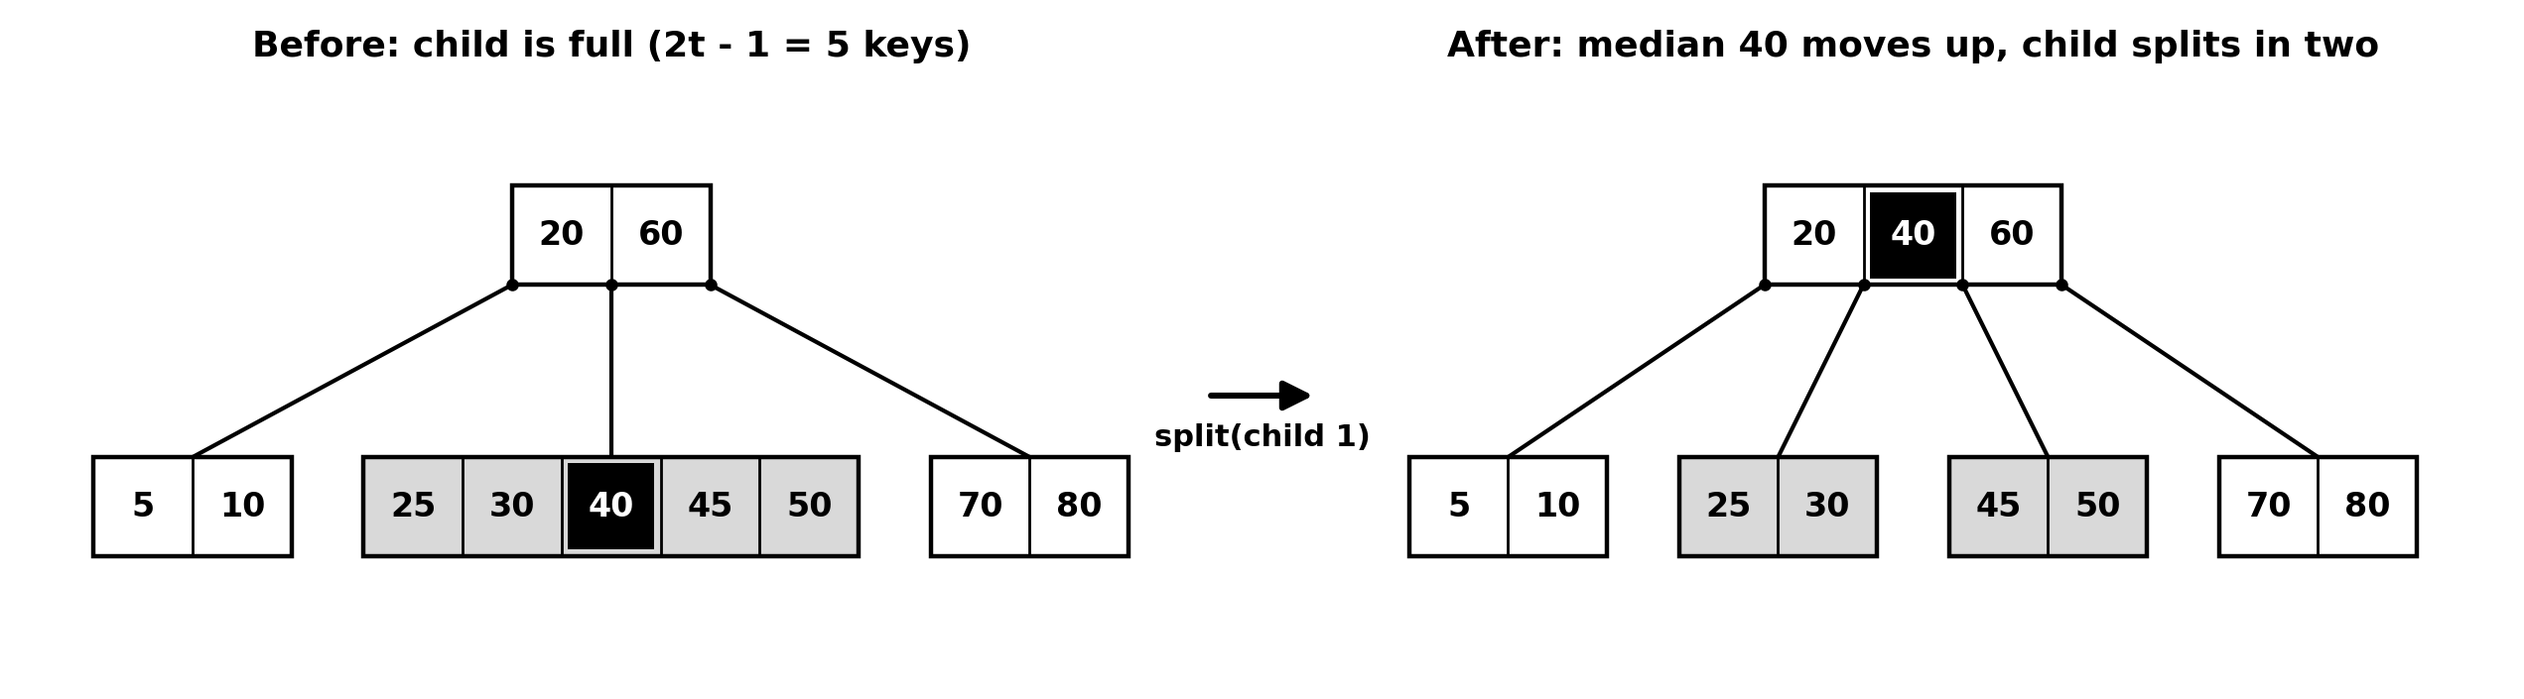
Figure 1. Splitting a full child (t = 3): the median 40 moves up into the parent.
C1 Paper first. Insert 8, 3, 15, 20, 1, 12, 25, 30, 18, 5 into an empty B-tree with t = 2 (nodes hold 1 to 3 keys). For each insertion record in Table 2 whether a split happens (and whether it is a root split), the height afterwards, and the tree written in bracket form, for example [8]([3], [15 20]). Draw the final tree. [8 marks]
C2 Complete _split_child(parent, i). Hint: with keys y.keys, the median is y.keys[t - 1]; the left half keeps y.keys[:t - 1], the right half gets y.keys[t:]; for internal nodes the children split at index t. [6 marks]
C3 Complete insert(key) (handles the full-root case) and _insert_nonfull(node, key) (walks down, splitting full children before entering them). After a split of child i, compare the key with the new median node.keys[i] to decide whether to continue into child i or i + 1. [8 marks]
C4 Complete is_valid(). Raise AssertionError with a reason if any rule is broken: node sizes, sorted keys inside a node, keys within the separator bounds inherited from ancestors, k + 1 children for internal nodes, and all leaves at the same depth. Return True otherwise. [6 marks]
Answer (C2-C4): _split_child() moves keys[t - 1] to the parent, keeps keys[:t - 1] on the left and keys[t:] on the right, and divides child pointers at index t. insert() splits a full root before descent; _insert_nonfull() splits full children before entering them. is_valid() checks node sizes, sorted keys, ancestor separator bounds, child counts and equal leaf depths. The complete code is in Appendix A.
C5 In two sentences: why does proactive splitting guarantee that a split never has to propagate back up the tree? [2 marks]
COMMON BUGS
Off-by-one slices in the split. Test _split_child on its own first (the automatic test does exactly that).
Forgetting to move child pointers when splitting an internal node.
Continuing into the wrong half after a split.
Testing with too few keys: internal-node splits only appear after dozens of insertions with t = 2.

6. Part D: deletion (10 min)
Deletion keeps every node it enters above the minimum: before descending into a child with t - 1 keys, it borrows a key from a sibling (case 3a) or merges the child with a sibling and the separator (case 3b). Keys in internal nodes are replaced by their predecessor (2a) or successor (2b), or the two children are merged (2c). The full code is provided in the starter file.
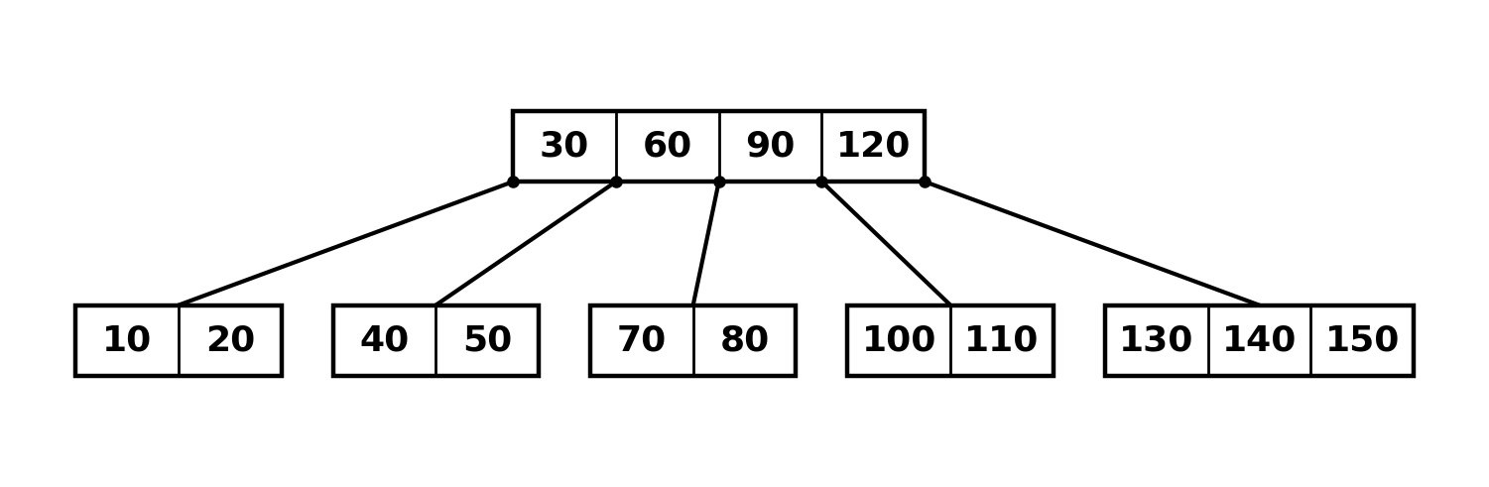
Figure 2. Starting tree for D1 (t = 3, keys 10 to 150). Non-root nodes hold 2 to 5 keys.
D1 Starting from Figure 2, delete 50, 130, 30, 110, 140 in that order. For each deletion, list every case applied on the way down (for example "3b, then 1") and write the tree afterwards in bracket form in Table 3. [9 marks]
D2 In the provided _delete and _fill methods, replace every # CASE ? comment with the correct case label (1, 2a, 2b, 2c, 3a or 3b) and a one-line explanation. Run your D1 deletions in code and check that is_valid() holds after each. [6 marks]
Answer (D2): Case 1 removes a key from a leaf; 2a replaces an internal key with its predecessor; 2b uses its successor; 2c merges both minimal children. Case 3a borrows from a sibling through the parent; 3b merges the child with a sibling and the separator before descent. The code labels these branches in Appendix A; the deletion tests pass.

7. Part E: benchmarking (15 min)
Compare search structures on n = 100,000 random keys: B-trees with t = 2, 4, 16, 64 and 256, the Red-Black tree from rbtree.py, and a Python list kept sorted with bisect.insort.
E1 Write run(make, keys, probe) that builds a structure, times the insertions, then times 5,000 searches and reports average page reads (B-trees only) and height. [5 marks]
Answer (E1): The completed run(make, keys, probe) timing harness is included in Appendix C (benchmark.py). It times construction and 5,000 searches, resets and averages B-tree page reads, and reports height when the structure provides it.
E2 Fill Table 4 with build time, microseconds per search, average reads per search and height for all seven structures. [5 marks]
E3 Plot (a) height against t (log scale on x), with a horizontal line for the Red-Black height, and (b) average page reads and microseconds per search against t. [4 marks]
Plot (a): Height against minimum degree t (logarithmic x-axis)
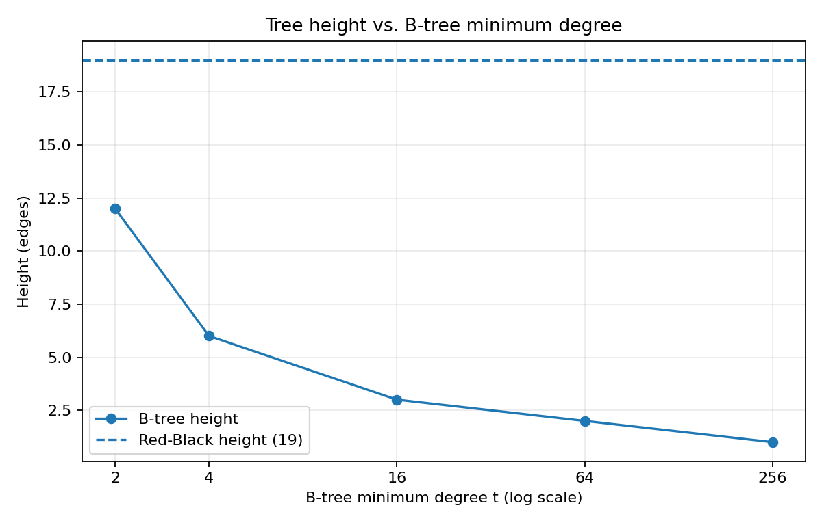
Plot (b): Average page reads and search time against t
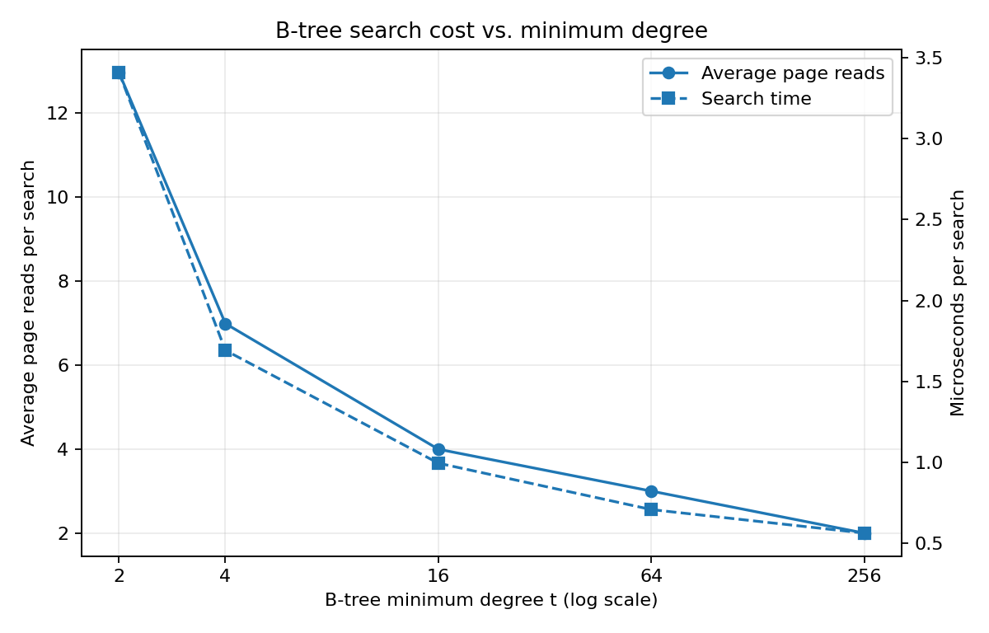
E4 Answer on the results sheet: (a) Why is the average number of reads slightly below height + 1? (b) Why is the B-tree with t = 2 shorter than the Red-Black tree on the same keys? (c) Why does a larger t make searches faster even in RAM in Python? (d) If every read cost 10 ms, how long would an average search take for t = 2 and for t = 256? [6 marks]
def run(make, keys, probe):
t = make()
start = time.perf_counter()
for key in keys: t.insert(key)
build_s = time.perf_counter() - start
if hasattr(t, "reads"): t.reads = 0
start = time.perf_counter()
for key in probe: t.search(key)
search_us = (time.perf_counter() - start) * 1_000_000 / len(probe)
reads_per_search = t.reads / len(probe) if hasattr(t, "reads") else None
height = t.height() if hasattr(t, "height") else None
return build_s, search_us, reads_per_search, height

8. Mini challenge: a bulk-loaded 1,000,000-record index
SCENARIO
A table of 1,000,000 records already exists and needs an index. Inserting keys one at a time is slow and, for sorted input, leaves pages half empty. Databases instead bulk-load: sort once, then build the tree bottom-up with packed pages.

Requirements
- Build a B+-style index: leaves hold the keys (and record ids) and are linked left to right; internal nodes hold the first key of every child except the first. Each node holds at most 2t - 1 keys. Use t = 64.
- Write bulk_load(sorted_pairs, fill): cut the sorted pairs into leaves of at most fill * (2t - 1) keys (equal sizes, so no leaf is underfull), then repeatedly group the nodes of one level into parents until a single root remains.
- Implement search(key) and range(lo, hi) counting page reads; a range query descends once and then follows the leaf links.
- Generate 1,000,000 distinct random keys. Compare: B-tree with random-order inserts, B-tree with sorted-order inserts, and bulk loading at 100%, 90% and 70% fill. Report build time, node count, height, fill factor and average page reads for 1,000 range queries returning about 2,000 keys each.
- Write a validator for your index and check every range answer against a sorted Python list.

Questions for your report
- Why do sorted one-by-one inserts produce about 50% full nodes?
Answer: When a full node splits, its keys are divided around the median. With sorted increasing input, new keys keep going to the rightmost node while older left halves remain near t - 1 keys, about half of the maximum 2t - 1.
- Why does a range query on the bulk-loaded index read fewer pages than on the one-by-one B-tree?
Answer: Bulk loading packs sorted records into dense leaves and builds parent levels bottom-up. A range query descends once and then scans linked leaves, so it avoids many of the less-full nodes created by one-by-one inserts.
- Databases often bulk-load at 90% rather than 100%. What happens on the first insertion into a 100%-full leaf?

9. Results sheet
Name: Damir Rasmuxamedov Student ID: 4245973 Date: ____________

Table 1. Part A1: height bounds
t | Max keys per node | Max height, n = 5,000,000 | Max height, n = 2,000,000,000 | Worst-case reads, n = 2,000,000,000
3 | 5 | 13 | 18 | 19
50 | 99 | 3 | 5 | 6
200 | 399 | 2 | 3 | 4
500 | 999 | 2 | 3 | 4
A2 (a) t = 127; (b) t = 64. Inequalities:
8-byte keys: 16 + 8(2t - 1) + 8(2t) <= 4096, so 32t + 8 <= 4096 and t <= 127.75; largest integer t = 127.
24-byte keys: 16 + 24(2t - 1) + 8(2t) <= 4096, so 64t - 8 <= 4096 and t <= 64.125; largest integer t = 64.
A3: Red-Black: 24 reads, HDD 240 ms, SSD 2.4 ms. B-tree (t = 127): 3 reads, HDD 30 ms, SSD 0.3 ms.
If the root is cached: Red-Black tree: 23 reads, HDD 230 ms, SSD 2.3 ms. B-tree: 2 reads, HDD 20 ms, SSD 0.2 ms.
B3: search 18 reads [15] -> [25] -> [18 20] (3 reads); search 13 reads [15] -> [8] -> [12] (3 reads).

Table 2. Part C1: insertion trace, t = 2
Insert | Split? (root?) | Height | Tree in bracket form
8 | No | 0 | [8]
3 | No | 0 | [3 8]
15 | No | 0 | [3 8 15]
20 | Yes - root split | 1 | [8]([3], [15 20])
1 | No | 1 | [8]([1 3], [15 20])
12 | No | 1 | [8]([1 3], [12 15 20])
25 | Yes - child split | 1 | [8 15]([1 3], [12], [20 25])
30 | No | 1 | [8 15]([1 3], [12], [20 25 30])
18 | Yes - child split | 1 | [8 15 25]([1 3], [12], [18 20], [30])
5 | Yes - root split | 2 | [15]([8]([1 3 5], [12]), [25]([18 20], [30]))
C5: Before descending, the algorithm splits any full child while its parent is still non-full. This leaves room for the promoted median immediately, so the split does not need to propagate back up the tree.
Final C1 tree:
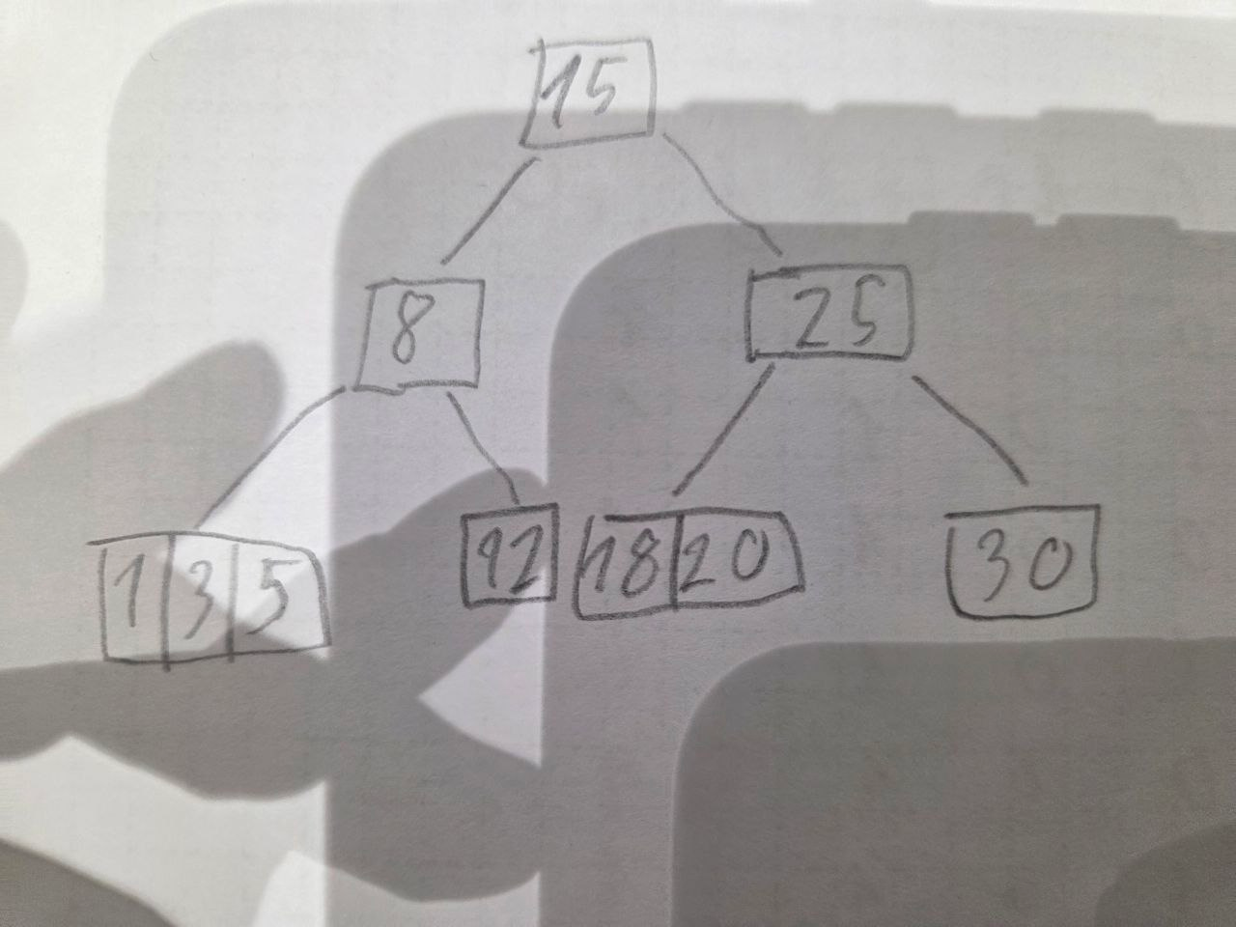

Table 3. Part D1: deletion trace, t = 3
Delete | Cases applied (in order) | Tree afterwards in bracket form
50 | 3b, then 1 | [30 90 120]([10 20], [40 60 70 80], [100 110], [130 140 150])
130 | 1 | [30 90 120]([10 20], [40 60 70 80], [100 110], [140 150])
30 | 2b, then 1 | [40 90 120]([10 20], [60 70 80], [100 110], [140 150])
110 | 3a, then 1 | [40 80 120]([10 20], [60 70], [90 100], [140 150])
140 | 3b, then 1 | [40 80]([10 20], [60 70], [90 100 120 150])

Table 4. Part E2: n = 100,000 random keys
Structure | Build (s) | Search (us) | Reads per search | Height
B-tree t = 2 | 0.5354 | 3.4095 | 12.9692 | 12
B-tree t = 4 | 0.2388 | 1.6924 | 6.9880 | 6
B-tree t = 16 | 0.1422 | 0.9955 | 3.9968 | 3
B-tree t = 64 | 0.1185 | 0.7090 | 2.9998 | 2
B-tree t = 256 | 0.1111 | 0.5637 | 2.0000 | 1
Red-Black tree | 0.2469 | 1.3329 | n/a | 19
Sorted list + bisect | 0.5321 | 0.5507 | n/a | n/a
Benchmark measurements are from the included run; build and search times can vary by computer and Python version.
E4 answers:
(a) Average reads are slightly below height + 1 because some searches find a matching key in an internal node and stop before reaching a leaf.
(b) A B-tree node holds several keys and can have many children; a Red-Black tree is binary and stores one key per node. Therefore the B-tree can be shorter even when t = 2.
(c) Larger t reduces the number of nodes visited. In Python this means fewer pointer traversals and less per-node overhead; binary search finds the position inside each wider node.
(d) Using these measured averages and 10 ms per read: t = 2 -> 12.9692 x 10 = about 129.7 ms; t = 256 -> 2 x 10 = 20 ms.

10. Deliverables and marking
- lab3b.py: the completed starter file; python lab3b.py must print PASS on all five lines.
- benchmark.py and the two plots as PNG files.
- The completed results sheet (Section 9), scanned or typed.
- Optional: bplus.py and a half-page write-up for the mini challenge.
Component | Marks | Full marks require
Part A | 15 | Correct Table 1, both page-layout inequalities solved, lookup times for both devices and the cached-root variant
Part B | 10 | Search with exact read counting; range query that prunes subtrees and stops early; correct B3 paths
Part C | 30 | Correct trace with split points and final tree; split, insert and validator pass the tests; clear C5 explanation
Part D | 15 | All five deletions with the correct case sequence and trees; every CASE label correct
Part E | 20 | Fair harness; complete table; two labelled plots; answers use the page-read model
Report | 10 | Clear, complete and neatly presented; code readable and commented
Challenge | +10 | Correct bulk loader and linked leaves; validator; all five configurations measured; trade-offs explained

ACADEMIC INTEGRITY
Discuss ideas freely, but write every line of code yourself. Cite any outside source in a comment.

Appendix A. Completed code solution: lab3b.py
import bisect
import random

class BNode:
def __init__(self, leaf=True):
self.keys = []
self.children = []
self.leaf = leaf

class BTree:
def __init__(self, t=2):
if t < 2:
raise ValueError("minimum degree t must be at least 2")
self.t = t
self.root = BNode()
self.reads = 0
self.writes = 0
self.splits = 0
self.merges = 0

def search(self, key):
node = self.root
while True:
self.reads += 1
i = bisect.bisect_left(node.keys, key)

if i < len(node.keys) and node.keys[i] == key:
return True
if node.leaf:
return False
node = node.children[i]

def insert(self, key):
node = self.root
while True:
i = bisect.bisect_left(node.keys, key)
if i < len(node.keys) and node.keys[i] == key:
return
if node.leaf:
break
node = node.children[i]

if len(self.root.keys) == 2 * self.t - 1:
old_root = self.root
self.root = BNode(False)
self.root.children.append(old_root)
self._split_child(self.root, 0)

self._insert_nonfull(self.root, key)

def _split_child(self, parent, i):
t = self.t
child = parent.children[i]
right = BNode(child.leaf)

middle_key = child.keys[t - 1]
right.keys = child.keys[t:]
child.keys = child.keys[:t - 1]

if not child.leaf:
right.children = child.children[t:]
child.children = child.children[:t]

parent.keys.insert(i, middle_key)
parent.children.insert(i + 1, right)
self.splits += 1
self.writes += 3

def _insert_nonfull(self, node, key):
i = bisect.bisect_left(node.keys, key)

if node.leaf:
if i == len(node.keys) or node.keys[i] != key:
node.keys.insert(i, key)
self.writes += 1
return

if len(node.children[i].keys) == 2 * self.t - 1:
self._split_child(node, i)
if key > node.keys[i]:
i += 1

self._insert_nonfull(node.children[i], key)

def delete(self, key):
self._delete(self.root, key)
if not self.root.keys and not self.root.leaf:
self.root = self.root.children[0]

def _delete(self, node, key):
t = self.t
self.reads += 1
i = bisect.bisect_left(node.keys, key)
found = i < len(node.keys) and node.keys[i] == key

if node.leaf:
if found:
node.keys.pop(i)
self.writes += 1
return

if found:
left = node.children[i]
right = node.children[i + 1]

if len(left.keys) >= t:
old_key = self._max_key(left)
node.keys[i] = old_key
self._delete(left, old_key)
elif len(right.keys) >= t:
old_key = self._min_key(right)
node.keys[i] = old_key
self._delete(right, old_key)
else:
self._merge(node, i)
self._delete(left, key)
return

if len(node.children[i].keys) == t - 1:
i = self._fill(node, i)
self._delete(node.children[i], key)

def _max_key(self, node):
while not node.leaf:
self.reads += 1
node = node.children[-1]
return node.keys[-1]

def _min_key(self, node):
while not node.leaf:
self.reads += 1
node = node.children[0]
return node.keys[0]

def _fill(self, node, i):
t = self.t

if i > 0 and len(node.children[i - 1].keys) >= t:
child = node.children[i]
sibling = node.children[i - 1]
child.keys.insert(0, node.keys[i - 1])
node.keys[i - 1] = sibling.keys.pop()
if not sibling.leaf:
child.children.insert(0, sibling.children.pop())
self.writes += 3
return i

if i < len(node.children) - 1 and len(node.children[i + 1].keys) >= t:
child = node.children[i]
sibling = node.children[i + 1]
child.keys.append(node.keys[i])
node.keys[i] = sibling.keys.pop(0)
if not sibling.leaf:
child.children.append(sibling.children.pop(0))
self.writes += 3
return i

if i < len(node.children) - 1:
self._merge(node, i)
return i

self._merge(node, i - 1)
return i - 1

def _merge(self, node, i):
left = node.children[i]
right = node.children[i + 1]
left.keys.append(node.keys.pop(i))
left.keys.extend(right.keys)
if not left.leaf:
left.children.extend(right.children)
node.children.pop(i + 1)
self.merges += 1
self.writes += 2

def range(self, lo, hi):
result = []
if lo > hi:
return result

def visit(node):
self.reads += 1
for i, key in enumerate(node.keys):
if not node.leaf and key >= lo:
visit(node.children[i])

if key > hi:
return
if key >= lo:
result.append(key)

if not node.leaf:
visit(node.children[-1])

visit(self.root)
return result

def inorder(self):
result = []

def visit(node):
for i, key in enumerate(node.keys):
if not node.leaf:
visit(node.children[i])
result.append(key)
if not node.leaf:
visit(node.children[-1])

visit(self.root)
return result

def height(self):
height = 0
node = self.root
while not node.leaf:
node = node.children[0]
height += 1
return height

def node_count(self):
def count(node):
total = 1
for child in node.children:
total += count(child)
return total
return count(self.root)

def fill_factor(self):
stack = [self.root]
node_total = 0
key_total = 0
while stack:
node = stack.pop()
node_total += 1
key_total += len(node.keys)
stack.extend(node.children)
return key_total / (node_total * (2 * self.t - 1))

def to_tuple(self, node=None):
if node is None:
node = self.root
return (tuple(node.keys), tuple(self.to_tuple(child) for child in node.children))

def is_valid(self):
t = self.t
leaf_depths = set()

def check(node, low, high, depth, is_root):
if node.keys != sorted(node.keys):
raise AssertionError("keys inside a node are not sorted")
if len(set(node.keys)) != len(node.keys):
raise AssertionError("duplicate keys inside a node")

if is_root:
if len(node.keys) > 2 * t - 1:
raise AssertionError("root has too many keys")
elif len(node.keys) < t - 1 or len(node.keys) > 2 * t - 1:
raise AssertionError("non-root node has an invalid number of keys")

for key in node.keys:
if low is not None and key <= low:
raise AssertionError("key violates lower separator bound")
if high is not None and key >= high:
raise AssertionError("key violates upper separator bound")

if node.leaf:
if node.children:
raise AssertionError("leaf has child pointers")
leaf_depths.add(depth)
return

if len(node.children) != len(node.keys) + 1:
raise AssertionError("internal node must have k + 1 children")

for i, child in enumerate(node.children):
child_low = low if i == 0 else node.keys[i - 1]
child_high = high if i == len(node.keys) else node.keys[i]
check(child, child_low, child_high, depth + 1, False)

check(self.root, None, None, 0, True)
if len(leaf_depths) != 1:
raise AssertionError("leaves are not all at the same depth")
return True

def bracket(node):
text = "[" + " ".join(str(key) for key in node.keys) + "]"
if node.leaf:
return text
return text + "(" + ", ".join(bracket(child) for child in node.children) + ")"

# ======================================================== tests (do not edit)
def run(name, fn):
try:
fn()
print(f"PASS {name}")
except NotImplementedError:
print(f"TODO {name}")
except AssertionError as e:
print(f"FAIL {name} {e}")

def test_search():
b = BTree(2)
b.root = BNode(False)
b.root.keys = [20]
left, right = BNode(True), BNode(True)
left.keys, right.keys = [5, 10], [30, 40, 50]
b.root.children = [left, right]
assert b.search(40) and not b.search(35), "search gives wrong answer"
b.reads = 0
b.search(50)
assert b.reads == 2, "a search for 50 should read exactly 2 nodes"
assert b.range(8, 40) == [10, 20, 30, 40], "range(8, 40) is wrong"

def test_split():
b = BTree(3)
parent, child = BNode(False), BNode(True)
parent.keys, child.keys = [100], [10, 20, 30, 40, 50]
parent.children = [child, BNode(True)]
parent.children[1].keys = [110, 120]
b._split_child(parent, 0)
assert parent.keys == [30, 100], "median must move up into the parent"
halves = [c.keys for c in parent.children]
assert halves == [[10, 20], [40, 50], [110, 120]], "split halves are wrong"

def test_insert():
rng = random.Random(7)
for t in (2, 3, 5):
b = BTree(t)
keys = rng.sample(range(10000), 3000)
for k in keys:
b.insert(k)
assert b.is_valid(), f"invalid tree for t = {t}"
assert b.inorder() == sorted(keys), f"keys lost or out of order for t = {t}"
b = BTree(2)
for k in range(1, 8):
b.insert(k)
expected = ((2, 4), (((1,), ()), ((3,), ()), ((5, 6, 7), ())))
assert b.to_tuple() == expected, "t = 2, keys 1..7 gives the wrong shape"

def test_validator():
b = BTree(2)
for k in range(20):
b.insert(k)
assert b.is_valid() is True
b.root.children[0].keys.append(999)
try:
b.is_valid()
raise AssertionError("validator accepted a tree with a key out of order")
except AssertionError as e:
if "accepted" in str(e):
raise

def test_delete():
rng = random.Random(3)
b, ref = BTree(3), set()
for _ in range(4000):
k = rng.randrange(800)
if rng.random() < 0.55:
b.insert(k)
ref.add(k)
else:
b.delete(k)
ref.discard(k)
assert b.is_valid(), "delete produced an invalid tree"
assert b.inorder() == sorted(ref), "delete broke the tree"

if __name__ == "__main__":
run("Part B search, read counter and range", test_search)
run("Part C split_child", test_split)
run("Part C insert (t = 2, 3, 5)", test_insert)
run("Part C validator detects a broken tree", test_validator)
run("Part D provided delete still works", test_delete)

Appendix B. Quick reference
Quantity | Formula (minimum degree t)
Keys per non-root node | t - 1 to 2t - 1 (root: 1 to 2t - 1)
Children of an internal node with k keys | k + 1 (between t and 2t for non-root nodes)
Maximum height | h <= log_t((n + 1) / 2)
Page reads per search | at most h + 1
Split of a full node | median keys[t - 1] moves up; halves keys[:t - 1] and keys[t:]

Case | Situation | Action
1 | Key in a leaf (which has >= t keys, or is the root) | Remove it
2a | Key in internal node; left child has >= t keys | Replace by predecessor; delete predecessor from left child
2b | Key in internal node; right child has >= t keys | Replace by successor; delete successor from right child
2c | Key in internal node; both children have t - 1 keys | Merge left + key + right; delete from merged node
3a | Key not here; next child has t - 1 keys; a sibling has >= t | Borrow through the parent, then descend
3b | Key not here; next child and its siblings have t - 1 keys | Merge child + separator + sibling, then descend
Root | Root has no keys after a merge | Its only child becomes the root (height - 1)

