1. ¿Cuánto vale una casa en Berisso?
2. Respuesta

NO hay casas en Berisso

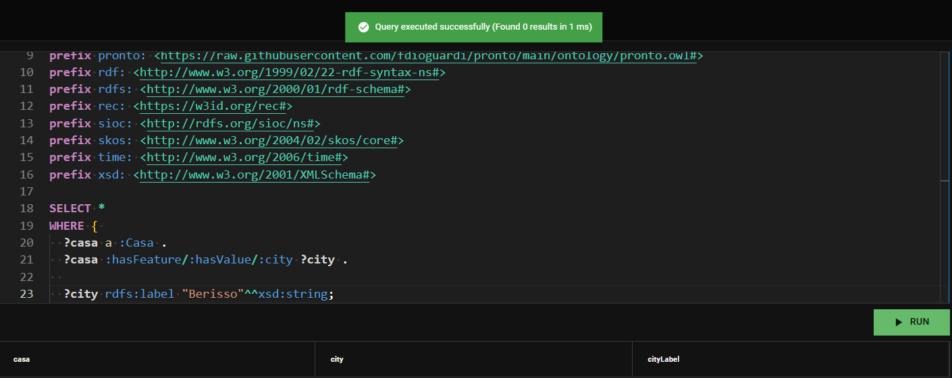

1. **prefix** : <http://www.semanticweb.org/luciana/ontologies/2024/8/inmontology#>
2. **prefix** brick: <https://brickschema.org/schema/Brick#>
3. **prefix** dc: <http://purl.org/dc/elements/1.1/>
4. **prefix** dcterms: <http://purl.org/dc/terms/>
5. **prefix** foaf: <http://xmlns.com/foaf/0.1/>
6. **prefix** gr: <http://purl.org/goodrelations/v1#>
7. **prefix** ns: <http://www.w3.org/2003/06/sw-vocab-status/ns#>
8. **prefix** owl: <http://www.w3.org/2002/07/owl#>
9. **prefix** pronto: <https://raw.githubusercontent.com/fdioguardi/pronto/main/ontology/pronto.owl#>
10. **prefix** rdf: <http://www.w3.org/1999/02/22-rdf-syntax-ns#>
11. **prefix** rdfs: <http://www.w3.org/2000/01/rdf-schema#>
12. **prefix** rec: <https://w3id.org/rec#>
13. **prefix** sioc: <http://rdfs.org/sioc/ns#>
14. **prefix** skos: <http://www.w3.org/2004/02/skos/core#>
15. **prefix** time: <http://www.w3.org/2006/time#>
16. **prefix** xsd: <http://www.w3.org/2001/XMLSchema#>
17. **SELECT** (**DISTINCT** **?city** **AS** **?X**)
18. **WHERE** {
19. **?casa** a :Casa .
20. **?casa** :hasFeature**/**:hasValue**/**:city**/**rdfs:label **?city** .
22. }

B. En brandsen

**SELECT** **?casa**

**WHERE** {

**?casa** a :Casa .

**?casa** :hasFeature**/**:hasValue**/**:city**/**rdfs:label **?city** .

**FILTER** (lcase(str(**?city**)) **=** "brandsen") .

}