Title: Mosquito bloodmeal source diversity between disturbed and wild environments in the Americas: a review

Short title: Mosquito blood source diversity in the Americas

Guadalupe López-Nava, Damián Villaseñor-Amador, César A. Sandoval-Ruiz

Laboratorio de Artropodología y Salud, Facultad de Ciencias Biológicas, Benemérita Universidad Autónoma de Puebla, Puebla, Pue., 72000, México

Corresponding author: César A. Sandoval-Ruiz

Email address: cesar.sandoval@correo.buap.mx

INTRODUCTION

Mosquitoes (Diptera: Culicidae) transmit many pathogens to humans and other animals (Becker et al., 2010). Particularly relevant mosquito-borne diseases in public health are malaria, dengue fever, yellow fever, zika, chikungunya, West Nile virus, lymphatic filariasis and different types of encephalitis (Tolle, 2009; Brugueras et al., 2020). Invasion of mosquito species adapted to proliferate in disturbed environments is involved in vector borne diseases expansion to new geographic areas (Brugueras et al., 2020; Cebrián-Camisón et al., 2020; Rose et al., 2020). Man-made environmental changes facilitate these invasions by modifying mosquito distribution and their bloodmeal source availability (Ramasamy & Surendran, 2016; Cebrián-Camisón et al., 2020; Rose et al., 2020; Schrama et al., 2020). Mosquito invasions can have a negative impact in both disturbed and wild environments (Cebrián-Camisón et al., 2020). Anthropogenic landscape disturbances effect in mosquito dynamics has been researched in Europe (Cebrián-Camisón et al., 2020), Africa (Rose et al., 2020; Schrama et al., 2020) and the indomalayan region (Ramasamy & Surendran, 2016).

The aim of our study was to identify mosquito bloodmeal source diversity between disturbed and wild environments in the Americas. Knowing mosquito bloodmeal sources allows for a better understanding of the zoonotic cycles of pathogens (Abella-Medrano et al., 2018), especially those carried by generalist vectors. Generalist mosquitoes have a higher chance of pathogen spread over a wide range of hosts (Abella-Medrano et al., 2018). If environmental disturbances are high, humans have an increased chance of becoming an accidental host.

MATERIALS AND METHODS

We performed an extensive literature review on the blood feeding patterns of mosquitoes in the Americas, whose bloodmeal source host had been identified through precipitin test, gel diffusion, enzyme-linked immunosorbent assay (ELISA) or other molecular techniques (Cebrián-Camisón et al., 2020). We used Clarivate Analytics Web of Science (core collection 1980-2020), Elsevier Scopus and SciELO as the main search engines to find articles identifying vertebrate hosts of mosquitoes. The 29 of September 2020 we made searches with keywords including: *“mosquitoes” AND (“blood meal sources” OR “blood feeding patterns”) AND “landscape”*, *"mosquito" AND ("blood" OR "host") AND ("feeding" OR "foraging") AND ("landscape" OR "deforestation")* and *(“blood meal” OR “bloodmeal”) AND “mosquitoes”*. Additional references were obtained from the citations in these studies and pertinent articles were identified with online software ([www.connectedpapers.com](http://www.connectedpapers.com)). The 23 of December of 2020 we made additional searches in the Web of Science and Scopus with keywords including: *“mosquito” AND “diet”*, *“mosquito” AND “diet change”* and *“mosquito” AND “feeding-pattern”*.

We used PRISMA guidelines for the study selection process (Moher et al., 2009) as suggested by previous authors (Nakagawa et al., 2017; Putman & Tippie, 2020). The initial search yielded 2,143 records (Fig. 1). We removed duplicates with *synthesisr* R package (Westgate & Grames, 2020) whose algorithm detects highly similar titles through a string distance method, which narrowed down the total to 1461 records. Next, we reviewed papers on their titles and abstracts, using criteria based on PECO (population, exposure, comparator, outcome) framework as suggested by Haddaway et al. (2016), to identify the set of highly relevant articles (Grames et al., 2019). Articles were deemed relevant if the study population was a mosquito species of the Americas, if the study was performed in either (or both) disturbed or wild landscapes (exposure of anthropogenic disturbance and comparator of disturbed vs. wild) and if the outcome of the study included the bloodmeal source host identified to species level. We also excluded studies not published in the English or Spanish languages, as these are the only languages we are proficient in. Additionally the majority of studies published in Portuguese include a title, abstract and keywords in English. The removal of studies lacking these criteria narrowed down our total to 126 papers. Full text screening was then conducted using the same inclusion criteria as above. We emailed authors when coordinates for each study site were not presented. Six out of 15 authors that were emailed replied and supplied the missing information. In all, we found 38 studies available for data extraction. An excel table was created including the information of interest, such as mosquito species, decimal coordinates of latitude and longitude, host richness, total number of blood engorged mosquitoes, bloodmeal host taxon, country where the study was developed and landscape type (i.e. disturbed or wild). We recognize the lack of globally universal criteria used to define disturbed environments from wild environments, and so we relied on authors’ descriptions of their study sites to determine landscape type. In 21 cases we had to determine whether a study site belonged to either a disturbed or wild landscape by ourselves, in which case we used the coordinates to overlap the site with vegetation and urbanization polygons in ArcMap v10.8. If the study site was placed inside an urban or secondary vegetation polygon it was deemed a disturbed landscape type, if it was placed inside a primary vegetation polygon it was labeled a wild landscape type. By acknowledging this added heterogeneity to our dataset we tried to account for it.

RESULTS

66 mosquito species were reported amongst the 21 studies. *Culex quinquefasciatus* was the most intensively studied with 7 articles reporting this species, followed by *Aedes aegypti* (5 studies), *Ae. scapularis*, *Ae. serratus, Cx. restuans, Mansonia tittilans* and *Psorophora ferox,* these last five being mentioned in 4 studies. Only 8 studies included data from both disturbed and wild landscapes. 16 mosquito species had data for both landscapes, the rest only had data for one of the two landscapes. The top 20 species with the highest host richness corresponded to 3,517 engorged mosquitoes. Over 50% of them corresponded to two species: *Cx. erraticus* (with 1,162) and *Cx. pipiens* (636). 9 studies were conducted in the USA and 12 were developed in Latin America. Out of the 1,055 host records 82% (866 records) were identified to species level. 90 records were labeled as ‘primate’, 52 as ‘bird’, 38 as ‘non-human-primate’ and 9 as ‘monkey’.

According to the published information, 56 species were identified as vertebrate hosts of at least one of the mosquito species studied (*Cx. erraticus*), including 32 birds, 11 reptiles, 10 mammals and 3 amphibians. This *Cx. erraticus* data was reported in Tuskegee National Park, Alabama, USA, labeled as a wild landscape in our study. In contrast, only 17 hosts were reported for the same species in the disturbed landscape (Auburn city, Alabama, USA), including 9 birds, 6 mammals and 1 amphibian. *Cx. pipiens* was the species with the highest host richness in disturbed landscapes: 32 hosts reported in Chicago, Illinois, USA, including 25 birds and 7 mammals. No record of *Cx. pipiens* for a wild landscape was found in our data. The top 20 species with the highest host richness showed an ability to feed on blood from different vertebrate groups, nevertheless 53% of the bloodmeals derived from mammals and 14% from humans. The anthropophilic behavior of species like *Aedes aegypti, Psorophora albigenu* and *Aedes mediovittatus* is supported by the fact that humans represent 49-88% of the total bloodmeal sources.

REFERENCES

Abella-Medrano, C. A., Ibáñez-Bernal, S., Carbó-Ramírez, P., & Santiago-Alarcon, D. (2018). Blood-meal preferences and avian malaria detection in mosquitoes (Diptera: Culicidae) captured at different land use types within a neotropical montane cloud forest matrix. *Parasitology International*, *67*(3), 313–320. https://doi.org/10.1016/j.parint.2018.01.006

Becker, N., Petrić, D., Zgomba, M., Boase, C., Madon, M., Dahl, C., & Kaiser, A. (2010). *Mosquitoes and Their Control* (2nd ed.). Springer: Berlin/Heidelberg.

Brugueras, S., Fernández-Martínez, B., Martínez-de la Puente, J., Figuerola, J., Porro, T. M., Rius, C., Larrauri, A., & Gómez-Barroso, D. (2020). Environmental drivers, climate change and emergent diseases transmitted by mosquitoes and their vectors in southern Europe: A systematic review. *Environmental Research*, *191*(August). https://doi.org/10.1016/j.envres.2020.110038

Cebrián-Camisón, S., Martínez-de la Puente, J., & Figuerola, J. (2020). A Literature Review of Host Feeding Patterns of Invasive Aedes Mosquitoes in Europe. *Insects*, *11*(12), 848. https://doi.org/https://doi.org/10.3390/insects11120848

Ramasamy, R., & Surendran, S. N. (2016). Mosquito vectors developing in atypical anthropogenic habitats: Global overview of recent observations, mechanisms and impact on disease transmission. *Journal of Vector Borne Diseases*, *53*(2), 91–98.

Rose, N. H., Sylla, M., Badolo, A., Lutomiah, J., Ayala, D., Aribodor, O. B., Ibe, N., Akorli, J., Otoo, S., Mutebi, J. P., Kriete, A. L., Ewing, E. G., Sang, R., Gloria-Soria, A., Powell, J. R., Baker, R. E., White, B. J., Crawford, J. E., & McBride, C. S. (2020). Climate and Urbanization Drive Mosquito Preference for Humans. *Current Biology*, *30*(18), 3570-3579.e6. https://doi.org/10.1016/j.cub.2020.06.092

Schrama, M., Hunting, E. R., Beechler, B. R., Guarido, M. M., Govender, D., Nijland, W., van ‘t Zelfde, M., Venter, M., van Bodegom, P. M., & Gorsich, E. E. (2020). Human practices promote presence and abundance of disease-transmitting mosquito species. *Scientific Reports*, *10*(1), 1–6. https://doi.org/10.1038/s41598-020-69858-3

Tolle, M. A. (2009). Mosquito-borne Diseases. *Current Problems in Pediatric and Adolescent Health Care*, *39*(4), 97–140. https://doi.org/10.1016/j.cppeds.2009.01.001

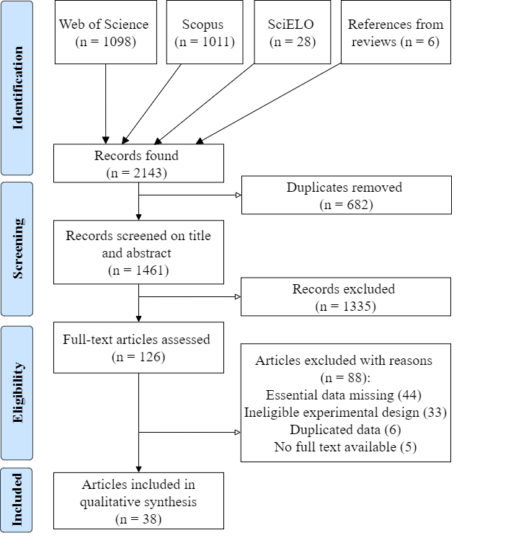

**Figure 1.** PRISMA flow diagram showing number of articles retrieved from the literature search and retained or excluded during the study selection process.