STRIDE Threat Model

Category | Threat Description | Implemented Security Controls
S – Spoofing | An attacker attempts to impersonate a legitimate user using stolen credentials. | TOTP-based MFA, one-time recovery codes, brute-force protection and account lockout.
T – Tampering | An attacker attempts to modify OAuth authorization responses or authentication parameters. | PKCE (S256), OAuth state validation and OIDC nonce validation.
R – Repudiation | An administrator denies performing account revocation or credential reset actions. | Security audit logs, Keycloak administrative event logging and timestamps
I – Information Disclosure | An attacker attempts to steal authentication tokens or session information. | HTTPS, server-side token storage in Redis, Secure and HttpOnly session cookies.
D – Denial of Service | An attacker repeatedly submits invalid login attempts to disrupt authentication services. | Rate limiting, temporary account lockout and brute-force detection.
E – Elevation of Privilege | A regular user attempts to access administrator functions or another user's protected resources. | Role-Based Access Control (RBAC), restricted administrative permissions and API authorization checks.

Additional Authentication and Recovery Threats

Security Feature | Potential Threat | Implemented Mitigation
Backup Authentication | Stolen recovery codes could allow an attacker who knows the password to bypass TOTP. | 12 single-use recovery codes and brute-force protection.
Credential Reset | An attacker with access to a user's email could attempt an unauthorized password reset. | 15-minute reset links, additional TOTP or recovery code verification.
Centralized Revocation | A compromised administrator could disable accounts or reset user credentials. | Restricted admin service account permissions and audit logging.

Security assessment

The implemented backup authentication, credential reset, and centralized revocation mechanisms improve account recovery and incident response capabilities. However, they also introduce additional attack surfaces.
One-time recovery codes, MFA verification during password reset, restricted administrative permissions, and audit logging reduce these risks. A residual risk remains: previously issued access tokens may stay valid for up to five minutes after centralized revocation. Overall, the additional security benefits outweigh the introduced risks under the defined threat model.

OWASP ASVS 5.0 Level 1 Compliance Assessment

V6 - Authentication

ASVS ID | Requirement | Project implementation | Status
6.1.1 | Document brute-force and automation defenses. | Authentication security controls are documented in README.md and docs/TESTING.md. Automated tests R1 and K7 confirmed login rate limiting and consistent error messages. Manual testing confirmed Keycloak temporary account lockout after five failed login attempts. | PASS
6.2.1 | Password minimum length of 8 characters. | Keycloak password policy requires 12 characters.  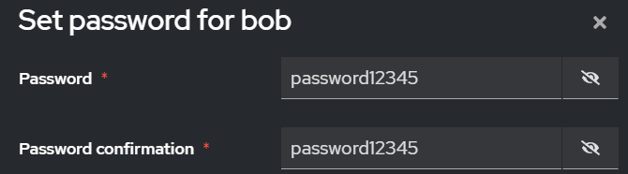  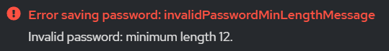 | PASS
6.2.2 | Users can change their passwords. | Keycloak account management, allows user to change his password  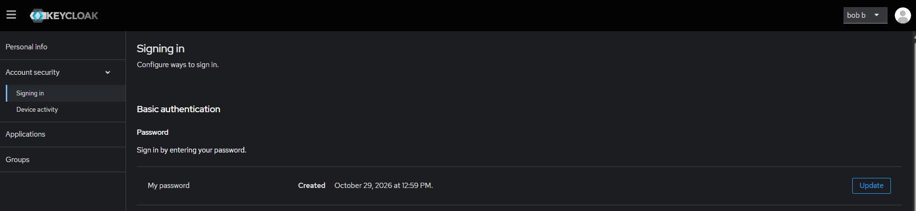 | PASS
6.2.3 | Password change requires current and new passwords. | Keycloak account management requires you to sign in with password, but doesn’t ask for password again, while trying to change password | PARTIAL
6.2.4 | Reject commonly used passwords (at least 3,000). | Keycloak password blocklist (~82,000 entries).  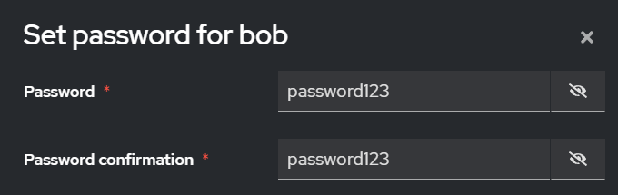  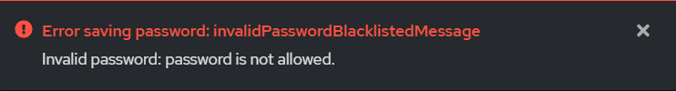 | PASS
6.2.5 | Do not enforce mandatory character composition rules. | No mandatory uppercase, digit or special-character requirements are configured.  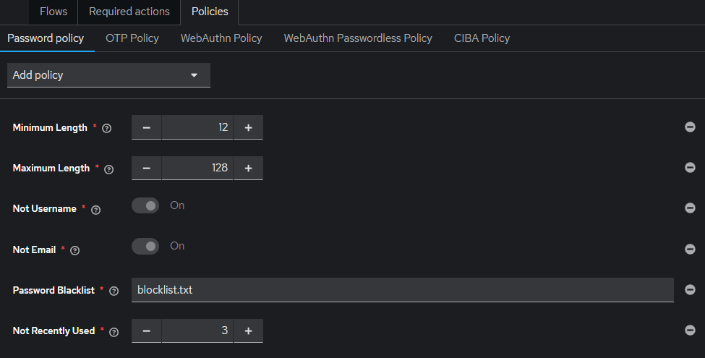 | PASS
6.2.6 | Mask password input fields. | Keycloak masskes password inputs  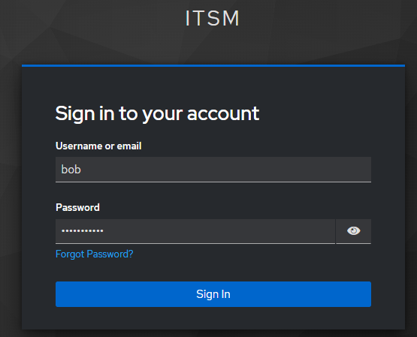 | PASS
6.2.7 | Allow password pasting and password uestio. | Keycloak allows password pasting and password manager autofill without restrictions. Both methods were successfully tested. | PASS
6.2.8 | Verify passwords without modifying input. | Keycloak verifies passwords exactly as entered. Authentication attempts with altered letter case or an additional trailing space were rejected, while the original password was accepted. | PASS
6.3.1 | Implement brute-force protection. | Keycloak temporarily locks user accounts after repeated failed authentication attempts. Five incorrect password attempts triggered brute-force protection. Application-level rate limiting was also verified by automated test R1 (HTTP 429).  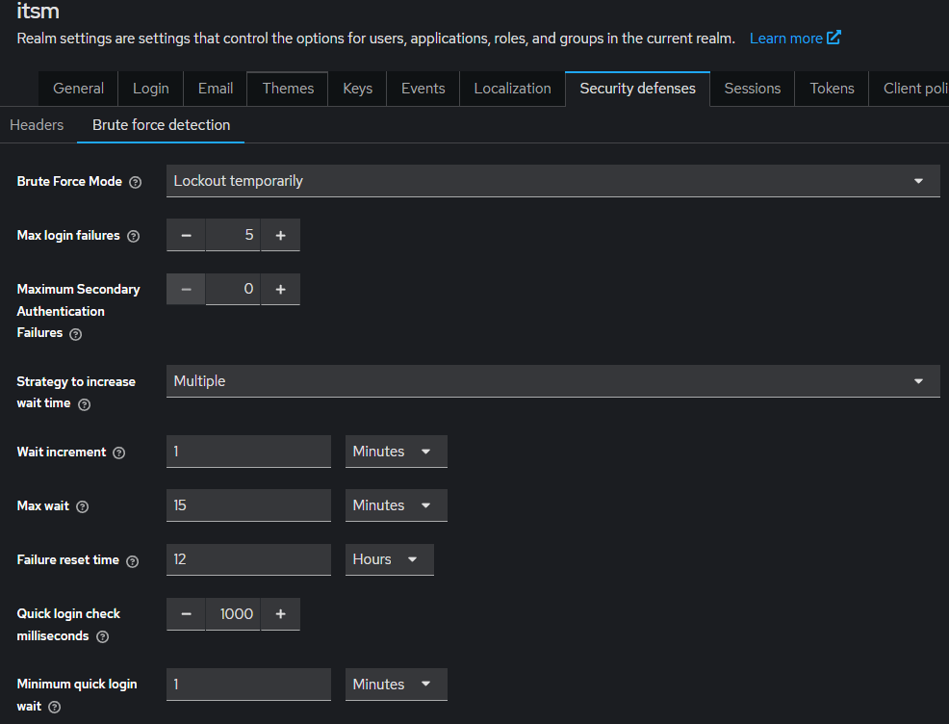  Test:  After typing 5 wrong passwords, tried to type correct one, still says “invalid username or password”  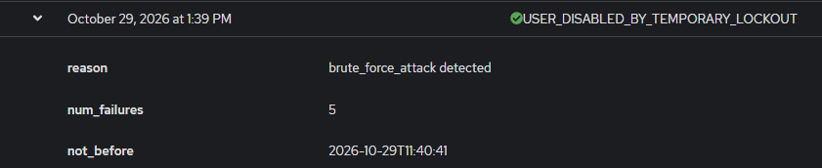 | PASS
6.3.2 | Disable or remove default application accounts. | We did not delete the temporary admin account for testing purposes | NOT VERIFIEDD
6.4.1 | Securely generate and expire initial credentials. | Keycloak requires users to change temporary initial passwords before accessing the application. Previously issued temporary passwords become invalid after replacement.  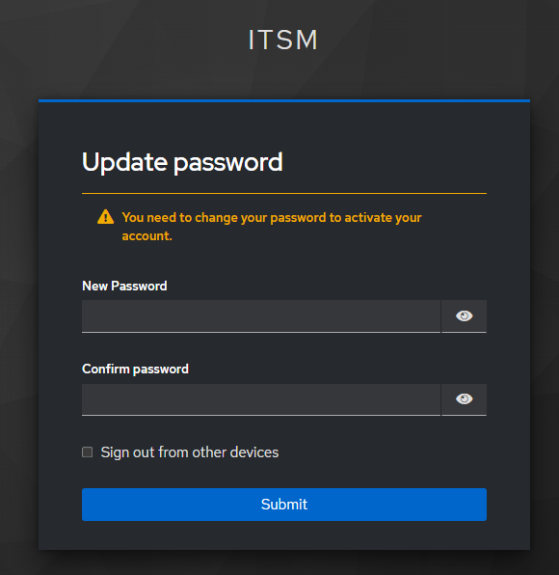 | PASS
6.4.2 | Do not use password hints or security uestion. | The application does not use password hints or knowledge-based security questions. Password recovery is performed through email-based reset links with additional TOTP or recovery code verification.  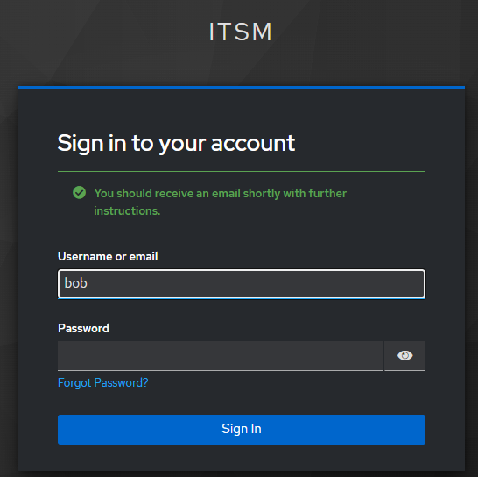 | PASS

V7 - Session Management

ASVS ID | Requirement (summarized) | Project Implementation / Evidence | Status
7.2.1 | Validate session tokens using a trusted backend. | Invalid session identifiers are rejected by the application. After modifying the session cookie, access to authenticated content was denied. Server-side sessions are managed using Redis.  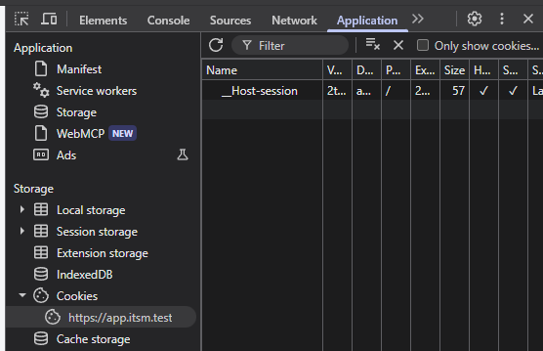  After Cookies change  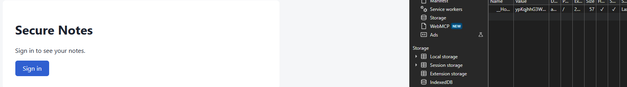 | PASS
7.2.2 | Use dynamically generated session tokens. | A new session identifier is generated dynamically for each authentication session. Different session identifiers were observed across consecutive logins.  Screemshots from 2 different sessions with different cookies value  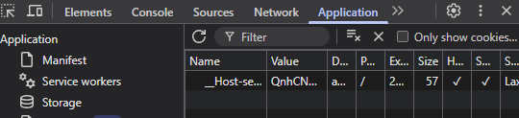  and  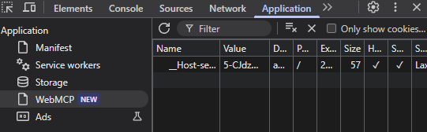 | PASS
7.2.3 | Use unique session tokens with at least 128 bits of CSPRNG entropy. | Flask-Session 0.8.0 generates session identifiers using secrets.token_urlsafe(32), providing 256 bits of cryptographically secure randomness. Session data is stored server-side in Redis.  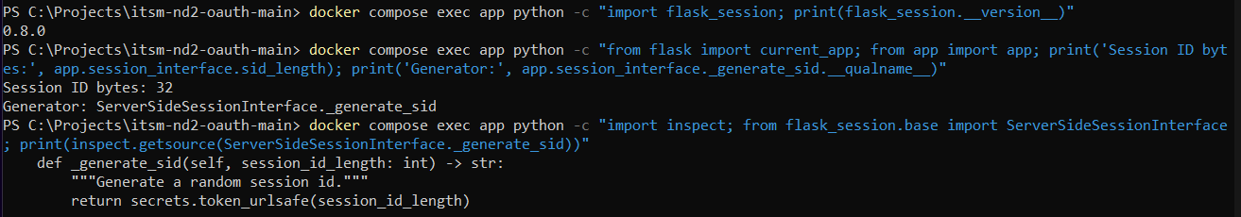 | PASS
7.2.4 | Generate a new session token after authentication and invalidate the previous one. | The application regenerates the session ID after successful OAuth/OIDC authentication using app.session_interface.regenerate(session). The previous session ID is invalidated and cannot access protected resources.  Also tested by comparing the session cookie ID before and after OAuth login using Chrome Developer Tools. Verified that a new session ID was generated and the previous one was invalidated. | PASS
7.4.1 | Invalidate sessions after logout or expiration. | Flask invalidates server-side Redis sessions after logout. Automated tests L2–L4 confirmed session termination and refresh token revocation.  Also tested by saving the session cookie before logout and attempting to reuse it afterward. The application rejected the old session and denied access to protected content. | PASS
7.4.2 | Terminate all active sessions when an account is disabled or deleted. | Keycloak terminates active user sessions when an account is disabled. The centralized revocation tool triggers back-channel logout, invalidating the user's Flask sessions stored in Redis.  Also tested by disabling an actively logged-in user (bob) through the centralized admin tool. After refreshing the website, the previous session was rejected and access to protected content was denied.  After I disabled bob and refreshed the page  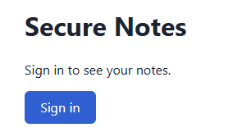 | PASS

Security Testing Results

Security testing was performed on the locally deployed Secure Notes application using automated test scripts and manual verification. The automated test suite reported 41 passed, 0 failed, and 1 skipped. The skipped test concerned refresh token rotation and requires separate verification. Additional manual tests verified password policies, MFA enforcement, brute-force account lockout, session identifier generation, session rotation, session invalidation after logout, and centralized session revocation. The application was also assessed against the OWASP ASVS 5.0 Level 1 requirements in chapters V6 (Authentication) and V7 (Session Management). The test evidence includes Keycloak configuration screenshots, security event logs, PowerShell test outputs, and browser Developer Tools observations.
Automated Security Test Resaults

Security test run 2026-10-29 11:13:59
alice: signed in
bob: signed in
admin1: signed in

== 1. Transport security (ASVS V12) ==
PASS T1 HTTP is redirected to HTTPS on all three hosts
PASS T2 TLS 1.3 and TLS 1.2 are accepted
PASS T3 TLS 1.1 is refused by the server [TLSV1_ALERT_PROTOCOL_VERSION]
PASS T4 TLS 1.0 is refused by the server [TLSV1_ALERT_PROTOCOL_VERSION]
PASS T5 Security headers on app.itsm.test (HSTS, CSP, nosniff, Referrer-Policy, no Server)
PASS T6 Security headers on api.itsm.test (HSTS, CSP, nosniff, Referrer-Policy, no Server)
PASS T7 Security headers on auth.itsm.test (HSTS, CSP, nosniff, Referrer-Policy, no Server)
PASS T8 Cache-Control: no-store on app and API responses

== 2. Session cookie, login and CSRF (ASVS V7, V3, V10) ==
PASS S1 Session cookie: __Host- prefix, Secure, HttpOnly, SameSite=Lax, Path=/, no Domain
PASS S2 Session cookie expires after 30 min idle (same as Keycloak SSO Session Idle) [1799 s]
PASS S3 Session fixation: a session id chosen by the attacker is not accepted
PASS S4 Open redirect: /login?next= accepts only local paths
PASS S5 OAuth callback with a forged state is rejected (login CSRF) [HTTP 400]
PASS S6 Form POST without a CSRF token is rejected [HTTP 400]

== 3. Authorization server (ASVS V10, V6) ==
PASS K1 Unregistered redirect_uri is rejected [HTTP 400]
PASS K2 PKCE is required (request without code_challenge) [error=invalid_request]
PASS K3 PKCE method 'plain' is refused, only S256 [error=invalid_request]
PASS K4 Implicit flow (response_type=token) is disabled [error=unauthorized_client]
PASS K5 Password grant (direct access) is disabled for webapp [unauthorized_client]
PASS K6 Wrong client secret is rejected [HTTP 401]
PASS K7 Same login error for existing and unknown users (no enumeration) ['Invalid username or password.' / 'Invalid username or password.']
PASS K8 Self-registration is disabled [HTTP 400]

== 4. Notes API: tokens and access control (ASVS V8, V9) ==
PASS A1 Valid access token is accepted (control) [HTTP 200]
PASS A2 No token -> 401 with WWW-Authenticate: Bearer [HTTP 401]
PASS A3 Malformed token -> 401 [HTTP 401]
PASS A4 Unsigned token (alg=none) -> 401 [HTTP 401]
PASS A5 Token signed with an attacker's key (real kid) -> 401 [HTTP 401]
PASS A6 Token with modified claims (sub, scope) -> 401 [HTTP 401]
PASS A7 ID token used as access token -> 401 [HTTP 401]
PASS A8 Refresh token used as access token -> 401 [HTTP 401]
PASS A9 alice can't read or delete bob's note (IDOR) -> 404 [read 404, delete 404, bob still sees it 200]
PASS A10 Non-admin (alice) on /admin/notes -> 403 [HTTP 403]
PASS A11 Admin (admin1) on /admin/notes -> 200 (control) [HTTP 200]
PASS A12 Invalid input (title too long, not an object, empty title) -> 400 [[400, 400, 400]]
PASS A13 Request body over 16 KB -> 413 [HTTP 413]
PASS A14 SQL injection text is stored as plain text, table intact

== 5. Logout and refresh tokens (ASVS V7, V10) ==
PASS L1 Sign-out without CSRF token is rejected (no logout CSRF) [HTTP 400]
PASS L2 Sign-out redirects to Keycloak end-session (SSO session ended too) [HTTP 302]
PASS L3 Old session cookie is useless after sign-out (deleted from Redis)
PASS L4 Refresh token is revoked at sign-out -> invalid_grant [HTTP 400]
SKIP L5 Refresh gives a new refresh token (rotation) [refresh failed: HTTP 400; alice's refresh token was used by an earlier run, sign out and sign in as alice again]

== 6. Rate limiting (ASVS V6) ==
PASS R1 /login is rate limited (20 per minute) -> 429 [first 429 at request 12 of 25]

41 passed, 0 failed, 1 skipped

