Damian Bhatia

**USER MANUAL FOR “BRICK BREAKER”**

**What is this game?**

This program is a rendition of the very popular retro game, Brick Breaker. The objective of the game is to break all the bricks seen on the screen without missing the ball with your paddle. Each brick is worth 5 points for a maximum of 105 points.

**Controls**

[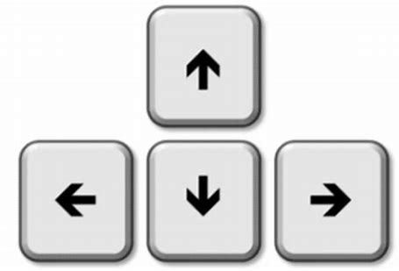](https://www.bing.com/images/search?view=detailV2&ccid=Ext5GXMy&id=F1A7BCF165B6EAB63C70264E69776784355A6F55&thid=OIP.Ext5GXMyHr7Sd55ex2KtgQHaFD&mediaurl=http%3a%2f%2fwww.101computing.net%2fwp%2fwp-content%2fuploads%2farrowKeys-300x205.png&exph=205&expw=300&q=arrow+keys+sprite&simid=607987382309293099&selectedIndex=0)

The paddle is moved using the left and right arrow keys.

**Opening Menu**



To begin the game, you are met with the menu. If you have played the game before you may press the play button, which will take you to the gameplay straight away. If you are new to the game, you can press the instructions button to figure out how to play and then proceed into the gameplay by clicking anywhere on the screen.



**Play Again**

Once all the bricks are broken, a “You Win” screen appears. If you wish to play again, you can hit the Enter key and the game will start again.

If you miss the ball with the paddle, a “Game Over” screen will appear. If you want to play again, you can press the Enter key.

In either case, if you do not wish to play again, you can press the X in the top right corner to exit the application. This game is a throwback and I hope that you enjoy it as much as the classic. Have fun!