Damian Bhatia & Aleksandar Stojanovic

**Shoot till You Drop Manual**

The Game

Shoot till You Drop is a top down 2-D shooter. The point of the game is to survive the zombie attack. Zombies will be attacking you from every corner, and you must stay alive. Each Zombie you kill with your gun will grant you 5 Points. To win you must get 200 points. Zombies will continue to spawn and if your health bar hits 0 you lose. Your gun also has a limited amount of ammo. Each clip has 20 bullets and you are only given 2 clips. Make sure to use your ammo wisely because you can only reload it twice. If you run out of ammo before getting 200 points you lose.

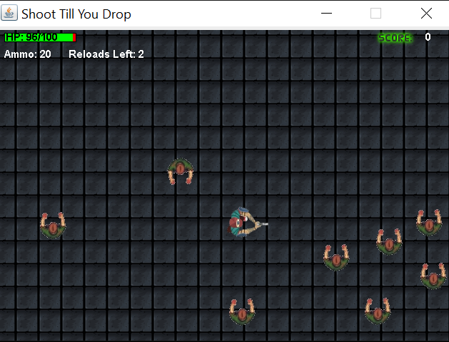

Controls

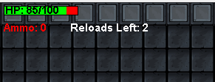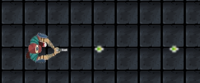 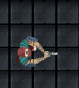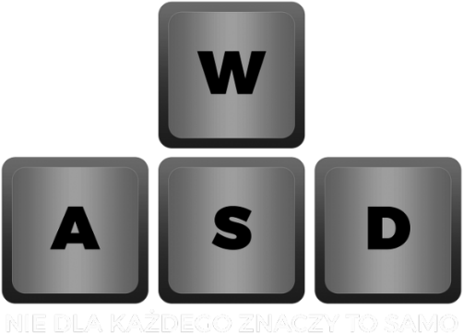

To reload Ammo, you press the R button

To shoot bullets, you press the space bar

To move the character, you use the WASD keys.