Kodowanie NEC i

algorytm wykorzystania

Damian Grzesło

Przemysław Kapała

# NEC CODING:

In our IR pilot , NEC coding works as fallows:

Carrier frequency is on 38 kHz.

Logic states of “0” and ”1” are coded like this:

* “0” – high logic state of signal spans for 562.5µs and then for 562.5µs there is low logic state. Total time is 1.125 ms.
* “1” – high logic state of signal spans for 562.5µs and then for 1.6875ms there is low logic state. Total time is 2.25 ms.

Coding of “0” and “1” differs only in how long is the space between high states of coded signals. For “1” this space is 3 times longer than for „0”.

Example of NEC transmission:

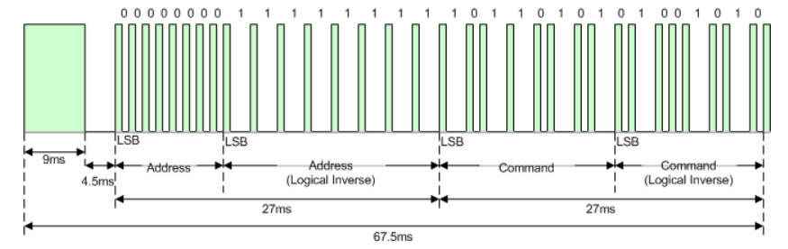

At the beginning of the code, there is an identificatory which signalizes the beginning of new transmission. It consist of 9 ms burst and then 4.5 ms pause. In the next 27 ms remote’s address is send. At first normally, then in inverse to check it’s correctness. Following the address there is an appropriate command, also send in two sections, first normally, second in logical inverse.

Every command is unique set of “0”s and “1”s for every button.

Transmission is ended by 562.5 us burst.

In the case button is held for a longer time, pilot sends periodical code different from the initial every 108 ms. This code consists of:

* 9ms Burst, the 2.25ms space and 562.5µs Burst at the end. This end Burst always means end of transmission.

As seen, code of the repeated signal doesn’t bring in any new information.

NEC decoding algorithm:

Firstly we must detect whether the message is initial or repeated.

After initial Burst repeated signal has pause shorter by half than in the initial signal.

It’s duration is 2.25ms.

Measuring this will allow to differentiate between them.

Time measurement in between successive high states will be the most important thing to do because it’s the only difference between “1” and “0”. High state in signal always takes the same amount of time: 562.5 us.

Proposed method is to measure time between signals rising-edges slopes and checking to which time interval it belongs to:

„1” – time measurement 2.25 ms ± error margin.

„0” – time measurement 1,125 ms ± error margin.

Signal with information – time in between first rising-edge slopes 5.0625 ms ± error margin.

Repeated signal – time in between first rising-edge slopes 2.8125 ms ± error margin.

Error margin is going to be experimentally appointed in the implementation phase.

It will still be possible to clearly read what was sent, also allowing for some error margin in case of hardware inaccuracy. Every command and address will have it’s correctness verified by comparing it with it’s inverted version.

Then using interrupts from IR receiver the measurement will start. Depending on whether it’s initial or repeated transmission it will be decided whether to continue handling interruption or not.

Remember: IR receiver works in negative logic.

If IR receiver receives high logical state, then microcontroller will get low logical state from it and for pause it will be high logical state.