Project requirements and schedule

Damian Grzesło, Przemysław Kapała

# Documentation of design assumptions

Final project will allow the end user to switch on/off selected devices. The switching of the devices will be done remotely using IR pilot and IR receiver.

Microcontroller will manage the whole system through the relays, according to the signal from the receiver. Any device powered by 230 [V] AC may be connected to one of the relays.

Arduino module, IR receiver and relays are powered from 5V DC supply, and pilot is powered by the battery.

# System block diagram

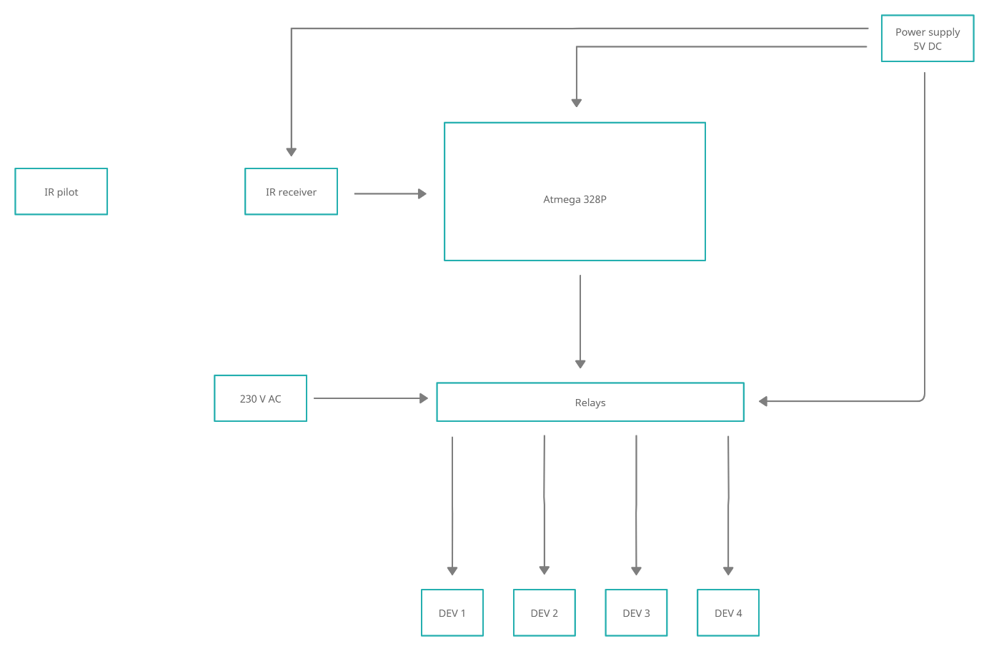

# Work schedule

|  |  |  |
| --- | --- | --- |
| Time | Tasks | Responsible |
| 17.11.2021 – 24.11.2021 | Project requirements and schedule:   * Looking for datasheets of elements * Working on schedule * Making block diagram | Przemysław Kapała,  Damian Grzesło |
| 24.11.2021 – 8.12.2021 | * Studying IR encoding standard of the pilot. * Analysis and creation of the algorithm to process the signal from the receiver. | Damian Grzesło |
| 8.12.2021 – 22.12.2021 | * Implementation of receiver and decoding algorithm to create IR decoder. * Programming of relay control system for device switching. | Przemysław Kapała |
| 22.12.2021 - 5.01.2022 | * Prototype creation * Verifying of decoding algorithm correctness. * Connecting various devices to relays. | Damian Grzesło |
| 5.01.2022 – 12.01.2022 | * Final testing * Project assumptions verification * Project validation | Przemysław Kapała |

# Technical specification of electronic components

**Arduino uno R3 features:**

ATMega328p Processor

Memory:

* AVR CPU up to 16 MHz
* 32KB Flash
* 2KB SRAM
* 1KB EEPROM

Security

* Power ON Reset (POR)
* Brown OUT Detection (BOD)

Peripherals

* 2x 7 bit Timer/Counter with a dedicated period register and compare channel
* 1x 16 Timer/Counter with a dedicated period register, input capture and compare channels
* 1x USART with fractional baud rate generator and start-of-frame detection
* 1x SPI
* Watchdog Tier with separate on-chip oscillator
* Interrupt and wake-up on pin change

Power

* 2.7 – 5.5 volts

Power Supply:

* Output voltage: 5 V
* Output current 1-1.5A.

CAR mp3 Remote:

* Remote control distance: more than 8 meters
* IR carrier frequency: 38 kHz
* Encoding: the encoding format of the NEC, upd6122 encoding scheme, the user code 00FF.
* Power supply: CR2025/160mAH

Segment of 4 relays SRD-05VDC-SL-C:

* Power supply VCC: 5 V
* Input active low
* Coil voltage: 5 V
* Maximal contact voltage: 250 VAC
* Maximal current: 10 A
* 4 led signalized activation of relays 1 led signalized power on

Working of relays:

Low logic level on INx switching relays and making connection beetwen COM and NO disconnecting COM with NC (NO default disconnected, NC – default connected with COM).

IR receiver HS0038B:

* Supply voltage: 4.5 – 5.5 V
* Supply current: 0.8 -1.5 mA
* Output voltage low: max 0.25 V
* Output current: 5 mA
* Output active low
* Working on signal at 38kHz or at any other  
  frequency

# Datasheets

GitHub -