***Project Code***

***Autorzy:***

***Damian Grzesło***

***Przemysław Kapała***

# Variables initialization:

In those lines there are six variables and two arrays initialized. All of them except for rx_buf are declared as volatile so that compilator does not optimize them during compilation.

# Uart setting:

It isn’t necessary for the project to work correctly, but if the user wants to lookup what’s happening inside the program, ex. check the NEC code for other buttons or if buttons are decoded correctly.

Function in lines [41-45] is used by the uart_puts function.

Function in lines [47-52] is for used for printing words to uart.

Function in lines [54-59] is used to initialize the uart.

# Timer Initialization



This function initializes timer important for NEC decoding, as information is coded by impulses of different duration.

It must be set on the rising edge, and have high enough accuracy for the program to differ different impulses.

# Relays

## Device Switching

Depending on the command send by the IR pilot, different device will be switched ON/OFF.

There are 2 cases in which allow us to switch ON/OFF all devices simultaneously.

## Relays initialization

They are initialized on PORTD, on the four pins. Each pin is connected to different relay and controls it.

# Times measurement interrupt

When the IR receiver, get’s the first rising edge, value of time is saved in ICR1 register by the microcontroller.

Time is measured between two rising edges, then saved to the array of times “pomiary”, in the index indicated by “licznik” variable.

Interrupt finishes it’s job after all 34 times are measured and saved.

On the lines [102-106], if the second time in “pomiary” in not within set boundaries, then the program knows that the button was held for extended period of time, and signal was send again.

In that case, “licznik” is cleared, second index in “pomiary” is cleared, and “przytrzymanie” flag is set to inform the rest of the program about this event.

# The main function

Functions are activated/initiated. Global interruptions are enabled

## While loop

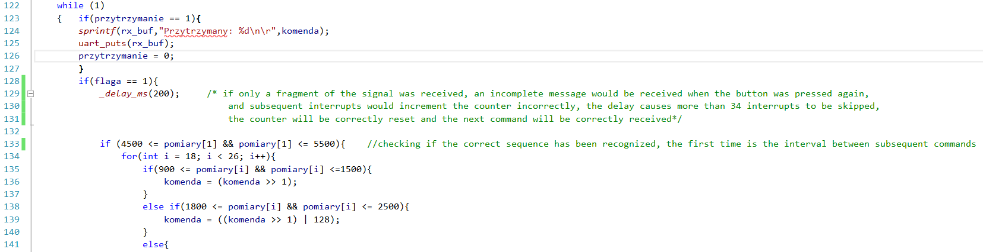

On the line [123], if statement checks, whether the received signal is an incomplete message.

If condition is true, then there is no change on relays, “przytrzymanie” flag is cleared.

On the line [128] if statement checks, whether the received signal is an complete message.

If condition is true, then there is 200 ms delays to ensure programs correct work (Written on the screen one).

On lines [133-159] there is NEC decoding algorithm implementation.

On lines [160], it’s checked if command was correctly received. There could have been receive error, or command was incorrectly decoded.

If condition is true, then react() function is activated and device or devices change it state/states.

Command can also be written on the console through uart, if the user wants it.

If condition is false, the receive error flag is cleared and the error message can be written on the console through uart. User can check if something was wrong and for example he can press the reset button.

At the end lines [171-173], “flaga” is cleared, command was decode, program waits for the next complete signal.