Project testing

Authors:

Damian Grzesło

Przemysław kapała

1. Used equipmnet:

- LED’s

- Battery

- Arduino Uno

1. LED’s connection.

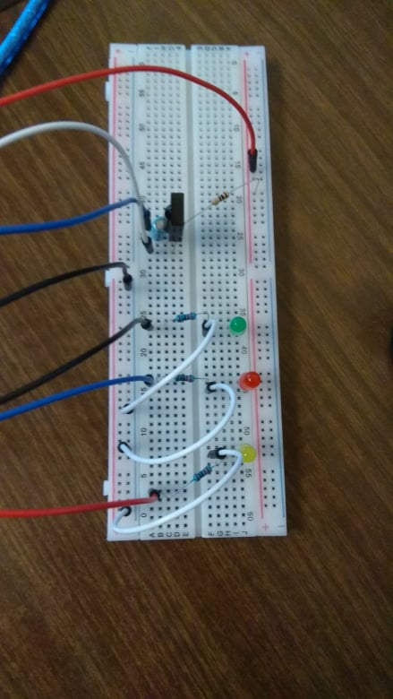

Photo nr. 1 – photo of connection

1. Test LED’s switch On to check the program

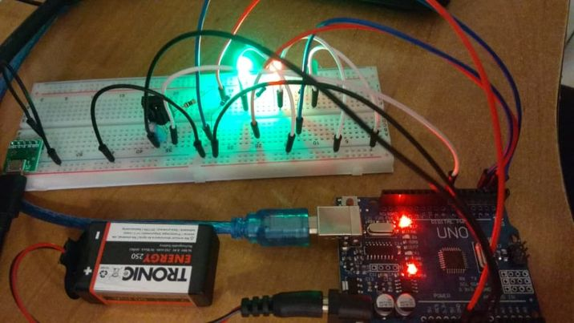

Photo nr. 2 – photo of the project during testing

1. Test LED’s switching, with the help of oscilloscope attached to the receiver

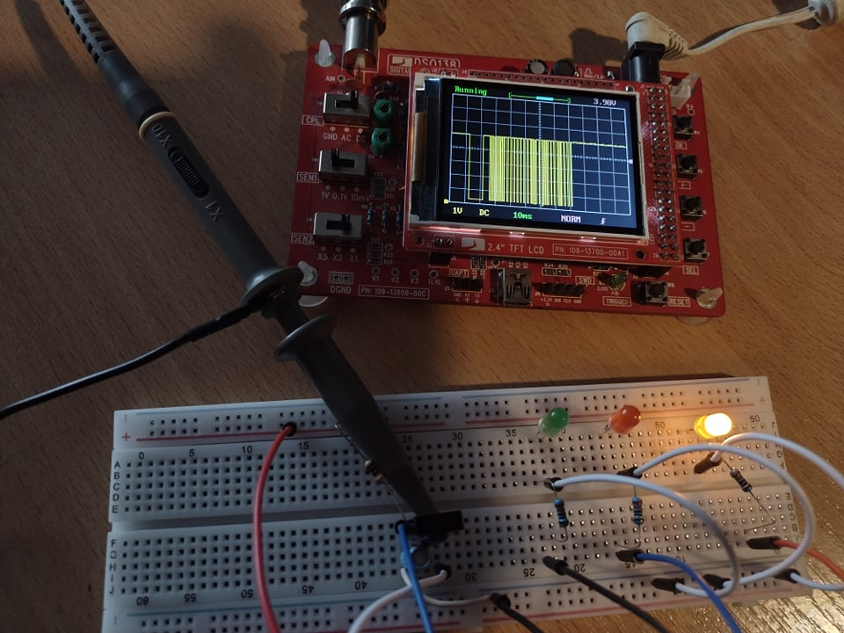

Photo nr. 3 – yellow diode switch on

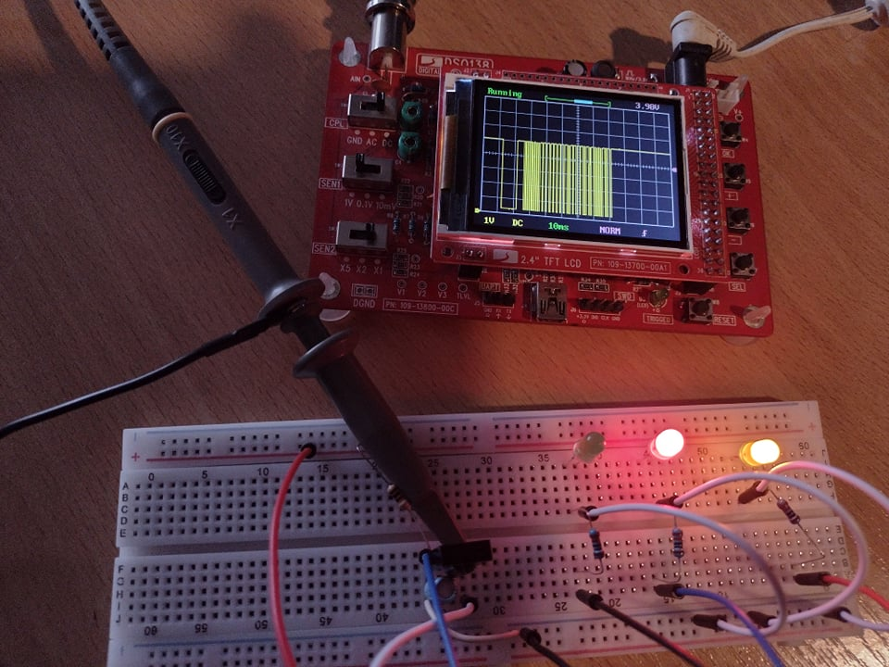

Photo nr. 4 – red diode switch on

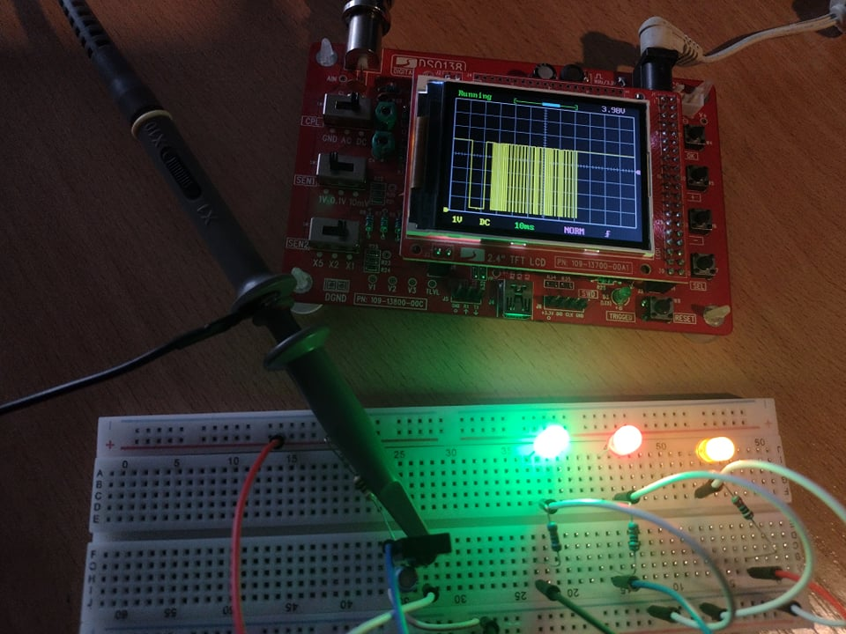

Photo nr. 5 – green diode switch on

As seen in the in the photos above, every diode was switched On by pressing different button on IR pilot. On oscilloscope display we see different waveform read from the IR receiver with each button.

1. Final version after testing

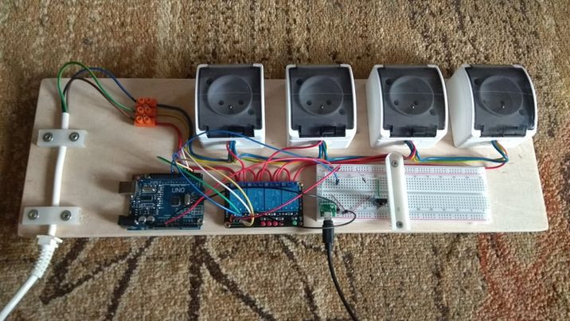

After checking with devices powered by 230 V, control works correctly.

**Please don’t touch the wires because you will be electrocuted:**



The one who tried