

C CONCEPT OF OPERATION

**Version1.0**

**<Phuong Trinh>**

**<18/11/2019>**

**VERSION HISTORY**

|  |  |  |  |  |  |
| --- | --- | --- | --- | --- | --- |
| **Version #** | **Implemented**  **By** | **Revision**  **Date** | **Approved**  **By** | **Approval**  **Date** | **Reason** |
| 1.0 | Phuong Trinh | <18/11/2019> | <dd/mm/yyyy> | <dd/mm/yyyy> | Release Document |
|  |  |  |  |  |  |
|  |  |  |  |  |  |
|  |  |  |  |  |  |

Table of Contents

1. Introduction 3

2. Referenced Document 4

3. Current System or situation 4

4. Justification and description of changes 4

5. PROPOSED SYSTEM OR SITUATION 5

6. Operational Scenarios 6

7. Summary of impacts 7

8. Analysis of the proposed system 7

# 

# Introduction

* The development of current technology, so the interaction between employees and leaders becomes more convenient. In order to build a modern management platform, companies are eager to track employees' work and key projects so we build the "BDS Management App" to Update information, schedule, project situation of the company
* The main content of the document
* Current system
* Justification and description
* Proposed systems

# Referenced Document

# Current System or situation

* 1. **Background, objectives and scope**

Real Estate Company has not used any software to store employee information, projects, work schedules, ... quickly. Employees, leaders, managers still use Excel to update the information on the company. Using the form of email to notify all employees, employees must write their own business registration form. And Meet each department directly to update information if there are errors

* 1. **Operational Policies and Constraints**

**-** The Direction is the person who approves the employee's job application

- Admin is the person who uploads the information of the App system and edits

- Employees can only view information and register business applications

* 1. **Decription of Current System or Situation**

Currently, Real Estate Company uses any internal management software, so all operations are done manually and stored in Excel files, each file includes project staff information, policies, .. .the employee has to spend a lot of time to submit the application to the management board and wait for approval, the leader cannot follow the staff's business trip schedule. All of the above work takes time and effort.

* 1. **Current Stakeholders**

|  |  |  |  |
| --- | --- | --- | --- |
| **#** | **Stakeholders** | **Roles** | **Responsibility** |
| 1 | Director | View, approve, search | View information, approve tasks, search project & personnel information |
| 2 | Department Head | View, approve, search | View information, approve tasks, search project & personnel information |
| 3 | Employee | View, register, search | View information, register work, search projects & personnel |
| 4 | Admin | Add, delete, edit, search, decentralize | Add, edit, delete, search project & staff information |

# Justification and description of changes

* 1. **Justification of changes**

- Due to the difficulty of updating information, it takes too much time but it is not effective, it is difficult to manage the employees of the company, looking up information and projects of the company is not fast. Regarding the sending staff, it is not possible to update the project information as soon as possible

- If using the app will help split employee information and the company's project will be easier and faster to find

* 1. **Description of Desired Changes**
* From the Excel file, the internal information of the Admin company will be imported into the system according to each information field: employees, projects, policies, .. The system will update internal information, register work faster. Compared to the current method, it is waiting for information from the leadership (process of uploading information: the staff summarizes the information sent to the admin -> Admin uploads the information to the system -> employees from the whole company can see all All information: Process of registration: employees register directly on the app -> wait for the leader to approve -> update the trip). The old system to see an updated information is very time-consuming because there are many document files. The new system will help employees minimize searches and updates faster. By searching for information fields, the system will display without spending much time.
* Employees can sign up for business and get approval quickly
  1. **Priorities Among Changes**

- Update information from Excel files to the system according to information fields. **(must have).**

- Employees can see all the information and register to work **(must have).**

- Leaders can approve applications, (**must have).**

# PROPOSED SYSTEM OR SITUATION

* 1. **Background, objectives and scope**

This system is only used for real estate company internally, with the purpose of helping employees and leaders to keep track of information anytime, anywhere, and help the company to search information quickly and easily. easy. This system will update information as soon as there is information from the leader, provide the information.

* 1. **Operational Policies and Constraints**

|  |  |  |
| --- | --- | --- |
| **#** | **ID** | **Business Rules** |
| **1** | **BR1** | When employees leave, the account will be hidden. |
| **2** | **BR2** | S staff only view and register applications |
| **3** | **BR3** | Only the administrator can update the information |
| **4** | **BR4** | Only director can approve employee applications |
| **5** | **BR5** | Unapproved applications will be canceled and not saved in history |
| **6** | **BR6** | Admin to update information continuously or when there is information from leaders and departments |
| ***7*** | **BR7** | Admin cannot use App Mobile to import files, etc. |

* 1. **Description of the Proposed System or Situation**

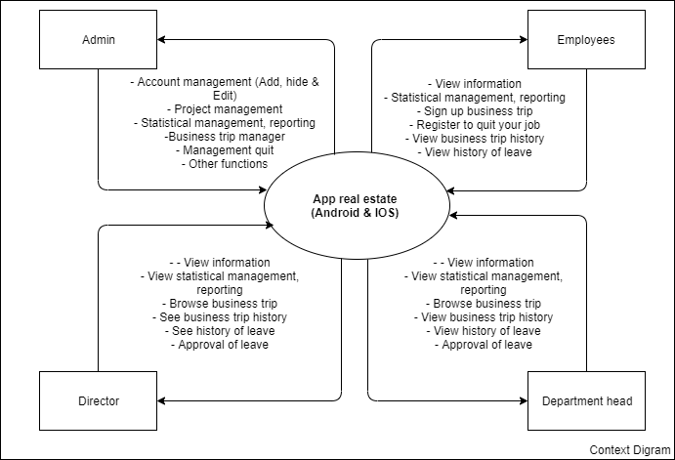

* 1. **Anticipated Users and Stakeholders**

|  |  |  |  |
| --- | --- | --- | --- |
| **#** | **Stakeholders** | **Roles** | **Responsibility** |
| 1 | Director | View, approve, search | View information, approve tasks, search project & personnel information |
| 2 | Department Head | View, approve, search | View information, approve tasks, search project & personnel information |
| 3 | Employee | View, register, search | View information, register work, search projects & personnel |
| 4 | Admin | Add, delete, edit, search, decentralize | Add, edit, delete, search project & staff information |

* 1. **Proposed Support Environment**

Supporting the number of employees who can access 200 users at the same time.

Build part on 2 platforms: Mobile and Website

# Operational Scenarios

Here are the protopying of the groups of people who will use this system: Demo Prototype

Here are the UseCase Diagrams of the groups of people who will use this system: UCD

**SCENARIOS: Employee, Director , Admin**

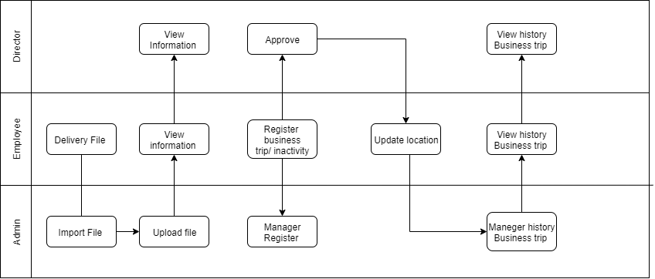

# Summary of impacts

* 1. **Operational Impacts**
  2. **Organizational Impacts**
     + Adding new personnel to manage the system when being put into use.
     + Need to retrain users because they have not used similar software before to update student information.
  3. **Impacts During Development**

# Analysis of the proposed system

* 1. **Summary of Improvement** 
     + Support updating personnel information, projects, policies.
     + Most clear updates on schedules and information.
     + Limit mistakes in updating.
     + Notify staff of application status
  2. **Disadvatages and Limitations** 
     + Benefits

• Staff can easily see the score.

• Help the leader inform the status of the application, new policies, schedules for employees faster.

• Easily manage employee data such as resume, academic results.

• Has large storage capacity.

• Easy to find information

• Limiting loss or errors in information

* + - Restrictions

• There is a possibility of errors during an update.

• Risks and delays can occur.

* 1. **Alternatives and Trade-Offs Considered**

It takes time for users to adapt the software.