REQUIREMENT PROCESS

**Version1.0**

**Trịnh Như Phương**

**<05/11/2019>**

**VERSION HISTORY**

|  |  |  |  |  |  |
| --- | --- | --- | --- | --- | --- |
| **Version #** | **Implemented**  **By** | **Revision**  **Date** | **Approved**  **By** | **Approval**  **Date** | **Reason** |
| 1.0 | Trịnh Như Phương | 05/11/2019 | 05/11/2019 | 05/11/2019 |  |
|  |  |  |  |  |  |
|  |  |  |  |  |  |
|  |  |  |  |  |  |

Table of Contents

Table of Contents

1. Introduction 4

1.1. The purpose and scope of the document 4

1.2. Objects towards 4

1.3. List of terms and acronyms 4

2. Requirement Management Process 5

2.1. Requirement Management Process 5

**2.1.1. Process** 5

**2.1.2. Roles and Responsibilities** 5

**2.1.3. Description** 6

2.2. Analysis process 8

**2.2.1.** **Process** 8

**2.2.2.** **Description** 9

2.3. Specification process 10

**2.3.1.** **Process** 10

**2.3.2.** **Description** 10

2.4. Validation process 12

**2.4.1.** **Process** 12

**2.4.2.** **Description** 12

3. Template for apply process 13

4. Tools 14

5. Reference document 14

# Introduction

## The purpose and scope of the document

This document describes an overview of the process of collecting customer requirements, resources, stakeholder information, documentation, and environmental requirements analysis of the project.

## Objects towards

|  |  |  |
| --- | --- | --- |
| No | Readers | Reason for reading |
| 1 | Project Manager | Understand and understand the project requirements in order to process and manage project requirements in certain stages of development. |
| 2 | Mentor | Review and guide the development process required by the project |
| 3 | Requirements Leader | Use this document to guide, control, and track the collection phase requirements for the project. |
| 4 | Requirement Engineer | Read document to know Requiment process, role and responsibility and follow it to work in Requirement phase. |

## List of terms and acronyms

|  |  |
| --- | --- |
| Terms | Define |
| Ver | Version |
| NMS | Network Monitoring System |
| SRS | Software Requirement Specification |
| ConOp | Concept of operation |
| URD | User Requirement document |
| RE | Requirements Engineering |
| AR | Architect |
| SH | Stakeholder |
| BRD | Business Process Document |
| PFP | Proposed Function Document |
| PT | Prototype |
| CO | Concept of Operation Document |

# Requirement Management Process

## 2.1. Requirement Management Process

### **2.1.1. Process**

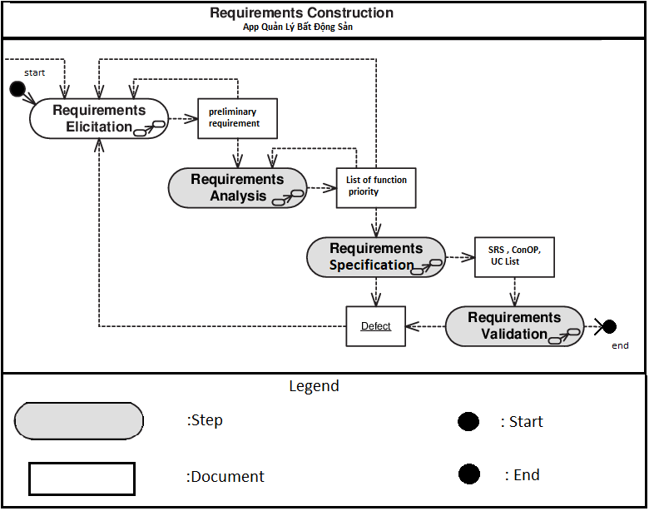

### **2.1.2. Roles and Responsibilities**

|  |  |
| --- | --- |
| Roles | Responsibilities |
| Requirement leader | Planning for the required collection phase and management based on it  Schedule customer interviews  Determine the progress of the required collection phase and update the content of the ongoing request.  Prepare all templates to use during project requirements collection  Track and evaluate the work of the members at the end of each stage.  Consolidate and release all documents during this period. |
| Requirement Engineers | Flexibly use the techniques of gathering requirements into actual operation  Cooperate with stakeholders to develop the requirements  Define user requirements, create models, forms, and documentation requirements.  Review the requirements are correct, appropriate and completed.  Converts user requests into functional requirements of the software. |
| Stakeholders | More important than a regular user  Provides documentation requests and endorsements once completed. |
| Architect | Provides detailed information about the needs of users, business operations and data  Demonstrates the needs of users who can participate in the system  Identify the problems that integrate hardware, software, and systems.  Ensure requirements close links with product orientation.  Exchange with experts who have in-depth knowledge of the field of data collection and analysis.  Review and re-evaluate the documents requested to ensure that the materials summarized are representative of the requirements of the system user. |
| Requirement Reviewer | Evaluate, review the documentation required of the project to ensure that the document fully reflects the needs of the user. |

### **2.1.3. Description**

|  |  |  |  |  |
| --- | --- | --- | --- | --- |
| Steps | Describe | Input | Output | Role attend |
| Elicitation | Understand customer requirements, user requirements, software and system development, and system development activities:   * Identify stakeholders * Ability to listen * Ability to ask questions to collect as much information as possible from the customer. * Have the ability to communicate * Ability to explore, interest in new things * Use prototype templates * Use Interviews / Surveys | * Initial Requirement * Commitment | * BRD * PFD | * Requirement Leader. * Requirement engineer. * Stakeholders |
| Analyze | Based on customer requests, project requirements and defined constraints to analyze customer requirements for technical documentation. Use the following techniques to analyze:   * Determine the scope of the system * Identify required documents from customers. * Defining business operations (business operations) or problems that may arise during development as well as operation * Use the questions (What, When, Why, Who, How) to analyze the requirements of customers as well as users * Reevaluate the request * Submit inquiries to customers so that stakeholders can work together * Providing solutions to solve problems and problems of customers. * Determine the priority on the requirements of the client / system user * Review, refine to collect requirements that accurately reflect the wishes and requirements of the parties involved * Bring out the original document proposal to document the project | * BRD * PFD | * Proposal document. * Prototype. | * Requirement Leader. * Requirement engineer. |
| Specification | Based on the suggested documents in the analytical stage to develop into the Concept of Operation document, the development team will use the following techniques:   * Shows the different perspectives of stakeholders * Describe clearly structured and formatted documents * Describe the system model * Document the system solutions in the form of functional, non-functional and strict constraints between the different components of the system. | * Proposal document. * Prototype. | * Concept of Operation * SRS * Use case. | * Requirement Leader. * Requirement engineer. * Customer |
| Validation | After the construction of the technical requirements, the validation phase confirms that the requirements meet the expectations of the user, the customer in a reasonable and clear way.   * Presentation of the document * Revise Requirements Documentation. | * Concept of Operation * Prototype (draft) * Use case Diagram * SRS | * Proposal * Concept of Operation * Use case Diagram * Prototype * SRS * (CON-FIRMED) | * Requirement Leader. * Requirement engineer. * Requirement Architects |

## Analysis process

### **Process**



### **Description**

|  |  |  |  |  |
| --- | --- | --- | --- | --- |
| Steps | Describe | Input | Output | Role attend |
| Verify Scope  of System | Define the scope of the system based on the project overview | * Business process * Proposed function |  | Requirement Leader |
| Identify  Candidate  RE | Identify potential requirements to identify what is required by the customer / user.  The stakeholder needs analysis process prepares and defines the concept of system corruption as well as the requirements for building software.  The requirements analysis process also focuses on analyzing the interrelation and priority levels between requirements to determine the reasonableness of priority in solving problems in the system.  Use the 5W + H questions to analyze the requirements. | * Business process * Proposed function |  | Requirement engineer. |
| Define Feature | The requirements analysis process also focuses on analyzing the interrelation and priority levels between requirements to determine the reasonableness of priority in solving problems in the system.  Define the function / characteristics the system will be developed. | * Business process * Proposed function * (Which are analyzed) | List of feature/function (Draft) | Requirement engineer. |
| Establish  QA  Res | Determine the quality standards of the system upon completion and ensure that it is achieved during deployment | * Business process * Proposed function (which are analyzed) | Danh sách các tiêu chuẩn chất luượng | Requirement engineer. |
| Train use tool | A guide to the tools used to design the prototype | Tool |  | Requirement engineer. |
| Model | Develop Use Case diagrams and prototypes to show the perspective of the customer. | * Business process * Proposed function   (Which are analyzed) | Prototype | Requirement engineer. |
| Document | Document all information that you have analyzed | REs overview which are analyzed. | * Proposal * Prototype | Requirement engineer. |
| Review | RL will review and re-evaluate the contents of the document prior to release. | * Proposal * Use case Diagram * Prototype | * Proposal * Prototype (new version) | Requirement Leader |

## Specification process

### **Process**



### **Description**

|  |  |  |  |  |
| --- | --- | --- | --- | --- |
| Steps | Describe | Input | Output | Role attend |
| Establish  Goals | Determine how the system will be used? | * Proposal * Prototype |  | Requirement Leader |
| Gather Facts | Provide, give roles and responsibilities of key stakeholders, and the system in which they operate, thereby proposing additional features for the project in terms of Concept of Operation. | * Proposal * Prototype |  | Requirement engineer. |
| Create  Concepts | Describe selected concepts / concepts that are cost effective and cost effective. This concept / concept will be the basis for the Concept of Operations. | * Proposal * Prototype |  | Requirement engineer, Architect Leader |
| Determine  Needs, | Identify everything that is relevant to the project, including the list of requirements, customer needs, their resources, and any constraints that may affect the proposed solution. .  The development of the Concept of Operation begins with the needs and constraints of this section. | * Proposal * Prototype |  | Requirement engineer. |
| Determine  Architect Driver | Fine-tune concepts / concepts that were previously identified throughout the course of the acquisition, to understand the nature of the problem, and to understand the best way to describe it from the perspective of the system architecture. Advanced to start the process of building Concept of Operation. | * Proposal * Prototype |  |  |
| Document | Document all information analyzed. | * Proposal * Prototype |  | * Concept of Operation * SRS * Use case Diagram |
| Review | RL will watch and replay all content before the release. | Concept of Operation  SRS | * Concept of Operation * SRS (new version) | Requirement Leader |

## Validation process

### **Process**



### **Description**

|  |  |  |  |  |
| --- | --- | --- | --- | --- |
| Steps | Describe | Input | Output | Role attend |
| Select REs  Validation Techniques | A formal, stakeholder meeting in which parts of the project will be debated, analyzed and evaluated to find faults and shortcomings to improve product quality to customers. | * Proposal * Use case * Prototype * Concept. * Prototype. * SRS |  | Requirement engineer. |
| Ensure Adequate  User Involvement | Formal reassessment of the defined processes for the implementation teams, in which each group is assigned different tasks and roles over a specified period of time. |  |  | Requirement engineer. |
| Validate the  REs | Review request evaluation process:   * Identify part of document to review. * Identify the evaluator. * Plan, explain role, responsibility and authority of the evaluator. * Use checklist to test, analyze the document * Review the identified processes to provide feedback. * Edit the document based on the feedback, feedback rating. | * Proposal * Use case * Prototype * Concept. * Prototype. * SRS |  | Stakeholder |
| Revise the  REs  Documentation | SE changes and defines goals and objectives for stakeholders to ensure consistency in understanding, thinking and system requirements, functions of system software. | * Proposal * Use case * Prototype * Concept. * Prototype. * SRS |  | Requirement engineer. |
| Document | Documentation of all information analyzed. | * Proposal * Use case * Prototype * Concept. * Prototype. * SRS |  | Proposal  Use case  Prototype  Concept.  Prototype.  RS  CONFIRMED |
| Review | RL will watch and replay all content before the release. | * Proposal * Use case * Prototype * Concept. * Prototype. * SRS | Proposal  Use case  Prototype  Concept.  Prototype.  SRS (new version) | Requirement Leader |

# Template for apply process

|  |  |  |  |
| --- | --- | --- | --- |
| Stt | Template | Describe | Place |
| 1 | Requirement Management Plan | This document aims to provide a detailed plan for demand management strategies, workflow management, human resources management and the environment to analyze project requirements. |  |
| 2 | Proposal document | Provides an overview of the system, related issues, solutions as well as project development plans. |  |
| 3 | Concept of Operation document | Provides an overview of the system, related issues, solutions, system constraints, features, and functions from a user perspective. |  |
| 4 | Use case document. | The content of this document is that the Use Case contexts are built |  |
| 5 | Software Requirement Specification (SRS) | Provides an overview of the system, related issues, solutions, system constraints, features, functions from a technical perspective. |  |

# Tools

Microsoft word 2013: to write this document

Microsoft Visio 2013: to draw charts.

Enterprise Architect: to draw use case examples.

Microsoft Excel 2013: to write test case.

# Reference document