

TESTING PROCESS

**Trịnh Như phương**

**Version 1.0**

**Revision History**

|  |  |  |  |  |  |
| --- | --- | --- | --- | --- | --- |
| **Version** | **Date** | **Author** | **Editor** | **Content** | **Status** |
| 1.0 | 08/11/2019 | Trịnh Như  Phương |  | Create Testing Process document | Done |

**Table of Contents**

**1.** **Introduction** 4

**1.1.** **Purpose** 4

**1.2.** **Intended audience** 4

**2.** **Testing Process** 4

**2.1.** **Roles and Responsibility** 4

**2.2.** **Testing process activity** 5

**2.3.** **Testing description** 5

**3.** **Documents Deleverables** 6

**5.** **Test Environment** 7

**5.1**  **Hardware** 7

**5.2**  **Software** 7

**List of Figure**

**Figure 1 Testing process** 5

**List of Table**

**Table 1. Intended audience** 4

**Table 2 . Role and Responsibility** 4

**Table 3. Testing Description** 6

**Table 4. Document Deliverables** 7

**Table 5. Measurement** 7

**Table 6. Hardware** 7

**Table 7. Software** 7

# **Introduction**

## **Purpose**

Test documentation is the complete suite of artifacts that describe test planning, test design, test execution, test results and conclusions drawn from the testing activity. As testing activities typically consume 30% to 50% of project effort, testing represents a project within a project. Testing activities must therefore be fully documented to support resource allocation, monitoring and control. This page identifies the types of documents you need to set up and run your test program and summarises their content.

**1.2 . Intended audience**

|  |  |  |
| --- | --- | --- |
| **Role** | **Name** | **Responsibility** |
| Test Leader | Như Phương | Develop Test Plan, Test Case and Monitoring in Tet Phase |
| Project Manager | Đạt Huỳnh | Monitoring and Control Schedule |
| Tester | Anh Minh , Quang Vương , Quốc Nhân | Develop Test Case, Execution Test Case and Develop Test Report. Communication with Develop Team |

**Table 1. Intended audience**

# **Testing Process**

## **Roles and Responsibility**

|  |  |  |
| --- | --- | --- |
| No | Roles | Responsibility |
| 1 | Test Leader | Responsible for guidance, plan and track the progress of the work of the test group, Write test summary report and update schedule in Test phase, overview report test case and reports directly to the PM. |
| 2 | Tester | Read document to know Test plan and follow it to work in Test phase. Responsible execute testing system following testing documents and reports bugs to Test Leader directly. |
| 3 | Customer | Responsible perform User Acceptance test for the release of system. |

**Table 2 . Role and Responsibility**

## **Testing process activity**

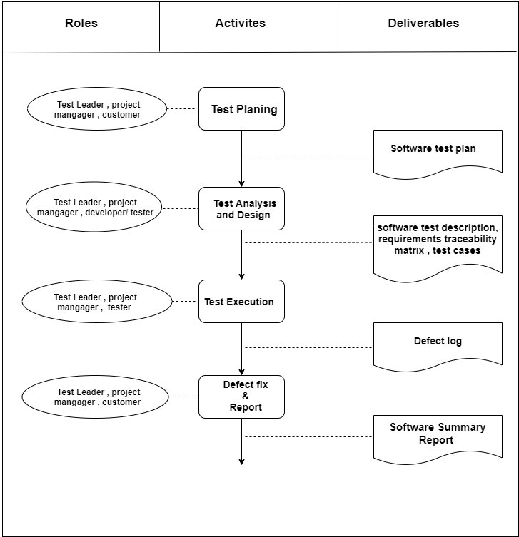

**Figure 1 Testing process**

## **Testing description**

|  |  |  |  |  |
| --- | --- | --- | --- | --- |
| Stages | Description | Input | Output | Role |
| test plan | Estimate the requirements, test techniques ,tools , and othee test artifacts  Develop test plan document to perform testing phase:   * Assign work * Schedule |  | Test Plan | Test Leader |
| Test Analysis and Design | Update test plan. Identify and design test scrips and test data  Test leader assigns tasks to tester for develop acceptance test case based on SRS and ConOps document | ConOps  SRS | Test Case | Tester and Customer |
| Test execution | After make test cases, test leader assign tasks to tester to execute test cases  Collect and build all the required test evironment. Run Tests and record defects | Test Case | Defect log | Tester |
| Defect fix and report | Defect fix and evaluate test results and generate a report |  | Test Summary Report | Tester leader |

**Table 3. Testing Description**

# **Documents Deleverables**

|  |  |
| --- | --- |
| No. | Document |
| 1 | TE_Testcase_Ver |
| 2 | TE _TestFunction_Ver |
| 3 | TE _IntegrationTest_Ver |
| 4 | TE _Defect log_Ver |
| 5 | TE _TestSummary_Ver |

**Table 4. Document Deliverables**

1. **Measurement**

|  |  |  |  |  |
| --- | --- | --- | --- | --- |
| Goal | Question | Metric | Source | Responsibility |
| Productivity of tester | How long a tester make a test case | Time/ Test Case | Member Time Log | Test Leader |
| How long a tester test a function | Time/ Test Case |

**Table 5. Measurement**

1. **Test Environment**

**5.1 Hardware**

|  |  |  |
| --- | --- | --- |
| No. | Description | Configuration |
| 1 | Main server |  |
| 2 | Work station. |  |

**Table 6. Hardware**

**5.2 Software**

|  |  |  |
| --- | --- | --- |
| No. | Description | Configuration |
| 1 | Main Server |  |
| 2 | Work station | * Microsoft Office Excel 2010 & 2013 * Github |

**Table 7. Software**