CMPT276 Group 20

Rob The Block: Report

Game Description:

Rob the Block is a very challenging 2D game where our main protagonist Rob must rob the whole house by collecting all the coins on the map and safely making his way to the exit. The exit only shows up when rob has collected all the rewards.
There are sleepwalking homeowners who patrol the map and a very responsive dog who comes running if the dog toy is stepped upon. Rob loses points if the dog catches him and he loses the game if one of the homeowners catch him.
The alarm goes off once Rob has robbed all the rewards and the homeowners start chasing him. Rob must safely exit through the door to reach next level.

Adjustments and Modifications to Initial Design:
We were able to achieve majority of our initial design, however there are a few minor changes we made-

We changed the punishments from garbage and water puddles to a dog toy.
Reason- Since stepping on these punishments was supposed to attract the dog, it made more sense for us to replace these items with a dog toy as it is more natural for a dog to run towards its toy.

We planned to have different regular rewards but ended up only having coins scattered throughout the map.
Reason- Since we already had some other items on the map, we did not want user to get confused with which items are rewards and which ones are not, so we proceeded with having a constant regular reward throughout the game, i.e. a coin.

Major Learnings:

I think other than the course material, the biggest practical lesson we learnt was teamwork. Everyone had their own schedules and challenges but we somehow managed to coordinate meeting times, divide development tasks, tackle merge-conflicts and were finally able to come up with a complete game.

Through regularly creating, pushing and merging branches we got a lot of hands-on git experience. There was even a point where we accidentally undid each other’s changes so we had to trace back commits and cherry pick the changes to include them again.

Due to the sheer size of the project and number of classes, we learnt the “why” to all these design principles. It felt like most issues were due to not following the design principles closely which led us to refactoring a lot for homework four.

Learning to not get carried away with features in the planning phase. We had to cut out a few features from our final game due to time constraints, we should have started small and expanded out instead of shrinking down.

There might be code smells even if you try your best to write clean code, hence its always a good idea to keep checking for them regularly.

Manual testing is not sufficient, writing test cases to ensure coverage and functionality might uncover some unused code, if statements that are always true/false and some bugs.

Since the whole project was divided into different phases, we also got a basic idea of what a real-life development cycle might look like.

Features Demo:

Basic Information
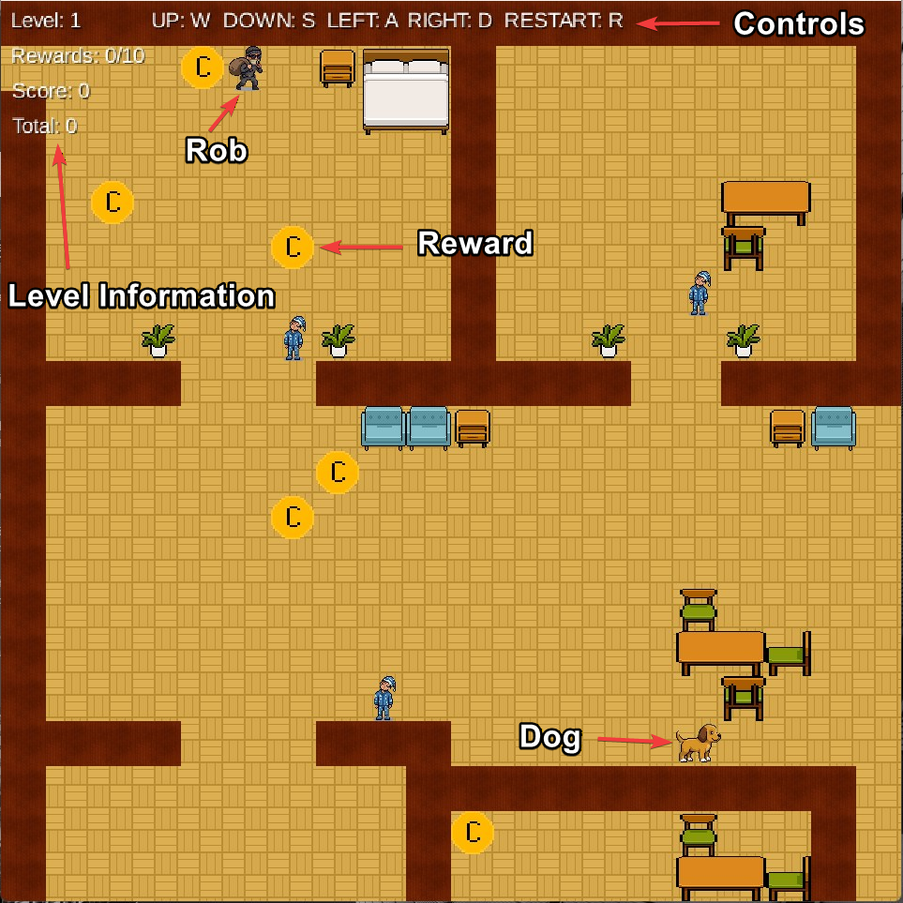 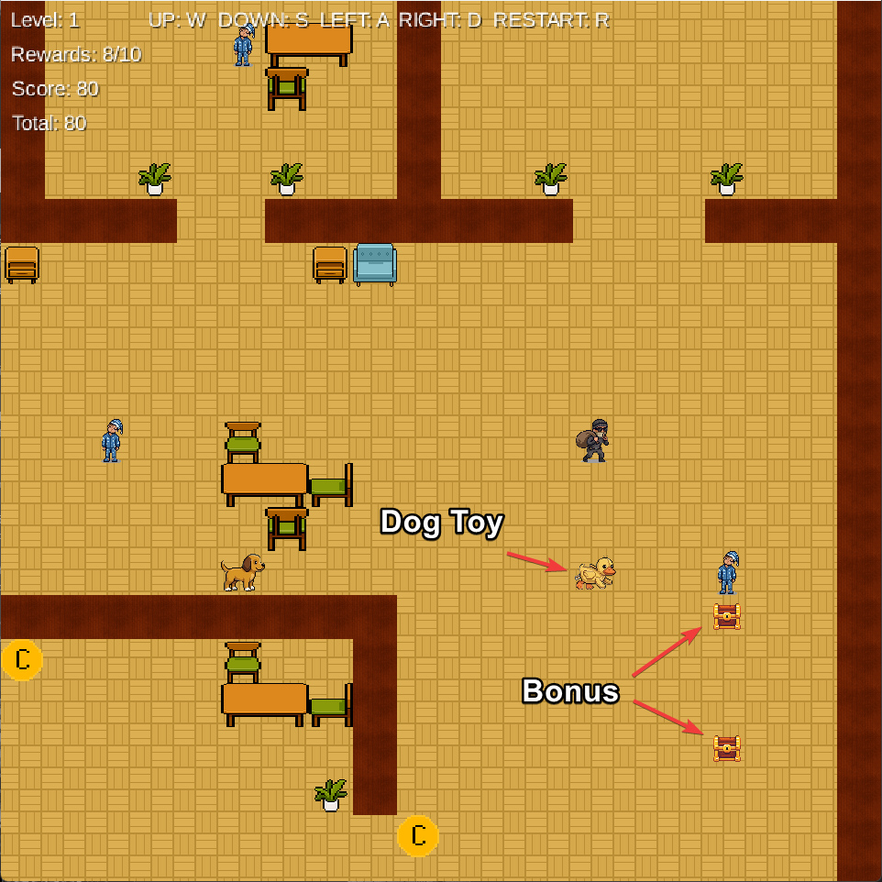

Dog Chasing
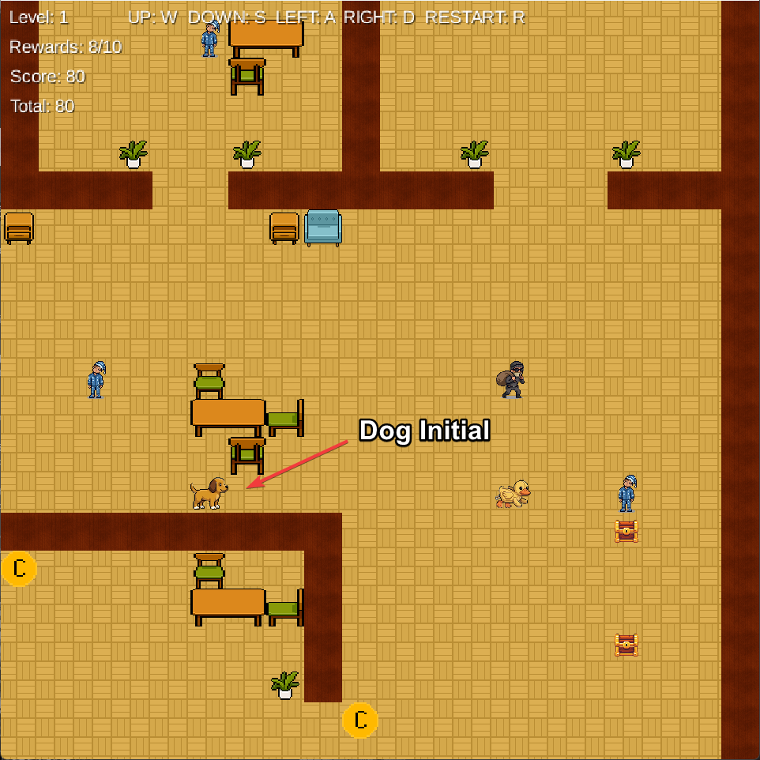 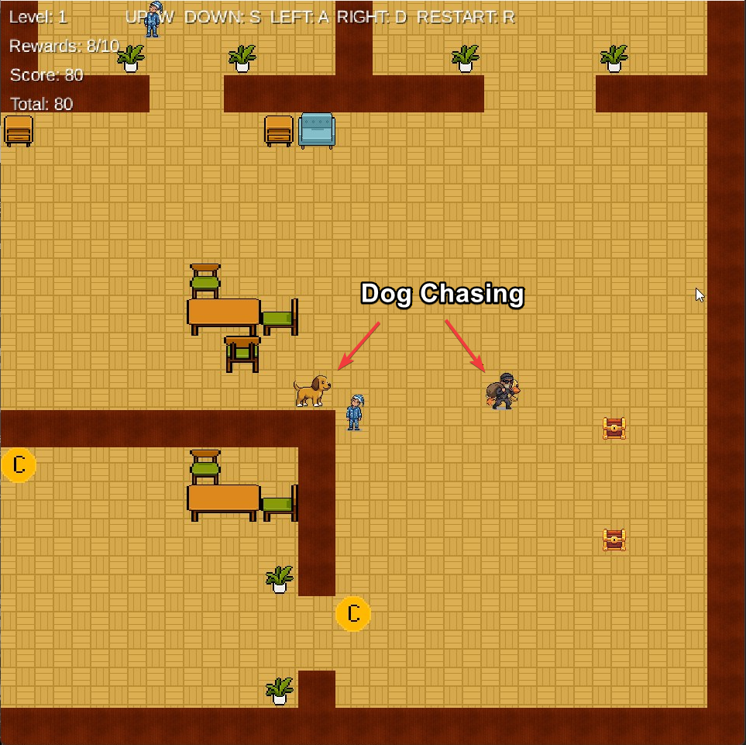

Exit Only Appears When All The Rewards Are Collected
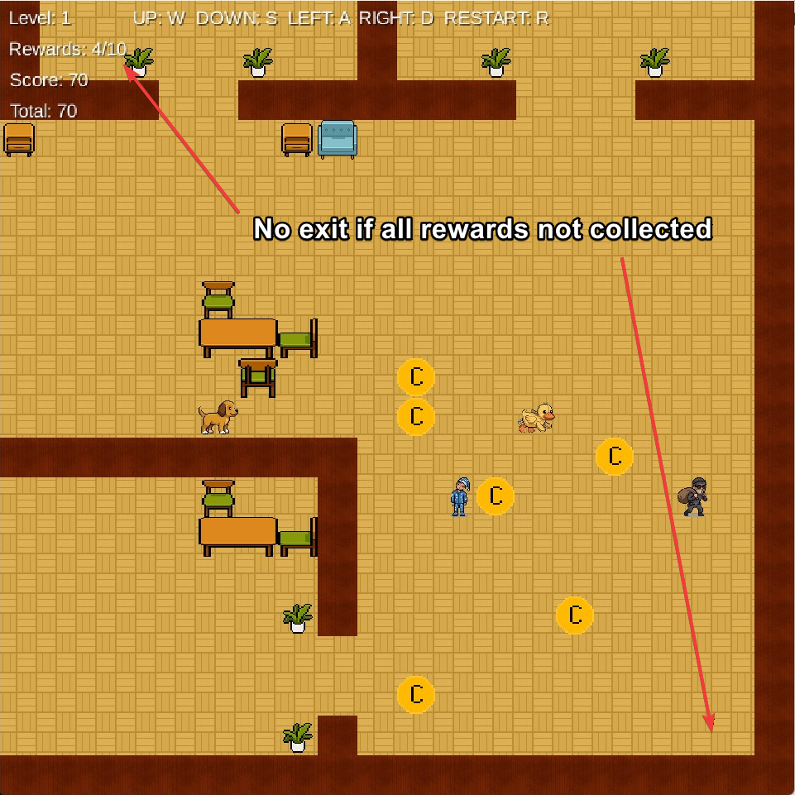 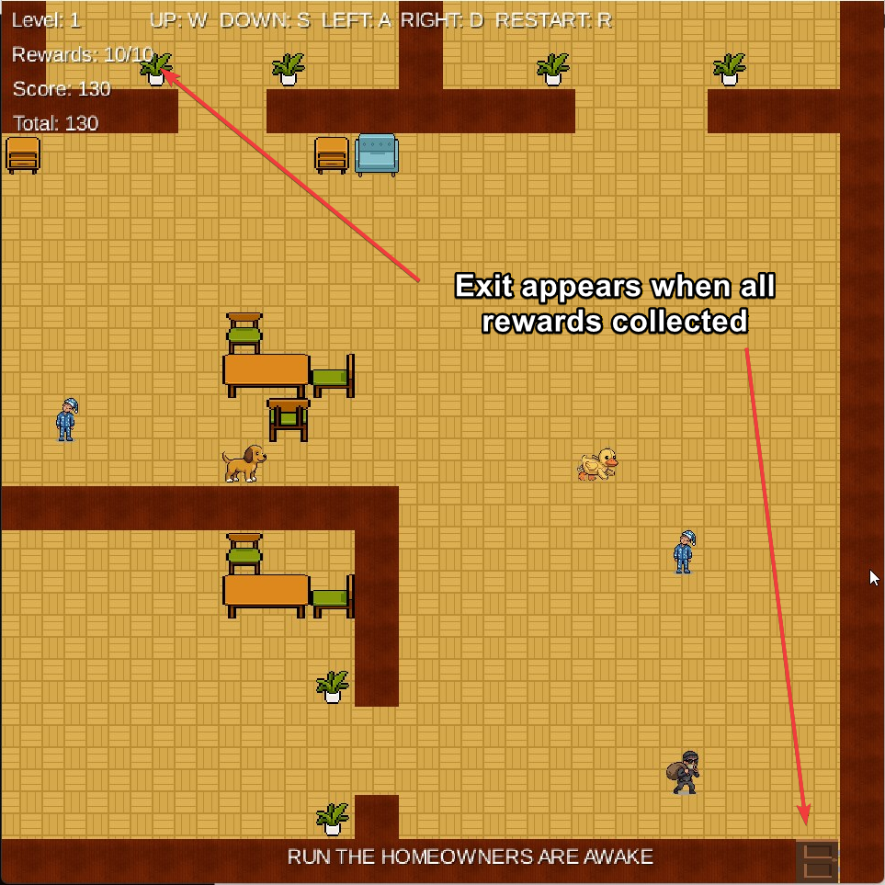

Homeowners Chase Rob When All Rewards Are Collected
