First you should open the ChatClientUI.zip and unzip the contents.



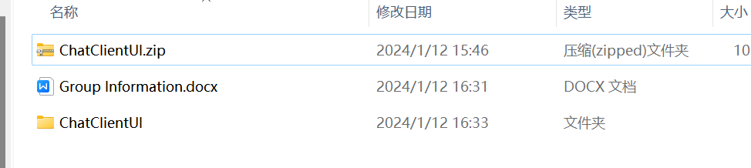

And then open the ChatClientUI folder

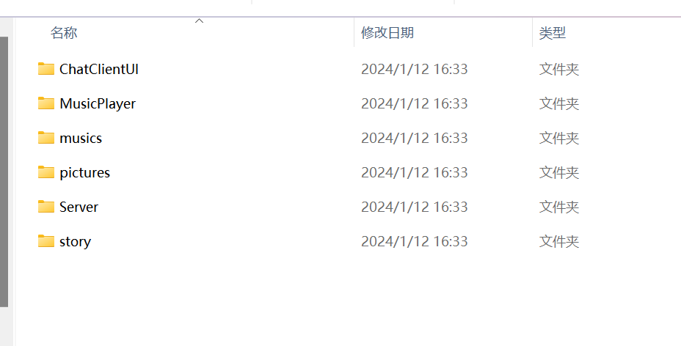

Right click the mouse and open with terminal

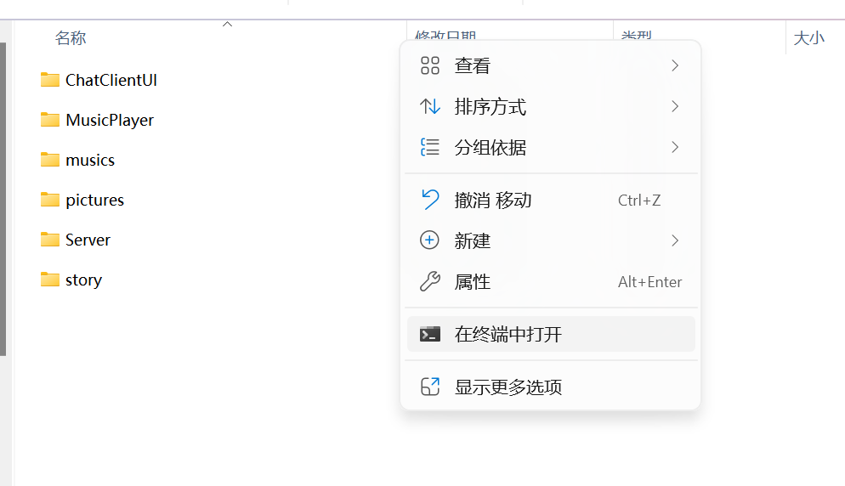

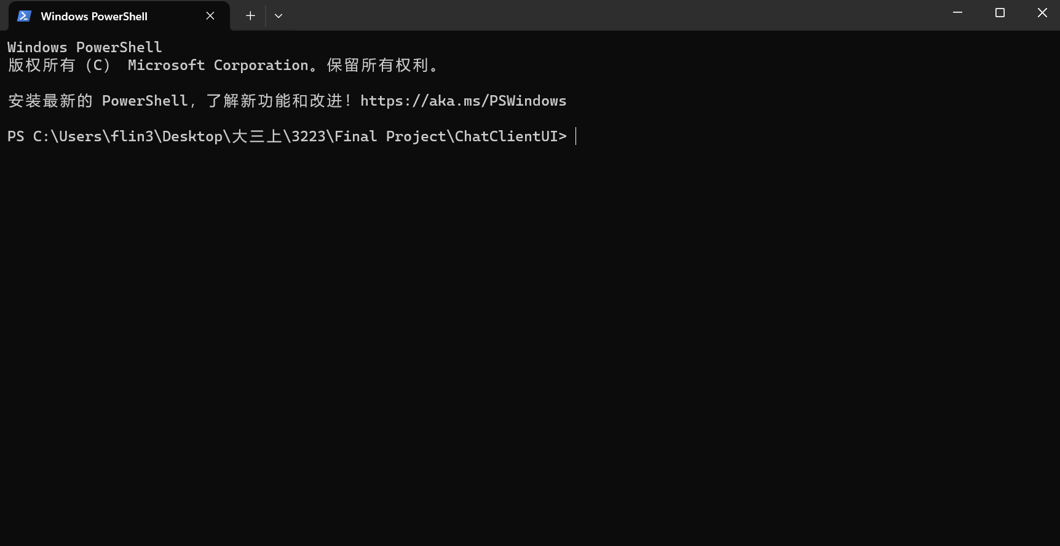

Back and open the folder,Check if there is a .class file

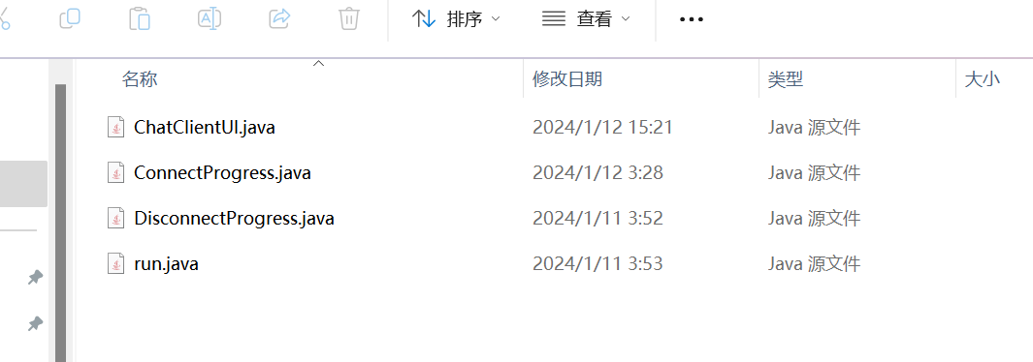

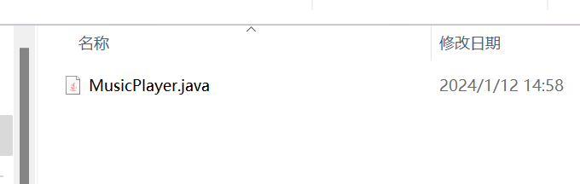

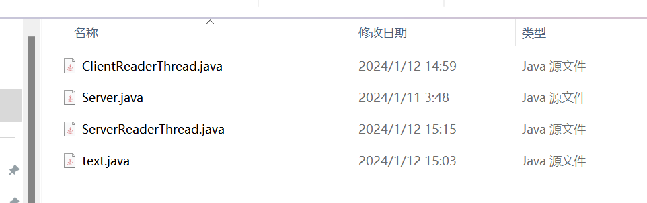

If, the .class file is missing in the folder, please enter the following code and run:

**javac ChatClientUI\ChatClientUI.java ChatClientUI\ConnectProgress.java ChatClientUI\DisconnectProgress.java ChatClientUI\run.java MusicPlayer\MusicPlayer.java Server\ClientReaderThread.java Server\Server.java Server\ServerReaderThread.java Server\text.java**

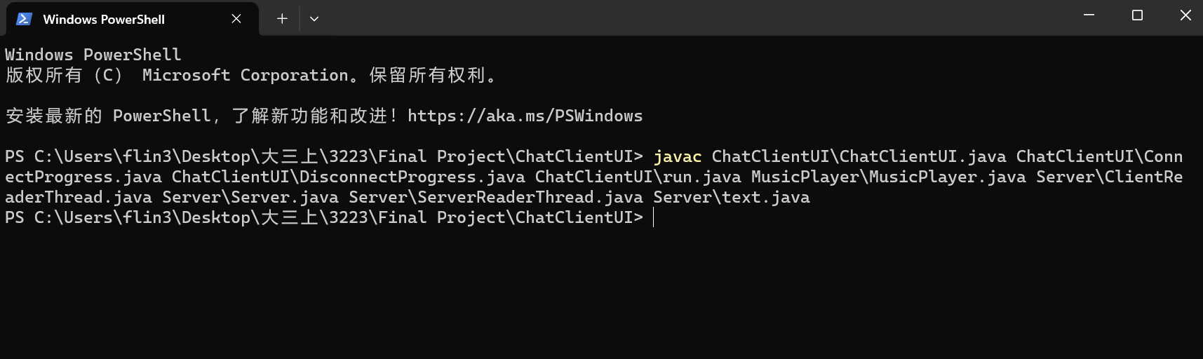

If a .class file exists, enter it java Server.Server and run:

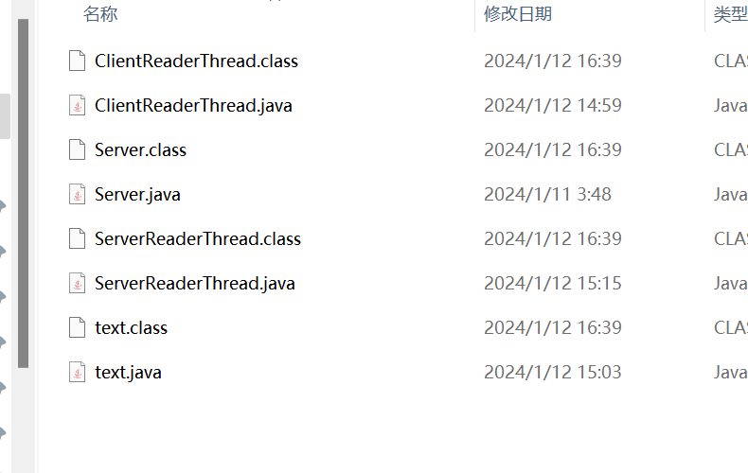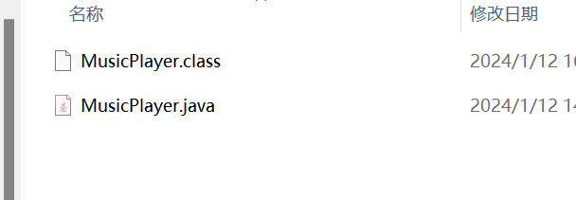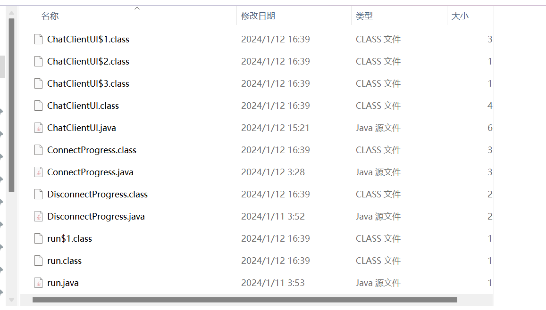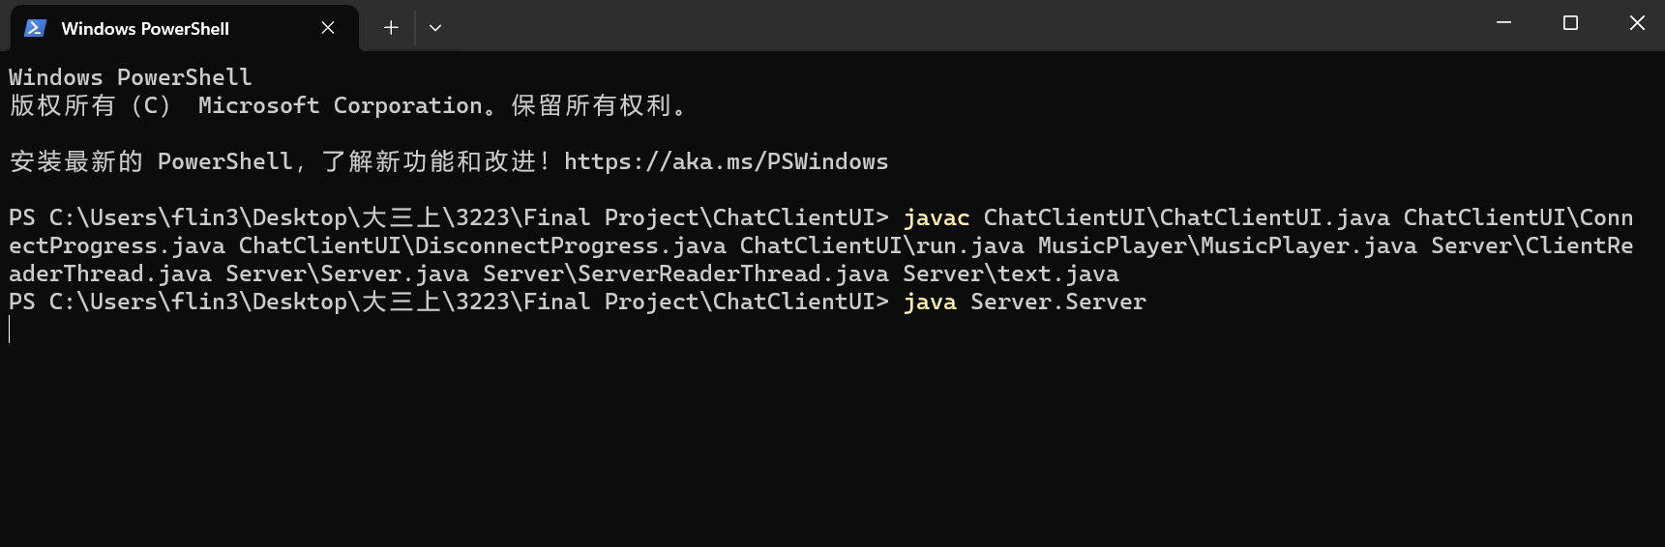

Then open a terminal again in the folder just now

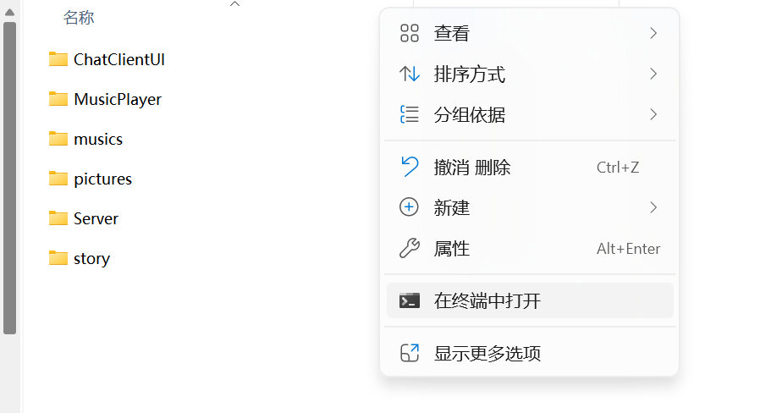

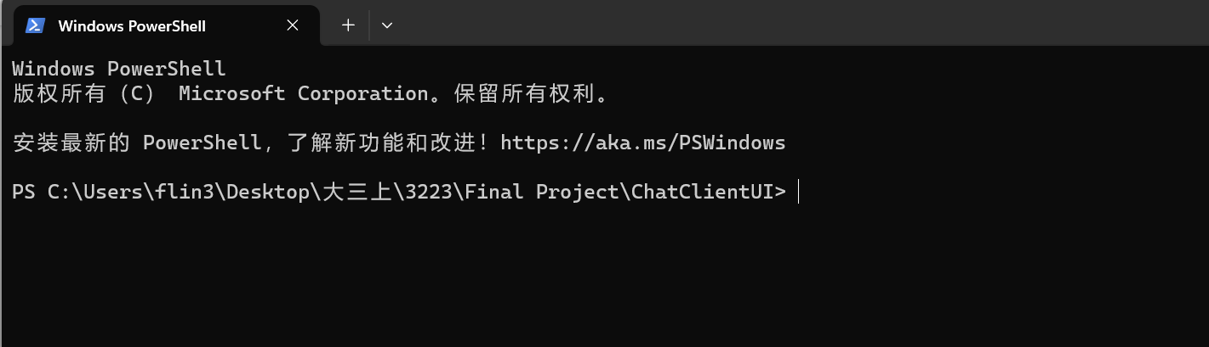

Enter and run the following code:

java ChatClientUI.run

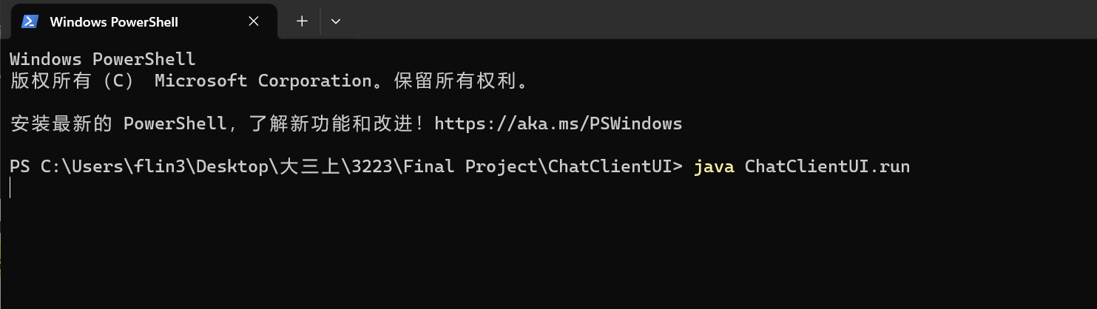

Now,you can see this view:

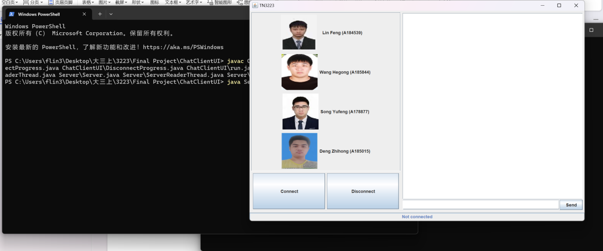

Click the Connect button the connect to server:

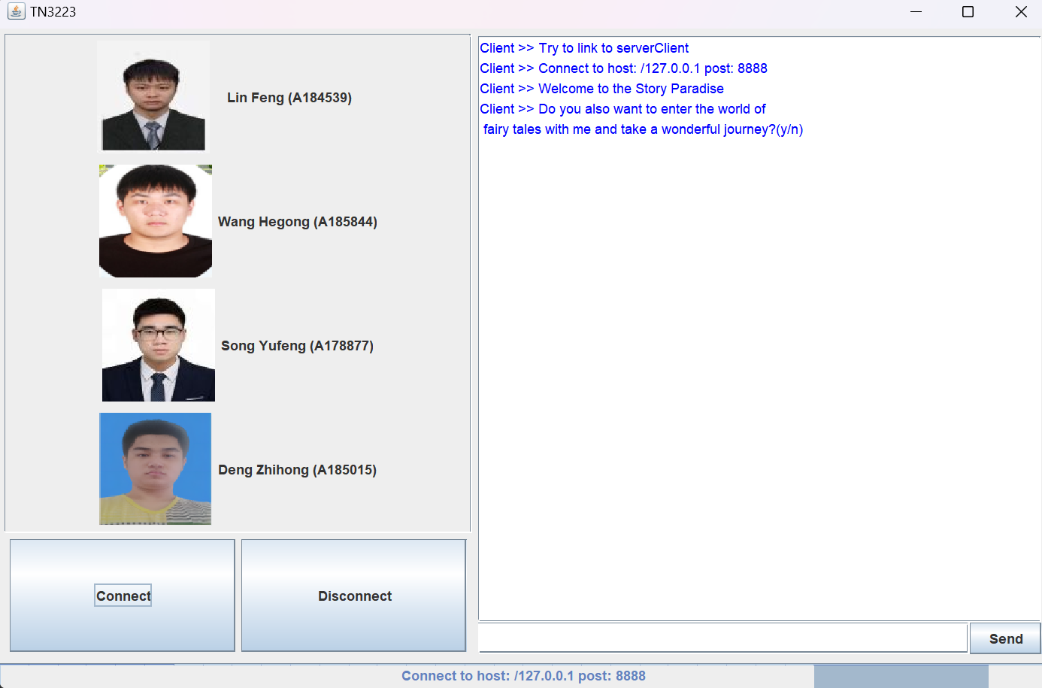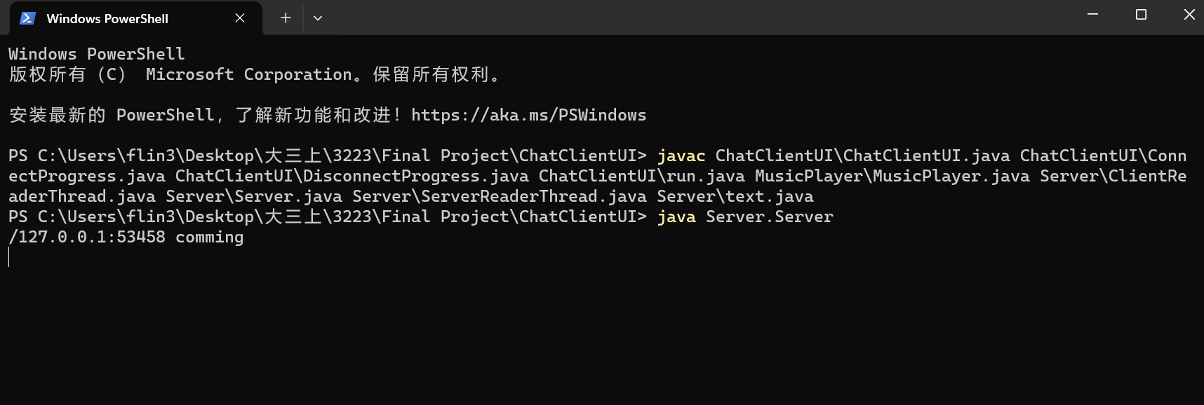

You can enter the corresponding text according to the message sent back by the system to get a response.

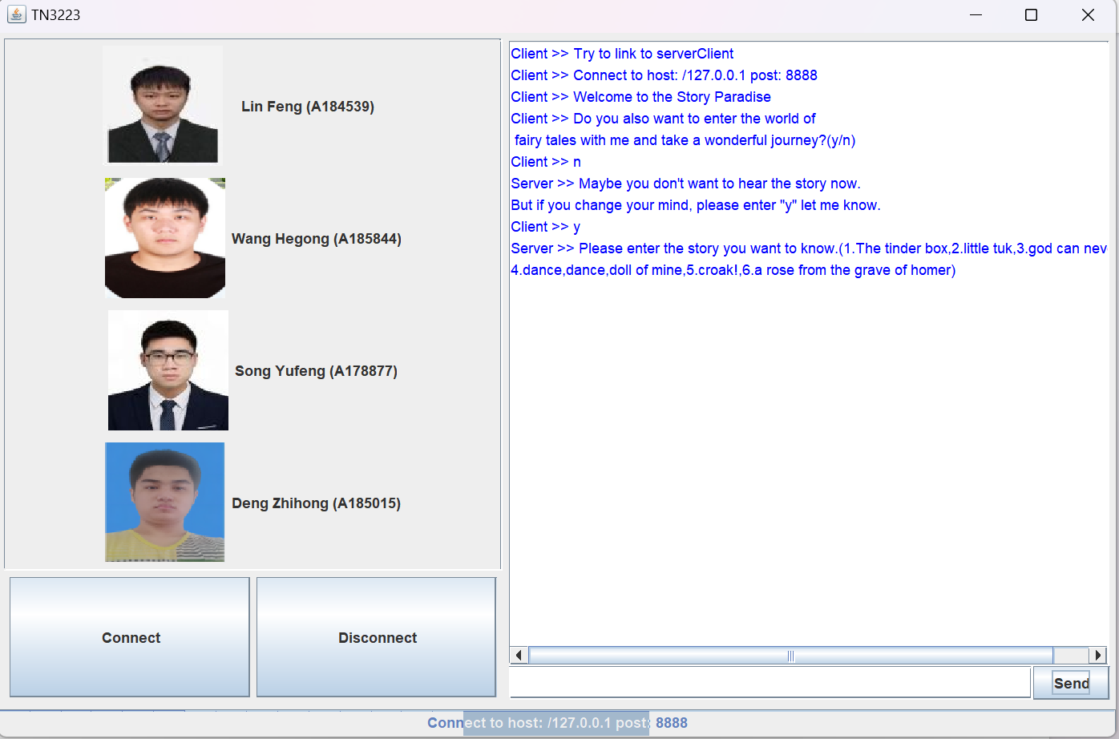

If you enter the false information,the system will do not know what you say

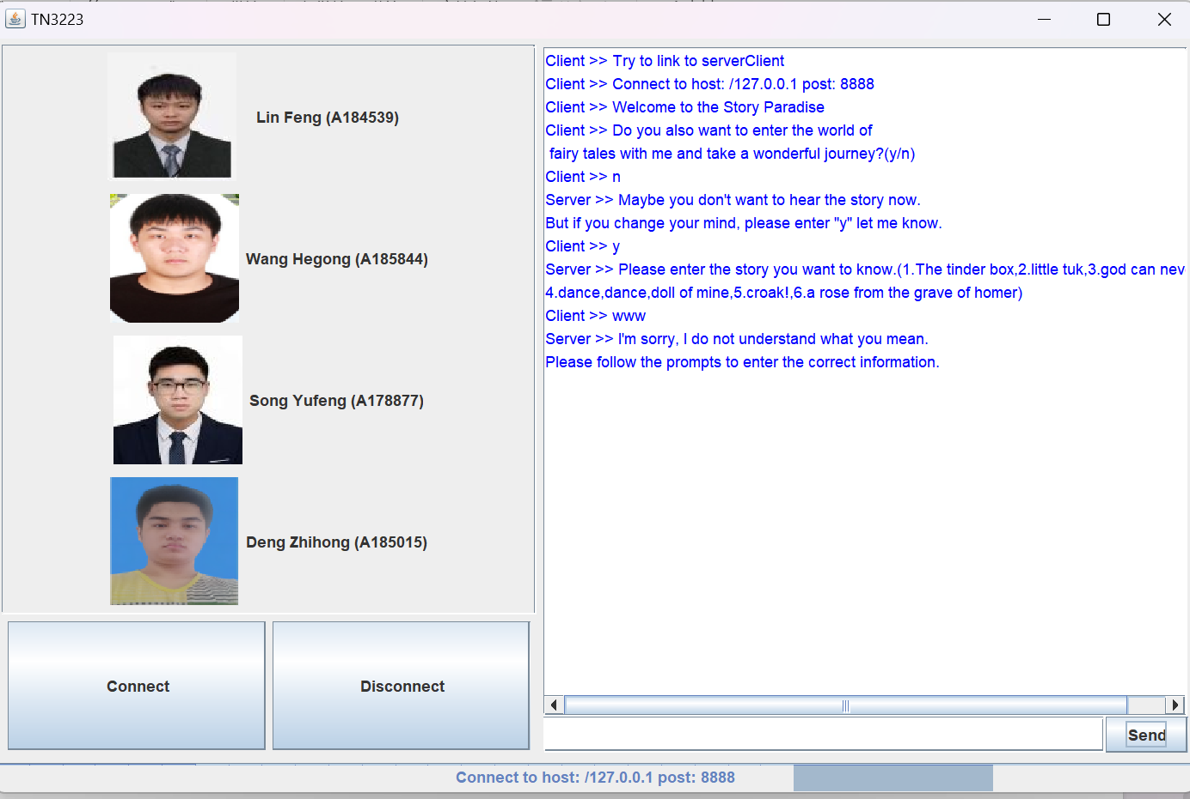

If you want to know some story,you can send the message according to the tips

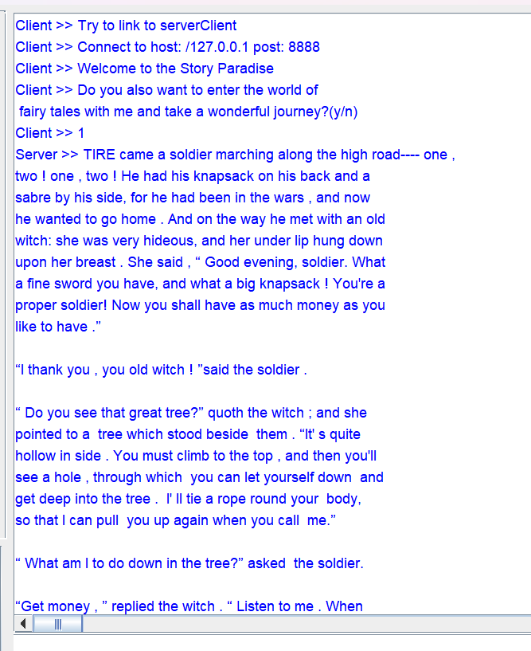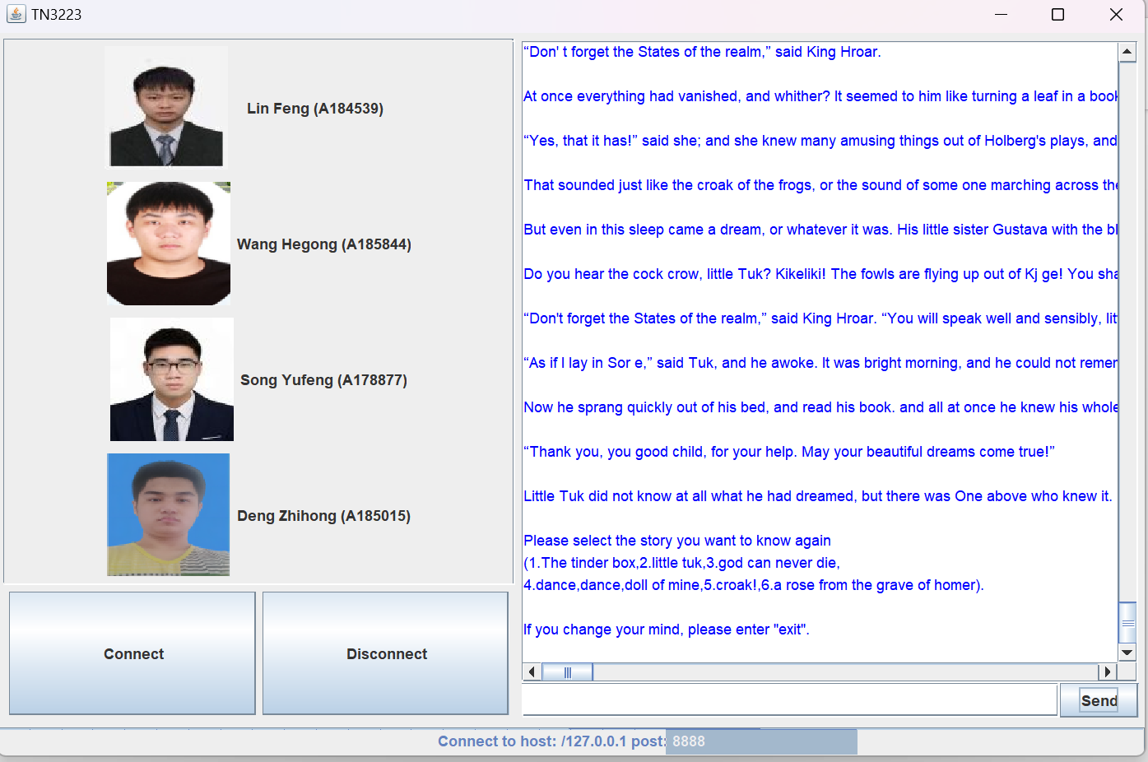

If you wanna disconnect the Server,you can click the disconnect button or input the exit

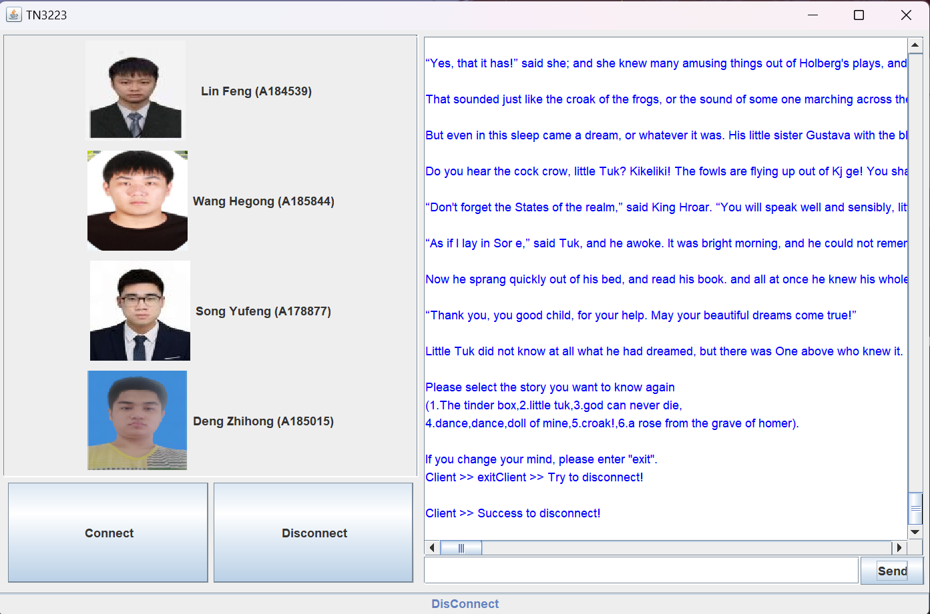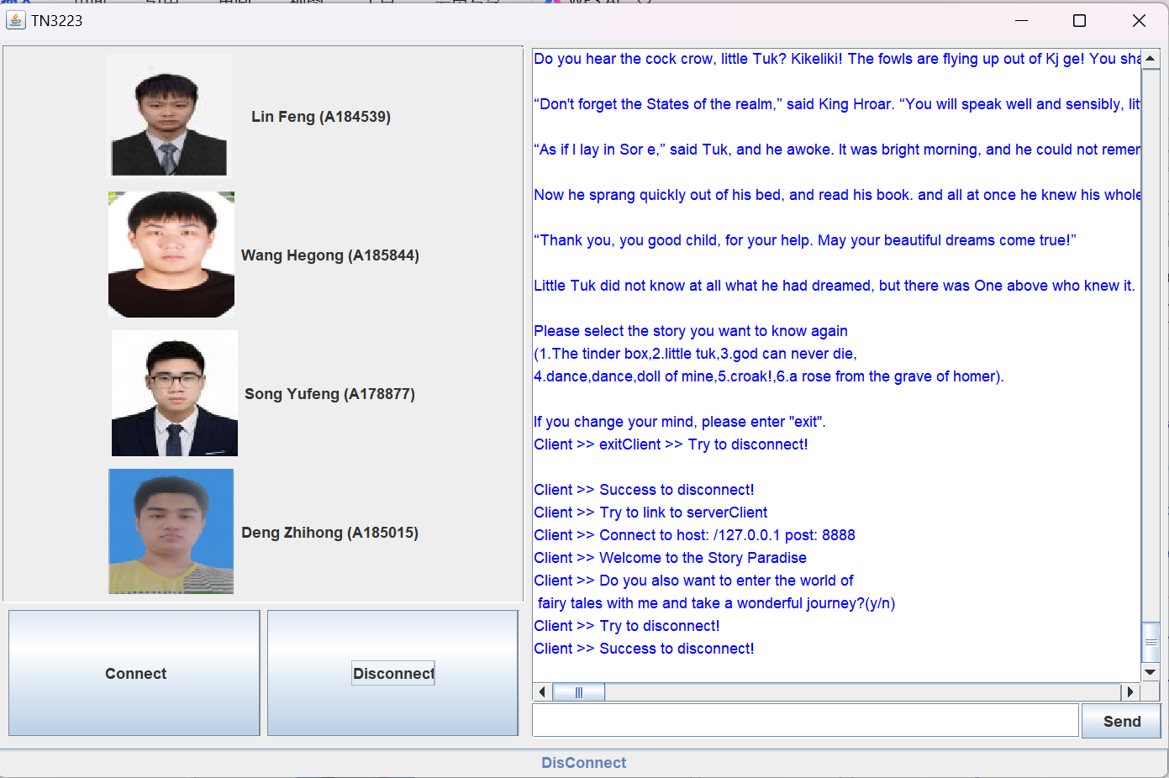

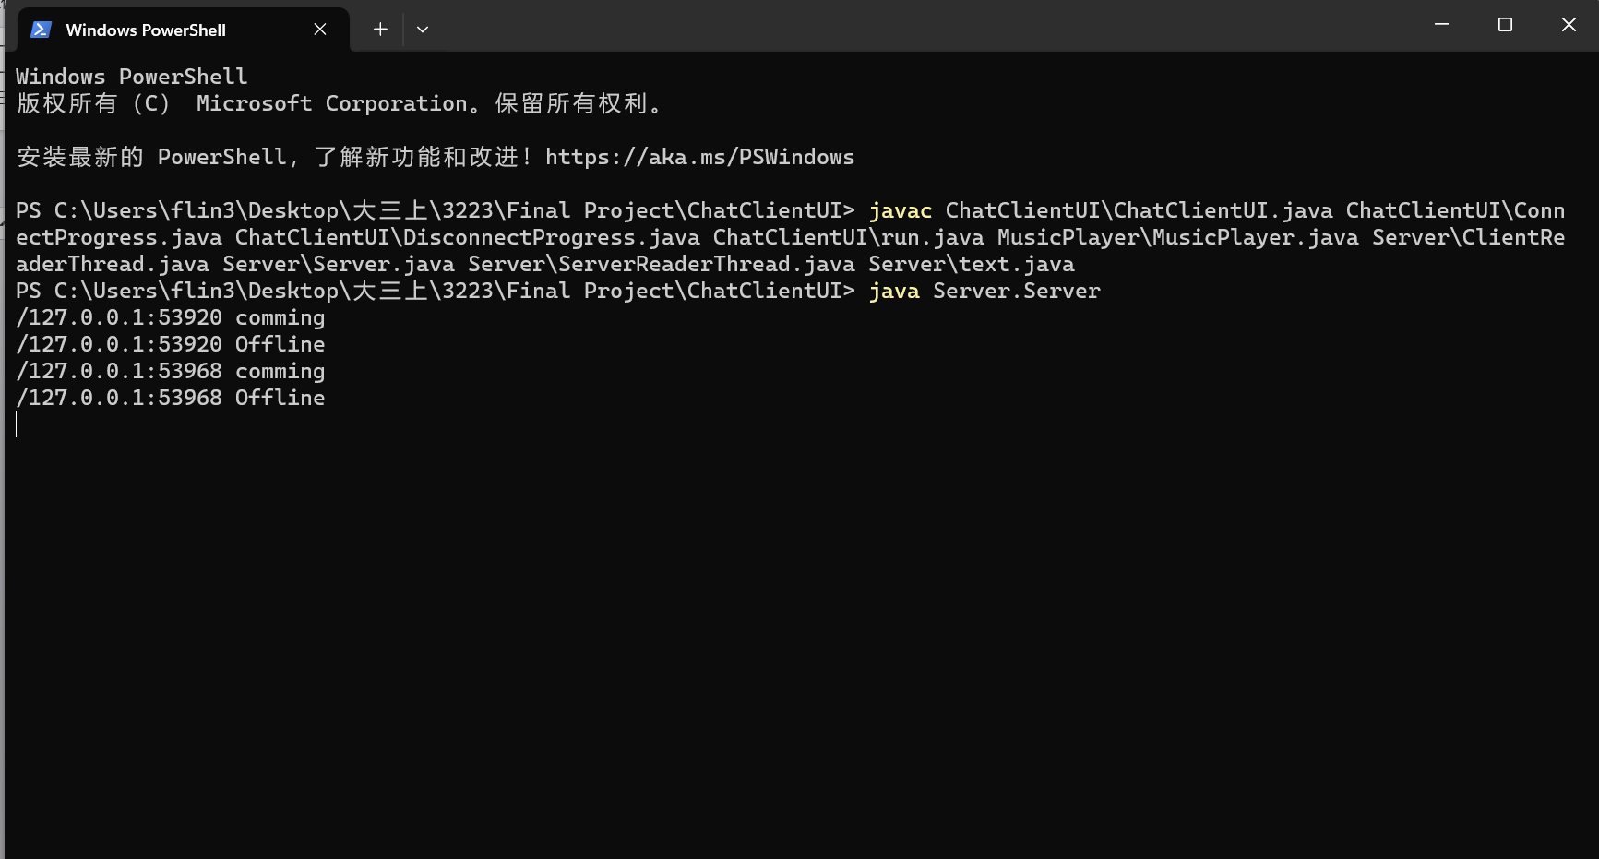

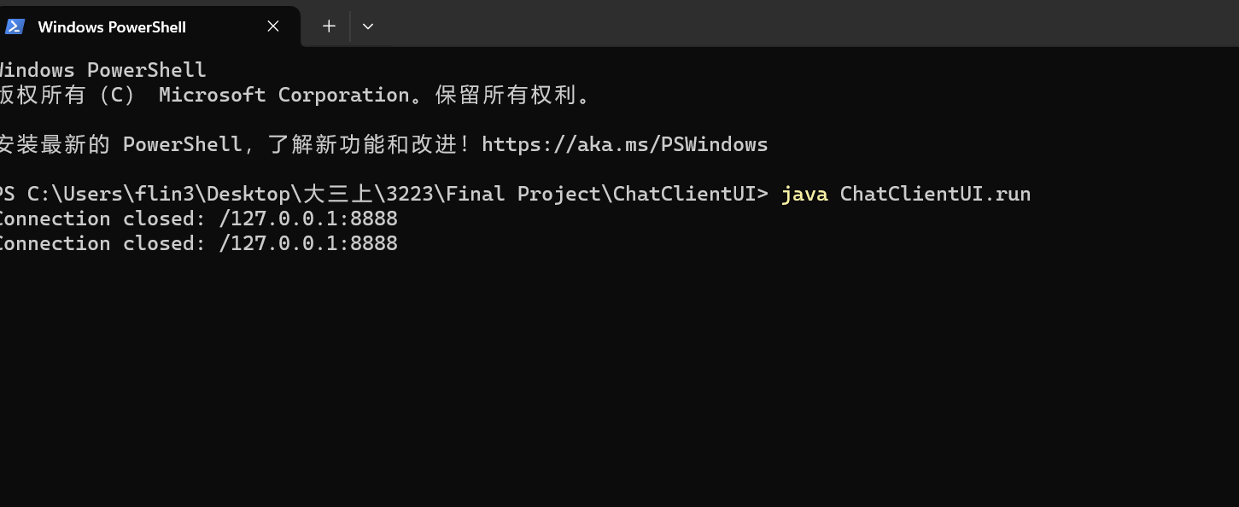

By the way,if you try to send the message within the connect,you will get the tips:

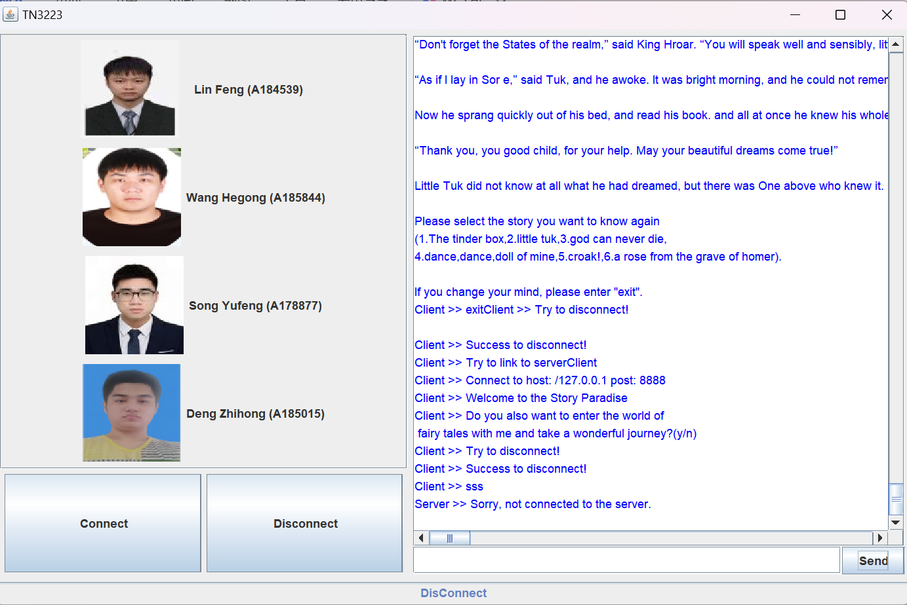

If you try to connect,but you didn’t run the server,you will be connect false

