Survey Description
This survey section explored public beliefs about the causes of autism. Respondents rated how likely they believed five different factors, which are genetic factors, environmental exposure, parenting or family environment, vaccines, and brain development differences before birth, contribute to autism. These items allow us to examine overall beliefs as well as differences across demographic groups.
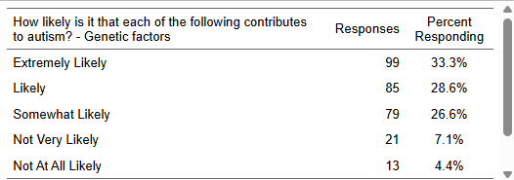

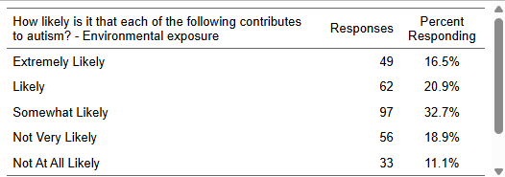

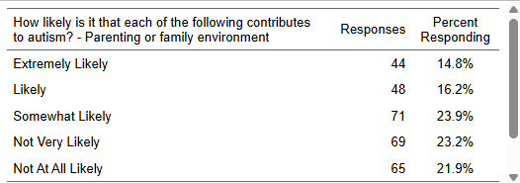

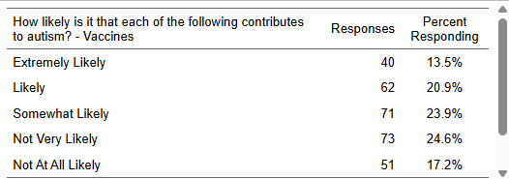

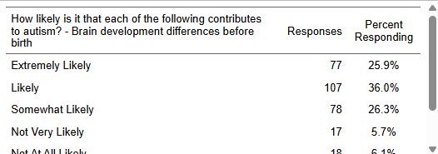

Crosstab 1: Age Group × Likelihood Genetics Contribute to Autism
The crosstab reveals clear age-based differences in perceptions of genetic contributions to autism. Respondents ages 40–49 show the strongest belief in genetic explanations, with over 70% selecting “Extremely Likely” or “Likely.” Younger adults (18–29) show more uncertainty, while older adults (65+) are less likely to rate genetics as “Extremely Likely.” This suggests that middle-aged respondents hold the strongest confidence in biological explanations.
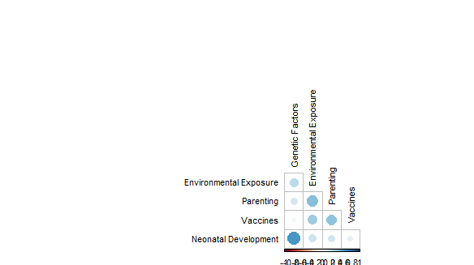

Correlation Analysis of Autism Cause Beliefs
A correlation plot was created to examine how beliefs about different autism causes relate to one another. The strongest positive association appears between genetic factors and neonatal development, suggesting that respondents who view autism as biologically based before birth consistently endorse multiple scientific explanations. Environmental exposure also shows moderate connections to these factors.
In contrast, beliefs about vaccines correlate only weakly with the other causes. This pattern suggests two distinct clusters of thinking: one grounded in scientific explanations (genetics, prenatal development, environmental exposure) and another reflecting alternative or myth-based beliefs (vaccines). Overall, respondents who endorse scientific explanations tend to do so consistently across multiple items, while vaccine beliefs appear isolated.
Summary of Findings
Across all five questions, respondents showed meaningful variation in how likely they believed different factors contribute to autism. Genetic factors were viewed as the most likely cause overall, while vaccines were rated the least likely. The results also reveal clear demographic patterns: respondents ages 40–49 expressed the strongest belief in genetic explanations, whereas education level strongly influenced beliefs about vaccines. Individuals with higher education were far less likely to attribute autism to vaccines, while respondents with lower education levels showed more mixed views. These findings highlight how perceptions of autism causation differ across demographic groups and underscore the role of scientific literacy in shaping these beliefs.

