**DS510 Artificial Intelligence for Data Science**

**PE02**

School of Technology & Computing (STC) @City University of Seattle (CityU)

**Before You Start**

* If you have questions about the lab requirements, please ask a TA to clarify for you.
* If you are not sure what to do:
  1. Consult the resources listed below.
  2. If you cannot solve the problem after a few tries, ask a TA for help.

**Lab Tasks**

* Revise the source code from HOS2 based on the following requirements:

write a new function called is_softmax_valid(output) that verifies whether the softmax output is a valid probability distribution. Your function should check:

1. Whether all values in the list are between 0 and 1 (inclusive).
2. Whether the sum of all values is approximately 1, allowing a margin of ±0.01.

Then, update your existing softmax Version 3 code to:

* Call is_softmax_valid() after computing the softmax result.
* Print a message stating whether the softmax output is valid or not.

Expected output:

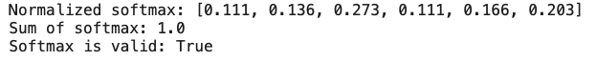

**Please download the source code file ipynb file and submit it to BrightSpace.**