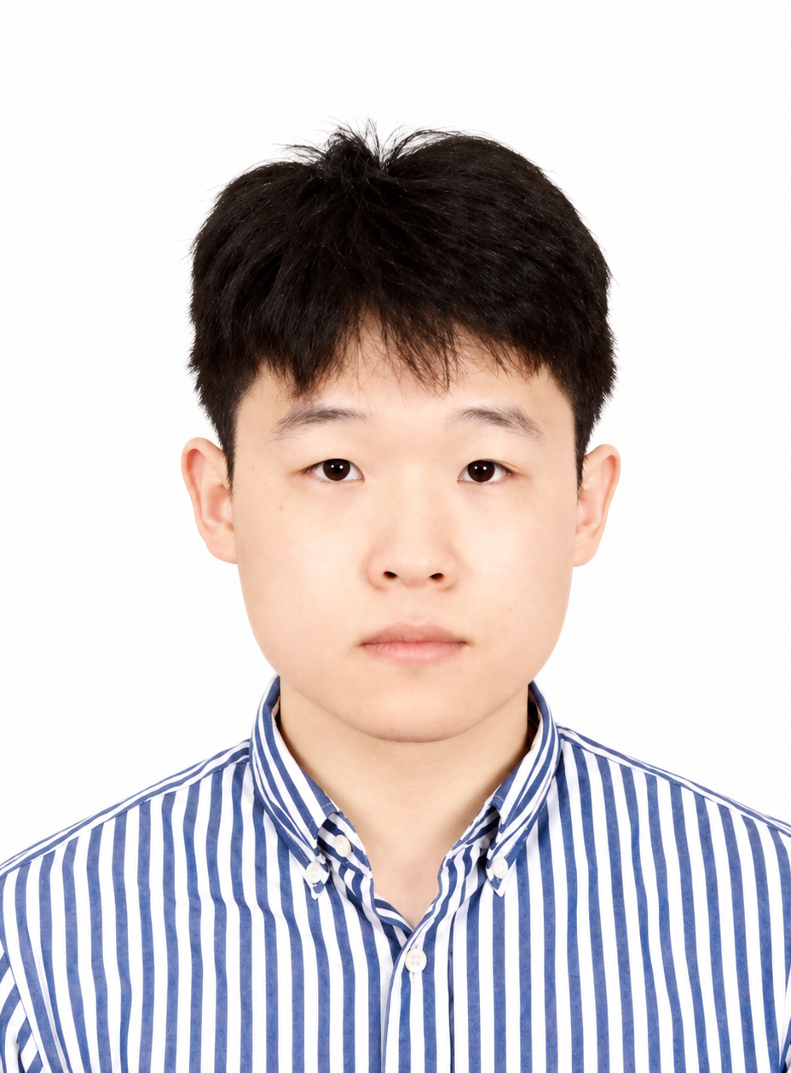
CHONG KAH JUN (DAMIEN)
FULL-STACK DEVELOPER
Seri Kembangan, Selangor, Malaysia
+60 10-229 5993 | damienckj5993@gmail.com
github.com/DamienCKj2812 | damienckj2812.github.io/damien-portfolio

PROFESSIONAL SUMMARY
Full-stack developer who has delivered production client systems end to end: an AI-powered CRM with RAG knowledge bases, a multilingual CMS backend, and a bilingual property website that reached top-five Google rankings for relevant searches. Works across React, Next.js, TypeScript, Express, Python, PostgreSQL, and MongoDB, through to Docker and Linux deployment and server operations.

TECHNICAL SKILLS
Languages: TypeScript, JavaScript, Python, Go, SQL, HTML, CSS; additional academic experience with Java and C++.
Frontend: React, Next.js, Tailwind CSS, Radix UI, Vite, Three.js / React Three Fiber.
Backend & data: Node.js, Express, REST APIs, WebSockets, Strapi, PostgreSQL, MongoDB, Supabase, Redis, authentication, access control, validation.
AI & machine learning: AI SDKs, RAG, Pinecone, XGBoost, LOF anomaly detection, pandas / NumPy.
Delivery & infrastructure: Git, GitHub Actions, Docker, Linux, PM2, Ansible, OpenTelemetry, Playwright, server operations, SEO.

PROFESSIONAL EXPERIENCE
Freelance Full-Stack Developer: Ongoing
Freelance / Client Projects
- Deliver web applications, custom CMS backends, and CRM platforms for clients, covering development, integration, deployment, and server operations.
- MyRumawip: built the bilingual property website end to end as sole developer and helped it reach top-five Google rankings for relevant affordable-housing searches.
- DWMLight / ANVA: developed the multilingual CMS backend and ran its deployment and server operations for a China-based client reaching international audiences.
- MyReport: sole developer of a customer workspace with WhatsApp ingestion and reviewed AI assistance.
- Contribute to product development for AMPLYFII (Ampress), an unreleased influencer-marketing platform, collaborating with another developer on the overall user experience.
Full-Stack Developer: July 2025 - November 2025
COS Great Trading
- Led the initial development of an AI-powered CRM, owning both frontend and backend implementation.
- Established core architecture, reusable components, and integrations for scalability and future development.
- Built initial RAG and Pinecone infrastructure for department-specific AI knowledge bases.
- Created technical documentation and development guidelines to support team collaboration, developer onboarding, and long-term maintainability.
- Tech stack: Next.js, TypeScript, Express, Python, MongoDB, Pinecone, and AI SDKs.
Front End Developer: April 2024 - November 2024
LYJ Events & Marketing
- Developed responsive web and mobile interfaces from design specifications, including a trading broker website and a community-chat / customer-support platform.
- Collaborated with stakeholders to adapt features to changing business requirements and maintain clean, reusable interface code.
- Participated in daily stand-ups and resolved bugs using QA feedback and issue tickets.
CHONG KAH JUN (DAMIEN)

SELECTED PROJECTS
MyRumawip - Bilingual Property Website: Client project
Next.js • TypeScript • Strapi • PostgreSQL • Docker • Ansible
- Developed the bilingual property website as sole developer, integrating CMS-managed listings, housing-scheme information, SEO content, and direct WhatsApp enquiries.
- Implemented English and Malay content, server-side CMS integration, content revalidation, and deployment workflows.
- Helped the website achieve top-five Google rankings for relevant affordable-housing searches.
DWMLight / ANVA CMS (Aria): Client project
TypeScript • Express • MongoDB • AJV • PM2 • OpenTelemetry
- Developed the custom CMS/backend supporting DWMLight’s multilingual website, including structured content management, validation, and translation handling.
- Implemented authenticated content operations and administrative permission checks for flexible, schema-driven content.
- Managed deployment and server operations, helping a China-based client present its products to international audiences.
MyReport - Customer Workspace & AI Assistance: Client project
Next.js • TypeScript • Supabase / PostgreSQL • WAHA • Google Calendar OAuth
- Built the customer workspace as sole developer, connecting WhatsApp message ingestion, customer records, reviewed AI assistance, and follow-up workflows.
- Separated immutable messages, AI-proposed information, and confirmed customer data; implemented structured validation, owner-scoped operations, and audit history.
- Integrated real-time workspace updates and calendar-related workflows in a privately hosted environment.
Hybrid Anomaly Detection for Microservice Observability: Final Year Project
Go • Python • OpenTelemetry • Redis Streams • PostgreSQL • XGBoost / LOF • React
- Investigated hybrid anomaly detection for application telemetry, combining metrics and trace ingestion, stream processing, ML inference, and a live observability dashboard.
- The XGBoost–LOF hybrid reached an F1 score of 0.84 and a 0.68% false-positive rate in offline evaluation on real telemetry with injected anomalies.
Interactive 3D Portfolio Website: Personal project
React • TypeScript • Three.js / React Three Fiber • Vite • Tailwind CSS • Blender • Playwright
- Built a scroll-driven 3D city walkthrough with four explorable rooms (profile, skills, projects, experience), plus a lightweight 2D mode that loads no 3D assets.
- Kept the Three.js scene demand-rendered with a capped pixel ratio, with a loading screen that tracks real asset preparation and layouts that adapt to mobile, touch, and keyboard input.
- Deployed to GitHub Pages through GitHub Actions with ESLint, strict TypeScript, and automated content and asset checks; added Playwright browser regression tests.

EDUCATION
Bachelor of Science (Honours) in Computer Science: Expected June 2027
Asia Pacific University | Specialism in Data Analytics
CGPA: 3.36 | Final results received
Diploma in Information Technology: Graduated 2024
Asia Pacific University | Specialism in Software Engineering
CGPA: 3.68

