**Evaluating NavMesh and Reinforcement Learning for Ghost AI in Pac-Man: A Pathfinding Performance Comparison**

Damien Galea MSD6.3A

Research Design 2

*Description of Theme and Topic Rationale.*

**Theme**:

Pathfinding is an important aspect of artificial intelligence in gaming as it was made to ensure smooth movement that affects the gameplay experience and efficiency. It involves calculating a number of moves that guide a GameObject from one position to another while avoiding obstacles. The criteria for a successful path are validity and optimality meaning the path is free from collisions and the shortest route possible [1].

**Rationale:**

This study compares the performance of reinforcement learning agent and the NavMesh agent by measuring the distance covered and the time taken to catch the player. By conducting this experience in 2 different environments one simple and one complex, this would help to prove if the RL agent is better at adapting that the traditional NavMesh.

*Positioning and Research Onion*

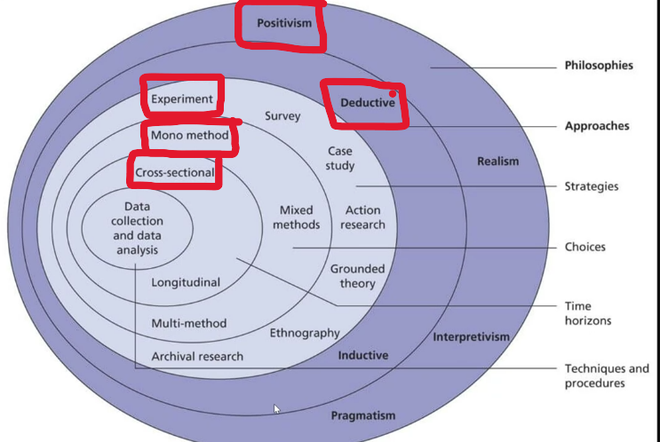

**Positivism (Philosophy):**

A positivism approach was chosen because the study relies on objective data to compare the performance of the 2 agents. To determine the which agent has preformed more effectively measurable factors such as time and distance to catch the player will be analysed. Making this study align with the positivist philosophy which gives importance to scientific evaluation to draw conclusions.

**Deductive (Approach):**

A deductive approach was chose due to this study wanting to prove an existing theory that reinforcement learning agent would outperform a NavMesh agent. This method follow a top-down approach, starting from the hypothesis and using data from the prototype to confirm or refute it.

**Experiment (Strategy):**

This study is classified as an experiment because it involves testing 2 controlled AI agents (the NavMesh and the reinforcement learning) in different environments to compare there performances. In this case we will be comparing the distance needed to catch the player and also the time taken.

**Mono-Method (Choice):**

This study employs a mono-method approach, utilizing a quantitative data collection method. Since this research aims to objectively compare the 2 agents, factual data such as time taken to catch the player would prove to be more precise.

**Cross-Sectional (Time Horizon):**

A cross-sectional approach was chosen due to the agents performance being testing once in 2 different environments and not over a period of time rather than being observed over an extended period of time.

*Background to this research theme*

In recent years, AI has significantly improved in many areas, including navigation and decision-making. These advancements are widely applied in many different areas, more notably in video games where Non-Playable Characters (NPCs) and other computer-controlled objects use AI to enhance playability and immersion. A common approach for navigation would be NavMesh while Reinforcement learning (RL) is mostly used for decision-making.

NavMesh is a navigation technique used in games that allows AI agents to move around a selected area. It is a technique that is favoured due to its fast and low-cost processing power, it works well for static environments and unchanged obstacles [1].

RL learns optimal navigation and adaptive decision-making by trail and error, adapting to different environments. However, RL can be computationally intensive and requires significant training time before achieving optimal performance [2].

Hypothesis

An agent utilizing reinforcement learning will outperform the NavMesh agent across both simple and complex environments.

Research Aim and Purpose statement

**Research Aim:**

The aim of this study is to evaluate and compare Reinforcement Learning (RL) and NavMesh in enemy behaviour, specifically focusing on the ghost AI in a Pac-Man-style game. The research seeks to determine which approach more effectively balances chasing, retreating.

**Purpose Statement:**

The purpose of this experiment is to test the theory that a reinforcement learning (RL) agent can outperform a NavMesh agent in terms of efficiency, specially in the time and distance taken to achieve a win. This study aims to train the agents in a controlled environment. The independent variables will be the algorithm of the agent and the 2 environments. The dependent variable will be the time taken and the amount of distance took to catch the player [3].

References:

[1] X. Cui and H. Shi, "An overview of pathfinding in navigation mesh," IJCSNS International Journal of Computer Science and Network Security, vol. 12, no. 12, pp. 48-51, Dec. 2012.

[2] E. K. Sure and X. Wang, “A Deep Reinforcement Learning Agent for General Video Game AI Framework Games,” in 2022 IEEE International Conference on Artificial Intelligence and Computer Applications (ICAICA), Jun. 2022, pp. 182–186. [Online]. Available:  
https://ieeexplore.ieee.org/document/9844524

[3] J. W. Creswell and J. D. Creswell, *Research Design: Qualitative, Quantitative, and Mixed Methods Approaches*, 6th ed. Thousand Oaks, CA: SAGE Publications, Inc., 2023.