2019 MCM
Problem B: Send in the Drones: Developing an Aerial Disaster Relief
Response System

Background: In 2017, the worst hurricane to ever hit the United States territory of Puerto Rico (see Attachment 1) left the island with severe damage and caused over 2900 fatalities. The combined destructive power of the hurricane’s storm surge and wave action produced extensive damage to buildings, homes, and roads, particularly along the east and southeast coast of Puerto Rico. The storm, with its fierce winds and heavy rain, knocked down 80 percent of Puerto Rico's utility poles and all transmission lines, resulting in loss of power to essentially all of the island's 3.4 million residents. In addition, the storm damaged or destroyed the majority of the island’s cellular communication networks. The electrical power and cell service outages lasted for months across much of the island, and longer in some locations. Widespread flooding blocked and damaged many highways and roads across the island, making it nearly impossible for emergency services ground vehicles to plan and navigate their routes. The full extent of the damage in Puerto Rico remained unclear for some time; dozens of areas were isolated and without communication. Demands for medical supplies, lifesaving equipment, and treatment strained health-care clinics, hospital emergency rooms, and non-governmental organizations’ (NGOs) relief operations. Demand for medical care continued to surge for some time as the chronically ill turned to hospitals and temporary shelters for care.

Problem: Non-governmental organizations (NGOs) are often challenged to provide adequate and timely response during or after natural disasters, such as the hurricane that struck the United States territory of Puerto Rico in 2017. One NGO in particular – HELP, Inc. - is attempting to improve its response capabilities by designing a transportable disaster response system called “DroneGo.” DroneGo will use rotor wing drones to deliver pre-packaged medical supplies and provide high-resolution aerial video reconnaissance. Selected drones should be able to perform these two missions – medical supply delivery and video reconnaissance – simultaneously or separately, depending on relief conditions and scheduling. HELP, Inc. has identified various candidate rotor wing drones that it would like your team to consider for possible use in designing its DroneGo fleet (see Attachments 2, 3).

DroneGo’s pre-packaged medical supplies, called medical packages, are meant to augment, not replace, the supplies provided by local medical assistance organizations on-site within the country affected by the disaster. HELP, Inc. is planning on three different medical packages referred to as MED1, MED2, and MED3. Drones will carry these medical packages within drone cargo bays for delivery to selected locations (see Attachments 4, 5). Depending on the specific drone being used to transport medical supplies, it may be possible that multiple medical packages can be transported in a single drone cargo bay. Note that drones must land on the ground to offload medical supplies from the drone cargo bays. The video capability of the drones will provide high-resolution video of damaged and serviceable transportation road networks to HELP, Inc.’s command and control center for ground-based route planning.

HELP, Inc. will use International Standards Organization (ISO) standard dry cargo containers to quickly transport a complete DroneGo disaster response system to a particular disaster area. The individual shipping containers for all drones in the DroneGo fleet, along with all required

medical packages, must fit within a maximum of three of the ISO cargo containers to be delivered to a single location, or up to three different locations if three cargo containers are used in the disaster area. Each shipping container’s contents should be packed in order to minimize any need for buffer materials for unused space. Table 1 shows the dimensions of an ISO standard dry cargo container.

Table 1. Standard ISO Container Dimensions
 |  | Exterior |  |  | Interior |  | Door Opening
 | Length | Width | Height | Length | Width | Height | Width | Height
20’
Standard | 20’ | 8’ | 8’6” | 19’3” | 7’8” | 7’ 10” | 7’8” | 7’5”
Dry
Container

HELP, Inc. is asking your team to use the 2017 situation in Puerto Rico to design a DroneGo disaster response system that will fit within the containers noted while meeting the anticipated medical supply demands during a potential similar future disaster scenario. It is possible that the demand requirements of this scenario may exceed the capabilities of the drone fleet your team identifies. If this occurs, HELP, Inc. wants to clearly understand any tradeoffs that it must make for implementing solutions to address these shortcomings.

Part 1. Develop a DroneGo disaster response system to support the Puerto Rico hurricane disaster scenario.

Consider the background information, the requirements identified in the problem statement, and the information provided in the problem attachments to address the following.

- Recommend a drone fleet and set of medical packages for the HELP, Inc. DroneGo disaster response system that will meet the requirements of the Puerto Rico hurricane scenario. Design the associated packing configuration for each of up to three ISO cargo containers to transport the system to Puerto Rico.

- Identify the best location or locations on Puerto Rico to position one, two, or three cargo containers of the DroneGo disaster response system to be able to conduct both medical supply delivery and video reconnaissance of road networks.

- For each type of drone included in the DroneGo fleet:

  - Provide the drone payload packing configurations (i.e. the medical packages packed into the drone cargo bay), delivery routes and schedule to meet the identified emergency medical package requirements of the Puerto Rico hurricane scenario.

  - Provide a drone flight plan that will enable the DroneGo fleet to use onboard video cameras to assess the major highways and roads in support of the Help, Inc. mission.
Part 2. Memo

Write a 1–2 page memo to the Chief Operating Officer (CEO) of HELP, Inc. summarizing your modeling results, conclusions, and recommendations so that she can share with her Board of Directors.

Your MCM team submission should consist of:

- One-page Summary Sheet,
- One- to Two-page memo to the HELP, Inc. CEO

- Your solution of no more than 20 pages, for a maximum of 23 pages with your summary and memo.

- Note: Reference list and any appendices do not count toward the 23-page limit and should appear after your completed solution.

Attachments:

- Map of Puerto Rico

- Potential Candidate Drones for DroneGo Fleet Consideration (with Drone payload capability)

- Drone Cargo Bay Packing Configuration/Dimensions by Type
- Anticipated Medical Package Demand
- Emergency Medical Package Configuration/Dimensions
Attachment 1: Map of Puerto Rico
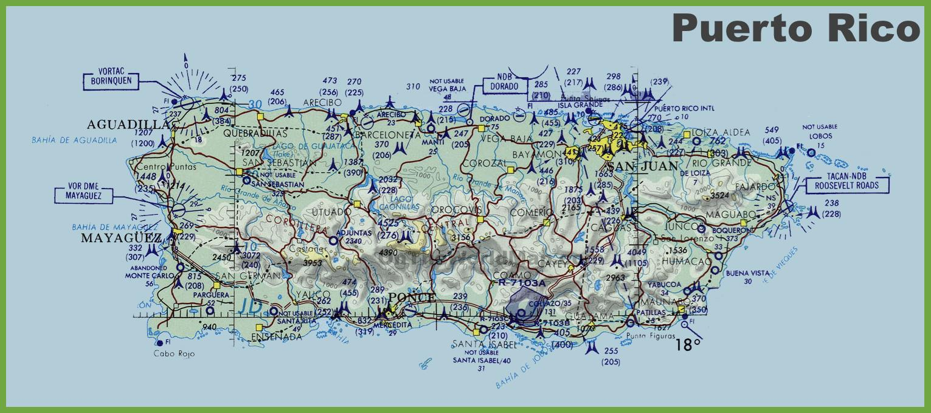

Attachment 2: Potential Candidate Drones for DroneGo Fleet Consideration (with Drone Payload Capability)

 | Shipping Container |  |  |  |  |  | Performance |  |  |  | Configurations Capabilities
 |  | Dimensions |  |  |  | Characteristics/Capabilities
 |  |  |  |  |  | Max Payload |  |  |  | Flight Time |  | Medical | Drone
 | Length |  | Width |  | Height | Max Payload |  | Speed |  | Flight Time | Video | Medical | Cargo
Drone | Length |  | Width |  | Height | Capability |  | Speed |  | No Cargo | Video | Package | Cargo
Drone | (in.) |  | (in.) |  | (in.) | Capability |  | (km/h) |  | No Cargo | Capable | Package | Bay
 | (in.) |  | (in.) |  | (in.) | (lbs.) |  | (km/h) |  | (min) | Capable | Capable | Bay
 |  |  |  |  |  | (lbs.) |  |  |  | (min) |  | Capable | Type*
A | 45 |  | 45 |  | 25 | 3.5 |  | 40 |  | 35 | Y | Y | 1
B | 30 |  | 30 |  | 22 | 8 |  | 79 |  | 40 | Y | Y | 1
C | 60 |  | 50 |  | 30 | 14 |  | 64 |  | 35 | Y | Y | 2
D | 25 |  | 20 |  | 25 | 11 |  | 60 |  | 18 | Y | Y | 1
E | 25 |  | 20 |  | 27 | 15 |  | 60 |  | 15 | Y | Y | 2
F | 40 |  | 40 |  | 25 | 22 |  | 79 |  | 24 | N | Y | 2
G | 32 |  | 32 |  | 17 | 20 |  | 64 |  | 16 | Y | Y | 2
H | 65 |  | 75 |  | 41 | N/A |  | N/A |  | Indefinite | N | N | N/A
Tethered | 65 |  | 75 |  | 41 | N/A |  | N/A

*Note that cargo bays are affixed to the drone and that drone must be on the ground to offload cargo. See Attachment 3 for Drone Cargo Bay Type Configuration/Dimensions.

Attachment 3: Drone Cargo Bay Packing Configuration/Dimensions by Type

 | Drone Cargo Bay Type |  | Length (in) |  |  |  | Width (in) |  | Height (in)
1 |  |  |  |  | 8 | 10 |  |  | 14 |  | Top Loaded
2 |  |  |  |  | 24 | 20 |  |  | 20 |  | Top Loaded
 | Attachment 4: Anticipated Medical Package Demand
 | Delivery Location |  |  |  |  |  |  |  | Emergency Medical Packages **
 | Location Name |  |  |  | Latitude |  | Longitude | Requirement |  | Quantity |  | Frequency
 | Caribbean Medical Center |  |  |  | 18.33 | -65.65 |  |  | MED 1 | 1 |  | Daily
 |  | Jajardo |  |  |  |  |  |  | MED 3 | 1 |  | Daily
 | Hospital HIMA |  |  |  | 18.22 | -66.03 |  |  | MED 1 | 2 |  | Daily
 |  | San Pablo |  |  |  |  |  |  | MED 3 | 1 |  | Daily
 | Hospital Pavia Santurce |  |  |  | 18.44 | -66.07 |  |  | MED 1 | 1 |  | Daily
 |  | San Juan |  |  |  |  |  |  | MED 2 | 1 |  | Daily
 | Puerto Rico Children's Hospital |  |  |  | 18.40 | -66.16 |  |  | MED 1 | 2 |  | Daily
 |  | Bayamon |  |  |  |  |  |  | MED 2 | 1 |  | Daily
 |  |  |  |  |  |  |  |  | MED 3 | 2 |  | Daily
 | Hospital Pavia Arecibo |  |  |  | 18.47 | -66.73 |  |  | MED 1 | 1 |  | Daily
 |  | Arecibo
**See Attachment 5 for Emergency Medical Packages 1, 2, and 3 Configurations/Dimensions.

Attachment 5: Emergency Medical Package Configuration/Dimensions

Emergency Medical Package Configuration

 | Weight | Package Dimensions
Package ID | Weight | (in.)
Package ID | (lbs.) | (in.)
 | (lbs.) | (L × W × H)
MED 1 | 2 | 14 × 7 × 5
MED 2 | 2 | 5 × 8 × 5
MED 3 | 3 | 12 × 7 × 4

Glossary:

Cargo Container (Shipping Container): a large rectangular container with doors on the ends for loading and packing, and made of material suitable for shipping, storing, and handling in many weather and climate conditions.

Drone (Unmanned Aerial Vehicle, UAV): a flying robot that can be remotely controlled or fly autonomously through software-controlled flight plans in their embedded systems that work in conjunction with onboard sensors and GPS.

Drone Cargo Bay: For rotor wing drones, this is an externally carried “box” used to transport materials. For this problem, the drones under consideration have one of two types (sizes) of cargo bays. Note that each drone must land for the medical packages to be unloaded from the bay at its destination.

Drone Fleet: a set of drones for a particular mission or purpose. For this problem, the total set of drones by type (A to H) and Payload Capability (Visual and Medical) needed to meet the requirements of HELP, Inc.

Drone Payload Packing Configuration: how the drone payload bays are packed. For this problem, how the medical packages being transported by a drone are packed inside the drone cargo bay.

Medical Package: a predetermined set of medical supplies packed in a single container. For this problem, there are three Medical Package Configurations (MED1, MED2, MED3) available for transport by a drone from a deployed cargo container location to the demand location.

Non-governmental Organization (NGO): Usually non-profit and sometimes international organization independent of government and governmental organizations that is active in humanitarian, educational, healthcare, social, public policy, human rights, environmental and other areas in attempts to affect change.

Payload Capability: the carrying capacity of an aircraft or launch vehicle, usually measured in terms of weight. For this problem, the capability/capacity of the drone to carry medical packages.

