NAME:BENIMANA DAMIEN

REG:21RP00133

I designed a user-friendly web and USSD application for Infocus Studio Ltd, a photography and videography company based in Kigali city. The application allows clients to register, request and order photography or videography services, and easily login and logout. Developed using Flask (Python framework) and MySQL, the application streamlines the client experience, making it seamless to access and utilize the company's services.

1. **Client Registration Form:** I created an HTML form for clients to register with their name, phone number, email, and password. It's designed with Bootstrap for a clean and responsive layout.
2. 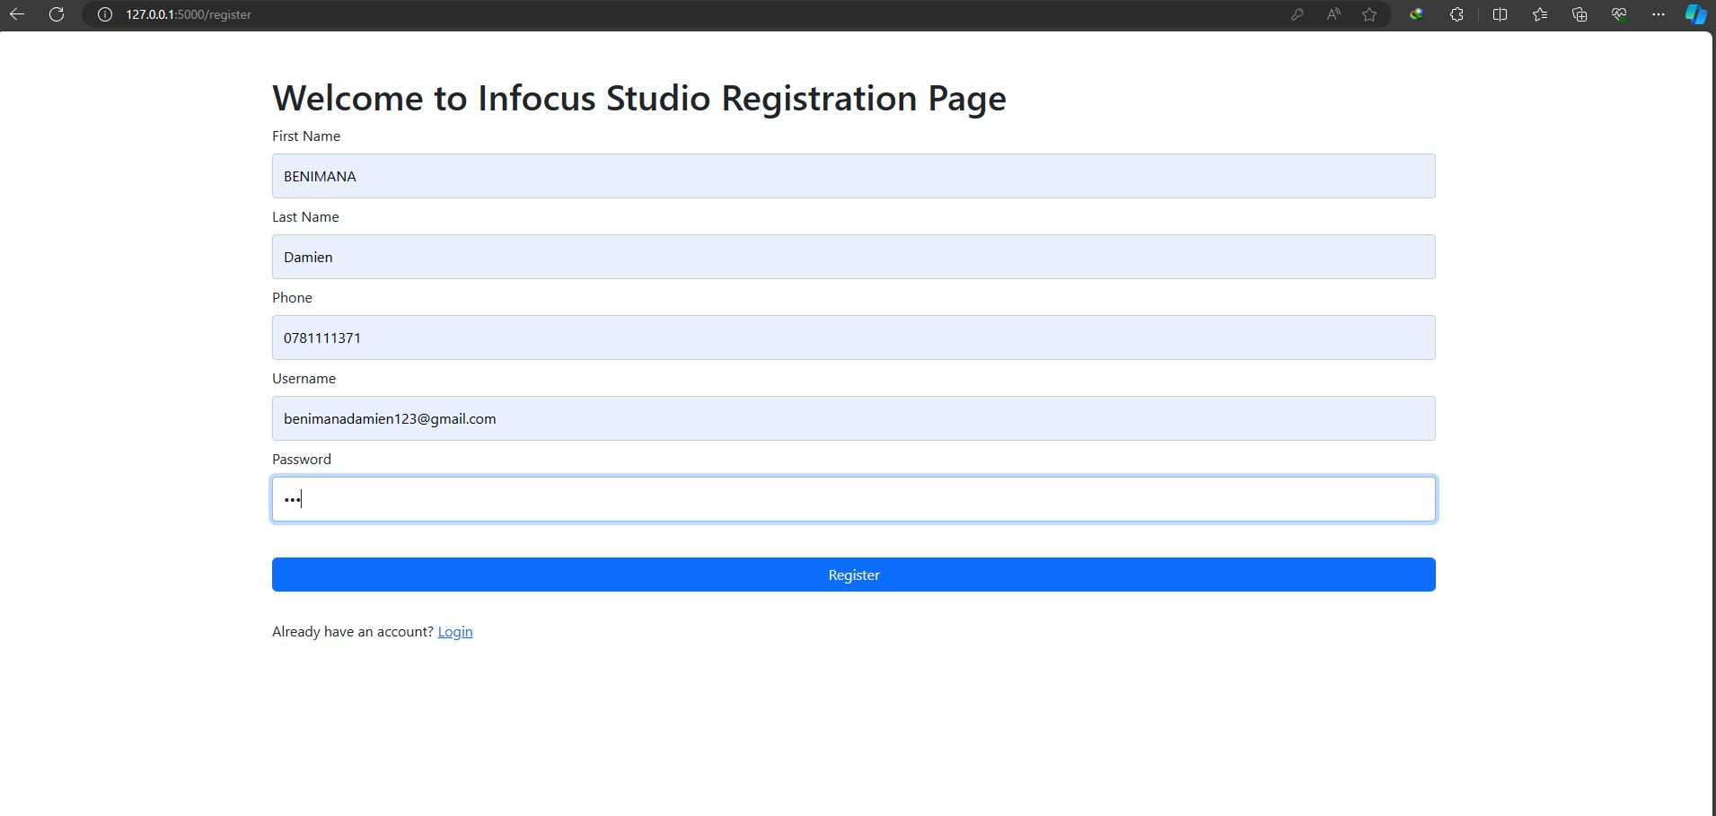

**Login and Logout Functionality:** I created a login form where users can input their username and password to access the system. Additionally, I included a link to the registration page for new users. The page utilizes Bootstrap for styling .

1. 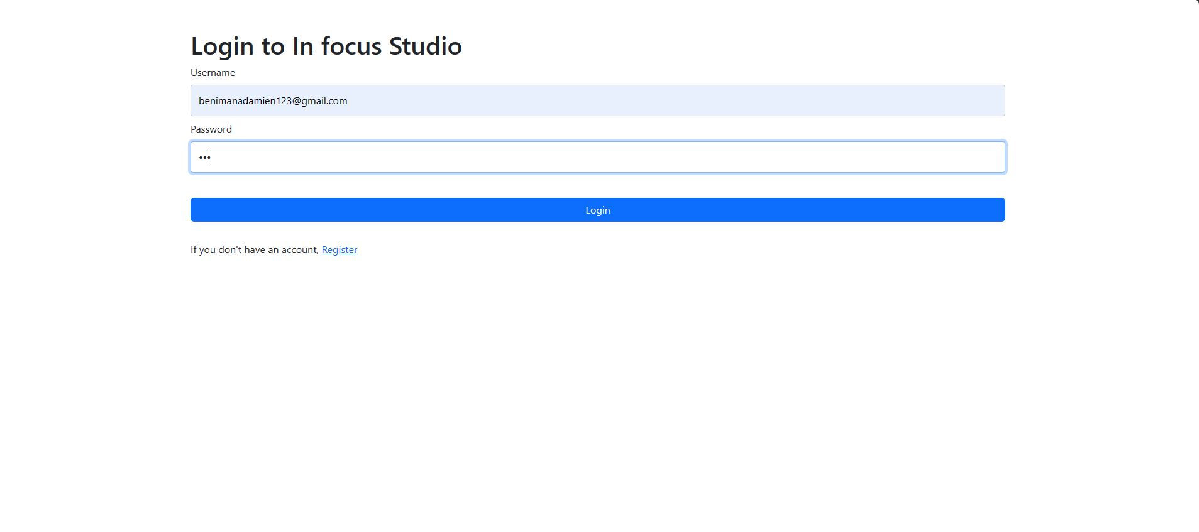

**Ordering Photography and Videography Services**: I designed a webpage where logged-in users can order photography or videography services. It includes fields for selecting the service, price, and date. The page also provides a note about service pricing and uses dynamic dropdowns for service selection.

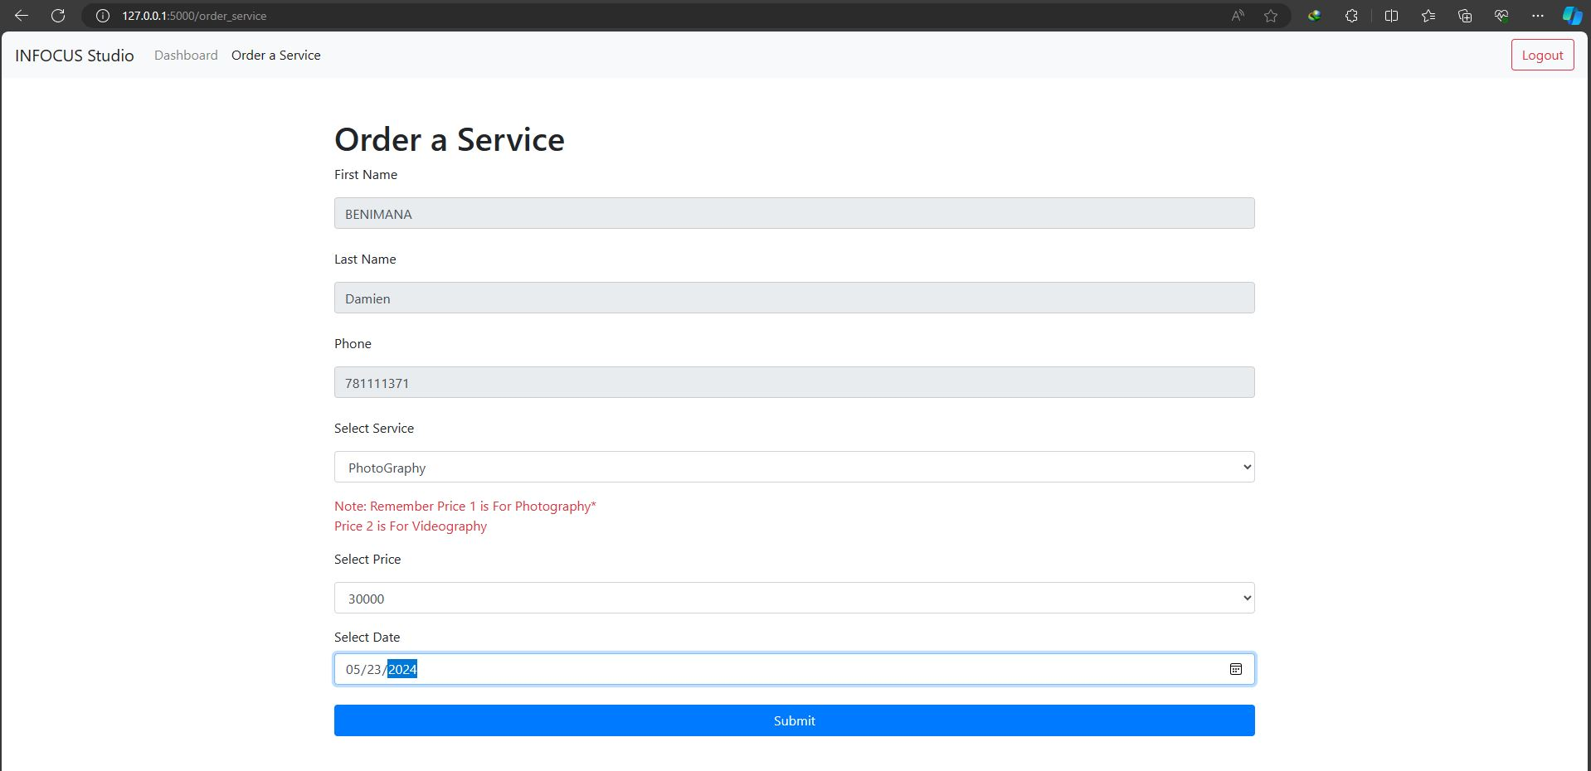

This design presents a dashboard for users logged into the Infocus Studio system:

- Navigation Bar: The navigation bar includes the Infocus Studio logo and links to the Dashboard (currently active) and the Order a Service page. It also provides a logout button for users to log out of the system.

- Dashboard Content: The dashboard container displays a welcome message with the user's username, followed by a brief welcome message to the Infocus Studio system. It lists the available services offered by the studio, including Photography and Videography, in a clean and organized manner.

