Name: Damil Jamil

Registration #: SP21-BCS-009

Aim + Introduction:

I have taken a data set containing necessary health related information like hypertension, heart disease, BMI, HbA1c_level, Blood glucose level etc that would be used to predict whether a person would get diabetes in future or not.  
  
Data Set:  
Data Source : <https://www.kaggle.com/datasets/iammustafatz/diabetes-prediction-dataset?select=diabetes_prediction_dataset.csv>

Feature List:



Feature Selection Algorithm:

Random Forest Classifier:

Preprocessing:

Changing the Gender Column from string to integer

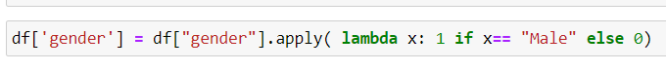

Removing the smoking column:

Importing Libraries:

Implementation:

Feature Ranking:

Deep Learning Model:

Import Libraries:

Implementation:

Results:

