Assignment 1

Damin Xu

CSCI-4100

661679187

$h\left(x\right)=sign\left(w^{t}x\right)=sign\left(\left(\sum_{i=1}^{d}{wixi}\right)+w_{0}\right)=sign\left(w^{T}\left(t\right)x\left(t\right)\right)$

$According to the rule 1.3, when y\left(t\right)≠sign\left(w^{T}\left(t\right)x\left(t\right)\right)=h\left(x\right),$

$$w\left(t+1\right)=w\left(t\right)+y\left(t\right)x\left(t\right)$$

$$Since y\left(t\right)!=h\left(x\right), so when h\left(x\right)>0, y\left(t\right)=-1;$$

$$and when h\left(x\right)<0, y\left(t\right)=1.$$

$$Therefore, y\left(t\right)w^{T}\left(t\right)x\left(t\right)<0.$$

$y\left(t\right)w^{T}\left(t+1\right)x\left(t\right)=y\left(t\right)\left(w\left(t\right)+w\left(t\right)x\left(t\right)\right)x\left(t\right)$

$$=y\left(t\right)w^{T}\left(t\right)x\left(t\right)+y^{2}\left(t\right)x^{T}(t)x(t)$$

$$It^{'}s clear that y^{2}\left(t\right)x^{T}\left(t\right)x\left(t\right) is always larger than 0 since x\left(0\right)=x_{0}=1,$$

$$y\left(t\right)w^{T}\left(t\right)x\left(t\right)+y^{2}\left(t\right)x^{T}\left(t\right)x\left(t\right)>y\left(t\right)w^{T}\left(t\right)x\left(t\right)$$

$$⇒y\left(t\right)w^{T}\left(t+1\right)x\left(t\right)>y\left(t\right)w^{T}\left(t\right)x\left(t\right)$$

$From part \left(b\right), we know that y\left(t\right)w^{T}\left(t+1\right)x\left(t\right)>y\left(t\right)w^{T}\left(t\right)x\left(t\right),$

$$which means it moves in the positive direction. This positive direction is$$

$$just to the right.$$

2. Learning approach.
3. Design approach.
4. Learning approach.
5. Design approach.
6. Learning approach.
8. Book recommendation is supervised learning. The training data is the collection of purchasing history for each user.
9. Tic-tac-toe can be supervised learning because the result of game is decided, and the process of study is reinforcement learning. The training data is the record of each step and the game result.
10. Categorizing movies is supervised learning. The training data is movies and their categories.
11. The results of learning to playing music is undecided, so it is unsupervised learning, and the process of study is reinforcement learning. The training data might be the comments from audiences.
12. Credit limit is supervised learning. The training data is customer’s personal information and their maximum amount of money paid to the bank.

|  |  |  |  |  |
| --- | --- | --- | --- | --- |
| x | g(a) | g(b) | g(c) | g(d) |
| 101 | ● | ○ | ○ | ● |
| 110 | ● | ○ | ○ | ● |
| 111 | ● | ○ | ● | ○ |

$The f agrees with all three points is f_{8}, agreess with 2 points are f_{4}, f_{6}, f_{7},$

$$agrees with only 1 point is f_{2}, f_{3}, f_{5}, and agrees with no point is f_{1}.$$

$The f agrees with all three points is f_{1}, agrees with 2 points are f_{2}, f_{3}, f_{5}, and$

$$agrees with only 1 point is f_{4}, f_{6}, f_{7}, and agrees with no point is f_{8}.$$

$The f agrees with all three points is f_{2}, agrees with 2 points are f_{1}, f_{4}, f_{6}, and$

$$agrees with only 1 point is f_{3},f_{5}, f_{8}, and agrees with no point is , f_{7}.$$

$The f agrees with all three points is f_{7}, agrees with 2 points are f_{3}, f_{5}, f_{8}, and$

$$agrees with only 1 point is f_{1}, f_{4}, f_{6}, and agrees with no point is f_{2}.$$

1. Bayes’ Theorem: $P\left[A and B\right]=P\left[A | B\right]P\left[B\right]=P\left[B | A\right]P\left[A\right]$

So, $P\left[1st bag | Black\right]=\frac{P[Black|1st bag]*P\left[1st bag\right]}{P\left[Black\right]}=\frac{1*\frac{1}{2}*\frac{1}{2}}{1*\frac{1}{2}+\frac{1}{2}*\frac{1}{2}}=\frac{\frac{1}{4}}{\frac{1}{2}+\frac{1}{4}}=\frac{2}{3}$

$h\left(x\right)=sign\left(w_{0}+w_{1}x_{1}+w_{2}x_{2}\right)$

$$if h\left(x\right)=-1, w_{0}+w_{1}x_{1}+w_{2}x_{2}<0;and if h\left(x\right)=1, w_{0}+w_{1}x_{1}+w_{2}x_{2}>0$$

$$So, if h\left(x\right)=0, w_{0}+w_{1}x_{1}+w_{2}x_{2}=0, which is a straight line.$$

$$w_{0}+w_{1}x_{1}+w_{2}x_{2}=0⇒x_{2}=-\frac{w_{1}}{w_{2}}x_{1}-\frac{w_{0}}{w_{2}}$$

$$which means a=-\frac{w_{1}}{w_{2}} and b=-\frac{w_{0}}{w_{2}}$$

2. 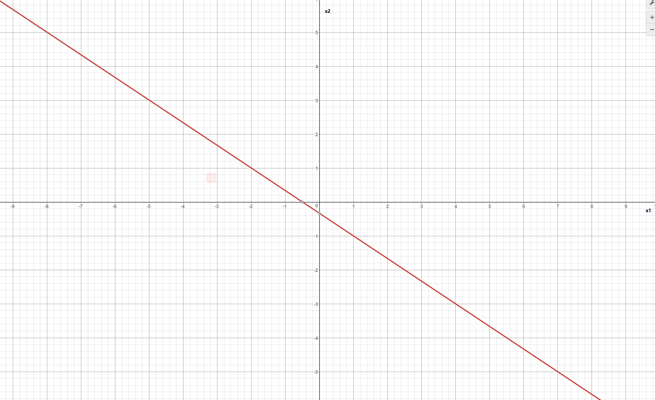
3. The blue line is f and the orange line is g.
4. 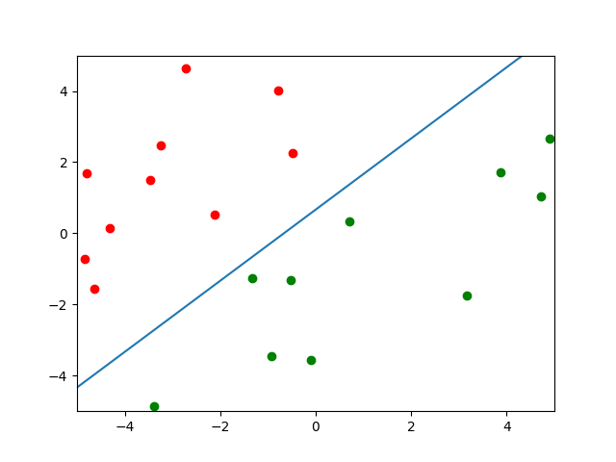
5. 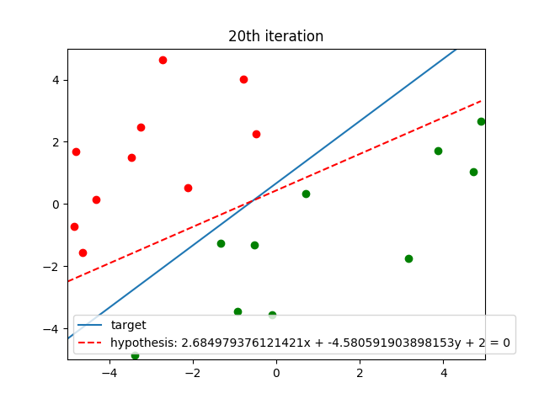

f is not close to g at this time

1. 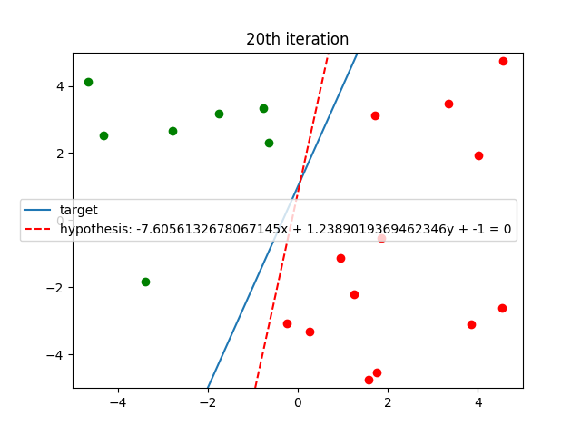

This time, the PLA takes much more iterations than last time, and f is close to g.

1. 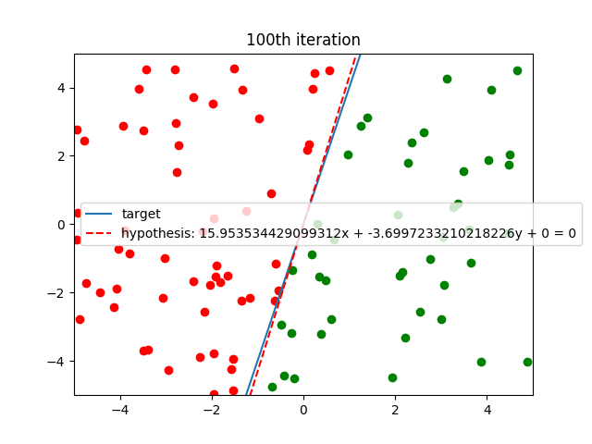

When there are 100 points, f is much close to g.

1. 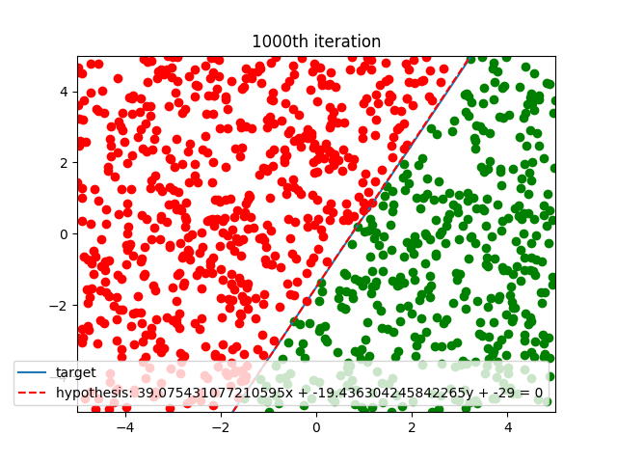

When there are 1000 points, f is much more close to g.