Project 3 – Rock, Paper, Scissors v2.0
( Documentation 30 points, Implementation 30 points, Testing 30 points, Peer Review 10 points )

Motivation
This assignment aims to help you practice the following concepts,

- Inheritance | - Subclasses
- Encapsulation | - Interfaces
- Polymorphism | - Abstract classes
- Abstraction | - UML diagrams

Project Description
Task 1.

For this task you need to upgrade the functionality of your Rock-Paper-Scissors game. After reading the slide package 5_4, add the methods hashCode(), equals(), and toString() and their test cases in all the classes in the game, World, Point, Rock, Paper, Scissors. The hashCode() for the Rock, Paper, and Scissors classes should not use the hash() method from the Objects class.

Task 2.

For this task you need to implement four different versions of the Rock-Paper-Scissors game from Project 2. Each version should use a different type of abstraction to improve encapsulation, and decoupling of your classes, and reduce code repetition.

Version 1: Subclasses
Version 2: Interfaces
Version 3: Abstract classes
Version 4: A combination of all the above to create the best version of the game possible.

Make four different copies of your game codebase. Name these copies,

Rock_Paper_Scissors_subclass_version
Rock_Paper_Scissors_interface_version
Rock_Paper_Scissors_abstract_version
Rock_Paper_Scissors_ultimate_version

Complete the first three versions by using only the specific type of abstraction to share and abstract functionality between the Main, World and the Rock, Paper, and Scissors classes.

In each version, you need to make the appropriate choices improving encapsulation, decoupling, and reducing code repetition.
To do that, you need to replace all class-specific references in the Main and World classes with calls to the new abstraction.

For example, if the game calls each class’s move method like below,

for ( int i = 0; i < myWorld.rows; i++) {
for( int j = 0; j < world.colms; j++ ) {
if ( map[i][j] instanceof Rock ) { map[i][j].moveRock( myWorld );
} else if ( map[i][j] instanceof Paper ) { map[i][j].move Paper( myWorld );
} else ( map[i][j] instanceof Scissors ) { map[i][j].move Scissors( myWorld ); }

after you introduce the new abstraction, let’s call it Entity, the above code should look like the one below,

for ( int i = 0; i < world.rows; i++) {
for( int j = 0; j < world.colms; j++ ) {
if ( map[i][j] != null ) { map[i][j].moveEntity(); }

One way to figure out whether the concrete classes Rock, Paper, and Scissors are used in the Main or World classes is to change the name of the Rock/Paper/Scissors class and see where errors occur. If there are still errors in your World or Main classes, your code is still too coupled. Error should only occur in the abstraction that is added into the project.

For the last copy, collect the best features from all the previous versions and come up with the best version of the game by combining all the concepts.

Task 3.

After reading the slide packages 5_6, create the UML diagrams for the four versions of your project. The diagrams should be drawn using a drawing software like those mentioned on the slides. See below for what is considered a good UML diagram.

Best UML diagram. 15 points Ok-ish UML diagram. 10 points Nop, don’t do it. 0 points

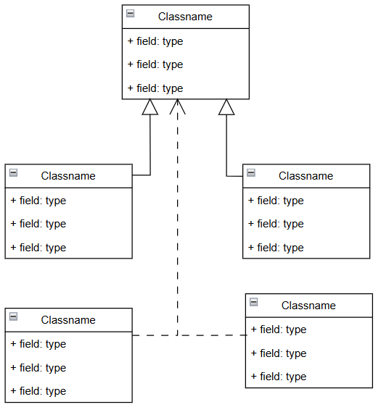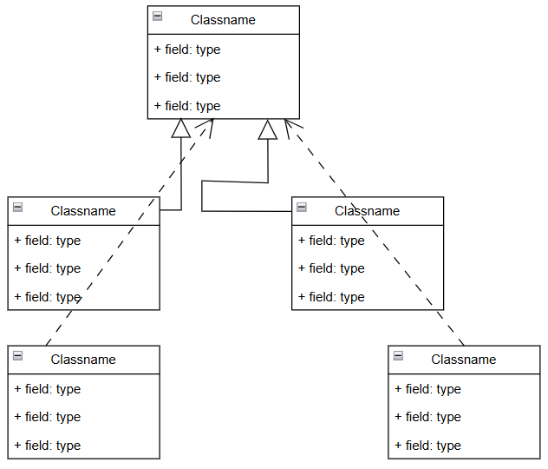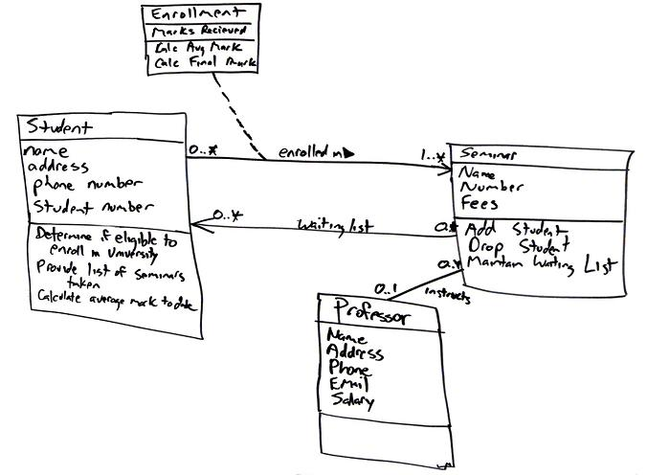

Notes:

For this project you are only allowed to use concepts that you learn in the class or are in the slides up to this point. Any concept included in the project that is not included in the lecture slides will cause a zero grade for the project. The reason for this is because the project is focused on practicing the concepts taught in the course. This will help you build the foundation you need for following courses. If you need any help, ask your instructor/TA. It’s their job to guide you through the material to figure out the solution.

Extra Credit:

You need to have at least 95% of your grade to be eligible for extra credit.

10 Points: Add different colors to your game for the map and the characters.
15 Points: Output your map on the RPS_GUI.
20 Points: Modify the RPS_GUI to be the interface of your game.

Submission

After you finish your project, complete the team evaluation for all the team members in your team, and the project evaluation from the project you received. Add the evaluations in your project folder and then compress your folder and submit your compressed folder on CANVAS.

