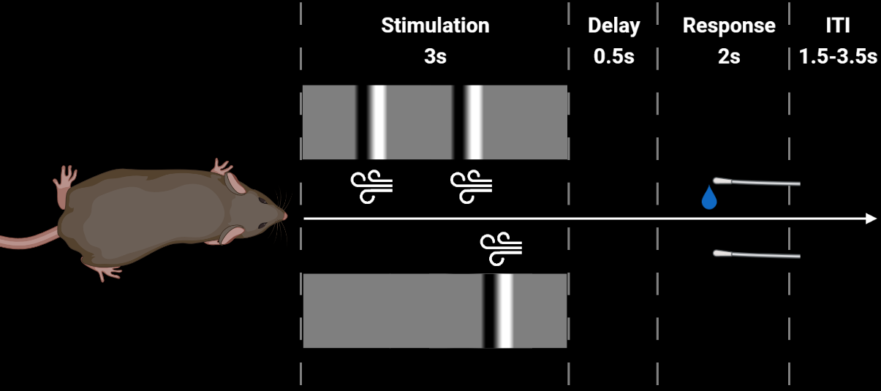

**Trial Parameters:**

**target_side_left**: The side where the target stimulus is presented [0: right, 1: left]

**modality**: The modality condition that was presented; [0: visual only, 1: tactile only, 2: visual+tactile]

**Response_left**: The Answer of the animal; [-1: no-response, 0: right, 1: left]

**auto_reward**: If the reward was automatically delivered [0: normal trial, 1: auto-rewarded]

**both_spouts**: If both water-spouts were presented [0: only target spout moved in, 1: normal trial]

**enable_reward**: If a reward is enabled [0: disabled, 1: normal trial]

**cues_left_visual, cues_left_tactile, cues_right_visual, cues_right_tactile**:

Each an Array of 6 element indicating the presents of a stimulus cue: [0, 1, 0, 0, 1, 1]

For tactile -> [None, 500ms, None, None, 2000ms, 2500ms]

For visual: portions of the texture moving over the monitor

**response_delay**: The duration of the delay period in ms. Usually 500ms

Not relevant for us now:

**valve_left_duration**, **valve_right_duration**: Durations in us for the valves

**Digital signals:**

DI:

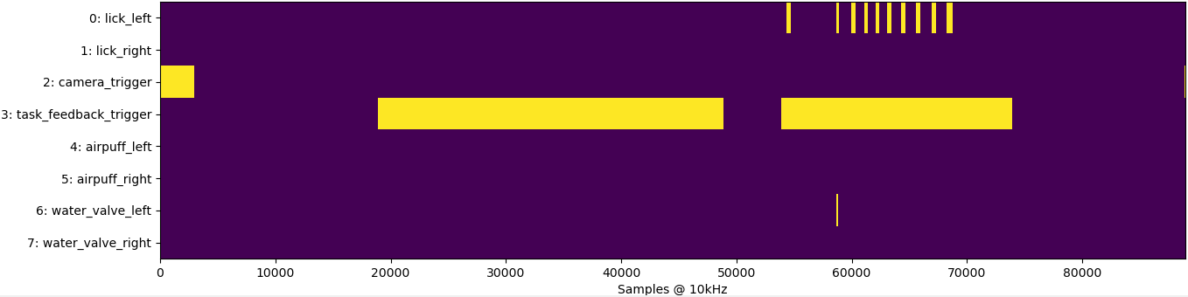

Camera_trigger: when rising-edge is detected the next recorded camera frame is assigned to the next trial. Represented in ‘frameCnt’ in ‘Vc.mat’

Task_feedback: consists of two signals, the first: stimulus period 3sec, the second reward-periode 2sec

photodiode: Indicates when precisely the monitor displayed the stimulus frames; sampled according to

‘n_DI_samples_since_last_wheel_update’

Wheel: wheel-position; sampled according to ‘n_DI_samples_since_last_wheel_update’

n_DI_samples_since_last_wheel_update: number of 10kHz samples since last update of the photodiode and wheel

example:

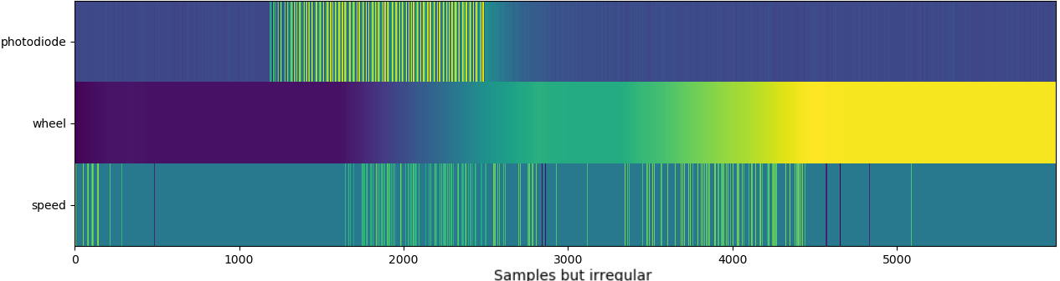

Speed can be derived as:

np.diff(np.array(wheel)) / np.array(n_DI_samples_since_last_wheel_update)[1:]

* should be binned over longer time periods to be informative

**Settings of the software:**

Not relevant for us now:

visual_trial_probability

both_spouts_probability

discrimination_probability

target_cue_probability_tactile

target_cue_probability_visual

distractor_cue_probability_tactile

distractor_cue_probability_visual

max_modality_imbalance_factor

reward_probability