**Report of the homework**

Student RS: Damindarov Ruslan Date: 26.09.2020

Language: Mathlab

Robot: AR-601 leg

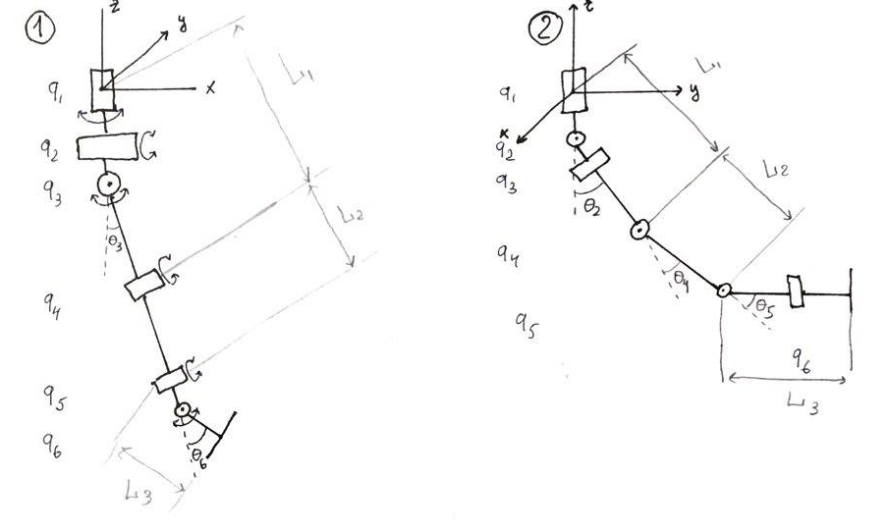

Pic 1. Kinematic scheme of robot

**Robot description**

This is part of robot-humanoid AR-601 – leg. This leg has 3 links and 6 joints. 3 joints united in one spherical hip.

**Forward kinematic**

For solve this task was used Mathlab. I create matrices translation and rotation for every links and joints, where on the picture 1:

q1 – rotates around axis z

q2 – rotates around axis y

q3 – rotates around axis x

q4 – rotates around axis x

q5 – rotates around axis y

q6 – rotates around axis x

L1 – translation along the axis z

L2 – translation along the axis z

L3 – translation along the axis z

H = RzQ1*RyQ2*RxQ3*TzL1*RxQ4*TzL2*RyQ5*RxQ6*TzL3

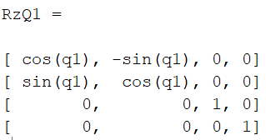 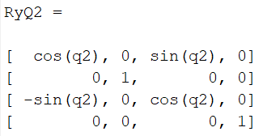

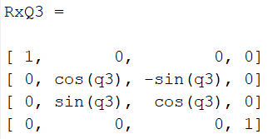 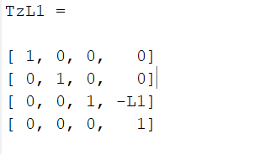

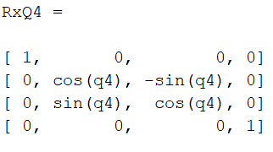 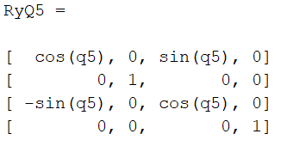

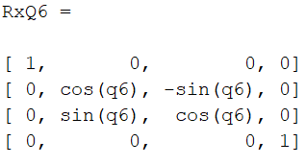 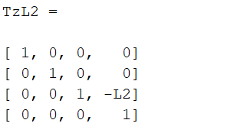

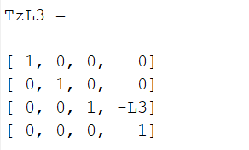

Pic 2. Matrices of rotation and translation

These final formulas for coordinate in forward kinematic:

**X** = - L1*(sin(q1)*sin(q3) + cos(q1)*cos(q3)*sin(q2)) - L2*(cos(q4)*(sin(q1)*sin(q3) + cos(q1)*cos(q3)*sin(q2)) + sin(q4)*(cos(q3)*sin(q1) - cos(q1)*sin(q2)*sin(q3))) - L3*(sin(q6)*(cos(q4)*(cos(q3)*sin(q1) - cos(q1)*sin(q2)*sin(q3)) - sin(q4)*(sin(q1)*sin(q3) + cos(q1)*cos(q3)*sin(q2))) + cos(q6)*(cos(q5)*(cos(q4)*(sin(q1)*sin(q3) + cos(q1)*cos(q3)*sin(q2)) + sin(q4)*(cos(q3)*sin(q1) - cos(q1)*sin(q2)*sin(q3))) + cos(q1)*cos(q2)*sin(q5)))

**Y** = L1*(cos(q1)*sin(q3) - cos(q3)*sin(q1)*sin(q2)) + L2*(cos(q4)*(cos(q1)*sin(q3) - cos(q3)*sin(q1)*sin(q2)) + sin(q4)*(cos(q1)*cos(q3) + sin(q1)*sin(q2)*sin(q3))) + L3*(sin(q6)*(cos(q4)*(cos(q1)*cos(q3) + sin(q1)*sin(q2)*sin(q3)) - sin(q4)*(cos(q1)*sin(q3) - cos(q3)*sin(q1)*sin(q2))) + cos(q6)*(cos(q5)*(cos(q4)*(cos(q1)*sin(q3) - cos(q3)*sin(q1)*sin(q2)) + sin(q4)*(cos(q1)*cos(q3) + sin(q1)*sin(q2)*sin(q3))) - cos(q2)*sin(q1)*sin(q5)))

**Z** = L3*(cos(q6) *(sin(q2) *sin(q5) - cos(q5) *(cos(q2)*cos(q3)*cos(q4) - cos(q2)*sin(q3)*sin(q4))) + sin(q6)*(cos(q2)*cos(q3)*sin(q4) + cos(q2)*cos(q4)*sin(q3))) - L2*(cos(q2)*cos(q3)*cos(q4) - cos(q2)*sin(q3)*sin(q4)) - L1*cos(q2)*cos(q3)

I tried check me solve and enter all length of my 10, and enter all angels equal 0, that’s mean that leg of my robot will be stretched along the z-axis and z = -10; 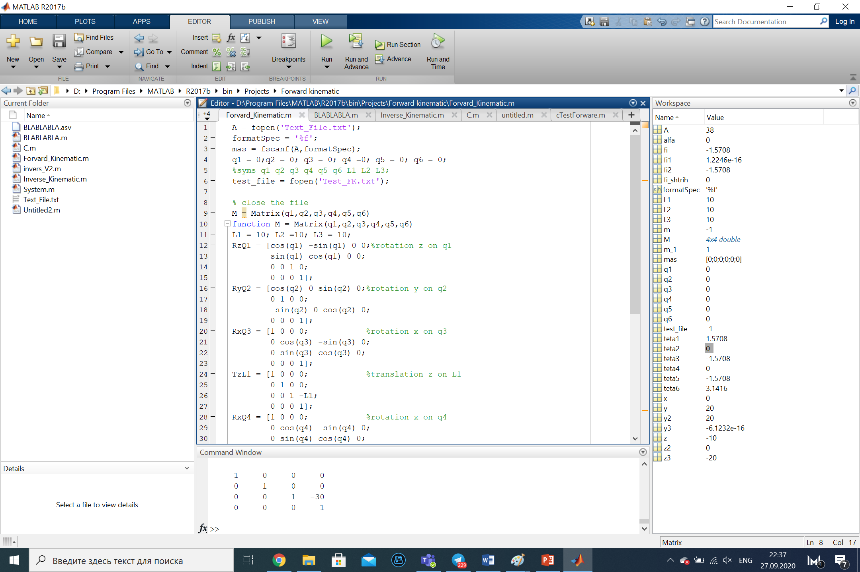

It was checked for y an z.

**Inverse kinematic**

For solve this problem I draw some pictures from different sides of my robot:

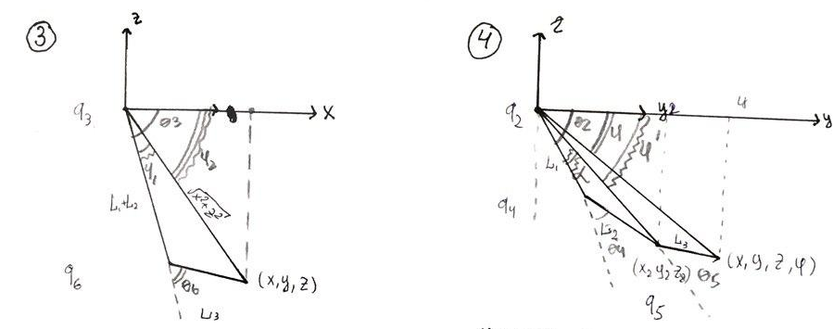

Pic 3. Active joints from different sides

We start derivation of equation for left picture on picture 3:

1. Find angle θ6, using law of cosines formula 1, where x and z this coordinates end-effector, L1, L2, L3 – length of links. Result – formula 2.

 (1)

(2)

2) After that let’s express the angle θ3 = m*φ1 + φ2. We find this using atan, because this allows you to consider extreme solutions. Find cos φ1  and sin φ1 form law of cosines and sinus:

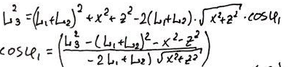 (3)

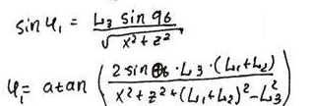(4)

For find φ2  we use atan too and this is formula 5:

(5)

Result equation is formula 6:

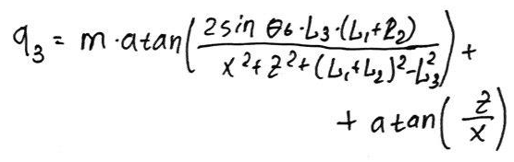 (6)

Where m:

(7)

For find the rest of assignment, I used second part of pic 3 and first of all express points y2 and x2. Formula 9:

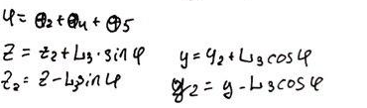(9)

After that from law of cosines I find angle θ4, formula 10:

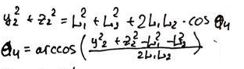(10)

And after, like in previous example we find α angle with using atan. Find cos φ1  and sin φ1 from law of cosines and sinus:

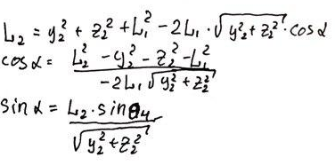(11)

And using pic 4 part 2 we can take a formula for full angle θ2:

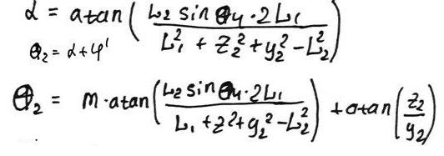(12)

That was cheeked, I wrote x = 0, y = 0, z = -30 and angles it give –pi/2 and pi/2, that’s true because when I derived equations for IK, angles were reported from the x-axes, and y-axes. 1.57 = pi/2/

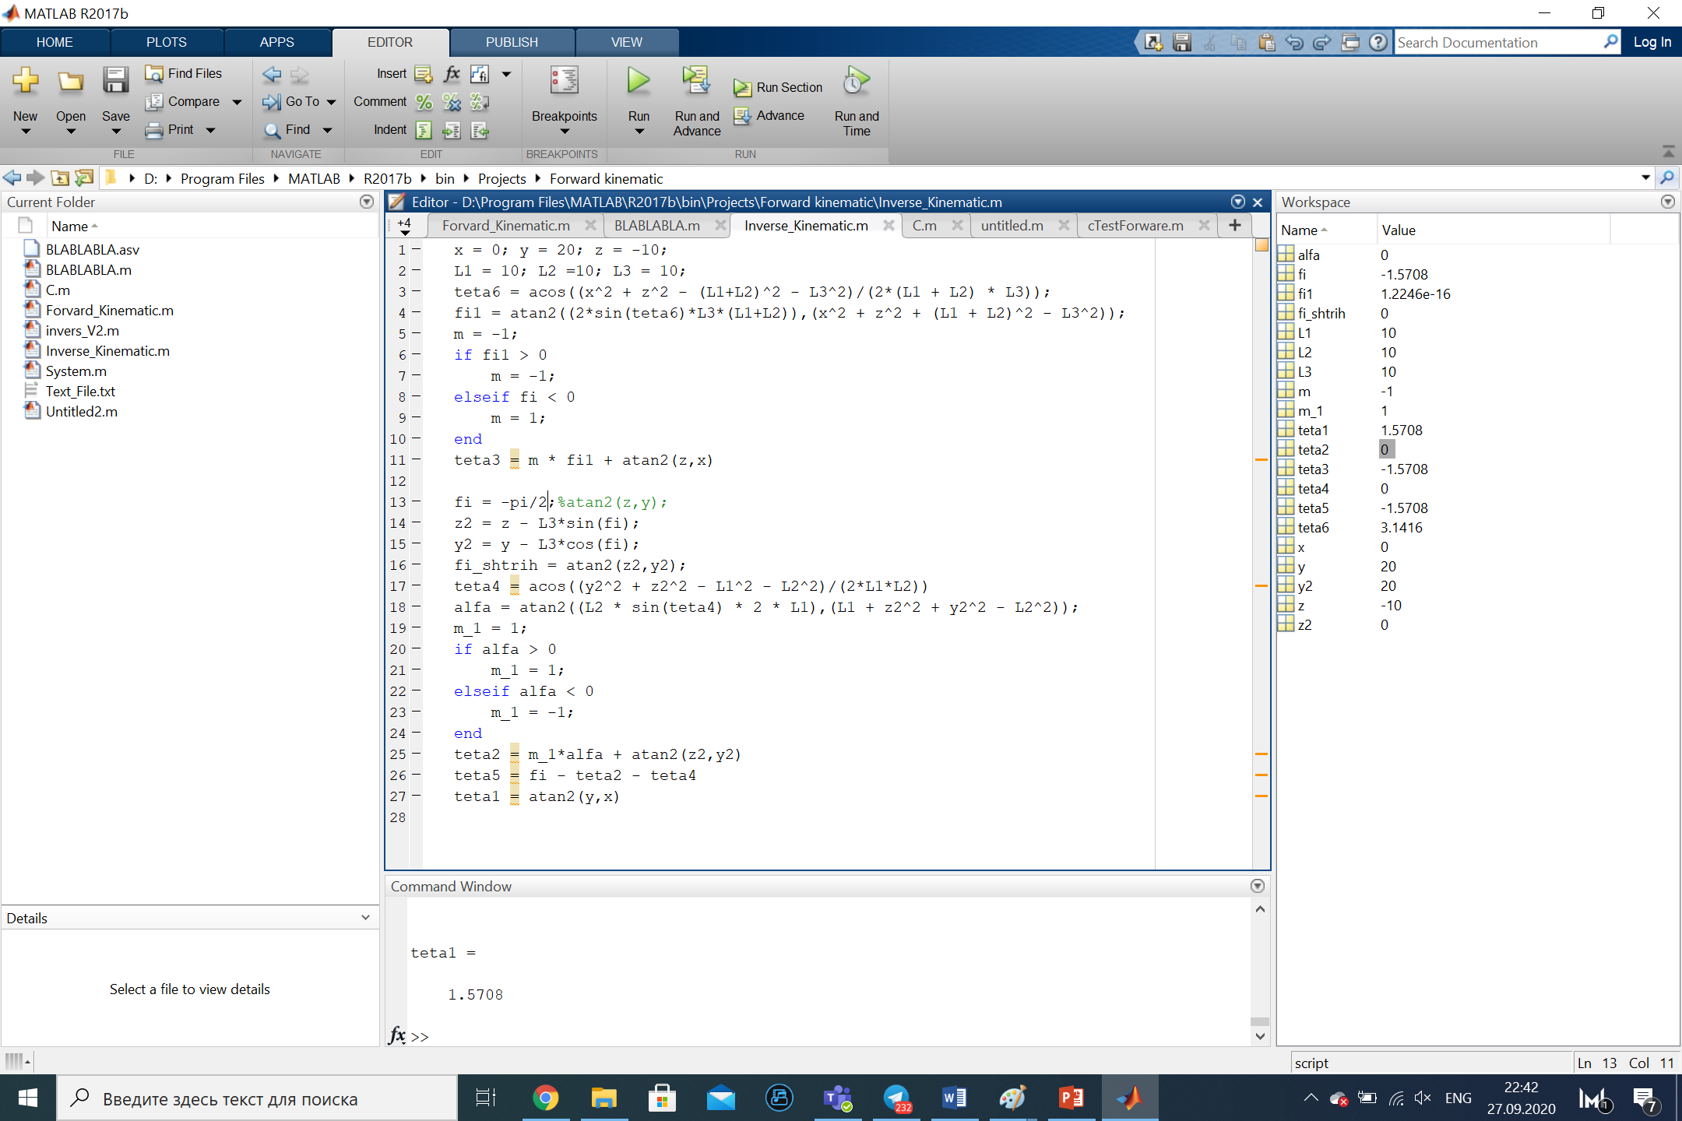

And finally for check, I tried derived equation for IK again

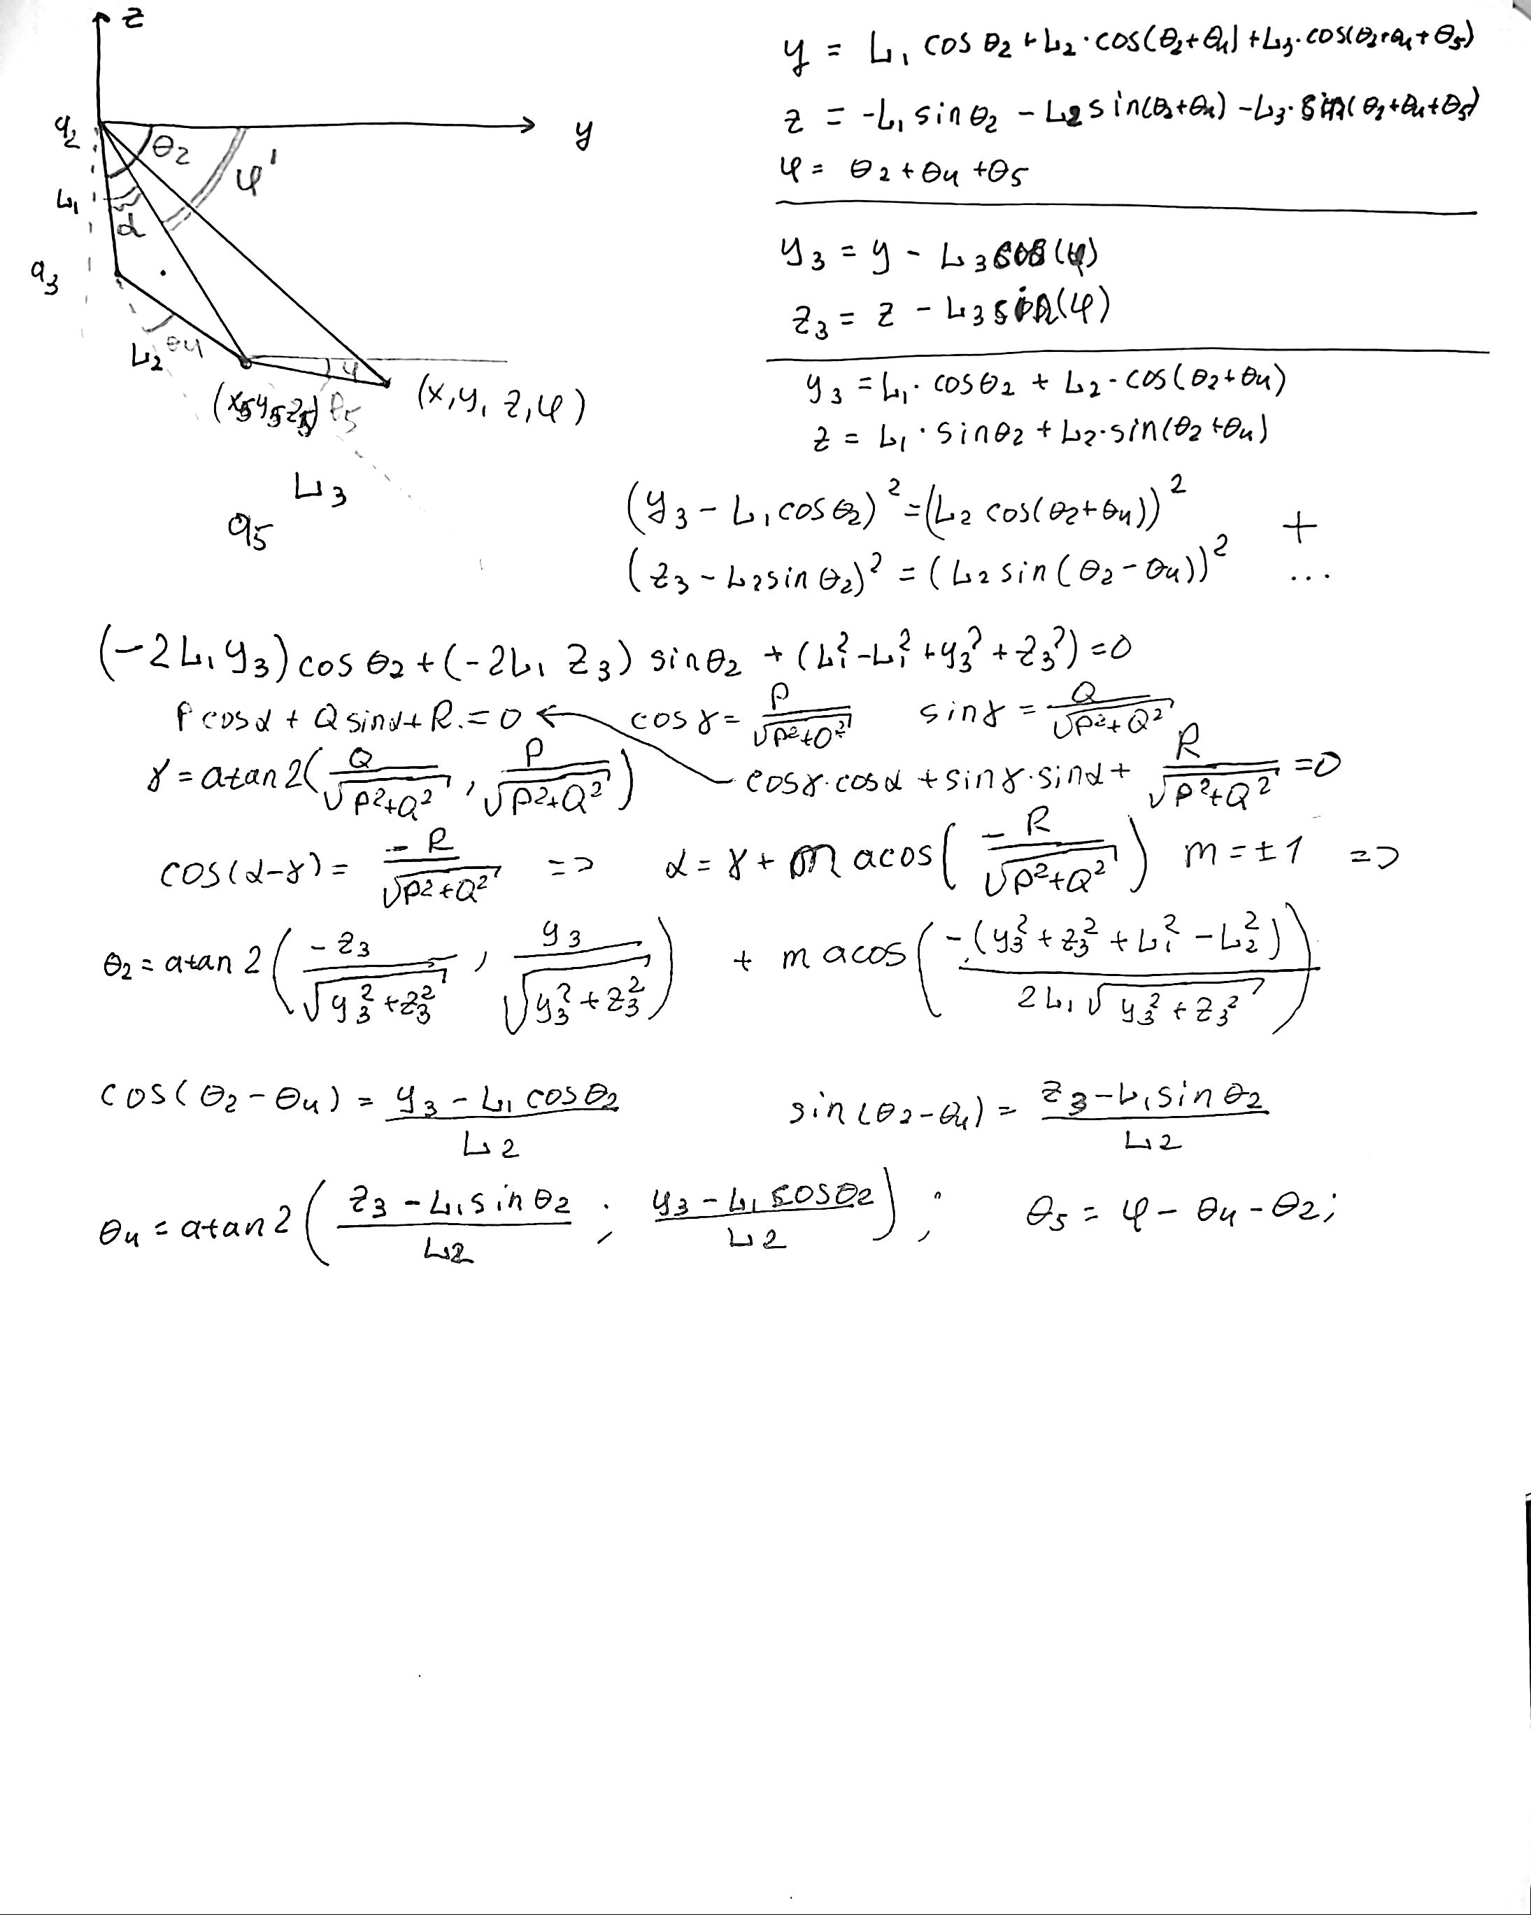

And

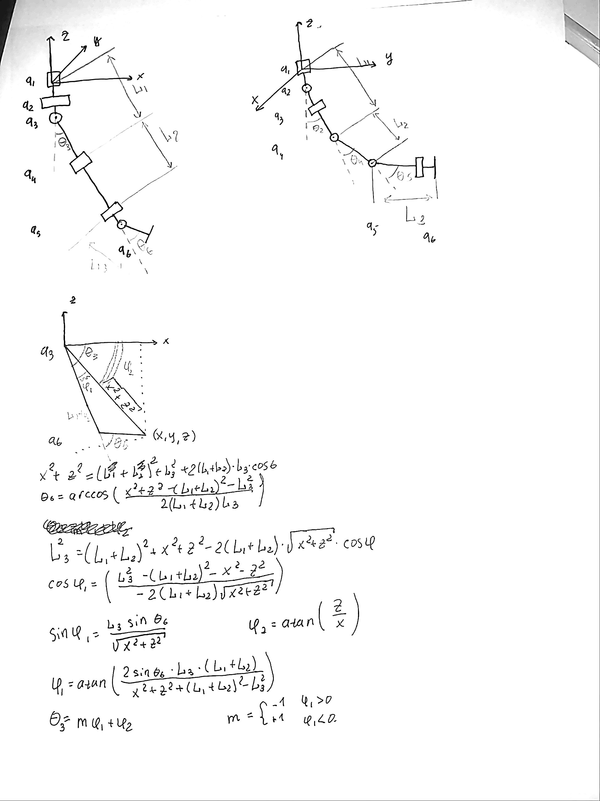

This calculation gave me following result:

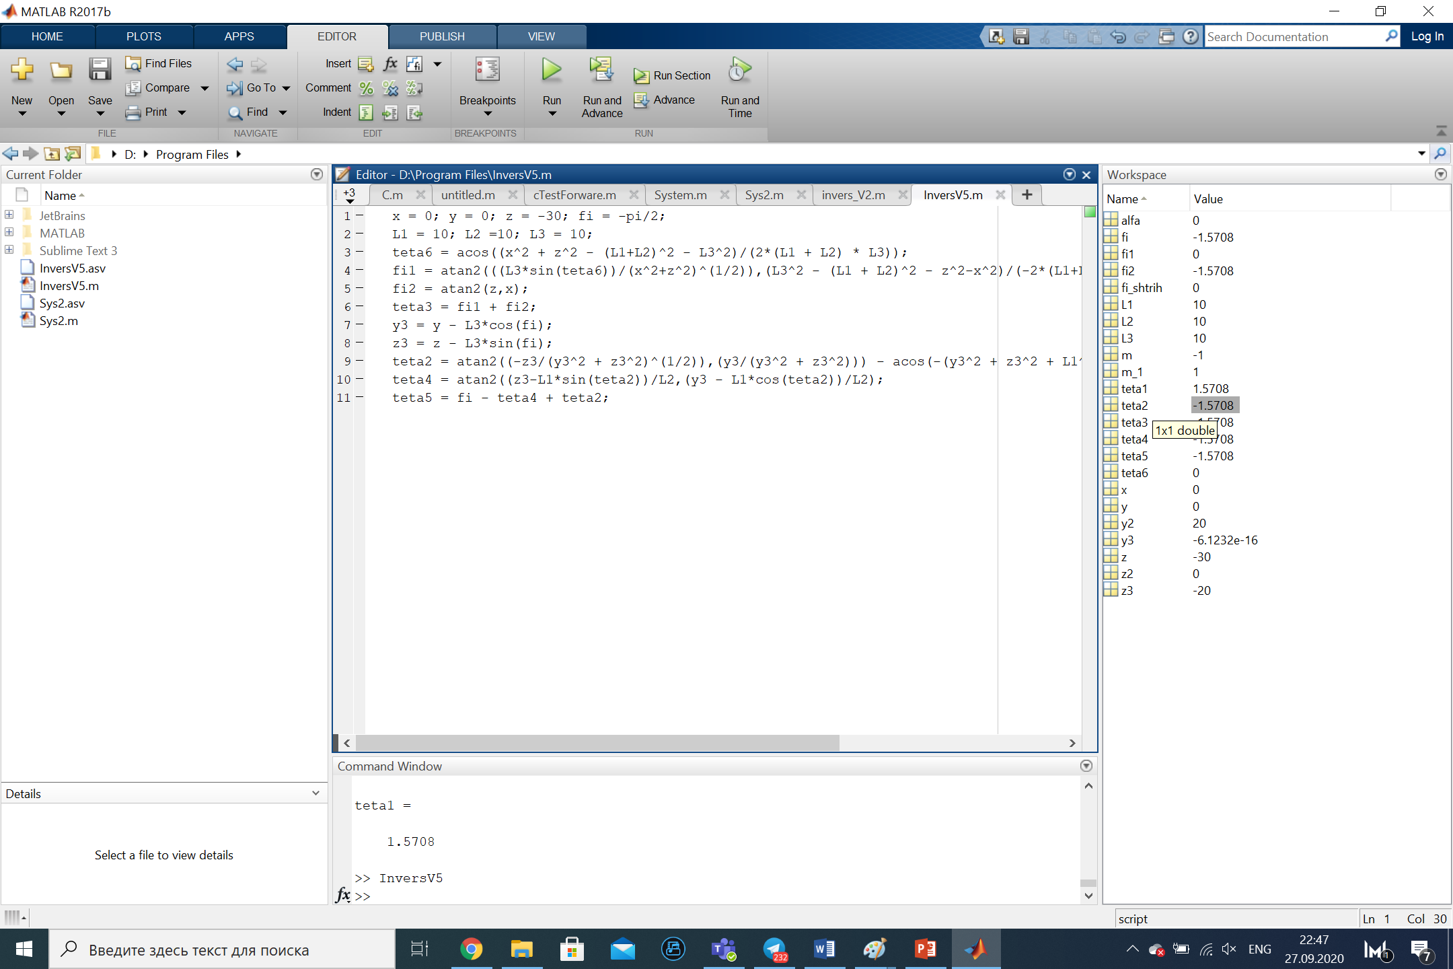

I tried check all equation in extremely position and we take length all link = 10(for simplify check). This position for example when leg bent a knee: z = -10, x = 20.