Report of the homework 2

Student RS: Damindarov Ruslan Date: 08.10.2020

Language: MathLab

GitHub link: https://github.com/Damindarov/HW3

Task 1: Forward kinematic
In this task we need solve case forward kinematic, for this I directed the robot around the x axis for correct count angle teta1. Set length D1 = 10 and A2 = 15. For angle teta1 = 0; teta2 = -pi; and distance last joint d3 = 5; answer is correct and shown in the picture 1.
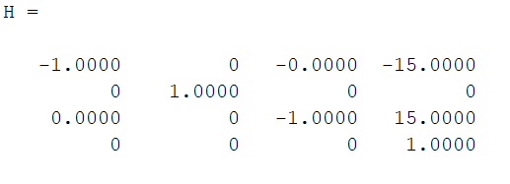
Pic 1. Result of solving forward kinematic

Task 2: Inverse Kinematic
In this task we need solve case forward kinematic, for this I directed the robot around the x axis for correct count angle teta1. Set length D1 = 10 and A2 = 15 and find teta1, teta2 and d3 from equation. Two solves because teta1 and teta2 we can move in two ways to position to one point, shown in picture 2. For check correctness I use forward kinematic.
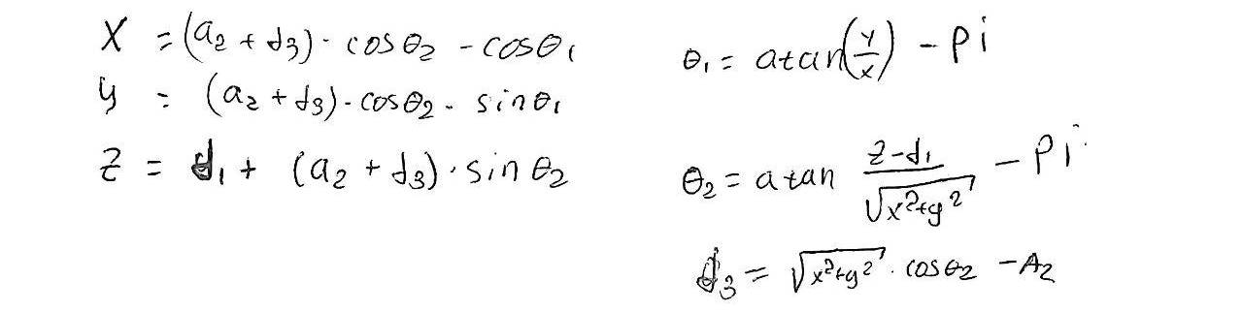
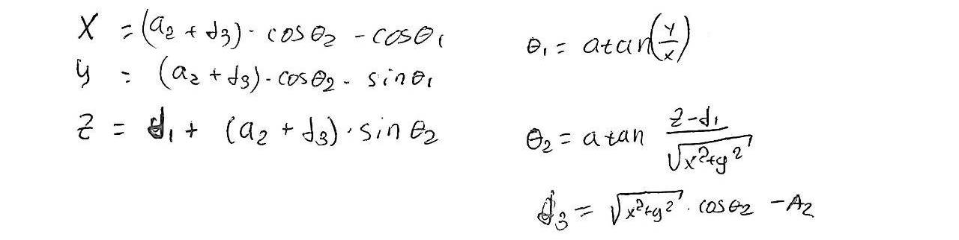
Pic 2. Result of solving inverse kinematic
Task3: Inverse Kinematic
In this task we need compute Jacobeans, using three different ways, for check correctness me solves I subtracted the Jacobians from different solutions and got a zero matrix. Check Test_Jacobians.m

Task 4: Analyze the Jacobian for singularities. Characterize each singular configuration if any.
In this task we need find singularity, I tried three different ways. Firs its manually, I think that we have two singularities here, first it’s when teta2 = pi/2 and we losing one DOF, when the robot is pulled. Second where robot is twisted into itself, when teta2 = -pi/2 and a2 + d3 = d1.
Second way, I tried use cond function for find condition number of inversion and create plot of this values in Cartesian space pic 3.
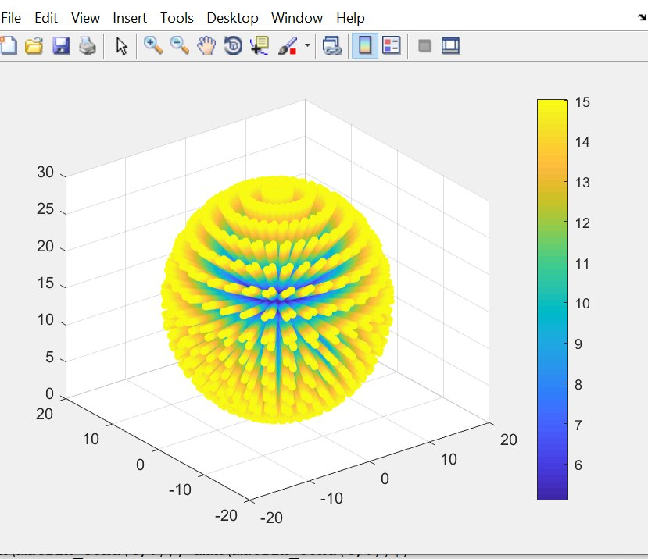
Pic 3. Result work cond in Cartesian space, value of cond – color.
And for check, what we have in sender of this pseudosphere, I limited angle teta2 pic 4:
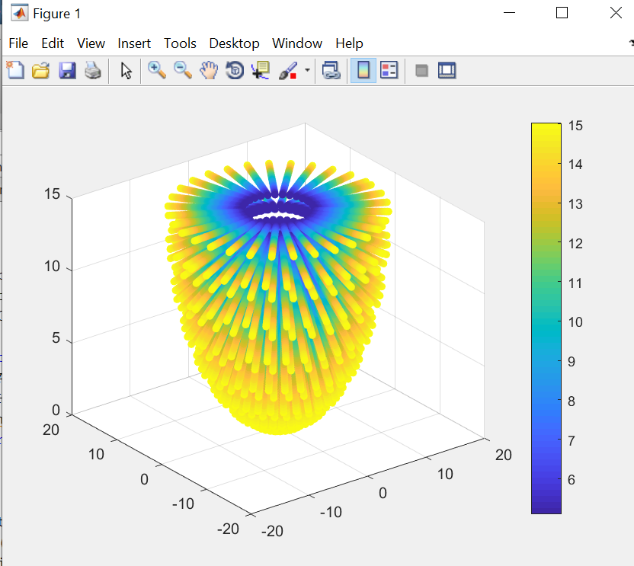
Pic 4. Result work cond in Cartesian space, value of cond – color.
And third way was using SVD. This way can help me find singular value decomposition and using matrix of singular values or more precisely only diagonal elements. When this element is state around zero, that mean that for this value of angles joints is find singularity. I tried find this using Mathlab and nested loops (SVD_Test.m), but this program didn’t return me singularity. It’s This may mean that there are no singularities, but this is not obvious.

Task 5: Compute the velocity of the tool frame when joint variables are changing
with time as follows: θ1 (t) = sin (t), θ2 (t) = cos (2t), d3 (t) = sin (3t).
In this task I use while loop and on every step of my loop I compute Jacobian and array q_dot, where I get derivative from all teta’s and keep time in separately array. After that I find array of my speed’s and omega’s multiplying Jacobian and array derivative. After that I create plot. Payment step 0.001 sec. I compute velocity for 15 seconds, picture 3:
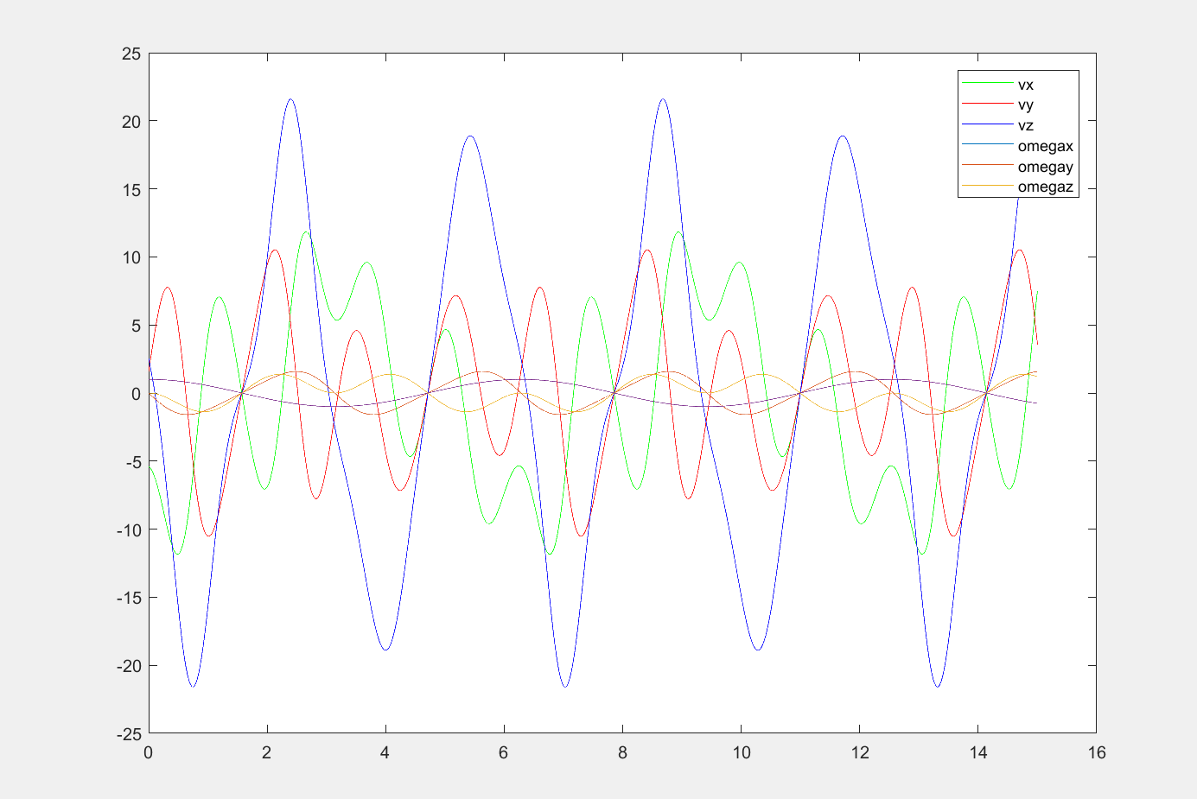
Pic 5. Result of finding velocities and omega’s.

