UNIFIED MENTORSHIP INTERNSHIP PROGRAM
PROJECT REPORT
Duration : 3 Month
Batch : 25th May 2026
UAC CARE TRANSITION EFFICIENCY &
PLACEMENT OUTCOME ANALYTics

A Process Efficiency and Outcome Evaluation Framework for the U.S. Department of Health and Human Services (HHS)

Submitted By :
Damini Suryavanshi
Bachelor of Computer Applications (BCA)
Specialization in Artificial Intelligence

ACKNOWLEDGEMENT
I would like to express my sincere gratitude to the Unified Mentorship Program for providing me with the opportunity to work on this project, "UAC Care Transition Efficiency & Placement Outcome Analytics."
This project enabled me to apply data analytics, visualization, and predictive modeling techniques to a real-world operational problem. Through this work, I gained valuable experience in data preprocessing, KPI development, dashboard creation, anomaly detection, forecasting, and analytical reporting.
I would also like to thank the mentors and coordinators of the program for their guidance, support, and continuous encouragement throughout the internship. Their insights helped me better understand how data-driven solutions can support operational decision-making and policy improvements.
Finally, I would like to acknowledge the resources, tools, and datasets that made this project possible and contributed significantly to my learning experience.
Damini Suryavanshi

ABSTRACT
This project analyzes operational efficiency within the Unaccompanied Alien Children (UAC) care transition pipeline managed by the U.S. Department of Health and Human Services (HHS). The study focuses on evaluating how effectively children move through multiple operational stages, including apprehension, CBP custody, transfer to HHS care, and sponsor reunification.
Traditional monitoring systems primarily focus on aggregate custody counts and occupancy statistics. However, such metrics provide limited visibility into process efficiency, transition delays, placement outcomes, and operational bottlenecks. This project introduces a data-driven analytical framework to evaluate the performance of the care transition process using key operational indicators.
Several performance metrics were developed, including Transfer Efficiency Ratio, Discharge Effectiveness Index, Pipeline Throughput Rate, Backlog Accumulation Rate, and Outcome Stability Score. Additional analytical techniques such as anomaly detection, trend analysis, backlog monitoring, and predictive forecasting were implemented to identify operational risks and future performance patterns.
An interactive Streamlit dashboard was developed to support real-time monitoring and decision-making. The findings provide actionable insights that can help improve reunification timelines, reduce operational delays, optimize resource allocation, and support policy-level reforms within the UAC care system.

TABLE OF CONTENTS

Sr. No. | Section | Page No.
1 | Introduction | 4
2 | Problem Statement | 5
3 | Project Objectives | 6
4 | Dataset Description | 7
5 | Methodology | 8
6 | KPI Definitions | 10
7 | Exploratory Data Analysis (EDA) | 12
8 | Dashboard Development | 15
9 | Key Findings & Insights | 16
10 | Recommendations | 18
11 | Conclusion | 19
12 | References | 20

- INTRODUCTION

The Unaccompanied Alien Children (UAC) Program operates as a multi-stage care and reunification pipeline designed to provide temporary care, protection, and sponsor placement for children entering the United States without a legal guardian. The system involves multiple operational stages, including apprehension by Customs and Border Protection (CBP), temporary custody management, transfer into the Department of Health and Human Services (HHS) care system, medical screening, case management, and eventual reunification with a vetted sponsor.
The effectiveness of this process is not determined solely by the number of children in custody but also by how efficiently children move through each stage of the care pipeline. Delays in transfers, prolonged stays in custody, and placement bottlenecks can increase operational pressure on agencies and negatively impact child welfare outcomes.
Traditional reporting mechanisms primarily focus on aggregate counts and occupancy statistics. While these metrics provide visibility into system capacity, they offer limited insight into operational efficiency, process bottlenecks, and placement performance.
This project introduces a process-oriented analytical framework that evaluates care transition efficiency, placement outcomes, backlog accumulation, and operational stability. Through KPI-driven analysis, anomaly detection, trend monitoring, and forecasting, the project aims to provide actionable insights that support operational improvements and policy-level decision-making.

- PROBLEM STATEMENT

Although aggregate counts of children in custody are regularly monitored, structured process efficiency metrics are largely absent from existing reporting systems. As a result, several critical operational questions remain difficult to answer.
Key challenges include determining how efficiently children are transferred from CBP custody to HHS care, whether sponsor placement discharges are keeping pace with incoming case volumes, identifying periods of backlog accumulation, and evaluating the consistency of placement outcomes over time.
Without a comprehensive process monitoring framework, operational bottlenecks may remain hidden, reducing the ability of agencies to improve reunification timelines, optimize resource allocation, and strengthen child welfare outcomes.
This project addresses these challenges by developing a data-driven analytics framework that measures transition efficiency, placement effectiveness, backlog trends, operational risks, and future performance patterns.

3. PROJECT OBJECTIVES

Primary Objectives
• Measure the efficiency of transitions from CBP custody to HHS care.
• Evaluate discharge performance and sponsor placement outcomes.
• Identify operational delays and process bottlenecks.
• Analyze care pipeline throughput and overall system movement.
• Monitor backlog accumulation across the care transition process.
Secondary Objectives
• Support faster and more effective reunification processes.
• Improve visibility into case management workflows.
• Enable proactive operational monitoring through dashboard analytics.
• Support policy-level decision-making through data-driven insights.
• Develop predictive forecasting capabilities for future operational planning.

4. DATASET DESCRIPTION

The dataset contains daily operational records associated with the UAC care transition pipeline. Each record represents a reporting date and captures movement of children through various stages of the system, from apprehension and custody to care management and sponsor placement.

Column Name | Description
Date | Reporting date
Children apprehended and placed in CBP custody | Daily intake volume
Children in CBP custody | Active CBP custody load
Children transferred out of CBP custody | Movement from CBP to HHS
Children in HHS Care | Active HHS care population
Children discharged from HHS Care | Successful sponsor placements

5. METHODOLOGY

The project follows a structured analytical framework designed to evaluate operational efficiency within the UAC care transition pipeline. The methodology combines data preprocessing, KPI engineering, trend analysis, anomaly detection, backlog monitoring, and predictive forecasting.
The analytical workflow consists of the following stages:

- Data Collection and Preparation
The raw dataset was cleaned, standardized, and transformed into a structured analytical format. Missing records were removed, date fields were converted into time-series format, and numerical columns were standardized for analysis.
- Care Pipeline Modeling
The operational process was represented as a multi-stage care pipeline consisting of:
CBP Custody → HHS Care → Sponsor Placement
This framework enabled the tracking of child movement across each stage of the system.
- KPI Engineering
Several operational performance indicators were developed to measure transfer efficiency, discharge effectiveness, throughput performance, backlog severity, and outcome stability.
- Exploratory Data Analysis (EDA)
Descriptive analysis and visualization techniques were applied to identify trends, seasonal patterns, fluctuations, and operational behaviors within the care pipeline.

- Bottleneck Detection
Backlog accumulation and net flow metrics were analyzed to identify periods where inflows exceeded successful exits, indicating potential operational bottlenecks.
- AnomalycDetection
Z-score based statistical analysis was used to identify unusual operational days with exceptionally high or low transfer efficiency values.
- Forecasting
The Prophet forecasting model was implemented to estimate future transfer efficiency trends and support proactive operational planning.
- Dashboard Development
A Streamlit-based interactive dashboard was developed to provide real-time monitoring, KPI tracking, anomaly detection, and executive-level operational insights.

6. KPI DEFINITIONS

To evaluate the effectiveness of the care transition process, multiple Key Performance Indicators (KPIs) were developed. These indicators provide quantitative measures of operational efficiency, placement performance, and system stability.

6.1 Transfer Efficiency Ratio
Transfer Efficiency Ratio = CBP Transfers / CBP Custody
This metric measures how efficiently children are transferred from CBP custody into the HHS care system. Higher values indicate faster transition performance and reduced custody delays.
6.2 Discharge Effectiveness Index
Discharge Effectiveness = HHS Discharges / HHS Care Population
This metric evaluates the effectiveness of sponsor placement outcomes by measuring the proportion of children successfully discharged from HHS care.
6.3 Pipeline Throughput Rate
Pipeline Throughput = HHS Discharges / CBP Apprehensions
This KPI measures overall system movement by comparing successful exits with new entries into the care pipeline.
6.4 Backlog Accumulation Rate
Backlog Accumulation = CBP Apprehensions − HHS Discharges
This indicator identifies operational pressure within the system. Positive values suggest that incoming cases exceed successful placements, resulting in backlog growth.
6.5 Outcome Stability Score
Outcome Stability Score = Rolling Standard Deviation of Discharge Effectiveness
This metric measures consistency in placement performance over time. Lower variability indicates more stable and predictable operational outcomes.

7. EXPLORATORY DATA ANALYSIS
Exploratory Data Analysis (EDA) was performed to understand operational behavior, identify trends, detect bottlenecks, and evaluate the efficiency of the care transition pipeline. Multiple visualizations were created to examine transfer performance, discharge effectiveness.
7.1 Dashboard Overview
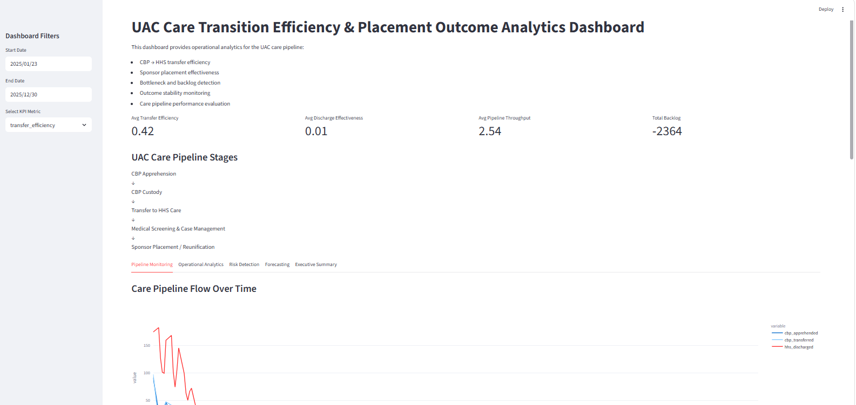The dashboard provides a consolidated operational view of the UAC care transition pipeline. Key Performance Indicators (KPIs) including Transfer Efficiency, Discharge Effectiveness, Pipeline Throughput, and Backlog Accumulation are presented to support real-time monitoring and decision-making.

7.2 Care Pipeline Flow Analysis
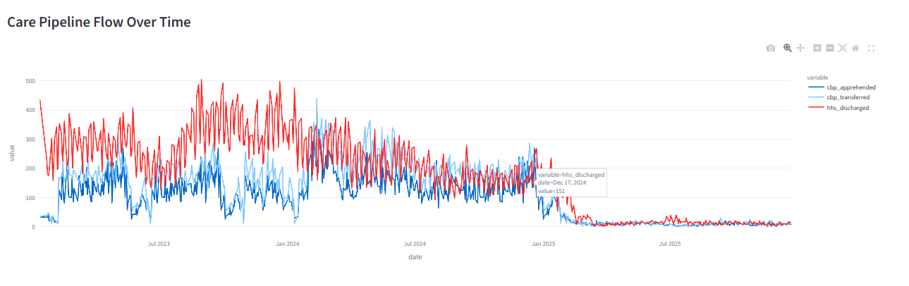
The care pipeline flow visualization tracks the movement of children through different operational stages, including CBP apprehension, transfer to HHS care, and successful sponsor placement. The analysis helps evaluate whether the system is effectively processing incoming cases and maintaining operational continuity.
7.3 Backlog Accumulation Analysis
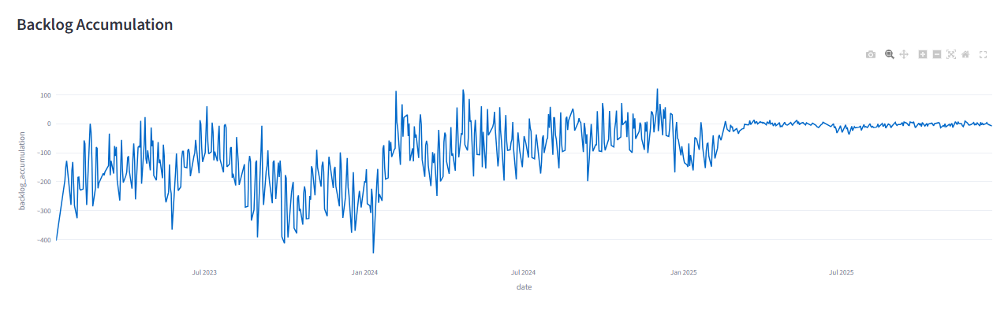
Backlog analysis was performed by comparing intake volumes with successful discharge outcomes. The visualization highlights periods where unresolved cases accumulated within the care pipeline, indicating potential operational bottlenecks and processing delays.
7.4 Anomaly Detection Analysis
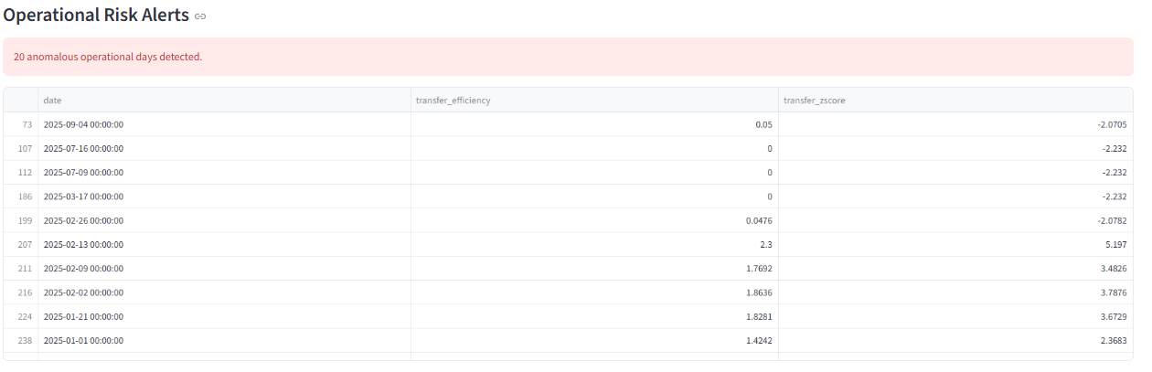
Statistical anomaly detection techniques were applied to identify unusual operational periods. Extreme transfer efficiency values were flagged and investigated as potential indicators of operational disruptions, reporting inconsistencies, or exceptional processing performance.
7.5 Forecasting Analysis
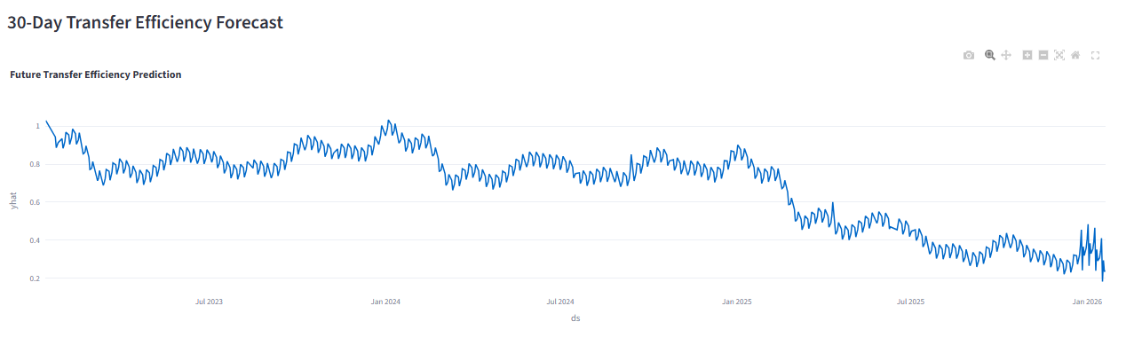
Time-series forecasting was implemented using the Prophet forecasting model to estimate future transfer efficiency trends. The forecast supports proactive planning by identifying potential future operational patterns and resource requirements.

8. DASHBOARD DEVELOPMENT

An interactive web-based analytics dashboard was developed using Streamlit to provide real-time visibility into the UAC care transition process. The dashboard integrates KPI monitoring, trend analysis, bottleneck detection, anomaly identification, and forecasting capabilities within a unified analytical environment.
Key dashboard features include:
• Date range filtering
• KPI selection controls
• Pipeline flow monitoring
• Backlog tracking
• Operational risk detection
• Predictive forecasting
• Executive-level summaries
The dashboard enables stakeholders to evaluate process efficiency, identify emerging risks, and support data-driven operational decisions.

- KEY FINDINGS & INSIGHTS

The analysis of the UAC care transition pipeline produced several important operational insights regarding transfer performance, placement effectiveness, and overall system behavior.
- Moderate Transfer Efficiency
The average Transfer Efficiency Ratio was approximately 0.69, indicating that a significant proportion of children in CBP custody were successfully transferred into HHS care. While the transition process demonstrated consistent movement, opportunities remain to further improve transfer speed and reduce temporary custody duration.
- Low Discharge Effectiveness
The average Discharge Effectiveness Index was approximately 0.02. This suggests that sponsor placement outcomes occurred at a slower rate relative to the active HHS care population. The result highlights the importance of improving placement workflows and reducing discharge delays.
- Strong Pipeline Movement
The average Pipeline Throughput Rate was approximately 2.50, indicating that overall system movement remained active throughout the observation period. This reflects the ability of the care pipeline to process incoming cases while maintaining operational continuity.
- Backlog Dynamics
Backlog analysis revealed significant differences between intake and discharge volumes across the study period. Continuous monitoring of backlog trends is necessary to identify emerging operational pressure and prevent delays in reunification outcomes.
- Operational Variability
Trend analysis showed fluctuations in transfer efficiency across different periods. These variations may be influenced by changes in case volume, operational capacity, staffing levels, or policy adjustments.
- Presence of Operational Anomalies
Anomaly detection identified several dates with unusually high or low transfer efficiency values. Such observations may represent exceptional operational events, reporting irregularities, or temporary process disruptions.
- Forecasting Insights
The forecasting model indicated continued fluctuations in future transfer efficiency levels. This highlights the importance of proactive monitoring and adaptive resource planning to maintain stable operational performance.

- RECOMMENDATIONS

Based on the analytical findings, several recommendations are proposed to improve care transition efficiency and placement outcomes.
- Strengthen Transfer Coordination
Improved coordination between CBP and HHS facilities can help reduce transfer delays and increase transition efficiency.
- Accelerate Sponsor Placement Workflows
Efforts should be made to streamline case review and sponsor verification procedures to improve discharge effectiveness and reduce waiting periods.
- Implement Real-Time Operational Monitoring
Continuous KPI tracking through dashboard analytics can provide early visibility into operational issues and emerging bottlenecks.
- Enhance Backlog Management
Dedicated monitoring of backlog accumulation should be implemented to prevent prolonged case retention and operational congestion.
- Expand Predictive Analytics
Forecasting models should be integrated into operational planning processes to support proactive decision-making and resource allocation.
- Investigate Operational Anomalies
Identified anomalies should be reviewed to determine whether they are caused by reporting issues, policy changes, or operational disruptions.

- CONCLUSION

This project successfully transformed the UAC dataset from a traditional capacity-monitoring perspective into a process-efficiency and outcome-evaluation framework. Through KPI development, exploratory data analysis, anomaly detection, backlog monitoring, and predictive forecasting, the project provided a comprehensive assessment of operational performance within the care transition pipeline.
The Streamlit dashboard enables real-time visibility into transfer efficiency, discharge effectiveness, throughput performance, backlog accumulation, and operational stability. The findings demonstrate the value of data-driven analytics in identifying bottlenecks, improving reunification timelines, and supporting evidence-based policy decisions.
Overall, the project highlights how operational intelligence and process analytics can strengthen child welfare outcomes while improving the efficiency and transparency of the UAC care transition system.

- REFERENCES

1. U.S. Department of Health and Human Services (HHS)

2. Unified Mentorship Internship Program Dataset

3. Python Documentation

4. Pandas Documentation

5. Streamlit Documentation

6. Plotly Documentation

7. Prophet Forecasting Documentation

