3. program to check wether the year is leap or not.

#include<stdio.h>
int main()
{
int year;
printf("program to check wether the year is leap or not\n");
printf("enter a year\n");
scanf("%d",&year);

if((year%4==0 && year%100!=0)||(year%400==0))
{
printf("the year is leap year\n");
}
else
{
printf("year is not a leap year\n");
}
return 0;
}
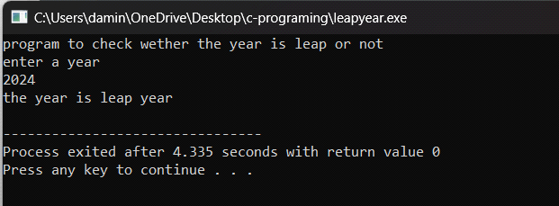

4. program to calculate sum of individual positive numbers.

#include<stdio.h>
int main()
{
int n,r,sum=0;
printf("progra to calculate sum of individual number\n");
printf("enter a three positive numbers\n");
scanf("%d",&n);

while(n!=0)
{
r=n%10;
sum=sum+r;
n=n/10;

}
printf("sum of individual positive numbers is:%d\n",sum);
return 0;
}
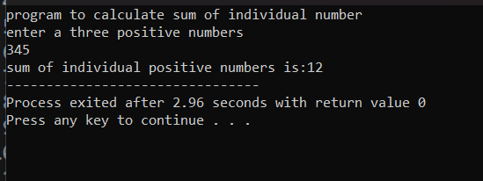

6. program to count digits in number.

#include<stdio.h>
int main()
{
int num,count=0;
printf("program to count digits in numbers\n");
printf("enter a number\n");
scanf("%d",&num);

while(num>0)
{
num=num/10;
count++;
}
printf("count of digits is : %d",count);
return 0;
}

