Beethoven Brick Ball
A Game of Classical Music and Competition

March 23, 2011

Concept By:
Ron Brown (Game Modes Section)
William Chamberlin (AI and Rejected Ideas Sections)
Gary Hogan (Power-Ups and Power-Downs Sections)
Duncan Wood (Appearance and Theme Section)
William Ziegler (Overview Section)

Developed By:
Emma Anderson
Jordan Byron
Dennis Honeyman
Kai Ito
Victoria Krauchunas

Overview

Beethoven Brick Ball is a ball-and-paddle game reminiscent of the classic Pong. The players each control a paddle on one side of the screen and attempt to keep the ball from getting past their paddles. The key difference between this idea and standard Pong is that the playing field contains bricks that players can break to increase their scores. The inclusion of bricks creates an environment much like another type of ball-and-paddle game: the brick-breaker. Combining these two types of paddle games creates an environment where players compete against the environment and against the opponent on the other side of the field. In a twist, the players will find that classical pieces by Beethoven provide the background theme for their struggles.

Gameplay Rules and Scoring

A round of Beethoven Brick Ball begins with one ball in the middle of the playing field and bricks in a predetermined configuration around the field. The ball propels itself towards one of the two players' paddles, and that player must bounce the ball into the field again to start the round proper. After that, each player tries to maneuver the ball past the opponent's paddle to score.
The goal of Beethoven Brick Ball is to end the game with a higher score than one's opponent. As time goes on and as bricks are broken in a round, a “score pool” in the right-center of the screen increases. Each second the ball is in play is worth two points, and each brick broken is worth 10 points. When a player loses the ball behind his/her paddle, the opponent obtains all of the points in the “score pool”. Points are only scored when a player loses a ball, and in only a few other circumstances. This is to make sure the players focus on each other instead of breaking bricks throughout the round for points.
When all of the bricks are broken, the game would simply devolve into a game of Pong. The team decided this was not a desired outcome of the game. Therefore, a “sudden death” mode would take effect to hasten the round's completion. In this mode, the players' paddles gradually shrink down to half of their normal size and the ball's speed continues to increase. The game as a whole is over when a player loses the ball during “sudden death” mode. The winner of the “sudden death” round would receive points according to the aforementioned rules. There is no “sudden death” mode. A round of competitive play will end with a timer counting down to zero. After that, the game declares the winner of the match by determining which player has a higher score. The winner should be shown on a pop-up box which takes priority over the rest of the screen. The pop-up box would announce the winner as well as provide a way to go back to the main menu or the set-up selection screen. There is one game play mode.

Control Scheme

The game Pong and most brick-breaker games share one important characteristic in terms of controls. Both have very simple controls. This game, a Pong brick-breaker hybrid, should have controls that are just as simple as those of its component parts. Even though they are not complex in the slightest, they still should be mentioned. The main menu and other menu screens can be controlled with the mouse, or they could be controlled by either of the players’ keys. In menus, they could be WASD or the arrow keys. On the menu screen, the Enter key is a choice confirmation. The main screen is controlled by the mouse only. For the game screen, only a few keys on the keyboard should have any input to the game. Those would probably be the A, D, and left Control keys for player 1. For player 2, they would be the left arrow, right arrow, and right Control keys. These keys are speculative for the time being. But, they make a good initial setup because many recent PC games use either WASD or the arrow keys for directional input. To move left and right, player 1 uses the A and D keys. Player 2 would use the left and right arrow keys. The Control keys up (player 1) and s (player 2) keys are used for special power-ups such as the sticky ball and the laser.

Screens

This game would require four or five distinct screens to function properly. While a title screen is not strictly necessary for gameplay purposes, one would help to draw potential players in. The “Title Screen” also features navigation between the credits, instructions, and game play. An instructions screen also would make sense. If the players are to play the game, they must know how to play in the first place. Explanations for the controls would be on this screen, as well as various warnings about what to watch for while playing. This includes power-ups, blocks, and how to score. Also, information about when the game ends and how the game starts should be on this screen. This could call for the instructions screen having multiple “pages.” The instructions screen ideally would have pictures. Pictures on the instructions screen would aid tremendously in conveying information to players. They (hopefully) would not be asking questions like “What does the ball look like?” A player losing the first few rounds he/she plays because of a visual misunderstanding is confusing and may deter him/her from playing any more. The instructions screen should have a button on it to go back to the main menu. Normally, there would also be a button to play the game immediately. However, in a game where there could be multiple game modes, it might clutter up the instructions screen too much.
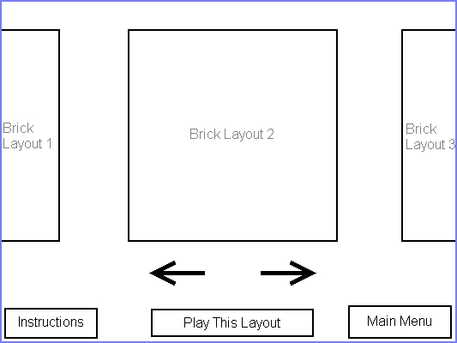

There may also be several different “stages,” or brick configurations, for players to choose from when deciding to play. In this case, there would be another screen for deciding which brick configuration to play with. The arrow buttons on the screen, the arrow keys, and both players’ left and right directional keys are all valid choices for scrolling through potential layouts. The bottom-center button would be used as a confirmation button to begin playing. There would be another button in the lower-left corner to return to the instructions screen, in case either player has reservations about controls or imagery. The lower-right button returns the players to the main menu.

There is only one starting configuration for the bricks in the prototype of the game, therefore this screen is unnecessary.

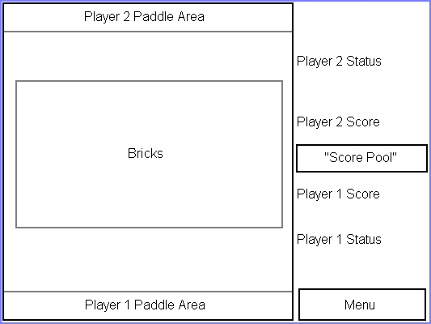

The layout of the game screen is pictured above. The players' paddles will be placed on the top and bottom of the screen. Player 1 may not always be on the bottom of the screen, and player 2 may not always be on the top. The box labeled “Bricks” is where all of the breakable bricks will go, but it is not necessarily filled to the brim with bricks. As stated before, there may be different configurations of bricks. While it is often a good idea to make fun shapes such as smiley faces and other simple artwork with bricks, such set-ups may offer advantages to one side. Each group of bricks should be horizontally symmetrical to make sure the brick layouts are fair for each player.
On the right side of the screen is the status and menu bar. The center of the bar is the “score pool” where all points will go before they are given to one of the players. Above and below the “score pool” are the players’ scores. Below player 1’s score and above player 2’s score is the status for each player, respectively. These status areas will show the effects of any power-up or power-down affecting each player. There is not a lot of space in this part of the screen, so the power-ups displayed would likely be reduced to icons alone. Icons and words would make a lot of clutter to have to look through in the middle of a quick-response game like this. The menu button at the bottom-right of the screen stops the game and returns to the main menu/title screen. Likely, some sort of confirmation would come up to make sure the players really do want to stop playing. This prevents any accidental quitting in the middle of a heated game (or “accidental” quitting if one plays with a sore loser).

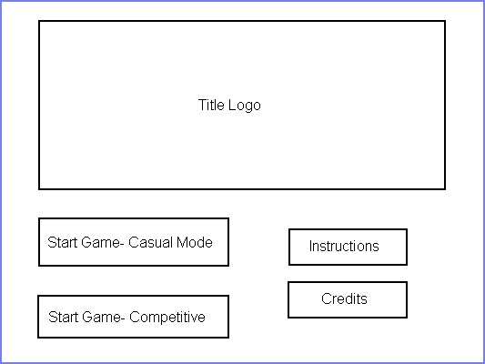

Speaking of the title screen, here is a potential layout. The title logo for the game would take up most of the main menu screen. The title screen would have start buttons for different game modes, if there is time to add more than one game mode. The instructions screen and the credits screens would both also be accessible from the main menu. The credits screen would not be too complex. There would be the names of all of the people who worked on the game, as well as information about where all of the assets and imagery came from. The only button the credits screen should have on it is the one returning the players to the main menu.

Power-Ups

A staple of the brick-breaker game type is the ability to attain power-ups, giving players new ways to play the game. Of course, this game would be no different. For balancing purposes, and ease of programming, the team decided that attaining power-ups should be simple: whichever character (or CPU) breaks the brick containing the power-up is immediately endowed with it. More simply, whichever player last hit the ball will receive the power-up if a power-up brick is broken. This “fast power-up” mechanic will sometimes give players great saving graces. The power-ups the team have thus far considered are as follows:

Sticky Paddle
Not implemented.
The “sticky” power-up is one common in brick-breaker games, showing up often alongside “multiball” and “fireball”. This power-up, once attained, allows players to hold onto the ball for a short time, and lets them launch when they prefer rather than having the ball immediately bounce away. This is helpful for several reasons. For one, it allows a player to move the ball away from a dangerous area when caught – say, for example, the resulting bounce would launch the ball sharply to the side and immediately into a brick that sends the ball into the player’s own goal. Second, it allows the players a degree more strategy, as they can launch the ball at other particular bricks to rack up pool points before attempting to score. Or, they could launch the ball at a poorly-protected section of their opponent’s goal.
The team decided to use this power-up because of its widespread use and undeniable tactical ability. In a game based largely on luck and fast reflexes over skill, a tactical edge is very much welcome.

Long Paddle
The classic elongated paddle power-up is one of the only, if not the only, power-up more common than “sticky.” As the name suggests, this power-up increases the length of the player's paddle for a period of time. The power-up would effectively make the ball easier to hit and make the goal significantly easier to defend. Why this is useful in a game like this needs no explanation.
When the team decided to use power-ups, this was one of the first to make the list. It is much too useful to ignore, and can sometimes give a player or a CPU the edge it needs to save itself, even for a moment.

Split Ball
Naturally, one of the power-ups is a simplified version of “multiball.” When a player earns this power-up, the next impact a ball has with a paddle will cause it to split in two, giving both players an increased chance to score on their opponent and an increased chance of destroying bricks. However, the logic used for a normal “Brick Breaker” game cannot apply in this game, due to a simple logic flaw. If there is no immediate reward to destroying a brick, and however many points scored with a multiball could be given to the opponent by the end of the game, what should be done with the case of one ball, but not all, falling? In most cases, unless it were the last ball, it would be essentially ignored. In this game, however, that gives too little incentive to keep the power-up. Instead, the team decided that for each ball that falls that isn’t the final ball, a portion of the score pool’s current amount (say, for argument’s sake, half) is given to the other player, without deducting from the score pool.
“Multiball” is easily one of the most common brick-breaker power-ups, and as such, was one of the first to come to mind. While it took some thought and balancing, it adds another dimension to gameplay, as well as a possible sense of urgency when the players are neck-and-neck.

Fireball
“Fireball” (sometimes referred to as “Comet” or the like) is a very common ability, and also often a favorite. When a player attains this power-up, the ball bursts into flames, giving it the ability to power through bricks rather than shatter and bounce away. This is a very handy power-up as it allows speedy destruction of bricks, racking up score quickly and potentially speeding up the acquisition of other power-ups. For this game, there was concern about possibly making comets also destroy or stun opponents’ paddles, but this was quickly dismissed as it would make scoring much too easy when this power-up appeared.
Not only would this power-up increase chances to score and rack up points more quickly, effectively shortening games, but it would also have the capability to save players from a dangerous situation in much the same way as “sticky.”

Laser
Slightly less common than “fireball” is the “laser” upgrade, sometimes using missiles instead. This power-up allows the player to destroy bricks without the use of the ball, in order to clear the board more quickly. When this power-up is unlocked, it gives the player who got it an addition to their paddle that fires small lasers with either limited ammunition or a limited time constraint to use, and each laser can destroy one block. As these lasers come from the paddle itself and travel straight up, they cannot hit bricks behind other bricks. Not only does this allow a player to quickly clear a board, but it can also allow for rapid boosts in the score pool.
The team opted to use the laser power-up primarily because it would make games move much more quickly.
Fitting with the game’s theme, the laser upgrade will be shaped like an organ pipe which will shoot from the player’s paddle.

Ball Speed Modifiers
One comparatively original power-up the team had considered for this game was a “speed mod.” This would, depending on which mod was found, speed up or slow down the ball, thereby making it tougher to hit for both players or making it vastly easier to hit by both players. The duality of this could serve as both a saving grace for players as well as their coup de grace. A slowed ball on a return could serve to save a player from imminent defeat, just as a sped-up ball on a launch could serve to finish off an opponent. At the same time, a sped-up ball on a return could bring a player to defeat in an instant, and a slowed ball on a launch could spare mercy on their opponent.
There are many reasons to use this power-up in the game. However, it is as yet unknown whether both power-ups would be implemented, just one of the two, or none at all.

Score Multiplier
Not implemented.
A score multiplier power-up is one of the few the team considered that would help or harm both players, rather than give one player a definitive advantage. When this power-up is found, it would increase the points added to the score pool for every brick destroyed for a limited amount of time. This works well in both players’ favor, as it would rather quickly make the score pool a much larger amount for either player to take. Unlike the aforementioned power-ups, it also does not make the game significantly easier for one player upon appearance, either.
We decided to put in this power-up mostly due to the capability it has to save a losing player. It can also create very varied games in terms of score, as one game could have two players with very low, even scores, whereas the next could have two players with very high, even scores, and all points in-between.

Ball Size
Not implemented.
Another potential power-up would be one that changes the size of the ball. Much like the speed mod, this power-up would have a strong duality to it. On one hand, the power-up might increase the size of the ball, thereby making it significantly easier to hit and save from scoring. On the other hand, the power-up could shrink the ball, making it much more difficult to hit and causing more frequent scoring for a short while.
The duality of this power-up, however, is also a good portion of the reason the team has yet to decide whether or not to use it. At best, it could be helpful and a savior of the game for the player by enlarging before hitting them, or shrinking just before going to the opponent. At worst, it could gyp the player out of a game by slipping by them at the worst time, or growing on its way to the opponent.

Screen Orientation
Not implemented.
Another power-up that was discussed, but ultimately rejected, was one that would alter the orientation of the screen. When this power-up is attained, it would change the direction of the screen. For example, if the game were set up vertically so that one player is on the bottom and one on the top, this power-up would change that to one player on the left and the other on the right.
However, it was decided that this power-up was naught more than a nuisance, and instead, we decided that we would alter game modes themselves. Rather than have the game set in stone as being just one of these orientations, we would give players the option to choose which orientation they preferred.

Guard Wall
Not implemented.
Of all of the power-ups we discussed, the “Guard Wall” power-up was easily the most controversial. When attained, this power-up would give the player a limited-time wall in their goal, allowing a one-time protection against scoring. While it would be useful in preventing players from inadvertently scoring on themselves via an unlucky bounce, it also seemed rather unfair, as it prevented one player from any scoring for a short time.
Ultimately, it was decided that this power-up would be included, but under heavy regulation. When a self-inflicted score is so easy in the game, this would be far too much help to ignore. However, it will be given an extremely short lifespan, disappearing after as little as five seconds, and will be destroyed on a bounce. Also, like the “split” power-up, it will grant the scoring party points equal to a portion of the score pool, but without deducting from the pool.

Parabola Paddle
The parabolized paddle power-up is a much more unique idea than many, and, while difficult to code, would be undeniably useful. This power-up would turn the player’s paddle into a curved shape, rather than its normal straight bar, and thus allow for different-direction shots. The parabolic paddle would be able to make much more diagonal shots than the normal bar, sometimes even launching the ball almost sideways.
However, due to its difficult nature, the team has yet to decide whether it would like to include this power-up. While it would be fun to use, it may be beyond the team's means to code the physics and collision of this change in a short time.
For clarification, the parabola paddle implemented is concave (curved inward).

Bomb Brick
Not implemented.
The final power-up idea was another that would not directly benefit one player over another is the bomb brick. When a brick containing this power-up is destroyed, it would explode, destroying any bricks nearby and adding their inherent values straight to the score pool. This is yet another example of a way to shorten map-clearing in any given level.
The team decided to use this power-up because of how, quite simply put, useful it would be. Not only does it clear out a section for players to shoot through, but it could also add more power-ups to a player’s arsenal indirectly, as well as boosting the game’s score.

Power-Downs (Debuffs)

Power-downs were not implemented.
Eventually, the team also came up with the idea to create “debuff” power-ups – instead of helping a player, it would hinder his/her opponent. Much like the power-ups, they would be applied as soon as the brick they are contained in is destroyed. However, rather than being applied to the player who last hit the ball, they would be applied to their opponent. This way, players can try to stack their own power-ups with debuffs for their opponent, making it infinitely more difficult on their opponent. A few current ideas are as follows:

Paddle Shrink
As the name suggests, this power-up would cause the opponent’s paddle to slowly shrink. This would effectively make catching and returning the ball significantly more difficult on their opponent and, when mixed with a power-up such as “Split Ball,” would make for a good way to rack up some quick points.
While the team decided to include this debuff ability, it was also decided that there should, obviously, be a limit on how small the paddle shrinks, and how long the paddle stays shrunken.

Slow Paddle
This debuff would, once attained, make the opponent’s paddle move significantly slower for a short period of time, effectively making scoring against them easier. When mixed with the shrunken paddle debuff, it would likely make defending nigh-impossible, and would work very much in one player’s favor.
The team decided to use this debuff because of how much easier it would make scoring. In a match between two skillful players, or between a player and a high-difficulty CPU, scoring would be very rare. Debuffs such as these would make these rare occurrences more common, and make the game not last hours on end.

Control Reversal
While other debuffs make defending more difficult, this debuff would serve much more as a two-hit disorientation tactic. When activated, this debuff would reverse the opponents controls, disorienting them for a few seconds while they realize that they must now press the opposite direction. After a short span of time, it would deactivate, causing another few seconds of disorientation, and possibly panic, when they readjust to normal controls.
This debuff, as well as a few others and a few power-ups, prompted us to ask what the team wanted the mood of this game to be: should it be more competitive, or for no sake but fun? The team opted to include this after coming to the decision that the game should not only be a competitive game, and this debuff would be little more than a nuisance in a competitive setting.

Game Modes

Casual Mode
Casual Mode not implemented

Casual Mode is geared towards the party gaming audience, typically twelve to twenty-three year old people who are bored and feel like burning some time. This mode will feature various different, unexpected events. This will make it more of a lighthearted session as opposed to the competitive mode, which will be explained in depth later. As in normal one-player mode, the game will start vertically with the two opponents facing off and several bricks in the center. Additionally the power-ups will not be revealed to the players (although they will be randomly generated at the beginning of the game as usual), so at any given time a player could hit a brick to gain a power-up or power-down the opponent.

-Example of Casual Mode

As well as the change in revealing power-ups, the game will also feature unexpected, drastic changes in gameplay that will force players to react quickly and change their inputs. This mode is inspired by the stage Spear Pillar featured in Super Smash Bros. Brawl. The game could undergo several flips. For example, instead of playing vertically, the entire board is flipped horizontally. The game could also change the controls to an inverted control scheme where left is right and up is down depending on which set-up the board is currently using. An example of the inverted board and inverted controls are displayed on the following page. Note that inverted situations can occur where inverted controls appear on an inverted board, causing complete mayhem.

Competitive Mode
This is the mode used for our prototype.

Competitive mode is for the player audience that wants a more strategic, tactical battle of wits between their opponent. While the age range is around the same, the audience is not. Competitive mode is for two players. In this mode, the game will always be featured in vertical mode. There will also be no control inversion or board inversion. Additionally, all blocks with power-ups will have some sort of indicator (whether that be flashing, different colors, or a letter inside the block) to differentiate between different power-ups as well as blocks with no power-ups at all. The mode which we are using in our game most resembles competitive mode, but also has aspects of time trial and score attack mode. There will be a time limit on play, and the player with the highest score at the end of that time period will be the winner. Similar to score attack mode, bricks will continue to spawn randomly throughout play. We found that it would better contribute to the overall experience of play if we were to focus our efforts on one specific level of play which borrowed aspects of many different modes. This also demonstrates that each of these different rules could potentially be implemented separately in a full game instead of a prototype.

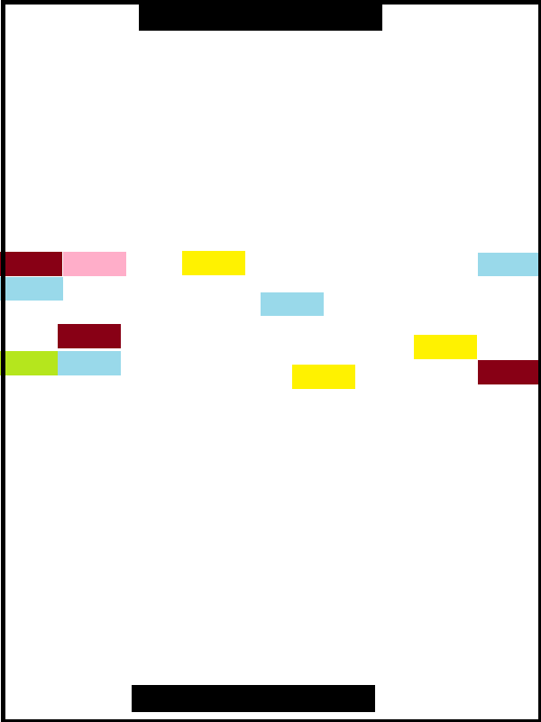

Score Attack Mode
Not implemented.

Score Attack Mode is a challenge mode for one to two players to see what the highest score a player or players can get. Normally, the objective is the game to outwit an opponent and score against them while gathering as many points into the score pool. However, Score Attack Mode is a more co-operative mode. The players work together to try and get as many points from the center blocks as possible. There are no power-ups, and bricks will randomly spawn in the center as the amount of remaining bricks deteriorates.
In addition, the ball will speed up. This makes it more difficult to continue this task as time goes on. Points are not added into the pool and allocated to a player when a player scores. Instead, points are added automatically after hitting a brick and the game ends with the current score once one of the players misses. Considering the fact that power-ups are nonexistent in this mode, the board will look identical to the casual mode. However, hitting bricks will never randomly generate a power-up, bricks will respawn, and inversion swaps will also never occur.

Time Trial Mode
Not implemented.

The Time Trial Mode is a one-player mode that focuses on the player being able to complete a board state in a certain given time. The idea behind this is that the player must destroy all the blocks in the center, and then additionally score on the opponent. If the player scores before all the blocks are destroyed, he/she will get a time of zero. The objective is to get the highest remaining time to put on
the list of high scores. Each board will be some sort of puzzle with varying difficulties and times.

AI
No AI present in this game, as there is no single player mode.

Beethoven’s Brick Ball will entail an artificial intelligence program to control an AI opponent in single player modes. This AI will need to be able to accurately catch the ball and return it to the other side. These requirements could allow us to create a very simple AI for the game. There are two possibilities for how we could implement the system into the game. The first method, the easiest method, will rely on retrieving the X and Y coordinates of the ball in the 2-Dimensional space. This method is not recommended as it will create an overly simplistic AI. The AI will most likely be far too easy to defeat, and will not allow for the player to have fun against such a simplistic opponent. However, this possibility should be outlined in the case of time or budget constraints. First, the AI will check the X position of the ball and compare it to the previous X position. If the ball is moving towards the AI it will then check the change in the Y coordinates. The return of the Y comparison will either result in the AI’s paddle moving up or down in an attempt to catch the ball. This is the simplest implementation and may result in a lot of misses for the AI.
The more reliable, and more recommended, process will be for the AI to draw a vector from the ball and predict where it will be moving, and then properly intercept the vector. First, the AI will need to be able to accurately draw a vector based on the movement of the ball. The AI will then need to determine where it will need to move the bar to intercept and ‘return’ the ball. In order to balance the AI and give it the possibility of error in this implementation, we can take several approaches. The first to come to mind is to limit the speed at which the AI can move the paddle. In this approach, the AI may ‘know’ exactly where the ball will be, but it cannot intercept in time due to the restrained movement speed. To increase difficulty and make the AI more fun to play against, we must also add in an element of randomness. That is to say, the speed of the AI can be slightly variable so as the opponent cannot accurately predict where the AI will not be able to return the ball. To more easily describe what is meant by drawing vectors, a diagram is the best solution.

The line represents the vector drawn by the computer in an attempt to figure out where it will move the paddle. The vector follows the previous path of the ball, and this vector is the result. The computer will then move its paddle into the vector to return the ball to the player.

· Possibility one: Do an X and Y coordinate comparison to determine which way to move the paddle.
o Keep in mind this is not a recommended approach. This should only be done in the case of serious constraints to the project.
· Possibility two: Draw vectors from the ball so that the AI can determine where to move the paddle.
o To increase difficulty and playability the AI will need an element of randomness in the speed
o The other possibility would be to give the AI a slight variability in the position the AI ‘thinks’ it needs to move the paddle to intercept the ball.

Rejected Ideas: Why not, and what we learned
These ideas were rejected by the design group, therefore we made sure not to implement them.

This section covers the seemingly good ideas thrown around in the brainstorming process, why they are not good ideas, and what was learned from them.

Infinite Shrinking Paddle

The sudden death mode that happens when all of the bricks on the current level have been broken originally was going to have the paddle just continuously shrink until one player scored the final point batch. Now obviously, if both players were rather skilled at the gameplay, this could lead to the paddles shrinking to nothing. This would lead to unfairness as it would just turn into a ‘luck of the draw’ situation. The player who happened to completely lose their paddle when the ball was coming towards them would lose based almost exclusively on luck. To remedy such a situation, the paddle only shrinks to a certain point. The exact number cannot be determined at this time, as those should be best left to playtesting.

Dual Paddles

The next idea rejected in the brainstorming process was that instead of having a barrier on the sides perpendicular to the players paddles, they player could just be controlling another paddle. This idea was very quick to hit the rejected pile as it would just be too difficult to control both paddles simultaneously, especially in a competitive sense.

Four Player Mode

In a quick defense of the previous idea of having four paddles, why not just add in a four player mode to the game? That way, the idea of no barriers can remain in the game, and the difficulty of controlling two paddles is also eliminated. This seems like the perfect solution, however, this idea would make the game too similar to another game of a similar style. In the similar game, four players on teams of two each control a paddle and they try to hit a ball into the other teams castle. The objective is to be the first team to destroy the enemy’s base. While this game doesn’t have the same objective, the idea of having two teams would make the games too similar.

Power-up Assignment

Originally power-ups were going to be assigned randomly whenever a brick was destroyed. The ball would hit a brick, the brick would be removed from the game and then a random number generator would decide if the brick contained a power-up or not. This idea was also quickly eliminated due to the strain on the game that the constant calculations would cause. There would also be a chance that power-ups would be too common, or would be too rare. Player’s might play entire games without ever seeing the vast array of power-ups. After this idea was rejected, the team decided the best way for power-ups to be added would be to simply randomly assign them to a bricks before the game actually starts. Another idea on the same topic is how players would get power-ups after they were released through the broken brick. The first idea was for power-ups to appear on the screen after they were released. The player would then have to hit the ball into the power-up to collect it. This caused much debate within the team. The first being, where would the power-up appear on the screen? Would it appear randomly, or would it simply appear on the remains of the broken brick? After much debate the idea of the power-up appearing would be too unfair to the players. One player may have revealed the power-up, and then the other player received it. Instead, the team decided to have power-ups implemented instantaneously after they were ‘released’ from the brick.

Guard Wall Power-up
While discussing which power-ups to add into the game, one of the classic favorites of brick break style games would be the barrier power-up. This power-up would allow the player to miss the ball without penalty. Immediately the power-up was criticized as being too powerful, and would give the player an extreme advantage over the opponent. The power-up was kept, but extreme modifications had to be made for the power-up to not be ‘broken.’ More on the improved power-up version can be found in the power-up section.

Screen Change Power-up

Another power-up that was suggested was the ‘change orientation’ power-up. This power-up, when activated, would change the orientation of play from horizontal to vertical or vice-versa. Once suggested, the power-up did seem to be a good idea, but quickly came under criticism. In the competitive mode, this offers power-up offers no advantage, and plays absolutely no tactical value what so ever. In response, the power-up would not be included in the competitive mode as it would simply be too irritating. However, the power-up would not remain in the game at all, even in the non-competitive sense. Players just do not respond well to having the whole orientation of the game world change so suddenly or drastically.

‘Wall’ of Bricks

At first the idea of a multiplayer brick-break/pong game brought the idea of a solid line of bricks down the middle to the minds of the designers. Now this idea would just make the game seem to be two players playing brick break simultaneously, and then the game would slowly morph into pong as the game goes on. This is not the kind of game the designers were going for. Instead, a smooth combination of pong and brick break is more like the intended idea. To more accurately reflect the intended design, the levels should be carefully designed to not create solid lines of bricks down the center of the play area.

Moving Bricks

The next idea thrown around by the design team was the idea of moving bricks. Right from the start this is more of a gimmick idea than an actual core content idea. Moving bricks in a brick break/pong like game. It was really just a silly idea to try and separate the game from other similar games. This idea was quickly rejected as it would just be irritating to the players trying to score points. Moving bricks just take away from the intended gameplay style and would simply irritate the players.

Name Generation

Once the most of the final details were decided upon in the game, it was time for one of the more dreaded parts of designing a game. What do we name this creation? While some ideas combining pong and brick break titles were attempted, one idea so terrible came up that it deserves to be mentioned in the design document. Game titles should be appropriate to mass audiences. This is why the name “Beethoven’s Balls of Steel” was rejected. At first, it seemed like a good idea. The public domain IP to be applied to the game was going to be Beethoven, and the players are trying to bounce a ball around the screen trying to break bricks and score points against the opponent. However, while the name did fit the IP and the mechanics of the game, it was finally rejected as just being too inappropriate for the project.

Appearance

The game will be themed to classical music- particularly Beethoven and his music. This section is broken down into various subsections that describe each element of appearance.

The Ball

The ball would take on the form of a whole note. That is, a circular shape that is hollow, much like the character 'o'. It would be colored to complement the current background being used. Our ball contains the shape of a whole note, but has a surrounding ball shape to make it more visible on the screen.

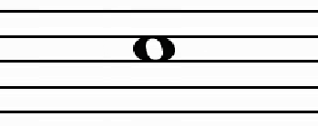
Our Ball (enlarged):

The Paddle

The Striking surface of the paddle would take on the shape of a violin bow; a slightly curved stick with a straight string that connects the ends, for a flat surface.

Bow picture:
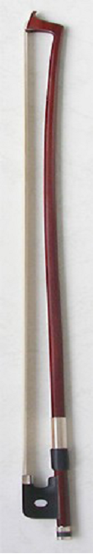

Our Bows(uncolored):

(parabola bow)
(normal bow)

The Bricks

The bricks would take on the appearance of different musical notes. The type of brick would affect the type of musical note. For example, normal bricks are quarter notes, and bricks with power ups are half notes. A quarter note is a filled ball with a little line that comes up from one side tangent to it. The half note is the same, except it is hollow, like a whole note. The bricks would be colored to distinguish them from each other, and to distinguish them from the background. Since the background is going to be a more muted probably brownish color, reds, greens and blues are good ideas.
Our bricks all have the same note, but are colored differently based on different power ups.

Uncolored brick:


The Interface

The interface elements will be themed along with the gameplay elements- in the spirit of classical music. For example, the text used in keeping score and such will have a 'classical' theme. The given font was stylized, but difficult to read for large amounts of text. Instead, menu heads use Blackadder ITC and large amounts of text use Monotype Corsiva.

The other elements of the interface will feature a 'woody' texture to compliment the idea of violins, and classical music.

The Background

The background texture of the board will be reminiscent of a Cello, or other stringed instrument. It will have to be non-distracting and muted in hue though, so the ball and bricks are still visible. To separate the board from the interface, there will be a border of a gold-ish color. See the color of the cello strings for that color.
Additional backgrounds used could be based on music halls. The backgrounds would change as the level changes. It could borrow the colors and shapes from them. For example, a bunch of chairs could be a background image, or the stage, or a balcony.

Menu Elements

The menu elements of the game would be 'Classical' themed too. This would take advantage of what people think classical music is represented by...wood textures, marble, arches, etc. The menu would also feature clickable buttons. To fit the fonts and theme, the buttons would be rather 'curvy'.

A rough shape example of an arrow button would be:
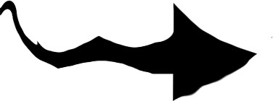

Our arrow:


Animation of Elements

The animations featured by the game will also compliment the used elements. For example, when a note is hit, it will flutter around and fade like we imagine a musical note would. The paddle would “vibrate” a little when hit, much like a real violin bow does. Power-ups would activate with a flourish of musical notes. The interface would animate like a book of sheet music. For example, when changing levels, it would appear as if a page were turning.
There was not time to implement these animations.

