Case Study
Image Classification for Medical Imaging
A comparative study of classical, convolutional and transfer-learning models on chest X-ray and dermatoscopic images (MedMNIST v2)

Authors: Dariga Abduali, Damir Assainov, Assanali Kurmangaliyev, Nurtore Onggarbay
Course: Artificial Intelligence
Astana IT University
October 2026

Abstract
Automated classification of medical images promises faster triage and wider access to specialist-level reading. Published results, however, often report a single headline accuracy, which hides the questions that matter in a clinic: which errors the model makes, how trustworthy its probabilities are, and what the model actually looks at. This case study compares three models of increasing capacity on two public benchmarks from the MedMNIST v2 collection: PneumoniaMNIST (pediatric chest X-rays, normal vs. pneumonia) and DermaMNIST (dermatoscopic images of seven skin-lesion types, derived from HAM10000). The models are a classical baseline (PCA + logistic regression on raw pixels), a compact convolutional neural network (CNN) trained from scratch, and an ImageNet-pretrained ResNet-18 fine-tuned end to end. Evaluation goes beyond accuracy: AUC with 95% bootstrap confidence intervals, balanced accuracy, sensitivity and specificity, per-class recall, expected calibration error (ECE), decision-threshold analysis and Grad-CAM saliency maps.
The transfer-learning ResNet-18 was the best model on both tasks: test AUC 0.990 (95% CI 0.984–0.996) with sensitivity 99.2% and specificity 89.3% for pneumonia, and macro AUC 0.958 with balanced accuracy 76.7% on the seven-class skin-lesion task. Convolutional models outperformed the pixel baseline by a large margin (AUC +0.14 on DermaMNIST). The analysis also exposes clinically important weaknesses. 47 of 223 melanomas (21%) were classified as benign nevi. A decision threshold tuned on the validation split did not transfer to the test split. Grad-CAM maps frequently highlight the cardiac and mediastinal region instead of the lung fields. The report concludes with recommendations for responsible development and deployment of such systems, including in the context of Kazakhstan's healthcare system.
Keywords: medical image classification, deep learning, transfer learning, ResNet, chest X-ray, dermatoscopy, MedMNIST, calibration, Grad-CAM.

1. Introduction
Medical imaging is one of the main sources of diagnostic information in modern medicine. Radiographs, CT and MRI scans, histopathology slides and dermatoscopic photographs are produced in growing volumes, while the number of specialists who can interpret them grows much more slowly. The result is long reporting queues, reader fatigue and unequal access to expertise between large cities and rural areas. Since the success of deep convolutional networks on ImageNet [5, 13], image classification has become the most mature application of artificial intelligence (AI) in medicine. Systems that read chest radiographs [2, 7], classify skin lesions [6] and grade retinal images [2] have reached accuracy comparable to specialists on retrospective test sets [15].
Two diagnostic problems are used here. Pneumonia is the single largest infectious cause of death in children worldwide; the World Health Organization (WHO) attributes about 14% of all deaths of children under five to it [16]. A chest X-ray is the standard confirmatory examination, but in many regions there are not enough pediatric radiologists to read it quickly. Skin cancer, and melanoma in particular, is highly curable when detected early and often fatal when detected late. Dermatoscopy improves diagnostic accuracy, but only in trained hands. In both cases an accurate automated pre-screen could shorten the time to diagnosis.
For Kazakhstan these problems are particularly relevant. The country is large and sparsely populated, and specialist radiologists and dermatologists are concentrated in Astana, Almaty and regional centres. The national digital-health agenda (electronic health records, telemedicine links with rural clinics) creates the infrastructure through which decision-support tools could reach primary care. Before such tools can be trusted, however, it is necessary to understand not only how accurate they are on average, but where and why they fail.
This case study therefore builds a complete, reproducible image-classification pipeline and evaluates it with the kind of analysis expected in clinical AI research: confidence intervals, error analysis by class, calibration, threshold selection and visual explanations.

2. Objectives and Research Questions
The objective is to assess how well modern image-classification methods solve two representative medical-imaging tasks, identify the main factors that limit their reliability, and formulate evidence-based recommendations for their development and use. The specific objectives are to:
- collect and preprocess public, well-documented medical-imaging datasets;
- implement a classical baseline, a CNN trained from scratch and a transfer-learning model under an identical training and evaluation protocol;
- compare the models with clinically meaningful metrics and quantify statistical uncertainty;
- analyse failure modes: class imbalance, calibration, threshold choice and the image regions the model relies on;
- propose short- and long-term recommendations for building and deploying such systems.
The study addresses five research questions:
- RQ1. How much does a deep CNN outperform a classical pixel-based machine-learning baseline?
- RQ2. Does ImageNet transfer learning help on small, low-resolution medical datasets?
- RQ3. How does class imbalance affect performance, and which diagnostic classes are hardest?
- RQ4. Are predicted probabilities calibrated, and how should the decision threshold be chosen for screening?
- RQ5. Do the models attend to clinically plausible image regions, and what risks does this imply for deployment?

3. Literature Review

3.1 Deep learning for medical image analysis
Convolutional neural networks learn hierarchical image features directly from pixels and replaced hand-crafted descriptors in computer vision after 2012 [13]. Residual networks (ResNets) introduced skip connections that make very deep networks trainable and remain a standard backbone [5]. Litjens et al. [8] surveyed more than 300 deep-learning papers in medical image analysis and found CNNs dominant across classification, detection and segmentation. They also noted recurring weaknesses: small datasets, label noise and limited external validation. Topol [15] reviewed the clinical evidence and argued that retrospective accuracy is necessary but not sufficient: prospective studies, calibration and workflow integration determine real-world benefit.

3.2 Pneumonia detection on chest X-rays
Kermany et al. [2] released a dataset of 5,856 pediatric chest radiographs from Guangzhou Women and Children's Medical Center and showed that a transfer-learned Inception network distinguishes pneumonia from normal images with about 93% accuracy. This dataset underlies PneumoniaMNIST. Rajpurkar et al. [7] trained a 121-layer DenseNet (CheXNet) on the 112,000-image ChestX-ray14 dataset and reported F1 scores above the average of four radiologists for pneumonia detection. Zech et al. [12] then showed an important limitation: pneumonia models trained at one hospital lost significant performance at others. One reason was that the networks partly recognised the hospital (scanner, markers, patient positioning) instead of the disease. Such *shortcut learning* is a central risk for any image classifier and motivates the saliency analysis in this study.

3.3 Skin-lesion classification
Esteva et al. [6] trained an Inception-v3 network on about 129,000 clinical images and matched 21 board-certified dermatologists on two binary tasks (carcinoma and melanoma). The HAM10000 dataset [3] provides 10,015 dermatoscopic images of seven diagnostic categories, more than half confirmed by histopathology, and became the training set of the ISIC 2018 challenge [4]. Its most notable property is severe class imbalance: about two thirds of the images are benign melanocytic nevi. Challenge results showed that accuracy alone is misleading on such data. Balanced multi-class accuracy became the official ranking metric, and the hardest clinical distinction was melanoma vs. nevus.

3.4 Transfer learning
Pretraining on ImageNet [17] and fine-tuning on the target task is the default strategy when labelled medical data are scarce. Raghu et al. [9] questioned its benefits: for large medical datasets, small networks trained from scratch performed comparably, and the gains of pretraining came mostly from better weight scaling and faster convergence rather than reusable features. For small datasets, pretraining still tends to help. This case study tests that claim at a small scale (RQ2).

3.5 Benchmarks: MedMNIST
Yang et al. [1] introduced MedMNIST v2, a collection of 12 two-dimensional and 6 three-dimensional biomedical datasets standardised to small resolutions with fixed train/validation/test splits. It covers X-ray, CT, ultrasound, OCT, pathology, dermatoscopy and blood-cell microscopy, and lets methods be compared without domain-specific preprocessing. The paper reports baselines for ResNet-18/50, auto-sklearn, AutoKeras and Google AutoML Vision. Later releases added 64, 128 and 224 pixel versions of the 2D datasets (MedMNIST+). This study uses the 64×64 versions and treats [1] as its primary reference paper.

3.6 Trustworthy medical AI: calibration, explainability and reporting
Guo et al. [11] showed that modern deep networks are often miscalibrated, that is, their confidence does not match their accuracy. This matters clinically because probabilities are used to prioritise cases and set thresholds. Grad-CAM [10] produces class-specific heatmaps from the gradients of the last convolutional layer and is the most widely used way to check what an image classifier relies on. Oakden-Rayner et al. [18] described *hidden stratification*: a model with high average performance can fail systematically on a clinically important subgroup. TRIPOD+AI [19] gives reporting guidelines for prediction models that use machine learning. In regulation, the EU Artificial Intelligence Act [20] classifies AI medical-device software as high-risk, which requires risk management, data governance, transparency and human oversight.
The literature thus suggests that (i) CNNs with transfer learning are a strong default, (ii) class imbalance and distribution shift are the main threats to validity, and (iii) evaluation should include calibration and explanation, not only accuracy. The methodology below follows these points.

4. Data Description
Both datasets were obtained from MedMNIST v2 [1] through the official `medmnist` Python package at 64×64 pixel resolution. Splits are the official ones provided by the benchmark, so the results are directly comparable with other work. Table 1 summarises the data.
Table 1. Datasets used in the study (official MedMNIST v2 splits).
Dataset | Modality / source | Task | Classes | Train | Val | Test
PneumoniaMNIST | Pediatric chest X-ray, Kermany et al. [2] | Binary | 2 | 4708 | 524 | 624
DermaMNIST | Dermatoscopy, HAM10000 [3] | Multi-class | 7 | 7007 | 1003 | 2005

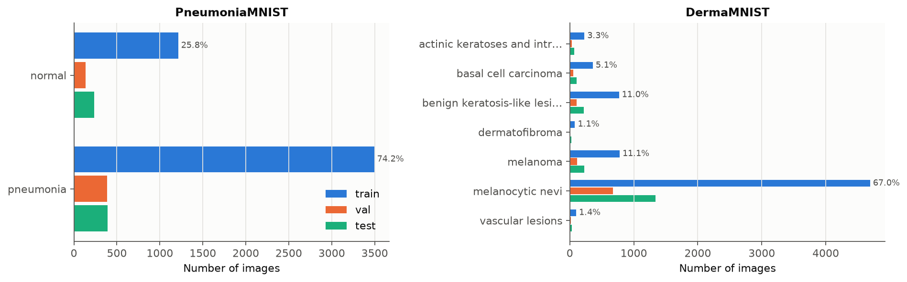
Figure 1. Class distribution per split. Percentages are shares of the training set. Both datasets are imbalanced; DermaMNIST is dominated by melanocytic nevi.
PneumoniaMNIST contains grayscale pediatric chest radiographs labelled normal or pneumonia (bacterial and viral pneumonia are merged). 74.2% of training images show pneumonia, so the positive class dominates. The test split (624 images) comes from the original test set of Kermany et al. and has a different class ratio (390 pneumonia / 234 normal), whereas validation was carved from the original training data.
DermaMNIST contains RGB dermatoscopic images of seven categories: actinic keratoses and intraepithelial carcinoma (AKIEC), basal cell carcinoma (BCC), benign keratosis-like lesions (BKL), dermatofibroma (DF), melanoma (MEL), melanocytic nevi (NV) and vascular lesions (VASC). AKIEC, BCC and MEL are malignant or pre-malignant. The data are highly imbalanced: NV accounts for 67.0% of the training set, while DF has only 80 training images (1.1%).
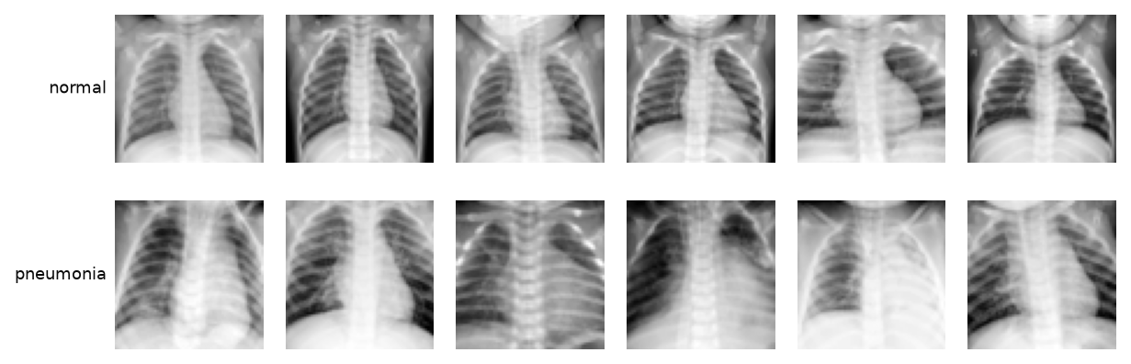 | 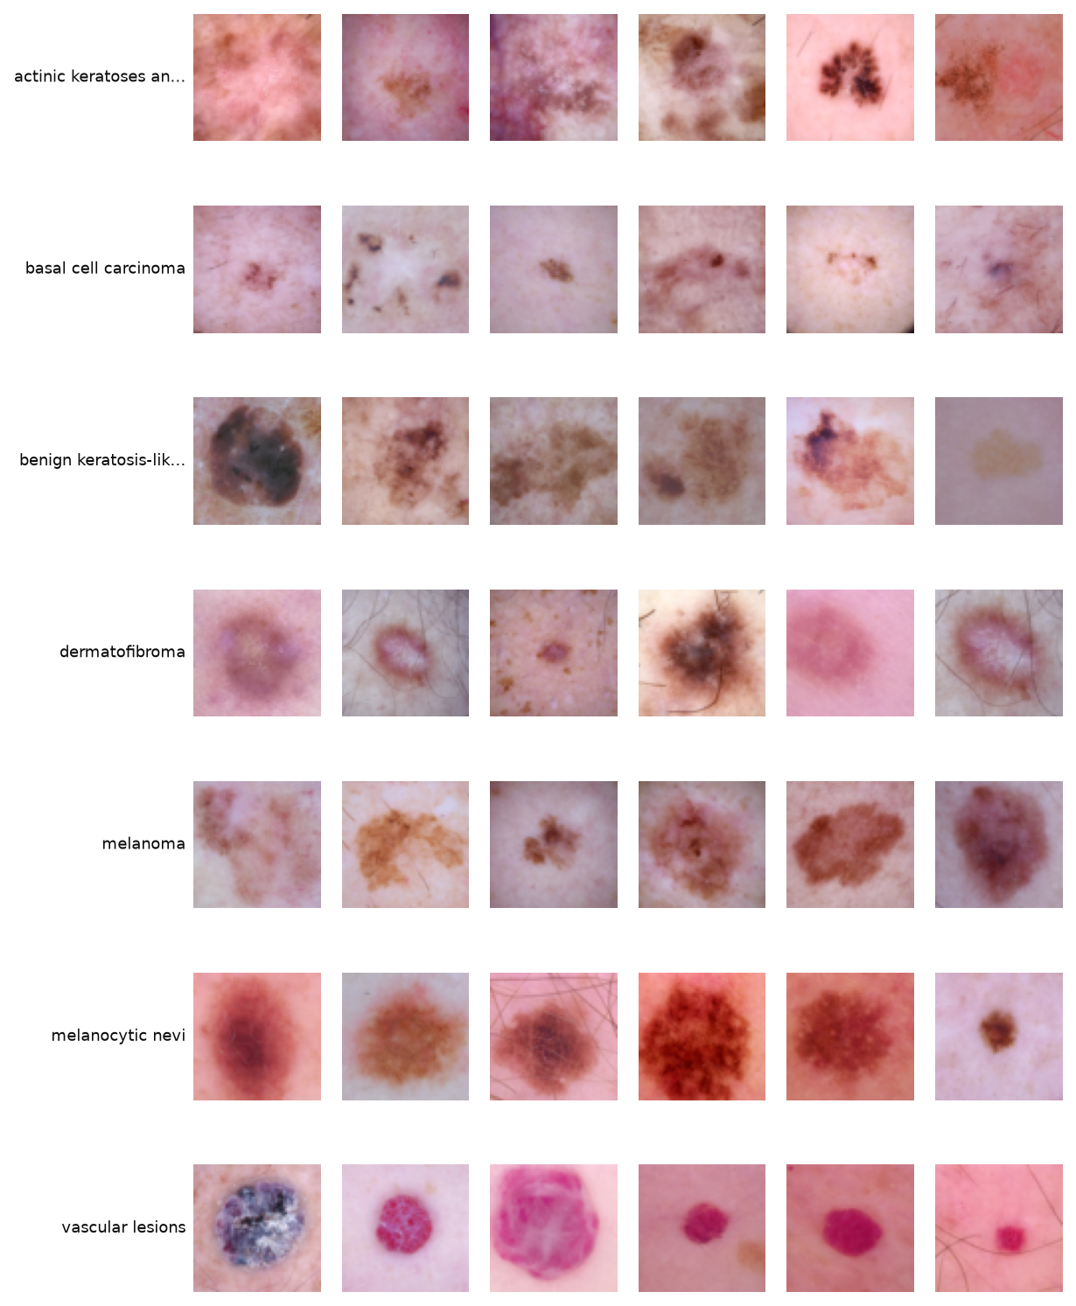
Figure 2. Random training examples (64×64): PneumoniaMNIST (left) and DermaMNIST, one row per class (right).

4.1 Preprocessing
- Pixel values were scaled to [0, 1] and normalised with ImageNet channel statistics. Grayscale X-rays were replicated to three channels so that all models share one input format.
- No images were removed: MedMNIST images are already centre-cropped, resized and quality-checked, and the package contains no missing labels.
- Training-time augmentation: random affine transform (±10° rotation, ±5% translation, 0.95–1.05 scale) and mild brightness/contrast jitter. Horizontal and vertical flips were used only for dermatoscopy, because skin lesions have no canonical orientation, whereas flipping a chest X-ray creates anatomically impossible images (heart on the right side).
- The classical baseline uses the flattened, standardised pixel vector without augmentation.

5. Methodology

5.1 Models
Three models of increasing capacity were compared (Table 2). All models were trained and evaluated under an identical protocol.
Table 2. Compared models.
Model | Description | Parameters
PCA + LogReg | Standardised pixels → PCA (200 components) → L2-regularised logistic regression (C = 0.1, class-balanced weights) | 200 × d PCA basis + ≤ 1.4 k
Simple CNN | 4 blocks × [2 × (3×3 conv, BatchNorm, ReLU), max-pool]; 32-64-128-256 channels; global average pooling; dropout 0.3; linear head. Trained from scratch. | 1.18 M
ResNet-18 (TL) | ImageNet-pretrained ResNet-18 [5]; new linear head with dropout 0.2; all layers fine-tuned. Input upsampled from 64 to 128 px so that the final feature map is 4×4 instead of 2×2. | 11.18 M

5.2 Training protocol
- Loss: cross-entropy with label smoothing 0.05 and class weights proportional to 1/√(class frequency), a compromise between ignoring and fully inverting the imbalance.
- Optimiser: AdamW (weight decay 10⁻⁴) with a one-cycle learning-rate schedule; peak learning rate 10⁻³ for the CNN and 5·10⁻⁴ for ResNet-18; batch size 64.
- Epochs: 30 for the CNN and 15 for ResNet-18 (pretrained networks converge faster). Mixed-precision (AMP) training on the GPU.
- Model selection: after each epoch the model is evaluated on the validation split, and the checkpoint with the highest validation AUC is kept. The test split is used only once, for the final evaluation.
- Reproducibility: fixed random seed (42). All code, the exact configuration and per-epoch logs are stored with the results (Appendix B).
- Hardware: a single NVIDIA H200 GPU. Training time per model was below one minute (e.g. ResNet-18 on DermaMNIST: 61 s).

5.3 Evaluation metrics
Because both datasets are imbalanced and the costs of errors are asymmetric, several complementary metrics are reported on the held-out test split:
- AUC (area under the ROC curve): threshold-independent ranking quality. For DermaMNIST, the macro average of one-vs-rest AUCs. 95% confidence intervals come from 1,000 bootstrap resamples of the test set.
- Accuracy, balanced accuracy (mean per-class recall, insensitive to class frequencies) and macro-F1.
- For the binary task: sensitivity (recall of pneumonia), specificity, PPV and NPV. For DermaMNIST: per-class recall, plus a derived malignant-vs-benign analysis (AKIEC + BCC + MEL vs. the rest).
- Expected calibration error (ECE) with 15 confidence bins: the average gap between predicted confidence and observed accuracy [11].
- Decision threshold: besides the default threshold of 0.5, a threshold maximising Youden's J = sensitivity + specificity − 1 was selected on the validation split and applied to the test split.

5.4 Explainability
Grad-CAM [10] heatmaps were computed for the last residual stage (layer4) of ResNet-18 on a stratified random sample of test images and overlaid on the inputs. They show which regions increase the score of the predicted class.

6. Results

6.1 Overall comparison
Table 3. Test-set performance of all models (default decision rule: argmax / threshold 0.5). Best model in bold.
Dataset | Model | AUC [95% CI] | Accuracy | Bal. acc. | Macro-F1 | ECE
PneumoniaMNIST | PCA + LogReg | 0.918 [0.890–0.943] | 0.877 | 0.844 | 0.860 | 0.095
PneumoniaMNIST | Simple CNN | 0.979 [0.964–0.992] | 0.947 | 0.931 | 0.942 | 0.020
PneumoniaMNIST | ResNet-18 (TL) | 0.990 [0.984–0.996] | 0.955 | 0.943 | 0.951 | 0.015
DermaMNIST | PCA + LogReg | 0.817 [0.798–0.836] | 0.526 | 0.442 | 0.334 | 0.148
DermaMNIST | Simple CNN | 0.948 [0.940–0.955] | 0.755 | 0.670 | 0.615 | 0.086
DermaMNIST | ResNet-18 (TL) | 0.958 [0.947–0.968] | 0.838 | 0.767 | 0.756 | 0.075

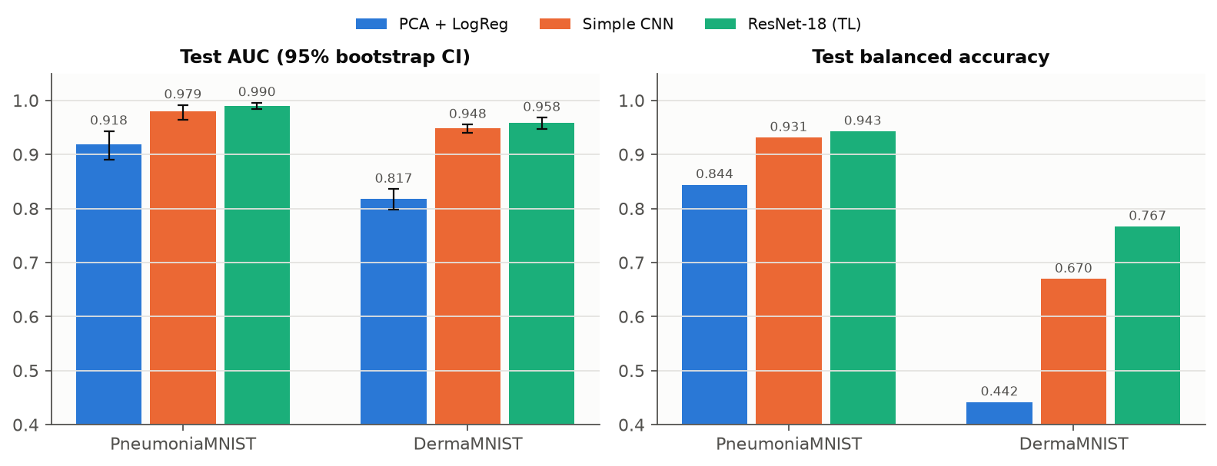
Figure 3. Test AUC with 95% bootstrap confidence intervals (left) and balanced accuracy (right).
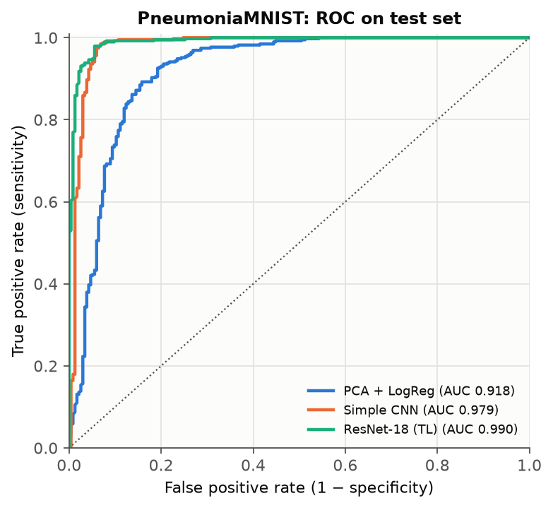 | 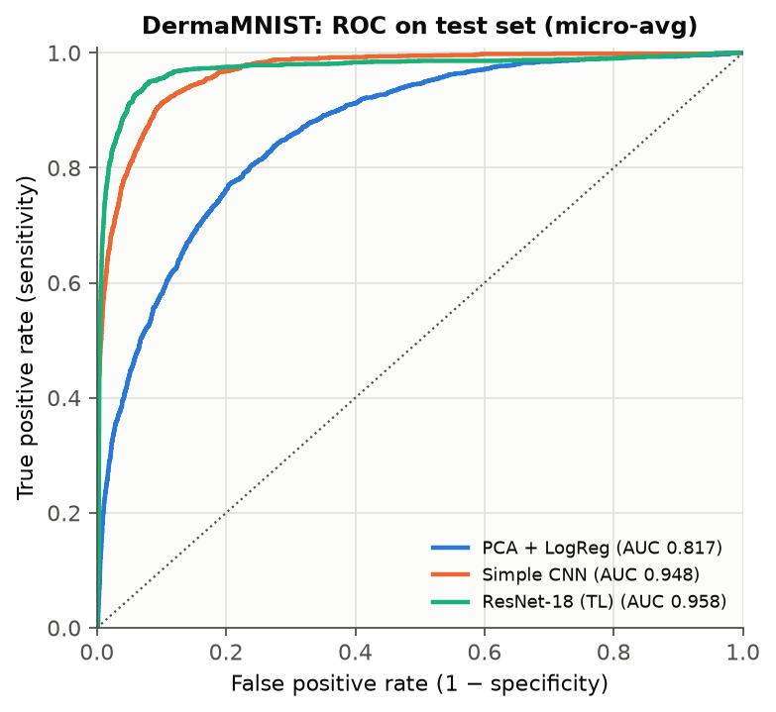
Figure 4. ROC curves on the test sets: PneumoniaMNIST (left) and DermaMNIST, micro-averaged one-vs-rest (right).
The ranking is the same on both datasets: PCA + LogReg < Simple CNN < ResNet-18 (TL). The gap between the classical baseline and the CNNs is large and statistically clear: the confidence intervals do not overlap. On PneumoniaMNIST the baseline already reaches AUC 0.918, because global brightness and texture differ between normal and consolidated lungs. On DermaMNIST it collapses to a balanced accuracy of 44.2%. Colour and shape cues of skin lesions are not linearly separable in pixel space. The difference between the two CNNs is smaller in AUC (0.979 vs. 0.990 and 0.948 vs. 0.958) but substantial in balanced accuracy on DermaMNIST (67.0% vs. 76.7%): pretraining helps mainly on the rare classes.

6.2 PneumoniaMNIST: pneumonia vs. normal
Table 4. PneumoniaMNIST test results at the default threshold and at the threshold selected on the validation split.
Model | Threshold | Sensitivity | Specificity | PPV | NPV | Accuracy
PCA + LogReg | 0.5 | 97.4% | 71.4% | 85.0% | 94.4% | 87.7%
 | 0.26 (Youden, val) | 97.9% | 63.2% | 81.6% | 94.9% | 84.9%
Simple CNN | 0.5 | 99.5% | 86.8% | 92.6% | 99.0% | 94.7%
 | 0.49 (Youden, val) | 99.5% | 86.3% | 92.4% | 99.0% | 94.6%
ResNet-18 (TL) | 0.5 | 99.2% | 89.3% | 93.9% | 98.6% | 95.5%
 | 0.14 (Youden, val) | 99.2% | 81.6% | 90.0% | 98.5% | 92.6%

At the default threshold ResNet-18 misses only 3 of 390 pneumonia cases (sensitivity 99.2%, NPV 98.6%), but produces 25 false alarms among 234 normal images (specificity 89.3%). The error profile is very asymmetric, and for a screening tool that is the desirable direction: a missed pneumonia is more costly than an extra radiologist review. The Simple CNN shows the same pattern with slightly lower specificity.
Threshold tuning on the validation split did not help. The Youden-optimal validation threshold for ResNet-18 was 0.14, which on the test split kept sensitivity at 99.2% but reduced specificity from 89.3% to 81.6%. The cause is a distribution shift between splits. The best validation AUC was 0.9988, almost perfect, while the test AUC is 0.990. Validation images come from the same pool as the training images, while the test images were collected separately by the dataset authors. Figure 5 (left) shows how sensitivity and specificity trade off on the test set: thresholds between about 0.6 and 0.9 raise specificity to 90–93% while sensitivity stays near 99%. Choosing the threshold on test data would be data leakage, however. The correct procedure is to choose the threshold on a calibration set drawn from the target hospital (Section 8).
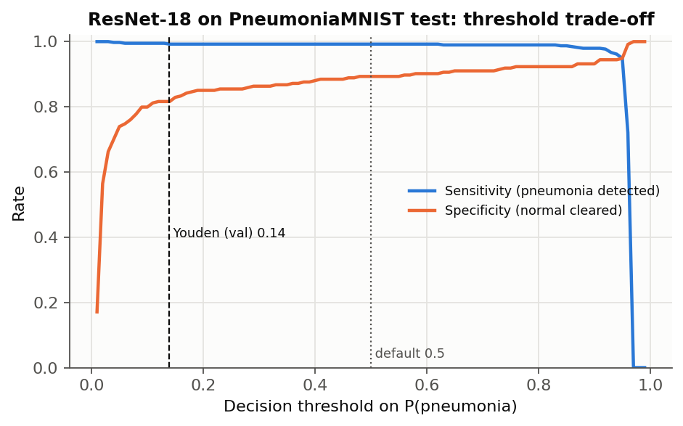 | 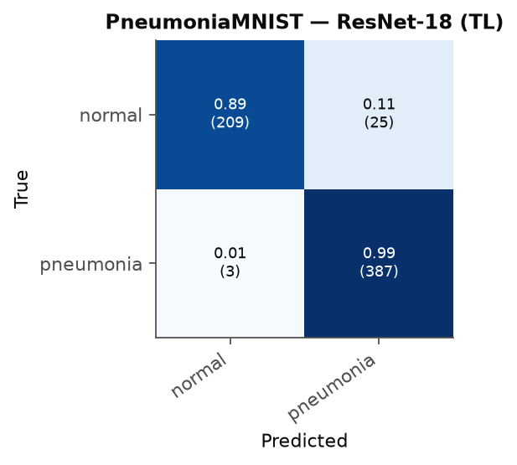
Figure 5. ResNet-18 on the PneumoniaMNIST test set: sensitivity and specificity as a function of the decision threshold (left) and confusion matrix at threshold 0.5, row-normalised with counts in brackets (right).

6.3 DermaMNIST: seven skin-lesion classes
Table 5. Per-class recall (sensitivity) on the DermaMNIST test set.
Class | Test n | PCA + LogReg | Simple CNN | ResNet-18 (TL)
AKIEC (actinic keratoses and intraepithelial carcinoma) | 66 | 0.364 | 0.530 | 0.606
BCC (basal cell carcinoma) | 103 | 0.417 | 0.621 | 0.796
BKL (benign keratosis-like lesions) | 220 | 0.432 | 0.514 | 0.700
DF (dermatofibroma) | 23 | 0.217 | 0.609 | 0.739
MEL (melanoma) | 223 | 0.390 | 0.650 | 0.695
NV (melanocytic nevi) | 1341 | 0.582 | 0.832 | 0.899
VASC (vascular lesions) | 29 | 0.690 | 0.931 | 0.931

The majority class NV has the highest recall among frequent classes (0.899), and the rare malignant class AKIEC the lowest (0.606). The notable exception is VASC: it has only 99 training images but reaches 0.931, because vascular lesions have a distinctive red-purple colour. The clinically most important error is in the melanoma row of Figure 6: 47 of 223 melanomas (21.1%) were predicted as benign nevi. In the opposite direction, 63 nevi were flagged as melanoma. This melanoma-nevus confusion is the classic failure mode reported in the ISIC challenges [4] and the main obstacle to using such a model as a rule-out tool.
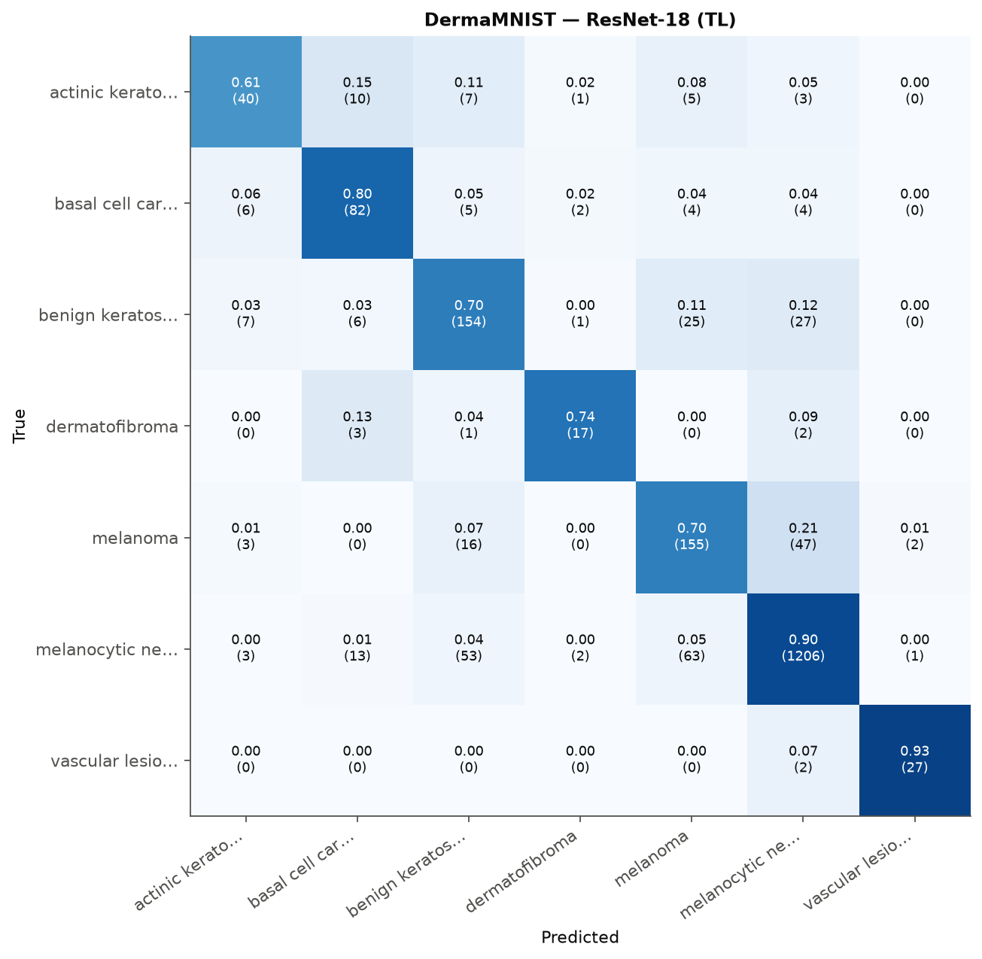
Figure 6. Confusion matrix of ResNet-18 on DermaMNIST (row-normalised; counts in brackets).
Table 6. Clinically grouped view of DermaMNIST: AKIEC + BCC + MEL (n = 392) vs. benign classes, computed from the 7-class probabilities.
Model | Malignant-vs-benign AUC | Malignant sensitivity | Malignant specificity | Melanoma-vs-rest AUC
PCA + LogReg | 0.699 | 57.4% | 73.0% | 0.694
Simple CNN | 0.911 | 74.0% | 85.8% | 0.895
ResNet-18 (TL) | 0.942 | 77.8% | 92.6% | 0.941

Grouping the seven classes into malignant vs. benign gives a more clinical view (Table 6). ResNet-18 detects 77.8% of malignant lesions at 92.6% specificity (AUC 0.942). For a triage tool, this operating point is too conservative: about one malignant lesion in five would not be flagged. Because the AUC is high, sensitivity can be increased by lowering the threshold for the malignant group at the cost of more referrals.

6.4 Training dynamics
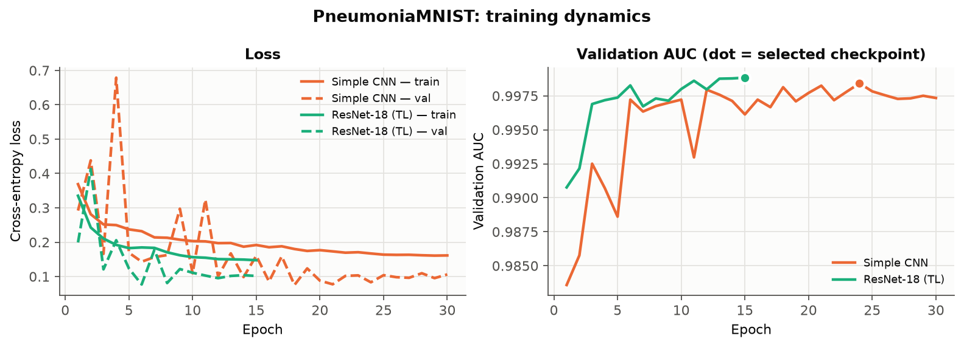
Figure 7. Training and validation loss and validation AUC on PneumoniaMNIST.
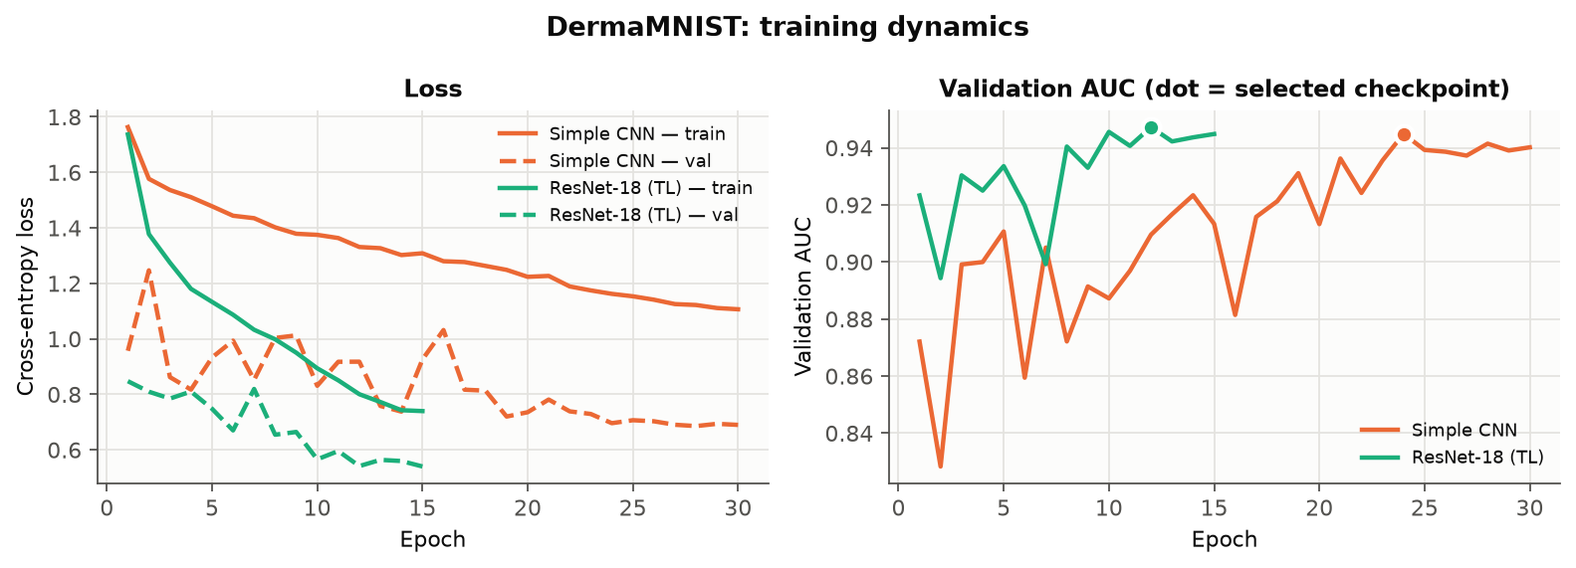
Figure 8. Training and validation loss and validation AUC on DermaMNIST.
ResNet-18 converges faster and to a better optimum. On DermaMNIST its validation AUC exceeds 0.92 after the first epoch and peaks at epoch 12. The CNN trained from scratch needs about 24 epochs and fluctuates strongly in early training. Validation loss stays below training loss for all models. This is expected rather than a sign of leakage: augmentation, dropout, label smoothing and class weighting are active only during training. Neither model shows overfitting within the training budget. On PneumoniaMNIST the validation AUC saturates near 0.998 within a few epochs. The validation split is too easy to discriminate between good models, which is another symptom of the split shift described in Section 6.2.

6.5 Calibration
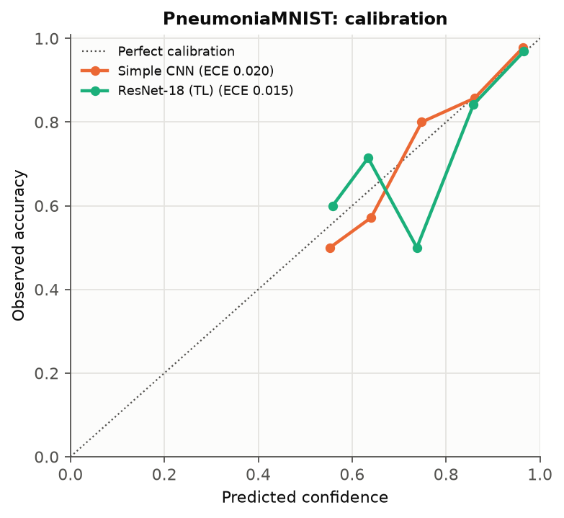 | 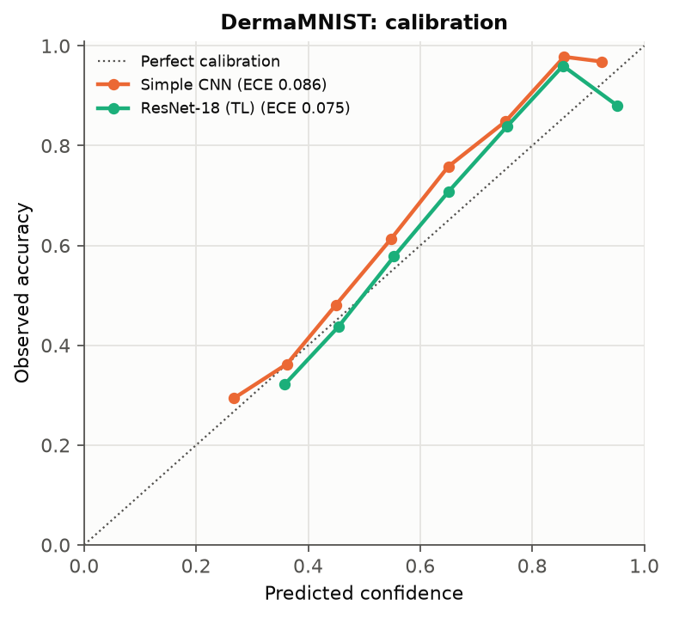
Figure 9. Reliability diagrams on the test sets: PneumoniaMNIST (left) and DermaMNIST (right).
On PneumoniaMNIST both CNNs are well calibrated (ECE 0.020 and 0.015). On DermaMNIST the reliability curves lie *above* the diagonal (ECE 0.086 and 0.075), so the models are systematically *under*-confident: when ResNet-18 predicts a class with 65% confidence, it is correct about 70% of the time. This is the opposite of the over-confidence usually reported for deep networks [11]. It is a side effect of label smoothing and class re-weighting, which both pull probabilities away from the majority class and from extreme values. Temperature scaling on a held-out set would correct it at no cost to accuracy.

6.6 Explainability (Grad-CAM)
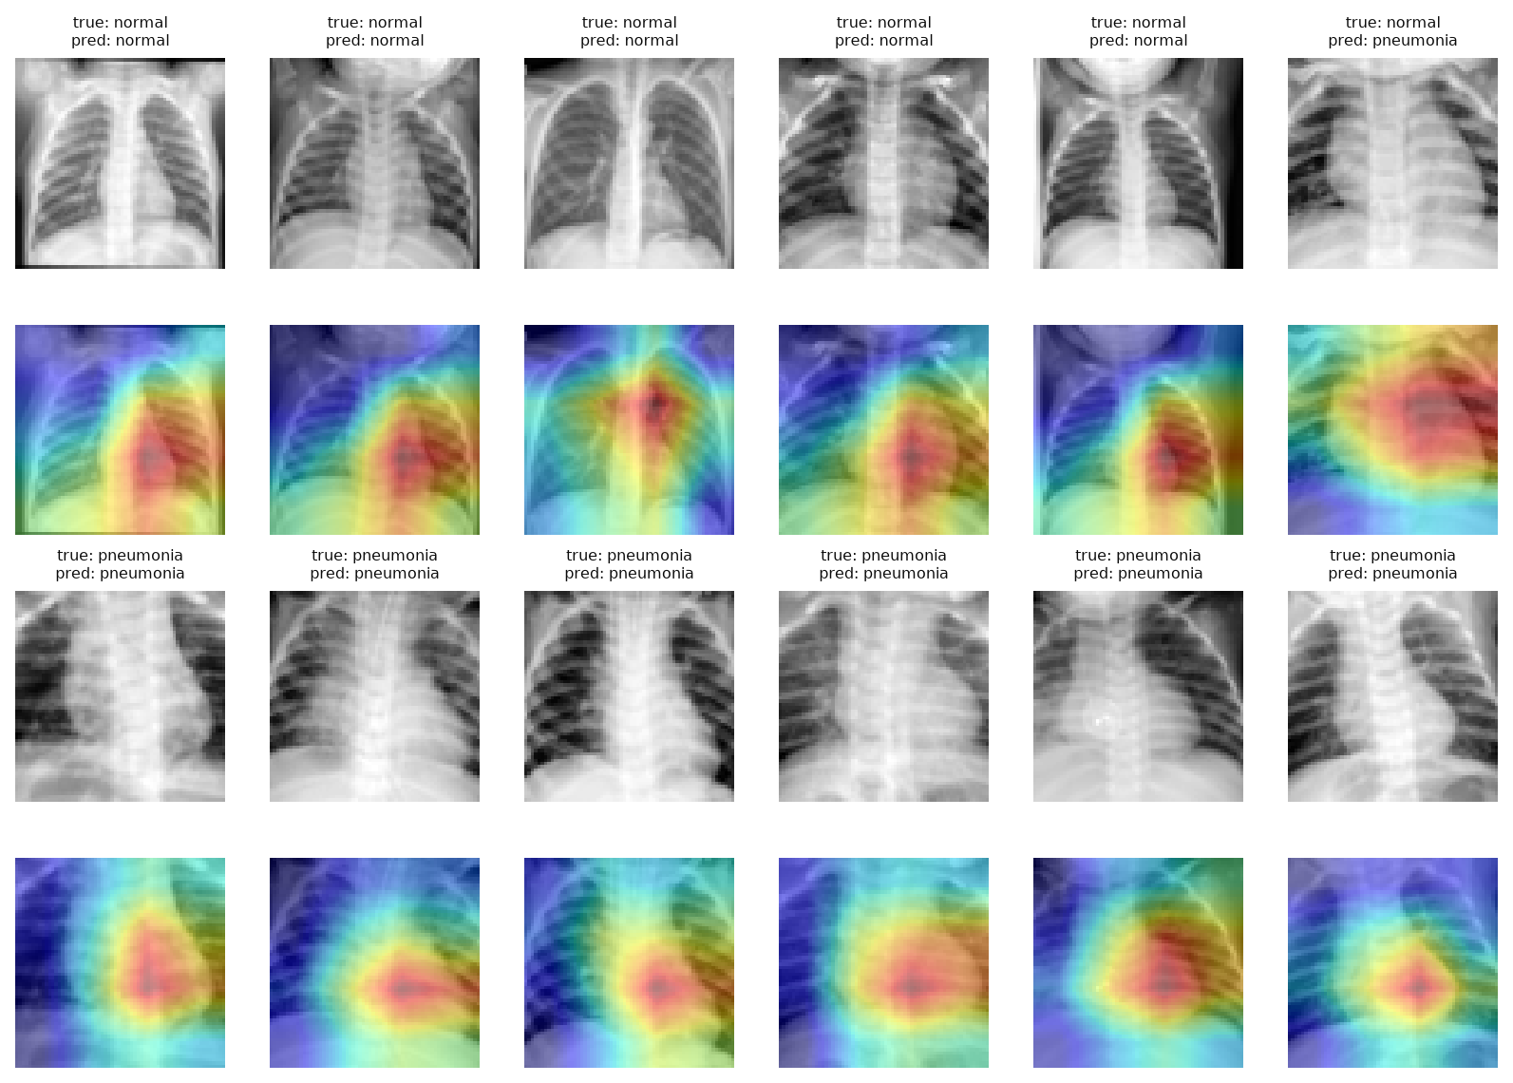
Figure 10. Grad-CAM for ResNet-18 on PneumoniaMNIST test images (top: input; bottom: heatmap; red = high importance).
The heatmaps for pneumonia cases are centred on the lower and middle thorax and often cover parts of the lung fields, which is plausible. However, for several images, including correctly classified normals, the strongest activation lies over the heart and mediastinum rather than the lungs. Part of this is technical: at 64-pixel input the last feature map is only 4×4, so the maps are very coarse. But it also matches the shortcut-learning concern of Zech et al. [12]. Global appearance (body size, positioning, exposure) may correlate with the label in this single-centre dataset. Grad-CAM cannot prove that the model uses a shortcut, but it shows that the model does not obviously rely on focal consolidations. External validation is therefore required.
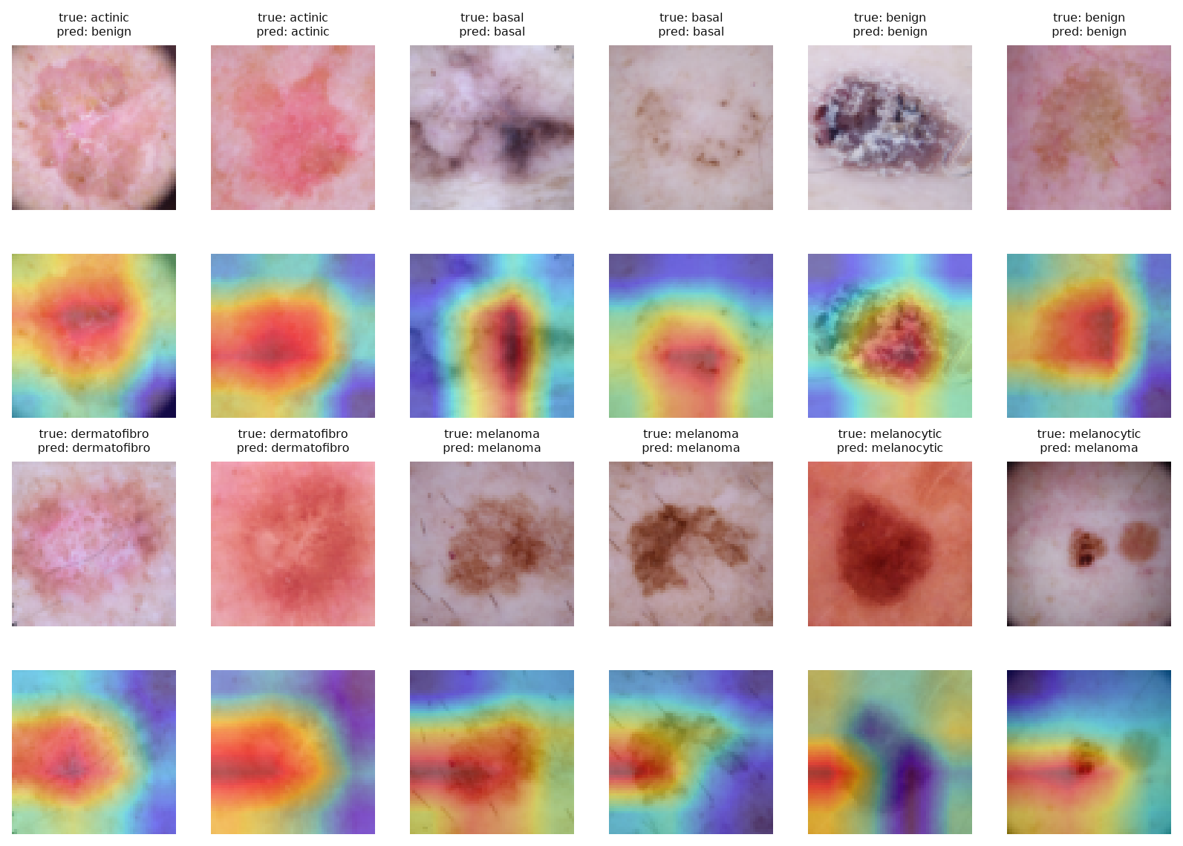
Figure 11. Grad-CAM for ResNet-18 on DermaMNIST test images.
For dermatoscopy the picture is mixed. For AKIEC, BCC, BKL and dermatofibroma the maps are centred on the lesion. For several melanomas and nevi, however, the strongest activation lies at the left image border or on the surrounding skin rather than on the pigmented lesion. This includes the nevus that was misclassified as melanoma. Image borders, vignetting and hair are acquisition properties that correlate with the imaging device and hence with the label distribution in HAM10000. A model that partly relies on them for the melanoma–nevus distinction would be fragile on images from another clinic, which is consistent with this class pair having the highest error rate.

6.7 Comparison with published benchmarks
Table 7. Comparison with baselines reported in the MedMNIST v2 paper (official test splits).
Method (source) | Resolution | Pneumonia AUC | Pneumonia ACC | Derma AUC | Derma ACC
ResNet-18 (Yang et al. [1]) | 28 | 0.944 | 0.854 | 0.917 | 0.735
ResNet-18 (Yang et al. [1]) | 224 | 0.956 | 0.864 | 0.920 | 0.754
Google AutoML Vision (Yang et al. [1]) | 28 | 0.991 | 0.946 | 0.914 | 0.768
ResNet-18 (TL), this study | 64 | 0.990 | 0.955 | 0.958 | 0.838

The results of this study exceed the ResNet baselines of the MedMNIST v2 paper on both datasets and are on par with Google AutoML Vision on PneumoniaMNIST. The likely reasons are ImageNet initialisation, higher input resolution, augmentation and class-weighted loss. The comparison is only indicative because training recipes differ, and it uses a single run with one random seed.

7. Discussion

7.1 Answers to the research questions
RQ1, CNN vs. classical baseline. Learned convolutional features are decisively better. The AUC gain is +0.072 on chest X-rays and +0.141 on dermatoscopy. Balanced accuracy on the seven-class task rises from 44.2% to 76.7%. A linear model on raw pixels is only adequate when the classes differ in global intensity, as normal vs. pneumonic lungs partly do.
RQ2, transfer learning. Pretraining improved every metric, with the largest effect on the imbalanced task (balanced accuracy +9.7 percentage points, macro-F1 +0.141). It also halved the number of epochs required. This agrees with Raghu et al. [9]: pretraining matters most when data are small and is less essential for large, easy binary problems, where the from-scratch CNN came within 0.011 AUC of ResNet-18.
RQ3, class imbalance. Imbalance is the dominant limitation on DermaMNIST. Accuracy (83.8%) overstates performance compared with balanced accuracy (76.7%). The minority malignant classes AKIEC and MEL have the lowest recall, and most errors fall into the majority NV class. Class weighting reduced but did not remove this bias. On PneumoniaMNIST the imbalance favours the positive class, which inflates sensitivity at the expense of specificity.
RQ4, calibration and thresholds. The models were reasonably calibrated (ECE ≤ 0.09) and were under- rather than over-confident. The more important finding concerns thresholds. A threshold optimised on an internal validation split did not transfer to a separately collected test set. Operating points must be set, and periodically re-checked, on data from the deployment site.
RQ5, explainability. Grad-CAM shows lesion-centred attention for dermatoscopy, but diffuse attention to the heart and mediastinum for chest X-rays. High test accuracy on a single-centre benchmark is therefore not evidence of clinically valid reasoning. The risk of shortcut learning and hidden stratification [12, 18] can only be addressed with external, multi-site data.

7.2 Limitations
- Low resolution. 64×64 images discard fine details (small infiltrates, dermatoscopic structures such as pigment networks). Clinical systems operate at 224–1024 px.
- Single-centre data, no external validation. Both datasets come from one institution or one collection effort. Performance on Kazakhstani hospitals, different scanners or skin types (HAM10000 is predominantly fair-skinned) is unknown.
- Single run. Results come from one random seed. Bootstrap CIs capture test-set sampling uncertainty but not training variance. Repeated runs would give a fuller picture.
- Simplified labels. Pneumonia is binary (bacterial and viral merged), and diagnosis in reality also uses clinical context (symptoms, age, history) that the model does not see.
- Retrospective evaluation. No reader study or prospective trial was performed, so the effect on clinicians' decisions is not measured.

8. Recommendations

8.1 Short-term (technical, 0–12 months)
- Use transfer learning by default and report balanced accuracy, per-class sensitivity and confidence intervals, not accuracy alone. Follow TRIPOD+AI [19] when reporting.
- Choose the operating point for the clinical task. For screening, fix a target sensitivity (e.g. ≥ 95% for pneumonia or for the malignant skin-lesion group) and select the threshold on a calibration set drawn from the target site. Never select it on the test set.
- Calibrate with temperature scaling and monitor ECE. Expose calibrated probabilities to clinicians instead of hard labels.
- Handle imbalance explicitly: weighted or focal loss, balanced sampling and, for skin lesions, a hierarchical output (malignant vs. benign first, then subtype).
- Increase resolution to 224 px and evaluate stronger backbones (ConvNeXt, EfficientNet, ViT), self-supervised medical pretraining and ensembles.
- Make explainability and error review routine: inspect Grad-CAM for systematic attention to non-anatomical regions, and test robustness to masking of borders, text markers and vignettes.

8.2 Long-term (deployment and policy, 1–5+ years)
- Build local, multi-centre datasets. Collect de-identified chest X-rays and dermatoscopic images from hospitals in several regions of Kazakhstan, with standardised labelling by multiple specialists. Without local data, performance on the target population cannot be verified.
- Validate externally and prospectively before clinical use: a silent-mode trial, in which the model runs alongside radiologists without influencing decisions, followed by a reader study and a prospective evaluation of patient outcomes.
- Keep a human in the loop. Position the systems as triage and second-reader tools (prioritising the worklist, flagging suspicious lesions in primary care and telemedicine), not as autonomous diagnosticians.
- Establish governance: a national certification pathway for AI software as a medical device, aligned with international practice such as the EU AI Act [20], with requirements for data protection, post-market monitoring of drift and incident reporting.
- Invest in infrastructure and skills: PACS integration, GPU capacity in regional centres or secure cloud, and AI literacy training for radiologists and dermatologists.

9. Conclusion
This case study implemented and evaluated a reproducible pipeline for medical image classification on two public benchmarks. An ImageNet-pretrained ResNet-18 achieved a test AUC of 0.990 for pneumonia detection and a macro AUC of 0.958 for seven-class skin-lesion classification. It clearly outperformed a CNN trained from scratch and, by a wide margin, a classical pixel-based model, and exceeded the reference baselines of the MedMNIST v2 paper.
The more important outcome is the analysis around these numbers. High average AUC coexists with 21% of melanomas being labelled benign. A decision threshold that is optimal on validation data fails to transfer to a new data source, and attention maps sometimes point to anatomy unrelated to the disease. Image classifiers are already technically strong enough to support clinicians. Their safe use depends less on further gains in accuracy than on local data, careful choice of operating points, calibration, external validation and human oversight.

References
[1] Yang, J., Shi, R., Wei, D., Liu, Z., Zhao, L., Ke, B., Pfister, H., & Ni, B. (2023). MedMNIST v2 – A large-scale lightweight benchmark for 2D and 3D biomedical image classification. Scientific Data, 10, 41. https://doi.org/10.1038/s41597-022-01721-8
[2] Kermany, D. S., Goldbaum, M., Cai, W., et al. (2018). Identifying medical diagnoses and treatable diseases by image-based deep learning. Cell, 172(5), 1122–1131.
[3] Tschandl, P., Rosendahl, C., & Kittler, H. (2018). The HAM10000 dataset, a large collection of multi-source dermatoscopic images of common pigmented skin lesions. Scientific Data, 5, 180161.
[4] Codella, N., Rotemberg, V., Tschandl, P., et al. (2019). Skin lesion analysis toward melanoma detection 2018: A challenge hosted by the International Skin Imaging Collaboration (ISIC). arXiv:1902.03368.
[5] He, K., Zhang, X., Ren, S., & Sun, J. (2016). Deep residual learning for image recognition. Proceedings of IEEE CVPR, 770–778.
[6] Esteva, A., Kuprel, B., Novoa, R. A., et al. (2017). Dermatologist-level classification of skin cancer with deep neural networks. Nature, 542, 115–118.
[7] Rajpurkar, P., Irvin, J., Zhu, K., et al. (2017). CheXNet: Radiologist-level pneumonia detection on chest X-rays with deep learning. arXiv:1711.05225.
[8] Litjens, G., Kooi, T., Bejnordi, B. E., et al. (2017). A survey on deep learning in medical image analysis. Medical Image Analysis, 42, 60–88.
[9] Raghu, M., Zhang, C., Kleinberg, J., & Bengio, S. (2019). Transfusion: Understanding transfer learning for medical imaging. Advances in Neural Information Processing Systems 32.
[10] Selvaraju, R. R., Cogswell, M., Das, A., et al. (2017). Grad-CAM: Visual explanations from deep networks via gradient-based localization. Proceedings of IEEE ICCV, 618–626.
[11] Guo, C., Pleiss, G., Sun, Y., & Weinberger, K. Q. (2017). On calibration of modern neural networks. Proceedings of ICML, 1321–1330.
[12] Zech, J. R., Badgeley, M. A., Liu, M., et al. (2018). Variable generalization performance of a deep learning model to detect pneumonia in chest radiographs: A cross-sectional study. PLoS Medicine, 15(11), e1002683.
[13] LeCun, Y., Bengio, Y., & Hinton, G. (2015). Deep learning. Nature, 521, 436–444.
[14] Goodfellow, I., Bengio, Y., & Courville, A. (2016). Deep Learning. MIT Press. https://www.deeplearningbook.org
[15] Topol, E. J. (2019). High-performance medicine: The convergence of human and artificial intelligence. Nature Medicine, 25, 44–56.
[16] World Health Organization. (2022). Pneumonia in children: Fact sheet. https://www.who.int/news-room/fact-sheets/detail/pneumonia
[17] Deng, J., Dong, W., Socher, R., et al. (2009). ImageNet: A large-scale hierarchical image database. Proceedings of IEEE CVPR, 248–255.
[18] Oakden-Rayner, L., Dunnmon, J., Carneiro, G., & Ré, C. (2020). Hidden stratification causes clinically meaningful failures in machine learning for medical imaging. Proceedings of ACM CHIL, 151–159.
[19] Collins, G. S., Moons, K. G. M., Dhiman, P., et al. (2024). TRIPOD+AI statement: Updated guidance for reporting clinical prediction models that use regression or machine learning methods. BMJ, 385, e078378.
[20] Regulation (EU) 2024/1689 of the European Parliament and of the Council laying down harmonised rules on artificial intelligence (Artificial Intelligence Act). Official Journal of the European Union, 2024.
[21] Loshchilov, I., & Hutter, F. (2019). Decoupled weight decay regularization. Proceedings of ICLR.

Appendix A. Reading List and Resources

Primary research paper
- Yang et al. (2023), MedMNIST v2, Scientific Data [1]: benchmark, datasets and baselines used in this study.

Books
- Goodfellow, Bengio & Courville. Deep Learning. MIT Press, 2016 (free online: deeplearningbook.org).
- Zhang, Lipton, Li & Smola. Dive into Deep Learning. Cambridge University Press, 2023 (free online: d2l.ai).
- Zhou, Greenspan & Shen (eds.). Deep Learning for Medical Image Analysis. Academic Press, 2nd ed., 2023.
- Topol, E. Deep Medicine: How Artificial Intelligence Can Make Healthcare Human Again. Basic Books, 2019.

Internet resources
- MedMNIST project page and Python package: https://medmnist.com
- PyTorch and torchvision documentation: https://pytorch.org/docs
- ISIC Archive (skin-lesion images and challenges): https://www.isic-archive.com
- Stanford AIMI shared datasets (CheXpert and others): https://aimi.stanford.edu/shared-datasets
- Papers with Code, medical image classification: https://paperswithcode.com/task/medical-image-classification

Datasets
- Public, used here: PneumoniaMNIST and DermaMNIST (MedMNIST v2), CC BY 4.0.
- Public, related: Kermany chest X-ray (Mendeley Data), HAM10000 (Harvard Dataverse), ChestX-ray14 (NIH), CheXpert (Stanford), MIMIC-CXR (PhysioNet, credentialed access).
- Private/local (recommended for future work): de-identified imaging data from Kazakhstani hospitals under an ethics-committee approval and data-sharing agreement.

Appendix B. Reproducibility
All code is provided with this report. The full experiment and this document are regenerated with:
pip install -r requirements.txt
python run_experiments.py --num-workers 8
python build_report.py

Table 8. Code structure.
File | Purpose
run_experiments.py | Entry point: data loading, training, evaluation, figures
src/data.py | MedMNIST loading, augmentation, class weights
src/models.py | Simple CNN and ResNet-18 transfer model
src/train.py | Training loop (AdamW, one-cycle LR, AMP, best-val-AUC checkpointing)
src/metrics.py | AUC with bootstrap CI, sensitivity/specificity, ECE, Youden threshold
src/gradcam.py | Grad-CAM implementation
src/plots.py | All figures
build_report.py | Generates this report from the saved results
outputs/ | results.json, per-epoch logs, test predictions, figures

Configuration of the reported run: image size 64 px, 30 CNN epochs, 15 ResNet-18 epochs, batch size 64, seed 42, NVIDIA H200 GPU, PyTorch 2.x.

