Software Requirements Specification
for
Online Bookstore
Prepared by Damir Denis,
Asmarandei Catalin,
Baroncea Andrei,
CTI 3rd year, gr. 1309A

Introduction

Purpose
The purpose of this SRS is to cover the scope and functionality of the software product “Online Bookstore”. This includes both the front-end and back-end components necessary to provide e-commerce functionalities related to selling books.

Product Scope
The primary purpose of this software is to provide book lovers and readers with a convenient and user-friendly online marketplace to purchase books from the comfort of their homes. The key objectives include:
- Convenience: Enable users to browse and shop for a wide range of books anytime, anywhere.
- Product Diversity: Offer a diverse selection of books catering to different genres, authors, and languages.
- Customer Satisfaction: Provide a seamless shopping experience with intuitive navigation, secure transactions, and reliable customer support.

Overall Description

Product Perspective
The “Online Bookstore” software is a self-contained product developed to meet the growing demand for purchasing books online.
The diagram below illustrates the major components and interfaces of the system:

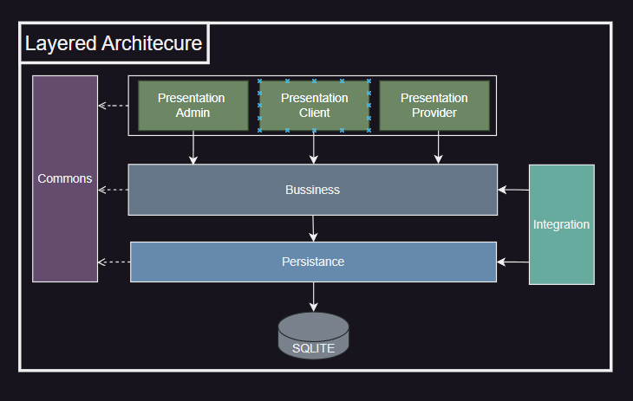

Product Functions
- User Functions:
  - Browse Books: Allow users to view a catalog of books.
  - Search and Filter: Enable users to search for specific books and apply filters based on genres.
  - Add to Cart: Allow users to select books and add them to a virtual shopping cart for purchase.
  - User Account Management: Enable users to create accounts, log in, view order history.
- Administrator Functions:
  - User Management: Enable administrators to manage user accounts, being able to remove users at will.
  - Reporting and Analytics: Provide reporting capabilities to track sales, inventory levels.
- Provider Functions:
  - Book Management: Allow providers to add, edit, or remove books from the catalog.

User Documentation
The "Online Bookstore" software will be accompanied by comprehensive user documentation to facilitate user understanding and adoption of the platform. The user documentation components that will be delivered with the software include the user documentation, which will be delivered in CHM (Compiled HTML Help) format, allowing users to access comprehensive help content offline.

System Features
This section outlines the major system features of the "Online Bookstore" software, describing the functional capabilities and requirements associated with each feature.

3.1 Product Browsing and Search
Description and Priority: This feature enables users to browse the catalog of books and perform searches based on specific criteria (e.g., genre, price range, author).
Stimulus/Response Sequences:
- Stimulus: User selects a genre or enters search criteria.
- Response: System displays relevant books matching the search criteria or selected genre.
Functional Requirements:
- REQ-1: Display a categorized list of books (e.g., fiction, non-fiction, sci-fi, romance).
- REQ-2: Implement search functionality allowing users to search by book title, author, genre, or keywords.
- REQ-3: Provide filtering options to refine search results by price genre.
- REQ-4: Display detailed book information including images, descriptions, and pricing.
- REQ-5: Enable users to add books to their shopping cart directly from the book details page.

3.2 Shopping Cart Management
Description and Priority: This feature allows users to manage items in their shopping cart, review selected books, and proceed to checkout.
Stimulus/Response Sequences:
- Stimulus: User adds or removes items from the shopping cart.
- Response: System updates the cart contents and calculates total order value.
Functional Requirements:
- REQ-1: Display the contents of the user's shopping cart with detailed book information.
- REQ-2: Allow users to add, remove, or update quantities of items in the shopping cart.
- REQ-3: Calculate the total order value including item prices, applicable taxes, and shipping costs.
- REQ-4: Handle cart interactions in real-time to reflect immediate changes made by the user.
- REQ-5: Validate cart items and display error messages for invalid operations (e.g., out-of-stock items).

3.3 User Account Management
Description and Priority: This feature enables users to create accounts, log in, and manage their personal information and order history.
Stimulus/Response Sequences:
- Stimulus: User registers a new account or logs in with existing credentials.
- Response: System authenticates user identity and provides access to account features.
Functional Requirements:
- REQ-1: Implement user registration process with required fields (e.g., name, email, password).
- REQ-2: Enable user authentication through login credentials.
- REQ-3: Provide user profile management options to update personal information (e.g., address, contact details).
- REQ-4: Display order history and status updates for logged-in users.
- REQ-5: Ensure user data privacy and security, storing passwords in hashed format.

3.4 Managing Users (For Administrators)
Description and Priority: This feature allows administrators to manage user accounts, including adding, removing, and modifying user details.
Stimulus/Response Sequences:
- Stimulus: Administrator accesses the user management section.
- Response: System displays user accounts and allows the administrator to perform management actions.
Functional Requirements:
- REQ-1: Provide an interface for administrators to view all user accounts.
- REQ-2: Enable administrators to delete user accounts.
- REQ-3: Ensure that only authorized administrators have access to user management functionalities.

3.5 Managing Books (For Providers)
Description and Priority: This feature allows providers to manage the book catalog, including adding, editing, and removing books.
Stimulus/Response Sequences:
- Stimulus: Provider accesses the book management section.
- Response: System displays the book catalog and allows the provider to perform management actions.
Functional Requirements:
- REQ-1: Provide an interface for providers to view all books in the catalog.
- REQ-2: Enable providers to add new books with necessary details (e.g., title, author, genre, price, description, cover image).
- REQ-3: Allow providers to edit book information (e.g., price, description, availability).
- REQ-4: Enable providers to remove books from the catalog.
- REQ-5: Ensure that only authorized providers have access to book management functionalities.

Other Nonfunctional Requirements

Safety and Security Requirements
The "Online Bookstore" software will implement safety measures to mitigate potential risks and ensure the security of user data and interactions. The safety requirements include:
- Password Security:
  - User passwords will be stored securely in a hashed format using industry-standard cryptographic hashing. This approach ensures that passwords are not stored in plaintext and cannot be easily compromised in the event of a data breach.
- Data Protection:
  - Personal and sensitive user information, including passwords, payment details, and personal profiles, will be encrypted during transmission using SSL/TLS protocols to protect against unauthorized access and interception of data.
- Access Control:
  - Role-based access control (RBAC) mechanisms will be implemented to enforce least privilege principles, ensuring that users, administrators, and providers have appropriate access rights based on their roles within the system.

