**Ex:1**

**a)** This is divided into three phases:

The initial phase - is to fully characterize the data needs of database users. You need to ask the client as much as possible what needs may arise and you need to take everything into account yourself.

The second phase- is the selection of the data model. Applying the concept of the selected data model, translate the requirements that were received at the initial phase into a conceptual database schema. You need to draw all this on paper and on special online sites to visually see how everything will turn out. And you need to describe the types of operations that will be performed with the data.

The final phase- is the transition from an abstract data model to a database implementation. Must decide which database schema we will use. We must choose the right and good design. And make the database schema such that if you need to change/add/delete something, it would be convenient.

**b)** An entity - relationship model (or ER model) describes interrelated things of interest in a specific domain of knowledge. A basic ER model is composed of entity types (which classify the things of interest) and specifies relationships that can exist between entities (instances of those entity types).

**Ex:2**

**a)**

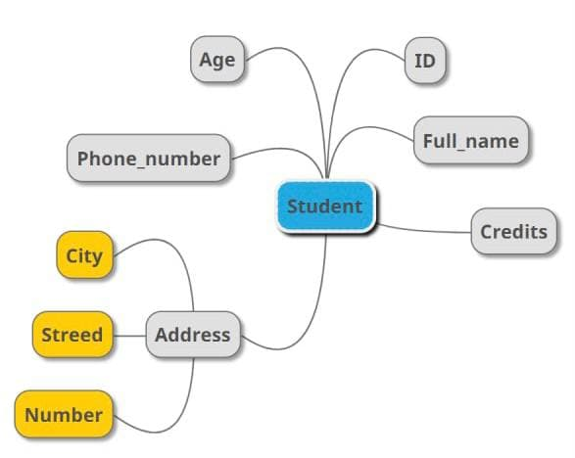

**b)**

|  |
| --- |
| **Student** |
| name |
| university_name |
| faculty |
| id |
| course_id |

|  |
| --- |
| **University** |
| name |
| address |
| Rating |

|  |
| --- |
| **Course** |
| faculty |
| title |
| course_id |

|  |
| --- |
| **Office_registrator** |
| Address |
| Room_number |
| Employee_number |

|  |
| --- |
| **Dormitory** |
| Address |
| Repaired_or_not |
| cost |

|  |
| --- |
| **Teacher** |
| Name |
| Salary |
| ID |

|  |
| --- |
| **Advisor** |
| Student_id |
| Teacher_id |

**Ex:3**

a) One – to – one relationship

ID

has

student

b) One – to – many relationship

assigned

order

customer

c) Many – to – one relationship

college

student

study

b) Many – to – many relationship

assigned

project

student

**Ex:4**

a)

|  |  |
| --- | --- |
| **Table** | |
| PK | S_id |
| FK | First_name  Last_name  Birth_of_date  Phone_number_id |

|  |  |
| --- | --- |
| **Phone_numbers** | |
| PK | Phone_number_id |
|  | number |

b)

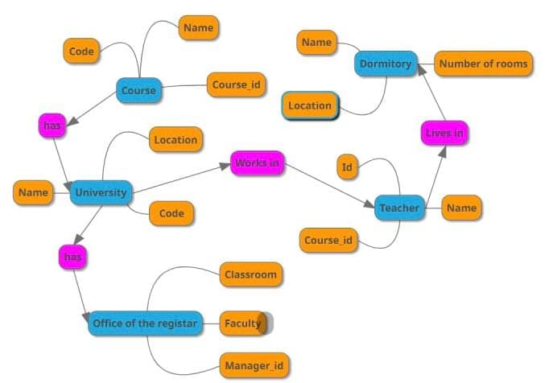

**Ex:5**

|  |  |
| --- | --- |
| **CompanyINFO** | |
| PK | Company_id |
| FK | Name  Location_id |

|  |  |
| --- | --- |
| **Location** | |
| PK | Location_id |
|  | name |

|  |  |
| --- | --- |
| **Employee** | |
| PK | Employee_id |
| FK  FK | Gender  Birth_of_date  Phone_number_id  First_name  Last_name  Company_id  Phone_number_id |

|  |  |
| --- | --- |
| **Works on** | |
| PK, FK | Employee_id |
| PK, FK | Project_id |

|  |  |
| --- | --- |
| **Phone numbers** | |
| PK | Phone_number_id |
|  | Phone_number |

|  |  |
| --- | --- |
| **Project** | |
| PK | Project_id |
| FK | Name  Company_id |