# Practice 1: Direct provisioning of Azure File storage

## Note: Try not to do a copy/paste on commands requests unless you are instructed to do so. Copy/paste will not help you to learn Kubernetes!

1. Login to Azure and connect to your AKS cluster.
2. Check if any pods run under the default namespace if so delete everything under the default namespace.

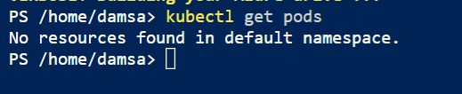

1. In this practice we will directly provision Azure Files to a pod running inside AKS.
2. First create the Azure Files share. Run the following commands:

# Change these four parameters as needed for your own environment AKS_PERS_STORAGE_ACCOUNT_NAME=mystorageaccount$RANDOM AKS_PERS_RESOURCE_GROUP=myAKSShare

AKS_PERS_LOCATION=eastus AKS_PERS_SHARE_NAME=aksshare

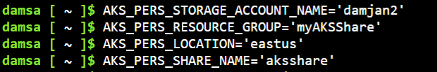

# Create a resource group

az group create --name $AKS_PERS_RESOURCE_GROUP --location $AKS_PERS_LOCATION

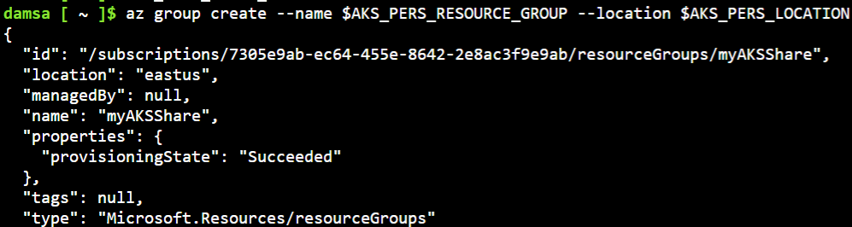

# Create a storage account

az storage account create -n $AKS_PERS_STORAGE_ACCOUNT_NAME -g $AKS_PERS_RESOURCE_GROUP -l

$AKS_PERS_LOCATION --sku Standard_LRS

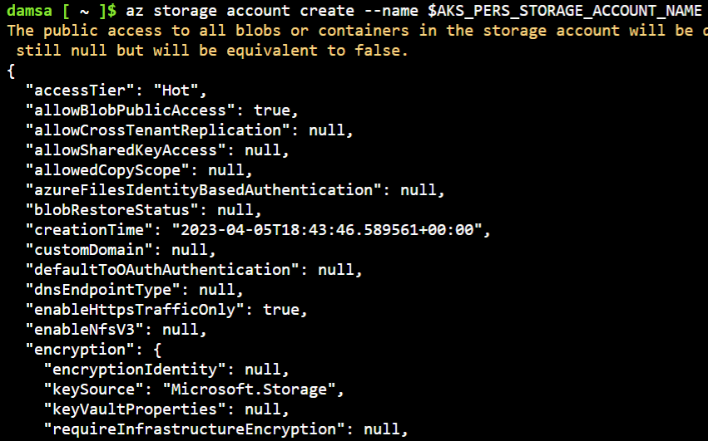

# Export the connection string as an environment variable, this is used when creating the Azure file share export AZURE_STORAGE_CONNECTION_STRING=$(az storage account show-connection-string -n

$AKS_PERS_STORAGE_ACCOUNT_NAME -g $AKS_PERS_RESOURCE_GROUP -o tsv)

# Create the file share

az storage share create -n $AKS_PERS_SHARE_NAME --connection-string

$AZURE_STORAGE_CONNECTION_STRING



# Get storage account key

STORAGE_KEY=$(az storage account keys list --resource-group $AKS_PERS_RESOURCE_GROUP --account-name

$AKS_PERS_STORAGE_ACCOUNT_NAME --query "[0].value" -o tsv)

# Echo storage account name and key

echo Storage account name: $AKS_PERS_STORAGE_ACCOUNT_NAME echo Storage account key: $STORAGE_KEY

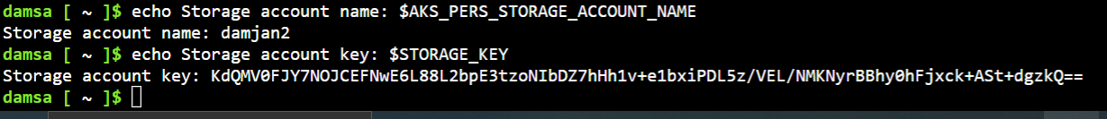

needed when you create the Kubernetes volume in one of the following steps.



5. Make a note of the storage account name and key shown at the end of the script output. These values are

1. Now we will need to create a Kubernetes secret that will be used to mount the Az File Share to the pod. You need to hide this information from the pod’s definition and K8S secret is the best way to do it.
2. Run the following (single) command to create the secret:

**kubectl create secret generic azure-secret --from- \ literal=azurestorageaccountname=$AKS_PERS_STORAGE_ACCOUNT_NAME \**

**--from-literal=azurestorageaccountkey=$STORAGE_KEY**



1. Check if secret was created. Run **kubectl get secret -A**.

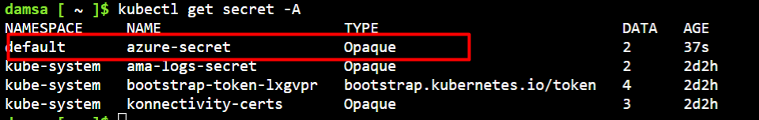

1. Now we can create the pod and mount the Azure File. Create a new file named azure-files-pod.yaml with the following contents:

apiVersion: v1 kind: Pod metadata:

name: mypod spec:

containers:

- image: mcr.microsoft.com/oss/nginx/nginx:1.15.5-alpine

name: mypod

resources: requests:

cpu: 100m

memory: 128Mi

limits:

cpu: 250m

memory: 256Mi

volumeMounts:

- name: azure

mountPath: /mnt/azure

volumes:

- name: azure

azureFile:

secretName: azure-secret

shareName: aksshare

readOnly: false

### Run kubectl apply -f azure-files-pod.yaml.

1. You now have a running pod with an Azure Files share mounted at /mnt/azure.
2. You can use **kubectl describe pod mypod** to verify the share is mounted successfully. Search for the Volumes section of the output

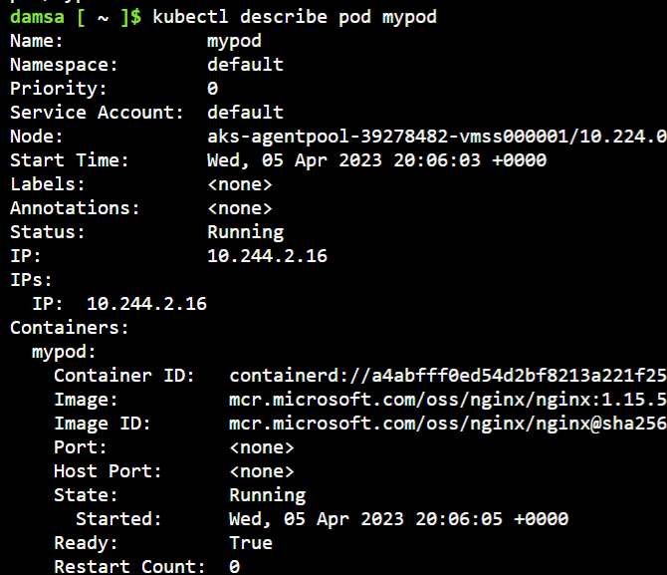

1. Now exec to the pod and try to access the mounted file share. Run the following command **kubectl exec -it mypod – bash**
2. Go to /mnt/azure and create a blank file test.txt file.
3. Go to the portal and locate your Azure storage provisioned for this practice.
4. Under the Files section, check the contents of the Azure file share and check if test.txt file exists.

# Practice 2: Provisioning Azure File storage using PVs and PVCs



17. Delete the mypod. What happens to the Azure File share?

## Note: Try not to do a copy/paste on commands requests unless you are instructed to do so. Copy/paste will not help you to learn Kubernetes!

1. Login to Azure and connect to your AKS cluster.
2. Check if any pods run under the default namespace if so delete everything under the default namespace.
3. Now we will provision Azure files storage to a pod using PV and PVC.
4. Create a azurefile-mount-options-pv.yaml file with a PersistentVolume like this:

apiVersion: v1

kind: PersistentVolume metadata:

name: azurefile spec:

capacity:

storage: 5Gi

accessModes:

- ReadWriteMany

azureFile:

secretName: azure-secret

shareName: aksshare

readOnly: false

mountOptions:

- dir_mode=0777

- file_mode=0777

- uid=1000

- gid=1000

- mfsymlinks

- nobrl

1. Note the access mode. Can you use other mode with Azure files?
2. Now create a azurefile-mount-options-pvc.yaml file with a PersistentVolumeClaim that uses the PersistentVolume like this:

apiVersion: v1

kind: PersistentVolumeClaim metadata:

name: azurefile spec:

accessModes:

- ReadWriteMany

storageClassName: ""

resources:

requests:

storage: 5Gi

### pvc.yaml.



7. Execute **kubectl apply -f azurefile-mount-options-pv.yaml** and **kubectl apply -f azurefile-mount-options-**

### 

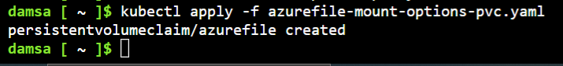

1. Verify your PersistentVolumeClaim is created and bound to the PersistentVolume. Run **kubectl get pvc azurefile.**

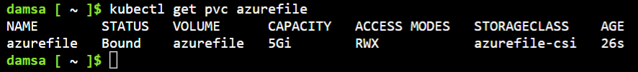

1. Now we can embed the PVC info inside our pod definition. Create the following file azure-files-pod.yaml with following content:

apiVersion: v1 kind: Pod metadata:

name: mypod spec:

containers:

- image: mcr.microsoft.com/oss/nginx/nginx:1.15.5-alpine

name: mypod

resources: requests:

cpu: 100m

memory: 128Mi

limits:

cpu: 250m

memory: 256Mi

volumeMounts:

- name: azure

mountPath: /mnt/azure

volumes:

- name: azure

persistentVolumeClaim:

claimName: azurefile

### Run kubectl apply -f azure-files-pod.yaml.

1. You now have a running pod with an Azure Files share mounted at /mnt/azure.
2. You can use **kubectl describe pod mypod** to verify the share is mounted successfully. Search for the Volumes section of the output.

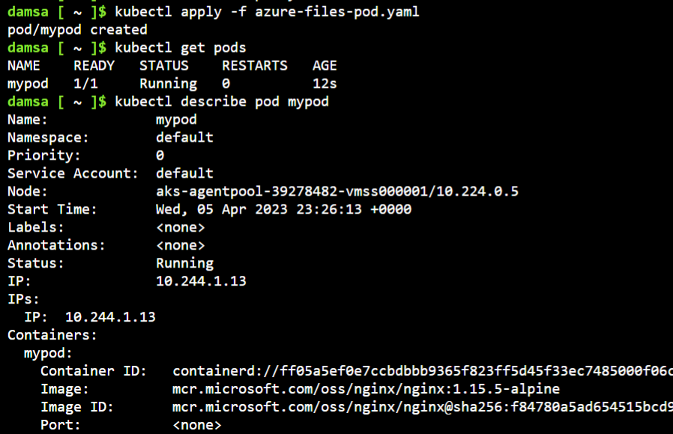

1. Now exec to the pod and try to access the mounted file share. Run the following command **kubectl exec -it mypod -- bash**
2. Go to /mnt/azure and create a blank file test.txt file.
3. Go to the portal and locate your Azure storage provisioned for this practice.
4. Under the Files section, check the contents of the Azure file share and check if test.txt file exists.
5. Delete the mypod the pv and pvc you have created so far. What happens to the Azure File share?

# Practice 3: Provisioning Azure file storage using Storage Classes



## Note: Try not to do a copy/paste on commands requests unless you are instructed to do so. Copy/paste will not help you to learn Kubernetes!

1. Login to Azure and connect to your AKS cluster.
2. Check if any pods run under the default namespace if so delete everything under the default namespace.
3. Now we will provision file storage using the definition of storage classes. Create a file named azure-file-sc.yaml and copy in the following example manifest:

kind: StorageClass apiVersion: storage.k8s.io/v1 metadata:

name: my-azurefile

provisioner: kubernetes.io/azure-file mountOptions:

- dir_mode=0777

- file_mode=0777

- uid=0

- gid=0

- mfsymlinks

- cache=strict

- actimeo=30 parameters:

skuName: Standard_LRS

1. Create the storage class with **kubectl apply -f azure-file-sc.yaml** .

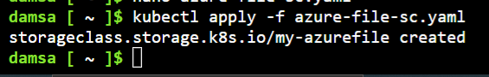

1. Now we will create the PVC that will consume the storage class defined previously. Create a file named azure- file-pvc.yaml and copy in the following YAML:

apiVersion: v1

kind: PersistentVolumeClaim metadata:

name: my-azurefile spec:

accessModes:

- ReadWriteMany

storageClassName: my-azurefile

resources:

requests:

storage: 5Gi

1. Create the persistent volume claim with the **kubectl apply -f azure-file-pvc.yaml.**

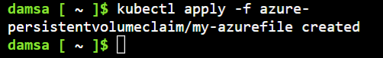

information and credentials. You can use the **kubectl get pvc my-azurefile** command to view the status of the PVC.



7. Once completed, the file share will be created. A Kubernetes secret is also created that includes connection

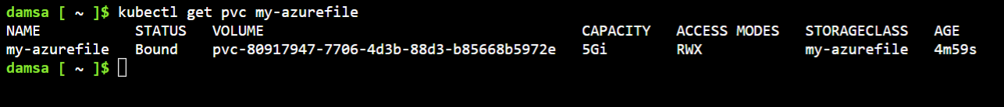

1. Now we will create the pod that consumes the PVC. Create a file named azure-pvc-files.yaml, and copy in the following YAML. Make sure that the claimName matches the PVC created in the last step:

kind: Pod apiVersion: v1 metadata:

name: mypod spec:

containers:

- name: mypod

image: mcr.microsoft.com/oss/nginx/nginx:1.15.5-alpine

cpu: 100m

resources: requests:

memory: 128Mi

limits:

cpu: 250m

memory: 256Mi

volumeMounts:

- mountPath: "/mnt/azure"

name: volume

volumes:

- name: volume

persistentVolumeClaim:

claimName: my-azurefile

1. Create the pod with **kubectl apply -f azure-pvc-files.yaml .**
2. Do a describe on the pod and check the volumes mounted.
3. Delete everything created under this practice including the storage class.

# Practice 4: Direct provisioning of Azure Disk storage

## Note: Try not to do a copy/paste on commands requests unless you are instructed to do so. Copy/paste will not help you to learn Kubernetes!

1. Login to Azure and connect to your AKS cluster.
2. Check if any pods run under the default namespace if so delete everything under the default namespace.
3. In this practice we will directly provision Azure Disk to a pod running inside AKS.
4. First create the disk in the node resource group. First, get the node resource group name with **az aks show -- resource-group myResourceGroup --name myAKSCluster --query nodeResourceGroup -o tsv** .



1. Now create a disk using:

az disk create \

--resource-group MC_myResourceGroup_myAKSCluster_eastus \

--name myAKSDisk \

--size-gb 20 \

--query id --output tsv

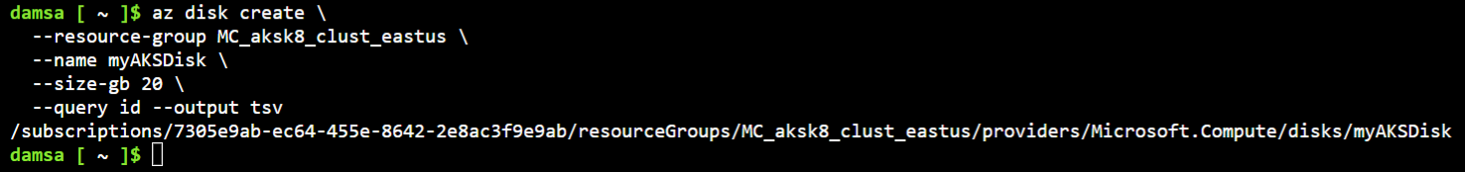

create the Kubernetes volume in one of the following steps.



6. Make a note of the disk resource ID shown at the end of the script output. This value is needed when you

1. Now we can create the pod and mount the Azure Disk. Create a new file named azure-disk-pod.yaml with the following contents:

apiVersion: v1 kind: Pod metadata:

name: mypod spec:

containers:

- image: mcr.microsoft.com/oss/nginx/nginx:1.15.5-alpine

name: mypod

resources: requests:

cpu: 100m

memory: 128Mi

limits:

cpu: 250m

memory: 256Mi

volumeMounts:

- name: azure

mountPath: /mnt/azure

volumes:

- name: azure

azureDisk:

kind: Managed

diskName: myAKSDisk

diskURI: **<!!!!!!!!!!!!! Put the Disk resource id noted before!!!**>

### Run kubectl apply -f azure-disk-pod.yaml.

1. You now have a running pod with an Azure Disk mounted at /mnt/azure.
2. You can use **kubectl describe pod mypod** to verify the share is mounted successfully. Search for the Volumes section of the output.
3. Now exec to the pod and try to access the mounted volume. Run the following command **kubectl exec -it mypod -- bash**
4. Go to /mnt/azure and try create a blank file test.txt file.
5. Delete everything created by this practice.

# Practice 5: Provisioning Azure Disk storage using Storage Classes



## Note: Try not to do a copy/paste on commands requests unless you are instructed to do so. Copy/paste will not help you to learn Kubernetes!

1. Login to Azure and connect to your AKS cluster.
2. Check if any pods run under the default namespace if so delete everything under the default namespace.
3. Now we will provision Azure disk and attach it to a running pod but this time using dynamic provisioning with storage classes. List the available storage classes, run **kubectl get sc.**

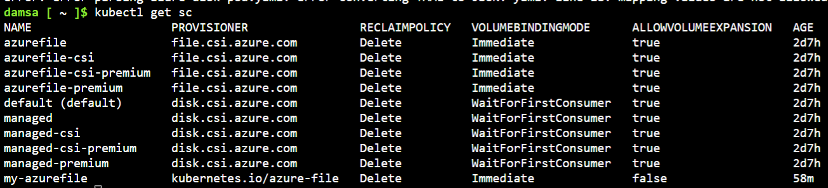

1. Examine the output. Each AKS cluster includes four pre-created storage classes, two of them configured to work with Azure disks, default and managed-premium. We will use the managed-premium in our PVC definition since it uses premium type of disks.
2. Now we will create the PVC that will consume the storage class defined previously. Create a file named azure- premium.yaml and copy in the following YAML:

apiVersion: v1

kind: PersistentVolumeClaim metadata:

name: azure-managed-disk spec:

accessModes:

- ReadWriteOnce

storageClassName: managed-premium

resources:

requests:

storage: 5Gi

1. Create the persistent volume claim with the **kubectl apply -f azure-premium.yaml.**

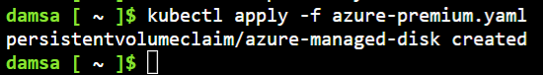

1. Check the status of your PVC.

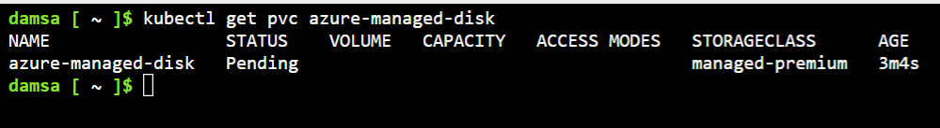

1. Now we will create the pod that consumes the PVC. Create a file named azure-pvc-disk.yaml, and copy in the following YAML. Make sure that the claimName matches the PVC created in the last step:

kind: Pod apiVersion: v1 metadata:

name: mypod spec:

containers:

- name: mypod

image: mcr.microsoft.com/oss/nginx/nginx:1.15.5-alpine

cpu: 100m

resources: requests:

memory: 128Mi

claimName: azure-managed-disk



limits:

cpu: 250m memory: 256Mi

volumeMounts:

* mountPath: "/mnt/azure" name: volume

volumes:

* name: volume persistentVolumeClaim:

1. Create the pod with **kubectl apply -f azure-pvc-disk.yaml .**
2. Do a describe on the pod and check the volumes mounted.
3. Delete everything created under this practice including the storage class.