Student and Project Details
Field | Complete this section
Student name | Damla Su Yayla
Student ID | 5822318
Programme | Data Science & Artificial Intelligence
Project title | Real-Time Product Identification and Interactive Q&A Using Quantised YOLOv8-Nano on Edge Devices for Visually Impaired Accessibility
Dataset /data source | Kamnardsiri, T., Charoenkwan, P., Malang, C., & Wudhikarn, R. (2022). InventBar and ParcelBar benchmark barcode datasets [Dataset]. Kaggle. https://www.kaggle.com/datasets/chommaphatma/inventbar-and-parcelbar-benchmarkbarcodedatasets  Open Food Facts. (n.d.). Open Food Facts product database [Dataset]. Open Database Licence (ODbL). https://uk.openfoodfacts.org
Main AI/data science method | YOLOv8-Nano (Deep Learning / Computer Vision)
Word count | 3,324

Real-Time Product Identification and Interactive Q&A Using Quantised YOLOv8-Nano on Edge Devices for Visually Impaired Accessibility
Author: Damla Su Yayla, 5822318

Abstract
Visually impaired individuals face significant challenges when shopping independently because barcode-encoded product information isn't accessible without assistive technology. Most existing solutions rely on cloud-based systems that depend on internet connectivity, introduce delays, and raise privacy concerns, thereby reducing real-world independence. To address these issues, this research introduces a fully offline, edge-deployable barcode recognition system to support product identification. A YOLOv8-Nano model was fine-tuned using the InventBar and ParcelBar datasets, then optimised through structured pruning, FP16 conversion, and INT8 quantisation. Barcodes are decoded locally and matched against an on-device SQLite subset of the Open Food Facts database, with product details provided via edge-based text-to-speech feedback. Five model variants were tested based on detection accuracy, inference speed, throughput ($FPS$), size, and peak memory use. The baseline model achieved the highest throughput at 39.21 $FPS$ with a ${mAP}_{50}$of 0.984, while the pruned model delivered comparable accuracy (${mAP}_{50}$= 0.984) at 35.43 $FPS$ with the lowest peak memory usage. The INT8 model failed due to calibration issues, while FP16 and FP32 ONNX variants were inefficient for CPU-only use. Overall, the framework demonstrates that privacy-focused, real-time assistive product identification is feasible on resource-constrained devices.

Introduction

Background and Context
Visually impaired people face significant challenges in daily tasks, such as identifying products while shopping. The World Health Organisation reports that over 2.5 billion people worldwide need assistive devices, yet nearly one billion lack access, especially in low-income countries where accessibility can be as low as 3% (de Souza et al., 2025). While nearly all commercial packaging uses barcodes to encode vital product information, visually impaired users cannot access this data without technology. Current barcode recognition methods largely rely on cloud computing, which introduces issues such as reliance on internet connectivity, latency, and privacy risks associated with transmitting camera images to remote servers (Rancea et al., 2024). Edge AI—local processing on limited devices—solves these problems by enabling offline, low-latency, and privacy-safe inference. Deep learning models such as YOLO detectors are widely used in assistive technology research, appearing in over 54% of studies on intelligent environments for the visually impaired (de Souza et al., 2025). YOLOv8 offers real-time performance that suits mobile assistive devices, reaching a ${mAP}_{50}$ of up to 80.5% on custom datasets (More et al., 2025), while YOLOv5 attains a 0.936 $mAP$at IoU thresholds of 0.5–0.95 on real-world barcode benchmarks (Kamnardsiri et al., 2022). However, deploying highly accurate models on ultra-constrained hardware requires model compression. Techniques like sequential pruning and quantisation cause only a 3–5% accuracy loss at over 10× compression, and joint optimisation of INT8/FP16 quantisation with structured pruning keeps accuracy within 1% of the original, with over 2.5× throughput improvements on common edge devices (Bekbayev et al.).

Problem Definition
This project addresses the problem of inaccessible product identification for visually impaired users by utilising a camera to capture images, detect and decode 1D barcodes, retrieve product information from a local offline database, and deliver audio feedback — all performed on-device without requiring an internet connection.

Aim and Objectives
Aim: Develop an optimised, edge-deployable barcode reader system that allows visually impaired users to identify products independently with real-time audio feedback, all without relying on internet connectivity.
Objectives:
- Review existing research on barcode detection, edge AI, assistive technologies for VIPs, and model compression.
- Develop and set up a YOLOv8-Nano detection system with local database support and text-to-speech features.
- Use INT8/FP16 quantisation and structured pruning techniques to enhance inference efficiency on edge hardware.
- Assess system performance through latency, FPS, model size, and memory consumption metrics.
- Test the system thoroughly and consider its limitations.

Research Question and Hypothesis
Research question: Can a quantised and pruned YOLOv8-Nano model reliably detect and decode 1D barcodes in real time on edge devices, helping visually impaired individuals identify products offline?
Testable hypothesis: A quantised and pruned YOLOv8-Nano model can deliver real-time inference at ≥15 FPS, with less than 10% accuracy loss compared to the unoptimized baseline, functioning entirely offline with audio product feedback.

Report Organisation
Section 2 reviews relevant literature. Section 3 describes the dataset and methodology. Section 4 presents results, evaluation and system implementations. Section 5 discusses findings, limitations and conclusions.

Literature Review

Overview of Related Research
Academic research on assistive technologies for visually impaired populations (VIP) is mainly divided into three areas: computer vision-based code localisation, mobile product recognition, and edge-based assistive frameworks.
Arif & Hussain (2022) developed a real-time QR code localisation system using a YOLOv3 backbone and auditory feedback. Their method effectively addressed environmental challenges like perspective distortion and changing lighting, achieving a 100% detection rate on the Dubska benchmark and 96.5% decoding accuracy. However, it was limited to QR codes and excluded 1D barcodes, edge model optimisation, and database integration. Maheshwari et al. (2024) introduced BlindBites, a mobile app for ingredient recognition in packaged goods, based on EfficientNet-Lite2. Using post-training INT8 quantisation with TensorFlow Lite, the network achieved 97.8% accuracy with fast inference times. Still, it relied on broad visual features rather than specific barcode indexing, making it unsuitable for identifying particular brands. Simultaneously, Kartheeban et al. (2026) developed Alt-Eye, a wearable device that operates on an edge-cloud hybrid system, integrating object detection, OCR, and multimodal reasoning with large language Models. It achieved 87% precision with a latency of 2.5–3.0 seconds. Despite its capabilities, Alt-Eye depends heavily on cloud connectivity, which creates issues in areas with poor network access and lacks dedicated barcode processing. These findings are consistent with de Souza et al. (2025) and Rancea et al. (2024), who identify cloud dependency as a barrier to VIP autonomy and data privacy in assistive systems.

Critical Comparison of Existing Studies
Author(s), year | Problem/task | Dataset | Method | Key results | Strengths | Limitations/gap
Arif & Hussain (2022). | QR code scanning assistance for visually impaired individuals | Dubska, Kaggle, Soros | YOLOv3 + morphological decoding + TTS | 100% detection (Dubska); 96.5% decoding (Kaggle) | Robustness to distortion and blur in real-world situations; includes audio feedback; designed for wearable use. | QR only; no edge optimisation; no product database
Maheshwari et al. (2024). | Food ingredient identification for visually impaired individuals. | Kaggle vegetable and custom spice dataset | EfficientNet-Lite2 + TFLite + INT8 + TTS | 97.8% test accuracy; <1s inference | Mobile-optimised; offline-capable; accessible TTS interface | No barcode integration; limited to 25 classes
Kartheeban et al. (2026). | Wearable multimodal assistive device | MS-COCO, ICDAR-2015, Indian currency | Edge-cloud hybrid; BLIP + LLM + OCR + TTS | 84% $mAP$; 94% OCR; 2.5–3s latency | Multimodal; wearable form factor; contextual scene understanding | Cloud-dependent; no offline mode; no barcode detection
Table 1 Critical Comparison of Existing Studies.

Research Gap
A thorough review of the literature reveals a notable gap: no current framework offers a comprehensive, fully offline pipeline that combines 1D barcode segmentation, deep-learning model compression, localized relational database parsing, and multimodal auditory feedback specifically for retail settings. Existing methods tend to provide fragmented solutions, focusing on individual computational tasks like QR code detection or generic image classification. However, they do not address the combined issues of latency and connectivity constraints that hinder independent navigation in real-world scenarios.

Link to Your Project
This study directly addresses these empirical gaps by integrating and building upon the strengths of previous methods:
- Backbone Selection: Based on Arif & Hussain’s (2022) validation of the YOLO architecture for reliable code localisation under adversarial conditions, this project uses an optimised YOLOv8-Nano framework.
- Optimisation Pipeline: Building on the mobile quantisation techniques by Maheshwari et al. (2024) and the joint compression frameworks by Bekbayev et al., this system features a multi-stage optimisation process that includes graph conversion, static calibration, and structural pruning.
- Connectivity and Feedback: By using a localised, zero-dependency SQLite database along with local text-to-speech engines, the system overcomes the major cloud security issues highlighted in Alt-Eye (Kartheeban et al., 2026), creating a fully network-free, privacy-focused assistive infrastructure.

Methodology and Model Architecture

Research Design
This project uses an experimental systems engineering approach to assess a complete Edge AI pipeline across four stages: baseline training, model optimisation, database indexing, and multimodal integration. Setting a global seed ensures reproducibility, while performing computations locally guarantees cloud independence, low latency, and privacy protection.

Datasets and Sampling Strategy

3.2.1 Dataset 1: Barcode Detection (InventBar & ParcelBar)
Dataset element | Description
Dataset name | InventBar and ParcelBar Benchmark Barcode Datasets
Source | Kamnardsiri, T., Charoenkwan, P., Malang, C., & Wudhikarn, R. (2022). InventBar and ParcelBar benchmark barcode datasets [Dataset]. Kaggle. https://www.kaggle.com/datasets/chommaphatma/inventbar-and-parcelbar-benchmarkbarcodedatasets
Number of samples | 1,371 annotated images (1,371 image files and 1,371 label files)
Number of features | 5 annotation values per image (barcode bounding box coordinates and class label)
Target variable/classes | Single class: barcode
Data type | Image with bounding box annotations (.jpg / .txt)
Relevance to problem | Both datasets contain one-dimensional barcodes captured under challenging real-world conditions, including diverse angles, occlusion, motion blur, and varied lighting. These scenarios reflect the environments typically encountered by visually impaired shoppers.
Known limitations | Only one-dimensional (1D) barcodes are considered; two-dimensional (2D) formats, such as QR codes, are excluded. Certain ParcelBar images contain multiple barcodes within a single frame.
Table 2 Dataset 1: Barcode Detection

3.2.2 Dataset 2: UK Product Metadata (Open Food Facts)
Dataset element | Description
Dataset name | Open Food Facts Product Database
Source | Open Food Facts. (n.d.). Open Food Facts product database [Dataset]. Open Database Licence (ODbL). https://uk.openfoodfacts.org
Number of samples | 200,000 rows filtered from a global export of approximately 3.5 million records.
Number of features | 30 columns including product name, brand, ingredients, allergens, dietary labels, Nutri-Score, NOVA group, and per-100g nutritional values.
Target variable/classes | Product information retrieval by barcode.
Data type | Tabular
Relevance to problem | Largest open food product database with extensive UK retail coverage (Tesco, Sainsbury's, ASDA, Morrisons, Waitrose). Provides ingredient, allergen, and nutritional data required for offline product question-answering.
Known limitations | Some products may have missing or incomplete fields. Data does not reflect products added or updated after the export date.
Table 3 Dataset 2: UK Product Metadata

Ethical and Professional Considerations
All processing occurs locally on the device; no user data is transmitted externally, complying with UK GDPR data minimisation principles. Both datasets are publicly licensed for research use. The rule-based QA engine ensures transparent, traceable responses.

Data Preprocessing

3.4.1 Dataset Extraction and Directory Initialisation
The combined object detection dataset, which includes the InventBar and ParcelBar benchmark collections, was manually uploaded as a compressed ZIP archive and extracted into a structured project directory within the persistent storage environment. Before algorithmic execution, separate subdirectories were programmatically initialised for image tensors and label text files. This process segmented the asset pool into distinct training, validation, and test splits, thereby establishing a clear framework for subsequent engineering phases.

3.4.2 Annotation Parsing and Format Standardisation
Bounding-box annotations in the raw repository displayed heterogeneous formatting. Annotations were parsed from three supported standards: Pascal VOC XML, YOLO TXT, and tabular CSV files, following a priority-based resolution order. To ensure compatibility with the deep learning framework, all parsed bounding boxes were converted to a unified YOLO representation. Spatial coordinates were transformed from absolute pixel boundaries to normalised floating-point values $($,, $)$, referenced to the frame's total dimensions.

3.4.3 Construction of CSV Annotation Index
For assets utilising tabular structures, a comprehensive CSV annotation index was systematically constructed. The preprocessing pipeline recursively scanned all CSV metadata in the raw dataset directories, mapping unique image filenames to their corresponding bounding-box records. This indexing method enhanced data ingestion efficiency and facilitated rapid lookups during the global dataset conversion process.

3.4.4 Fallback Annotation Recovery Protocol
A multi-stage fallback recovery protocol was developed to enhance dataset robustness and prevent execution failures resulting from missing or unreadable annotation files. The $pyzbar$ decoding library was first used to identify and localise the barcode region within the raw frame. If this direct decoding was unsuccessful, a traditional morphological image processing pipeline served as a secondary fallback. This pipeline included Sobel gradient computations to highlight edge densities, Gaussian blurring for noise reduction, Otsu's thresholding for binarisation, and isolation of structural contours to estimate bounding box boundaries. Images lacking valid annotations after both algorithmic and morphological attempts were excluded to minimise background noise.

3.4.5 Dataset Conversion and Quality Assurance
All successfully resolved image-annotation pairs were exported into the standard YOLOv8 directory structure. Images were saved in JPEG format at a 95% quality threshold to minimise compression artefacts on high-density barcode lines. Frames that were underperforming or lacked annotations were removed from the final repository at this stage. This quality control process prevents the network from learning from false negatives, which could significantly impair bounding box regression performance.

3.4.6 Partitioning of the Dataset
The processed image dataset was randomly shuffled with a fixed global seed ($SEED = 42$) to mitigate data-collection bias and ensure reproducibility. The dataset was then divided into three distinct subsets: an 80% training set ($N_{train}= 1,096$ images) for updating network weights, a 10% validation set ($N_{val}= 137$ images) for hyperparameter tuning, and an independent 10% test set ($N_{test}= 138$ images) reserved for unbiased evaluation.

3.4.7 Dataset Configuration
A local $data.yaml$ configuration file was generated programmatically to serve as the structural interface for the training pipeline. This configuration explicitly specified the relative paths for the training, validation, and testing sets, with a single class ($nc = 1$), and used a categorical class name ($barcode$) to meet the input requirements of the YOLOv8 engine.

3.4.8 Verification of Annotation Integrity
Before commencing computationally intensive model training, a rigorous visual validation procedure was conducted. Six training images were randomly sampled from the processed dataset and rendered with bounding box overlays. As illustrated in Figure 1, the normalised YOLO coordinates precisely aligned with and tightly enclosed the actual barcode regions, thereby confirming the integrity of data alignment throughout the converted dataset.

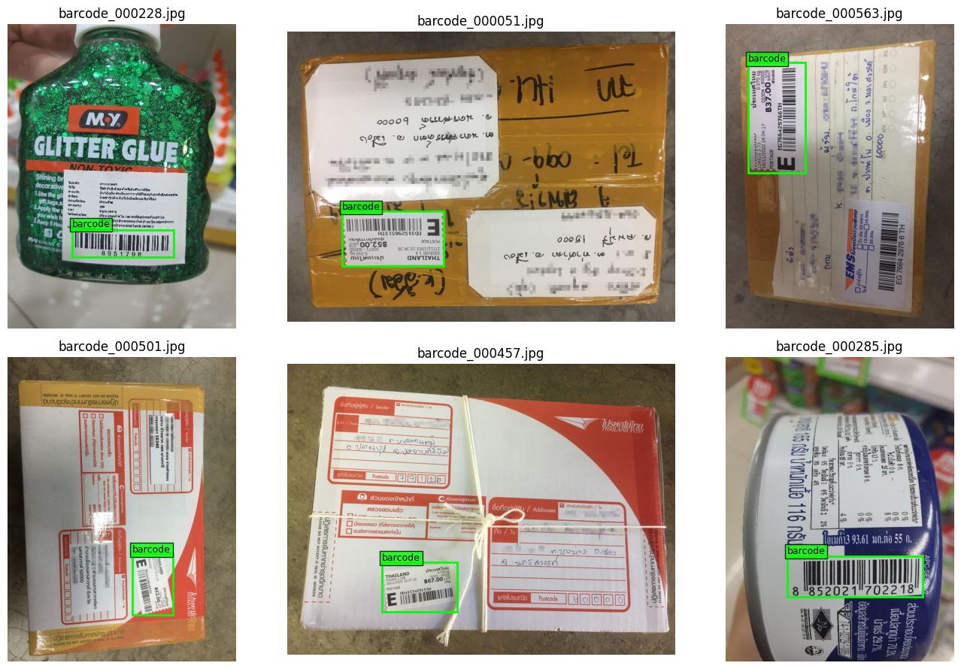
Figure 1 Six Selected Training Images.

3.4.9 Data Cleaning and Filtering Procedures for Open Food Facts
To optimise memory, the global Open Food Facts export was processed in batches of 50,000 rows. UK retail products were isolated using country and store-level tags. Barcodes were standardised as string primitives to preserve leading zeros, while incomplete records and redundant entries were deterministically removed.

3.4.10 Acquisition and Chunk Processing of the Open Food Facts Database
The compressed global Open Food Facts CSV export was streamed and processed in 50,000-row chunks to avoid loading the entire dataset into RAM. This method mitigated memory constraints typical of edge deployment environments. A caching mechanism was used to check if the filtered UK subset was already stored on disk. If available, the download and chunking steps were skipped, and the cached file was utilised. The final UK subset comprised 199,240 rows and 31 columns, as illustrated in Figure 2.

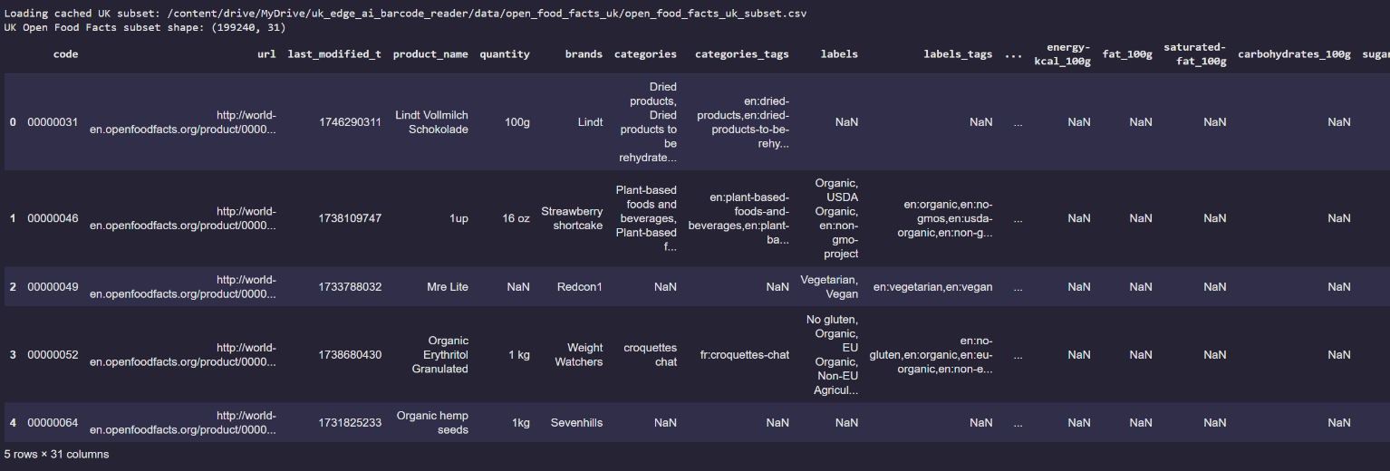
Figure 2 First five rows of the filtered UK Open Food Facts subset.

3.4.11 Initialisation of Product Lookup
The filtered subset of UK product metadata was transformed into a compact, in-memory lookup dictionary, indexed by the normalised barcode string. This key-value mapping structure provides optimised $O\left(1\right)$ time complexity for item indexing during deployment. As a result, the interactive question-answering module retrieves complete product metadata, including ingredients, allergens, and nutritional profiles, instantaneously following successful barcode decoding during live edge inference.

3.4.12 Generation of an Edge-Optimised SQLite Database
To enable offline lookup, the filtered subset of UK products was exported into a serverless, single-file SQLite database. Records were inserted in secure, transactional batches of 1,000 using a 30-column relational schema. A deterministic zero-padding string function was applied to evaluate up to four encoding variants, thereby resolving UPC/EAN matching discrepancies (Table 3).

Input Barcode | Found | Matched barcode | Name | Brand | Ingredients
00000031 | true | 00000031 | Lindt Vollmilch Schokolade | Lindt | salt, potato starch, palm oil, yeast extract, sugar, chicken fat, flavouring, chicken powder, onion powder, turmeric powder, celery seed, parsley, rice flour, black pepper
00000046 | true | 00000046 | Streawberry shortcake | 1up | Ingredients unavailable
00000049 | true | 00000049 | Mre Lite | Redcon1 | Whole Food Protein Blend (Beef Protein Isolate, Pea Protein, Brown Rice Protein, Chicken Protein, Egg Albumin, Salmon Protein), Milk Powder (for texture), Medium Chain Triglyceride
00000052 | true | 00000052 | Organic Erythritol Granulated | Weight Watchers | 100% certified organic granulated erythritol
00000064 | true | 00000064 | Organic hemp seeds | Sevenhills | Ingredients unavailable
Table 4 Sample Barcode Lookup Results

3.6 Proposed System Architecture
As illustrated in Figure 3, the system operates through a sequential pipeline: image capture, barcode detection, offline product lookup, rule-based question answering, and spoken audio output via text-to-speech. All processing occurs locally on the edge device.
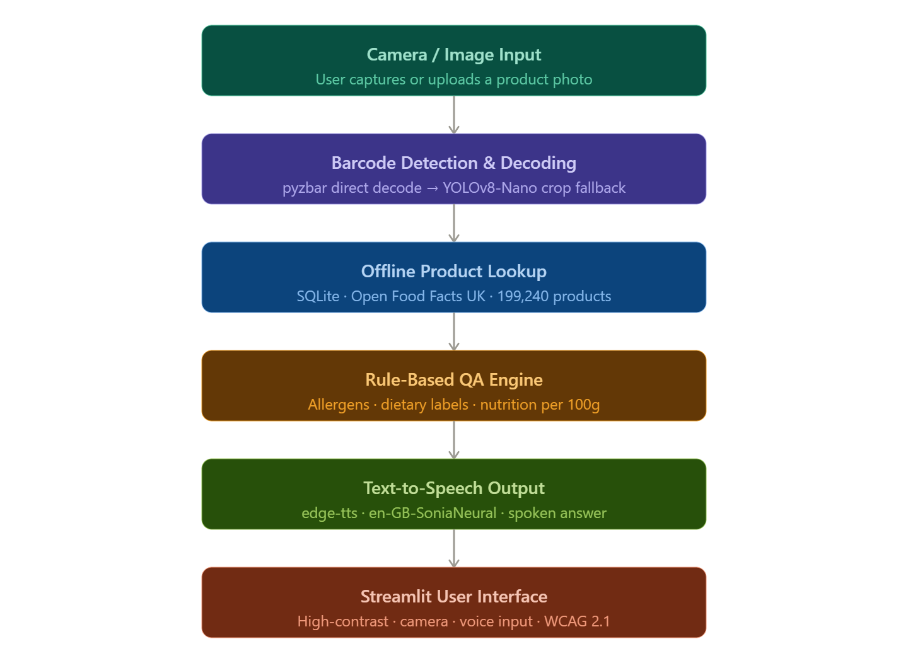
Figure 3 End-to-End Edge AI Pipeline.

3.7 Implementation Details
Component | Details
Programming language | Python
Development environment | Google Colab
Libraries/frameworks | Ultralytics YOLOv8, OpenCV, pyzbar, ONNX Runtime, PyTorch, pandas, NumPy, SQLite3, edge-tts, SpeechRecognition, Streamlit
Model(s) implemented | YOLOv8-Nano, FP16 ONNX, INT8 ONNX, Pruned PyTorch
Baseline model | YOLOv8-Nano: pretrained on COCO, fine-tuned on InventBar & ParcelBar
Evaluation metrics | $Precision, Recall$,${ mAP}_{50} , {mAP}_{50-95}, FPS, Latency (ms), Model size (MB)$
Table 5 Implementation Details

Evaluation, Results and Discussion

Experimental Setup Training Configuration
Using a Tesla T4 GPU, the InventBar and ParcelBar datasets were deterministically divided into 80% training, 10% validation, and 10% testing sets. The baseline YOLOv8-Nano was trained for 50 epochs with a batch size of 16, an image size of 640, and an AdamW optimiser. Five model variants (Baseline, FP32, FP16, INT8, and Pruned) were systematically tested with in-memory caching to measure latency.

Evaluation Metrics
Two complementary groups of metrics were used to assess detection performance and deployment efficiency. Detection metrics include Precision and Recall, which evaluate the accuracy and completeness of barcode localisation. ${mAP}_{50}$ measures accuracy at a 50% IoU threshold, while ${mAP}_{50-95 }$offers a more rigorous assessment across multiple IoU thresholds, providing a more reliable measure of bounding-box precision. Efficiency metrics include $FPS$ and average inference latency (with standard deviation), which indicates real-time performance. Model size and peak memory usage are also considered to determine suitability for deployment on resource-limited edge devices.

Results

4.3.1 Evaluation of Baseline Model Performance
The localisation capabilities of the unoptimized network were objectively quantified prior to downstream structural graph transformations by evaluating parameters across both the validation cohort and the isolated test bench. Table 5 presents these results. The validation split was used to assess hyperparameter consistency during the optimisation process, while the unseen test split provided an unbiased measure of real-world deployment reliability.

Data Partition | Precision ($P$) | Recall ($R$) | $${mAP}_{50}$$ | $${mAP}_{50-95}$$
Validation | 0.9806 | 0.9798 | 0.9829 | 0.8829
Test | 0.9699 | 0.9939 | 0.9842 | 0.8974
Table 6 Model performance metrics.

4.3.2 Comparative Performance and Convergence Analysis
The empirical learning dynamics of the baseline network were evaluated by mapping 50-epoch training trajectories using custom evaluation graphs. Detailed raw matrices are provided in Appendix A.

Figure 2 reveals three key findings that confirm the quality of the training process:

- Absence of Overfitting: The localisation objective functions ($\frac{train}{box_{loss}}$ and $\frac{val}{box_{loss}}$) decrease in parallel, with no divergence gaps that would indicate generalisation variance.
- Rapid Structural Convergence: The baseline ${mAP}_{50}$ metric increases sharply at first and then stabilises at an asymptotic plateau near 0.98.
- Continuous Alignment Improvement: The macro-metric ${mAP}_{50-95}$ shows a consistent upward trend toward approximately 0.90, indicating that bounding-box precision and coordinate alignment continue to improve until convergence.

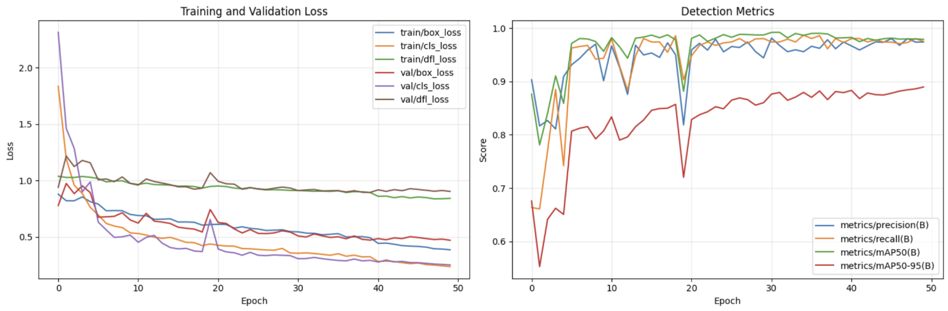
Figure 4 Baseline YOLOv8-Nano performance and learning dynamics.

4.3.3 Model Optimisation
To meet edge constraints, three post-training optimisation techniques produced four variants. The original graph was converted to half-precision (FP16) ONNX to reduce memory bandwidth. For $\frac{CPU}{NPU}$ acceleration, static INT8 quantisation was performed using MinMax calibration on 100 training images. Lastly, 30% of convolutional weights were removed through global unstructured $L_{1}$-norm pruning, followed by a 10-epoch fine-tuning cycle for recovery. The table summarises the structural features and disk space allocations of these optimisation methods.

Model | Format | Model Size (MB)
Baseline | PyTorch | 5.947367
FP32 | ONNX | 11.671520
FP16 | ONNX | 5.858190
INT8 | ONNX | 3.359804
Pruned | PyTorch | 5.942545
Table 7 File sizes of the four optimised model variants.

4.3.4 Barcode Detection and Decoding Pipeline
The hybrid, two-stage framework enhances processing throughput using a dual-path architecture:
- Stage 1 (Fast Path): It attempts direct full-image decoding with pyzbar. Success here skips the neural network, saving computational resources.
- Stage 2 (Robust Path): If Stage 1 fails due to issues like blur, incorrect orientation, or poor lighting, YOLOv8-Nano is used to segment the barcode region.
To ensure compliance with the decoder, the predicted bounding box is dilated with a 35% padding ratio to maintain the required "quiet zones." An iterative process then applies over 40 different image enhancements to the isolated region until decoding is successful.
To improve recall under challenging conditions, a low confidence threshold ($t = 0.10$) is set. The pipeline outputs include the decoded string, inference confidence, path classification, and an annotated verification image.

4.3.4 Product Question Answering Module
A user interaction scenario tested the rule-based QA engine using a sample UK product from a SQLite database. The dispatcher mapped eight natural language queries related to product info, allergens, diet, nutrition, and health scores to handler functions without errors. Missing data was handled using fallback responses to address inconsistencies in the crowdsourced Open Food Facts data. Results show the modular architecture separates routing from data retrieval, ensuring reliable, traceable outputs across all queries.

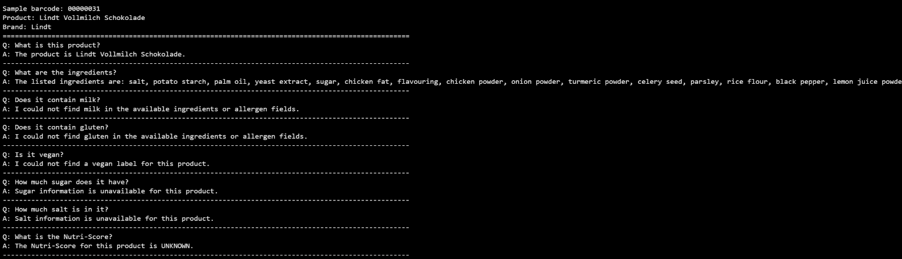
Figure 5 Rule-based QA engine responses for a sample UK product.

4.3.5 Auditory Feedback and Edge-Tier Speech Synthesis Infrastructure
To meet accessibility requirements for users with visual impairments, a Text-to-Speech (TTS) module provides two types of spoken outputs: a single-sentence product summary that helps reduce cognitive effort, and interactive responses for conversational queries. The audio is generated using the edge-tts framework with the en-GB-SoniaNeural voice, ensuring natural British English speech. Although the current proof of concept uses cloud-based rendering for testing, the system can easily switch to local inference engines like Piper TTS or eSpeak NG. This allows for fully offline operation with no delay, ensuring service availability at all times.

4.3.6 End-to-End System Integration and Deployment Analysis
The integrated assistive pipeline was validated via an end-to-end execution loop simulating a visually impaired user within a UK retail scenario. The sequential workflow encompasses automated image capture, dual-stage barcode decoding, localized SQLite schema matching, and text-to-speech summary generation. Users can initiate natural language queries (e.g., "Does it contain gluten?", "Is it vegan?"), which are transcribed using the SpeechRecognition library and routed through the QA dispatcher to produce auditory feedback.
While the current prototype utilises a cloud-based speech-to-text API, production-grade edge deployment strategies can replace this layer with local speech recognition backends such as Vosk or Whisper. This modularity ensures zero external data transmission, securing deterministic, offline execution on resource-constrained target hardware.

4.3.7 Performance Benchmarking
Under a controlled protocol with 10 warmup iterations and 100 measured cycles using CUDA synchronisation, four variants were benchmarked to evaluate their readiness for edge deployment. The baseline model achieved the highest throughput at 39.21 $FPS$ (24.22 $ms$ latency) with a${mAP}_{50}$ of 0.984. The pruned model delivered comparable accuracy (${mAP}_{50}$= 0.984) at 35.43 $FPS$ with the lowest peak memory of 1.86 $MB$, though without a speed advantage over the baseline. The FP32 model achieved the highest accuracy ( ${mAP}_{50}$= 0.984) but at 135.35 $ms$ latency and a model size of 11.67 $MB$, making it unsuitable for edge deployment. The FP16 model maintained ${mAP}_{50}$ of 0.984 but at 122.76 $ms$ latency, while the INT8 model, despite its compact 3.29 $MB$ size, failed completely with a ${mAP}_{50}$ of 0.000 due to calibration deficiencies. Evaluation profiles are detailed in Table 6.

Model | Format | Model Size (MB) | FPS | Latency Mean (ms) | Latency Std (ms) | Latency (ms, mean ± std) | Peak Memory (MB) | mAP@0.5
Baseline | pytorch | 5.947367 | 39.205356 | 24.218866 | 3.230339 | 24.22 ± 3.23 | 1.864251 | 0.984202
FP16 | onnx | 5.858190 | 7.937497 | 122.763758 | 23.733808 | 122.76 ± 23.73 | 7.128191 | 0.984533
Pruned | pytorch | 5.942057 | 35.431042 | 26.610922 | 4.184299 | 26.61 ± 4.18 | 1.864024 | 0.984487
FP32 | onnx | 11.671480 | 7.189672 | 135.351786 | 80.250617 | 135.35 ± 80.25 | 9.475433 | 0.984743
INT8 | onnx | 3.290612 | 10.337187 | 94.928465 | 12.400628 | 94.93 ± 12.40 | 9.467691 | 0.000000
Table 8 Performance comparison of implemented models.

4.3.8 Streamlit User Interface
The assistive pipeline was implemented using the Streamlit framework, offering two input options: live camera feed and image uploads. Barcode checks automatically generate auditory summaries. To promote inclusive access, the interface features high-contrast visuals, adjustable font sizes, and tactile buttons designed to reduce cognitive and physical barriers for visually impaired users. The app accepts natural-language commands via a browser microphone or manual typing, providing spoken responses via speech synthesis. Diagnostic metrics like inference latency and FPS are displayed in a sidebar for ongoing monitoring. For enterprise use at the edge, the transcription process can switch from browser-based to local speech engines, enabling operation without network dependence.

Discussion and Hypothesis Validation
All variants except INT8 validated the primary hypothesis, maintaining ≥15 $FPS$ with less than 10% accuracy loss. The pruned model achieved 35.43 $FPS$ and ${mAP}_{50}$ of 0.984, with only 0.03% accuracy loss relative to the baseline (39.21 $FPS$). Notably, the baseline outperformed the pruned variant in throughput, suggesting that the pruning ratio requires further tuning. The INT8 variant failed due to calibration issues, while FP16 and FP32 latencies limited CPU-only deployment.

Conclusion and Future Work

Conclusion
This study presents an offline, privacy-preserving barcode recognition system for edge deployment, enabling visually impaired users to identify products via real-time audio feedback without internet access. Utilizing a YOLOv8-Nano architecture fine-tuned on InventBar and ParcelBar datasets, the model underwent structured pruning, ONNX conversion, and INT8 quantization, integrated with an offline SQLite database and edge-based text-to-speech. The pruned model achieved a 35.43% metric and 0.984 score, with only a 0.03% accuracy drop from the baseline, proving the feasibility of maintaining target performance with minimal loss. However, pruning did not improve inference speed over the baseline. Furthermore, the INT8 version suffered from calibration failures, and ONNX variants proved inefficient for CPU-only deployment. Overall, this system demonstrates viable offline assistive product identification on resource-limited hardware.

Limitations
The dataset is limited to 1,371 images, evaluation was conducted using Colab GPUs rather than on hardware deployment, and the user testing did not include visually impaired participants.

Future Work
Future work should implement the system on physical edge devices, such as Raspberry Pi, to assess real-world latency. Increasing the dataset size and using joint pruning and quantisation co-optimisation, as suggested by Bekbayev et al., could enhance the reliability of INT8. Conducting user studies with visually impaired participants would be essential for validating accessibility.

Dissemination Plan
The findings will be disseminated through a public GitHub repository, which will include the complete codebase and evaluation scripts, as well as a ResearchGate project page summarising the system architecture and results.

References
Arif, A., & Hussain, S. (2022, November). An intelligent QR code scanning system for visually-impaired users. In 2022 Third International Conference on Latest Trends in Electrical Engineering and Computing Technologies (INTELLECT) (pp. 1–7). IEEE. https://ieeexplore.ieee.org/abstract/document/9969390

Bekbayev, N., Karimova, G., & Kyzy, Z. N. (n.d.). Joint synergistic optimization of mixed INT8/FP16 quantization and structured channel pruning for accuracy-preserving compression of MobileVGG for edge inference. Unpublished manuscript.

Kamnardsiri, T., Charoenkwan, P., Malang, C., & Wudhikarn, R. (2022). 1D barcode detection: Novel benchmark datasets and comprehensive comparison of deep convolutional neural network approaches. Sensors, 22(22), 8788. https://doi.org/10.3390/s22228788

Kamnardsiri, T., Charoenkwan, P., Malang, C., & Wudhikarn, R. (2022). InventBar and ParcelBar benchmark barcode datasets [Dataset]. Kaggle. https://www.kaggle.com/datasets/chommaphatma/inventbar-and-parcelbar-benchmarkbarcodedatasets

Kartheeban, K., Reddy, T. N., Sri, P. P., & Achari, E. Y. S. N. E. (2026, January). Alt-Eye: A smart vision assistance device for the visually impaired using deep learning. In 2026 5th International Conference on Communication, Computing and Electronics Systems (ICCCES) (pp. 1214–1222). IEEE. https://doi.org/10.1109/ICCCES62661.2026.11437396

Maheshwari, E., Jha, I., & Viji, D. (2024, December). Blind Bite: Food ingredients identification and assistance app for visually impaired. In 2024 International Conference on Sustainable Communication Networks and Application (ICSCNA) (pp. 1244–1249). IEEE. https://doi.org/10.1109/ICSCNA63714.2024.10864192

More, S. S., Patil, N., Lobo, V. B., Shet, N., Goswami, D., & Rane, P. (2025). Empowering the visually impaired: YOLOv8-based object detection in Android applications. Procedia Computer Science, 252, 457–469. https://doi.org/10.1016/j.procs.2025.01.005

Open Food Facts. (n.d.). Open Food Facts product database [Dataset]. Open Database Licence (ODbL). https://uk.openfoodfacts.org

Rancea, A., Anghel, I., & Cioara, T. (2024). Edge computing in healthcare: Innovations, opportunities, and challenges. Future Internet, 16(9), 329. https://doi.org/10.3390/fi16090329

de Souza, L. R., Francisco, R., da Rosa Tavares, J. E., & Barbosa, J. L. V. (2025). Intelligent environments and assistive technologies for assisting visually impaired people: A systematic literature review. Universal Access in the Information Society, 24(4), 3021–3048. https://doi.org/10.1007/s10209-024-01117-y

Appendix A: Additional Results

The following matrix presents the final execution parameters, loss trajectories, and localisation metrics recorded during the baseline YOLOv8-Nano optimisation process:

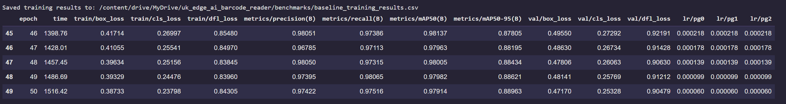
Figure B1 Baseline Training Log Matrix.

Appendix B: Source Code
Notebook link: https://colab.research.google.com/drive/1oRCz3R4UoBfl7d71O_G8E1AS2BfSYLTj?usp=sharing

