Contents

Creating Class and Inheriting Class: 2

Methods: 3

Objects: 4

String Functions: 5

Method Parametrize: 6

Operators: 7

Decision Making: 8

Loops: 9

Casting Data Types: 11

Multi Line String: 11

Interpolation: (using variables along with string) 12

Regular Expressions: 13

Arrays: 16

Push and Pop: 17

Hash’s: 19

Deletion of key: 19

# Creating Class and Inheriting Class:

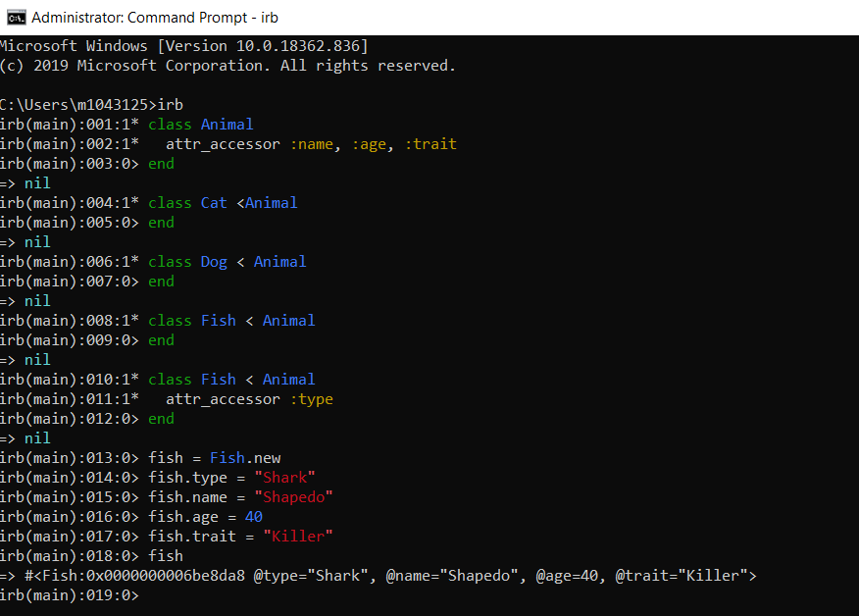

# Methods:

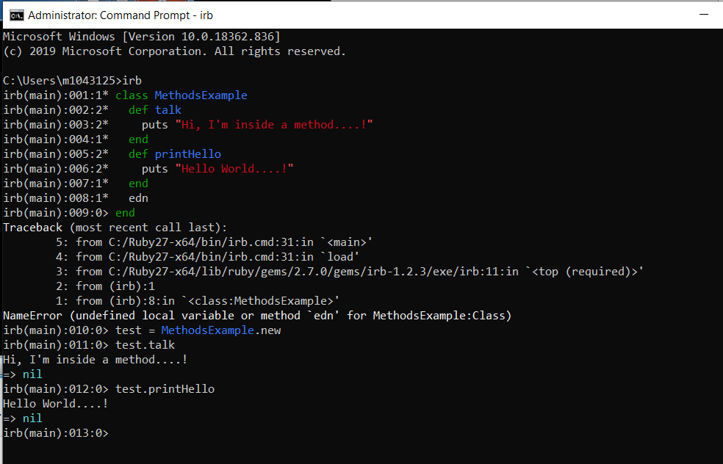

# Objects:

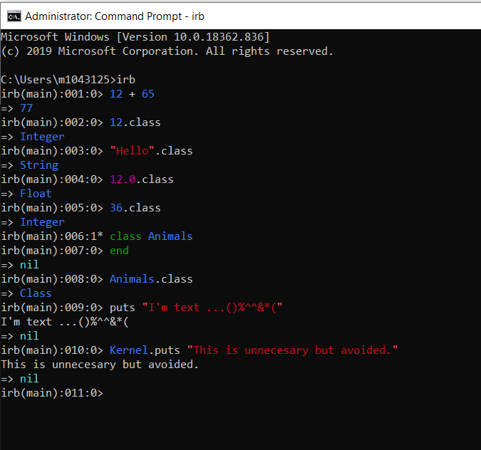

# String Functions:

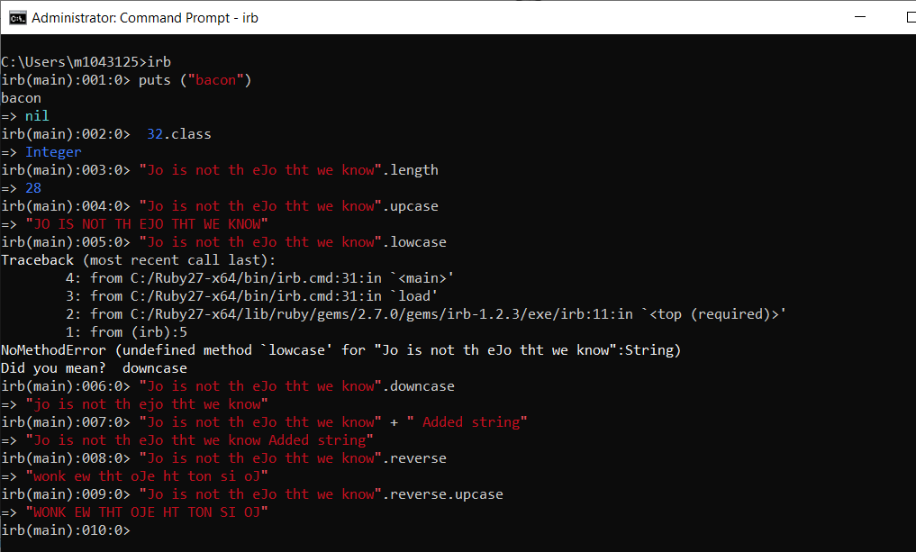

# Method Parametrize:

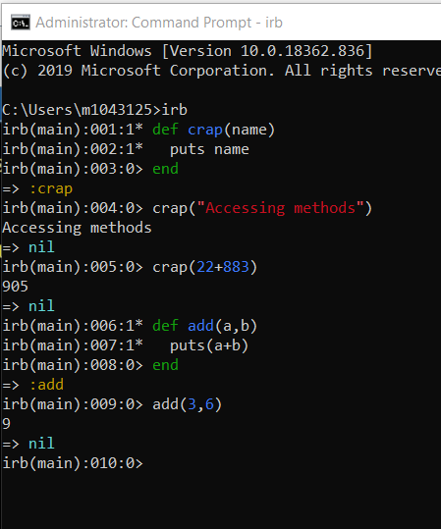

# Operators:

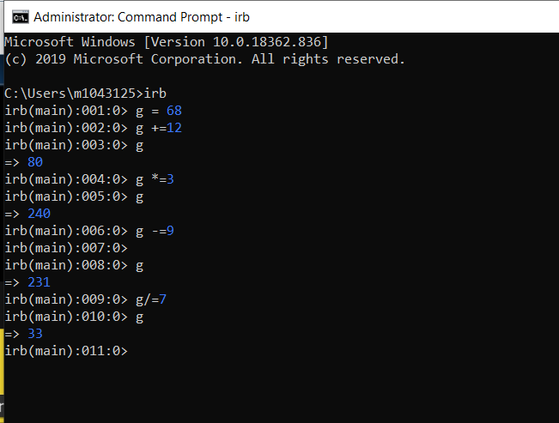

# Decision Making:

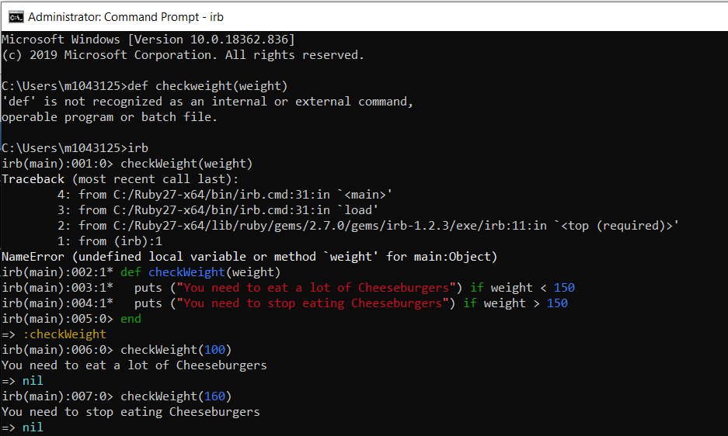

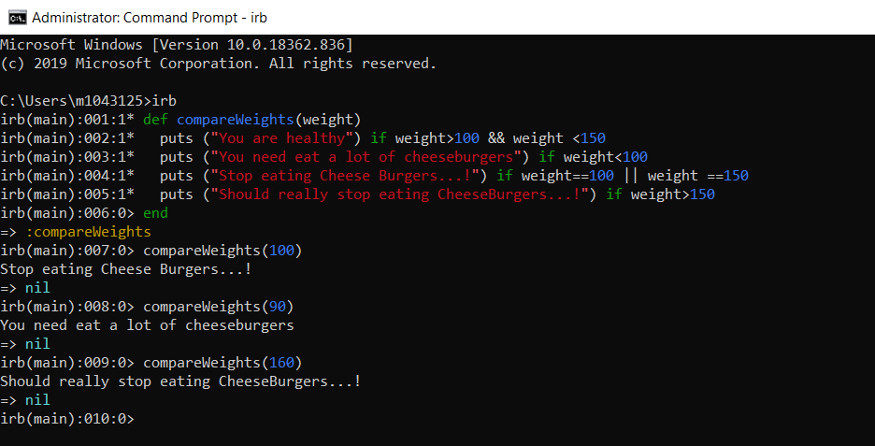

# Loops:

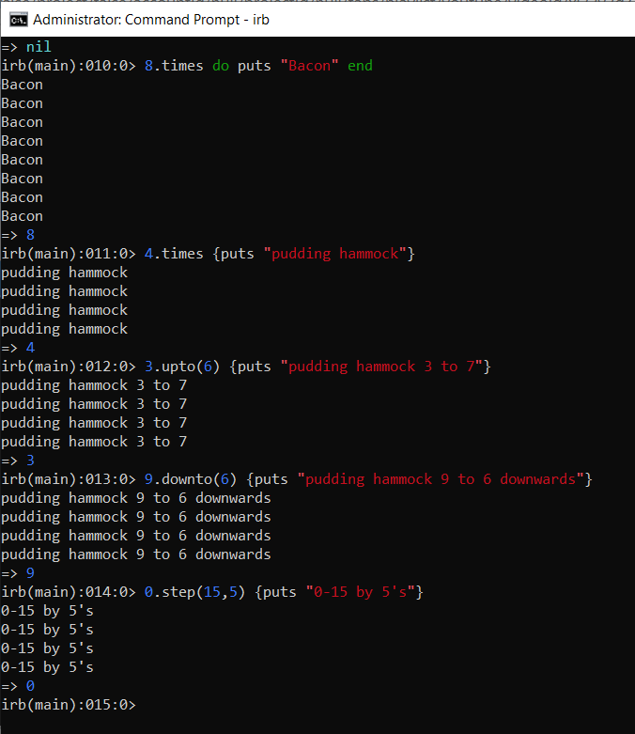

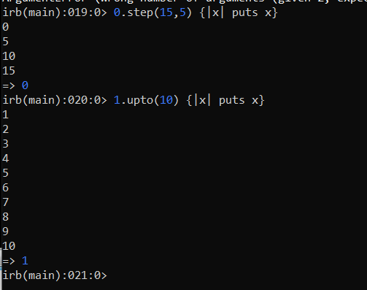

# Casting Data Types:

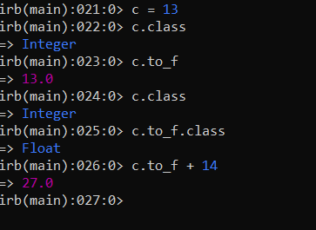

# Multi Line String:

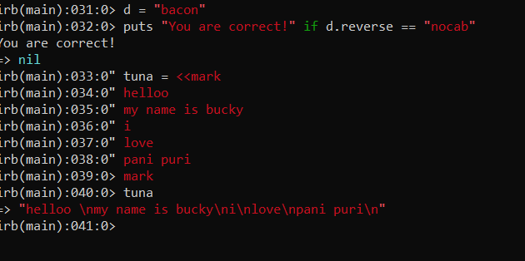

# Interpolation: (using variables along with string)

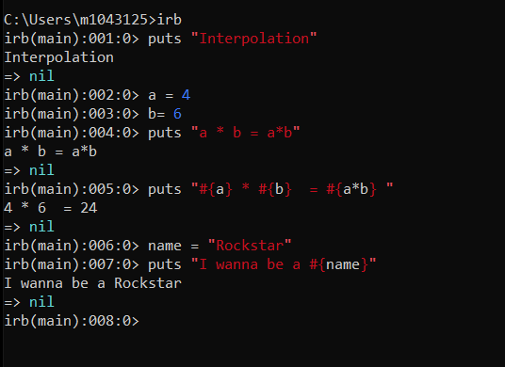

# Regular Expressions:

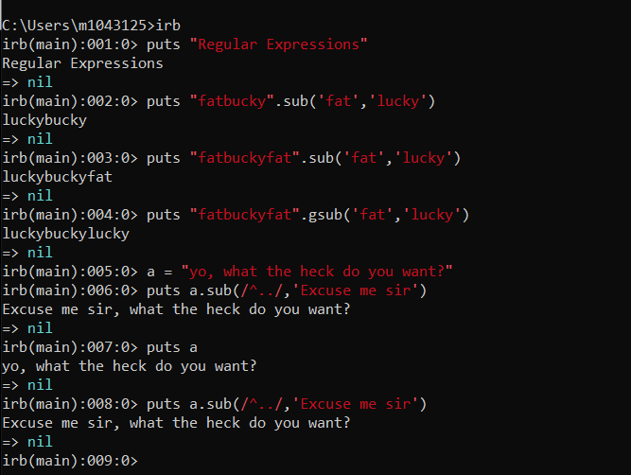

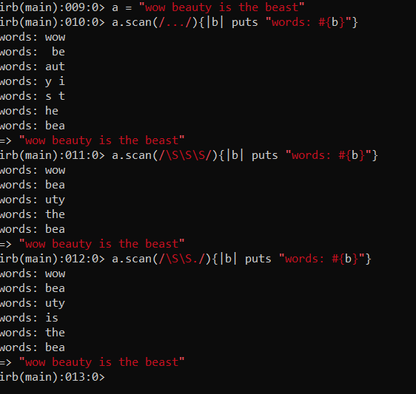

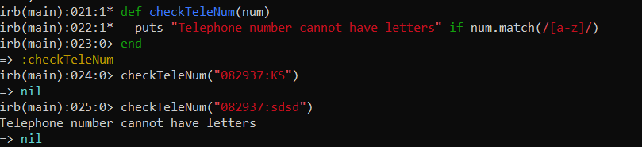

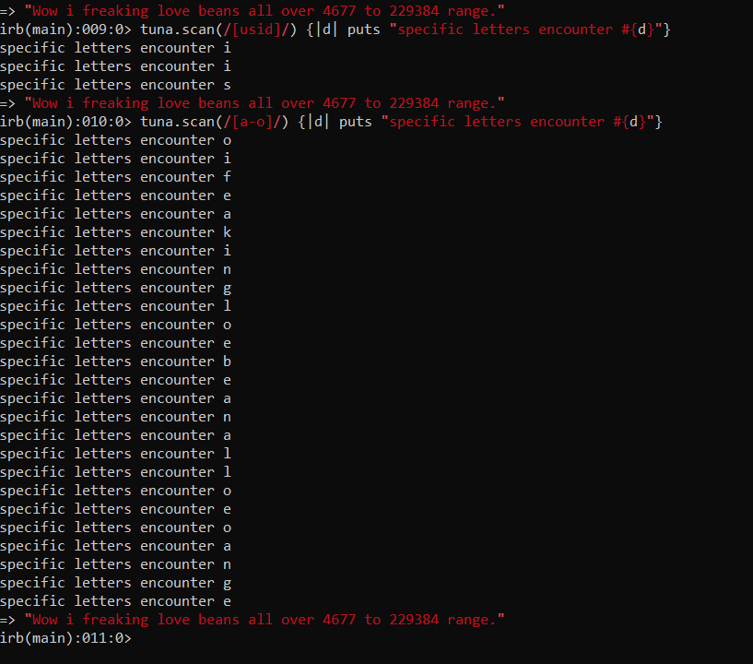

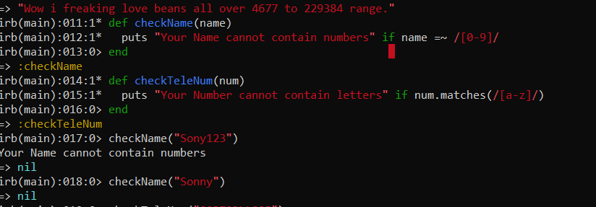

# Arrays:

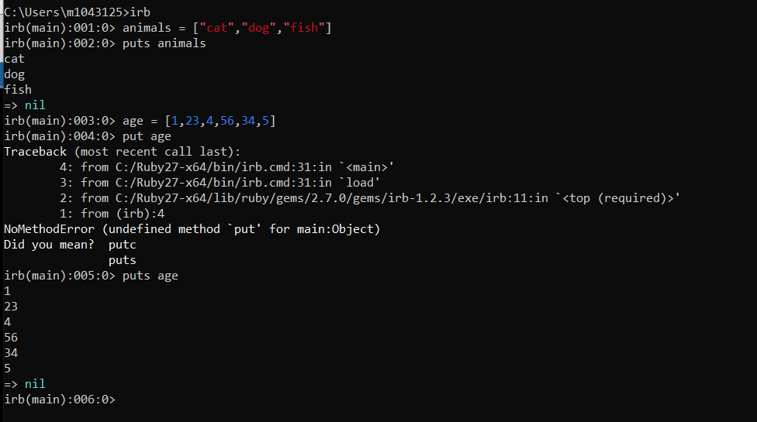

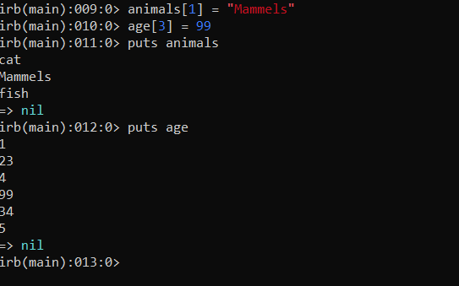

## Push and Pop:

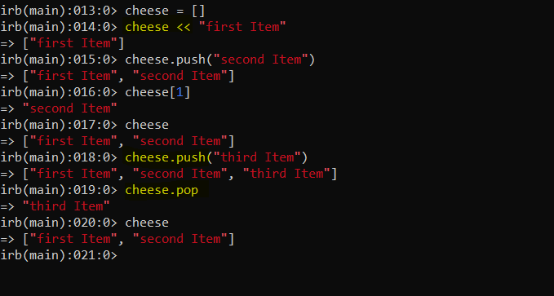

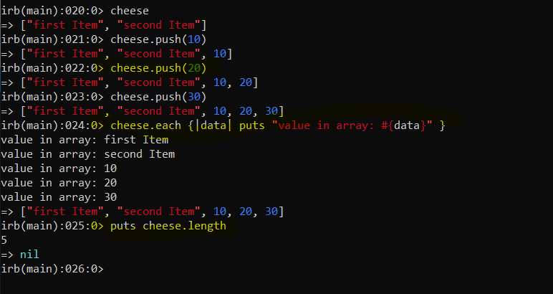

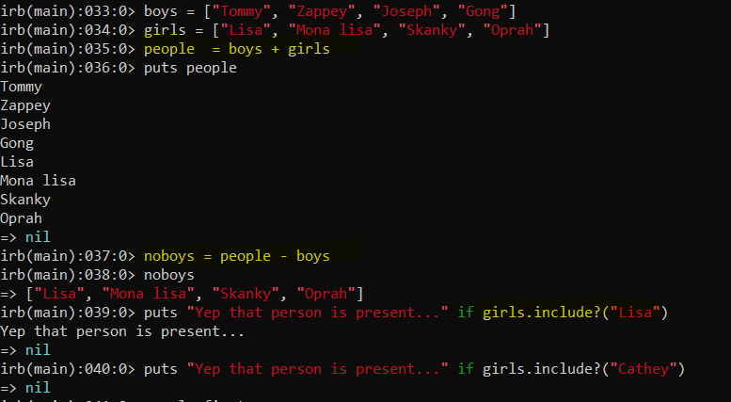

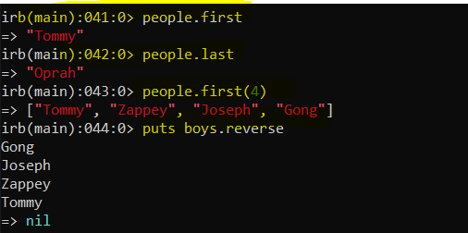

# Hash’s:

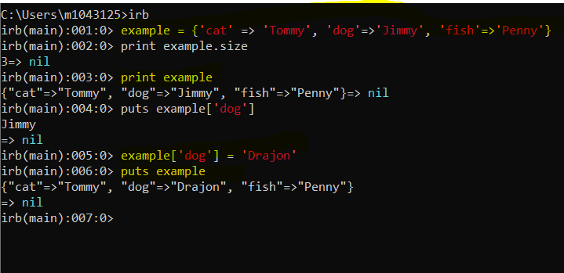

## Deletion of key:

