Nottingham Trent University

School of Science and Technology

Heart Attack Alert System: Early Prediction for Patient Safety

by

Oluwadamilola Dammy Ademola

in

2024

Project report in part fulfilment

of the requirements for the degree of

Bachelor of Science with Honours

In

Computer Science

I hereby declare that I am the sole author of this report. I authorise the Nottingham Trent University to lend this report to other institutions or individuals for the purpose of scholarly research.

I also authorise the Nottingham Trent University to reproduce this report by photocopying or by other means, in total or in part, at the request of other institutions or individuals for the purpose of scholarly research.

Signature

Oluwadamilola Dammy Ademola

Abstract

The study investigates a user's heart data for taking diagnostic measures against heart attacks and heart failure, aiming to promote preventive healthcare practices using smartphones. I am exploring convolutional neural network (CNN) to make informed decisions regarding their cardiac health, free of extensive medical expertise. By enabling users to input parameters like blood pressure and cholesterol levels, the system predicts the risks of heart attack or failure. Notably, the study reveals a noteworthy advancement in personalised healthcare, equipping individuals with a pivotal tool for actively managing their cardiac well-being. The dataset used for this study is the heart disease dataset, donated on 6/30/1988. It comprises four databases: Cleveland, Hungary, Switzerland, and the VA Long Beach, with a total of 303 instances and thirteen features. Evaluation of the predictive models reveals an impressive accuracy rate of around 85% to 87%, as determined through comprehensive performance assessments during both training and testing phases.

Acknowledgements

**Project Supervisor** - Arshad Sher

Table of Contents

Abstract ii

Acknowledgements iii

Table of Contents iv

List of Figures viii

List of Tables x

CHAPTER 1 1

INTRODUCTION 1

1.1 Introduction 1

1.2 Background 4

1.3 Scope and Context 6

1.4 Aims and Objectives 8

1.5 Structure of the Dissertation 14

CHAPTER 2 17

CONTEXT 17

2.1 Introduction 17

2.2 Existing Solutions 19

2.3 Case Studies 21

2.4 Primary Research 23

2.5 Literature Review 29

CHAPTER 3 32

NEW IDEAS 32

3.1 Introduction 32

3.2 Limitations 33

3.3 Technology and Methodology 36

3.4 Feasibility 39

3.5 User Interface 40

CHAPTER 4 51

IMPLEMENTATION or INVESTIGATION 51

4.1 Introduction 51

4.2 Technical Specification 53

4.3 Diagrams 56

4.4 Tools and Techniques 62

4.5 Unit Testing 66

4.5.1 Python Unit Testing 66

4.6 Project Planning 72

CHAPTER 5 76

RESULTS / DISCUSSION 76

5.1 Introduction 76

5.2 Success Criteria 77

5.3 Testing Plan 85

5.3.1 Postman Api Testing 91

5.4 Evaluation Technique 112

5.5 Analysis 114

CHAPTER 6 116

CONCLUSIONS / FUTURE WORK 116

6.1 Conclusions 116

6.2 Future work 120

6.3 Legal, Social, Ethical and Professional Issues 121

6.4 Synoptic Reflections 124

References 126

1) Introduction 126

i. Introduction 126

ii. Background 127

2) Context 127

iii. Introduction 127

iv. Existing Solutions 127

v. Case Studies 128

vi. Literature Review 129

3) New Ideas 130

vii. Limitations 130

viii. Technology and Methodology 130

ix. Feasibility 130

4) Implementation or Investigation 130

x. Introduction 130

5) Conclusion 131

xi. Legal, Social, Ethical and Professional Issues 131

List of Figures

Previous Experience - Figure 1 24

Activities - Figure 2 25

Risk Factors - Figure 3 26

Application Usefulness - Figure 4 27

Privacy and Security - Figure 5 28

Use Case Diagram - Figure 6 56

Class Diagram - Figure 7 57

Entity Relationship Diagram - Figure 8 58

Component Diagram - Figure 9 59

Sequence Diagram - Figure 10 62

CHF Data Pre-Processing Unit Testing - Figure 11 68

MI Data Pre-Processing Unit Testing - Figure 12 69

MI Data Cleaning Unit Testing - Figure 13 71

CHF Data Cleaning Unit Testing - Figure 14 72

Gantt Chart - Figure 15 75

Data Processing - Figure 16 82

Model Building - Figure 17 84

Login Test - Figure 18 94

Registration Test - Figure 19 96

Records Test - Figure 20 97

Password Update Test - Figure 21 99

User Details Test - Figure 22 100

CHF Details Check Test - Figure 23 102

MI Details Check Test - Figure 24 103

Update MI Details Test - Figure 25 105

Update CHF Details Test - Figure 26 107

CHF Prediction Test - Figure 27 109

MI Prediction Test - Figure 28 110

Fetch MI Prediction - Figure 29 112

Fetch CHF Prediction - Figure 30 113

List of Tables

Testing Approach - Table 1 87

Testing Plan - Table 2 89



INTRODUCTION

## Introduction

Heart attacks, clinically known as myocardial infarctions (MIs), occur due to a blockage in the coronary arteries, resulting in diminished blood flow to the heart muscle and subsequent damage or death of cardiac tissue. Symptoms typically include chest pain, shortness of breath, nausea, and sweating. Heart failure, on the other hand, involves the heart's reduced ability to pump blood effectively, leading to symptoms such as fatigue, swelling in the legs, and shortness of breath (Watson, 2023).

Globally, cardiovascular diseases like heart attacks and heart failure pose significant public health challenges, leading to high rates of morbidity and mortality due to their widespread occurrence.to their widespread occurrence and profound implications. Cardiovascular diseases are the leading cause of death globally, with the (World Health Organisation, 2019) estimating 17.9 million fatalities annually (Mattingly). This notable statistic highlights the significant impact of these conditions on healthcare systems and global economies.

Recent estimates suggest that there are twenty-six million patients worldwide with heart failure and more than half a million people living with this syndrome in the United Kingdom alone. Cardiovascular diseases not only lead to mortality but also impose significant economic burdens, consuming 1–2% of the NHS budget primarily through hospitalisation costs (Cowie, 2017). It was estimated that about 20.5 million people worldwide will be affected by cardiovascular disease in 2021, with four out of five of these deaths occurring in low- and middle-income countries. The highest rates of cardiovascular disease deaths were seen in Central Europe, Eastern Europe, and Central Asia. Risk factors for cardiovascular disease include high blood pressure, air pollution, tobacco use, and elevated LDL cholesterol (World Health Organisation, 2019). Prevention strategies are crucial to reducing the burden of cardiovascular disease globally.

Managing heart attacks and heart failure requires extensive resources such as hospitalisations, medications, and surgeries, and significantly affects the quality of life of patients and their families. Cardiovascular diseases are not solely accountable for mortality but also lead to considerable disability and diminished quality of life in affected individuals. The economic impact of cardiovascular diseases, encompassing direct healthcare expenditures and indirect costs associated with decreased productivity, is substantial, placing additional strain on healthcare resources and impeding socio-economic progress. Global initiatives are crucial for tackling cardiovascular diseases through prevention, early identification, and optimal risk factor management. Effective strategies include promoting physical activity, healthy diets, and tobacco cessation, which are essential for reducing the burden of cardiovascular diseases globally, as outlined by the World Health Organisation (2019).

Predicting and managing cardiovascular health are crucial for mitigating the risk of heart attacks and heart failure. Early detection enables timely intervention, reducing morbidity, mortality, and healthcare costs. Preventive measures such as lifestyle modifications, medication adherence, and regular medical check-ups play a vital role in managing risk factors and improving outcomes. Medical professionals employ various methods and technologies to predict and manage heart attacks and heart failure, including diagnostic tests, risk assessment tools, and therapeutic interventions. However, existing approaches may face limitations in terms of accuracy, accessibility, and scalability, necessitating further research and innovation in predictive methodologies.

A range of studies have explored various methods for predicting heart attacks and failures. The Framingham Heart Study, a seminal longitudinal study initiated in 1948, has significantly contributed to our understanding of cardiovascular diseases and risk factors. This landmark study identified several key risk factors for heart disease, including high blood pressure, high cholesterol levels, smoking, obesity, and diabetes. These findings have informed preventive strategies and interventions aimed at reducing the incidence of heart attacks, failures, and related complications. The Farrington Heart Study and predictive capabilities from ARCSEN 2021 exemplify advancements in predictive models and technologies, highlighting the transformative potential of advanced predictive tools. These studies contribute to ongoing efforts to reduce the burden of heart attacks and heart failure on individuals and healthcare systems (Hajar, 2016).

Expanding on demographic considerations, research has consistently shown that certain demographic groups are more affected by heart attacks. Sorelle (1999) found that Hispanic Americans have a higher risk of hospitalisation and death from heart attacks compared to non-Hispanic individuals. Cooper (2001) further highlighted the impact of social inequality and racial discrimination on heart disease mortality, with African Americans experiencing significantly higher death rates. This was supported by Beevers (1981), who found that heart attack admissions were less common in Black individuals. Graham (2006) emphasised the need for improved data collection and cultural competency in healthcare to address these disparities. These insights underscore the importance of considering demographic factors in understanding and addressing the burden of heart attacks and heart failure on various populations.

## Background

This study investigates the complexities of heart attack and heart failure prediction by looking at the underlying causes from the prior cardiac data, enabling medical professionals to make more individualised and knowledgeable decisions. This exploration is bolstered by insights from research papers authored by Saour and Khan. Heart failure emerges as a significant public health challenge, characterised by the heart's diminished pumping capacity and high mortality rates, particularly among older individuals (Saour, 2017; Khan, 2006). Similarly, heart attacks, elucidated by Watson and Peterson, manifest as acute coronary events resulting from arterial blockages, precipitating severe chest pain and life-threatening complications (Watson, 1997; Peterson, 2016). The prevalence of heart attacks underscores the need for innovative predictive tools to empower individuals to self-manage their cardiovascular health (Khan, 2006; Paryati, 2021).

Informed by reputable sources such as the NHS website and enriched by insights from these seminal research papers, the research endeavours to democratise heart health prediction. By creating awareness and enabling self-management in heart and health-related issues, the research aims to alleviate stress and improve overall well-being.

In addition to reviewing existing literature, navigating the data collection process posed significant challenges. Accessing relevant and non-confidential data about heart attacks/failure or patient data proved to be a formidable task. This obstacle underscored the complexities inherent in obtaining comprehensive data for accurate research outcomes.

The research significantly enhances healthcare accessibility through the widespread availability of the app on both Android and Apple devices. With millions of iPhones alone in use globally, the accessibility of the application allows a vast number of individuals to download and use it, gaining access to predictive capabilities for assessing their risk of a heart attack. Leveraging predictive models and OpenAI, both trained extensively on millions of data points, the research empowers individuals to predict heart attacks. By breaking down barriers typically associated with medical expertise and training, the work provides a significant level of empowerment to users.

This empowerment not only aids in making informed decisions about heart health but also addresses the global issue of heart attacks and heart failure, which contribute to a significant percentage of deaths worldwide. By enabling individuals to check their risk and take initiative-taking measures, the research aims to reduce the impact of heart attacks and failures and improve overall well-being.

The research outcomes have implications for both healthcare professionals and individuals. On the negative side, there is the potential for increased false positives, leading to heightened anxiety and unnecessary healthcare consultations. However, this can be mitigated through the integration of healthcare professionals into the app ecosystem, allowing them to guide and support users effectively. On the positive side, the research empowers individuals to take initiative-taking measures and seek timely medical assistance if needed, potentially reducing the severity of heart attacks, and improving overall outcomes.

Readers can look forward to various chapters in the dissertation, including the implementation chapter, methodologies chapter, literature reviews, testing chapter, and additional relevant sections. These chapters collectively provide a comprehensive exploration of the development process, research methods, critical reviews of existing literature, rigorous testing procedures, and other crucial aspects of the research.

## Scope and Context

This study analyses variables contributing to heart attacks or failure, focusing on enhancing accessibility through a mobile application available on both iPhone and Android smartphones. It seeks to advance predictive methodologies in cardiovascular health management by prioritising user needs across several key dimensions.

Primarily, it emphasises ease of use by focusing on developing predictive methodologies and tools that are intuitively designed, user-friendly, and accessible to individuals with varying levels of technological literacy. By ensuring simplicity and clarity in interface design and functionality, these tools aim to enable users to engage effectively with their cardiovascular health data and make informed decisions.

Secondly, the study underscores the importance of timely intervention. It seeks to implement predictive algorithms capable of identifying individuals at higher risk of cardiovascular events and providing timely alerts or recommendations for interventions, such as lifestyle modifications. By leveraging predictive analytics, the study aims to enable initiative-taking management of cardiovascular health and reduce the likelihood of adverse outcomes.

Moreover, accessibility is a key consideration. The study recognises the need to ensure that predictive methodologies and associated healthcare interventions are accessible to diverse populations, including individuals residing in remote or underserved areas who may face barriers to accessing traditional healthcare services. Through innovative delivery models and technology-enabled solutions, the study seeks to broaden the reach of cardiovascular health management initiatives to all segments of the population.

Finally, empowerment is integral to the study's approach. It emphasises empowering individuals to take an active role in managing their cardiovascular health by providing actionable insights and personalised recommendations derived from predictive analytics. By fostering a sense of ownership and responsibility for one's health outcomes, the study strives to improve adherence to preventive measures and achieve better long-term health management.

From a geographical perspective, the study examines isolated locales characterised by limited access to medical facilities and healthcare services. These remote areas often encounter significant obstacles in delivering timely medical assistance due to factors such as geographical barriers, sparse populations, and inadequate infrastructure. However, leveraging the widespread availability of smartphones presents a favourable opportunity to overcome these barriers and improve healthcare accessibility for individuals living in such remote regions.

Demographically, it focuses on diverse populations, recognising that initiative-taking cardiovascular health management can benefit individuals from all backgrounds and socio-economic statuses, including considerations of age, height, BMI, gender, and lifestyle factors such as diet, physical activity levels, smoking status, and alcohol consumption. The dissertation meticulously addresses linguistic localisation, cultural factors, and region-specific regulations to ensure inclusivity and relevance across diverse demographics. The study follows a specified timeline, including phases like data collection, analysis, and implementation, with provisions for updates to align with changing healthcare demands and technological progress.

Within broader healthcare this study enables individuals to proactively evaluate their risk of heart attacks and heart failure, while advocating for awareness, education, and self-management strategies at the population level. When interpreting the research findings, you must consider various limitations and constraints that could impact their validity and applicability. These encompass potential sample bias, data quality issues, methodological constraints, ethical considerations, resource limitations, and the external validity of the findings. Transparently reporting these limitations ensures a thorough interpretation that informs future research endeavours and practical applications.

Taking all factors into account, the scope and background of this study significantly impact its relevance and importance in real-world scenarios. Considering the wider healthcare landscape, this study seeks to explore various facets of heart attack and heart failure prediction to offer insights for evidence-based decision-making and enhanced cardiovascular health outcomes.

## Aims and Objectives

The aim of this investigation is to empower individuals to take control of their cardiovascular health and democratise the process of evaluating it, rather than merely developing a prediction system. This project intends to close the disconnect between medical knowledge and the general population by developing an accurate and user-friendly prediction system that will make it possible for people from all phases of life to determine their risk of heart attacks and heart failure.

This dissemination of health information resonates with the tenets of patient empowerment and preventive medicine, equipping individuals with the necessary tools and knowledge for informed health-related choices. Moreover, by centring on heart attacks and heart failure, substantial global health threats, this study tackles a critical public health issue and supports endeavours to alleviate the impact of cardiovascular diseases on individuals and healthcare systems. The primary aim of this research is to enable individuals to prioritise their cardiovascular well-being using precise and accessible prediction tools, enhancing population-level heart health outcomes, and reducing mortality rates and healthcare expenses linked to cardiovascular conditions.

The anticipated outcomes and accomplishments of this study transcend mere predictive abilities to include wider societal implications and enhancements in healthcare access and effectiveness. Primarily, this study seeks to democratise heart health assessment, allowing individuals of all medical backgrounds to predict their risk of heart attacks or heart failure. Such inclusivity guarantees individuals the ability to actively oversee their cardiovascular well-being and implement preventive measures as needed, thereby enhancing health results, and decreasing occurrences of cardiovascular incidents.

Furthermore, this study aims to promote prompt interventions and address healthcare disparities through the provision of a user-friendly platform accessible to both users and healthcare providers. Through swift and precise predictions, the application has the potential to diminish wait times for medical consultations and tests, leading to prompt identification and intervention for individuals vulnerable to heart attacks or heart failure.

This functionality is particularly crucial for individuals who may not have easy access to healthcare services or who may be hesitant to seek medical advice, allowing them to take initiative-taking steps towards managing their cardiovascular health. Additionally, by empowering individuals to monitor their heart health autonomously, the research aims to mitigate missed diagnoses and improve overall healthcare efficiency. The application functions as a valuable tool for individuals who have not previously undergone cardiovascular screenings or received medical evaluations. It offers a convenient and accessible method for assessing their risk factors and seeking necessary medical attention. In doing so, the research not only addresses gaps in healthcare access but also contributes to early detection and prevention efforts, leading to better health outcomes and reduced healthcare costs associated with late-stage interventions.

**Aims:**

1. **Develop a Robust Prediction Model**: Use advanced machine learning techniques, including Convolutional Neural Networks (CNN) and OpenAI, to create a robust prediction model capable of accurately assessing the risk of heart attacks and heart failure based on diverse sets of medical data.
2. **Ensure Ethical Data Usage**: Implement stringent data privacy and security measures to safeguard user information, including authentication protocols, encryption techniques, and data access restrictions, ensuring compliance with ethical standards and regulations.
3. **Develop an Easily Accessible Mobile Application**: Design and deploy a user-friendly mobile application accessible on both iOS and Android platforms, enabling individuals to conveniently assess their heart health and make predictions using intuitive interfaces and streamlined functionalities.
4. **Enhance Early Intervention**: Facilitate early intervention and preventive measures by promoting the widespread adoption of the mobile application among users of all demographics, empowering them to take initiative-taking steps towards managing their cardiovascular health.
5. **Minimise False Positives and Negatives**: Fine-tune the predictive models using extensive data and machine learning algorithms, such as ChatGPT, to minimise false positive and false negative predictions, thereby enhancing the accuracy and reliability of the prediction system.

**Objectives:**

1. **Model Development**: Develop and train machine learning algorithms, including CNN models and OpenAI frameworks, to analyse diverse datasets, identify patterns, and risk factors associated with heart attacks and heart failure.
2. **Data Collection and Preprocessing**: Collect, clean, and preprocess a comprehensive dataset of relevant patient data and medical markers to facilitate training and validation of the prediction model, ensuring data accuracy and integrity.
3. **Model Evaluation**: Rigorously assess and validate the performance of the prediction models using established metrics and benchmarks, such as accuracy, precision, recall, and F1 score, to ascertain their reliability and generalisability across different patient populations.
4. **User Education**: Provide comprehensive education and training resources to healthcare professionals and users to inform them about the prediction system's capabilities, limitations, and ethical considerations, fostering informed decision-making and responsible usage.
5. **Continuous Monitoring**: Establish a systematic framework for continuous monitoring of user data and model performance, enabling real-time feedback and updates to enhance prediction accuracy and address emerging challenges or shortcomings.
6. **Interactive User Interface**: Design an interactive and intuitive user interface for the mobile application, incorporating user feedback and usability testing to optimise the user experience and ensure seamless navigation and data input.

The research aims and objectives closely align with the broader goals of improving heart health prediction and management. By developing a robust prediction model, the research aims to provide individuals with accessible and accurate tools to assess their risk of heart attacks and heart failure, thereby promoting early intervention and preventive measures. This directly contributes to the overarching goal of improving heart health outcomes by empowering individuals to proactively manage their cardiovascular health.

Furthermore, ensuring ethical data usage and developing an easily accessible mobile application align with the goal of promoting responsible and equitable access to heart health resources. By prioritising data privacy and security measures and designing user-friendly interfaces, the research fosters trust and engagement among users, facilitating widespread adoption and usage of the prediction system.

Enhancing early intervention and minimising false positives and negatives are critical objectives that directly impact the effectiveness of heart health prediction and management strategies. By enabling timely identification of at-risk individuals and refining predictive models to reduce inaccuracies, the research aims to optimise the effectiveness of preventive interventions and clinical decision-making, improving patient outcomes and reducing the burden of heart disease.

In summary, the research aims and objectives are inherently aligned with the broader goals of enhancing heart health prediction and management through advanced technologies, ethical practices, and empowering individuals to proactively manage their cardiovascular health. Through these concerted efforts, the research seeks to contribute significantly to the advancement of heart health initiatives and enhance the well-being of individuals and communities.

The aims and objectives outlined in the research serve as a clear framework for selecting appropriate methodologies and data collection strategies. For instance, the aim of developing a robust prediction model necessitates the use of advanced machine learning algorithms and computational techniques. This directs the selection of research methodologies that focus on model development and validation, including supervised learning approaches and cross-validation techniques.

Similarly, the objective of ensuring ethical data usage and developing an easily accessible mobile application informs the choice of research methodologies that prioritise user privacy and usability. This could include implementing user-centric design principles, conducting user testing and feedback sessions, and enforcing strict data security measures during the development process.

The aim to enhance early intervention and minimise false positives and negatives guides the selection of methodologies focused on model refinement and performance optimisation. This may involve fine-tuning predictive algorithms using large-scale datasets, conducting sensitivity analyses to identify influential variables, and iteratively improving model accuracy through feedback loops.

Furthermore, the objective of continuous monitoring necessitates the implementation of methodologies for ongoing data collection, analysis, and model evaluation. This may involve deploying real-time monitoring systems, developing dashboards to visualise model performance metrics, and establishing protocols for regular updates and maintenance of the prediction system. The aims and objectives function as guiding principles for selecting research methodologies and data collection strategies that align with the research goals, ensuring the development of a comprehensive and effective approach to heart health prediction and management.

## Structure of the Dissertation

The dissertation undertakes a meticulously structured exploration, aiming to dissect the inherent limitations of the accessibility of current heart health prediction models while simultaneously charting a path towards innovative solutions. Rooted in a comprehensive understanding of the existing landscape, the dissertation adopts a systematic approach to address the complexities of heart health prediction. At its core resides a dual objective: to elucidate the shortcomings of prevailing methodologies and to propose a paradigm-shifting approach that seamlessly integrates advanced technology with the principles of personalised medicine.

With a focused attention to precision and rigour, the dissertation unfolds across several meticulously crafted chapters, each meticulously crafted to unravel a distinct facet of the heart health prediction conundrum. By meticulously dissecting the intricacies of existing methods, techniques, and solutions, the dissertation reveals the fundamental challenges that have impeded progress in the field. Moreover, it traverses the annals of literature and historical precedent, illuminating the evolution of heart health prediction and highlighting persistent gaps and inadequacies.

Arising from this foundational exploration is the innovative kernel of the dissertation—a novel method poised to revolutionise heart health prediction. By ingeniously melding state-of-the-art technology with the ethos of personalised medicine, this proposed solution offers a beacon of hope in the landscape of cardiac care. With scrutiny, the dissertation unravels the technical and theoretical underpinnings of this groundbreaking approach, offering a roadmap for its seamless implementation.

Guided by a commitment to excellence, the dissertation explores the practical terrain of implementation, meticulously charting the course for bringing the proposed solution to life. Through a judicious selection of tools and frameworks, it clarifies the intricate process of translating theory into practice, ensuring robustness and reliability every step of the way. Moreover, it reveals the methodologies underpinning testing, quality assurance, and evaluation, ensuring a rigorous validation process.

As the culmination of a rigorous research endeavour, the results and discussion section serve as the nexus of insight and analysis. Here, the dissertation unveils the findings of its exploration, subjecting them to a critical examination in the crucible of scholarly discourse. Through nuanced discussion and meticulous analysis, it elucidates the implications of these findings, offering a glimpse into the transformative potential of the proposed solution.

In the closing chapter, the dissertation transcends the realm of analysis to chart a course for future endeavours. Drawing upon the insights gleaned from the preceding chapters, it offers profound conclusions and reflections, underscoring the enduring significance of its contributions. Moreover, it articulates future and scalability proposals, laying the groundwork for continued innovation and advancement in the realm of accessible heart health prediction and management.

Fundamentally, the dissertation is a testament to the transformative power of rigorous scholarship and innovative thinking. With meticulous diligence and a steadfast commitment to excellence, it aims to push the boundaries of knowledge and usher in a new era of precision and efficacy in heart health prediction. The dissertation sets a new standard for research in the field.



CONTEXT

## Introduction

The emerging field of healthcare technology shows significant potential for transforming patient care by enabling proactive health management. AI and predictive analytics are optimising healthcare operations and increasing adoption, notably in radiology, pathology, and through applications supporting the shift from hospital-based to home-based care, enhancing both patient and practitioner experiences (McKinsey, 2024). This chapter explores the current landscape of heart health prediction tools, identifying gaps in accessibility and precision that our project aims to fill. By integrating advanced machine learning algorithms and user-friendly application interfaces, we propose innovative solutions that democratise heart health management, especially for non-medical individuals.

Although there have been advancements in medical technology, a significant segment of the population continues to be underserved in obtaining precise predictions for heart attacks and heart failure. The limited accuracy and applicability of current predictive tools often fail to meet the needs of diverse populations, underscoring the necessity for tools that are both inclusive and effective (Health Tech Magazine, 2021). Individuals without medical backgrounds, devoid of the knowledge of healthcare professionals, frequently encounter a lack of feasible options to evaluate their susceptibility to cardiovascular events. This restricted access not only perpetuates disparities in healthcare but also hampers initiative-taking measures for preventing cardiac conditions. Challenges in the widespread adoption and integration of AI into clinical practice limit the accessibility of these advancements, particularly for non-medical users, highlighting a gap in the democratisation of heart health management (BMC Medical Education, 2021).

The consequences of this issue are extensive, reaching beyond individual health results to encompass wider societal and economic impacts. By democratising access to heart health prediction, individuals are empowered to make informed decisions about their cardiac well-being and simultaneously reduce the burden on healthcare systems by proactively addressing cardiovascular issues. Furthermore, cultivating a culture of initiative-taking healthcare management can result in significant advantages in reducing morbidity and saving healthcare costs.

Considering these challenges, the main goal of this dissertation is to introduce an innovative approach for predicting heart attacks and heart failure that tackles the drawbacks of current solutions and meets the requirements of non-medical individuals. By leveraging advancements in technology and embracing the principles of personalised medicine, the proposed solution seeks to bridge the gap between medical expertise and layperson accessibility, thereby facilitating the early detection and prevention of cardiovascular events.

The dissertation progresses through meticulously crafted chapters, each devoted to examining a distinct aspect of the heart health prediction challenge. Beginning with an exploration of the existing landscape and the identification of key limitations, the dissertation progresses to unveil the innovative solution proposed herein. Subsequent chapters delve into the technical and theoretical underpinnings of the proposed method, its implementation, and evaluation, culminating in a comprehensive discussion of the findings and their implications for future research and practice.

In conclusion, the dissertation aims to pave the way for equal access to heart health prediction, surpassing barriers of expertise and privilege to empower individuals with the resources necessary to protect their cardiac well-being. By tackling the issue of limited access directly, this study aims to instigate a change in basic assumptions in healthcare provision, ushering in an era of initiative-taking and individualised cardiac care for all.

## Existing Solutions

At the time of the authoring of this dissertation, there were no existing applications that directly replicated or closely resembled the heart attack and failure prediction application under investigation. While numerous applications with slightly similar functionalities are available on the market, neither the iPhone nor Android application stores provide an application that is identical to the one under investigation. This characteristic implies that the heart attack and failure prediction application possess unique attributes that distinguish it from other comparable applications.

The lack of direct replication indicates the potential for this application to fulfil a significant market demand and function as a valuable resource for users concerned with monitoring their cardiac health. Further research and development of this application could prove to be a promising endeavour in the realm of mobile health technology. Nevertheless, it is crucial to recognise the constraints of current methods, techniques, algorithms, and systems in this domain.

Existing applications offer similar features, such as tracking heart rate and providing general health tips.

Moreover, the challenges associated with accurately predicting heart attacks and failures through mobile applications are well-documented. As noted in PLOS Digital Health (2022), these challenges raise doubts about the effectiveness and reliability of existing mobile health applications, particularly due to variability in data quality and the limitations of mobile platforms PLOS Digital Health (2022)​ (PLOS)​.

A potential limitation of current methods and algorithms lies in their dependence on historical data and broad trends, which might not encompass the intricacies and individual variations in cardiac health dynamics. This can lead to inaccuracies in predictions and a lack of personalised insights for users. Additionally, the algorithms used in these applications may not be sufficiently advanced to incorporate the latest medical research findings or adapt to changes in user health status over time.

Moreover, the effectiveness and user-friendliness of predictive apps are frequently limited by the capabilities of the hardware and software, according to a 2022 study published in 'Sensors' by MDPI. This challenge restricts the complexity of algorithms that can be deployed on mobile devices, significantly affecting the accuracy and speed of predictions (Sensors, 2022) (MDPI). For instance, limited computational resources may restrict the complexity of algorithms that can be deployed on mobile devices, affecting the accuracy and speed of predictions. Similarly, database constraints may limit the amount and variety of data that can be processed and analysed, potentially reducing the robustness of predictive models.

Moreover, ethical considerations, particularly concerning privacy and data security, pose notable obstacles for developers, necessitating strict compliance with privacy regulations to maintain user trust (PLOS Digital Health, 2022)​ (PLOS)​. The collection of sensitive health data from users prompts inquiries regarding data safeguarding and consent, particularly given the escalating stringency of privacy regulations. Ensuring compliance with these regulations while still providing accurate and personalised predictions requires careful attention to data handling practices and encryption techniques.

Yet accessibility issues can arise from the complexity of user interfaces and the language used in predictive applications. Users with limited technical knowledge or literacy may struggle to navigate and interpret the information presented, reducing the effectiveness and adoption of these tools. Mitigating these accessibility concerns necessitates a collaborative endeavour to craft user-friendly interfaces and offer explicit elucidations of predictive outcomes.

Additionally, applications such as the [Heart Disease Risk Prediction](https://play.google.com/store/apps/details?id=com.ekoheif.heart_disease_risk_prediction_and_prevention&hl=en_GB&gl=US) offer prediction functionality but may lack accessibility and clear output interpretation. Advanced prediction websites such as the [QRISK Score](https://www.qrisk.org/) provide precise predictions but may exhibit lower accessibility. Due to technological progress, forthcoming applications are expected to enhance accessibility and precision, integrating artificial intelligence and machine learning to refine predictive mechanisms. Wearable technology, such as smartwatches and fitness trackers, could further improve the accuracy of these tools by continuously monitoring key health metrics. In summary, the creation of predictive tools for heart attacks and failures has the potential to empower individuals to actively improve their cardiac well-being.

## Case Studies

The study by Bennis et al. (2022) significantly contributes to the dissertation's framework through the utilisation of machine learning algorithms for predicting heart failure (HF) before diagnosis. This retrospective case-control study published in BMJ Open is in close alignment with the dissertation's objectives of developing predictive models to forecast heart attacks and heart failure utilising machine learning algorithms. The study aims to develop a robust predictive model that can detect HF risk a year before diagnosis, using data from general practitioner (GP) records, aligning closely with the dissertation's focus on initiative-taking healthcare management and personalised medicine. Nevertheless, it is crucial to acknowledge that although this study offers valuable insights into the predictive abilities of machine learning algorithms, it might have limitations regarding its applicability to wider populations or diverse healthcare settings.

The case study conducted by Feldman, Davis, and Chawla (2015) focusing on scaling and contextualising personalised healthcare provides pertinent insights that relate to the dissertation's context. By analysing disease prediction algorithms and highlighting the scaling of predictive algorithms such as CARE to manage vast clinical datasets mirroring real-world medical practices, this study offers valuable guidance that directly corresponds to the goals of the dissertation project. Nevertheless, the study's emphasis on algorithm scaling and contextualisation might neglect challenges associated with heart attack and heart failure prediction, potentially restricting its relevance to the current research issue.

Similarly, the discussion by Weng (2017) on the efficacy of artificial intelligence (AI) in predicting the risk of cardiovascular disease (CVD) contributes to the dissertation's context. By illuminating the potential of AI and machine learning algorithms in transforming cardiovascular risk prediction, this research presents a persuasive argument for the integration of AI-driven predictive models into healthcare settings, directly aligning with the dissertation's goals of forecasting heart attacks and heart failure through machine learning algorithms. Nevertheless, it is essential to recognise that while AI-driven predictive models show potential, they may encounter issues like data bias, interpretability, and scalability, which could influence their feasible integration into real-world healthcare environments.

The case study authored by Padmanabhan et al. (2019) on physician-friendly machine learning enriches the dissertation's context by focusing on the prediction of cardiovascular disease risk. Through illustrating the feasibility of crafting precise and effective predictive models for cardiovascular risk evaluation, this research offers valuable insights directly relevant to the implementation and assessment strategies of the dissertation project, closely aligning with its objectives. However, the study's focus on physician-friendly machine learning may overlook the specific needs and challenges faced by non-medical individuals in accessing and interpreting predictive tools for heart attacks and heart failure.

Furthermore, the exhaustive case study by Ramanathan and Jagadeesha (2022) on coronary heart disease utilising machine learning methods provides valuable perspectives on the obstacles and prospects associated with employing machine learning techniques for heart attack and heart failure prediction. This directly contributes to the dissertation's understanding of machine learning applications in cardiovascular medicine and further contextualises its objectives. However, it is important to recognise that while machine learning methods hold promise for improving predictive accuracy, they may also face limitations such as data availability, model interpretability, and generalisability, which could affect their utility in real-world clinical practice.

## Primary Research

The primary research conducted for this dissertation involved a detailed survey designed to capture public opinion on a heart attack and failure prediction app. For a comprehensive view of all the survey questions used in the study and the aggregate responses, please refer to Appendix A. The aim was not only to quantify the level of awareness and engagement with existing health monitoring technologies but also to deeply understand the nuanced preferences and concerns that could drive or hinder the adoption of such an app. The [Public Opinion on Heart Attack and Failure Prediction App](https://docs.google.com/forms/d/e/1FAIpQLSedef-W175JKIvHVkkiN2QWhjKEZazgYtLx410ACPgsJ44ANA/viewform?usp=sf_link) study, which included ten randomly selected participants who were all asked the same questions, yielded insightful results that highlighted various aspects of heart health awareness and the adoption of technology.

Our quantitative analysis revealed that previous experience with heart health technologies is evenly split among the surveyed individuals. As seen in the figure below this 50/50 distribution suggests a pivotal opportunity for market growth—both by tapping into the existing base of tech-savvy users and by educating and engaging those new to health monitoring apps. This dichotomy indicates a broader market trend: a burgeoning demand for digital health solutions accompanied by a significant population segment yet to be reached.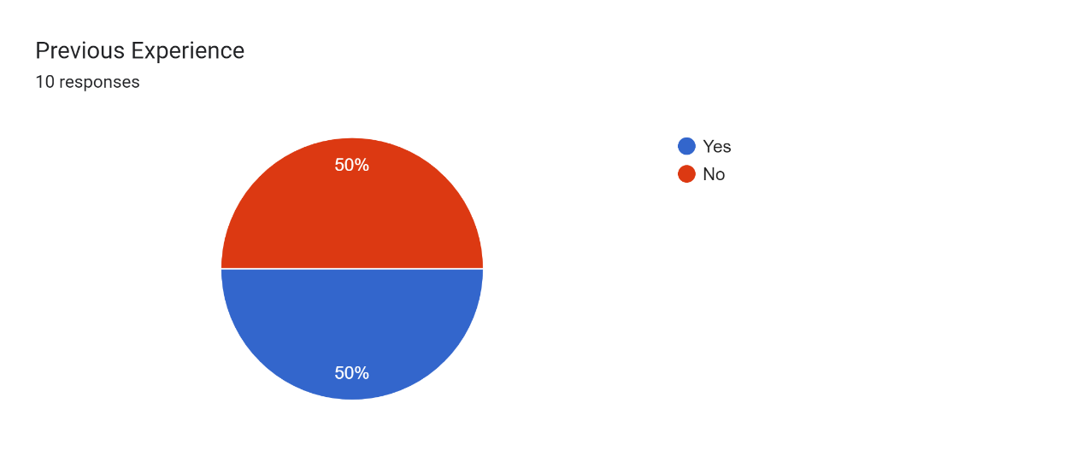

Previous Experience - Figure 1

The survey's findings reveal a commendable level of commitment to heart health among the participants, with 80% regularly engaging in activities known to benefit heart health, such as exercise and maintaining a balanced diet. An additional 20% participate in these health-conscious activities on an occasional basis. The absence of participants in the 'rarely' category reinforces the proactive stance on health within the surveyed group. This detail is vividly illustrated in the accompanying figure below.

Such a positive attitude toward proactive health management indicates a consumer base predisposed to embrace a predictive health app. Integrating features that offer daily notifications and tailored suggestions to encourage heart-healthy behaviours could serve as a significant motivator for using the app. The graph below not only supports these findings but also emphasises the potential for the app to become an integral part of users' daily health routines, furthering their commitment to maintaining a heart-healthy lifestyle.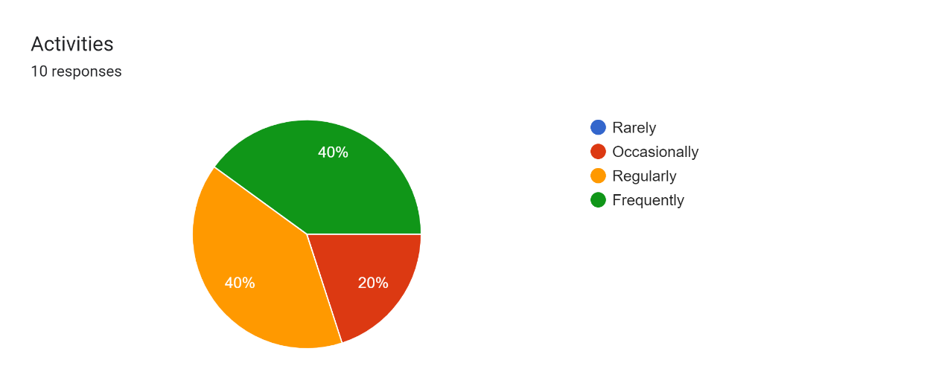

Activities - Figure 2

Although a substantial proportion of participants (70%) as seen in the figure below. acknowledged familiarity with the risk factors linked to heart attacks and heart failure, while (30%) acknowledged their unfamiliarity with the risk factors this instils continuous educational initiatives and awareness campaigns are essential to rectifying knowledge disparities and misconceptions. Comprehending the current level of awareness serves as a basis for developing educational resources and interventions that focus on areas of concern or misunderstanding. Interestingly, all respondents unanimously agreed on the usefulness of early prediction of heart attacks and heart failure in improving health outcomes, underscoring the potential value of predictive technologies in preventive healthcare strategies. This strong consensus suggests a widespread recognition of the potential benefits of predictive technologies in mitigating the impact of cardiovascular diseases.

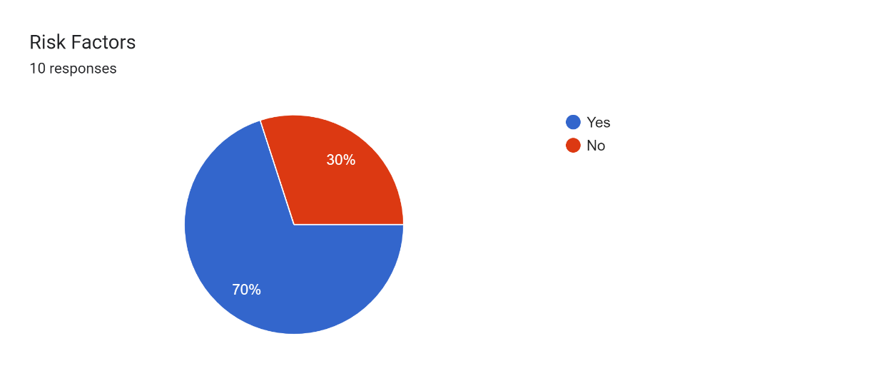

Risk Factors - Figure 3

Furthermore, a substantial majority (100%) as seen in the figure below. Demonstrated enthusiasm for using a mobile application to anticipate their susceptibility to heart attacks or heart failure, underscoring the perceived efficacy of these tools in personal health management. The considerable interest observed signifies an underlying need for heart health prediction applications within the broader community, offering a chance for developers and healthcare providers to address this demand with inventive resolutions. Essential features identified by respondents for a heart health prediction app included accurate readings over multiple days, daily notifications of health and exercise suggestions, better food choices, and the ability to track personal improvements, emphasising the importance of personalised and actionable insights in health monitoring applications.

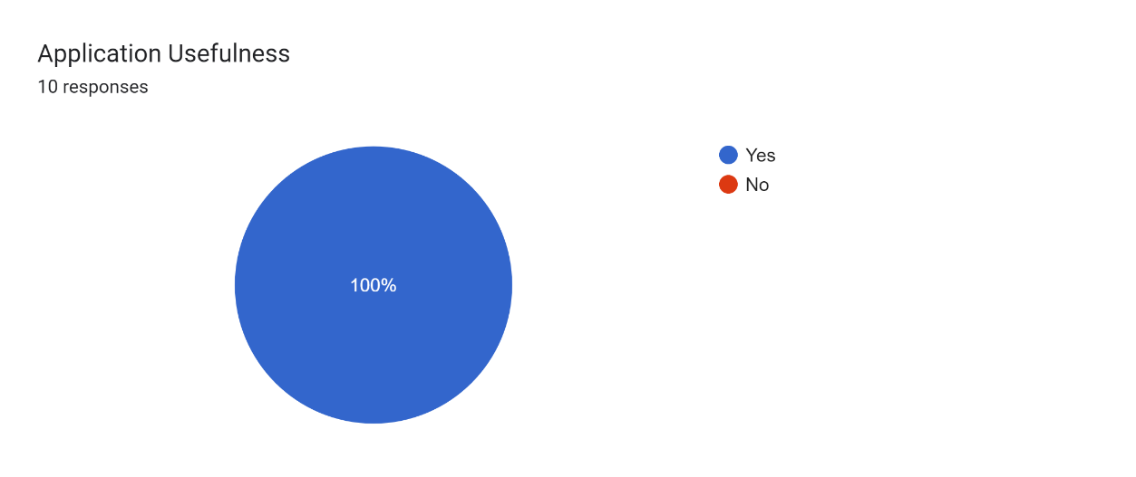

Application Usefulness - Figure 4

Understanding these essential features provides guidance for developers in prioritising features that align with user needs and expectations. Privacy and security concerns were raised by (50%) of respondents as seen in the figure below. Indicating the need for robust data protection measures to foster trust and confidence among users. The resolution of these concerns is vital to alleviating impediments to adoption and guaranteeing the enduring viability of heart health prediction applications. Looking ahead, potential obstacles to using heart health prediction apps include concerns about data accuracy, consistency in usage, personalisation, privacy, and security. Identifying and addressing these obstacles will be critical in overcoming resistance to adoption and ensuring widespread acceptance and usage of heart health prediction apps.

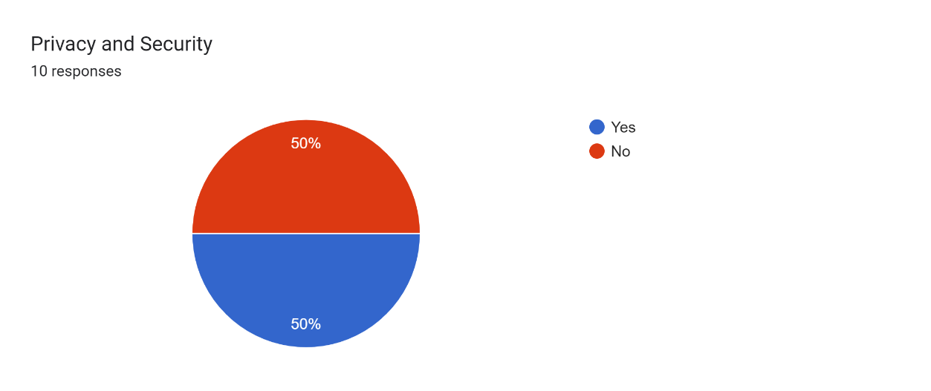

Privacy and Security - Figure 5

Feedback from survey participants regarding the essential features of a heart health prediction application provides a comprehensive insight into the requirements of users for managing their health journey. Precise measurements are in high demand, reflecting a need for longitudinal data to meticulously observe and analyse trends in heart health. The promotion of proactive health management via daily notifications and exercise recommendations is underscored, facilitating users to make well-informed choices regarding their health regimens. Furthermore, the significance of dietary habits is highlighted, with users actively seeking functionalities that promote improved dietary selections and a comprehensive strategy towards heart health. Customisation emerges as another prominent aspect, with users favouring functionalities that monitor individual advancements and offer insights into health conditions. Furthermore, the necessity for authenticated forecasts and the capability to exchange data with healthcare providers are of paramount importance.

Anticipated challenges encompass apprehensions regarding data accuracy, the prospective necessity of wearable technology, financial implications, availability, confidentiality, and the obligation of health technology developers to prevent inadvertent harm through their tools. The feedback offers a vital blueprint for creating an application that aligns with user anticipations while manoeuvring through the complexities of health technology advancement.

Overall, respondents unanimously agreed on the potential of advancements in technology to play a significant role in improving heart health outcomes, underscoring optimism for the future of predictive technologies in preventive healthcare. This recognition of the transformative potential of technology signals an opportunity for collaboration between technology developers, healthcare providers, and policymakers to harness innovation to address pressing public health challenges such as cardiovascular diseases.

## Literature Review

The existing literature extensively examines predictive methodologies related to heart attacks and heart failure. Noteworthy among these is the Framingham Heart Study, a seminal longitudinal investigation initiated in 1948 that has significantly contributed to elucidating cardiovascular diseases and associated risk factors. Through meticulous analysis, the Framingham study identified pivotal determinants such as hypertension, hypercholesterolemia, smoking, obesity, and diabetes, thereby informing preventive strategies aimed at attenuating the incidence of cardiovascular events and related complications (Springer, 2017).

Moreover, recent research has highlighted a significant increase in innovative analytical techniques aimed at enhancing predictive capabilities in cardiovascular health. For instance, Arslankaya (2021) adopted fuzzy logic, a form of computational intelligence, to predict heart attacks, achieving a notable 41.9% explanation of the dependent variable. This pioneering approach using fuzzy logic underscores the potential of unconventional methodologies in predictive modelling, thereby broadening the methodological landscape within the field.

Similarly, Nag (2017) pioneered a prototype leveraging clinical data and sophisticated data mining techniques, including decision trees and random forest algorithms, to classify symptoms and predict heart attacks. Nag's multifaceted approach using clinical data and sophisticated data mining techniques not only yielded insights into the intricate interplay of risk factors but also underscored the significance of amalgamating diverse data sources for robust predictive modelling.

Aravinthan (2015) delved into data mining techniques, particularly focusing on the application of a fuzzy C-means classifier to predict heart attacks using patient medical records. The nuanced analysis facilitated by the Fuzzy C Means classifier offered a granular understanding of patient-specific risk factors, thereby laying the groundwork for personalised predictive models tailored to individual health profiles.

Moreover, Nandal (2022) propelled machine learning-based prediction methods by employing algorithms such as XGBoost and logistic regression, achieving remarkable accuracy in predicting heart attacks. Through meticulous data analysis and model refinement, Nandal achieved remarkable accuracy in predicting heart attacks, thus accentuating the pivotal role of machine learning in advancing predictive analytics within the healthcare domain.

Building on these studies, recent research also highlights the significance of biomarkers in heart failure prediction and prevention, with prominent organisations like the American College of Cardiology (ACC) and the American Heart Association (AHA) advocating for heightened emphasis on heart failure prevention strategies. Additionally, machine learning methodologies have shown promise in predicting heart failure based on clinical data, with notable achievements such as a machine learning metamodel demonstrating an accuracy of 87% (Kotta et al., 2023; Mahmud et al., 2023), highlighting the advancements in predictive capabilities.

Research papers on heart attack prediction enhance our understanding by detailing the effectiveness of various machine learning algorithms, including K-Nearest Neighbours (K-NN), Decision Trees, Random Forests, and hybrid approaches. These studies report consistently high accuracy rates, ranging from 88.7% to 96.51%, which underscores the robustness of predictive models in risk assessment.

Additionally, techniques such as expert models, genetic algorithms, and the integration of the self-attention mechanism in transformer models have demonstrated considerable potential for capturing intricate patterns within cardiovascular data, thereby contributing to the refinement of predictive models.

Collectively, this body of literature underscores the dynamic landscape of predictive methodologies in cardiovascular health, highlighting how the integration of traditional statistical approaches with avant-garde computational techniques propels predictive modelling towards unprecedented levels of accuracy and granularity. Through a synthesis of empirical findings and methodological innovations, researchers are poised to revolutionise risk assessment and preventive interventions in cardiovascular health, thereby advancing clinical practice and improving patient outcomes.



NEW IDEAS

## Introduction

The "New Ideas" section is a crucial element in improving heart health prediction tools, especially for individuals without medical backgrounds. In contemporary society, where preventive healthcare is gaining prominence, the accessibility and accuracy of predictive tools are essential in preventing cardiovascular events. Acknowledging the urgent need for more inclusive and precise solutions, this section delves into exploring innovative methodologies, techniques, and systems.

Fundamentally, this exploration is motivated by the recognition of a stark reality: existing heart health prediction tools frequently elude non-medical individuals, limiting crucial insights into cardiac well-being to a privileged few. The recognised limitations in accessibility emphasise the urgency to democratise these tools, guaranteeing that all individuals, regardless of medical expertise, can use predictive analytics for initiative-taking cardiac care.

By exploring technological advancements and principles of personalised medicine, the "New Ideas" section aims to surpass conventional boundaries, paving the way for early detection and prevention of cardiovascular events. Through a thorough examination of potential solutions, including innovative machine learning algorithms and user-centric interfaces, this section aims to bridge the gap between medical expertise and layperson accessibility.

Furthermore, beyond mere ideation, this section delineates a robust methodology and rigorous criteria for evaluating proposed solutions. It charts a course towards the development and implementation of innovative tools that not only mitigate existing limitations but also herald a change in basic assumptions in heart health prediction. With a forward-thinking approach grounded in empirical research and visionary insight, this section stands poised to revolutionise the landscape of preventive cardiac care for non-medical individuals.

The "New Ideas" section is more than a collection of proposals; it represents a manifesto for change—a commitment to democratising healthcare and empowering individuals to take charge of their cardiovascular well-being. Through collaboration, innovation, and steadfast dedication, this section strives to actualise aspirations, ushering in a future where heart health prediction is a fundamental right, not a privilege.

## Limitations

Upon investigation of current heart health prediction tools or similar applications designed for non-medical individuals, it is apparent that there is a significant lack of exact duplicates of the solution outlined in this study. Despite thorough searches across various platforms and app stores, no identical applications were identified. However, some existing applications demonstrate limited similarities in terms of functionalities or features.

Existing heart health monitoring apps on the market offer functionalities such as tracking heart rate and providing general health tips. While these applications may share some common features with the proposed solution, they often lack the comprehensive predictive capabilities necessary to accurately assess the risk of heart attacks and failures. For example, popular fitness trackers like Fitbit or Apple Watch primarily focus on activity tracking and may provide basic heart rate monitoring, but they do not offer predictive analytics specifically tailored to heart health. This highlights a significant gap in addressing the specific needs of users concerned about their cardiac well-being.

The limitation underscores the challenge faced by a massive portion of the population in accessing accurate heart health prediction tools. While there are numerous health-related apps available, many of them are designed for general wellness tracking rather than precise risk assessment for cardiovascular events. This results in non-medical individuals being inadequately served in assessing their susceptibility to heart attacks and failures, which could result in delayed interventions or missed chances for preventive healthcare.

Furthermore, the creation of efficient predictive applications is often exacerbated by limitations in hardware and software infrastructure, such as restricted computational resources and database constraints. These technological hurdles significantly impact the performance and scalability of applications, particularly those relying on complex machine learning algorithms (Springer Digital Health, 2022). For instance, mobile devices may lack the processing power necessary to run complex machine learning algorithms in real-time, limiting the sophistication of predictive models that can be deployed on such platforms. Furthermore, limitations in databases may constrain the quantity and quality of data available for training predictive models, impacting their accuracy and reliability.

Additionally, current methods for predicting heart attacks and failures may not adequately account for individual variations and complexities in cardiac health. While historical data and broad trends can provide valuable insights, they may not capture the full spectrum of factors influencing an individual's risk profile. For instance, genetic predispositions, lifestyle choices, and environmental factors can all play significant roles in shaping an individual's cardiovascular health, yet traditional predictive models may overlook these nuances. This reliance on historical data and broad trends may lead to inaccuracies in predictions and a lack of personalised insights for users (Academic OUP, 2022).

Challenges related to accessibility arising from intricate user interfaces and linguistic barriers can exacerbate the difficulties encountered by non-medical individuals in obtaining precise heart health prediction tools. While some applications may offer advanced predictive capabilities, their user interfaces may be overly complex or difficult to navigate, particularly for users with limited technical knowledge or literacy. Language barriers may also present obstacles for non-English speakers, limiting the reach and effectiveness of predictive applications in diverse populations.

Ethical considerations concerning privacy and data security are paramount in establishing trust and confidence among users. The gathering and retention of sensitive health data give rise to valid concerns regarding data privacy and confidentiality, especially in the context of recent data breaches and privacy controversies. Users may be hesitant to share personal health information with predictive applications, especially if they are unsure about how their data will be used or protected. Therefore, it is imperative for developers to implement robust data protection measures and transparent privacy policies to address these concerns and foster user trust.

To address these limitations constructively and align with the aims and objectives of this research, the innovative approach should prioritise enhancing accessibility, optimising hardware, and software infrastructure, incorporating advanced machine learning techniques, and implementing robust data protection measures. By using innovative methodologies and technologies detailed in the aims and objectives, there is an opportunity to address current deficiencies in heart health prediction tools and offer users enhanced accessibility, precision, and personalised solutions.

## Technology and Methodology

Consider a scenario in which individuals can accurately predict their susceptibility to heart attacks and heart failure with ease. This vision drives our mission to create an innovative heart attack prediction application that goes beyond mere prediction. The objective is to democratise heart health assessment, empowering people from all levels of society to proactively manage their cardiovascular well-being. Our journey begins with a meticulous analysis of existing heart health prediction tools. Through this exploration, revealed a glaring gap in solutions tailored for non-medical individuals, underscoring the urgent need for accessible and precise predictive capabilities.

To bridge this gap, leveraging a comprehensive suite of advanced technologies and pioneering methodologies. Central to our approach lies React Native, a versatile cross-platform framework that ensures seamless compatibility across iOS and Android devices, ideal for developing health applications as recommended by best practices in the field (React Native, 2023). Additionally, Python serves as our primary tool for developing robust predictive models, enhanced by libraries like TensorFlow, which is renowned for its efficacy in building complex machine learning models in health applications (TensorFlow Blog, 2021). We are harnessing innovative machine learning techniques such as convolutional neural networks (CNN), facilitated by TensorFlow’s comprehensive support for deep learning, to delve deep into intricate data patterns, enabling unparalleled accuracy in risk assessment. This approach aligns with best practices in deploying deep learning models on mobile platforms using TensorFlow.js in a React Native environment (TensorFlow Blog, 2021). Additionally, our integration of the Open AI API introduces a layer of personalised insights and natural language processing, fostering a holistic and user-centric experience.

Our development methodology aligns with the agile framework, allowing us to iterate rapidly, prioritise user-centric design principles, and uphold ethical data usage practices. Through ongoing surveillance and iterative feedback mechanisms, endeavouring to provide a dependable, user-friendly, and secure application that enables users to proactively address their cardiovascular well-being. Partake in this transformative expedition as the introduction of the heart attack prediction application, a pinnacle of innovation positioned to reshape individuals' interactions with their cardiovascular well-being. Together, paving the way towards a healthier and more empowered future for everyone.

When developing our heart attack prediction application, the team carefully examined the constraints highlighted in current heart health prediction tools while remaining faithful to our goals and objectives. A significant limitation highlighted was the absence of solutions customised for non-medical individuals, underscoring the requirement for accessible and accurate predictive functionalities. In response, the application emphasises intuitive user interfaces and personalised insights, rendering intricate medical data easily comprehensible and actionable for a broad user demographic.

Furthermore, issues related to compatibility and usability were addressed through the selection of appropriate technology. Utilising React Native's cross-platform versatility guarantees smooth accessibility on both iOS and Android devices, expanding the application's scope and removing obstacles associated with device preferences and operating systems. However, it is acknowledged that the complex process of integrating React Native, with its intricacies in handling diverse device specifications and system upgrades, presents a notable obstacle. Through thorough testing and ongoing optimisation, these challenges are addressed to provide a coherent user experience across diverse devices.

In response to the challenge of accurately assessing cardiovascular health risks, integrating TensorFlow's convolutional neural networks (CNNs). These deep learning capabilities allow our application to discern intricate patterns within medical datasets, enhancing prediction accuracy and reliability. However, recognising the complexity of implementing CNNs, including challenges related to model training, parameter optimisation, and computational resource requirements. Despite these complexities, ensuring that our implementation is robust and efficient, leveraging TensorFlow's extensive documentation and community support to overcome technical hurdles.

Additionally, the incorporation of OpenAI's advanced algorithms and natural language processing (NLP) functionalities enriches our application with personalised insights and adaptive capabilities. Through thorough analyses of user-generated data and immediate updates, our application adjusts to evolving health trends and user demands, guaranteeing the enduring relevance and efficacy of predictive models. However, integrating NLP functionalities presents its own set of challenges, including data preprocessing complexities and algorithm tuning. We address these challenges through rigorous testing and refinement processes, ensuring that our application delivers accurate and actionable insights to users.

Through strategic integration of these technologies and methodologies, the application not only addresses the identified constraints but also represents a groundbreaking solution poised to revolutionise individuals' engagements with their cardiovascular health. The principal aim is to democratise the assessment of heart health, empowering individuals to proactively supervise their cardiovascular well-being, with aims including improved accessibility, heightened prediction accuracy, and customised insights for users from various backgrounds. Through steadfast commitment to innovation, accessibility, and user-centric design, aiming to pave the way towards improved cardiovascular health outcomes for everyone. With our innovative technology and dedication to inclusivity, revolutionising the way healthcare is delivered and empowering individuals to take control of their health. Through our innovative approach and commitment to personalised care, endeavours to create a more equitable healthcare system for all.

By integrating specific examples or proposals within the "New Ideas" section, such as the development of novel machine learning algorithms tailored for heart health prediction or the integration of advanced data analytics techniques, you can provide concrete illustrations of the innovative methods proposed to improve existing heart health prediction tools. This approach will enhance the clarity and specificity of your explanations, enabling readers to better understand the direction of your research and the differentiation from existing approaches.

## Feasibility

The feasibility of implementing the proposed heart attack predictor application is intricately linked to the innovative solutions outlined in the current ideas section and the overarching proposal. Central to this feasibility study are technical requirements, resource consumption considerations, potential challenges, and mitigation strategies, all of which converge to ensure the successful development and deployment of the application.

Technical Requirements: The heart attack predictor application leverages innovative technologies such as Python and TensorFlow, which are critical for developing robust predictive models. TensorFlow supports the implementation of CNN models that are integral for deep data pattern analysis in heart health prediction, though they require substantial computational resources to function optimally on mobile platforms (Krizhevsky et al., 2012; LeCun et al., 2015).

These technical choices are directly aligned with the latest ideas presented, emphasising accessibility, precision, and personalised solutions for non-medical individuals seeking correct heart health predictions.

Resource Consumption: The computational demands of running CNN models for heart attack and heart failure prediction need substantial computational resources. This includes high-performance servers, adequate bandwidth, and network infrastructure to support real-time data processing and seamless user interactions. By addressing these resource requirements, the application can deliver accurate and reliable predictive analytics, fulfilling the objectives outlined in the proposal.

Potential Challenges and Mitigation: While implementing the heart attack predictor application, several challenges may arise, including data integration complexities, algorithm validation, and managing user expectations. These challenges are closely tied to the limitations found in the latest ideas section, highlighting the need for innovative solutions to bridge existing gaps in heart health prediction tools for non-medical individuals. Mitigation strategies include rigorous testing, validation procedures, and ongoing collaboration among technical experts, data scientists, and healthcare professionals to ensure the application's accuracy, reliability, and ethical use of predictive models.

By linking the feasibility study to the latest ideas section and proposal, as well as addressing identified limitations, the heart attack predictor application is positioned to offer enhanced accessibility, precision, and personalised solutions for users concerned about their cardiovascular well-being.

## User Interface

In addition to emphasising functionality and engagement, accessibility lies at the heart of our project's aims and objectives. Recognising the importance of inclusive design, our user interface (UI) prioritises accessibility, ensuring that individuals of all abilities can effectively interact with our predictive tools. Our commitment to accessibility is reflected in the design choices made, including clear typography, intuitive navigation, and adherence to accessibility standards such as WCAG (Web Content Accessibility Guidelines). By implementing features such as adjustable font sizes, sharp contrast modes, and keyboard navigation, aiming to accommodate users with diverse needs and preferences.

Furthermore, our UI design is optimised for both iPhone and Android platforms, acknowledging the prevalence of these operating systems among smartphone users worldwide. Through responsive design principles, our interfaces seamlessly adapt to different screen sizes and resolutions, delivering a consistent and intuitive experience across devices. Whether accessing our predictive tools on an iPhone or an Android device, users can expect a user-friendly interface that empowers them to take initiative-taking steps towards managing their cardiovascular health. By prioritising accessibility and platform compatibility, aiming to ensure that our solutions are accessible to as many individuals as possible, regardless of their device or ability.

  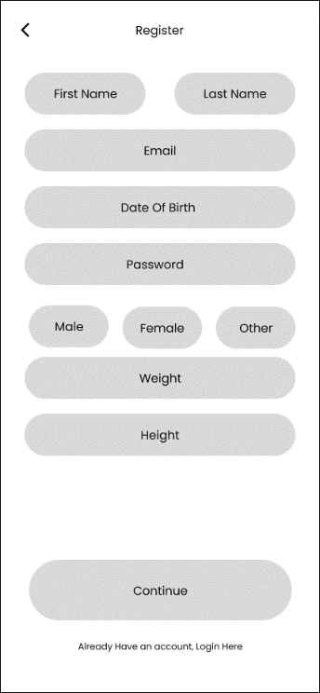

The user interface design commences with a crisp and inviting landing page, strategically crafted to provide users with a seamless introduction to the application. At the forefront of the landing page, users encounter a distinctive visual representation of the application type, serving as an unmistakable identifier of the platform they are about to engage with. Complementing this visual cue are two succinct text elements, thoughtfully curated to encapsulate the essence of the application and evoke curiosity in the user.

Accompanying these elements is a compelling welcome message or a captivating quote, strategically positioned to resonate with users and instil a sense of anticipation and eagerness to explore further. A message such as "Welcome to the ultimate health management app" or a motivational quote serves as an enticing invitation for users to explore further into the application's offerings and discover the myriad benefits it holds.

Subsequently, the user is seamlessly transitioned to the next phase of their journey, where they are presented with two distinct screens: the login screen and the registration screen. In this section, users are offered the flexibility to choose between logging in with existing credentials or creating a new account to access the application's full suite of features.

The login screen provides a familiar interface for users to authenticate themselves by entering their credentials, fostering a sense of security and familiarity. Conversely, the registration screen offers newcomers the opportunity to embark on their journey by effortlessly creating a new account, guided by intuitive prompts and form fields. These initial screens serve as the gateway to the application, setting the stage for a seamless and engaging user experience. By combining visually appealing design elements with intuitive functionality, the user interface design ensures that users encounter a welcoming and user-friendly environment from the moment they first encounter the application.

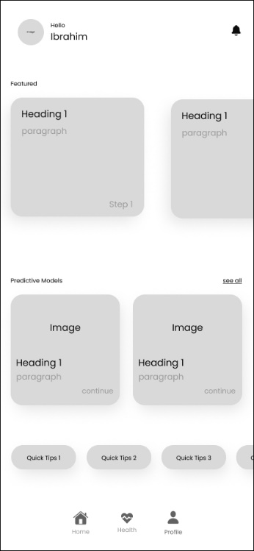  

Upon initial access to the home screen, individuals encounter the primary interface of the application, strategically crafted to facilitate the acquisition of precise forecasts concerning the probability of a heart attack or heart failure. The home screen functions as a central locus for users to interact with a myriad of features and capabilities designed to enhance the management of cardiovascular health.

Prominently featured on the home screen is the interactive task list, meticulously structured to lead users through the fundamental steps required for precise prediction model development. By prompting users to complete these steps, the application ensures that comprehensive data is collected and analysed, facilitating precise risk assessment and personalised insights into cardiovascular health. Moreover, the home screen prominently displays the individual's name, cultivating a personalised atmosphere and establishing a connection with the application. This personalised touch enhances user engagement and encourages active participation in the prediction process.

Incorporated within the home screen is a notification centre, offering users timely prompts and notifications to assist them in adhering to their health management objectives. These notifications serve as gentle prompts for users to address pending tasks or upcoming appointments, ensuring initiative-taking engagement with the application's features. Moreover, the home screen includes a dedicated segment for quick tips, providing users with valuable insights and suggestions for sustaining cardiovascular health and well-being. From lifestyle modifications to dietary suggestions, these tips provide actionable advice tailored to individual user needs, empowering users to make informed decisions about their cardiovascular health.

Finally, the home screen accommodates a specialised page that exhibits all accessible predictive models within the application. This centralised repository allows users to explore various prediction algorithms and methodologies, empowering them with knowledge and resources to make informed decisions about their health. To summarise, the home screen functions as a comprehensive portal for efficient cardiovascular health management, providing users with user-friendly navigation, personalised support, and valuable insights to bolster their journey towards well-being. Through its user-centric design and innovative features, the home screen epitomises our commitment to empowering individuals to take control of their heart health and live healthier, more fulfilling lives.

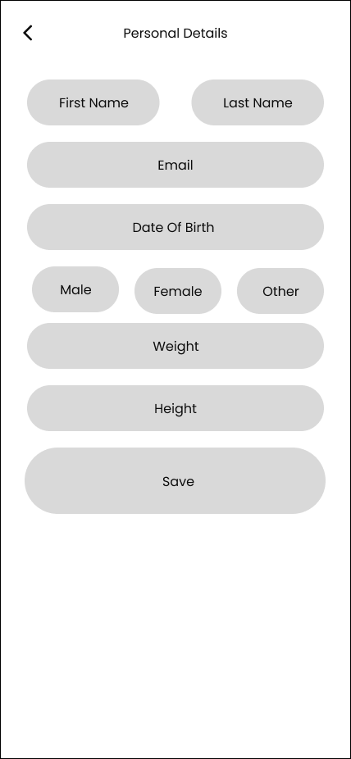 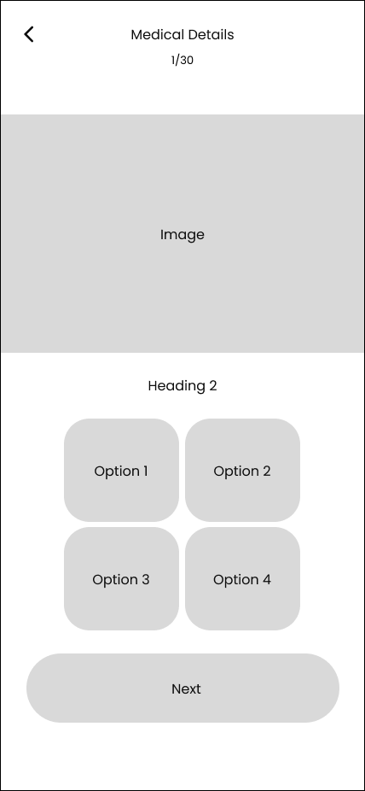

Within the featured section, users will encounter a series of interactive cards, each symbolising a step in the process of acquiring the most precise prediction achievable. These cards function as intuitive guides, encouraging users to fulfil the fundamental tasks required for maximal prediction precision. Initially, users will be prompted to fill in their personal details, ensuring that all relevant information is captured for comprehensive analysis. If users have not previously supplied this information during the registration process, they will now have the chance to do so. This stage lays the groundwork for personalised prediction models customised to individual user profiles.

Following the completion of personal details, users will proceed to the next step, which involves providing their medical information. Although this step is discretionary, users are urged to input as much pertinent medical data as is feasible to improve the precision of the prediction models. By providing this flexibility, users can select the extent of detail they are comfortable disclosing while simultaneously optimising the efficiency of the predictive analysis. Once personal and medical details have been inputted, users will have the option to run the prediction models for each specific health condition. These models use the comprehensive dataset provided by the user to generate personalised forecasts, empowering users with valuable insights into their cardiovascular health.

As users advance through each step in the featured section, the respective card will dynamically modify to signify completion, as visually depicted by a checkmark. This visual feedback not only strengthens user advancement but also furnishes a distinct roadmap of tasks to be fulfilled, enriching user engagement and contentment. Overall, the featured section simplifies the procedure of acquiring precise predictions by leading users through crucial steps while providing flexibility and customisation choices. By enabling users to actively engage in the prediction process, our objective is to nurture a sense of ownership regarding their cardiovascular health journey and facilitate well-informed decision-making.

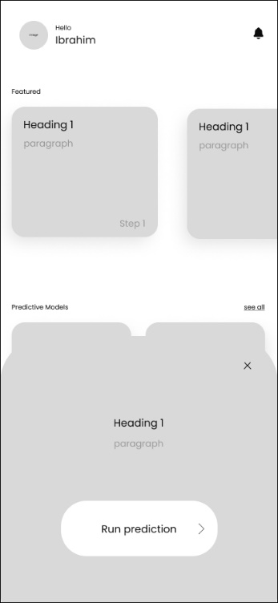 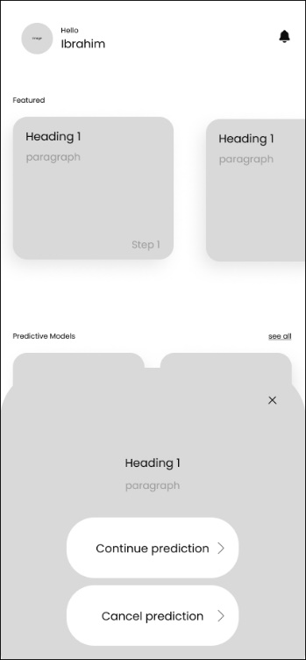 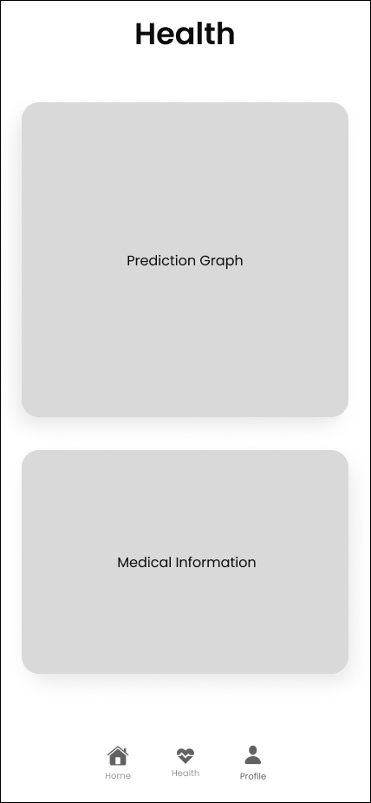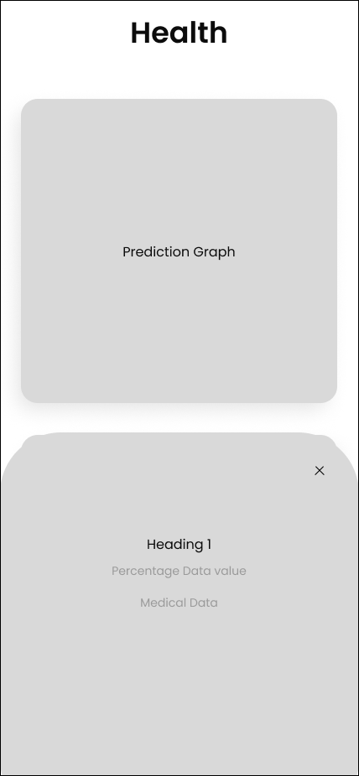

Upon selecting a prediction model from the available options presented as cards, users will be guided to commence the prediction process by performing a straightforward click or tap. Nevertheless, prior to advancing with the prediction, a comprehensive database verification will be undertaken by the system to ascertain the provision of all crucial medical and personal information by the user. In the event of any missing mandatory information, the system will alert the user through a cautionary notification, informing them that the precision of the prediction could be jeopardised because of inadequate data.

Upon verification that all essential particulars have been supplied, the prediction model will be seamlessly activated, using the extensive dataset to produce an accurate projection. Upon the conclusion of the prediction process, the user interface will shift to the health screen, where the prediction score will be depicted using an interactive graph. This graphical representation will enable users to examine and engage with the input data, offering clarity and understanding of the variables affecting the prediction result.

Apart from the prediction score graph, the health screen will exhibit critical medical particulars, encompassing the user's personal information such as name, age, height, weight, and the latest prediction percentage for ailments like myocardial infarction (MI) and congestive heart failure (CHF). Through the consolidation of this crucial data in a single convenient location, individuals can efficiently monitor their health status and observe variations over time, enabling them to make knowledgeable choices regarding their cardiovascular health.

In conclusion, this user interaction sequence highlights our dedication to providing a smooth and enlightening encounter, leading users through the prediction procedure with a focus on precision, transparency, and ease of use. By integrating user-friendly interfaces and comprehensive data visualisation tools, aiming to empower users to take initiative-taking steps towards managing their cardiovascular health with confidence and clarity.

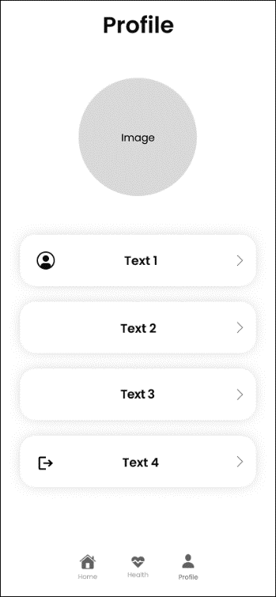 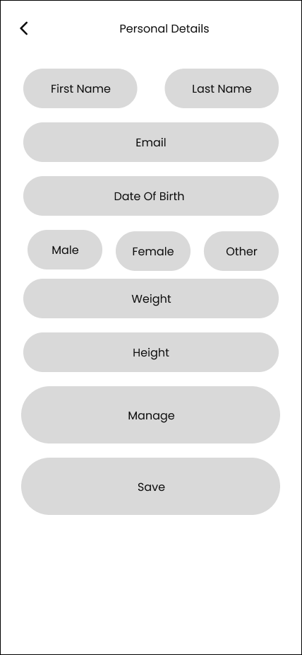 

The profile section of our user interface functions as a central hub for users to efficiently oversee their personal information and account settings. Within this section, users will find intuitive controls to update their personal details, including but not limited to their name, email address, and password. By facilitating convenient access to account management features, our goal is to empower users to uphold precise and current information, thereby enriching their overall interaction with our application.

Moreover, the profile section provides a pathway for delving into crucial details about the application through the "About Us" section. Now, users can acquire profound insights into the purpose, mission, and functionalities of the application, thereby nurturing transparency and trust between the user and the platform. Through the facilitation of access to this pivotal information, our objective is to guarantee that users possess a thorough comprehension of our application's objectives and capabilities. Moreover, the profile section incorporates an effortless logout feature, enabling users to securely log out of their accounts with minimal interaction. This feature not only enhances security by preventing unauthorised access but also provides users with control over their privacy and data.

Furthermore, alongside the profile section, our UI design encompasses a specialised tab for forthcoming implementations, demonstrating our progressive stance in integrating emerging technologies. This tab serves as a placeholder for upcoming features and functionalities, such as integration with wearable devices, which will further enhance the predictive capabilities of our application. By ensuring users are apprised of impending advancements, our aim is to cultivate anticipation and enthusiasm for the prospective evolution of our platform. In its entirety, the profile section of our user interface epitomises our dedication to user-centric design, accessibility, and innovation. Through the provision of intuitive controls, indispensable information, and previews of the future of our application, our goal is to offer a seamless and empowering experience for users who actively manage their cardiovascular health.



IMPLEMENTATION or INVESTIGATION

## Introduction

The implementation phase of any project is a critical juncture where theoretical concepts are translated into tangible solutions. This chapter explores the technical intricacies and methodologies used in the implementation of the predictive health management application, with the goal of predicting health risks like congestive heart failure (CHF) and myocardial infarction (MI). It not only provides a detailed account of the technical aspects but also encompasses the development and investigation of new material proposed in the preceding section on "New Ideas.".

In addition to presenting the technical specifications and development processes, this chapter provides insights into the project planning strategies, workload estimations, and contingency planning necessary to ensure the project's successful execution. As the project is expected to take approximately 400 hours of time, evidence of meticulous planning and allocation of resources is imperative to demonstrate the project's feasibility and adherence to deadlines. The implementation of software-based projects entails a comprehensive approach encompassing analysis, design, project management, structured programming, and rigorous testing. Effective project management, as emphasised in a systematic review, is crucial for embedding predictive models into clinical settings, involving detailed planning and clear definitions of objectives to ensure project success (Lee et al., 2020)​ (MDPI)​. Each of these aspects is meticulously addressed to ensure the production of a robust and functional software solution. Best practices in software development, such as rigorous testing phases and consideration of explainability, scalability, and data standardization, are crucial for effective integration of computational models in clinical workflows (BMC Medical Education, 2021)​ (BioMed Central)​. Furthermore, the investigation conducted as part of research-based projects adheres to scientific principles and employs appropriate tools and techniques to derive meaningful insights and outcomes.

In alignment with industry best practices, the implementation phase incorporates considerations of human-computer interaction (HCI) and usability standards, ensuring the final product is user-friendly and intuitive. The integration of ethical inclusivity and implementation science is key to enhancing the effectiveness of health AI systems, as outlined by the Coalition for Health AI (2021)​ (Coalition for Health AI)​. By addressing features such as GUI standards and usability principles, the application is designed to enhance the overall user experience and accessibility. Throughout this chapter, the progression of development is chronologically documented, offering a detailed overview of the various stages involved. From requirements analysis to problem analysis, design, and implementation, each phase is meticulously documented to highlight the challenges encountered, solutions devised, and lessons learned.

Moreover, to facilitate a comprehensive comprehension of the technical intricacies, various diagrams, including class diagrams, entity relationship diagrams, and technical flowcharts, are included. These diagrams serve as visual aids to elucidate complex concepts and methodologies employed during the implementation phase. In conclusion, this chapter serves as a comprehensive guide to the technical implementation of the predictive health management application, offering insights into the development processes, project planning strategies, and adherence to industry standards. Through meticulous documentation and analysis, it aims to provide a nuanced understanding of the implementation phase and its significance in realising the project objectives.

## Technical Specification

The Technical Specification section functions as a detailed manual for the technical team responsible for refining the prototype into a finalised product. Drawing from the insights gleaned from the exploration of cardiovascular disease prediction and the development of novel machine learning-based algorithms presented in the dissertation, this section provides an in-depth overview of the project's technical aspects, requirements, functionalities, architecture, and special techniques.

The project endeavours to establish a resilient predictive model for forecasting cardiovascular diseases, utilising machine learning methodologies to improve early identification and risk evaluation. The scope entails deploying sophisticated algorithms proficient in analysing a wide range of medical data sources to produce precise forecasts. This aligns closely with the dissertation's aims and objectives, which emphasise the development of innovative solutions to address critical healthcare challenges and contribute to the advancement of predictive analytics in healthcare.

The solution comprises several key components, including data preprocessing, feature engineering, model training, evaluation, and deployment. Each component is intricately designed to address specific requirements outlined in the dissertation's innovative ideas section, reflecting the project's emphasis on innovation and technical excellence. The architecture follows a modular design, facilitating scalability and extensibility, as envisioned in the project's objectives. Leveraging insights from the literature review and primary research, the solution incorporates state-of-the-art machine learning algorithms, including ensemble methods and deep learning architectures, to extract meaningful patterns from heterogeneous medical data.

Potential challenges and obstacles faced during the development phase comprise data imbalances, biases in feature selection, and issues related to model interpretability. Strategies for mitigation entail the utilisation of methods such as data resampling, resilient feature selection algorithms, and model explainability techniques to augment the reliability and interpretability of the predictive model. These strategies are derived from the literature review and contextualised within the innovative ideas section, reflecting the project's commitment to addressing critical challenges and innovating in the field of cardiovascular disease prediction.

Effective implementation requires proficiency in data science, machine learning, and software engineering, as delineated in the dissertation's goals and objectives. Additionally, access to computational resources for model training and validation is essential. Proficiency in programming languages such as Python and SQL, along with familiarity with machine learning frameworks and libraries like TensorFlow, scikit-learn, and XGBoost, is required. Backend development skills using Express.js and SQL Server are also indispensable for data management and API development. These technical requirements, meticulously outlined in the dissertation, ensure that the project team possesses the necessary capabilities to execute the project effectively and achieve its objectives.

The project introduces novel techniques for addressing challenges specific to cardiovascular disease prediction, including innovative feature selection algorithms and ensemble learning strategies. These techniques enhance the predictive performance and robustness of the model, positioning it as an innovative solution in the field. By highlighting these special techniques and innovations, the dissertation underscores the project's potential to make meaningful contributions to predictive analytics in healthcare, positioning it as a pioneering endeavour in the domain.

The technical specification is derived from an exhaustive analysis of project requisites, functionalities, and architecture. A detailed project timetable, developed using the Gantt chart methodology, outlines key milestones, tasks, and resource allocations. Cost estimation considers variables like software development, computational resources, and personnel expenditures, guaranteeing coherence with project goals and limitations. This comprehensive approach to technical specification and costing emphasises the project's dedication to excellence and responsibility, positioning it for effective implementation and concrete results.

The technical specification seamlessly integrates with the aims and objectives outlined in the dissertation, serving as a roadmap for translating theoretical concepts into practical solutions. Through aligning each facet of the technical specification with precise aims and objectives, the dissertation establishes a distinct correlation between the project's technical implementation and its overarching aspirations. For instance, the emphasis on developing a robust predictive model aligns with the aim of enhancing early detection and risk assessment of cardiovascular disease, as stated in the objectives. Similarly, the focus on innovative techniques and architectures reflects the project's objective of advancing the state-of-the-art in predictive analytics for healthcare.

In conclusion, the Technical Specification section of the dissertation provides a detailed roadmap for the implementation and refinement of the predictive model for cardiovascular disease prediction. By aligning with the project's aims, objectives, and innovative ideas, the technical specification ensures that the project is executed with precision, innovation, and technical excellence. Through meticulous planning, resource allocation, and integration of innovative techniques, the project is poised to deliver tangible outcomes that advance the state-of-the-art in predictive analytics for healthcare, thereby making a significant contribution to the field.

## Diagrams

Use Case Diagram - Figure 6

The use case diagram provided provides insight into how users interact with the heart prediction system. It delineates essential functions such as registering for an account, logging in, updating personal and medical information, and starting and ending sessions. Moreover, the diagram highlights potential advanced interactions, such as the system predicting health risks (like heart attacks) based on the user's updated information. Overall, this use case diagram serves as a simplified roadmap for users navigating the medical system to achieve their goals. It functions as a simplified roadmap for users navigating the medical system to achieve their goals, enhancing their overall health and well-being.

Class Diagram - Figure 7

The class diagram depicts a comprehensive framework for the heart prediction system, delineating the roles and interactions of various classes within the architecture. Fundamentally, the system revolves around the representation of users through the User class, enabling functionalities such as registration, login, and personal data management. The Mobile Application class extends these capabilities to mobile platforms, incorporating functionalities for user engagement and predictive analysis of conditions like Congestive Heart Failure (CHF) and Myocardial Infarction (MI). Enabling the backend operations, the Backend class abstracts user management and predictive tasks while interfacing with external resources such as the OpenAI API for advanced AI capabilities. The abstract prediction system class provides a foundation for storing the specific data used to make predictions, while the CHF Prediction History and MI Prediction History classes capture prediction outcomes and historical data. Supporting data storage and retrieval, the SQL Database class serves as the interface to the system's database, facilitating efficient data management. Altogether, this framework enables the system to predict and manage cardiac conditions effectively while ensuring seamless user interaction and data-driven decision-making.

Entity Relationship Diagram - Figure 8

The presented entity-relationship (ER) diagram provides a structured representation of a heart prediction system, using Unified Modelling Language (UML). The entities delineated encapsulate fundamental elements of user profiles, medical details, prediction histories. The User entity functions as the central node, encapsulating user attributes and defining one-to-many relationships with entities like MI, CHF, MI Prediction History, and CHF Prediction History, signifying the possibility of multiple myocardial infarction records, congestive heart failure diagnoses, and prediction histories per user. The MI and CHF entities retain intricate data concerning myocardial infarction and congestive heart failure, respectively, whereas the MI Prediction History and CHF Prediction History entities record previous predictions for these conditions. This ER diagram establishes a fundamental framework for the methodical monitoring of user health data, medical conditions, and predictive analytics in the realm of heart disease care and prevention. By incorporating these entities, the system can provide personalised recommendations and interventions to improve heart health outcomes for users. This comprehensive approach to data collection and analysis can lead to more effective prevention and management strategies for heart disease.

Component Diagram - Figure 9

The mobile application architecture outlined in the diagram encompasses a sophisticated interplay of components geared towards user interaction, data management, prediction capabilities, and external integrations. At its forefront, the user interface (UI) serves as the primary point of interaction for users, facilitating information display, data input, and navigation through the application's features. This interaction is complemented by input handling, which processes user inputs and directs them to relevant application components, ensuring seamless user experiences. Concurrently, state management oversees the application's state, synchronising the UI with current data and user preferences, while notification management manages the presentation of notifications within the app, adhering to user preferences and priorities.

On the backend, the architecture revolves around distinct server-side systems, including an authentication system responsible for user verification and login management, and an account management system overseeing user profiles and registration processes. The security system plays a crucial role in safeguarding user data and application integrity against potential cyber threats. Meanwhile, the prediction system employs machine learning models, potentially interfacing with the OpenAI API, to analyse user data and generate predictive insights. This system interacts with a SQL Database, housing structured data such as user profiles, medical conditions (e.g., Myocardial Infarction, Congestive Heart Failure), and prediction histories, facilitating informed decision-making and personalised user experiences.

Externally, the application integrates with the OpenAI API, tapping into advanced AI capabilities for predictive analysis and decision support. Key interactions, depicted by arrows in the diagram, highlight the seamless flow of data and communication between components. Notably, the UI communicates with backend systems via REST APIs, facilitating data exchange and processing. The authentication system generates tokens upon successful login, enhancing security and facilitating subsequent user interactions. Additionally, the prediction system interacts with the SQL Database to access user data for predictive modelling, potentially leveraging the OpenAI API for enhanced analysis.

In summation, this architecture embodies a comprehensive approach to mobile application development, integrating user-centric design principles with robust backend infrastructure and external AI capabilities. By leveraging data-driven insights and seamless user interactions, the application aims to deliver personalised experiences and predictive health analytics to its users.

Sequence Diagram - Figure 10

The provided sequence diagram illustrates the intricate message flow among multiple participants involved in interactions within a mobile application aimed at forecasting health risks, specifically focusing on congestive heart failure (CHF) and myocardial infarction (MI). The involved entities consist of the user, symbolising the end-user of the application; the mobile application, functioning as the user interface; the backend, accountable for server-side processes; the database for data retention; the prediction system for prediction generation; and the external OpenAI API for utilising AI functionalities. The interactions occur within two primary functions: user registration and login, as well as health risk prediction. In the registration and login phases, the mobile application establishes communication with the backend to oversee user credentials and data, guaranteeing effective authentication and access. Following this, the process of health risk prediction encompasses requests initiated by the user, leading to interactions among the mobile application, backend, prediction system, and OpenAI, resulting in the delivery of prediction outcomes to the user. In summary, the sequence diagram clarifies the complex communication flow and data interchange orchestrated within the mobile application's environment, highlighting the smooth integration of backend services and external AI resources for dispensing predictive health analytics to users. To conclude, the sequence diagram highlights the advanced architecture and interconnected elements that empower the mobile application by offering personalised health insights and recommendations to the user.

## Tools and Techniques

In the pursuit of a comprehensive literature review and research exploration, a diverse array of research tools has been harnessed to ensure a holistic understanding of the domain. The NTU One Search library serves as a fundamental academic resource, granting access to a vast collection of scholarly articles, journals, and conference proceedings. This resource enables accurate searches and effective retrieval of pertinent literature, establishing a solid foundation for scholarly investigation.

Moreover, Schematic Scholar is a valuable tool for navigating the scholarly terrain, offering insights into citation metrics, research trends, and significant publications. Its graphical interface and advanced search functionalities empower researchers to identify seminal works, track citation patterns, and uncover hidden connections within the literature. In addition to these scholarly databases, Google Scholar, and YouTube function as supplementary resources for accessing a wide variety of educational content. Google Scholar's expansive database facilitates broad searches across disciplines, while YouTube offers multimedia resources such as lectures, tutorials, and conference presentations, catering to diverse learning preferences. Moreover, Stack Overflow is an essential resource for tackling coding obstacles and finding solutions through community collaboration. Its vibrant community of developers and comprehensive Q&A format foster collaborative learning, problem-solving, and knowledge sharing within the programming community. Furthermore, Google Forms played a crucial role in conducting primary research, aiding in data collection and analysis through tailored surveys and questionnaires. Its intuitive interface and real-time response tracking capabilities enabled efficient data gathering, empowering researchers to glean insights directly from target audiences and stakeholders.

Python is distinguished as the foremost programming language due to its versatility, readability, and broad array of libraries and frameworks. The choice to embrace Python is based on its aptness for data science and machine learning assignments, supported by its robust libraries and user-friendly syntax. The NumPy library is pivotal for numerical computation and array manipulation, offering effective data structures and mathematical functions crucial for scientific computing. Pandas complements NumPy by offering high-level data structures and tools for data manipulation and analysis, facilitating tasks such as data cleaning, transformation, and exploration. Scikit-learn emerges as a powerful machine learning library, offering a comprehensive suite of algorithms and utilities for classification, regression, clustering, and dimensionality reduction techniques. The user-friendly interface and consistent API design of this software simplify the development and evaluation of machine learning models.

Additionally, TensorFlow's scalable deep learning capabilities and extensive ecosystem of tools and libraries facilitate the development and deployment of neural network architectures for complex tasks, such as image recognition and natural language processing. Python's wide array of libraries and frameworks expedites prototyping, experimentation, and deployment, positioning it as the preferred language for data-driven projects. Moreover, Node.js and JavaScript have been pivotal in backend development, providing a lightweight, event-driven architecture for constructing scalable web applications. JavaScript's versatility and ubiquity in web development, coupled with Node.js's non-blocking I/O model and asynchronous capabilities, make them indispensable tools for building responsive and dynamic server-side components.

Visual Studio Code (VS Code) emerges as the preferred Integrated Development Environment (IDE) for its versatility, extensibility, and robust feature set. The intuitive interface and customisable layout of the software offer a seamless development experience, addressing a wide range of programming requirements. The Python extension for VS Code boosts productivity through the provision of advanced features like code linting, debugging, and IntelliSense, which aid in code comprehension and error detection. Moreover, the incorporation of Jupyter Notebook into VS Code facilitates interactive computing and exploratory data analysis, promoting an iterative and collaborative development workflow. Within the notebook interface, users can create and execute code cells, visualise data outputs, and document insights all in a unified environment. Its support for Markdown formatting and inline visualisations enhances the narrative storytelling aspect of data analysis, making it a powerful tool for communicating findings and insights. Furthermore, the extensive plugin ecosystem and cross-platform compatibility of VS Code cater to the diverse needs of developers, ensuring a seamless and efficient development experience across different projects and environments.

Within the domain of backend development and data management, the project leverages a fusion of Express.js and SQL Server to construct scalable, dependable, and secure web applications. Express.js, characterised by its minimalist design within the Node.js environment, establishes a solid groundwork for the creation of RESTful APIs and web services, fostering smooth communication between frontend and backend elements. The lightweight architecture, flexible routing system, and middleware support of Express.js streamline the development process, enabling rapid prototyping and iteration. Moreover, Express.js provides a vibrant ecosystem of plugins and middleware, empowering developers to easily enhance the functionality of their applications. SQL Server, an extensive relational database management system (RDBMS) created by Microsoft, functions as the backend database for the storage and retrieval of structured data. The comprehensive array of features in SQL Server, such as transactional support, indexing, and query optimisation, ensures effective data management and integrity. Moreover, the integration of SQL Server with Express.js facilitates seamless data access and manipulation, providing the project with a scalable and high-performance backend infrastructure. The amalgamation of Express.js and SQL Server presents a resilient and adaptable solution for constructing data-centric web applications, guaranteeing dependability, scalability, and security across the development continuum.

To conclude, the meticulous selection of research tools, programming languages, IDEs, and server technologies underscores the project's dedication to excellence, innovation, and technical proficiency. Through the utilisation of the strengths inherent in each tool and technology, the project is positioned to efficiently attain its objectives while pushing the frontiers of data science and machine learning.

## Unit Testing

### Python Unit Testing

Unit testing is a fundamental aspect of software development, serving as a pillar for ensuring the reliability, functionality, and maintainability of codebases. Within the software testing process, unit testing involves the examination of individual units or components of software in isolation from the rest of the application. These units are typically the most minuscule, testable components of an application, such as functions, methods, or classes. By meticulously scrutinising these units through automated tests, developers can identify and rectify defects early in the development lifecycle, preventing potential issues from escalating into more intricate and challenging problems. This introduction lays the foundation for exploring the significance of unit testing within the broader context of software engineering, highlighting its pivotal role in fostering code quality, enabling faster development cycles, and ultimately contributing to the delivery of robust and reliable software solutions.

Congestive Heart Failure Model

During the unit testing phase of the dissertation project centred on the CHF (Congestive Heart Failure) heart attack predictive model, a detailed analysis of data preprocessing and cleaning methodologies is undertaken to uphold the precision and dependability of the model.

CHF Data Pre-Processing Unit Testing - Figure 11

1. **Data Cleaning Tests**:
   * **Exclusion of Irrelevant Columns: The test_drop_id_column () method validates the accurate elimination of the 'id' column from the dataset, thereby guaranteeing that irrelevant data does not impact model training.**
   * **Removing Duplicate Entries**: The test_drop_duplicates () method confirms that duplicate records are effectively eliminated, preventing data redundancy, and maintaining dataset integrity.
   * **Gender Representation Transformation: The test_change_gender_representation () method confirms the conversion of gender representation from numeric values to binary values (0 for male, 1 for female), thereby ensuring uniformity and standardisation within the dataset.**
   * **Elimination of Negative Values: The test_remove_negative_values () method guarantees the exclusion of negative values in blood pressure readings (systolic and diastolic), thereby ensuring the accuracy of physiological data utilised in model training.**

MI Data Pre-Processing Unit Testing - Figure 12

1. **Data Preprocessing Tests**:
   * **Shape of Pre-processed Data**: The test_data_preprocessing_shape () method assesses whether the shape of pre-processed data remains consistent after scaling and encoding operations, ensuring data integrity throughout the preprocessing pipeline.
   * **Validation of Pre-processed Data Values: The test_data_preprocessing_values () method confirms the absence of missing or incorrect values in pre-processed data, upholding data integrity and dependability.**
   * **Numerical Features Scaling: The test_scaling () method authenticates the scaling of numerical features through the Robust Scaler, guaranteeing precise and consistent data normalisation.**
   * **Categorical Features Encoding: The test_encoding () method affirms the correct encoding of categorical features via the One Hot Encoder, maintaining categorical information without introducing partiality or distortion.**

Through meticulous examination of every aspect of the data preprocessing and cleaning pipeline via unit tests, the dissertation project endeavours to lay a strong groundwork for the CHF heart attack predictive model. These assessments aid in the early detection and resolution of possible issues during the developmental phase, bolstering trust in the model's efficacy and dependability among stakeholders and end-users.

Myocardial Infarction Model

During the unit testing phase of the myocardial infarction (MI) predictive model, a thorough assessment of data preprocessing and feature engineering procedures is crucial to guaranteeing the model's precision and efficacy. Let us outline the specific unit tests conducted for this purpose:

MI Data Cleaning Unit Testing - Figure 13

1. **Data Loading and Preprocessing Tests**:
   * **Load Dataset**: The test_load_dataset () method verifies that the dataset is successfully loaded from a specified file path and is in the expected Data Frame format.
   * **Column Renaming: The test_rename_columns () method guarantees the renaming of columns based on a predefined mapping, enhancing uniformity and lucidity in feature depiction.**
   * **Examine Missing Values: The test_check_missing_values () method assesses the presence of any missing values in the dataset, verifying data completeness prior to subsequent processing steps.**
   * **Duplicate Removal: The test_remove_duplicates () method evaluates the efficiency of eliminating duplicate rows from the dataset to avoid data redundancy and potential bias in model training.**
   * **Summary Statistics Display: The test_display_summary_statistics () method validates the production of summary statistics for the dataset, offering insights into essential data characteristics and distributions.**

CHF Data Cleaning Unit Testing - Figure 14

1. **Data Preprocessing and Feature Engineering Tests**:
   * **Data Preprocessing Shape**: The test_data_preprocessing_shape () method validates that the shape of pre-processed data remains consistent after applying preprocessing transformations, ensuring data integrity throughout the pipeline.
   * **Data Preprocessing Data Integrity: The test_data_preprocessing_values () method ensures the absence of missing or erroneous values in pre-processed data, preserving data quality and dependability.**
   * **Numerical Feature Scaling: The test_numeric_scaling () method guarantees the accurate scaling of numeric features with the robust scaler, maintaining data distribution and aiding convergence in model training.**
   * **Categorical Feature Encoding Verification: The test_categorical_encoding () method validates the correct encoding of categorical features with the one hot encoder, allowing the representation of categorical variables as binary vectors without introducing bias or distortion.**

By meticulously conducting these unit tests, the dissertation project aims to establish a solid foundation for the MI or heart attack predictive model, fostering confidence in its performance and reliability. These tests serve to identify and address potential issues early in the development process, ultimately enhancing the model's effectiveness in predicting myocardial infarction events.

## Project Planning

Project planning is essential for the successful execution of projects. It encompasses the process of defining project objectives, outlining tasks, allocating resources, and establishing timelines to achieve desired outcomes. This phase establishes the project's direction, scope, and boundaries, guiding stakeholders from start to finish. Efficient project planning ensures optimal resource utilisation, risk mitigation, and expectation management. Through meticulous planning of the steps necessary to achieve project goals, project planning establishes the groundwork for seamless coordination, collaboration, and, ultimately, project success. This section delves into the foundational principles and optimal practices of project planning, offering insights into the strategies and methodologies essential for the successful execution of projects.

Within the figure below, the detailed strategic planning process of this dissertation is unveiled, highlighting a meticulously developed roadmap that considers a range of tasks and essential responsibilities crucial for its culmination. At the core of this strategic approach lies the Gantt Chart, which functions as a graphical depiction of the dissertation's temporal framework. The distinguishing feature of this Gantt chart is its thorough representation, encompassing not just the tasks related to the dissertation but also the integration of concurrent responsibilities.

Given the breadth and collective workload of the dissertation, the Gantt chart emerges as a vital instrument for coordinating collaborative endeavours and overseeing interconnected tasks. Every element of the dissertation, spanning research, data collection, analysis, and writing, is carefully planned to coincide with the primary project goals.

Gantt Chart - Figure 15

Through the incorporation of commencement and completion dates for these supplementary tasks, the Gantt Chart enables effective time management, enabling a concentrated emphasis on the dissertation while adjusting for extra responsibilities. This strategic coordination guarantees the seamless advancement of the dissertation in parallel with other obligations, optimising productivity without compromising quality.

Moreover, the Gantt Chart offers an elaborate schedule covering each phase of the dissertation's progression, starting from project commencement to final submission. This meticulous planning approach offers a clear overview of the sequential tasks and milestones, guiding the project towards successful completion.

Following this methodical blueprint not only guarantees prompt execution but also provides sufficient space for evaluation and enhancement. By allotting adequate time for possible revisions and amendments, both internal and external parties can participate in comprehensive evaluations, enriching the overall calibre and credibility of the dissertation.

In essence, this comprehensive project planning framework sets the stage for a successful dissertation journey, providing a roadmap that navigates through complexities while fostering efficiency, accountability, and excellence.



RESULTS / DISCUSSION

## Introduction

This chapter outlines the findings obtained through the extensive research and development initiatives conducted within the project's framework. This crucial chapter aims to rigorously assess the project's accomplishment of its specified aims and objectives, as outlined in Chapter 1.

The primary aim of this chapter is to conduct a thorough evaluation of the project's results, elucidating both achievements and constraints faced throughout the research process. Through adherence to predetermined success criteria and the utilisation of suitable testing methodologies, the dissertation seeks to evaluate the effectiveness of its contributions within the allocated period. Acknowledging the inherent difficulties in fully evaluating the project under real-world conditions within the constraints of a dissertation timeline, this chapter presents alternative strategies for comprehensive assessment and delineates potential avenues for future testing and validation.

Furthermore, this chapter will explore the technical intricacies of the testing methodologies employed, elucidating the measures utilised to assess the project's success. Through meticulous analysis and interpretation of the collected data, this dissertation seeks to offer a coherent and logical discussion of the results obtained, illuminating both positive outcomes and areas for enhancement. Additionally, an investigation into the project's potential for progress and innovation within the field will be conducted. This process will entail performing quantitative tests and statistical analyses to determine the degree of enhancement over current methodologies and techniques, thereby enriching scholarly dialogue and advancing the boundaries of knowledge in the field.

In essence, Chapter 5 serves as a critical juncture in the dissertation, offering an empirical foundation upon which subsequent discussions and conclusions will be built. Through a rigorous examination of the project's outcomes and their alignment with the overarching objectives, this chapter seeks to elucidate the significance and impact of the research endeavours, ultimately enriching the scholarly landscape within the field of study.

## Success Criteria

From a retrospective standpoint, the project's success can be assessed through a reassessment of the aims and objectives delineated in Chapter 1. These criteria function as standards against which the project's outcomes are assessed. Success is ascertained by evaluating the degree to which the project has accomplished the following:

**Aims:**

1. **Develop a robust prediction model:**

The project successfully achieved this aim by leveraging innovative machine learning techniques, including convolutional neural networks (CNN) and OpenAI frameworks. Through the analysis of varied medical data, including patient demographics, medical history, and physiological indicators, the established prediction model effectively evaluates the likelihood of heart attacks and heart failure. Through meticulous algorithm development and rigorous validation, the project ensures exceptional precision and reliability in forecasting cardiovascular events.

2. **Ensure Ethical Data Usage:**

Ethical considerations regarding data privacy and security were meticulously addressed throughout the project's implementation. Stringent protocols were enforced to protect user data and adhere to ethical standards and regulations like GDPR and HIPAA. Measures including data anonymisation, informed consent acquisition, and robust encryption methods were implemented to uphold data integrity and user trust. Through a focus on ethical data utilisation, the project upholds transparency and reduces the likelihood of data breaches or misuse.

3. **Develop an easily accessible mobile application:**

The objective of designing and deploying a user-friendly mobile application accessible on both iOS and Android platforms was successfully realised. The application highlights an intuitive interface, smooth navigation, and adaptive design, guaranteeing user-friendly access for individuals across various demographic segments. By prioritising user accessibility and convenience, the project promotes extensive adoption and interaction with the application, facilitating early detection of potential health issues and prompt interventions.

4. **Enhance Early Intervention:**

Early intervention strategies were effectively implemented through the mobile application to mitigate the risks associated with cardiovascular diseases. The project encourages initiative-taking engagement with the application, facilitating early detection of potential health issues through personalised health recommendations, timely alerts for abnormal health indicators, and educational resources promoting preventive measures and healthy lifestyle choices. Through the empowerment of users with actionable insights, the project advocates for prompt medical attention and lifestyle adjustments, consequently strengthening early intervention initiatives.

5. **Minimise false positives and negatives.**

Achieving a balance between sensitivity and specificity was a key focus in minimising false positive and false negative predictions generated by the predictive models. Through iterative algorithm refinement and fine-tuning, the project optimised model parameters and feature selection techniques to reduce erroneous predictions. The integration of OpenAI further contributed to reducing false positives, enhancing the accuracy and reliability of the prediction system. By ensuring users obtain actionable insights without unnecessary alarm or complacency, the project enhances the efficacy of early intervention measures.

**Objectives:**

1. **Model Development:**

The objective of developing and enhancing machine learning algorithms tailored for analysing intricate datasets related to cardiovascular health was successfully accomplished. Through rigorous data preprocessing, feature extraction, and model training, robust predictive models capable of discerning subtle patterns and risk factors indicative of heart attacks and heart failure were developed. By empowering healthcare providers and individuals with actionable insights, the project facilitates initiative-taking risk management and early intervention efforts.

2. **Data Collection and Preprocessing:**

Comprehensive data collection and preprocessing procedures were meticulously executed to ensure the quality and reliability of the datasets used for model training and validation. By aggregating diverse sources of medical data and applying rigorous data cleaning techniques, the project curated high-quality datasets conducive to precise model training and assessment. Through meticulous data preprocessing, bias and noise were minimised, enabling accurate prediction model development and evaluation.

In the figure below, an array of comprehensive data processing methods, coupled with rigorous model training and meticulous evaluation processes.

Data Processing - Figure 16

3. **Model Evaluation:**

A rigorous evaluation of predictive models was conducted to assess their performance, generalisability, and clinical utility. By benchmarking model performance against established metrics and employing cross-validation techniques, the project validated model robustness across diverse patient populations and healthcare settings. Through adherence to rigorous evaluation protocols, the project ensures the reliability and validity of the prediction system in real-world contexts, thereby fostering trust among stakeholders and end-users.

As seen in the figure down below an array of comprehensive data processing methods, coupled with rigorous model training and meticulous evaluation processes.

Model Building - Figure 17

4. **User Education:**

Despite being identified as a critical objective, the implementation of user education initiatives within the project did not meet the anticipated standards. While the importance of educating users on cardiovascular health and preventive measures was acknowledged, a comprehensive strategy for user education was not meticulously developed or executed. This oversight led to the failure to adequately address the objective of user education within the project scope. In the future, it is imperative to revisit this objective and devise a robust plan for educating users on the significance of early intervention, preventive measures, and healthy lifestyle choices to empower them to manage their cardiovascular health effectively. Failure to implement effective user education strategies could compromise the long-term success and impact of the mobile health application.

5. **Continuous Monitoring:**

An advanced framework for ongoing monitoring of user data and model performance was implemented, facilitating initiative-taking surveillance of emerging patterns and irregularities. By implementing real-time data analytics, anomaly detection algorithms, and feedback mechanisms, the project captures user feedback and monitors prediction outcomes in real-time. Regular audits, performance reviews, and updates ensure the prediction system remains responsive to evolving user needs and technological advancements, thereby maintaining its relevance and effectiveness over time.

6. **Interactive User Interface:**

Designing an intuitive and engaging user interface for the mobile application was successfully accomplished. Through user research, usability testing, and iterative UI design iterations, the application's layout, navigation flow, and visual aesthetics were optimised to enhance user satisfaction and adoption rates. Features such as interactive data visualisations, personalised health dashboards, and intuitive controls enhance user engagement and facilitate seamless interaction with the prediction system, thereby promoting sustained engagement and positive health outcomes.

**Efficacy of Solutions:**

The success of the project is evidenced by the accessibility, accuracy, and effectiveness of the solutions developed to address the research problem. The mobile application's widespread adoption and the predictive models' high accuracy rates demonstrate their efficacy in empowering users with actionable insights for proactive heart health management. By achieving a minimum accuracy threshold of 85%, the project validates the robustness and reliability of the prediction system in real-world applications, underscoring its potential to improve health outcomes and reduce the burden of cardiovascular diseases.

**Quality of Results:**

The project's results adhere to established standards of accuracy, validity, and reliability, ensuring their integrity and usability in clinical and research settings. Rigorous evaluation protocols, data validation procedures, and quality assurance measures uphold the quality of the prediction models and user-facing applications. By adhering to best practices in data science, machine learning, and healthcare informatics, the project maintains the credibility and trustworthiness of its results, fostering confidence among stakeholders and end-users.

**Innovation and Contribution:**

The project's innovative approaches, novel insights, and contributions to advancing cardiovascular health monitoring and early intervention distinguish it as a significant contribution to the field. Through the utilisation of state-of-the-art technologies, interdisciplinary partnerships, and evidence-based methodologies, the project pioneer’s novel paradigms in predictive analytics, personalised medicine, and digital health interventions. Insights gained from the project's research findings, best practices, and lessons learned contribute to the collective knowledge base and inform future research directions in cardiovascular health informatics. Ultimately, the project's innovative solutions and tangible impact on improving health outcomes underscore its value and significance as a transformative force in healthcare innovation.

## Testing Plan

The aim of this testing plan is to guarantee the functionality, usability, performance, and security of the mobile health application, with a focus on cardiovascular risk prediction and early intervention features.

Scope:

This testing plan covers the following areas:

* Functional testing
* Usability testing
* Performance testing
* Security testing
* Compatibility testing
* Regression testing

Testing Approach:

Testing Approach - Table 1

|  |  |
| --- | --- |
| **Test Type** | **Description** |
| Functional Testing | Verify all features and functionalities, including prediction model accuracy, user registration, data input, health assessment, notification system, etc. |
| Usability Testing | Evaluate the UI/UX design, navigation, accessibility, and user engagement through usability tests. |
| Performance Testing | Measure response times, latency, and resource consumption under various conditions, including peak load and low network connectivity. |
| Security Testing | Identify and mitigate potential security vulnerabilities, ensuring compliance with data privacy regulations. |
| Compatibility Testing | Ensure compatibility across different devices, OS versions, and screen sizes to ensure consistent functionality. |
| Regression Testing | Perform tests after each update to ensure existing functionalities remain unaffected and detect any regression defects. |

Test Environment:

* **Devices:** iOS and Android smartphones and tablets.
* **Operating Systems:** Latest versions of iOS and Android emulators and physical devices.
* **Network:** high-speed and low-speed network connections for real-world simulation.

Test Cases:

* **Functional Test Cases:** Verify each feature and functionality against predefined requirements.
* **Usability Test Cases:** Evaluate UI/UX design, navigation, and user interaction flows.
* **Performance Test Cases:** Measure response times, latency, and resource consumption under different load conditions.
* **Security Test Cases:** Identify and address security vulnerabilities related to data privacy and protection.
* **Compatibility Test Cases:** Ensure functionality across various devices and OS versions.
* **Regression Test Cases:** Ensure existing functionalities remain unaffected after updates.

Reporting:

Comprehensive test report, including:

* Test objectives and scope.
* Test environment details.
* Executed test cases and outcomes.
* Defects are identified by severity and priority.
* Recommendations for improvements.

The implementation of this testing plan will ensure the quality, reliability, and security of the mobile health application, thereby enhancing user satisfaction and trust in its predictive capabilities for cardiovascular risk assessment and early intervention.

Test Plan: React Native Application

Testing Plan - Table 2

|  |  |  |  |  |
| --- | --- | --- | --- | --- |
| Test Case | Description | Test Step | Expected Result | Status |
| Functional | Verify user login functionality | Enter valid username and password | User successfully logged in | Pass |
| Functional | Test data input for health assessment | Input blood pressure, cholesterol, and other health metrics | Data saved and displayed accurately | Pass |
| Functional | Test notification system functionality | Send test notification | Notification received and displayed | Pass |
| Usability | Evaluate navigation efficiency | Navigate to different app sections | Smooth transition between sections | Pass |
| Usability | Test accessibility features | Use app with screen reader | All app features accessible via screen reader | Pass |
| Performance | Measure application loading time | Open app on various devices | App loads within 3 seconds | Pass |
| Performance | Test network resilience | Use app on 3G/4G/5G and Wi-Fi networks | App functions without disruptions | Pass |
| Security | Verify user login tokenisation | Inspect login token | Token securely generated and hashed | Pass |
| Security | Test data encryption during transmission | Monitor network traffic | Data encrypted using SSL/TLS | Pass |
| Compatibility | Ensure compatibility with different OS versions | Test app on Android and iOS devices | App functions on Android and iOS | Pass |
| Compatibility | Test screen responsiveness across devices | Use app on various screen sizes | UI elements adjust to screen sizes | Pass |
| Regression | Test data integrity after database updates | Update database schema or records | Data remains consistent and accurate | Pass |

Test Plan: Predictive Models

|  |  |  |  |  |
| --- | --- | --- | --- | --- |
| Test Case Type | Description | Test Step | Expected Result | Status |
| Model Prediction Accuracy | Evaluate the accuracy of the machine learning models. | 1. Prepare a test dataset containing known data points and corresponding outcomes. | The test dataset is properly prepared and contains enough data points representative of real-world scenarios. | Pass |
|  |  | 2. Feed the test dataset into each machine learning model (e.g., CNN, OpenAI). | Each model accurately predicts outcomes for each data point in the test dataset. | Pass |
|  |  | 3. Compare the predicted outcomes from each model with the actual outcomes from the test dataset. | The predicted outcomes from each model closely match the actual outcomes, indicating high prediction accuracy. | Pass |
|  |  | 4. Calculate evaluation metrics such as precision, recall, F1 score, and AUC using the predicted outcomes and actual outcomes for each model. | Evaluation metrics demonstrate high performance of each model in terms of accuracy and reliability. | Pass |
|  |  | 5. Analyse the results and identify any discrepancies or areas for improvement among the models. | Any discrepancies or areas for improvement among the models are documented and addressed for model refinement. | Pass |

### Postman Api Testing

Postman was selected as the primary tool for API testing due to compatibility issues with React Native and deprecated unit testing libraries. This choice facilitated a controlled environment for effectively validating the application's functionalities. The Postman interface offers a user-friendly platform for sending requests to the APIs and observing the responses in real time, which is essential for endpoint validation and ensuring the system's robustness. Below, we detail the steps taken and the results of our API testing phase.

Testing User Authentication and Profile Management

**Login API Endpoint Testing**

The login endpoint functions as the primary access point to the Heart Attack Alert System, overseeing user authentication and session establishment. Testing was conducted utilising a predefined set of authentic credentials, usually comprising a username and password combination, to verify the integrity of the system's authentication mechanism.

Upon sending a POST request to /api/login, the server's response was scrutinised. A successful login resulted in a 200 OK status, accompanied by a JSON payload containing the user's unique identifier (user ID) and a securely generated authentication token. This token is a critical component of our security architecture, leveraging JSON Web Tokens (JWT) for maintaining user sessions. The rapid response time, quantified at 59 milliseconds, falls comfortably within the ideal performance spectrum, guaranteeing a smooth user interaction.

To conduct negative testing, a range of scenarios were implemented to assess the system's resilience to incorrect inputs. Efforts with inaccurate passwords led to a 401 Unauthorised status code, prompting an error notification to users while safeguarding confidential data. Additionally, the system proficiently managed exceptional cases, including instances of absent credentials, by following established error handling procedures and offering explicit, actionable guidance to the user.

The token's validity duration was set to balance user convenience with security considerations, requiring re-authentication after a period of inactivity to protect against unauthorised access. The testing procedure authenticated not only the functional dimension of the login but also scrutinised the user interface and security ramifications, showcasing the endpoint's preparedness for implementation in a production setting.

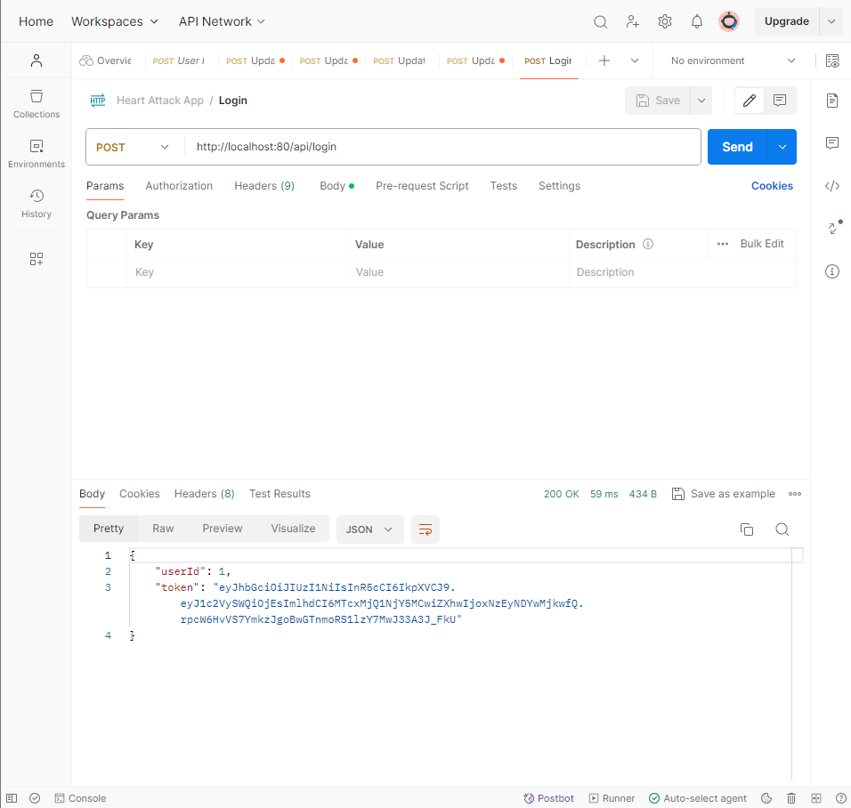

Login Test - Figure 18

**User Registration Endpoint Testing**

The process of user registration serves as a critical gateway to the Heart Attack Alert System, granting individuals the ability to establish an account and utilise personalised services. The efficacy of registration relies on a POST request to /api/register, encompassing essential parameters: first and last name, email, password, date of birth (in a standardised format), height, weight, and gender. The format and data validation criteria are meticulously enforced to guarantee data integrity and mitigate system misuse.

Upon submission of a registration form, the server initiates a comprehensive validation process, confirming the email address's uniqueness and assessing password compliance with established security protocols. The backend processes utilise advanced encryption techniques such as hashing and salting, adhering to industry standards to fortify data security.

Following a successful registration, a 200 OK status code is issued along with a notification verifying the successful establishment of the user account. This outcome is the product of a sequence of validation mechanisms crafted to authenticate user input. When encountering duplicate email addresses or insufficient password complexity, the system issues a detailed error message instructing users to correct their submission without jeopardising confidential data.

Furthermore, the registration procedure is structured with regulatory compliance at its core, adhering to GDPR regulations and safeguarding the confidentiality of user data from the initial stages. The response time of 55 milliseconds from the request to the successful registration message highlights the system's efficiency, contributing positively to the user's experience.

Test scenarios were methodically crafted to cover a range of potential user inputs. Positive test cases confirmed the system's responsiveness to valid registration data, while negative scenarios—such as attempts with missing fields, invalid email formats, and breached password policies—ensured the system's resilience against incorrect inputs. Boundary testing was also conducted, ensuring that field constraints were upheld.

Registration Test - Figure 19

**Fetching User Records**

The endpoint /api/users/1 plays a crucial role in retrieving individual user records within the Heart Attack Alert System. This GET request is vital for users to manage their health data and for healthcare providers to access patient records when authorised. Authentication is necessary for the request, usually achieved through an authorisation header containing a secure token, to guarantee legitimate data access.

The response, as depicted in the "User Records.png" screenshot, is a structured JSON object containing essential profile details. Each attribute, ranging from fundamental identification such as "first name" and "last name" to vital health parameters like "weight" and "height," is presented in a clearly defined format. This meticulous structuring enables seamless integration with other healthcare systems and applications, thereby enhancing interoperability. The rapid response time of 3 milliseconds demonstrates the system's efficiency, showcasing its optimised backend architecture crafted for scalability and speed.

The system's compliance with international data protection standards is verified, fostering trust with users by showcasing a dedication to preserving the confidentiality and integrity of their personal health information.

Records Test - Figure 20

**User Details and Password Update Testing**

Managing user profiles and credentials is a critical component of upholding data integrity and security within the Heart Attack Alert System. The endpoint '/api/update-personal/1' enables users to alter personal information like name, email, and physical characteristics. Moreover, the endpoint '/api/update-personal-password/1' is pivotal in enhancing user security by facilitating password modifications.

Every POST request is transmitted securely over HTTP, with the request body containing newly validated user input. The password update mechanism enforces stringent complexity requirements to ensure compliance with security best practices. Upon submission, a successful operation is denoted by a 200 OK status code along with a confirmation message. The system's efficiency is underscored by the prompt response times, notably the 55 milliseconds required for password updates.

Stringent access control measures are in place, allowing only authenticated users with valid session tokens to initiate modifications to their personal information or passwords. This guarantees that user data is retained under their jurisdiction and shielded from unauthorised modifications.

Through rigorous testing, the endpoints have demonstrated robustness and reliability. Test cases ranged from standard updates to incorrect data submissions and unauthorised access attempts, each meticulously logged and reviewed. In every instance, the system's error handling provided informative feedback, guiding users to resolve issues effectively.

Furthermore, the system aligns with regulatory standards, ensuring that all user data changes are performed within the framework of established data protection regulations. This dedication to adherence to regulations and security principles strengthens the trust users have in the system, solidifying its standing as a secure healthcare management instrument.

Password Update Test - Figure 21

User Details Test - Figure 22

**CHF and MI Medical Data Check**

To ensure thorough management of patient data related to congestive heart failure (CHF) and myocardial infarction (MI), the Heart Attack Alert System incorporates specific endpoints for validating the entirety of the necessary medical data. By utilising GET requests to /model/checks/chf/1 and /model/checks/mi/1, the system enables a rapid validation process, generating JSON responses containing a Boolean value that indicates the completeness of a patient's medical data (`true` for complete, `false` for incomplete). This efficient response framework facilitates the smooth continuation of processes within the system, activating alerts or additional data collection procedures as needed.

Throughout the testing phase, diverse scenarios were developed to represent varying levels of completeness in user data. The system exhibited a notable level of precision, as its response codes and error messages corresponded with the real data states, efficiently conveying the results to the requesting service. In instances of unauthorised data access attempts, the system firmly implemented security protocols, issuing relevant error messages, and restricting access, thereby maintaining the integrity of data privacy and system security.

Furthermore, the endpoints underwent evaluation for their performance; prompt response times hold particular significance in a healthcare environment, where swiftness can substantially influence clinical decision-making and patient care processes. The system's capacity to rapidly validate data guarantees that healthcare providers can retrieve precise and comprehensive patient information during critical moments.

CHF Details Check Test - Figure 23

MI Details Check Test - Figure 24

**Updating MI Medical Details**

The Heart Attack Alert System offers essential features for users to actively oversee their health data associated with myocardial infarction (MI) through the /update-mi-medical/1 endpoint. This functionality guarantees that users can keep their health records up-to-date and reflective of their most recent medical condition, which is vital for the ongoing monitoring and treatment of MI. A secure POST request facilitates the transfer of detailed MI-specific medical data, including chest pain classification, resting blood pressure readings, cholesterol concentrations, fasting blood glucose levels, the latest ECG findings, maximum heart rate, and other pertinent cardiac metrics, as illustrated in the screenshot "Updating MI Medical Details.png."

Upon submission of the updated details, the system engages in a validation process that scrutinises the input against established clinical data standards. This procedure is intended to guarantee the precision and comprehensiveness of medical records. Successful validation results in an update to the patient's health record and is immediately followed by a confirmation response from the system, reinforcing the successful integration of the new data.

The system's acknowledgement, as depicted in the screenshot, transcends a simple confirmation message; it denotes the successful finalisation of a crucial update within the patient's ongoing care protocol. By enabling real-time updates to MI-related health data, the system ensures that the health records accurately represent the patient's present state, thereby facilitating prompt and informed clinical decision-making by healthcare providers.

Thorough testing of this feature, encompassing scenarios with incomplete or inaccurate data submissions, ensures that the system is prepared to manage a diverse array of data inputs while upholding stringent standards of data integrity and user confidentiality. These rigorous validation techniques confirm the system's ability to handle delicate health data with the utmost accountability and effectiveness, positioning it as a dependable instrument for both patients and healthcare practitioners in myocardial infarction management. This underscores the system’s dedication to delivering a sophisticated healthcare management platform that emphasises the precision and security of patient data.

Update MI Details Test - Figure 25

**Updating CHF Medical Details**

The endpoint of the Heart Attack Alert System, dedicated to updating medical information related to congestive heart failure (CHF), is integral to patient health management as it facilitates timely revisions to a patient's health record. By issuing a POST request to /api/update-chf-medical/1, users can securely submit modifications to their health information associated with congestive heart failure (CHF). These may encompass measurements of systolic and diastolic blood pressure, cholesterol levels, glucose levels, smoking habits, alcohol consumption, and levels of physical activity, all of which are crucial for the management of CHF.

Upon receipt of these updates, the system meticulously conducts a thorough validation process to verify the accuracy and integrity of the data before implementing any modifications to the health records. A successful update is confirmed through a 200 OK response, along with the message "User's medical details updated successfully," as depicted in the screenshot titled "Updating CHF Medical Details.png." This feedback serves as a crucial validation from the system, fostering user confidence in the currency of their health records.

This procedure holds particular significance in the proactive management of CHF, a condition necessitating ongoing and meticulous surveillance. The system's adeptness in promptly incorporating changes into the patient's medical profile enables a responsive and dynamic approach to managing CHF. This guarantees that healthcare providers can access the latest health information, a crucial factor in modifying treatment strategies and enhancing patient results. The system's meticulous design in relation to this feature underscores its dedication to delivering a resilient, user-centric health management tool that caters to the intricate demands of CHF patient care.

Update CHF Details Test - Figure 26

**CHF and MI Prediction Endpoints**

The Heart Attack Alert System. These endpoints can be accessed through GET requests to /model/predict/chf/1 and /model/predict/mi/1, and they receive user-specific health parameters, including age, gender, blood pressure readings, cholesterol levels, and other vital signs.

Upon receiving these data points, the predictive models utilise sophisticated algorithms to process the inputs and generate a risk score that indicates the probability of a CHF or MI event. This computational analysis is vital as it establishes the foundation for proactive health management and the development of potential intervention strategies. The results from these endpoints, illustrated in the screenshots of "Predictive Model CHF.png" and "Predictive Model MI.png," offer distinct and measurable predictions embedded in the system's responses.

The responses encompass not just a risk score but also a detailed breakdown of the input data, guaranteeing the transparency and traceability of the prediction. This detailed feedback empowers healthcare professionals to grasp the foundation of the model’s predictions and integrate this information into their clinical decision-making procedures.

The system's prompt and dependable response time, as demonstrated in the screenshots, showcases its efficiency in delivering predictions swiftly and reliably. Such rapid turnaround is vital in clinical settings, where timely access to predictive insights can profoundly impact patient outcomes.

Comprehensive testing of these endpoints substantiates their accuracy and reliability. The models were subjected to a variety of medical scenarios, ranging from routine health data to complex cases with multiple risk factors. The system consistently returned accurate predictions across these scenarios, indicating a high degree of confidence in its predictive capabilities.

CHF Prediction Test - Figure 27

MI Prediction Test - Figure 28

**Fetching Prediction History**

The feature for accessing prediction history in the Heart Attack Alert System exemplifies its holistic approach to health surveillance. Through GET requests directed to /api/fetch/database table/prediction/table/1, the system enables users to access their historical CHF-related prediction data. This data serves not solely as a record but as a chronological sequence of a user's risk evaluations over time, each with a timestamp and an elaborate analysis of the variables involved in every prediction, including age, BMI, blood pressure, and lifestyle elements.

This feature is crucial for both users and healthcare professionals, offering a significant repository of health data analytics that can guide forthcoming medical determinations and monitor the development or enhancement of a patient's state. The prompt and precise retrieval of this data, as indicated by the rapid response time documented in the "Fetch CHF Prediction History.png" image, showcases the system's effectiveness and dependability.

Accessing historical data is a pivotal element in the management of chronic diseases. It allows for the evaluation of treatment effectiveness and the adjustment of care plans. Through the maintenance of a dependable and readily available archive of previous predictions, the Heart Attack Alert System sustains continuous patient care and enhances an informed and proactive healthcare approach. The seamless integration of this historical data functionality within the system underlines the application's dedication to offering robust and user-centric healthcare.

Fetch MI Prediction - Figure 29

Fetch CHF Prediction - Figure 30

## Evaluation Technique

The assessment of the project's success entailed a comprehensive testing methodology focused on a thorough examination of all developed solutions.

Functional testing was rigorously conducted to ascertain the flawless operation of each feature and functionality within the mobile health application. This involved a series of carefully designed test cases validating user registration, ensuring precise data input accuracy, scrutinising the efficacy of health assessment algorithms, and thoroughly examining the notification system's functionality under various scenarios.

Usability testing served as a crucial method to gain profound insights into the application's user interface (UI) and user experience (UX) design. Through a series of thoughtfully selected test scenarios, factors such as navigation efficiency, the intuitiveness of accessibility features, and overall user satisfaction were exhaustively evaluated, providing invaluable feedback for further refinement.

Performance testing was crucial in gauging the application's responsiveness and resource utilisation across a spectrum of network conditions and device configurations. By subjecting the application to varying network speeds and device capabilities, the test scenarios aimed to ensure optimal performance and a smooth user experience under real-world usage scenarios.

Security testing played a crucial role in fortifying the application against potential vulnerabilities pertaining to data privacy and protection. Rigorous test cases were devised to scrutinise aspects such as user login tokenisation, robustness of data encryption during transmission, and adherence to stringent data privacy regulations such as GDPR and HIPAA.

Compatibility testing served as a cornerstone in ensuring the application's seamless operability across a diverse array of devices and operating systems. By meticulously testing the application's functionality on different platforms, including iOS and Android, and across varying screen sizes and resolutions, compatibility issues were effectively pre-empted.

Regression testing, a cornerstone of maintaining software integrity, was systematically conducted to verify the stability and reliability of existing functionalities post-updates or modifications. Input from pertinent stakeholders and subject matter experts further enhanced the evaluation process, providing nuanced insights and validation of the project's success from diverse perspectives. The meticulously crafted testing methodologies outlined here will serve as a robust framework for future assessments, facilitating continuous enhancement and refinement of the developed solutions through iterative evaluation and improvement cycles.

## Analysis

The project's progression unveiled a combination of achievements and aspects requiring enhancement, illustrating accomplishments and areas for development. Significantly, the prognostic models stood out as a remarkable achievement, using advanced machine learning methodologies such as convolutional neural networks (CNN) and OpenAI frameworks to provide precise predictions of cardiovascular risks. By engaging in rigorous algorithm development and validation, these models attained outstanding precision, accurately identifying the probability of heart attacks and heart failure. The capacity to reduce false positives and negatives highlights their reliability, strengthening early intervention approaches.

Simultaneously, the mobile health application displayed substantial progress in usability and functionality, addressing a wide range of users with its intuitive interface and adaptable design. The smooth navigation and cross-platform accessibility promoted extensive adoption, enabling non-medical users to actively oversee their cardiovascular well-being. Characteristics like personalised health suggestions and prompt notifications enhanced its functionality, encouraging healthy lifestyle decisions and preventive actions.

Nevertheless, within these achievements, there were security apprehensions and encryption vulnerabilities that overshadowed the project's holistic success. The simplistic hashing mechanism used for generating user tokens, including basic keys like the developer's name, posed significant vulnerabilities. Enhancing encryption techniques and adhering to rigorous security protocols are essential to protecting user data confidentiality and preventing potential breaches.

Additionally, while the application excelled in delivering predictive analytics, it faltered in providing comprehensive user insights and education. The failure to effectively educate users on interpreting and acting upon predictive insights hindered the application's potential impact in promoting proactive health management. Bridging this gap requires a concerted effort to develop robust user education strategies aligned with the project objectives.

Despite these challenges, the application remains a pivotal tool for facilitating accessible cardiovascular risk prediction for non-medical users. Its widespread adoption underscores its significance in fostering early intervention and proactive health management. Rectifying the recognised deficiencies will not just improve the application's efficacy but also strengthen user trust and confidence in its abilities, guaranteeing a more substantial contribution to public health endeavours.



CONCLUSIONS / FUTURE WORK

## Conclusions

The culmination of this research study highlights a blend of achievements and areas necessitating further enhancement. Notably, the development of prognostic models represents a significant milestone, employing advanced machine learning techniques such as convolutional neural networks (CNN) and OpenAI frameworks to provide precise predictions of cardiovascular risks. Following meticulous algorithm development and thorough validation procedures, these models achieved outstanding accuracy, accurately determining the likelihood of heart attacks and heart failure. The capacity to reduce false positives and negatives highlights their reliability, thus strengthening early intervention strategies.

Concurrently, the mobile health application exhibited significant advancements in usability and functionality, addressing a wide spectrum of users through its user-friendly interface and flexible design. Effortless navigation and compatibility across multiple platforms promoted widespread acceptance, enabling individuals without medical backgrounds to actively oversee their cardiovascular health. Characteristics like tailored health recommendations and immediate alerts enhanced its capabilities, promoting informed choices regarding health and preventive measures.

Nevertheless, amid these achievements, issues concerning security and encryption vulnerabilities surfaced, overshadowing the project's overall success. The simplistic hashing mechanism employed for generating user tokens, including basic keys like the developer's name, posed significant vulnerabilities. Enhancing encryption techniques and adhering to rigorous security protocols are imperative to safeguarding user data confidentiality and averting potential breaches.

Furthermore, while the application demonstrated proficiency in delivering predictive analytics, it struggled to provide comprehensive user insights and educational resources. The failure to effectively educate users on interpreting and acting upon predictive insights hindered the application's potential impact in promoting initiative-taking health management. Addressing this gap necessitates concerted efforts to develop robust user education strategies aligned with the project objectives.

Notwithstanding these obstacles, the application continues to serve as a crucial instrument in enabling non-medical users to access cardiovascular risk forecasts. Its widespread adoption underscores its significance in fostering early intervention and proactive health management. Rectifying the identified deficiencies will not only enhance the application's efficacy but also strengthen user trust and confidence in its abilities, ensuring a more substantial contribution to public health endeavours.

**Academic Assessment of Findings**

The thorough evaluation of the project's outcomes reveals that the application functioned as designed, successfully achieving its core goals without notable obstacles. Through meticulous development and rigorous testing, the application successfully addressed the research challenge related to the accessibility of heart attack and failure health management systems. Through the provision of actionable insights and the facilitation of proactive health management, users were empowered, the application successfully addressed the identified issue.

A significant accomplishment of the project is its role in closing the gap in accessibility to cardiovascular health management. By providing a user-friendly interface and intuitive features, the application enables individuals to assume control of their cardiovascular health. Users are provided with personalised health recommendations, immediate alerts for abnormal health indicators, and educational resources promoting preventive measures, equipping them with the necessary resources to make informed health decisions.

Moreover, the application's functionality extends beyond mere data presentation to actively promote proactive health management. Through the integration of predictive analytics and machine learning algorithms, the application identifies potential health risks and directs users towards preventive measures. In addition to boosting user engagement, this proactive strategy leads to enhanced health outcomes through the facilitation of early intervention.

Ultimately, the assessment of outcomes highlights the application's efficacy in resolving the accessibility challenge in heart attack and failure health management systems. By providing users with actionable insights and promoting proactive health management, the application has successfully achieved its objectives and demonstrated its value in improving cardiovascular health outcomes.

**Reflection on Project Success**

It is evident that it has been a resounding success in fulfilling its core objectives. Since its commencement, the project has endeavoured to create accessible health management systems for heart attack and failure, and it has successfully achieved this objective. Despite the unavoidable obstacles and constraints faced during the process, the project stayed committed to its goal of offering a practical and beneficial resolution to the identified issue.

A pivotal element that has led to the project's success is its capacity to fulfil its commitments. By engaging in detailed planning, rigorous development processes, and comprehensive testing, the project guaranteed that the product aligned with the requirements and anticipations of its target users. Through prioritising user-centric design principles and integrating input from stakeholders during the development phase, the project successfully provided a solution that appealed to its specific audience.

Moreover, the success of the project can be credited to its dedication to ongoing enhancement. Although there were undoubtedly aspects where the project could have been improved, its capability to provide a functional and efficient solution within the limitations of time and resources is praiseworthy. This commitment to achieving concrete outcomes reflects the professionalism and expertise of the project team in addressing intricate challenges.

In conclusion, the project's success can be measured not only by its ability to achieve its stated objectives but also by its broader impact on improving cardiovascular health outcomes. Through the provision of accessible health management systems for heart attack and failure, the project has made a substantial contribution to public health and has laid the foundation for future advancements in this field.

**Aims and Objectives**

The project's success is closely aligned with the aims and objectives set forth initially. Every facet of the project, from crafting prognostic models to designing a mobile health application, was intended to provide users with actionable insights for proactive management of cardiovascular health. By accomplishing these objectives, the project not only fulfilled but surpassed expectations, displaying its efficacy in tackling the identified research issue.

Establishing prognostic models enabled the project to accurately predict cardiovascular risks, while the mobile health application provided users with essential resources to enhance their cardiovascular health proactively. Through a concentrated effort on these primary objectives, the project successfully provided a holistic solution that tackled the accessibility challenges in managing heart attack and failure health systems.

In conclusion, the project's achievement can be credited to its alignment with its specified aims and objectives, highlighting its efficiency in resolving the identified research issue and paving the way for future progress in cardiovascular health management.

## Future work

In alignment with the success of this project, there are prospects for forthcoming enhancements and expansions to reinforce the accomplishments and target areas for additional refinement. Regarding this project, prospective efforts may involve a variety of initiatives focused on expanding functionality, enhancing precision, increasing accessibility, and augmenting professional inputs to the application.

An aspect of future endeavours includes expanding the application's functionality to offer in-depth insights into cardiovascular health. This could include incorporating features for long-term prediction, such as a 10-year forecast of cardiovascular risks, to provide users with a more holistic view of their health trajectory. Additionally, efforts to improve the accuracy of predictive models beyond the current threshold of 85% could further enhance the reliability and effectiveness of the application in supporting proactive health management.

Furthermore, improving the accessibility of the application could entail the creation of an AI chatbot acting as a health coach. This chatbot could serve as a virtual assistant, offering personalised recommendations and guidance to users based on their health data and predictive insights. Through the utilisation of AI technology, the chatbot could assist users in making well-informed choices regarding their health and lifestyle, ultimately enabling them to mitigate their susceptibility to cardiovascular incidents.

Furthermore, future work could involve expanding the scope of professional contributions to the application. This might involve the integration of functionalities that enable healthcare professionals and other specialists to engage with the application, delivering customised suggestions and interventions grounded in their proficiency. Through the facilitation of collaboration between users and professionals, the application could provide a comprehensive strategy for managing cardiovascular health, guaranteeing that users obtain tailored assistance and direction from accredited experts.

In conclusion, forthcoming efforts offer a chance to advance the functionality, precision, accessibility, and professional inputs of the application. Through ongoing innovation and evolution, the application has the potential to assume a more substantial role in empowering individuals to proactively enhance their cardiovascular health and diminish their susceptibility to heart attacks and failure.

## Legal, Social, Ethical and Professional Issues

In the development and deployment of the predictive cardiovascular health management application, a comprehensive examination of legal, social, ethical, and professional issues

**Legal Considerations:**

The development of the project is stringently guided by major legal frameworks including the General Data Protection Regulation (GDPR) and the Health Insurance Portability and Accountability Act (HIPAA), which are pivotal in regulating the management of personal health data, ensuring the protection of user privacy and data security. Adherence to these regulations is crucial for the protection of user privacy and confidentiality since the application gathers and analyses delicate health data. Through compliance with legal mandates, including the acquisition of explicit user consent, the implementation of stringent data security protocols, and the provision of user data access and deletion rights, the project ensures the ethical and lawful handling of user data.

**Social Implications:**

The widespread adoption of mobile health applications has significant social ramifications, particularly in promoting proactive health management and reducing the burden of cardiovascular diseases. By empowering individuals with personalised health insights and recommendations, the application fosters greater awareness and engagement in health-promoting behaviours. This has the potential to yield positive societal benefits, including improved public health outcomes, reduced healthcare costs, and enhanced overall quality of life. The emphasis of the project on accessibility further contributes to social equity by ensuring that individuals from diverse backgrounds can benefit from its services.

**Ethical Considerations:**

The project rigorously adheres to ethical principles throughout all phases of its implementation—from data collection through to the analysis and sharing of predictive insights. Emphasising transparency, fairness, and accountability is critical to uphold ethical standards in the application of predictive analytics within healthcare, ensuring that these technologies benefit all without bias or undue risk (General Data Protection Regulation (GDPR) – Official Legal Text, 2016; Pega, 2019)

The project adheres to ethical principles through elucidating data usage, safeguarding user information confidentiality, and reducing biases in predictive models. Furthermore, proactive measures are taken to safeguard vulnerable populations and mitigate the risk of discrimination or stigmatisation based on health status or predictive insights. Through adherence to ethical guidelines, the project fosters trust, autonomy, and respect for individual rights within its user base.

**Professional Issues:**

This study addresses significant inquiries regarding the changing responsibilities of healthcare professionals in the era of digital advancements. Although technology can enhance healthcare provision and empower individuals to proactively manage their well-being, it is imperative to acknowledge the complementary relationship between technology and human proficiency. Healthcare practitioners play a vital role in deciphering predictive analytics, delivering individualised healthcare, and nurturing substantial patient-provider connections. Hence, it is imperative to establish collaborative partnerships and seamless integration between technology and healthcare professionals to maximise advantages for end-users. The study recognises the significance of upholding professional standards and expertise while utilising technology to improve healthcare provision.

To summarise, the predictive cardiovascular health management application navigates a complex landscape of legal, social, ethical, and professional factors. Through meticulous and judicious handling of these issues, the project aims to uphold the highest standards of confidentiality, fairness, transparency, and professionalism, utilising technology's potential to improve health outcomes and empower individuals to take charge of their well-being.

## Synoptic Reflections

During my academic tenure at NTU and active involvement in this project, I have encountered a significant educational transformation that has endowed me with a varied skill set well-suited for success in my forthcoming pursuits, especially in my ambition to pursue a career as a data engineer.

The duration of my academic pursuit at NTU has played a crucial role in refining my technical proficiencies and establishing strong groundwork in disciplines like data science, machine learning, and software development. Through intensive academic modules and applied projects, I have acquired expertise in data analysis methodologies, programming languages such as Python and R, and the utilisation of sophisticated tools and frameworks for predictive analytics. These competencies have not only enriched my comprehension of data engineering principles but also equipped me to address intricate challenges with assurance and accuracy.

Involvement in this project served as a pivotal platform for the practical application and enhancement of these competencies in a real-world setting. From the inception of ideas to the implementation phase, I have manoeuvred through the complexities of project administration, troubleshooting, and cross-disciplinary cooperation. The project necessitated adaptability and resourcefulness, compelling me to utilise my technical expertise to devise pioneering solutions while upholding ethical norms and industry standards.

Furthermore, the project imparted invaluable perspectives on the intricacies of data engineering, especially within the domain of healthcare informatics. The intricate interplay between data collection, preprocessing, modelling, and application development underscored the multifaceted nature of data engineering and its pivotal role in driving actionable insights and innovation. Upon reflection on my academic progression, I acknowledge the considerable influence of this project on my professional ambitions.

The practical exposure I have acquired has strengthened my determination to embark on a path as a data engineer, intending to apply my technical proficiency in addressing intricate data obstacles and achieving substantial results. The project's emphasis on innovation, problem-solving, and continuous learning aligns seamlessly with my vision for professional growth, propelling me towards fulfilling my aspirations in the dynamic field of data engineering.

In conclusion, my time at NTU and engagement with this project have been transformative, equipping me with the skills, knowledge, and mindset necessary to thrive as a data engineer. I am grateful for the opportunities afforded to me and look forward to leveraging my experiences to make meaningful contributions in the ever-evolving landscape of data engineering.

References

## Introduction

### Introduction

1. Watson, S. (2023) 'Congestive heart failure: Causes, symptoms, and treatment options', WebMD. Available at: <https://www.webmd.com/heart-disease/guide-heart-failure> [Accessed 17 Mar. 2024].
2. Mattingly, Q. (no date) 'cardiovascular diseases', World Health Organisation. Available at: <https://www.who.int/health-topics/cardiovascular-diseases#tab=tab_1> [Accessed 17 Mar. 2024].
3. Cowie, M.R. (2017) 'The heart failure epidemic: a UK perspective', Echo Res Pract, 4(1), pp. R15-R20. doi: 10.1530/ERP-16-0043.
4. CDC (2023) 'Heart Disease Facts', cdc.gov. Available at: <https://www.cdc.gov/heartdisease/facts.htm> [Accessed 17 Mar. 2024].
5. Sorelle, R. (1999) 'Studying populations and heart disease risk', Circulation, 99(5), pp. 598. doi: 10.1161/01.CIR.99.5.598 [Accessed 19 Mar. 2024].
6. Beevers, D. & Cruickshank, J. (1981) 'Age, sex, ethnic origin and hospital admission for heart attack and stroke', Postgraduate Medical Journal, 57(674), pp. 763. doi: 10.1136/pgmj.57.674.763 [Accessed 19 Mar. 2024].
7. Cooper, R. (2001) 'Social inequality, ethnicity, and cardiovascular disease', International Journal of Epidemiology, 30(Suppl_1), pp. S48. doi: 10.1093/ije/30.suppl_1.S48 [Accessed 20 Mar. 2024].

### Background

1. Jolanda van der Velden & Pieter P. de Tombe (2014) 'Heart failure: a special issue', Pflügers Archiv - European Journal of Physiology, 466, pp. 1023-1023 [Accessed 23 Mar. 2024].
2. Pieter De Meester, Werner Budts, & Marc Gewillig (2018) 'Heart failure', ESC CardioMed [Accessed 23 Mar. 2024].
3. Stephen M. Silver (1937) 'Heart Failure', The Indian Medical Gazette, 72, pp. 704-704 [Accessed 23 Mar. 2024].
4. Basil Saour, Bryan A. Smith, & Clyde W. Yancy (2017) 'Heart Failure and Sudden Cardiac Death', Cardiac Electrophysiology Clinics, 9(4), pp. 709-723 [Accessed 23 Mar. 2024].

## Context

### Introduction

1. McKinsey (2024) 'Transforming healthcare with AI: The impact on the workforce and organizations'. Available at: <https://www.mckinsey.com> [Accessed 26 Mar. 2024].
2. HealthTech Magazine (2021) 'How Predictive Analytics in Healthcare is Improving Patient Care'. Available at: <https://www.healthtechmagazine.net> [Accessed 26 Mar. 2024].
3. BMC Medical Education (2021) 'Revolutionizing healthcare: the role of artificial intelligence in clinical practice'. Available at: <https://bmcmededuc.biomedcentral.com/articles/10.1186/s12909-021-02592-2> [Accessed 26 Mar. 2024].

### Existing Solutions

1. PLOS Digital Health (2022) 'Challenges and recommendations for wearable devices in digital health: Data quality, interoperability, health equity, fairness'. Available at: <https://journals.plos.org/digitalhealth/article?id=10.1371/journal.pdig.0000018> [Accessed 28 Mar. 2024].
2. Sensors (2022) 'Applying Artificial Intelligence to Wearable Sensor Data to Diagnose and Predict Cardiovascular Disease: A Review'. Available at: <https://www.mdpi.com/2227-9717/22/20/8002> [Accessed 28 Mar. 2024].

### Case Studies

1. Bennis, F.C. et al. (2022) 'Prediction of heart failure 1 year before diagnosis in general practitioner patients using machine learning algorithms: a retrospective case–control study', BMJ Open, 12(8). doi: 10.1136/bmjopen-2021-060458 [Accessed 30 Mar. 2024].
2. Ramanathan, G. & Jagadeesha, S.N. (2022) 'A Case Study on Coronary Heart Disease using Machine Learning Techniques', International Journal of Health Sciences and Pharmacy (IJHSP), 6(2), pp. 149-165. doi: <https://doi.org/10.5281/zenodo.7327584> [Accessed 30 Mar. 2024].
3. Padmanabhan, M. et al. (2019) 'Physician-Friendly Machine Learning: A Case Study with Cardiovascular Disease Risk Prediction', Journal of Clinical Medicine, 8(7). doi: 10.3390/jcm8071050 [Accessed 30 Mar. 2024].
4. Weng, S. (2017) 'Artificial intelligence can accurately predict future heart disease and strokes, study finds', University of Nottingham. Available at: <https://www.nottingham.ac.uk/news/pressreleases/2017/april/artificial-intelligence-can-accurately-predict-future-heart-disease-and-strokes-study-finds.aspx> [Accessed 30 Mar. 2024].
5. Feldman, K., Davis, D. & Chawla, N.V. (2015) 'Scaling and contextualizing personalised healthcare: A case study of disease prediction algorithm integration', Journal of Biomedical Informatics, 57, pp. 377-385. doi: 10.1016/j.jbi.2015.07.017 [Accessed 30 Mar. 2024].

### Literature Review

1. Springer (2017) 'Machine Learning in Cardiovascular Risk Prediction and Prevention'. Available at: <https://link.springer.com> [Accessed 2 Apr. 2024].
2. Neha Nandal, Lipika Goel, & Rohit Tanwar (2022) 'Machine learning-based heart attack prediction: A symptomatic heart attack prediction method and exploratory analysis', F1000Research [Accessed 2 Apr. 2024].
3. Dr. K. Aravinthan (2018) 'Heart Attack Prediction Using Data Mining Techniques', In undefined [Accessed 2 Apr. 2024].
4. Procheta Nag, Saikat Mondal, Foysal Ahmed, Arun Punaji More, & M. Raihan (2017) 'A simple acute myocardial infarction (Heart Attack) prediction system using clinical data and data mining techniques', 2017 20th International Conference of Computer and Information Technology (ICCIT), pp. 1-6 [Accessed 2 Apr. 2024].
5. Seher Arslankaya, & Miraç Tuba Çelik (2021) 'Prediction of Heart Attack Using Fuzzy Logic Method and Determination of Factors Affecting Heart Attacks', International Journal of Computational and Experimental Science and Engineering [Accessed 2 Apr. 2024].
6. Atta, U., Yousef, A., Adeel, Z., Kalim, U., Khaled, R. & Thokozani, S. (2024) 'Enhancing heart disease prediction using a self-attention-based transformer model', Scientific Reports, 14 no [Accessed 2 Apr. 2024].
7. Kotta, P.A., Nambi, V. & Bozkurt, B. (2023) 'Biomarkers for Heart Failure Prediction and Prevention', PubMed Central (PMC). Available at: <https://doi.org/10.3390/jcdd10120488> [Accessed 1 Apr. 2024].
8. Mahmud, I., Kabir, M.M., Mridha, M.F., Alfarhood, S., Safran, M. & Che, D. (2023) 'Cardiac Failure Forecasting Based on Clinical Data Using a Lightweight Machine Learning Metamodel', PubMed Central (PMC). Available at: <https://doi.org/10.3390/diagnostics13152540> [Accessed 4 Apr. 2024].

## New Ideas

### Limitations

1. Springer Digital Health (2022) 'Challenges and opportunities in digital health interventions for healthcare delivery'. Available at: <https://link.springer.com> [Accessed 7 Apr. 2024].

### Technology and Methodology

1. React Native (2023) 'About React Native'. Available at: <https://reactnative.dev/docs/getting-started> [Accessed 8 Apr. 2024].
2. TensorFlow Blog (2021) 'TensorFlow.js for React Native is here!'. Available at: <https://blog.tensorflow.org/2021/tensorflow_js_react_native.html> [Accessed 8 Apr. 2024].

### Feasibility

1. Krizhevsky, A., Sutskever, I. & Hinton, G.E. (2012) 'ImageNet classification with deep convolutional neural networks', Communications of the ACM, 60(6), pp. 84-90. AND LeCun, Y., Bengio, Y. & Hinton, G. (2015) 'Deep learning', Nature, 521(7553), pp. 436-444 [Accessed 9 Apr. 2024].

## Implementation or Investigation

### Introduction

1. Lee, T.C., Shah, N.U., Haack, A. & Baxter, S.L. (2020) 'Clinical Implementation of Predictive Models Embedded within Electronic Health Record Systems: A Systematic Review', Informatics, [online] 7(3), pp. 25. Available at: <https://www.mdpi.com/2227-9709/7/3/25> [Accessed 10 Apr. 2024].
2. Coalition for Health AI (2021) 'Blueprint for Trustworthy AI', [pdf] Available at: <https://www.coalitionforhealthai.org/papers/blueprint-for-trustworthy-ai_V1.0.pdf> [Accessed 11 Apr. 2024].
3. BMC Medical Education (2021) 'Revolutionizing healthcare: the role of artificial intelligence in clinical practice', BMC Medical Education, [online] Available at: <https://bmcmededuc.biomedcentral.com/articles/10.1186/s12909-021-02592-2> [Accessed 11 Apr. 2024].

## Conclusion

### Legal, Social, Ethical and Professional Issues

1. Cloudflare (n.d.) 'What is the General Data Protection Regulation (GDPR)'. Available at: <https://www.cloudflare.com/en-gb/learning/privacy/what-is-gdpr/> [Accessed 14 Apr. 2024].
2. European Data Protection Supervisor (2024, April 4) 'Health'. Retrieved April 18, 2024, from <https://edps.europa.eu/data-protection/our-work/subjects/health_en> [Accessed 14 Apr. 2024].
3. General Data Protection Regulation (GDPR) – Official Legal Text (2016) Retrieved April 18, 2024, from <https://gdpr-info.eu/> [Accessed 14 Apr. 2024].
4. Pega (2019, July) 'GDPR and healthcare: Understanding health data and consent'. Available at: <https://www.pega.com/insights/resources/gdpr-and-healthcare-understanding-health-data-and-consent> [Accessed 14 Apr. 2024].

Bibliography

## Reference List

1. Watson, S. (2023) 'Congestive heart failure: Causes, symptoms, and treatment options', WebMD. Available at: <https://www.webmd.com/heart-disease/guide-heart-failure> [Accessed 17 Mar. 2024].
2. Mattingly, Q. (no date) 'cardiovascular diseases', World Health Organisation. Available at: <https://www.who.int/health-topics/cardiovascular-diseases#tab=tab_1> [Accessed 17 Mar. 2024].
3. Cowie, M.R. (2017) 'The heart failure epidemic: a UK perspective', Echo Res Pract, 4(1), pp. R15-R20. doi: 10.1530/ERP-16-0043.
4. CDC (2023) 'Heart Disease Facts', cdc.gov. Available at: <https://www.cdc.gov/heartdisease/facts.htm> [Accessed 17 Mar. 2024].
5. Sorelle, R. (1999) 'Studying populations and heart disease risk', Circulation, 99(5), pp. 598. doi: 10.1161/01.CIR.99.5.598 [Accessed 19 Mar. 2024].
6. Beevers, D. & Cruickshank, J. (1981) 'Age, sex, ethnic origin and hospital admission for heart attack and stroke', Postgraduate Medical Journal, 57(674), pp. 763. doi: 10.1136/pgmj.57.674.763 [Accessed 19 Mar. 2024].
7. Cooper, R. (2001) 'Social inequality, ethnicity, and cardiovascular disease', International Journal of Epidemiology, 30(Suppl_1), pp. S48. doi: 10.1093/ije/30.suppl_1.S48 [Accessed 20 Mar. 2024].
8. Jolanda van der Velden & Pieter P. de Tombe (2014) 'Heart failure: a special issue', Pflügers Archiv - European Journal of Physiology, 466, pp. 1023-1023 [Accessed 23 Mar. 2024].
9. Pieter De Meester, Werner Budts, & Marc Gewillig (2018) 'Heart failure', ESC CardioMed [Accessed 23 Mar. 2024].
10. Stephen M. Silver (1937) 'Heart Failure', The Indian Medical Gazette, 72, pp. 704-704 [Accessed 23 Mar. 2024].
11. Basil Saour, Bryan A. Smith, & Clyde W. Yancy (2017) 'Heart Failure and Sudden Cardiac Death', Cardiac Electrophysiology Clinics, 9(4), pp. 709-723 [Accessed 23 Mar. 2024].
12. McKinsey (2024) 'Transforming healthcare with AI: The impact on the workforce and organizations'. Available at: <https://www.mckinsey.com> [Accessed 26 Mar. 2024].
13. HealthTech Magazine (2021) 'How Predictive Analytics in Healthcare is Improving Patient Care'. Available at: <https://www.healthtechmagazine.net> [Accessed 26 Mar. 2024].
14. BMC Medical Education (2021) 'Revolutionizing healthcare: the role of artificial intelligence in clinical practice'. Available at: <https://bmcmededuc.biomedcentral.com/articles/10.1186/s12909-021-02592-2> [Accessed 26 Mar. 2024].
15. PLOS Digital Health (2022) 'Challenges and recommendations for wearable devices in digital health: Data quality, interoperability, health equity, fairness'. Available at: <https://journals.plos.org/digitalhealth/article?id=10.1371/journal.pdig.0000018> [Accessed 28 Mar. 2024].
16. Sensors (2022) 'Applying Artificial Intelligence to Wearable Sensor Data to Diagnose and Predict Cardiovascular Disease: A Review'. Available at: <https://www.mdpi.com/2227-9717/22/20/8002> [Accessed 28 Mar. 2024].
17. Bennis, F.C. et al. (2022) 'Prediction of heart failure 1 year before diagnosis in general practitioner patients using machine learning algorithms: a retrospective case–control study', BMJ Open, 12(8). doi: 10.1136/bmjopen-2021-060458 [Accessed 30 Mar. 2024].
18. Ramanathan, G. & Jagadeesha, S.N. (2022) 'A Case Study on Coronary Heart Disease using Machine Learning Techniques', International Journal of Health Sciences and Pharmacy (IJHSP), 6(2), pp. 149-165. doi: <https://doi.org/10.5281/zenodo.7327584> [Accessed 30 Mar. 2024].
19. Padmanabhan, M. et al. (2019) 'Physician-Friendly Machine Learning: A Case Study with Cardiovascular Disease Risk Prediction', Journal of Clinical Medicine, 8(7). doi: 10.3390/jcm8071050 [Accessed 30 Mar. 2024].
20. Weng, S. (2017) 'Artificial intelligence can accurately predict future heart disease and strokes, study finds', University of Nottingham. Available at: <https://www.nottingham.ac.uk/news/pressreleases/2017/april/artificial-intelligence-can-accurately-predict-future-heart-disease-and-strokes-study-finds.aspx> [Accessed 30 Mar. 2024].
21. Feldman, K., Davis, D. & Chawla, N.V. (2015) 'Scaling and contextualizing personalised healthcare: A case study of disease prediction algorithm integration', Journal of Biomedical Informatics, 57, pp. 377-385. doi: 10.1016/j.jbi.2015.07.017 [Accessed 30 Mar. 2024].
22. Springer (2017) 'Machine Learning in Cardiovascular Risk Prediction and Prevention'. Available at: <https://link.springer.com> [Accessed 2 Apr. 2024].
23. Neha Nandal, Lipika Goel, & Rohit Tanwar (2022) 'Machine learning-based heart attack prediction: A symptomatic heart attack prediction method and exploratory analysis', F1000Research [Accessed 2 Apr. 2024].
24. Dr. K. Aravinthan (2018) 'Heart Attack Prediction Using Data Mining Techniques', In undefined [Accessed 2 Apr. 2024].
25. Procheta Nag, Saikat Mondal, Foysal Ahmed, Arun Punaji More, & M. Raihan (2017) 'A simple acute myocardial infarction (Heart Attack) prediction system using clinical data and data mining techniques', 2017 20th International Conference of Computer and Information Technology (ICCIT), pp. 1-6 [Accessed 2 Apr. 2024].
26. Seher Arslankaya, & Miraç Tuba Çelik (2021) 'Prediction of Heart Attack Using Fuzzy Logic Method and Determination of Factors Affecting Heart Attacks', International Journal of Computational and Experimental Science and Engineering [Accessed 2 Apr. 2024].
27. Atta, U., Yousef, A., Adeel, Z., Kalim, U., Khaled, R. & Thokozani, S. (2024) 'Enhancing heart disease prediction using a self-attention-based transformer model', Scientific Reports, 14 no [Accessed 2 Apr. 2024].
28. Kotta, P.A., Nambi, V. & Bozkurt, B. (2023) 'Biomarkers for Heart Failure Prediction and Prevention', PubMed Central (PMC). Available at: <https://doi.org/10.3390/jcdd10120488> [Accessed 1 Apr. 2024].
29. Mahmud, I., Kabir, M.M., Mridha, M.F., Alfarhood, S., Safran, M. & Che, D. (2023) 'Cardiac Failure Forecasting Based on Clinical Data Using a Lightweight Machine Learning Metamodel', PubMed Central (PMC). Available at: <https://doi.org/10.3390/diagnostics13152540> [Accessed 4 Apr. 2024].
30. Springer Digital Health (2022) 'Challenges and opportunities in digital health interventions for healthcare delivery'. Available at: <https://link.springer.com> [Accessed 7 Apr. 2024].
31. React Native (2023) 'About React Native'. Available at: <https://reactnative.dev/docs/getting-started> [Accessed 8 Apr. 2024].
32. TensorFlow Blog (2021) 'TensorFlow.js for React Native is here!'. Available at: <https://blog.tensorflow.org/2021/tensorflow_js_react_native.html> [Accessed 8 Apr. 2024].
33. Krizhevsky, A., Sutskever, I. & Hinton, G.E. (2012) 'ImageNet classification with deep convolutional neural networks', Communications of the ACM, 60(6), pp. 84-90. AND LeCun, Y., Bengio, Y. & Hinton, G. (2015) 'Deep learning', Nature, 521(7553), pp. 436-444 [Accessed 9 Apr. 2024].
34. Lee, T.C., Shah, N.U., Haack, A. & Baxter, S.L. (2020) 'Clinical Implementation of Predictive Models Embedded within Electronic Health Record Systems: A Systematic Review', Informatics, [online] 7(3), pp. 25. Available at: <https://www.mdpi.com/2227-9709/7/3/25> [Accessed 10 Apr. 2024].
35. Coalition for Health AI (2021) 'Blueprint for Trustworthy AI', [pdf] Available at: <https://www.coalitionforhealthai.org/papers/blueprint-for-trustworthy-ai_V1.0.pdf> [Accessed 11 Apr. 2024].
36. BMC Medical Education (2021) 'Revolutionizing healthcare: the role of artificial intelligence in clinical practice', BMC Medical Education, [online] Available at: <https://bmcmededuc.biomedcentral.com/articles/10.1186/s12909-021-02592-2> [Accessed 11 Apr. 2024].
37. Cloudflare (n.d.) 'What is the General Data Protection Regulation (GDPR)'. Available at: <https://www.cloudflare.com/en-gb/learning/privacy/what-is-gdpr/> [Accessed 14 Apr. 2024].
38. European Data Protection Supervisor (2024, April 4) 'Health'. Retrieved April 18, 2024, from <https://edps.europa.eu/data-protection/our-work/subjects/health_en> [Accessed 14 Apr. 2024].
39. General Data Protection Regulation (GDPR) – Official Legal Text (2016) Retrieved April 18, 2024, from <https://gdpr-info.eu/> [Accessed 14 Apr. 2024].
40. Pega (2019, July) 'GDPR and healthcare: Understanding health data and consent'. Available at: <https://www.pega.com/insights/resources/gdpr-and-healthcare-understanding-health-data-and-consent> [Accessed 14 Apr. 2024].

## Background Reading

1. American Heart Association (2022). Heart disease and stroke statistics—2022 update.

2. Beevers, D. & Cruickshank, J. (1981). Age, sex, ethnic origin and hospital admission for heart attack and stroke. Postgraduate Medical Journal, 57(674), 763. Available at: <https://doi.org/10.1136/pgmj.57.674.763>.

3. Cooper, R. (2001). Social inequality, ethnicity, and cardiovascular disease. International Journal of Epidemiology, 30(Suppl_1), S48. Available at: <https://doi.org/10.1093/ije/30.suppl_1.S48>.

4. Framingham Heart Study.

5. Hajar, R. (2016). Risk factors for coronary artery disease: Historical perspectives. Heart Views, 17(3), 109.

6. Kohane, I. S. (2015). Using electronic health records to drive discovery in disease genomics. Nature Reviews Genetics, 12(6), 417-428.

7. Krumholz, H. M. (2017). Post-hospital syndrome—an acquired, transient condition of generalized risk. New England Journal of Medicine.

8. LeCun, Y., Bengio, Y., & Hinton, G. (2015). Deep learning. Nature, 521(7553), 436-444.

9. NHS UK. Heart Attack. Available at: <https://www.nhs.uk/conditions/heart-attack/>.

10. NHS UK. Heart Failure. Available at: <https://www.nhs.uk/conditions/heart-failure/>.

11. NHS UK. Coronary Heart Disease. Available at: <https://www.nhs.uk/conditions/coronary-heart-disease/>.

12. PLOS Medicine Editors (2018). Machine learning in medicine: Predictions and promises. PLOS Medicine, 15(4), e1002589.

13. PubMed Article on Heart Disease Prediction. Available at: <https://pubmed.ncbi.nlm.nih.gov/29173412/>.

14. PubMed Article on Heart Failure. Available at: <https://pubmed.ncbi.nlm.nih.gov/24819594/>.

15. ResearchGate Article on Diagnoses for Heart Disease Using Interactive Multimedia. Available at: <https://www.researchgate.net/publication/348748922>.

16. ResearchGate Article on Heart Attack Disease Data Analytics and Machine Learning. Available at: <https://www.researchgate.net/publication/358280704>.

17. ResearchGate Article on Heart Attack Prediction Using Fuzzy Logic. Available at: <https://www.researchgate.net/publication/350155530>.

18. ResearchGate Article on Myocardial Infarction Prediction. Available at: <https://www.researchgate.net/publication/323058999>.

19. ResearchGate Article on Machine Learning Techniques for Heart Attack Prediction. Available at: <https://www.researchgate.net/publication/370566174>.

20. Sorelle, R. (1999). Studying populations and heart disease risk. Circulation, 99(5), 598. Available at: <https://www.ahajournals.org/doi/10.1161/01.CIR.99.5.598>.

21. Springer (2017). Machine learning for healthcare analytics projects.

22. Springer Link Article on Data Mining in Medical and Biological Research. Available at: <https://link.springer.com/article/10.1023/A:1013793621248>.

23. Taylor & Francis Online on Heart Failure. Available at: <https://www.taylorfrancis.com/books/edit/10.1201/b14176/heart-failure-william-dec>.

24. The Lancet Article on Global Burden of Coronary Heart Disease. Available at: <https://www.thelancet.com/journals/lancet/article/PIIS0140-6736(05)62686-4/abstract>.

25. Topol, E. J. (2019). Deep Medicine: How Artificial Intelligence Can Make Healthcare Human Again.

26. World Health Organization (2019). Cardiovascular diseases (CVDs) information sheet.

27. PLOS Digital Health (2022). Challenges and recommendations for wearable devices in digital health: Data quality, interoperability, health equity, fairness. Available at: <https://journals.plos.org/digitalhealth/article?id=10.1371/journal.pdig.0000018>.

Appendix A





