CS 255 Business Requirements Document
Brandon Willis
9/28/2026

System Components and Design

Purpose
What is the purpose of this project? Who is the client and what do they want their system to be able to do?
- DriverPass is a new company started by owner Liam to help people prepare for their driving test. He's noticed a lot of people fail at the DMV and wants to offer better training to fix that.
- The plan is to offer both online classes and practice tests, plus in-person driving lessons with an instructor.
- Liam wants our team to build a system that can handle all of this: customer sign-ups, the online coursework, and scheduling for driving lessons.
- The system needs to work for several different users, including customers, Liam, his IT officer, his secretary, and the drivers who leave notes after lessons. Each of them needs different access and different things they can do.

System Background
What does DriverPass want the system to do? What is the problem they want to fix? What are the different components needed for this system?
- Before DriverPass, there are very few tools that help students get ready for the driving test. DriverPass's research found that more than 65 percent of students applying for the license exam fail, because all they did was study previous tests. They show up at the DMV having studied but not practiced.
- Liam sees this as a gap in the market and started DriverPass to fill it with better driver training.
- DriverPass is a new company. It has ten cars with a driver for each one, a secretary who answers the phone and makes appointments, Ian as the IT officer, and Liam as the owner. Customers sign up by calling or visiting the office.
- The interview did not describe any existing software, so we are treating this as a new build with nothing to move over from an old system.
- The solution combines online learning, meaning classes and practice tests, with hands-on driving lessons with a trainer.
- Customers pick from three packages, and each one includes a different mix of driving hours, an in-person DMV rules session, and access to the online materials.
- The system also has to handle reservations, keep a record of who made or changed each one, and stay connected to the DMV so the practice material stays current.
- Physical component: ten company cars, each with a driver, used for the on-the-road lessons.
- Physical component: the DriverPass office, where the secretary takes phone and walk-in requests on an office computer and phone.
- Physical component: computers for Liam and Ian, plus the customers' own computers, tablets, and phones, all connecting through a web browser.
- Technical component: a web application with the customer pages, the student information form, and the contact page, laid out like Liam's sketch.
- Technical component: cloud hosting, so the provider runs the servers, backups, and security, which is what Ian asked for. The warehouse app I built for work runs the same way on Firebase, so it's a realistic setup for a small team.
- Technical component: a database that stores customer accounts, packages, reservations, drivers and cars, test results, driver notes, and the activity log.
- Technical component: a business logic layer that handles logins, roles, and rights for the owner, IT officer, secretary, drivers, and customers.
- Technical component: a connection to the DMV so DriverPass is notified when rules, policies, or sample questions change.
- Technical component: report downloads that open in Excel, and email notices for things like password resets.

Objectives and Goals
What should this system be able to do when it is completed? What measurable tasks need to be included in the system design to achieve this?
- Objective: The system shall let customers create an account and sign up for one of the three training packages. Goal: A customer can finish registration in under 5 minutes, and no account is saved without all the required information.
- Objective: The system shall let customers book, cancel, or change their own lesson times online, or by calling or visiting the office. Goal: Every booking, change, or cancellation is confirmed on screen within 5 seconds, whether the customer or the secretary makes it.
- Objective: The system shall assign each lesson a driver, car, time, and pickup and drop-off spot, and make sure nothing gets double booked. Goal: No driver or car is ever booked twice at the same time, and every reservation shows its driver, car, time, and locations.
- Objective: The system shall let Liam turn off a package so people can't sign up for it anymore. Goal: Once a package is turned off, no new customer can sign up for it, and customers who already booked keep their lessons.
- Objective: The system shall let customers see their online test progress. Goal: Every test a customer takes shows the test name, time taken, score, and a status of not taken, in progress, failed, or passed.
- Objective: The system shall give Package Three customers the online class and practice tests. Goal: Every Package Three customer has access from the day they register, and their progress is tracked.
- Objective: The system shall log who created, changed, or canceled each reservation, and let Liam print a report if he needs to check something. Goal: Every reservation change has a log entry with the user and the date and time, and the activity report prints whenever Liam asks for it.
- Objective: The system shall give the IT officer full account access so he can reset passwords or shut off access for anyone who leaves the company. Goal: Ian can reset a password or block an account from one admin screen, with no code changes.
- Objective: The system shall let customers reset their own password without needing to contact IT. Goal: A customer can reset a forgotten password on their own in under 5 minutes.
- Objective: The system shall notify staff whenever the DMV updates its rules or test questions, so the practice material can stay up to date. Goal: Staff are notified the same day the DMV posts an update, and the practice tests match the current DMV rules.
- Objective: The system shall let authorized users pull up and download reports from any device, with the option to export data to something like Excel. Goal: Liam and Ian can download any report from any device, and it opens in Excel without any reformatting.

Requirements

Nonfunctional Requirements

Performance Requirements
What environments (web-based, application, etc.) does this system need to run in? How fast should the system run? How often should the system be updated?
- The system shall be web-based and run in a standard browser on any desktop, laptop, tablet, or phone, so customers and staff can reach it from anywhere with an internet connection.
- The system shall be hosted in the cloud, so the hosting provider handles server backups and security instead of DriverPass staff.
- Pages, including the reservation page and the test progress page, should load in 3 seconds or less under normal use.
- Booking, changing, or canceling a reservation should be confirmed on screen within 5 seconds.
- The system should handle customers taking practice tests and booking lessons at the same time without a noticeable slowdown.
- Changes to data, like bookings and account updates, shall only be made while the user is online, so the same record never ends up duplicated on different servers. Reports can still be downloaded for offline use.
- DMV changes to tests and materials should be applied as soon as DriverPass reviews them. Regular system updates should go out about once a month, outside business hours and with notice to staff, and urgent security fixes should go out right away.
Rationale: The interview said the system needs to run on the web, preferably in the cloud, and be reachable from any computer or mobile device. It did not give exact speeds, so we set targets that keep booking quick for customers online and for the secretary on the phone. Keeping edits online only follows Sam's point about avoiding duplicate data.

Platform Constraints
What platforms (Windows, Unix, etc.) should the system run on? Does the back end require any tools, such as a database, to support this application?

- The system shall work in the current versions of the major browsers, including Chrome, Edge, Firefox, and Safari, on desktop and mobile, with no specific operating system required for users.
- The system shall run on a cloud hosting platform, so DriverPass does not have to buy or manage its own servers.
- The back end shall include a database to store customer accounts, packages, reservations, drivers, cars, test results, driver notes, and the activity log.
- The system shall connect to the DMV so the DMV can send new rules, policies, and sample questions.
- The system shall export reports and data in a format that opens in Excel, like CSV.

Rationale: Ian wants the system on the web and in the cloud so his team can focus on running the business instead of servers, backups, and security. Liam wants to get to data from any device and download reports to work on in Excel. Because the system tracks customers, reservations, drivers, and cars, it needs a database behind it. The DMV connection depends on what the DMV can support, so we will need to confirm that with them.

Accuracy and Precision
How will you distinguish between different users? Is the input case-sensitive? When should the system inform the admin of a problem?

- The system shall give each user their own login and one of five roles: customer, secretary, driver, owner, or IT officer. What each user can see and do depends on their role.
- Passwords shall be case-sensitive. Usernames shall not be case-sensitive.
- The system shall require first name, last name, address, phone number, state, card number, expiration date, security code, and pickup location to register, and shall check the format of each, for example that the card has not expired.
- The system shall set the drop-off location to match the pickup location.
- The system shall schedule driving lessons in two-hour blocks and shall not let the same driver or car be booked twice at the same time.
- The system shall show test status as one of four values: not taken, in progress, failed, or passed.
- The system shall notify the IT officer when an account is locked, when the DMV connection fails, or when the system hits an error.

Rationale: Ian said different employees have different rights and roles, so the system has to know who is logging in. The two-hour sessions, matching pickup and drop-off, and the four test statuses all come straight from the interview. The interview did not say when the admin should be told about problems, so we picked the cases that could affect customers or security.

Adaptability
Can you make changes to the user (add/remove/modify) without changing code? How will the system adapt to platform updates? What type of access does the IT admin need?

- The IT officer shall be able to add, change, remove, or block user accounts from within the system, with no code changes.
- The owner shall be able to disable a package from within the system so no new customers can register for it, with no code changes.
- Package details, like hours, the in-person lesson, and online class access, shall be stored as data instead of hard-coded, so customizing packages in a later release takes less work. Adding or removing whole packages will still need a developer.
- Practice tests and DMV rules shall be updatable as the DMV changes them, without redesigning the system.
- The system shall keep working as browsers and the cloud platform update, and updates shall be tested before they go live.
- The IT officer shall have full access to every account in the system.

Rationale: Liam wants to turn off a package himself and eventually customize packages. Sam explained that adding or removing modules needs a developer, and Liam agreed that can wait for a future release, so for now we only build in disabling a package. Ian needs full access to accounts so he can reset passwords and cut off access when someone leaves the company.

Security
What is required for the user to log in? How can you secure the connection or the data exchange between the client and the server? What should happen to the account if there is a “brute force” hacking attempt? What happens if the user forgets their password?

- Users shall log in with a unique username and password.
- All data between the browser and the server shall be encrypted with HTTPS.
- After 5 failed login attempts, the system shall lock the account and notify the IT officer, since that could be a brute force attempt. The account stays locked until the IT officer unlocks it or the customer resets their password.
- Customers who forget their password shall be able to reset it automatically with a link sent to the email on file, without contacting IT.
- The IT officer shall be able to reset any password and block access for any user, including employees who leave the company.
- Users shall only see what their role allows. For example, a customer sees only their own account and reservations.
- The system shall log who made, changed, or canceled each reservation, along with the date and time.
- Credit card numbers shall be encrypted, and the security code shall only be used to process the payment and not stored afterward.
- The cloud host shall run regular automatic backups of all system data.

Rationale: This follows what Ian and Liam asked for: role based rights, password resets, blocking access, and a record of who touched each reservation. Card information is the most sensitive data in the system, so we called it out on its own. The lockout after failed logins protects accounts from someone guessing passwords.

Functional Requirements
Using the information from the scenario, think about the different functions the system needs to provide. Each of your bullets should start with “The system shall . . .” For example, one functional requirement might be, “The system shall validate user credentials when logging in.”

- The system shall validate user credentials when logging in and give access based on the user's role.
- The system shall let customers create an account with their name, address, phone number, email, and payment card information.
- The system shall let the secretary create accounts for customers who call or visit the office.
- The system shall ask for a pickup location at registration and set the drop-off location to match.
- The system shall let customers choose one of three packages: Package One, six hours in a car with a trainer; Package Two, eight hours in a car plus an in-person lesson on DMV rules and policies; or Package Three, twelve hours in a car, the in-person lesson, and access to the online class with practice tests.
- The system shall let the owner disable a package so no new customers can register for it.
- The system shall let customers make, change, and cancel driving lesson reservations online by picking a day and time. Each lesson is two hours.
- The system shall let the secretary make, change, and cancel reservations for customers who call or visit the office.
- The system shall match each reservation with a driver and a car, and track which customer is paired with which driver, time, and car.
- The system shall break a package's driving hours into two-hour sessions and keep track of how many hours each customer has left.
- The system shall record who made, changed, or canceled each reservation and when.
- The system shall let the owner print an activity report showing who did what and when.
- The system shall show customers their online test progress, including test name, time taken, score, and status.
- The system shall give Package Three customers access to the online class and its practice tests.
- The system shall let drivers add comments after each lesson, and shall show customers and staff the driver notes with lesson time, start hour, end hour, and comments.
- The system shall let customers reset a forgotten password on their own.
- The system shall let the IT officer reset any user's password and block access for any user.
- The system shall connect to the DMV and notify DriverPass whenever the DMV posts new rules, policies, or sample questions.
- The system shall let authorized users download reports and data to use in Excel.
- The system shall include a contact page and a way for staff to contact a student.

Rationale: These cover what each type of user needs to do. Customers book and study, the secretary handles phone and walk-in requests, drivers leave notes, Liam tracks activity and controls packages, and Ian manages accounts. Package Three is the only one that includes the online class, so the system needs to check the package before giving access.

User Interface
What are the needs of the interface? Who are the different users for this interface? What will each user need to be able to do through the interface? How will the user interact with the interface (mobile, browser, etc.)?

- The people using the interface are customers, the secretary, drivers, the owner, and the IT officer.
- Customers need to register, book, change, or cancel lessons, see their test progress and driver notes, take the online class and practice tests if their package includes them, and reset their password.
- The secretary needs to do the same things for customers who call or visit the office.
- Drivers need to add comments after each lesson.
- The owner needs to run reports and the activity report, download data, and disable packages.
- The IT officer needs screens to manage every account.
- Everyone uses the system in a web browser on a computer or mobile device, and the layout should adjust to the screen size.
- Users interact with the system by filling in forms, picking a day and time for a lesson, clicking buttons to book, change, or cancel, reading progress panels and tables, and downloading reports. The secretary uses the same screens while on the phone with a customer, and drivers use a simple form to add their notes.
- The main customer page follows Liam's sketch. It has the logo at the top, an online test progress panel showing test name, time taken, score, and status, and a student information panel with first name, last name, address, city, state, zip, phone, and email. Below that are a special needs section, a driver photo, a student photo, and a driver notes tab with a table of lesson time, start hour, end hour, and driver comments.
- There shall be an input form where the student or the secretary enters the student information.
- There shall be a contact us page and a way to contact the student.
- Invalid input shall be highlighted with a message that says what to fix. Pages shall use the same layout, colors, and wording throughout, and the system shall ask for confirmation before a reservation is canceled.

Rationale: Liam gave us a sketch, so the customer page follows it closely. He also said this is one of many pages, so the input form and contact page are included. The last bullet follows standard interface design guidelines, like consistency, clear feedback on errors, and preventing mistakes.

Assumptions
What things were not specifically addressed in your design above? What assumptions are you making in your design about the users or the technology they have?

- Customers have internet access and a phone or computer with a web browser.
- Customers give a working email address at registration, since password resets and notices depend on it.
- The DMV is able to send updates electronically and is willing to connect to the system.
- The cloud provider will handle backups and server security the way Ian expects.
- Payment cards will be processed through a secure payment service, not stored by DriverPass.
- DriverPass keeps ten cars, each with one driver, and every driving session stays two hours long.
- The secretary, IT officer, and owner have computers with internet access at the office and will get basic training on the system.
- No features beyond what came up in the interview are needed for the first release, since Liam said to focus on this and consider new features later.

Rationale: These are things the interview did not say directly, but the design depends on them. If the DMV cannot connect or customers do not have email, parts of the system would need to change.

Limitations
Any system you build will naturally have limitations. What limitations do you see in your system design? What limitations do you have as far as resources, time, budget, or technology?

- Data can only be changed while online, so offline use is limited to downloaded reports.
- Only disabling a package is built in. Adding, removing, or customizing packages needs a developer and is planned for a later release.
- With ten cars and ten drivers, no more than ten lessons can happen at the same time.
- The DMV connection depends on what the DMV supports, so the timing and format of updates are outside DriverPass's control.
- The system depends on the cloud provider for uptime and security, so DriverPass has limited direct control over those.
- The schedule runs from January 22 to May 10, and some tasks depend on people's availability, like John returning from vacation on March 1. The interview did not mention a budget, so we will confirm that with the client.

Rationale: These are the boundaries we already know about from the interview and the project schedule. Most of them, like online only edits and developer-only package changes, were choices the client agreed to so the first release stays simple.

Gantt Chart

Please include a screenshot of the GANTT chart that you created with Lucidchart. Be sure to check that it meets the plan described by the characters in the interview.

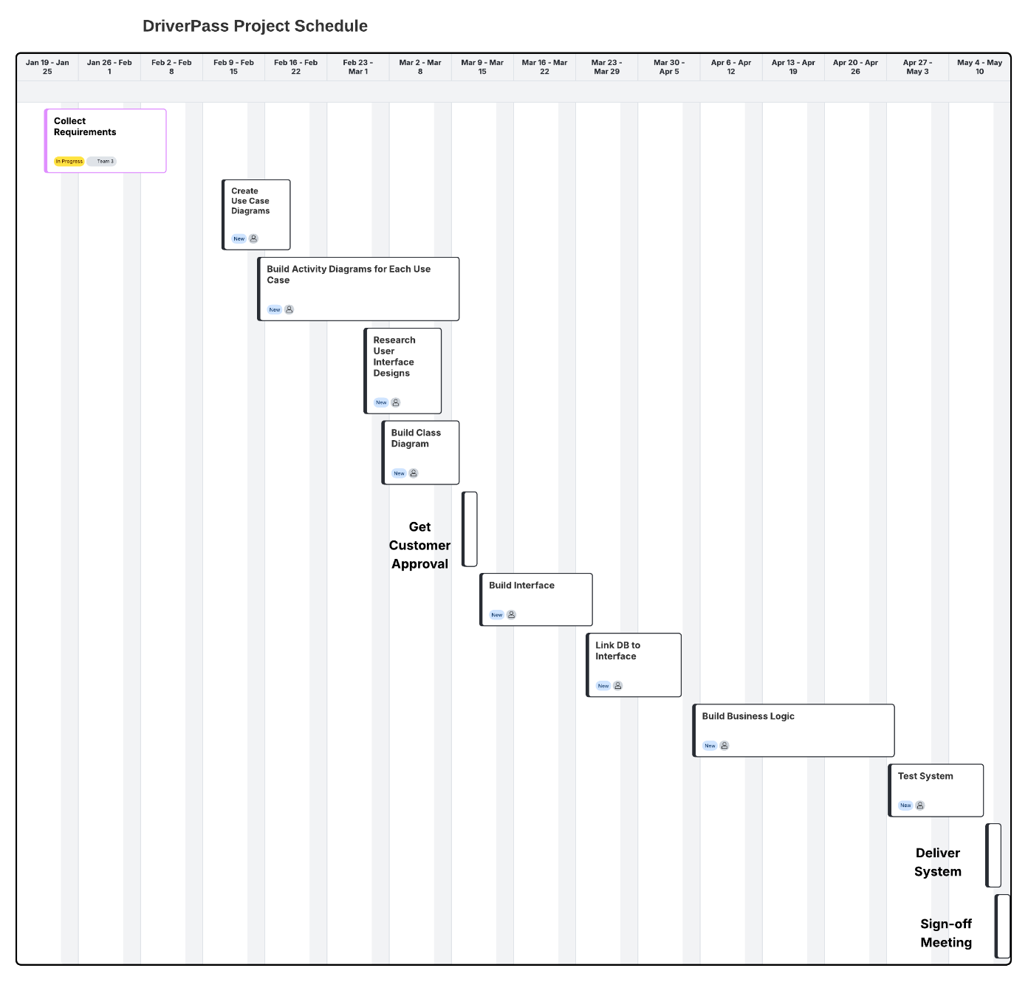
Collecting requirements takes 14 days, from January 22 to February 4, and everything else builds on it. Use case diagrams start February 11, and activity diagrams start February 15 once the use cases are underway. UI research runs at the same time because it does not depend on the use cases, and the class diagram waits for John to get back from vacation on March 1. Get Customer Approval on March 10 and 11 has to wait for all four of those to finish. After approval, the work runs in order: Build Interface, Link DB to Interface, Build Business Logic, Test System, Deliver System, and Sign-off Meeting, since each one needs the one before it to be done. Build Business Logic is the longest task at 22 days, so it takes the biggest block of the schedule.

