CS 255 System Design Document
Brandon Willis

UML Diagrams

UML Use Case Diagram
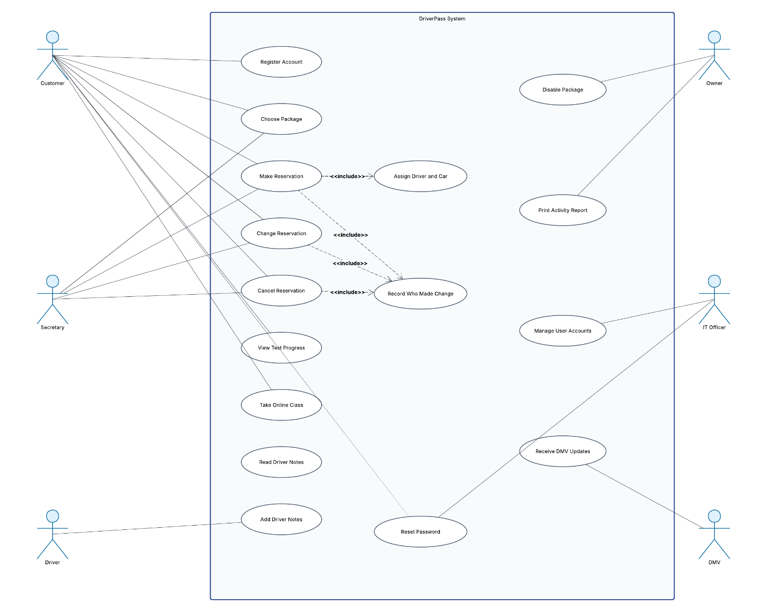

UML Activity Diagrams

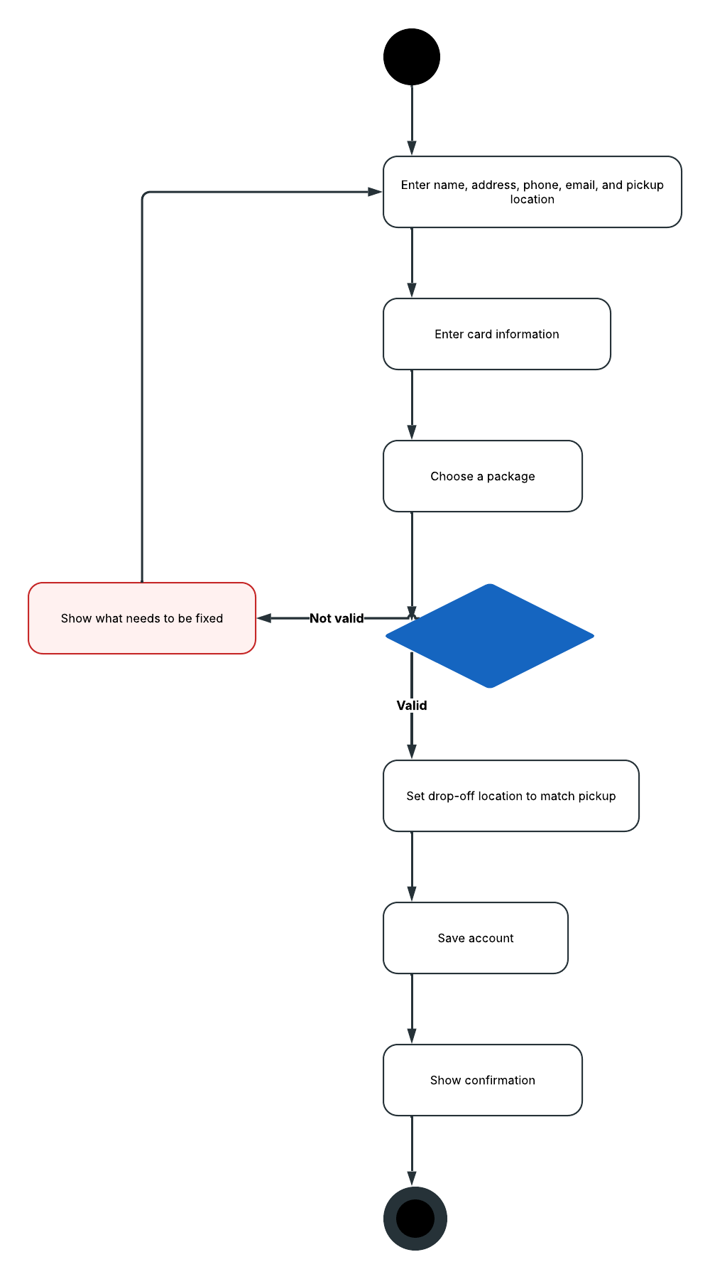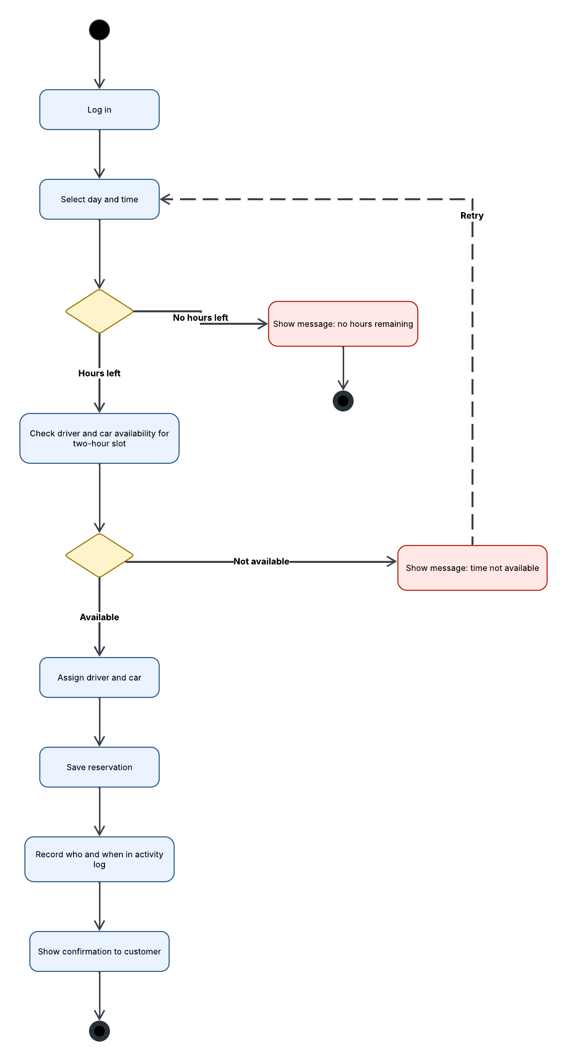

UML Sequence Diagram
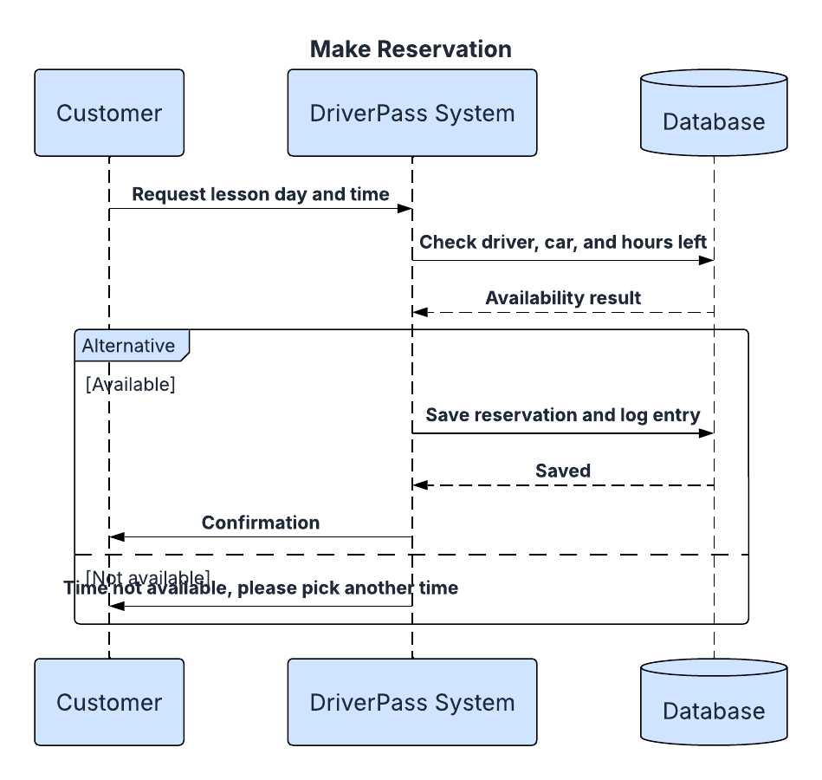

UML Class Diagram

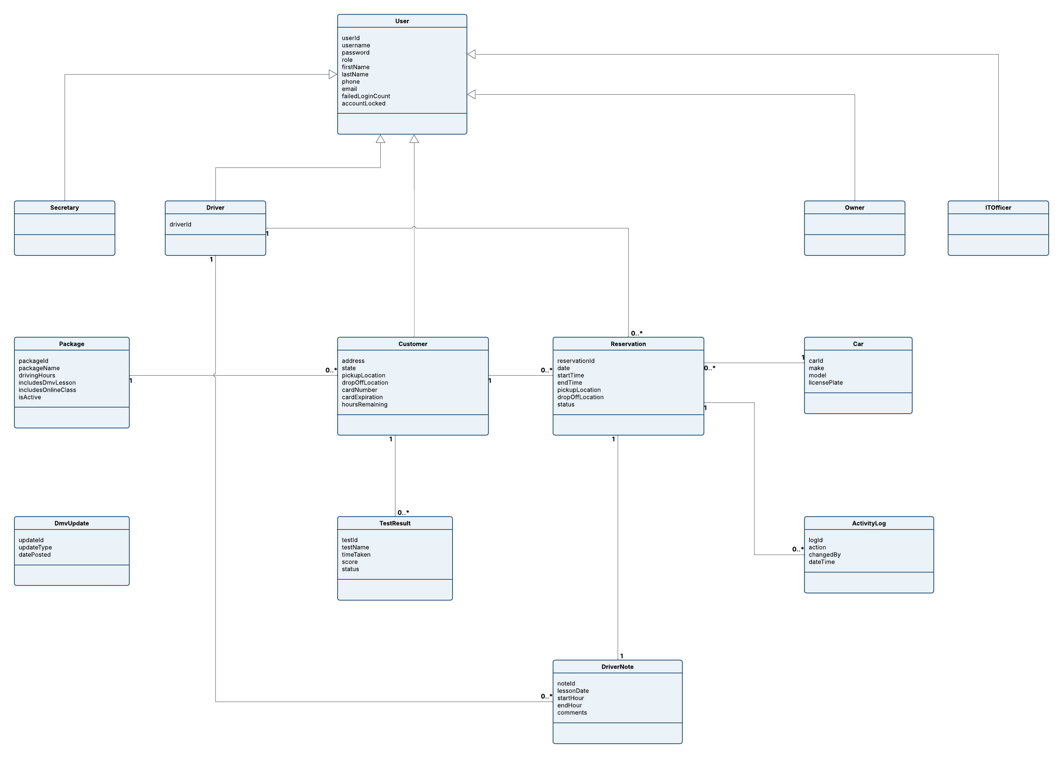

Technical Requirements

The DriverPass system does not need a lot of special equipment since most of the work will be handled through the cloud. The requirements below explain what is needed for hardware, software, tools, and infrastructure.

Hardware. Customers will be able to use their own computers, tablets, or phones to access DriverPass through a web browser, so the company will not need to provide equipment for them. The office will need a computer and phone for the secretary to handle reservations from customers who call or walk in, along with computers for Liam and Ian. Drivers will also need access to a phone, tablet, or computer so they can enter notes after each lesson. Since the system is cloud-based, DriverPass will not have to purchase or maintain its own servers.

Software. The system will be a web application that works with current versions of Chrome, Edge, Firefox, and Safari. Customers will be able to create accounts, schedule lessons, and check their test progress. Each user will have a login that only gives them access to the features they need for their role. A database will store customer information, packages, reservations, drivers, vehicles, test results, driver notes, and activity logs, as shown in the class diagram. The system will also check whether a driver and vehicle are available before confirming a reservation, following the process shown in the activity and sequence diagrams. Other features will include emails for password resets, reports that can be opened in Excel, and a connection to the DMV so DriverPass can stay updated on changes to rules and test questions.

Tools. Ian will need an admin dashboard where he can reset passwords, lock accounts, and review system alerts. Liam will need access to manage packages, including disabling ones that are no longer offered, and print activity reports. The system should also alert Ian when an account gets locked, the DMV connection stops working, or another system error occurs.

Infrastructure. DriverPass should use a cloud hosting platform that takes care of the servers, automatic backups, and security. Information sent between the browser and server should be protected using HTTPS, and stored credit card information should be encrypted. Users will need an internet connection to schedule lessons or make changes, which will help prevent duplicate or conflicting records. System updates should happen about once a month, preferably outside normal business hours, with employees being notified ahead of time. I actually built the warehouse application I use at work on a similar cloud platform, so I have seen how much easier it makes things. It allows a smaller team to focus on running and improving the application instead of worrying about maintaining servers.

