Digital Solutions
Unit 2: Application and data solutions
FIA4 Practice Examination 1
Stimulus, question and response book
Student name
Teacher
Date

Section | Questions | Marks
Section 1: Multiple choice | 1–10 | 10
Section 2: Short response | 11–15 | 50
Section 3: Extended response | 16 | 40
Total |  | 100

This is a practice paper. Its structure and marking mirror the FIA4 examination.

Stimulus book
Use this stimulus to answer the questions that refer to it.

Stimulus 1
Below is the relational schema for part of the database of a podcast streaming service.
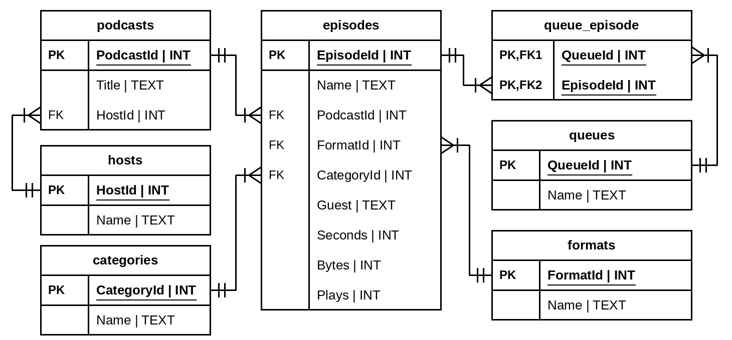

Stimulus 2
Below is a wireframe for a school sports carnival registration screen.
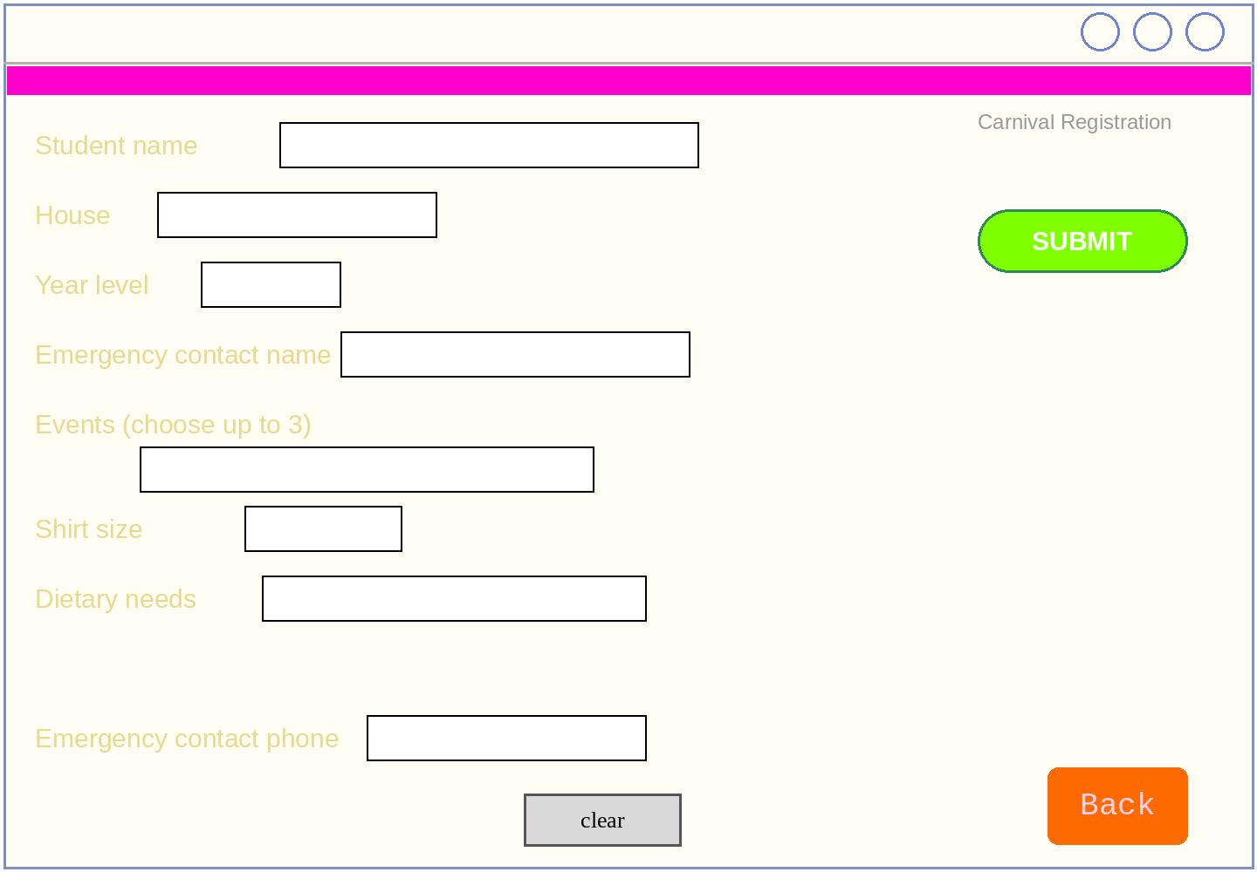

Stimulus 3
Below is the relational schema for a car hire company database.
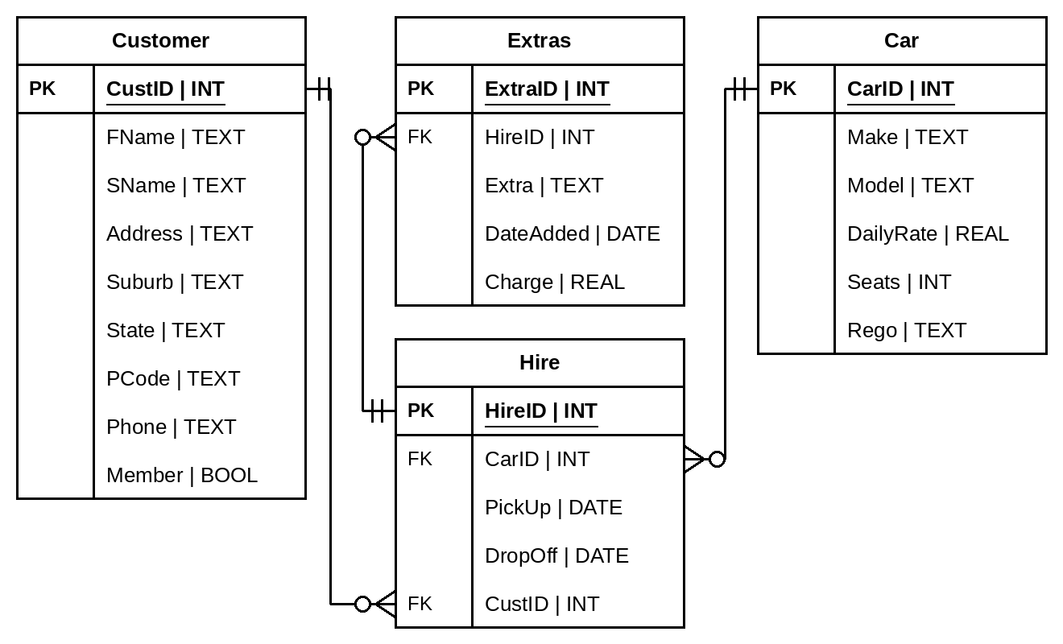

Stimulus 4
Tomas and Ana Ruiz run a pizza van at weekend markets. As well as serving walk-up customers, they let customers text their orders ahead. Their current process for recording texted orders is writing them on a notepad. An example of their notes can be seen in the table below.
An app is being designed which will accept texted orders and display the orders on a screen in the van.
The prescribed criteria for this app:
- Accepts texted pizza orders
- Matches phone number to customer name
- Records the order, including a date and time stamp
- Displays all current orders
- Allows the user to record when an order has been completed
- Records the staff member who completed the order

Saturday 14th March
Time | Name | Pizza | Size | GF base | Done
11:02 | Jacob | margherita | large | N | TR
11:04 | Sienna | pepperoni | medium | Y | AR
11:04 | Kai | hawaiian | small | N | AR
“ | “ | vegetarian | large | N | AR
11:07 | Ruby | pepperoni | large | N | TR
11:10 | Ahmed | margherita | medium | Y | TR
11:12 | Leila | supreme | large | N
“ | “ | margherita | small | Y
11:15 | Noah | vegetarian | medium | N

Section 1
Instructions
- Choose the best answer for Questions 1–10.
- This section has 10 questions and is worth 10 marks.
- Fill in the A, B, C or D answer bubble on the response grid at the end of this section completely.
- If you change your mind, erase your response and fill in the new answer bubble completely.

QUESTION 1
In the data, information, knowledge and wisdom pyramid, data that has been processed and organised so that it has meaning is called:
(A) Data
(B) Wisdom
(C) Information
(D) Knowledge

QUESTION 2
The useability principle concerned with ensuring that people with a wide range of abilities, including people with vision impairment, can use a solution is:
(A) Accessibility
(B) Effectiveness
(C) Learnability
(D) Utility

QUESTION 3
Refer to Stimulus 1.
Identify the SQL command that will show the number of episodes belonging to each category.
(A)
SELECT COUNT(DISTINCT CategoryId)
FROM episodes
GROUP BY CategoryId
(B)
SELECT CategoryId
FROM episodes
GROUP BY CategoryId
(C)
SELECT CategoryId, COUNT(EpisodeId)
FROM episodes
GROUP BY CategoryId
(D)
SELECT COUNT(CategoryId)
FROM episodes

QUESTION 4
Refer to Stimulus 1.
Identify the SQL command that will show the names of all the episodes in the queue named 'Commute'.
(A)
SELECT episodes.Name
FROM episodes
JOIN queue_episode
ON episodes.EpisodeId = queue_episode.EpisodeId
JOIN queues
ON queue_episode.QueueId = queues.QueueId
(B)
SELECT episodes.Name
FROM episodes
JOIN queue_episode
ON episodes.EpisodeId = queue_episode.EpisodeId
JOIN queues
ON queue_episode.QueueId = queues.QueueId
WHERE queues.Name = Commute
(C)
SELECT episodes.Name
FROM episodes
JOIN queue_episode
ON episodes.EpisodeId = queue_episode.EpisodeId
JOIN queues
ON queue_episode.EpisodeId = queues.QueueId
WHERE queues.Name = "Commute"
(D)
SELECT episodes.Name
FROM episodes
JOIN queue_episode
ON episodes.EpisodeId = queue_episode.EpisodeId
JOIN queues
ON queue_episode.QueueId = queues.QueueId
WHERE queues.Name = "Commute"

QUESTION 5
A sports club database stores information about players and teams. Each player plays for exactly one team, and a team has many players. Identify which entity relationship diagram best represents the relationship between players and teams.
(A) | 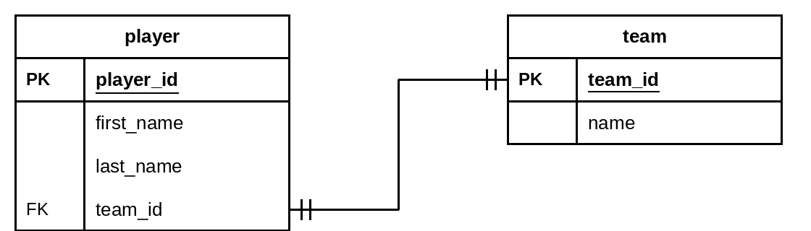
(B) | 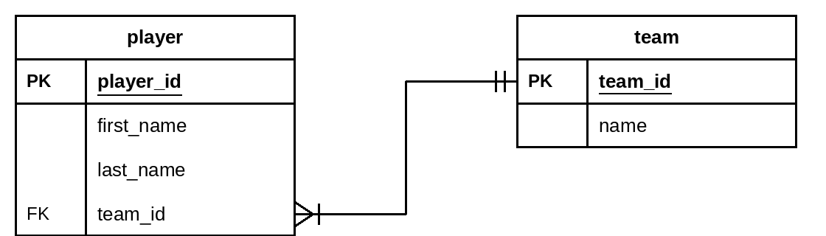
(C) | 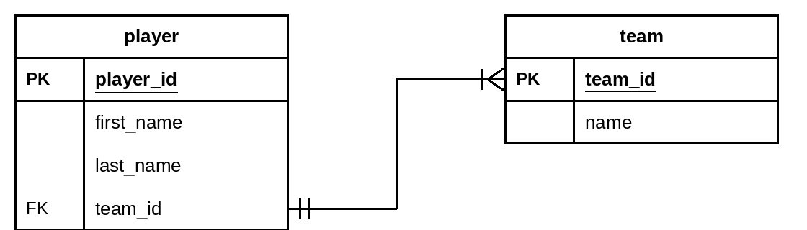
(D) | 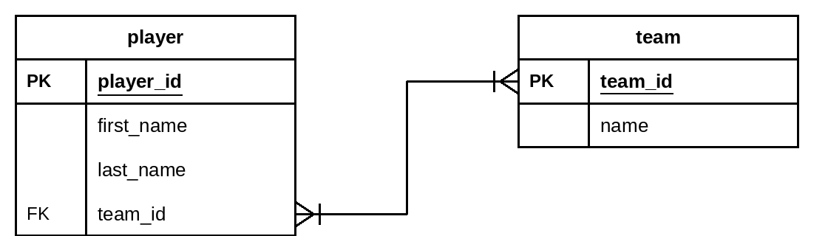

QUESTION 6
Refer to Stimulus 1.
The following SQL command will return data from the podcast database:
SELECT hosts.Name, podcasts.Title
FROM hosts
JOIN podcasts
ON hosts.HostId = podcasts.HostId
ORDER BY hosts.Name DESC
Which option below best describes the function of the command?
(A) Displays all the hosts and their podcasts contained in the database, sorting them in descending alphabetical order according to the host.
(B) Displays all the hosts and their podcasts contained in the database, sorting them in ascending alphabetical order according to the host.
(C) Displays all the hosts contained in the database, sorting them in descending alphabetical order.
(D) Displays all the hosts and their podcasts contained in the database.

QUESTION 7
In data flow diagrams, what is represented by the following symbol?

(A) Process
(B) Digital data store
(C) External entity
(D) Data flow

QUESTION 8
Examine the following data flow diagram for a gym that registers new members.
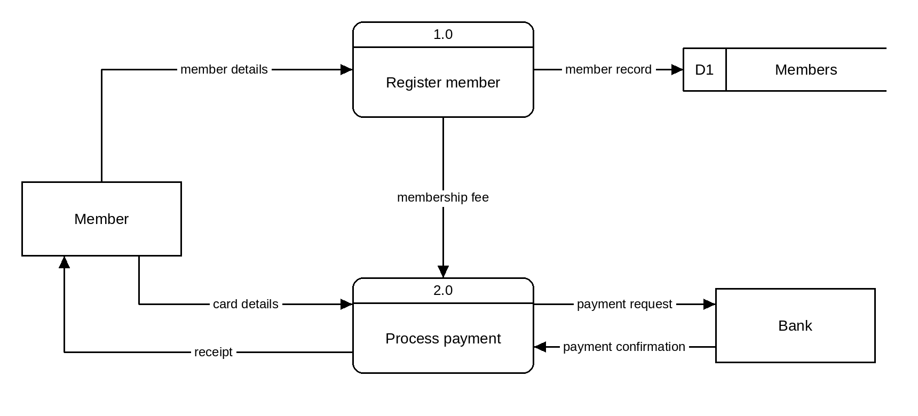
From the diagram, identify which of the following statements is most correct.
(A) The Bank stores member details in D1 Members.
(B) The system consists of two processes, two data stores and one external entity.
(C) D1 Members is a manual data store.
(D) Process 2.0 sends a payment request to the Bank.

QUESTION 9
Refer to Stimulus 1.
The following SQL command will return data from the podcast database (note: 1 minute = 60 seconds):
SELECT SUM(Seconds)/60
FROM episodes
WHERE PodcastId IN (
SELECT PodcastId
FROM podcasts
WHERE HostId IN (
SELECT HostId
FROM hosts
WHERE Name = "Ava Chen"
)
)
Which option below best describes the function of the command?
(A) The command will not run due to a syntax error.
(B) Lists the total number of minutes of episodes from podcasts hosted by Ava Chen.
(C) Lists the number of minutes of episodes for each podcast hosted by Ava Chen.
(D) Lists the total number of seconds of episodes from podcasts hosted by Ava Chen.

QUESTION 10
Refer to Stimulus 1.
Which SQL command returns a listing containing only each episode name and its number of plays?
(A)
SELECT EpisodeId, Plays
FROM episodes
(B)
SELECT Name, Plays
FROM episodes
(C)
SELECT *
FROM episodes
(D)
SELECT Name, Plays
FROM podcasts

Section 1 response grid
 | A | B | C | D
1. | ○ | ○ | ○ | ○
2. | ○ | ○ | ○ | ○
3. | ○ | ○ | ○ | ○
4. | ○ | ○ | ○ | ○
5. | ○ | ○ | ○ | ○
6. | ○ | ○ | ○ | ○
7. | ○ | ○ | ○ | ○
8. | ○ | ○ | ○ | ○
9. | ○ | ○ | ○ | ○
10. | ○ | ○ | ○ | ○

Section 2
Instructions
- Write using black or blue pen.
- Respond in paragraphs consisting of full sentences unless the question asks for code, a table or a diagram.
- If you need more space for a response, use the additional pages at the back of this book. Write the question number you are responding to, and write 'See page …' next to your original response.
- This section has five questions and is worth 50 marks.

QUESTION 11 (15 marks)
Refer to Stimulus 2.
Identify five principles of visual communication that could be employed to improve this wireframe. For each principle identified:
- name the principle
- explain how this principle has not been applied to the wireframe
- outline how you would change the wireframe to apply the principle.

Principle 1:

Principle 2:

Principle 3:

Principle 4:

Principle 5:

QUESTION 12 (12 marks)
Refer to Stimulus 3.
A. Write an SQL command to provide the full name of all the customers who are loyalty members. (2 marks)

B. Write an SQL command to book a hire for customer CustID 215 of car CarID 48, to be picked up on 12th March 2026 and dropped off on 19th March 2026. (2 marks)

C. At the end of a hire, the cost of all extras needs to be calculated. Write an SQL command that will calculate the total cost of the extras for HireID 587. (2 marks)

D. Write an SQL command that will identify the full name of all the customers who have hired the car with CarID 48. (3 marks)

E. Write an SQL command that lists each customer postcode, and the number of hires made by customers who live in that postcode. (3 marks)

QUESTION 13 (7 marks)
A. Rewrite the table below into first normal form. (2 marks)
FirstName | LastName | Instrument
Priya | Sharma | Guitar, Drums
Liam | Walsh | Piano, Violin, Flute
Mei | Tanaka | Bass
Priya | Sharma | Ukulele, Cello

B. Rewrite the table below into second normal form (primary key is indicated by *). (3 marks)
StudentID* | ClubID* | StudentName | ClubName | Role
501 | 3 | Ella Nguyen | Chess | Captain
501 | 7 | Ella Nguyen | Robotics | Member
502 | 3 | Sam Okafor | Chess | Member

C. Rewrite the table below into third normal form (primary key is indicated by *). (2 marks)
StaffID* | Name | Mobile | DeptCode | Department
1101 | Grace Lee | 0412 345 678 | SCI | Science
1102 | Omar Haddad | 0423 456 789 | MAT | Mathematics
1103 | Ruby Park | 0434 567 890 | SCI | Science

QUESTION 14 (6 marks)
Pawsome Walks is a small business that walks dogs for owners who work long hours. Owners book walks through a mobile app, which they use to register their details and their dog's details, choose a walk length and pay for each walk.
State the most appropriate data type or structure for each variable, considering its accompanying explanation.
Variable name | Data type or structure | Explanation
ownerName |  | the name of the dog's owner
ownerEmail |  | the email address of the owner, e.g. sam.lee@example.com
dogDesexed |  | a value indicating whether the dog has been desexed
walkMinutes |  | the length of the walk, in whole minutes
walkStart |  | the date and time the walk begins
walkPrice |  | the amount the owner is charged for the walk

QUESTION 15 (10 marks)
Below is a Level 0 data flow diagram for resetting a password. Draw the Level 1 data flow diagram showing the data flow in greater detail.
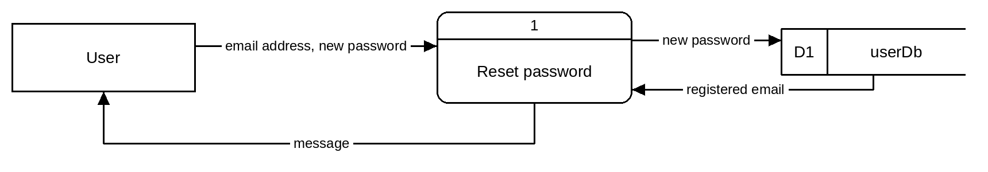

Section 3
Instructions
- Write using black or blue pen.
- This section has one question and is worth 40 marks.

QUESTION 16 (40 marks)
Refer to Stimulus 4.
A. Represent the flow of the pizza order data in a Level 0 data flow diagram. (10 marks)

B. Symbolise the Pizza Order app's universe of discourse in an entity relationship diagram. (14 marks)

C. Using the entity relationship diagram from Part B, develop a data dictionary. (10 marks)
Field name | Data type | Constraints

D. Using the data flow diagram from Part A and the entity relationship diagram from Part B, develop input, process, output (IPO) tables showing only the SQL commands for: (6 marks)
- ordering of pizzas
- display of pizzas to be made
- marking an order as complete.
Orders placed
Input | Process | Output

Orders listed
Input | Process | Output

Mark complete
Input | Process | Output

END OF PAPER

Additional page for student responses
Write the question number you are responding to.

Additional page for student responses
Write the question number you are responding to.

