FIA4 Practice Examination 1 — Marking Schema
Digital Solutions 2025 — Unit 2: Application and data solutions

Grading
Marks (out of 100) | Grade
≥ 82 | A
≥ 66 and < 82 | B
≥ 50 and < 66 | C
≥ 25 and < 50 | D
< 25 | E

Criteria summary
Objective | Questions
1 | 1, 2, 3, 4, 6, 9, 10, 11, 12, 13, 14, 15, 16A, 16B, 16C, 16D
2 | 5, 7, 8, 13, 14, 15, 16A, 16B, 16D
3 | 13, 14, 15, 16A, 16B, 16C, 16D
5 | 12, 16C, 16D
7 | 11

Section | Questions | Marks
1 | 1–10 | 10
2 | 11–15 | 50
3 | 16 | 40
Total |  | 100

Section 1
Q | Answer | Obj. | Explanation
1 | C | 1 | Information is data that has been processed, organised or structured so that it has meaning.
2 | A | 1 | Accessibility is about making the solution usable by as many people as possible, regardless of ability.
3 | C | 1 | GROUP BY creates one group per category and COUNT counts the episodes in each group. (A) returns 1 for every group, (B) does not count, and (D) counts every episode as one total.
4 | D | 1 | (A) has no WHERE clause, so it lists episodes in every queue. (B) does not put the text value in quotes. (C) joins queue_episode.EpisodeId to queues.QueueId, which are unrelated fields.
5 | B | 2 | The crow's foot (many) belongs at the player end and the 'one' symbol at the team end. The foreign key team_id is in the player table, which is the 'many' side.
6 | A | 1 | The JOIN returns each host with each of their podcasts, and ORDER BY ... DESC sorts by host name from Z to A.
7 | C | 2 | In Gane-Sarson notation, a plain rectangle is an external entity (a source or destination of data outside the system).
8 | D | 2 | The payment request flow goes from 2.0 Process payment to the Bank. There are two external entities and one data store, the store is labelled D (data on disk), and the Bank never connects to D1.
9 | B | 1 | The inner queries find Ava Chen's podcasts; SUM adds every matching episode's seconds and /60 converts the total to minutes. There is no GROUP BY, so a single total is returned.
10 | B | 1 | Only Name and Plays are selected from the episodes table. The podcasts table has no Plays field.

One mark for each correct answer.

Section 2

QUESTION 11 (15 marks)
Refer to Stimulus 2. Identify five principles of visual communication that could be employed to improve this wireframe. For each principle: name it, explain how it has not been applied, and outline how you would change the wireframe to apply it.
Expected responses (any five)
Principle | How it has not been applied | Suggested change
Contrast | The pale yellow labels on the cream background are very hard to read. | Use dark text (e.g. black or navy) on the light background so labels stand out.
Alignment | The input fields start at different horizontal positions, giving a ragged layout. | Left-align all labels and place every input field on the same vertical line.
Repetition | The Submit, clear and Back buttons all use different shapes, colours and fonts. | Give all buttons the same shape, font and colour scheme (with one accent colour for the main action).
Hierarchy | The title 'Carnival Registration' is small, grey and tucked in the corner, so it is not the most dominant element. | Make the title large and bold at the top-left or top-centre of the screen.
Proximity | Emergency contact name and emergency contact phone are far apart, and Submit is separated from the form. | Group related fields (both emergency contact fields together) and place the buttons together below the form.
Balance | All the fields are crowded into the left half, leaving a large empty area on the right. | Spread the form across the screen or centre it, e.g. a two-column layout.
Harmony | The magenta header bar, lime Submit button and orange Back button clash with each other. | Use a limited, coordinated colour palette across the header and buttons.

Descriptor | Mark | Notes
For each principle (maximum five):  - names the principle  - identifies how it has not been applied and outlines a change | 3 | - Principles are limited to balance, contrast, proximity, harmony, alignment, repetition and hierarchy (syllabus).  - Elements (e.g. colour, space) alone do not score as principles.  - Each principle may only be credited once.
- names the principle  - identifies how it has not been applied or outlines a change | 2
- names the principle | 1
- does not satisfy the above descriptors | 0

Objectives
 | Unit 2 objective
1 | Recognise and describe programming features, data and useability principles, and data management processes.
7 | Evaluate components and solutions against criteria to make refinements and justified recommendations, and evaluate impacts.

QUESTION 12 (12 marks)
Refer to Stimulus 3. Accept single or double quotes, any letter case for keywords, and a trailing semicolon or none.
A. Write an SQL command to provide the full name of all the customers who are loyalty members. (2 marks)
SELECT FName, SName
FROM Customer
WHERE Member = TRUE
Checking SQL command | Mark | Notes
- correct code with no errors | 2 | - Accept Member = 1, Member IS TRUE or Member = "Yes"; the value stored for a member is not given.
- code contains one error | 1
- does not satisfy the above descriptors | 0

B. Write an SQL command to book a hire for customer CustID 215 of car CarID 48, to be picked up on 12th March 2026 and dropped off on 19th March 2026. (2 marks)
INSERT INTO Hire (CarID, PickUp, DropOff, CustID)
VALUES (48, '2026-03-12', '2026-03-19', 215)
Checking SQL command | Mark | Notes
- correct code with no errors | 2 | - Students may list field names or rely on field order.  - Students may supply a HireID.  - Accept any unambiguous date format in quotes.
- code contains one error | 1
- does not satisfy the above descriptors | 0

C. At the end of a hire, the cost of all extras needs to be calculated. Write an SQL command that will calculate the total cost of the extras for HireID 587. (2 marks)
SELECT SUM(Charge)
FROM Extras
WHERE HireID = 587
Checking SQL command | Mark | Notes
- correct code with no errors | 2
- code contains one error | 1
- does not satisfy the above descriptors | 0

D. Write an SQL command that will identify the full name of all the customers who have hired the car with CarID 48. (3 marks)
SELECT FName, SName  FROM Customer  WHERE CustID IN (  SELECT CustID  FROM Hire  WHERE CarID = 48) | SELECT Customer.FName, Customer.SName  FROM Customer  JOIN Hire  ON Customer.CustID = Hire.CustID  WHERE Hire.CarID = 48

Checking SQL command | Mark | Notes
- correct code with no errors | 3 | - Either a subquery or a join is acceptable.
- code contains one error | 2 | - Either a subquery or a join is acceptable.
- code contains two errors | 1 | - Either a subquery or a join is acceptable.
- does not satisfy the above descriptors | 0 | - Either a subquery or a join is acceptable.

E. Write an SQL command that lists each customer postcode, and the number of hires made by customers who live in that postcode. (3 marks)
SELECT Customer.PCode, COUNT(Hire.HireID)
FROM Customer
JOIN Hire
ON Customer.CustID = Hire.CustID
GROUP BY Customer.PCode
Checking SQL command | Mark | Notes
- correct code with no errors | 3 | - A join is needed because the count comes from Hire and the postcode comes from Customer.  - Accept COUNT(*) or COUNT(Hire.CustID).
- code contains one error | 2
- code contains two errors | 1
- does not satisfy the above descriptors | 0

Objectives
 | Unit 2 objective
1 | Recognise and describe programming features, data and useability principles, and data management processes.
5 | Synthesise information and ideas to develop possible digital solutions.

QUESTION 13 (7 marks)
A. Rewrite the table into first normal form. (2 marks)
Original
FirstName | LastName | Instrument
Priya | Sharma | Guitar, Drums
Liam | Walsh | Piano, Violin, Flute
Mei | Tanaka | Bass
Priya | Sharma | Ukulele, Cello

Model answer
FirstName | LastName | Instrument
Priya | Sharma | Guitar
Priya | Sharma | Drums
Liam | Walsh | Piano
Liam | Walsh | Violin
Liam | Walsh | Flute
Mei | Tanaka | Bass
Priya | Sharma | Ukulele
Priya | Sharma | Cello

Normalisation process | Mark | Notes
- correct with no errors | 2 | - Each cell holds a single (atomic) value.  - Accept the addition of a surrogate key, e.g. PersonID.
- contains one error | 1
- does not satisfy the above descriptors | 0

B. Rewrite the table into second normal form. (3 marks)
Original
StudentID* | ClubID* | StudentName | ClubName | Role
501 | 3 | Ella Nguyen | Chess | Captain
501 | 7 | Ella Nguyen | Robotics | Member
502 | 3 | Sam Okafor | Chess | Member

Model answer
StudentID* | ClubID* | Role
501 | 3 | Captain
501 | 7 | Member
502 | 3 | Member

StudentID* | StudentName
501 | Ella Nguyen
502 | Sam Okafor

ClubID* | ClubName
3 | Chess
7 | Robotics

Normalisation process | Mark | Notes
- correct with no errors | 3 | - Partial dependencies removed: each non-key field depends on the whole composite key.  - Duplicate rows must not remain in the new tables.  - Primary keys must be identified.
- contains one error | 2
- contains two errors | 1
- does not satisfy the above descriptors | 0

C. Rewrite the table into third normal form. (2 marks)
Original
StaffID* | Name | Mobile | DeptCode | Department
1101 | Grace Lee | 0412 345 678 | SCI | Science
1102 | Omar Haddad | 0423 456 789 | MAT | Mathematics
1103 | Ruby Park | 0434 567 890 | SCI | Science

Model answer
StaffID* | Name | Mobile | DeptCode
1101 | Grace Lee | 0412 345 678 | SCI
1102 | Omar Haddad | 0423 456 789 | MAT
1103 | Ruby Park | 0434 567 890 | SCI

DeptCode* | Department
SCI | Science
MAT | Mathematics

Normalisation process | Mark | Notes
- correct with no errors | 2 | - Transitive dependency removed: the name now depends only on its own code.  - The code remains in the first table as a foreign key.  - Primary keys must be identified.
- contains one error | 1
- does not satisfy the above descriptors | 0

Objectives
 | Unit 2 objective
1 | Recognise and describe programming features, data and useability principles, and data management processes.
2 | Symbolise and explain information, ideas and data flow relationships within and between systems related to digital problems.
3 | Analyse problems and information related to the selected technology context.

QUESTION 14 (6 marks)
Variable name | Data type or structure | Explanation
ownerName | string / text | the name of the dog's owner
ownerEmail | string / text | the email address of the owner, e.g. sam.lee@example.com
dogDesexed | Boolean (accept integer 0/1 or text Y/N) | a value indicating whether the dog has been desexed
walkMinutes | integer | the length of the walk, in whole minutes
walkStart | date/time (accept text / string) | the date and time the walk begins
walkPrice | float / real (accept decimal / currency) | the amount the owner is charged for the walk

Number of correct answers | Mark | Notes
- 6 correct answers | 6 | - Allow for different SQL implementations and programming languages (e.g. str, TEXT, VARCHAR).  - Numbers containing spaces or leading zeros, such as phone and licence numbers, must be text.
- 5 correct answers | 5
- 4 correct answers | 4
- 3 correct answers | 3
- 2 correct answers | 2
- 1 correct answer | 1
- no correct answers | 0

Objectives
 | Unit 2 objective
1 | Recognise and describe programming features, data and useability principles, and data management processes.
2 | Symbolise and explain information, ideas and data flow relationships within and between systems related to digital problems.
3 | Analyse problems and information related to the selected technology context.

QUESTION 15 (10 marks)
Draw the Level 1 data flow diagram for resetting a password.
Model answer
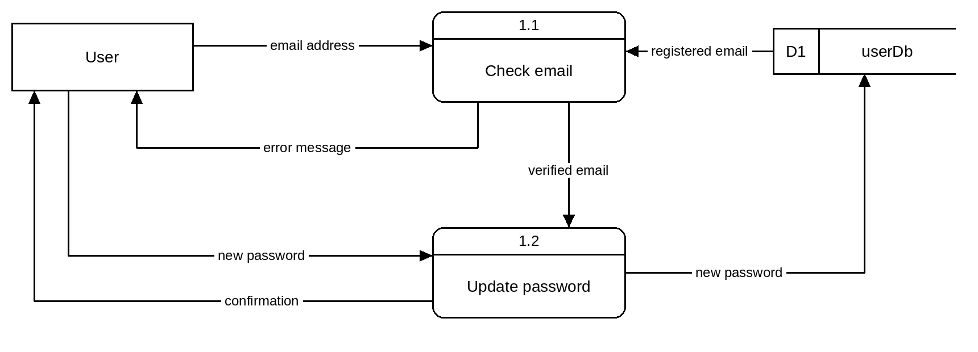
Included in the diagram | Mark | Notes
- User external entity | 1 | - Names and structure may differ.  - Symbols must follow Gane-Sarson notation.  - Flows must pass through a process: no flow may connect an entity directly to a store.  - Total cannot fall below 0.
- 2 processes (numbered 1.1 and 1.2, verb–object names) | 2
- 1 process | 1
- data store (D1 userDb) | 1
- 6 or more correct data flows (labelled, correct direction) | 6
- 5 correct data flows | 5
- 4 correct data flows | 4
- 3 correct data flows | 3
- 2 correct data flows | 2
- 1 correct data flow | 1
- each symbol or convention error | -1

Objectives
 | Unit 2 objective
1 | Recognise and describe programming features, data and useability principles, and data management processes.
2 | Symbolise and explain information, ideas and data flow relationships within and between systems related to digital problems.
3 | Analyse problems and information related to the selected technology context.

Section 3

QUESTION 16 (40 marks)
A. Represent the flow of the pizza order data in a Level 0 data flow diagram. (10 marks)
Model answer
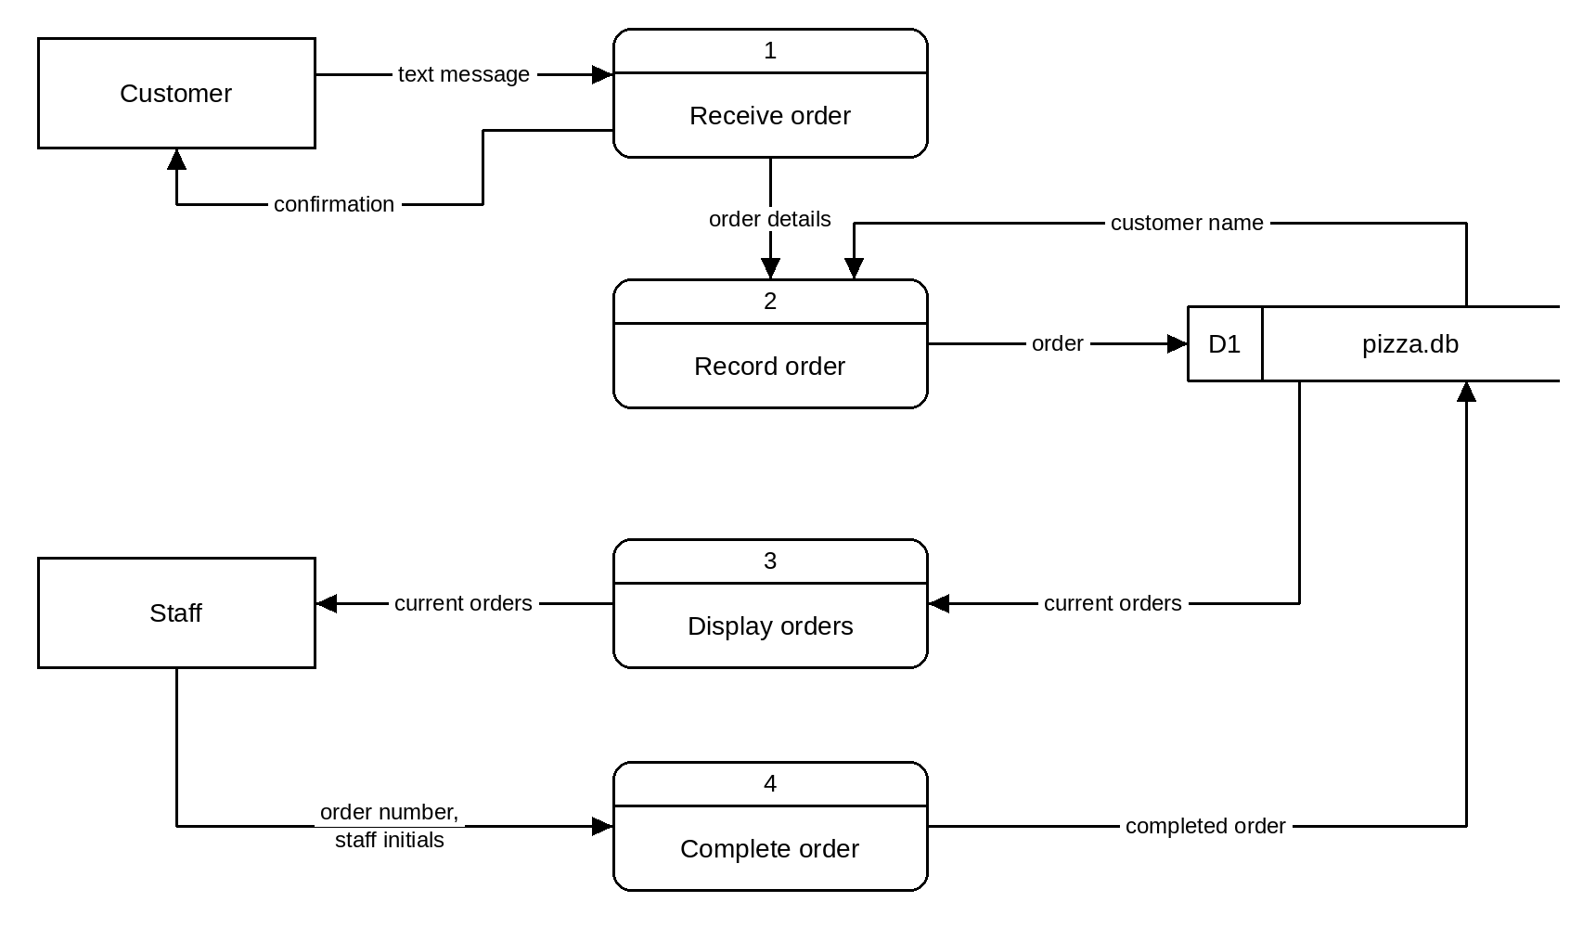
Included in the diagram | Mark | Notes
- 4 processes recorded | 4 | - Names and structure may differ.  - Symbols must follow Gane-Sarson notation.  - Processes should be numbered and named with verb–object names.
- 3 processes recorded | 3
- 2 processes recorded | 2
- 1 process recorded | 1
- 2 external entities (Customer, Staff) | 2
- 1 external entity | 1
- 1 data store (pizza.db) | 1
- all data flows connected correctly | 1
- all data flow arrows correct | 1
- all data flow labels correct | 1

Objectives
 | Unit 2 objective
1 | Recognise and describe programming features, data and useability principles, and data management processes.
2 | Symbolise and explain information, ideas and data flow relationships within and between systems related to digital problems.
3 | Analyse problems and information related to the selected technology context.

B. Symbolise the Pizza Order app's universe of discourse in an entity relationship diagram. (14 marks)
Model answer
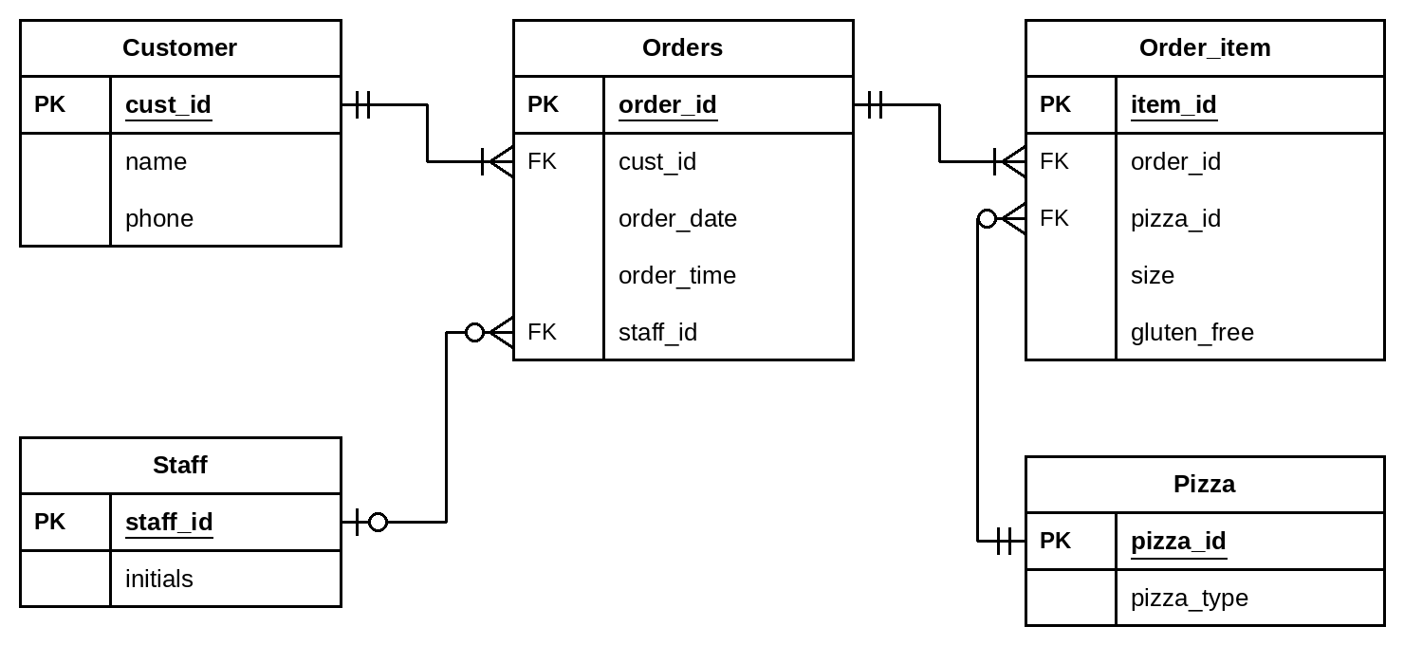
Correctly included in the diagram | Mark | Notes
- 5 entities | 5 | - Names and structure may differ.  - Symbols must be accurate (crow's foot notation).  - Accept a composite primary key (order_id, product id) in Order_item.  - Accept one-to-many in place of the optional (zero) cardinalities shown.  - Table name 'Orders' avoids the reserved word ORDER; accept 'Order'.
- 4 entities | 4
- 3 entities | 3
- 2 entities | 2
- 1 entity | 1
- 4 relationships | 4
- 3 relationships | 3
- 2 relationships | 2
- 1 relationship | 1
- 4 cardinalities | 4
- 3 cardinalities | 3
- 2 cardinalities | 2
- 1 cardinality | 1
- all attributes, with PK and FK identified | 1
- attributes with errors | 0

Objectives
 | Unit 2 objective
1 | Recognise and describe programming features, data and useability principles, and data management processes.
2 | Symbolise and explain information, ideas and data flow relationships within and between systems related to digital problems.
3 | Analyse problems and information related to the selected technology context.

C. Using the entity relationship diagram from Part B, develop a data dictionary. (10 marks)
Model answer
Field name | Data type | Constraints
Customer table
cust_id | Integer | Primary key
name | Text | Not null
phone | Text | Format: 04XX XXX XXX, unique
Orders table
order_id | Integer | Primary key
cust_id | Integer | Foreign key = Customer.cust_id
order_date | Date | dd/mm/yyyy
order_time | Time | hh:mm
staff_id | Integer | Foreign key = Staff.staff_id, null until complete
Staff table
staff_id | Integer | Primary key
initials | Text | 2 characters
Order_item table
item_id | Integer | Primary key
order_id | Integer | Foreign key = Orders.order_id
pizza_id | Integer | Foreign key = Pizza.pizza_id
size | Text | small, medium or large
gluten_free | Boolean | True / False
Pizza table
pizza_id | Integer | Primary key
pizza_type | Text | Not null

Correct for each table | Mark | Notes
For each table (5 tables × 2 marks):  - all field names | ½ | - Names and constraints may differ but must match the student's own ERD.  - Primary and foreign keys must be identified as constraints.
- errors in field names | 0
- all data types | 1
- more than half of the data types | ½
- half or fewer of the data types | 0
- all constraints | ½
- errors in constraints | 0

Objectives
 | Unit 2 objective
1 | Recognise and describe programming features, data and useability principles, and data management processes.
3 | Analyse problems and information related to the selected technology context.
5 | Synthesise information and ideas to develop possible digital solutions.

D. Develop IPO tables showing only the SQL commands for the ordering of pizzas, the display of pizzas to be made, and marking an order as complete. (6 marks)
Orders placed
Input | Process | Output
customer phone (customer)  pizza type (customer)  size (customer)  gluten-free base (customer)  cust_id (pizza.db) | INSERT INTO Orders (cust_id, order_date, order_time)  VALUES (<cust_id>, CURRENT_DATE, CURRENT_TIME)  INSERT INTO Order_item (order_id, pizza_id, size, gluten_free)  VALUES (<order_id>, <pizza_id>, <size>, <gluten_free>) | Text sent to customer: “Order received”

Correct in the table | Mark | Notes
- required inputs identified | ½ | - SQL may be at pseudocode level.  - <value> marks a value supplied by the app at run time.  - Field and table names must match the student's own ERD.
- errors in required inputs | 0
- both INSERT statements made | 1
- one INSERT statement made | ½
- no INSERT statements | 0
- confirmation message output | ½
- no message output | 0

Orders listed
Input | Process | Output
Refresh of the display (staff) | SELECT Orders.order_id, Orders.order_time, Customer.name,  Pizza.pizza_type, Order_item.size, Order_item.gluten_free  FROM Orders  JOIN Customer ON Orders.cust_id = Customer.cust_id  JOIN Order_item ON Orders.order_id = Order_item.order_id  JOIN Pizza ON Order_item.pizza_id = Pizza.pizza_id  WHERE Orders.staff_id IS NULL  ORDER BY Orders.order_time | Table listing all incomplete orders

Correct in the table | Mark | Notes
- required inputs identified | ½ | - SQL may be at pseudocode level.  - <value> marks a value supplied by the app at run time.  - Field and table names must match the student's own ERD.
- errors in required inputs | 0
- SELECT includes adequate joins/subqueries and a WHERE limiting to incomplete orders | 1
- SELECT includes adequate joins/subqueries or a WHERE | ½
- SELECT includes neither | 0
- output identified | ½
- no output identified | 0

Mark complete
Input | Process | Output
order_id (staff)  staff initials / staff_id (staff) | UPDATE Orders  SET staff_id = <staff_id>  WHERE order_id = <order_id> | Updated table of current orders (completed order removed)

Correct in the table | Mark | Notes
- required inputs identified | ½ | - SQL may be at pseudocode level.  - <value> marks a value supplied by the app at run time.  - Field and table names must match the student's own ERD.
- errors in required inputs | 0
- correct field updated and limited to the identified order | 1
- correct field updated or limited to the identified order | ½
- neither | 0
- output identified | ½
- no output identified | 0

Objectives
 | Unit 2 objective
1 | Recognise and describe programming features, data and useability principles, and data management processes.
2 | Symbolise and explain information, ideas and data flow relationships within and between systems related to digital problems.
3 | Analyse problems and information related to the selected technology context.
5 | Synthesise information and ideas to develop possible digital solutions.

