Digital Solutions
Unit 2: Application and data solutions
FIA4 Practice Examination 2
Stimulus, question and response book
Student name
Teacher
Date

Section | Questions | Marks
Section 1: Multiple choice | 1–10 | 10
Section 2: Short response | 11–15 | 50
Section 3: Extended response | 16 | 40
Total |  | 100

This is a practice paper. Its structure and marking mirror the FIA4 examination.

Stimulus book
Use this stimulus to answer the questions that refer to it.

Stimulus 1
Below is the relational schema for part of the database of a recipe sharing website.
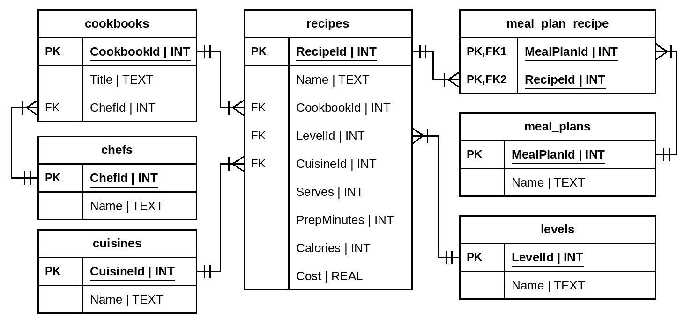

Stimulus 2
Below is a wireframe for a screen used to book a session with a school tutor.
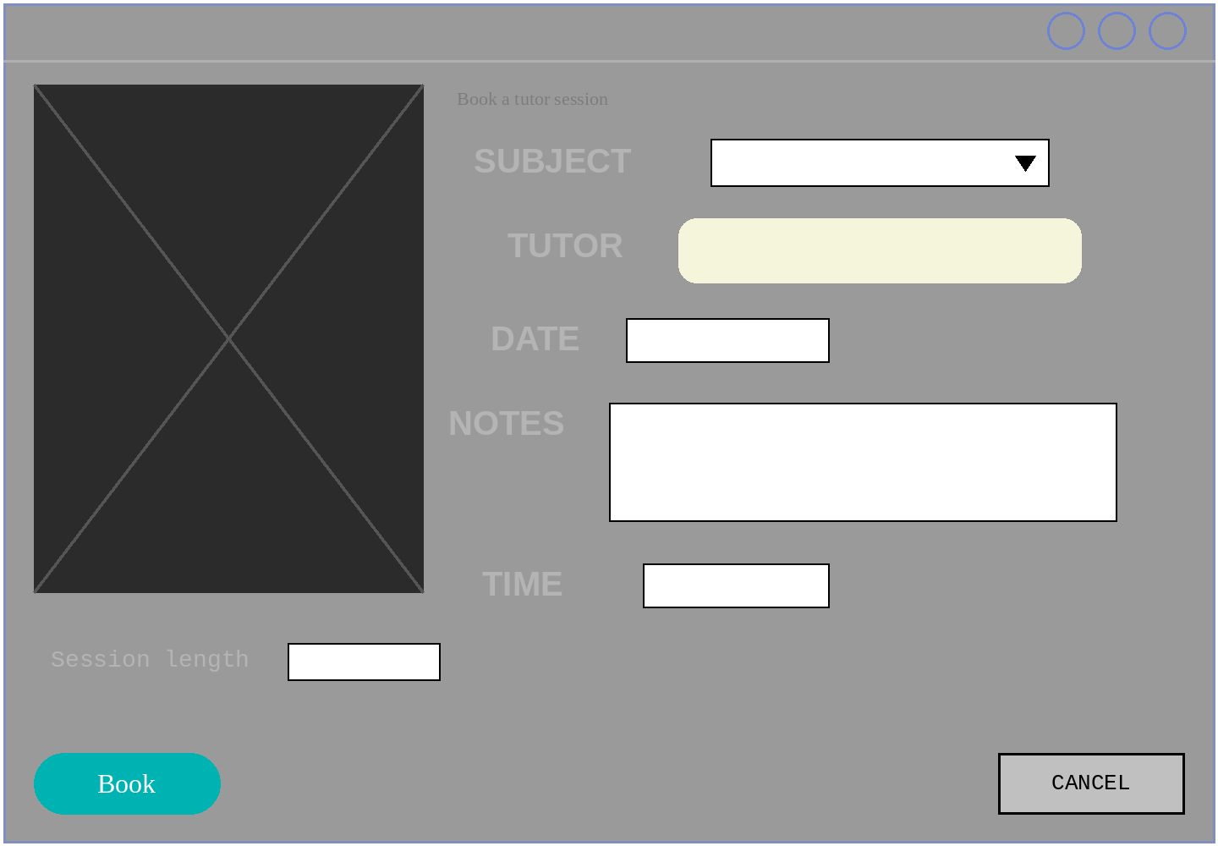

Stimulus 3
Below is the relational schema for a music tuition studio database.
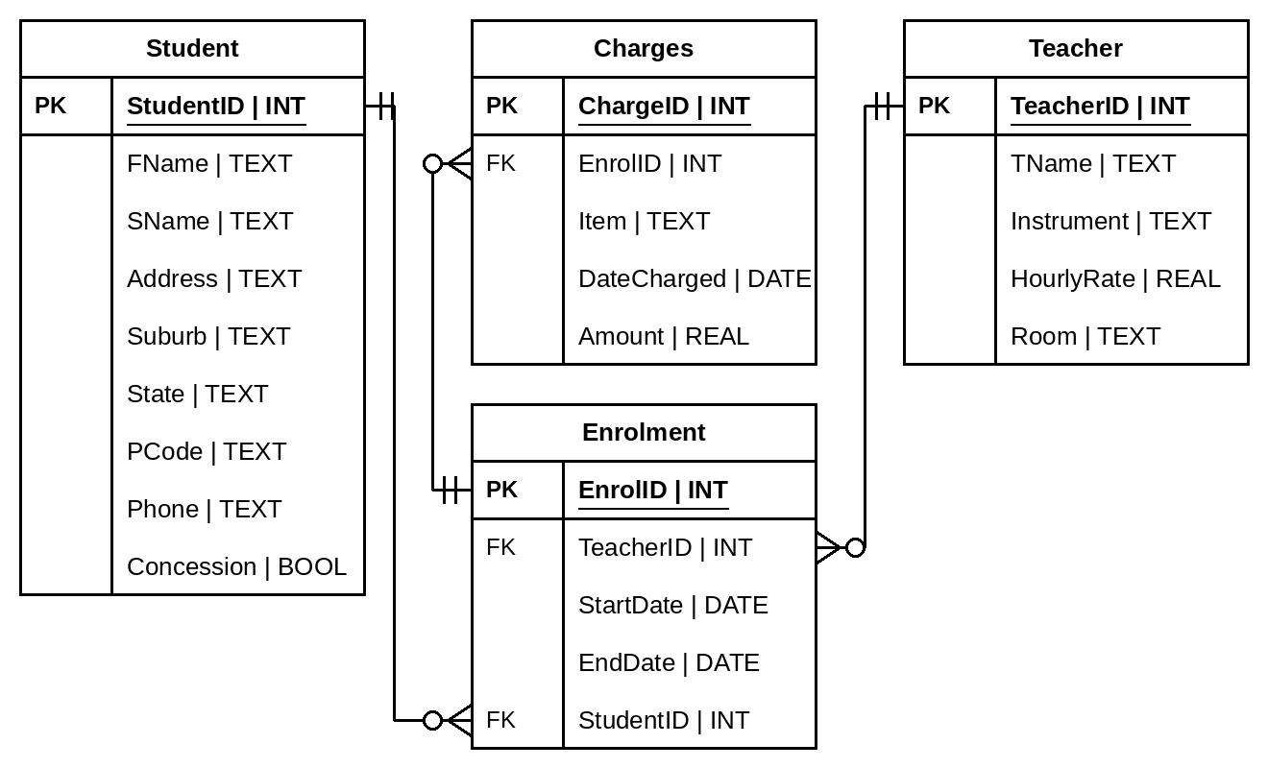

Stimulus 4
Linh and Minh Tran run a bubble tea kiosk at a busy train station. As well as serving walk-up customers, they let commuters text their orders ahead. Their current process for recording texted orders is writing them on a notepad. An example of their notes can be seen in the table below.
An app is being designed which will accept texted orders and display the orders on a screen in the kiosk.
The prescribed criteria for this app:
- Accepts texted bubble tea orders
- Matches phone number to customer name
- Records the order, including a date and time stamp
- Displays all current orders
- Allows the user to record when an order has been completed
- Records the staff member who completed the order

Tuesday 9th June
Time | Name | Tea | Sweetness | Pearls | Done
7:02 | Oscar | brown sugar milk | 50% | Y | LT
7:03 | Grace | taro | 25% | N | MT
7:03 | Hamish | matcha latte | 0% | Y | MT
“ | “ | “ | “ | “ | MT
7:06 | Zara | passionfruit green | 75% | N | LT
7:09 | Ethan | taro | 100% | Y | LT
7:11 | Mila | jasmine milk | 50% | Y
“ | “ | brown sugar milk | 25% | N
7:14 | Ravi | matcha latte | 50% | N

Section 1
Instructions
- Choose the best answer for Questions 1–10.
- This section has 10 questions and is worth 10 marks.
- Fill in the A, B, C or D answer bubble on the response grid at the end of this section completely.
- If you change your mind, erase your response and fill in the new answer bubble completely.

QUESTION 1
In the data, information, knowledge and wisdom pyramid, applying knowledge with insight and judgement to make good decisions is called:
(A) Wisdom
(B) Information
(C) Data
(D) Knowledge

QUESTION 2
The useability principle that describes how easily a first-time user can work out how to complete basic tasks with a solution is:
(A) Safety
(B) Utility
(C) Effectiveness
(D) Learnability

QUESTION 3
Refer to Stimulus 1.
Identify the SQL command that will show the number of recipes belonging to each cuisine.
(A)
SELECT CuisineId, COUNT(RecipeId)
FROM recipes
GROUP BY CuisineId
(B)
SELECT CuisineId, COUNT(RecipeId)
FROM recipes
(C)
SELECT COUNT(DISTINCT CuisineId)
FROM recipes
(D)
SELECT CuisineId
FROM recipes
ORDER BY CuisineId

QUESTION 4
Refer to Stimulus 1.
Identify the SQL command that will show the names of all the recipes in the meal plan named 'Weeknight Dinners'.
(A)
SELECT recipes.Name
FROM recipes
JOIN meal_plan_recipe
ON recipes.RecipeId = meal_plan_recipe.RecipeId
JOIN meal_plans
ON meal_plan_recipe.MealPlanId = meal_plans.MealPlanId
(B)
SELECT recipes.Name
FROM recipes
JOIN meal_plan_recipe
ON recipes.RecipeId = meal_plan_recipe.RecipeId
JOIN meal_plans
ON meal_plan_recipe.MealPlanId = meal_plans.MealPlanId
WHERE meal_plans.Name = "Weeknight Dinners"
(C)
SELECT recipes.Name
FROM recipes
JOIN meal_plan_recipe
ON recipes.RecipeId = meal_plan_recipe.RecipeId
JOIN meal_plans
ON meal_plan_recipe.MealPlanId = meal_plans.MealPlanId
WHERE meal_plans.Name = Weeknight Dinners
(D)
SELECT recipes.Name
FROM recipes
JOIN meal_plan_recipe
ON recipes.RecipeId = meal_plan_recipe.RecipeId
JOIN meal_plans
ON meal_plan_recipe.RecipeId = meal_plans.MealPlanId
WHERE meal_plans.Name = "Weeknight Dinners"

QUESTION 5
A library database stores information about books and their publishers. Each book has exactly one publisher, and a publisher publishes many books. Identify which entity relationship diagram best represents the relationship between books and publishers.
(A) | 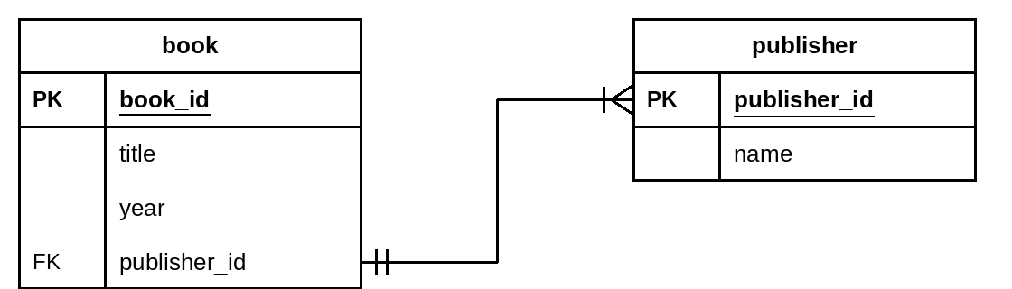
(B) | 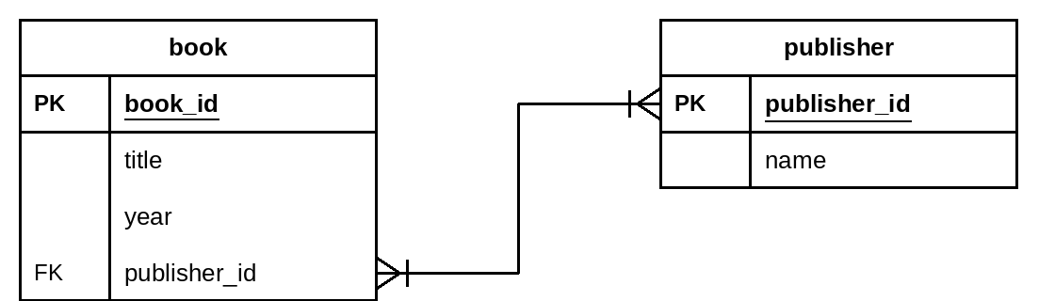
(C) | 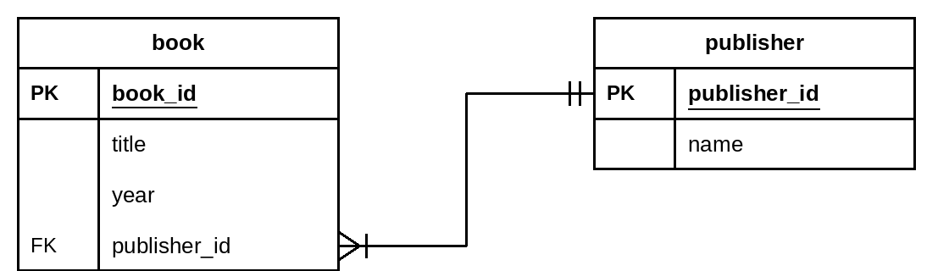
(D) | 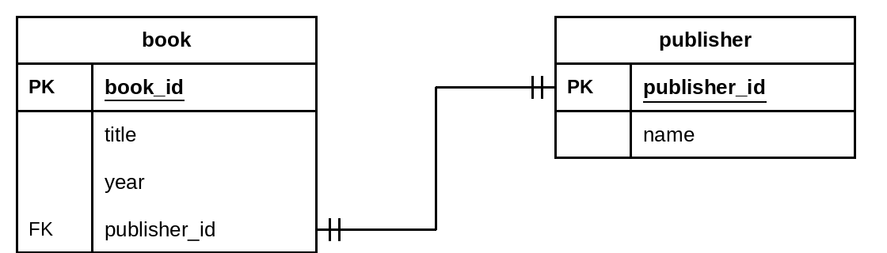

QUESTION 6
Refer to Stimulus 1.
The following SQL command will return data from the recipe database:
SELECT Name, PrepMinutes
FROM recipes
WHERE PrepMinutes < 30
ORDER BY PrepMinutes
Which option below best describes the function of the command?
(A) Displays the name and preparation time of recipes that take less than 30 minutes to prepare, longest first.
(B) Displays the name and preparation time of recipes that take 30 minutes or less to prepare, shortest first.
(C) Displays the name and preparation time of recipes that take less than 30 minutes to prepare, shortest first.
(D) Displays the name and preparation time of all recipes, shortest first.

QUESTION 7
In data flow diagrams, what is represented by the following symbol?
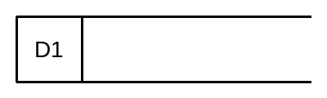
(A) Process
(B) Data store (data on disk)
(C) External entity
(D) Manual data store

QUESTION 8
Examine the following data flow diagram for a school library loans system.
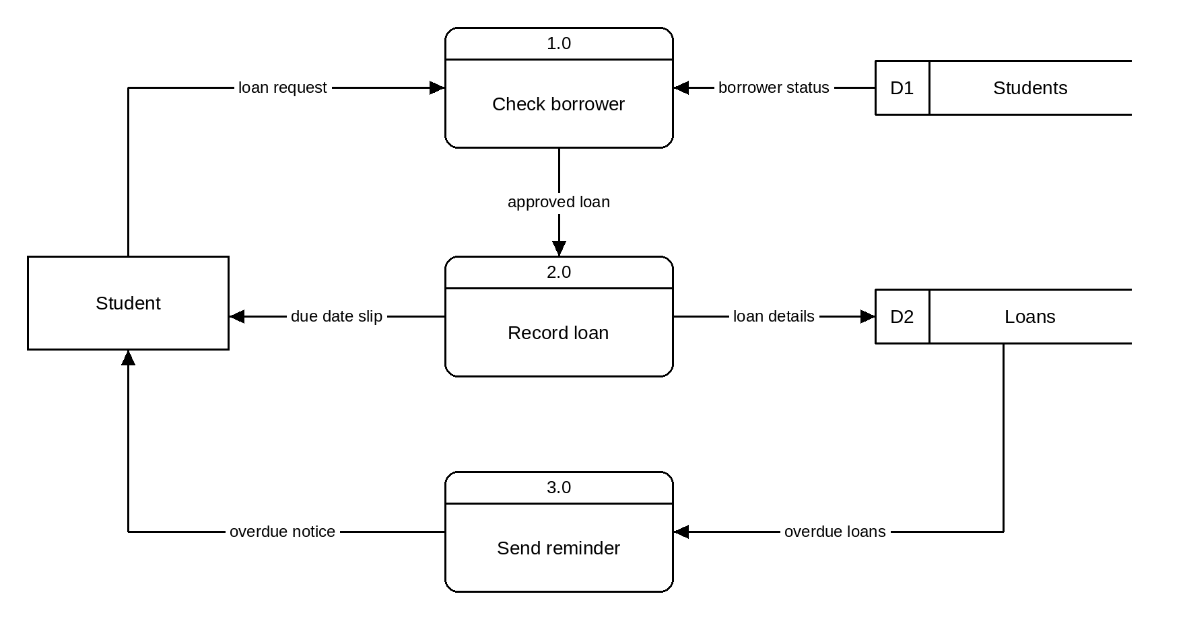
From the diagram, identify which of the following statements is most correct.
(A) Process 3.0 uses data from D2 Loans to send an overdue notice to the student.
(B) The student sends loan details directly to D2 Loans.
(C) The system consists of two external entities and two data stores.
(D) 2.0 Record loan receives input from 3.0 Send reminder.

QUESTION 9
Refer to Stimulus 1.
The following SQL command will return data from the recipe database:
SELECT AVG(Calories)
FROM recipes
WHERE CookbookId IN (
SELECT CookbookId
FROM cookbooks
WHERE ChefId IN (
SELECT ChefId
FROM chefs
WHERE Name = "Marco Rossi"
)
)
Which option below best describes the function of the command?
(A) Lists the total number of calories of all recipes in cookbooks by Marco Rossi.
(B) Lists the average number of calories of the recipes in each cookbook by Marco Rossi.
(C) The command will not run due to a syntax error.
(D) Lists the average number of calories of all recipes in cookbooks by Marco Rossi.

QUESTION 10
Refer to Stimulus 1.
Which SQL command returns a listing containing only each recipe name and its cost?
(A)
SELECT *
FROM recipes
(B)
SELECT RecipeId, Cost
FROM recipes
(C)
SELECT Name, Cost
FROM recipes
(D)
SELECT Name, Cost
FROM cookbooks

Section 1 response grid
 | A | B | C | D
1. | ○ | ○ | ○ | ○
2. | ○ | ○ | ○ | ○
3. | ○ | ○ | ○ | ○
4. | ○ | ○ | ○ | ○
5. | ○ | ○ | ○ | ○
6. | ○ | ○ | ○ | ○
7. | ○ | ○ | ○ | ○
8. | ○ | ○ | ○ | ○
9. | ○ | ○ | ○ | ○
10. | ○ | ○ | ○ | ○

Section 2
Instructions
- Write using black or blue pen.
- Respond in paragraphs consisting of full sentences unless the question asks for code, a table or a diagram.
- If you need more space for a response, use the additional pages at the back of this book. Write the question number you are responding to, and write 'See page …' next to your original response.
- This section has five questions and is worth 50 marks.

QUESTION 11 (15 marks)
Refer to Stimulus 2.
Identify five principles of visual communication that could be employed to improve this wireframe. For each principle identified:
- name the principle
- explain how this principle has not been applied to the wireframe
- outline how you would change the wireframe to apply the principle.

Principle 1:

Principle 2:

Principle 3:

Principle 4:

Principle 5:

QUESTION 12 (12 marks)
Refer to Stimulus 3.
A. Write an SQL command to provide the full name of all the students who receive a concession. (2 marks)

B. Write an SQL command to enrol student StudentID 342 with teacher TeacherID 7, starting on 2nd February 2026 and ending on 26th June 2026. (2 marks)

C. At the end of a term, all charges need to be totalled. Write an SQL command that will calculate the total of the charges for EnrolID 1150. (2 marks)

D. Write an SQL command that will identify the full name of all the students taught by the teacher with TeacherID 7. (3 marks)

E. Write an SQL command that lists each student suburb, and the number of enrolments made by students who live in that suburb. (3 marks)

QUESTION 13 (7 marks)
A. Rewrite the table below into first normal form. (2 marks)
FirstName | LastName | Language
Hana | Kim | Korean, English
Mateo | Garcia | Spanish, English, French
Aisha | Rahman | Arabic
Hana | Kim | Japanese, Mandarin

B. Rewrite the table below into second normal form (primary key is indicated by *). (3 marks)
AthleteID* | EventID* | AthleteName | EventName | Time
77 | 2 | Jack Brown | 100 m sprint | 12.4
77 | 5 | Jack Brown | 400 m | 58.1
78 | 2 | Zoe Clarke | 100 m sprint | 13.0

C. Rewrite the table below into third normal form (primary key is indicated by *). (2 marks)
BookID* | Title | Year | PubCode | Publisher
9001 | The Silent Reef | 2021 | HBR | Harbour Press
9002 | Red Dust Road | 2019 | RGB | Redgum Books
9003 | Night Train | 2023 | HBR | Harbour Press

QUESTION 14 (6 marks)
ShareRide hires out electric scooters in the city centre. Riders install an app on their mobile phones, register with their driver licence, and unlock a scooter by scanning the code on its handlebars. The app records each ride and charges the rider when the ride ends.
State the most appropriate data type or structure for each variable, considering its accompanying explanation.
Variable name | Data type or structure | Explanation
riderName |  | the name of the rider
riderLicence |  | the rider's driver licence number, in the form 012 345 678
helmetHired |  | a value indicating whether the rider also hired a helmet
scooterNum |  | the fleet number painted on the scooter, e.g. 1047
rideStart |  | the date and time the ride began
rideCharge |  | the amount the ride cost the rider

QUESTION 15 (10 marks)
Below is a Level 0 data flow diagram for registering a new account. Draw the Level 1 data flow diagram showing the data flow in greater detail.
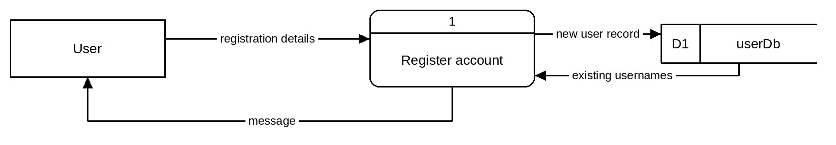

Section 3
Instructions
- Write using black or blue pen.
- This section has one question and is worth 40 marks.

QUESTION 16 (40 marks)
Refer to Stimulus 4.
A. Represent the flow of the bubble tea order data in a Level 0 data flow diagram. (10 marks)

B. Symbolise the Bubble Tea Order app's universe of discourse in an entity relationship diagram. (14 marks)

C. Using the entity relationship diagram from Part B, develop a data dictionary. (10 marks)
Field name | Data type | Constraints

D. Using the data flow diagram from Part A and the entity relationship diagram from Part B, develop input, process, output (IPO) tables showing only the SQL commands for: (6 marks)
- ordering of bubble teas
- display of bubble teas to be made
- marking an order as complete.
Orders placed
Input | Process | Output

Orders listed
Input | Process | Output

Mark complete
Input | Process | Output

END OF PAPER

Additional page for student responses
Write the question number you are responding to.

Additional page for student responses
Write the question number you are responding to.

