FIA4 Practice Examination 2 — Marking Schema
Digital Solutions 2025 — Unit 2: Application and data solutions

Grading
Marks (out of 100) | Grade
≥ 82 | A
≥ 66 and < 82 | B
≥ 50 and < 66 | C
≥ 25 and < 50 | D
< 25 | E

Criteria summary
Objective | Questions
1 | 1, 2, 3, 4, 6, 9, 10, 11, 12, 13, 14, 15, 16A, 16B, 16C, 16D
2 | 5, 7, 8, 13, 14, 15, 16A, 16B, 16D
3 | 13, 14, 15, 16A, 16B, 16C, 16D
5 | 12, 16C, 16D
7 | 11

Section | Questions | Marks
1 | 1–10 | 10
2 | 11–15 | 50
3 | 16 | 40
Total |  | 100

Section 1
Q | Answer | Obj. | Explanation
1 | A | 1 | Wisdom is the top of the pyramid: using knowledge with judgement to decide what to do.
2 | D | 1 | Learnability measures how easy it is for new users to accomplish basic tasks the first time they use the solution.
3 | A | 1 | GROUP BY CuisineId makes one group per cuisine and COUNT counts the recipes in each. (B) has no GROUP BY, (C) counts how many different cuisines there are, and (D) only sorts.
4 | B | 1 | (A) has no WHERE clause, (C) does not put the text value in quotes, and (D) joins RecipeId to MealPlanId, which are unrelated fields.
5 | C | 2 | The crow's foot (many) belongs at the book end and the 'one' symbol at the publisher end, because the foreign key publisher_id is in the book table.
6 | C | 1 | < 30 excludes recipes of exactly 30 minutes, and ORDER BY without DESC sorts in ascending order (shortest first).
7 | B | 2 | The open-ended rectangle is a data store, and the D prefix shows the data is stored on disk. A manual store would be labelled M.
8 | A | 2 | Overdue loans flow from D2 into 3.0, which sends the overdue notice to the Student. There is only one external entity, the student never writes to D2 directly, and 2.0 receives input from 1.0, not 3.0.
9 | D | 1 | The inner queries find Marco Rossi's cookbooks, and AVG returns one average across all matching recipes (no GROUP BY, so not per cookbook).
10 | C | 1 | Only Name and Cost are selected from the recipes table. The cookbooks table has no Cost field.

One mark for each correct answer.

Section 2

QUESTION 11 (15 marks)
Refer to Stimulus 2. Identify five principles of visual communication that could be employed to improve this wireframe. For each principle: name it, explain how it has not been applied, and outline how you would change the wireframe to apply it.
Expected responses (any five)
Principle | How it has not been applied | Suggested change
Contrast | The light grey labels and title on the mid-grey background are very hard to read. | Use a light background with dark text (or white text on a dark background) to give strong contrast.
Hierarchy | The title 'Book a tutor session' is tiny while the field labels are large and bold, so the labels dominate. | Make the title the largest, boldest text and reduce the labels to a consistent, smaller size.
Alignment | The labels and input fields are staggered, starting at different horizontal positions. | Left-align all labels in one column and all inputs in a second column.
Repetition | The two drop-down lists are styled differently, and the Book and CANCEL buttons use different shapes, fonts and colours. | Use one consistent style for all drop-downs and for all buttons.
Proximity | The Notes box sits between Date and Time, and the Book and Cancel buttons are in opposite corners. | Place Date and Time next to each other and group the two buttons together at the bottom right.
Balance | The large dark image block on the left is not balanced by anything of similar visual weight on the right. | Reduce or remove the image, or balance it with a matching element so visual weight is spread evenly.
Harmony | The screen mixes serif, sans-serif and monospace fonts and unrelated colours (teal, beige, grey). | Use one font family and a small, coordinated colour palette throughout.

Descriptor | Mark | Notes
For each principle (maximum five):  - names the principle  - identifies how it has not been applied and outlines a change | 3 | - Principles are limited to balance, contrast, proximity, harmony, alignment, repetition and hierarchy (syllabus).  - Elements (e.g. colour, space) alone do not score as principles.  - Each principle may only be credited once.
- names the principle  - identifies how it has not been applied or outlines a change | 2
- names the principle | 1
- does not satisfy the above descriptors | 0

Objectives
 | Unit 2 objective
1 | Recognise and describe programming features, data and useability principles, and data management processes.
7 | Evaluate components and solutions against criteria to make refinements and justified recommendations, and evaluate impacts.

QUESTION 12 (12 marks)
Refer to Stimulus 3. Accept single or double quotes, any letter case for keywords, and a trailing semicolon or none.
A. Write an SQL command to provide the full name of all the students who receive a concession. (2 marks)
SELECT FName, SName
FROM Student
WHERE Concession = TRUE
Checking SQL command | Mark | Notes
- correct code with no errors | 2 | - Accept Concession = 1, Concession IS TRUE or Concession = "Yes"; the value stored is not given.
- code contains one error | 1
- does not satisfy the above descriptors | 0

B. Write an SQL command to enrol student StudentID 342 with teacher TeacherID 7, starting on 2nd February 2026 and ending on 26th June 2026. (2 marks)
INSERT INTO Enrolment (TeacherID, StartDate, EndDate, StudentID)
VALUES (7, '2026-02-02', '2026-06-26', 342)
Checking SQL command | Mark | Notes
- correct code with no errors | 2 | - Students may list field names or rely on field order.  - Students may supply an EnrolID.  - Accept any unambiguous date format in quotes.
- code contains one error | 1
- does not satisfy the above descriptors | 0

C. At the end of a term, all charges need to be totalled. Write an SQL command that will calculate the total of the charges for EnrolID 1150. (2 marks)
SELECT SUM(Amount)
FROM Charges
WHERE EnrolID = 1150
Checking SQL command | Mark | Notes
- correct code with no errors | 2
- code contains one error | 1
- does not satisfy the above descriptors | 0

D. Write an SQL command that will identify the full name of all the students taught by the teacher with TeacherID 7. (3 marks)
SELECT FName, SName  FROM Student  WHERE StudentID IN (  SELECT StudentID  FROM Enrolment  WHERE TeacherID = 7) | SELECT Student.FName, Student.SName  FROM Student  JOIN Enrolment  ON Student.StudentID = Enrolment.StudentID  WHERE Enrolment.TeacherID = 7

Checking SQL command | Mark | Notes
- correct code with no errors | 3 | - Either a subquery or a join is acceptable.
- code contains one error | 2 | - Either a subquery or a join is acceptable.
- code contains two errors | 1 | - Either a subquery or a join is acceptable.
- does not satisfy the above descriptors | 0 | - Either a subquery or a join is acceptable.

E. Write an SQL command that lists each student suburb, and the number of enrolments made by students who live in that suburb. (3 marks)
SELECT Student.Suburb, COUNT(Enrolment.EnrolID)
FROM Student
JOIN Enrolment
ON Student.StudentID = Enrolment.StudentID
GROUP BY Student.Suburb
Checking SQL command | Mark | Notes
- correct code with no errors | 3 | - A join is needed because the count comes from Enrolment and the suburb comes from Student.  - Accept COUNT(*) or COUNT(Enrolment.StudentID).
- code contains one error | 2
- code contains two errors | 1
- does not satisfy the above descriptors | 0

Objectives
 | Unit 2 objective
1 | Recognise and describe programming features, data and useability principles, and data management processes.
5 | Synthesise information and ideas to develop possible digital solutions.

QUESTION 13 (7 marks)
A. Rewrite the table into first normal form. (2 marks)
Original
FirstName | LastName | Language
Hana | Kim | Korean, English
Mateo | Garcia | Spanish, English, French
Aisha | Rahman | Arabic
Hana | Kim | Japanese, Mandarin

Model answer
FirstName | LastName | Language
Hana | Kim | Korean
Hana | Kim | English
Mateo | Garcia | Spanish
Mateo | Garcia | English
Mateo | Garcia | French
Aisha | Rahman | Arabic
Hana | Kim | Japanese
Hana | Kim | Mandarin

Normalisation process | Mark | Notes
- correct with no errors | 2 | - Each cell holds a single (atomic) value.  - Accept the addition of a surrogate key, e.g. PersonID.
- contains one error | 1
- does not satisfy the above descriptors | 0

B. Rewrite the table into second normal form. (3 marks)
Original
AthleteID* | EventID* | AthleteName | EventName | Time
77 | 2 | Jack Brown | 100 m sprint | 12.4
77 | 5 | Jack Brown | 400 m | 58.1
78 | 2 | Zoe Clarke | 100 m sprint | 13.0

Model answer
AthleteID* | EventID* | Time
77 | 2 | 12.4
77 | 5 | 58.1
78 | 2 | 13.0

AthleteID* | AthleteName
77 | Jack Brown
78 | Zoe Clarke

EventID* | EventName
2 | 100 m sprint
5 | 400 m

Normalisation process | Mark | Notes
- correct with no errors | 3 | - Partial dependencies removed: each non-key field depends on the whole composite key.  - Duplicate rows must not remain in the new tables.  - Primary keys must be identified.
- contains one error | 2
- contains two errors | 1
- does not satisfy the above descriptors | 0

C. Rewrite the table into third normal form. (2 marks)
Original
BookID* | Title | Year | PubCode | Publisher
9001 | The Silent Reef | 2021 | HBR | Harbour Press
9002 | Red Dust Road | 2019 | RGB | Redgum Books
9003 | Night Train | 2023 | HBR | Harbour Press

Model answer
BookID* | Title | Year | PubCode
9001 | The Silent Reef | 2021 | HBR
9002 | Red Dust Road | 2019 | RGB
9003 | Night Train | 2023 | HBR

PubCode* | Publisher
HBR | Harbour Press
RGB | Redgum Books

Normalisation process | Mark | Notes
- correct with no errors | 2 | - Transitive dependency removed: the name now depends only on its own code.  - The code remains in the first table as a foreign key.  - Primary keys must be identified.
- contains one error | 1
- does not satisfy the above descriptors | 0

Objectives
 | Unit 2 objective
1 | Recognise and describe programming features, data and useability principles, and data management processes.
2 | Symbolise and explain information, ideas and data flow relationships within and between systems related to digital problems.
3 | Analyse problems and information related to the selected technology context.

QUESTION 14 (6 marks)
Variable name | Data type or structure | Explanation
riderName | string / text | the name of the rider
riderLicence | string / text | the rider's driver licence number, in the form 012 345 678
helmetHired | Boolean (accept integer 0/1 or text Y/N) | a value indicating whether the rider also hired a helmet
scooterNum | integer | the fleet number painted on the scooter, e.g. 1047
rideStart | date/time (accept text / string) | the date and time the ride began
rideCharge | float / real (accept decimal / currency) | the amount the ride cost the rider

Number of correct answers | Mark | Notes
- 6 correct answers | 6 | - Allow for different SQL implementations and programming languages (e.g. str, TEXT, VARCHAR).  - Numbers containing spaces or leading zeros, such as phone and licence numbers, must be text.
- 5 correct answers | 5
- 4 correct answers | 4
- 3 correct answers | 3
- 2 correct answers | 2
- 1 correct answer | 1
- no correct answers | 0

Objectives
 | Unit 2 objective
1 | Recognise and describe programming features, data and useability principles, and data management processes.
2 | Symbolise and explain information, ideas and data flow relationships within and between systems related to digital problems.
3 | Analyse problems and information related to the selected technology context.

QUESTION 15 (10 marks)
Draw the Level 1 data flow diagram for registering a new account.
Model answer
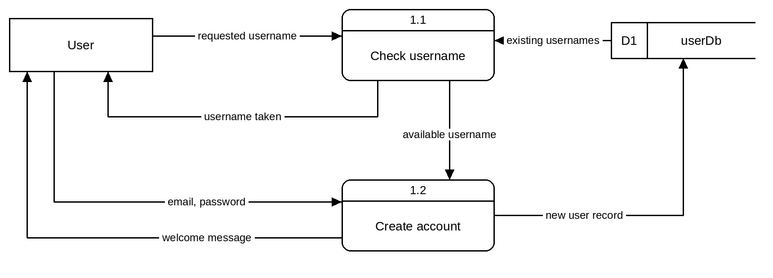
Included in the diagram | Mark | Notes
- User external entity | 1 | - Names and structure may differ.  - Symbols must follow Gane-Sarson notation.  - Flows must pass through a process: no flow may connect an entity directly to a store.  - Total cannot fall below 0.
- 2 processes (numbered 1.1 and 1.2, verb–object names) | 2
- 1 process | 1
- data store (D1 userDb) | 1
- 6 or more correct data flows (labelled, correct direction) | 6
- 5 correct data flows | 5
- 4 correct data flows | 4
- 3 correct data flows | 3
- 2 correct data flows | 2
- 1 correct data flow | 1
- each symbol or convention error | -1

Objectives
 | Unit 2 objective
1 | Recognise and describe programming features, data and useability principles, and data management processes.
2 | Symbolise and explain information, ideas and data flow relationships within and between systems related to digital problems.
3 | Analyse problems and information related to the selected technology context.

Section 3

QUESTION 16 (40 marks)
A. Represent the flow of the bubble tea order data in a Level 0 data flow diagram. (10 marks)
Model answer
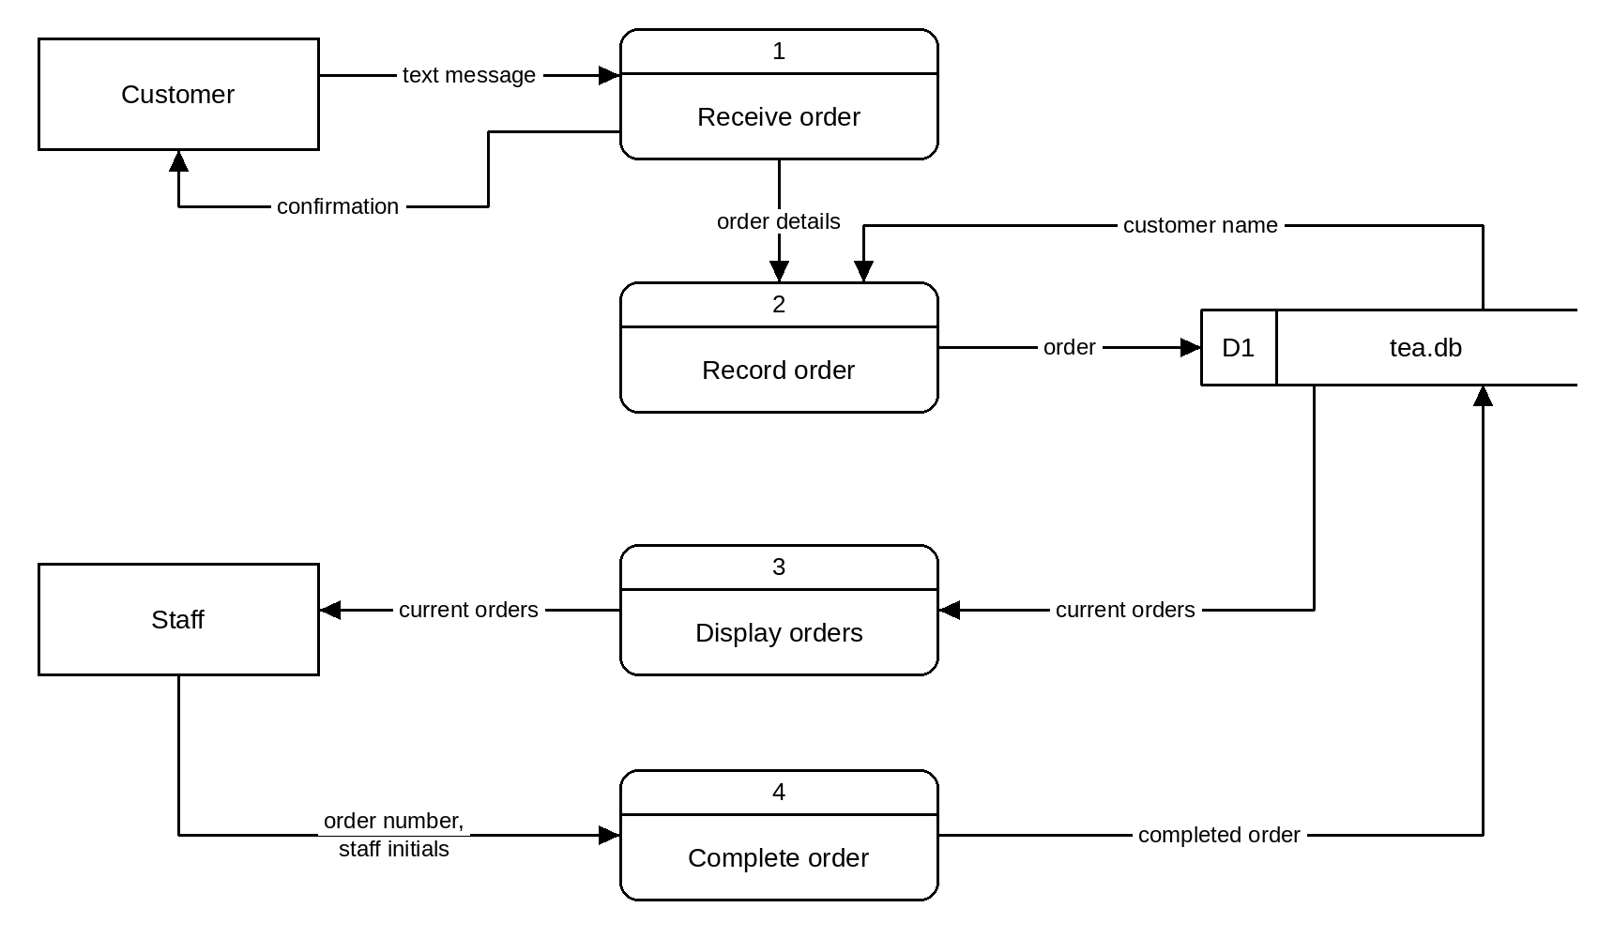
Included in the diagram | Mark | Notes
- 4 processes recorded | 4 | - Names and structure may differ.  - Symbols must follow Gane-Sarson notation.  - Processes should be numbered and named with verb–object names.
- 3 processes recorded | 3
- 2 processes recorded | 2
- 1 process recorded | 1
- 2 external entities (Customer, Staff) | 2
- 1 external entity | 1
- 1 data store (tea.db) | 1
- all data flows connected correctly | 1
- all data flow arrows correct | 1
- all data flow labels correct | 1

Objectives
 | Unit 2 objective
1 | Recognise and describe programming features, data and useability principles, and data management processes.
2 | Symbolise and explain information, ideas and data flow relationships within and between systems related to digital problems.
3 | Analyse problems and information related to the selected technology context.

B. Symbolise the Bubble Tea Order app's universe of discourse in an entity relationship diagram. (14 marks)
Model answer
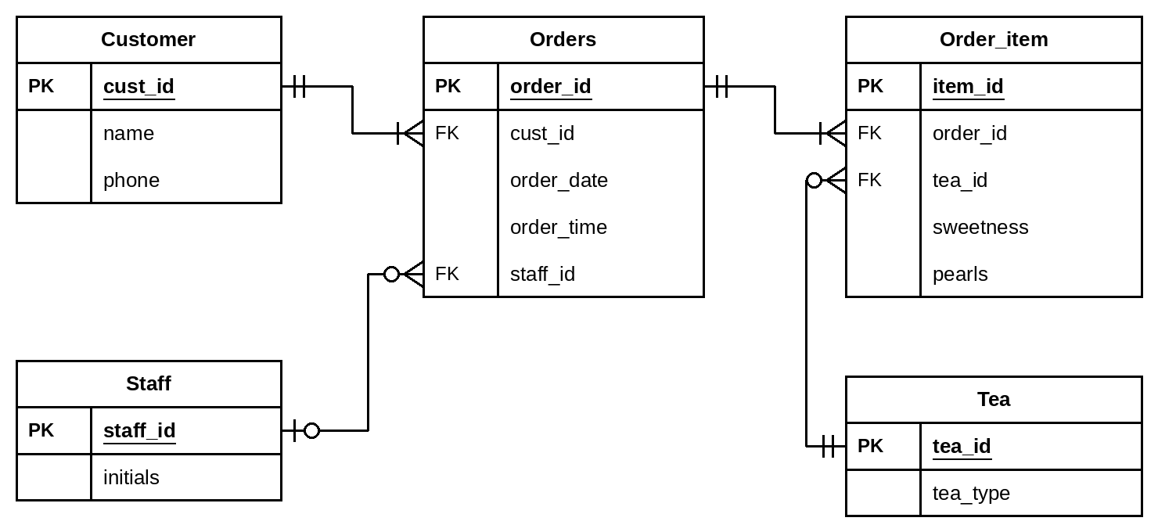
Correctly included in the diagram | Mark | Notes
- 5 entities | 5 | - Names and structure may differ.  - Symbols must be accurate (crow's foot notation).  - Accept a composite primary key (order_id, product id) in Order_item.  - Accept one-to-many in place of the optional (zero) cardinalities shown.  - Table name 'Orders' avoids the reserved word ORDER; accept 'Order'.
- 4 entities | 4
- 3 entities | 3
- 2 entities | 2
- 1 entity | 1
- 4 relationships | 4
- 3 relationships | 3
- 2 relationships | 2
- 1 relationship | 1
- 4 cardinalities | 4
- 3 cardinalities | 3
- 2 cardinalities | 2
- 1 cardinality | 1
- all attributes, with PK and FK identified | 1
- attributes with errors | 0

Objectives
 | Unit 2 objective
1 | Recognise and describe programming features, data and useability principles, and data management processes.
2 | Symbolise and explain information, ideas and data flow relationships within and between systems related to digital problems.
3 | Analyse problems and information related to the selected technology context.

C. Using the entity relationship diagram from Part B, develop a data dictionary. (10 marks)
Model answer
Field name | Data type | Constraints
Customer table
cust_id | Integer | Primary key
name | Text | Not null
phone | Text | Format: 04XX XXX XXX, unique
Orders table
order_id | Integer | Primary key
cust_id | Integer | Foreign key = Customer.cust_id
order_date | Date | dd/mm/yyyy
order_time | Time | hh:mm
staff_id | Integer | Foreign key = Staff.staff_id, null until complete
Staff table
staff_id | Integer | Primary key
initials | Text | 2 characters
Order_item table
item_id | Integer | Primary key
order_id | Integer | Foreign key = Orders.order_id
tea_id | Integer | Foreign key = Tea.tea_id
sweetness | Integer | 0, 25, 50, 75 or 100 (%)
pearls | Boolean | True / False
Tea table
tea_id | Integer | Primary key
tea_type | Text | Not null

Correct for each table | Mark | Notes
For each table (5 tables × 2 marks):  - all field names | ½ | - Names and constraints may differ but must match the student's own ERD.  - Primary and foreign keys must be identified as constraints.
- errors in field names | 0
- all data types | 1
- more than half of the data types | ½
- half or fewer of the data types | 0
- all constraints | ½
- errors in constraints | 0

Objectives
 | Unit 2 objective
1 | Recognise and describe programming features, data and useability principles, and data management processes.
3 | Analyse problems and information related to the selected technology context.
5 | Synthesise information and ideas to develop possible digital solutions.

D. Develop IPO tables showing only the SQL commands for the ordering of bubble teas, the display of bubble teas to be made, and marking an order as complete. (6 marks)
Orders placed
Input | Process | Output
customer phone (customer)  tea type (customer)  sweetness (customer)  pearls (customer)  cust_id (tea.db) | INSERT INTO Orders (cust_id, order_date, order_time)  VALUES (<cust_id>, CURRENT_DATE, CURRENT_TIME)  INSERT INTO Order_item (order_id, tea_id, sweetness, pearls)  VALUES (<order_id>, <tea_id>, <sweetness>, <pearls>) | Text sent to customer: “Order received”

Correct in the table | Mark | Notes
- required inputs identified | ½ | - SQL may be at pseudocode level.  - <value> marks a value supplied by the app at run time.  - Field and table names must match the student's own ERD.
- errors in required inputs | 0
- both INSERT statements made | 1
- one INSERT statement made | ½
- no INSERT statements | 0
- confirmation message output | ½
- no message output | 0

Orders listed
Input | Process | Output
Refresh of the display (staff) | SELECT Orders.order_id, Orders.order_time, Customer.name,  Tea.tea_type, Order_item.sweetness, Order_item.pearls  FROM Orders  JOIN Customer ON Orders.cust_id = Customer.cust_id  JOIN Order_item ON Orders.order_id = Order_item.order_id  JOIN Tea ON Order_item.tea_id = Tea.tea_id  WHERE Orders.staff_id IS NULL  ORDER BY Orders.order_time | Table listing all incomplete orders

Correct in the table | Mark | Notes
- required inputs identified | ½ | - SQL may be at pseudocode level.  - <value> marks a value supplied by the app at run time.  - Field and table names must match the student's own ERD.
- errors in required inputs | 0
- SELECT includes adequate joins/subqueries and a WHERE limiting to incomplete orders | 1
- SELECT includes adequate joins/subqueries or a WHERE | ½
- SELECT includes neither | 0
- output identified | ½
- no output identified | 0

Mark complete
Input | Process | Output
order_id (staff)  staff initials / staff_id (staff) | UPDATE Orders  SET staff_id = <staff_id>  WHERE order_id = <order_id> | Updated table of current orders (completed order removed)

Correct in the table | Mark | Notes
- required inputs identified | ½ | - SQL may be at pseudocode level.  - <value> marks a value supplied by the app at run time.  - Field and table names must match the student's own ERD.
- errors in required inputs | 0
- correct field updated and limited to the identified order | 1
- correct field updated or limited to the identified order | ½
- neither | 0
- output identified | ½
- no output identified | 0

Objectives
 | Unit 2 objective
1 | Recognise and describe programming features, data and useability principles, and data management processes.
2 | Symbolise and explain information, ideas and data flow relationships within and between systems related to digital problems.
3 | Analyse problems and information related to the selected technology context.
5 | Synthesise information and ideas to develop possible digital solutions.

