1. Create a docker account and push an image
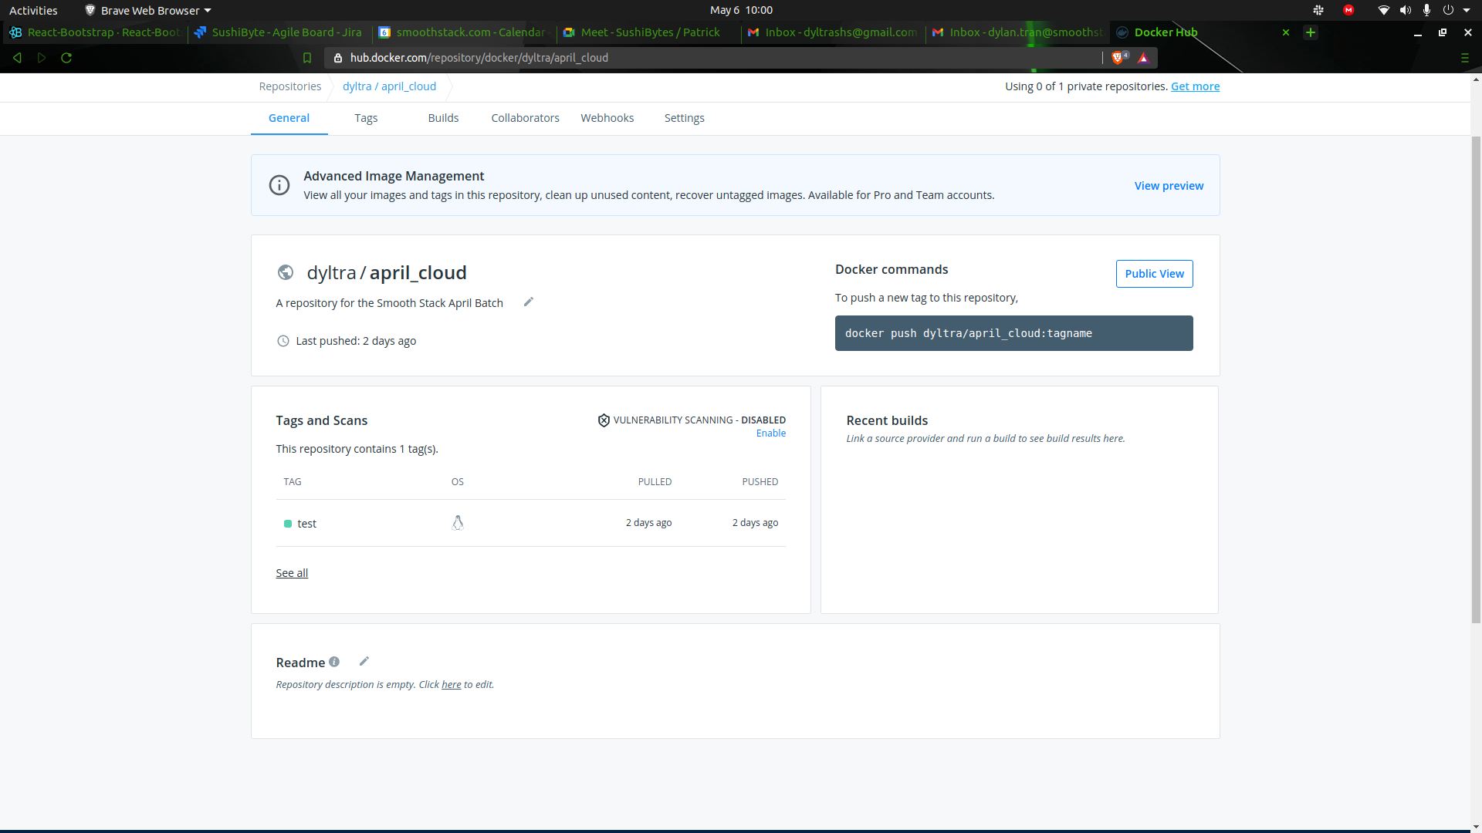
2. What location are the files related to the docker containers and images stored?
/var/lib/docker

3. What is cpu share in container and what is default?
The cpu-shares option allows you to specify the relative share of cpu a container will receive when there is contention for cpu.
The default is whatever the container wants, so the limit of the host’s capabilities, evenly distributed across containers

4. What command to use the share of CPU cycles for containers?
--cpu-shares {# of Shares}

5. Provide a screen shot of running a Ubuntu container
which copies a simple shell script(echo "hello world") from host and executes inside the container.
[Use docker volume bind]

Used command from external source but researched what each flag and argument meant from docker run | docker documentation

