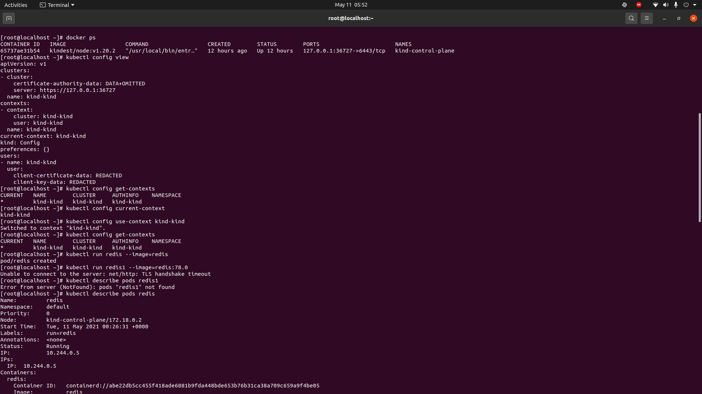
1. Run a redis pod. -
kubectl run redis --image=redis
kubectl run redis1 --image=redis:78.0
2. Describe the redis pod and see if there is any failure. Explain why redis1 pod failed.
Redis 1 failed because it couldn’t find the image with associated tag of 78.0.

