Question Bank &
Interview Preparation Platform
Proof of Concept (POC) Document
React + FastAPI + PostgreSQL
Prepared for internal management and technical discussion

1. POC Overview
The purpose of this POC is to create a simple internal web application where interview questions can be stored in one place and assigned to employees for client interview preparation. Managers or administrators can manage questions and employees, assign questions, and check preparation progress. Employees can log in, view their assigned questions, search for the content, bookmark useful questions, and update their progress.
The POC will use React for the frontend, Fast API for the backend, PostgreSQL for the database, and JWT-based login authentication.

2. POC Goals
- Create one central place for interview preparation questions.
- Allow admin users to add employees and questions manually or through Excel upload.
- Allow admin users to assign questions to employees.
- Allow employees to view and prepare assigned questions.
- Provide simple search, assignment status, and progress features.
- Show basic dashboard information for admin and employees.
- Validate that React, FastAPI, PostgreSQL, and JWT work well together for this use case.

3. POC Scope

3.1 Included in the POC
- Login and role-based access for Admin and Employee.
- Employee management.
- Bulk employee upload from Excel.
- Question management and Excel question upload.
- Question assignment to employees.
- Search and filter by technology.
- Track question preparation status and completion percentage.
- Admin and employee dashboards.

4. User Roles and Main Features
Role | Main Activities
Admin | Manage employees, manage questions, upload Excel files, assign questions, and view progress.
Employee | Login, view assigned questions, search, and update preparation progress.

5. High-Level Architecture
The recommended POC architecture is a modular monolith. React communicates only with the FastAPI API. FastAPI owns authentication, authorization, validation, imports, assignments, progress and reporting. PostgreSQL is the system of record. Uploaded Excel files may be retained in simple file/object storage for traceability, while parsed business data is persisted relationally.

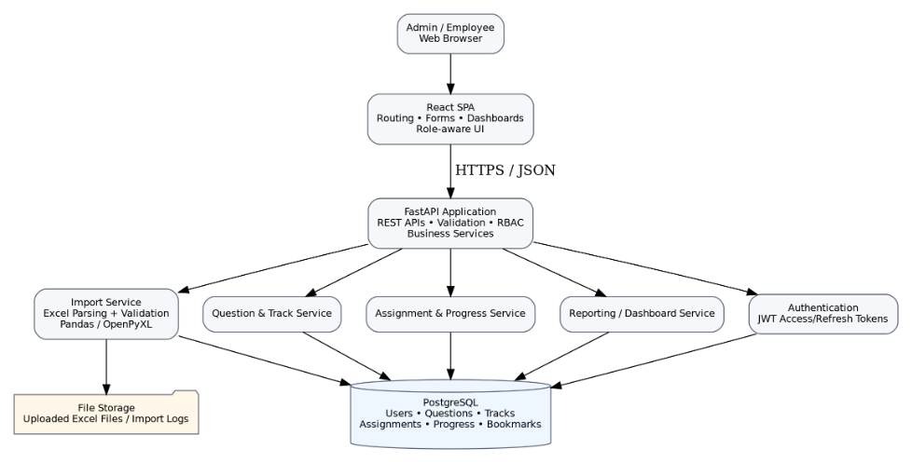
For the POC, uploaded Excel files are used as an input source. FastAPI reads the file, validates the rows, and stores valid data in PostgreSQL.

6. Application Flow

6.1 Admin Flow
- Admin logs in.
- Admin opens the dashboard.
- Admin creates or uploads employees.
- Admin uploads question file.
- Admin assigns questions to employees.
- Admin checks completion and pending progress.

6.2 Employee Flow
- Employee logs in.
- Employee opens My Dashboard.
- Employee views assigned questions.
- Employee searches or filters questions by technology.
- Employees can bookmark useful questions.
- Employee updates preparation status and checks progress.

7. Excel Upload Process
The base document includes an Excel upload for questions and employees. The POC will keep this process simple and easy to understand.
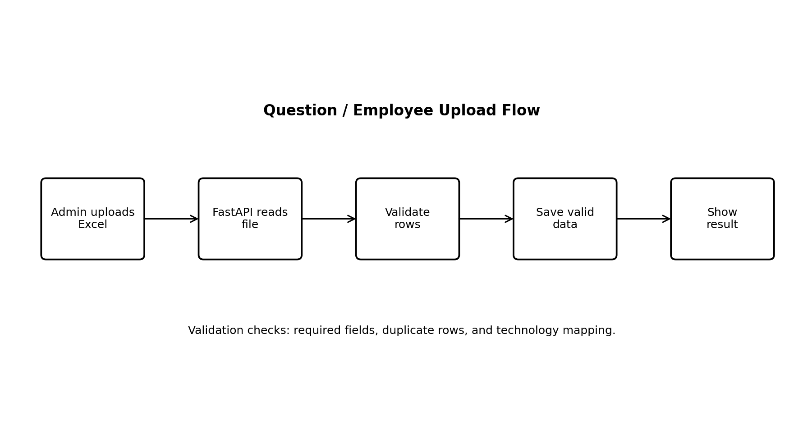

7.1 Question Excel Example
Technology | Question | Answer | Difficulty
Python | What is GIL? | <answer text> | Medium
SQL | Difference between JOIN and UNION | <answer text> | Medium
Azure | What is Azure Function? | <answer text> | Easy

7.2 Employee Excel Example
Employee ID | Name | Email | Experience | Technology
E001 | Test User | user@test.com | 8 | Python

During upload, the backend will check required values, duplicate rows, and technology values before saving records.

8. Database Design
To keep the POC close to the base document, the ER diagram uses only the four tables already listed there: USERS, QUESTION_ASSIGNMENTS, QUESTIONS, and QUESTION_TRACK.
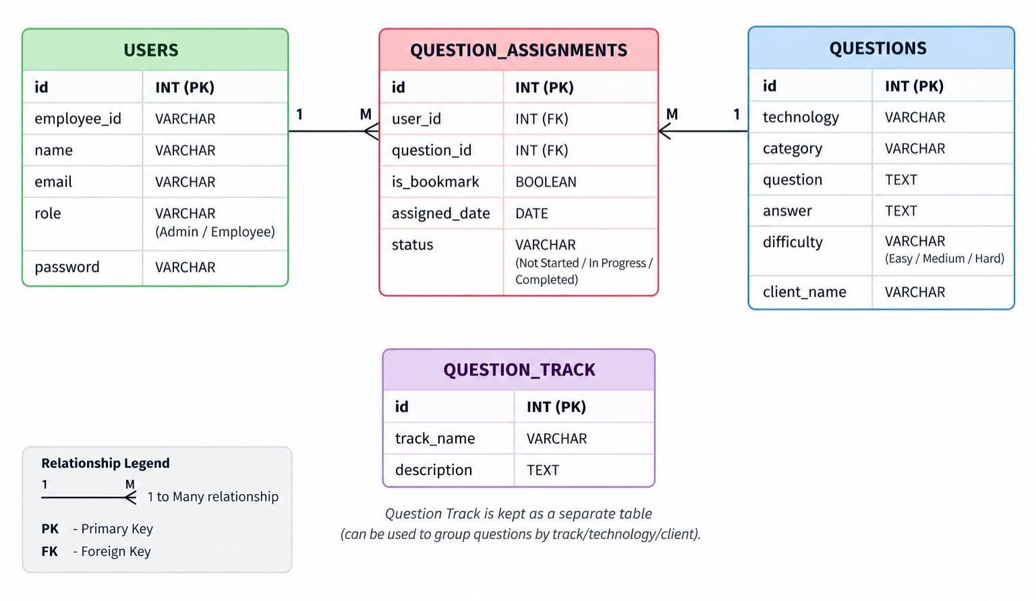

8.1 Table Summary
Table | Purpose
USERS | Stores employee/admin login and basic user information.
QUESTIONS | Stores interview questions, answers, technology, category, and difficulty.
QUESTION_ASSIGNMENTS | Connects a user with an assigned question and stores assignment status.
QUESTION_TRACK | Stores a track name and description for grouped interview preparation.

Note: Currently we did not define any database relationship between QUESTION_TRACK and QUESTIONS. For this POC document, the table is therefore kept simple. If track-to-question mapping is required during implementation, it can be discussed with the team before development.

9. Simple API Design
FastAPI will expose REST APIs. The exact request and response fields can be finalized during implementation. The following endpoints are enough for the POC discussion.
Area | Example Endpoint | Purpose
Authentication | POST /api/login | Login and return JWT token.
Employees | GET /api/users | List employees.
Employees | POST /api/users | Create employee.
Employees | POST /api/users/upload | Upload employee Excel file.
Questions | GET /api/questions | List/search questions.
Questions | POST /api/questions | Create question.
Questions | POST /api/questions/upload | Upload question Excel file.
Assignments | POST /api/assignments | Assign question to employee.
Assignments | GET /api/my-questions | Get employee assigned questions.
Progress | PATCH /api/assignments/{id} | Update preparation status.
Dashboard | GET /api/dashboard | Return dashboard summary.

10. Frontend and Backend Structure

10.1 React Screens
- Login Page
- Admin Dashboard
- Employee Management
- Question Management
- Question Assignment
- Employee Dashboard / My Questions
- Search and Filter view
- Progress view

10.2 FastAPI Modules
- Authentication APIs
- User / Employee APIs
- Question APIs
- Assignment APIs
- Dashboard APIs
- Excel upload and validation logic

11. Authentication and Security
The POC will use JWT token authentication. After a successful login, FastAPI returns a token. React sends this token with protected API requests. FastAPI checks the token and user role before allowing access.
- Passwords will not be stored as plain text.
- Admin-only APIs will check the user role.
- Employee users will only access features allowed for employees.
- Uploaded Excel data will be validated before saving to the database.
- Basic input validation will be added using FastAPI/Pydantic models.

12. Dashboard Information

12.1 Admin Dashboard
- Total employees
- Total questions
- Total assignments
- Completed assignments
- Pending assignments

12.2 Employee Dashboard
- Assigned questions
- Completed questions
- Pending questions
- Completion percentage

13. POC Testing
The POC does not need a very large testing setup, but the main business flows should be checked before the management demo.
Test Area | What to Check
Login | Valid login, invalid login, and role access.
Employee Management | Create user and upload employees from Excel.
Question Management | Create question and upload questions from Excel.
Assignment | Assign a question and confirm it appears for the employee.
Search / Filter | Search questions by text or technology.
Progress | Update assignment status and confirm dashboard counts.
Security | Employee cannot use admin-only APIs.

14. Deployment Approach
The organization will provide the server for hosting the POC/application. The final deployment approach, server configuration, web server setup, process management, database location, domain/SSL, and access rules will be discussed with the organization infrastructure/technical team before deployment.
For the POC document, no specific deployment technology is being fixed. The application will be prepared so that the React frontend, FastAPI backend, and PostgreSQL database can be configured on the server provided by the organization.

15. Suggested POC Implementation Steps
Step | Work
1 | Project setup, database connection, and login.
2 | Employee management and employee Excel upload.
3 | Question management and question Excel upload.
4 | Question assignment and employee My Questions screen.
5 | Search, filter, and progress tracking.
6 | Admin/employee dashboard and final POC testing.

16. Flow for Admin and Employee
- Login as Admin.
- Upload a small employee Excel file.
- Upload a small question Excel file.
- Assign questions to one employee.
- Login as the employee.
- Show assigned questions, search/filter, and progress updates.
- Return to Admin and show the updated dashboard/progress.

17. POC Success Criteria
- Admin and employee users can log in successfully.
- Employee and question Excel files can be uploaded and validated.
- Questions can be assigned to an employee.
- Employee can see assigned questions and update preparation status.
- Search and filter features work for the POC.
- Dashboard values update based on assignment status.
- Role-based access is working for Admin and Employee.
- The complete flow can be demonstrated from React UI through FastAPI to PostgreSQL.

18. Future Enhancements
After the POC is accepted, the following items from the base proposal can be considered in later phases:
- Interview tracks such as Python Core, FastAPI, and SQL.
- Bookmarking important questions.
- Email notifications for new assignments, reminders, and password reset.
- AI-based question recommendation based on technology and experience.
- AI mock interview with answer feedback.

19. Conclusion
This POC keeps the solution intentionally simple. It focuses on the main interview-preparation workflow and demonstrates the complete React, FastAPI, PostgreSQL, and JWT integration. Once the POC is reviewed by management and the technical team, database details, deployment decisions, and later-phase features can be finalized before production development.

