Task 1 : What is SDLC?

SDLC is a structured process that is used by organizations to build a software step by step.

At first we have to figure it out what’s needed and plan it out,

Then we have to design, code and test the product.

Finally, we have to launch it and make sure that the product aligns with the expectations of the stakeholders.

Popular methods:

Waterfall

Agile

V

Scrum

Devops

Task 2 : Why do we use SDLC?  
  
We use SDLC so that we have a clear path of steps to follow.

It is to make sure that we reduce our errors and get aligned on the process flow on where to start and how to progress.  
  
This make sures that the product meets the quality standards expected by the stakeholders.

Task 3 : Stages of SDLC

Planning :   
 We decide on what the project is about and the way of approach we are going to use for this project.

Requirements :   
We have to get all the features and the functions that the product needs(User’s expectations)

Design :  
We have to create a flowchart or a blueprint on how the product will work and look.

Development :

This is entirely based on the coding section where we develop our code based on the User’s request.

Testing :

This is to ensure that the product works without any issues and identify the issues by testing all the functions of the product.

Deployment:

End product ( final version) that we share to the Users/Stakeholders.

Maintenance:

Continued support from the dev team by introducing updates and fixing existing bugs if present any.

Task 4 : SDLC Models

**Waterfall model**

Model flows in a strict step by step order

You have to complete the previous step completely before moving on the next phase

It is easy to manage the project in this model but the drawback is you cannot change the requirements later on.

Well suitable for projects which are well defined and won’t require changes in the middle of the project.

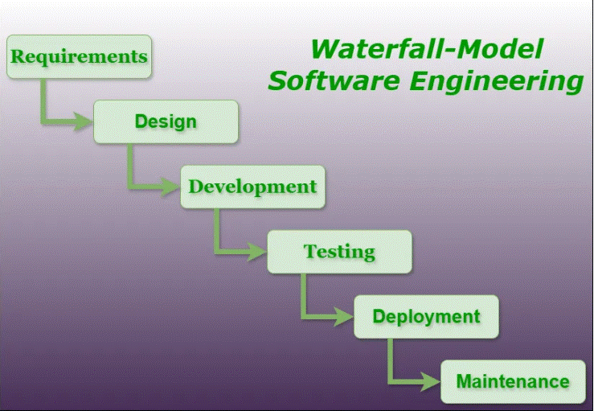

**Task 5 : Applications of Waterfall Model**

Waterfall model is used in government, construction or hardware projects.

Projects where the requirements are clear and the changes are very minimal.

Building the payroll system or working on a aircraft control system

**Advantages :**

Works well when the requirements are defined.

Simple and easy to follow

**Disadvantages :**

Working solution is available in the late stages of the process.

Hard to make changes once the phase has been completed.

**Agile Model**

Work is done in small consecutive cycles named sprints where a small part of the project is focused and it is completed thoroughly before moving on to the next part.

Building, testing and getting the feedback constantly occurs for every sprint.

It is flexible since the whole project is not carried out in a single go.

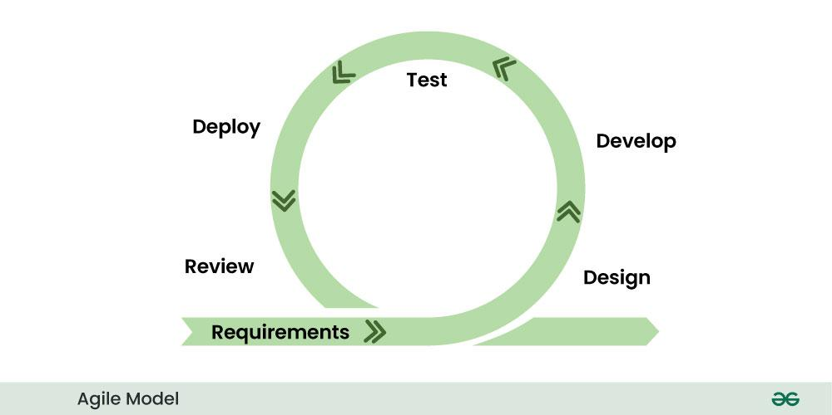

**Task 5 : Applications of Agile Model**

Used in web apps and mobile apps, startups.

Projects where the requirements constantly evolve and continuous feedback is needed from the Users.

Building the E commerce platforms or updates in social media platforms like Instagram and Twitter.

**Advantages :**

Highly flexible and it can adapt to the changes that occur in the middle of the development.

Working software is delivered sooner in this model.

**Disadvantages :**

Since it works with the changes in the project, it requires an experienced team and constant communication to work on.

Cannot estimate the cost upfront as it might change during the development.

**Iterative Model**

A simple version of the product is created at first and then it is improved on every iteration.

Each version ensures that we are adding new features and eliminating existing bugs.

Useful in projects where the requirements are not well defined in the beginning.

Engagement with the end users(stakeholders) would be high since we are releasing each version to the user for their feedback and improvements.

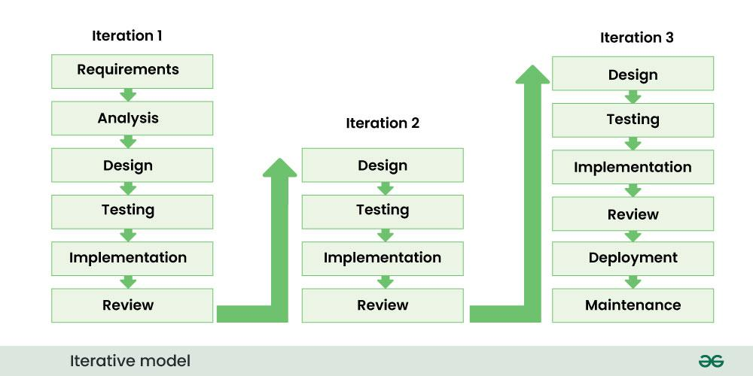

**Task 5: Applications of Iterative Model:**

Used in prototypes (beta and alpha versions), Design focused apps.

Projects where the initial version is provided at first and then constant iterations are done to improve the quality.

Internal communication applications (Amazon Chime) , Banking applications(customer centric)

**Advantages:**

Early versions of the product are available quickly compared to others.

Issues can be detected and fixed in the early stages.

**Disadvantages :**

If the planning is not proper , then it might lead to repetitive steps

Since the cycles are repeated, it might seem time consuming and it leads to a higher resource usage.

Scrum is a project management framework that implements Agile methodology that is focused on team collaboration to manage work and solve issues.  
  
Problems are converted into small portions named sprints.

Three types are roles are available in scrum projects

Product owner

Developers

Scrum Master

In each Sprint , there will be daily stand ups

Sprints are Short time fixed periods( typically 2 weeks , Max 1 month) Where the team has to work on a specific goal and complete it within the time period so that they can move on to the next sprint.

What needs to be done :

Focus on the goal.

Prioritize tasks.

Ensure good communication with the team.

What should be avoided :

Ignoring Stakeholder feedback

Compromising on quality

Over estimating the Team’s capability

Backlogs :

Specific list of tasks that has to be completed within the current sprint.

Stories :

It is a way of describing products features from a user’s /Stakeholder’s perspectives

Scrum Artifacts

* Product Backlog
* Sprint Backlog
* Burn-Down Chart
* Increment

Product Backlog :

Specific list of tasks that we have to complete by the end of the project. It undergoes changes throughout the project to ensure that we are aligning the project’s evolved requirements

Sprint Backlog :

Specific list of tasks that has to be completed within the current sprint.

Burn down chart :

It is a visual representation where we can track the progress of the project.

Increment :

Progress made on a project during a sprint. Each increment is like a product item completed, all of them together makes the project goal.

Ports and Protocols

Protocols are the set of rules that devices should follow when they are exchanging data.

Ports are channels through which applications send and receive data on a network.

Different Network Types

Local area network

Wide area network

Metropolitan area network

Virtual private network

Different types of server

Web server :

Type of server that hosts programs and data requested by the user on the internet.

It displays website content to users through protocols such as HTTP or HTTPS.

File server :

It allows users to store , access and manage files over a certain network.

It is primarily used in organizations to share data to multiple users from the central hub.

Database Server :

It manages and datasets and provides access to them using applications like Mysql ,SQL Server or Oracle.

DNS Server : ( Domain Name System)

It helps to translate human friendly domain names ([www.google.com](http://www.google.com)) into machine – readable IP addresses.

It helps the browsers to locate each domain.

This makes the website load faster since the system looks through the DNS Server to find the valid website.

Types of Network Topolgy

Bus Topology

All the devices are connected to the single central line.

Cost effective for small networks but the drawback is everything depends on the central line.

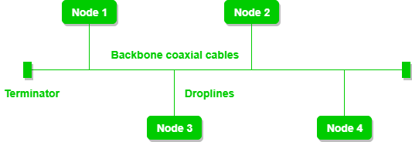

Star topology

Each device is connected to a central hub , it’s reliable but if the central hub is down, all the devices would be of the same condition.

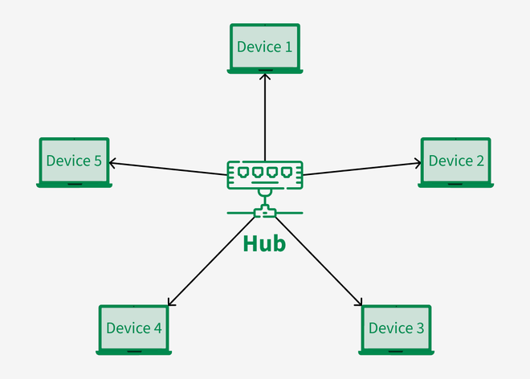

Ring topology

All the devices are connected in a circular loop and the data travels in a single direction.

Since it is uni-directional , data transmission speed is high.

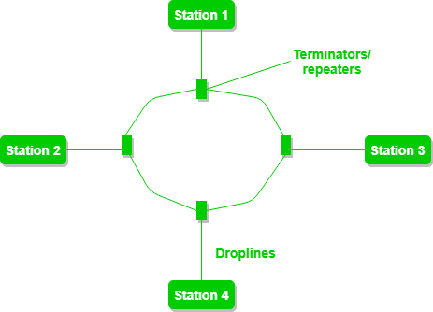

Mesh Topology

Every device is connected to each other directly. This increases the reliability but the complexity is high and the cost of installation is high as well.

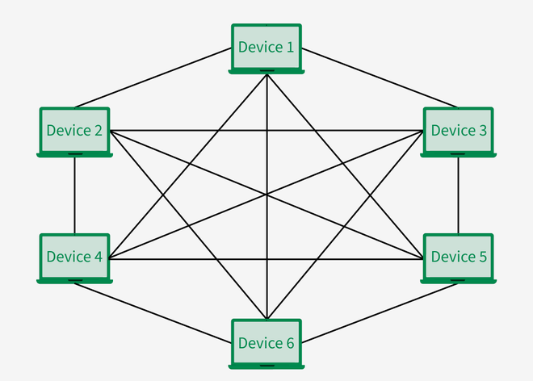

**OSI Model**

OSI is a framework or set of rules that explains how different systems communicate over a network. It can be explained in 7 steps.

Physical Layer :

This is the hardware layer , it deals with the cables , switches , voltages etc.

It explains about how devices are connected physically and the way data is transmitted(electrical,optical, or radio signals).

Data link layer :

It handles the transmission between two connected devices.

It organizes the data bits into frames , detects and fixes basic errors

Network Layer:

It manages addressing and routing the data through multiple networks with the help of logical addresses (IP addresses)

It decides on the best path to send the data from sender to receiver.

Transport layer:

It ensures that data transfer between two connected devices are safe and reliable.

It handles the flow control, error correction through protocols such as TCP and UDP

Session Layer :

Manages connections between multiple applications.

It ensures proper communication flow between two applications.

Presentation Layer :

Translates the data between different application formats.

Eg Converting a JPEG format file into a bitmap or PNG format)

Application Layer :

The final layer of the OSI model which helps the applications to interact with the network.

This includes protocols like HTTPS,FTP,SMTP etc.