Online Bookstore Application – Project Report
1. Introduction
The Online Bookstore Application is a Java-based console system designed to manage book inventory, user interactions, and orders efficiently. It allows users to browse books, manage carts, place orders, and view recommendations, all backed by a DynamoDB database for scalability and performance.

2. Requirements
2.1 Functional Requirements
- View all available books.
- Add new books to the inventory.
- Delete books from the inventory.
- Add or remove books from the cart.
- Checkout and create orders.
- Display order history per user.
- Provide personalized book recommendations using DynamoDB.
- Maintain browsing history using data structures (LinkedList).

2.2 Non-Functional Requirements
- Performance: Database operations should execute under 1 second for standard queries.
- Scalability: Must support multiple users and large inventories using DynamoDB.
- Reliability: Data persistence ensured via AWS SDK.
- Usability: Simple text-based console interface for ease of interaction.
- Maintainability: Modular design with clear service layers for easy code updates.

3. Design
3.1 System Architecture
The system follows a Layered Architecture pattern:
Main (Driver)
↓
Controller Layer → Handles user interaction (BookController)
↓
Service Layer → Business logic (BookService, CartService, CheckoutService, RecommendationService)
↓
Model Layer → Data representation (Book, Cart, Order, User)
↓
Database Layer → DynamoDB integration via AWS SDK

3.2 Class Diagram
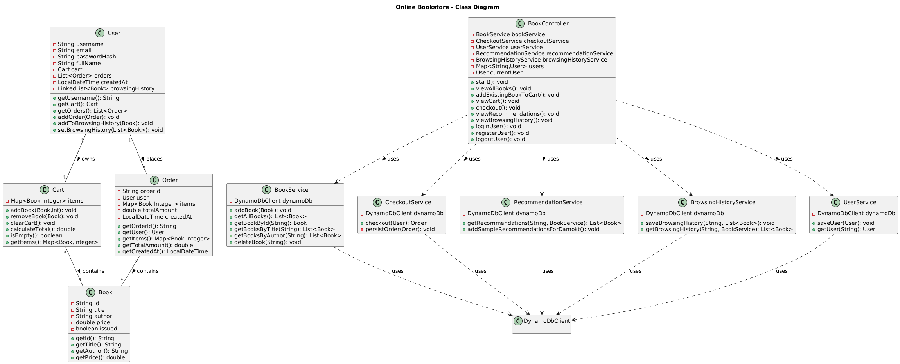
Link for the original size
Use Case Diagram
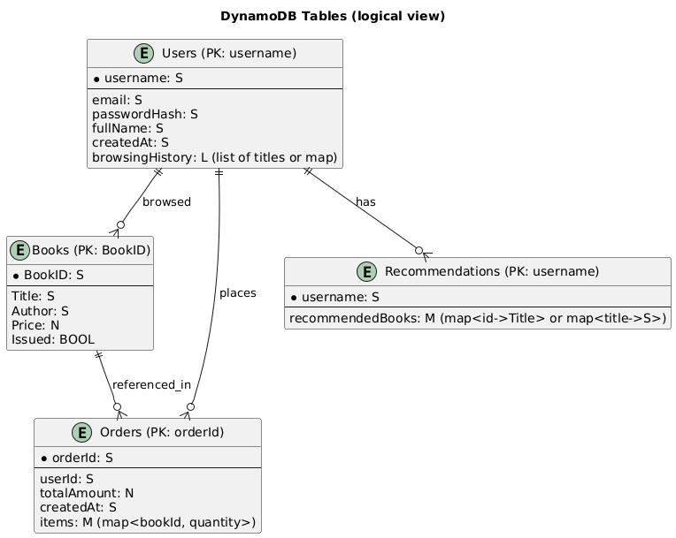

Sequence Diagram — Checkout Flow :

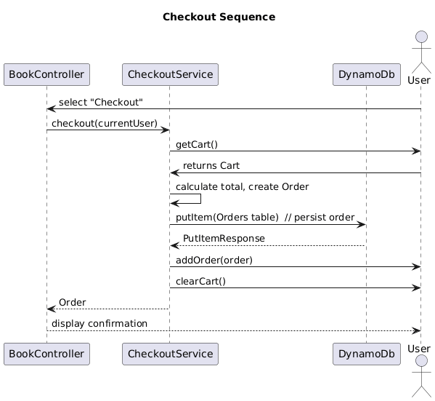

3.3 Data Flow
- User selects an operation from the main menu.
- The controller calls the appropriate service class.
- Services perform operations using Book and Cart models.
- DynamoDB stores persistent data like books, orders, and recommendations.

4. Implementation
4.1 Technologies Used
- Programming Language: Java 17
- Database: Amazon DynamoDB (AWS SDK)
- Build Tool: Maven
- Testing Framework: JUnit 5
- IDE: IntelliJ IDEA / Eclipse
- Version Control: Git & GitHub

4.2 Key Features Implemented
- Book Management: CRUD operations for books.
- Cart and Checkout: Add, remove, and checkout books with total calculation.
- Order Management: Generates orders and maintains order history.
- Browsing History: Tracks user’s recent views using LinkedList.
- Recommendations: Fetches personalized book suggestions from DynamoDB.
- Automation: All modules are tested with JUnit test cases for validation.
4.3 DynamoDB Integration
- Tables used:
  - Books → Stores all available books.
  - Orders → Stores user order history.
  - Recommendations → Maps usernames to recommended book titles.
- AWS SDK (software.amazon.awssdk.services.dynamodb) used for CRUD operations.

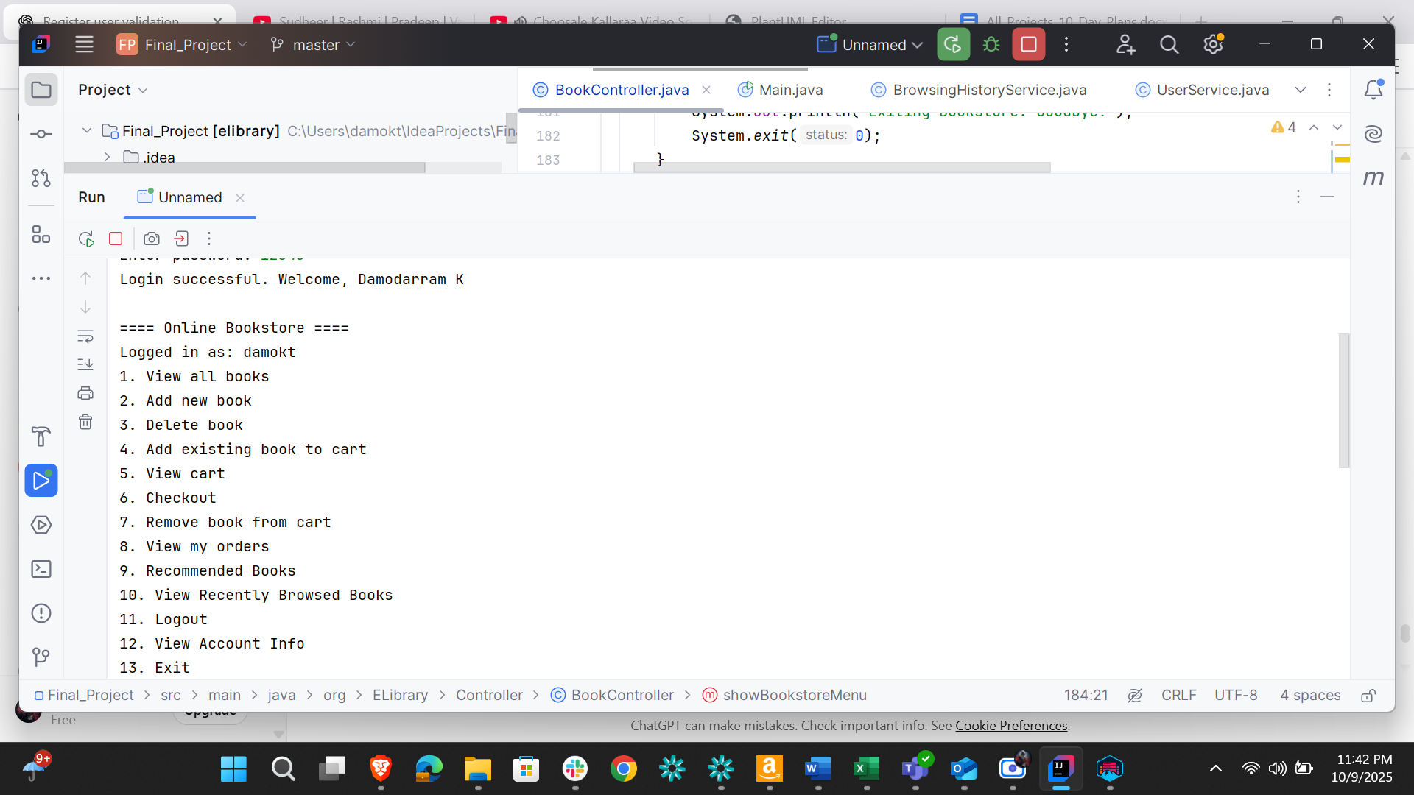

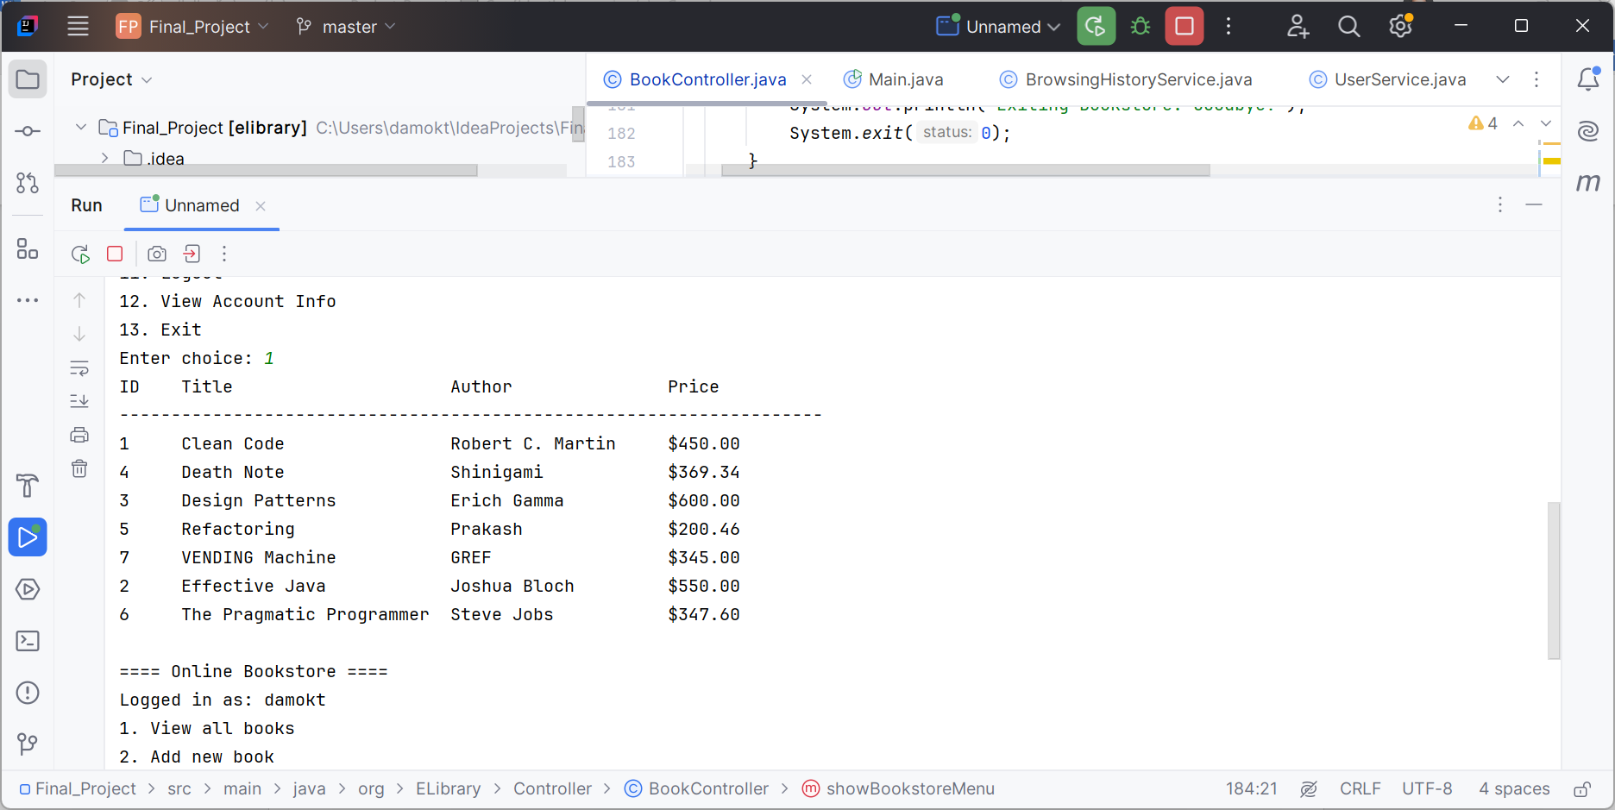

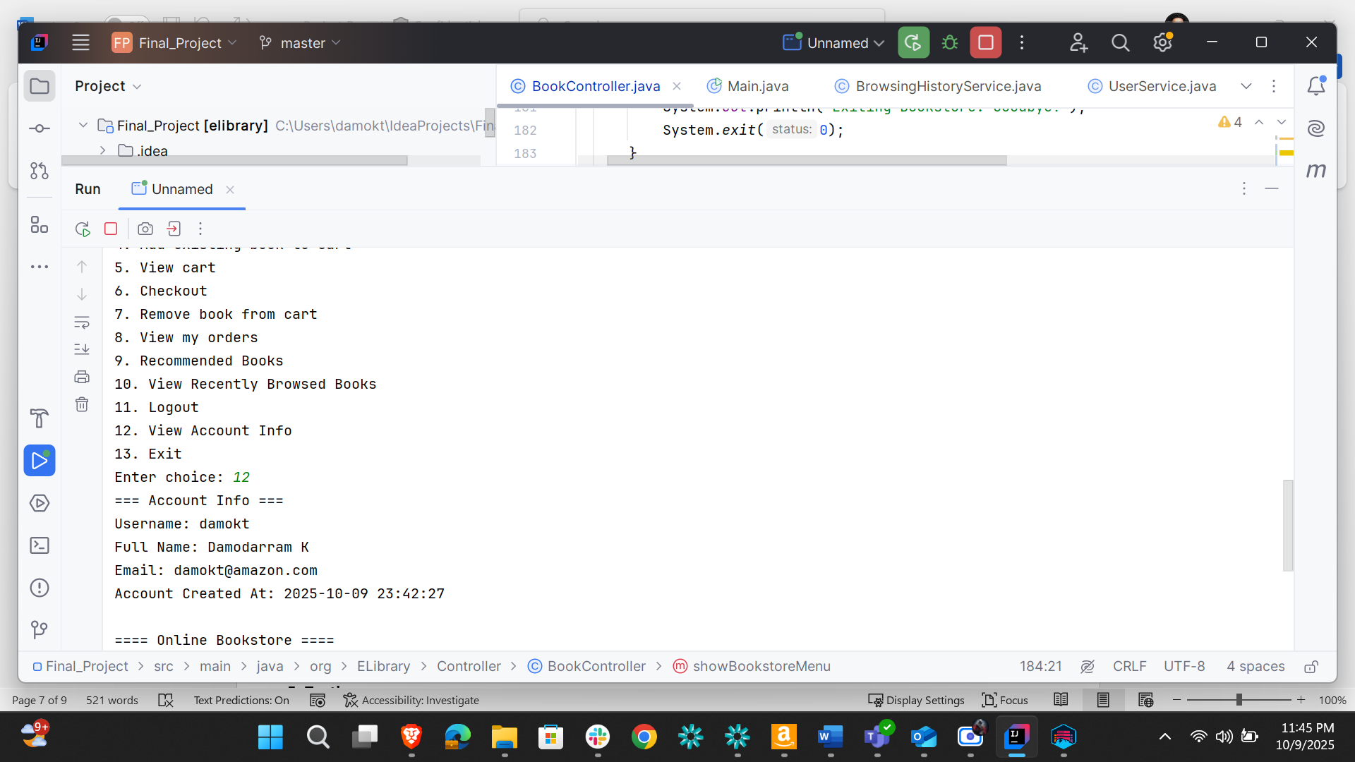

5. Testing
5.1 Unit Testing
- Framework: JUnit 5
- Classes Tested:
  - BookServiceTest
  - CheckoutServiceTest
  - UserServiceTest
  - RecommendationServiceTest
  - BrowsingHistoryServiceTest

5.2 Sample Test Scenarios
Test Case | Description | Expected Result
Add Book | Add a new book to catalog | Book added successfully
View Books | Retrieve all books | Display list of books
Add to Cart | Add book to cart | Book appears in cart
Checkout | Perform checkout | Order created successfully
Get Recommendations | Fetch user’s recommendations | Display list of titles

5.3 Test Results
All unit tests executed successfully in JUnit with green status:
Tests run: 10
Passed: 10
Failed: 0
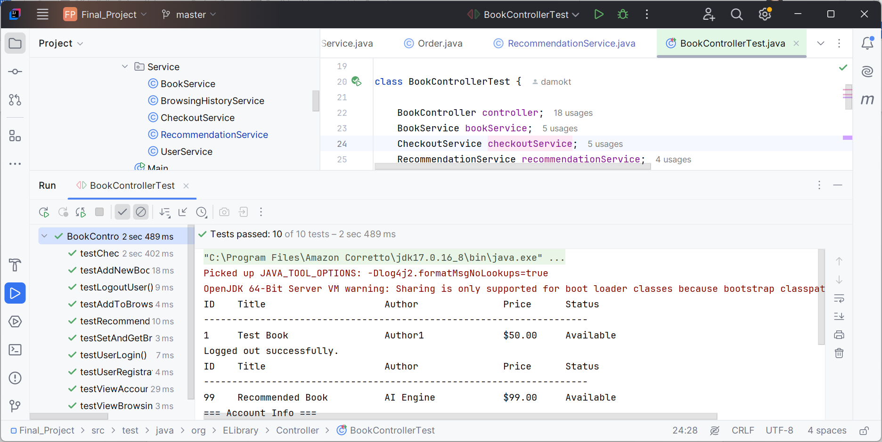

6. Conclusion
The Online Bookstore Application successfully meets its design and functional objectives.
It offers a modular, scalable solution with persistent storage in DynamoDB and clean Java-based service architecture.
Further improvements can include:
- GUI front-end (Swing/React + Spring Boot API).
- Advanced recommendation engine using collaborative filtering.
- Integration of payment gateways and authentication modules.

