Task1:
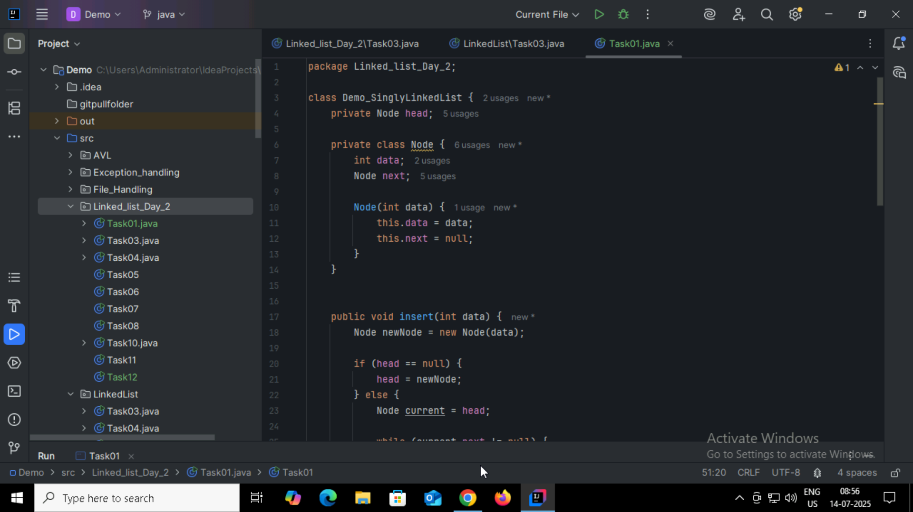
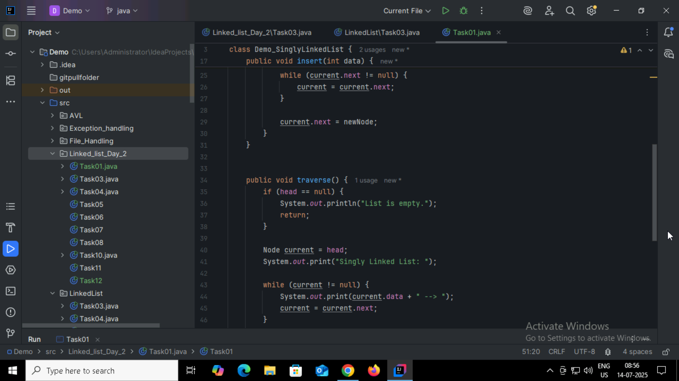
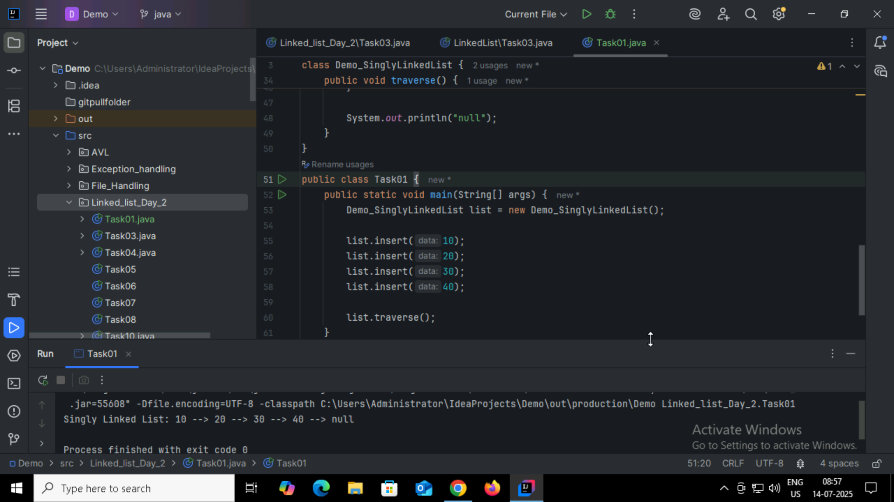

Task2:
What do you mean by traversing?
Traversing a list means visiting each one by one from the start to the end to read data perform operations like print,search,count.

Task3:
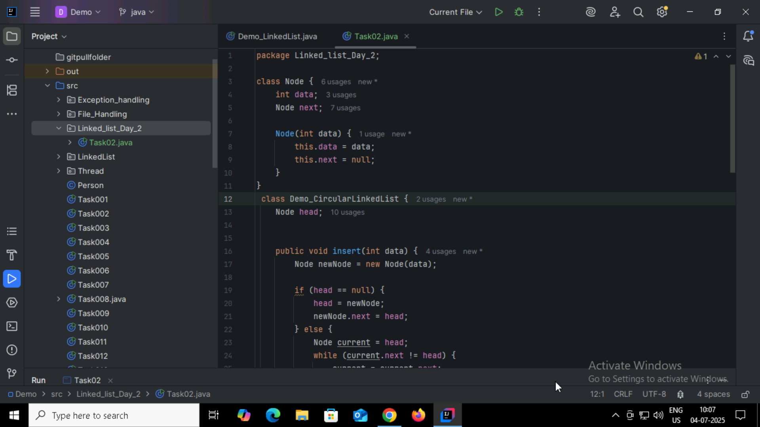
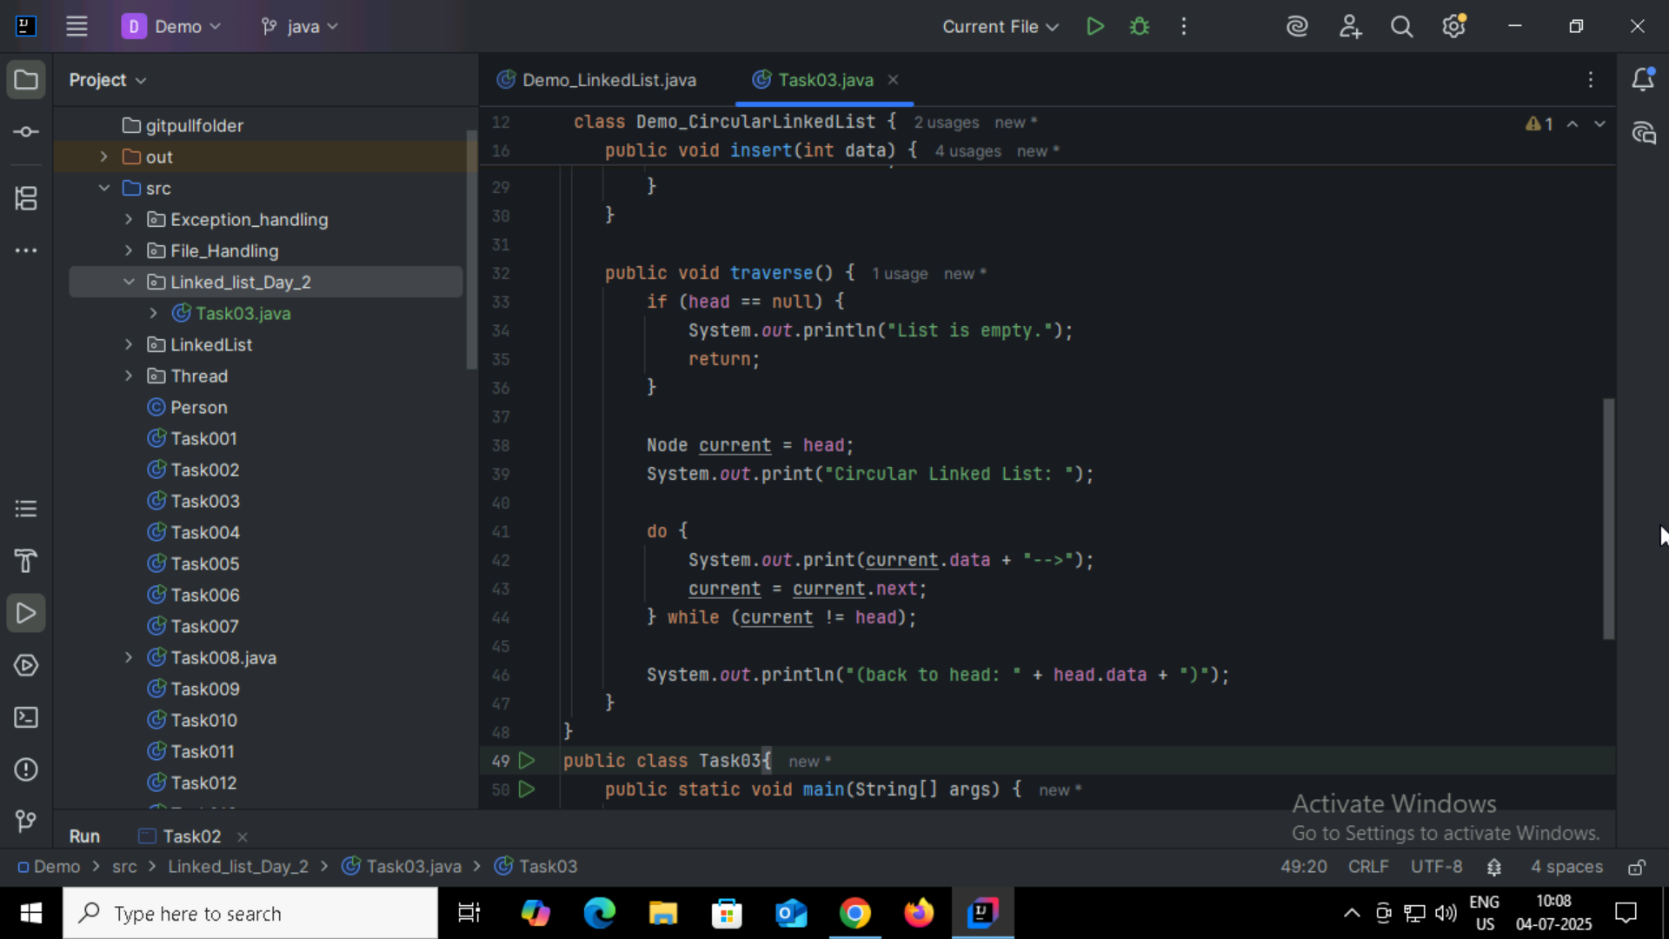
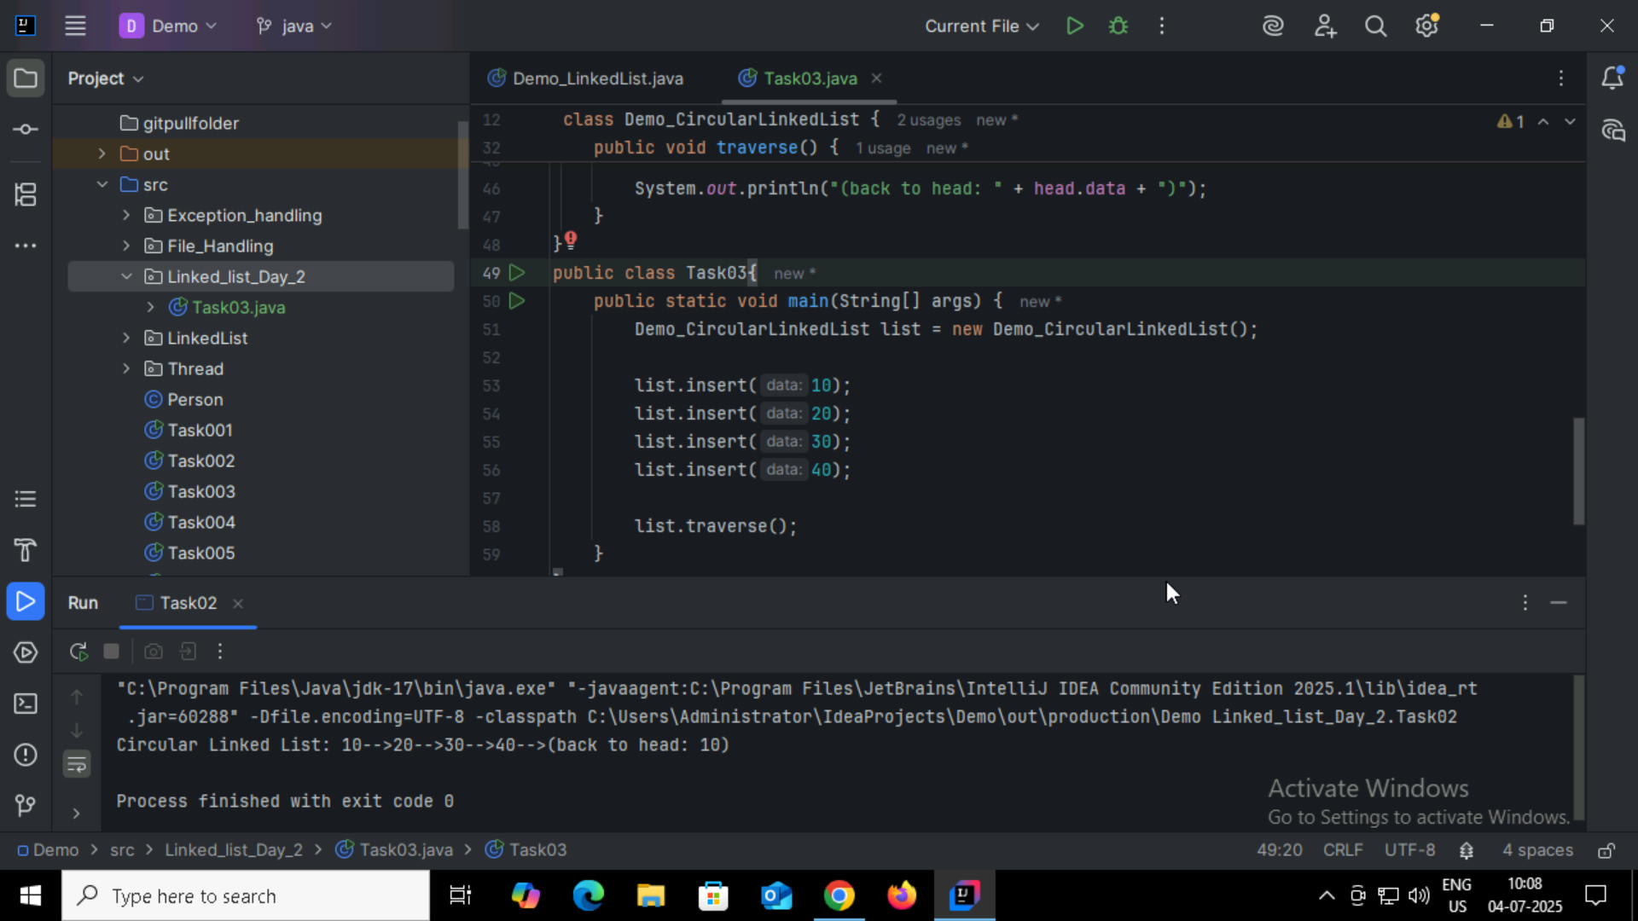
Task4:
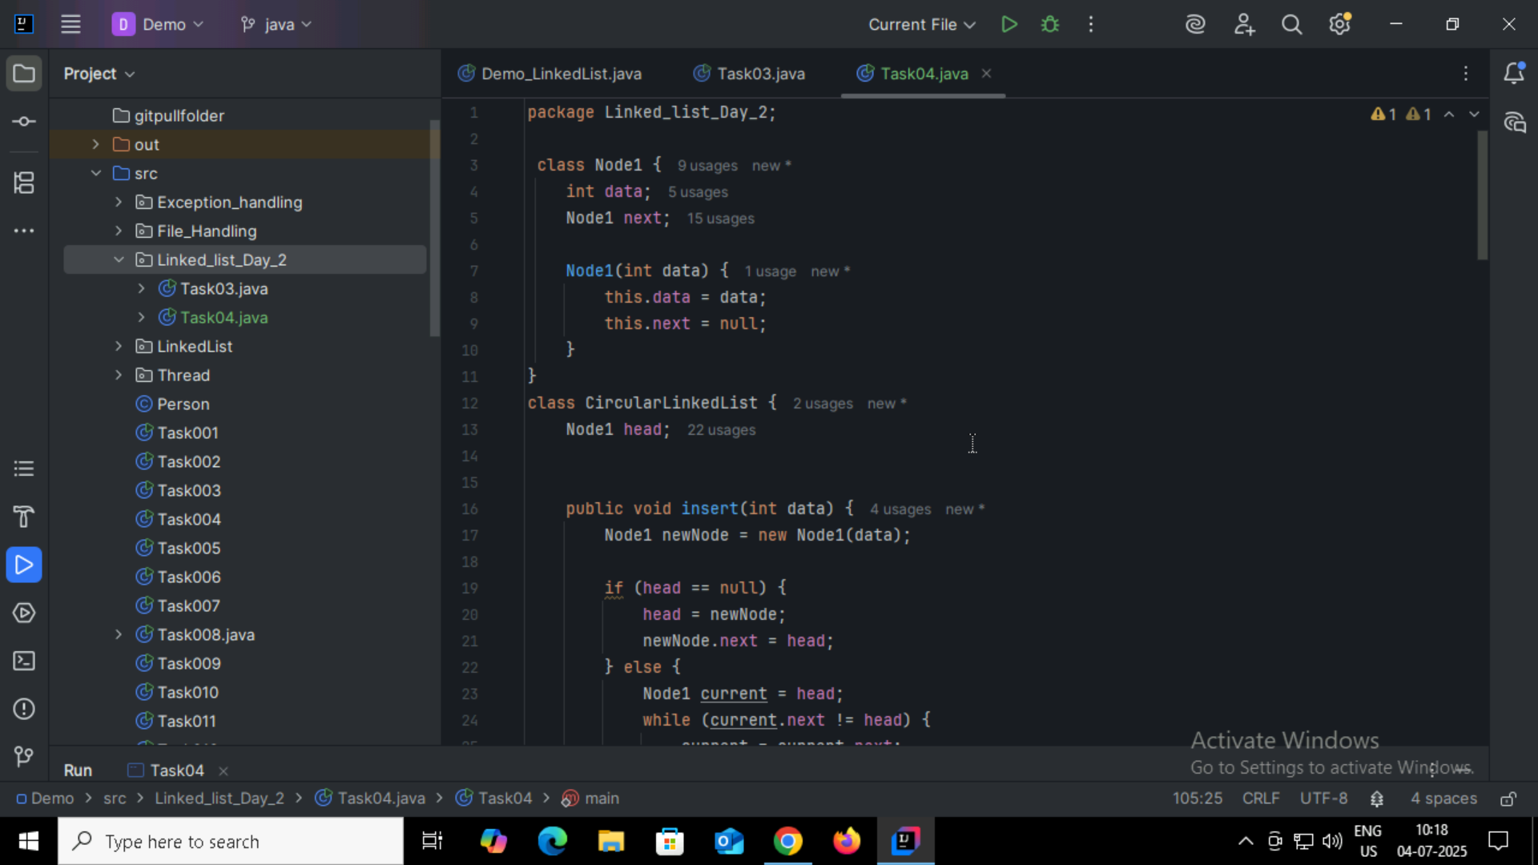
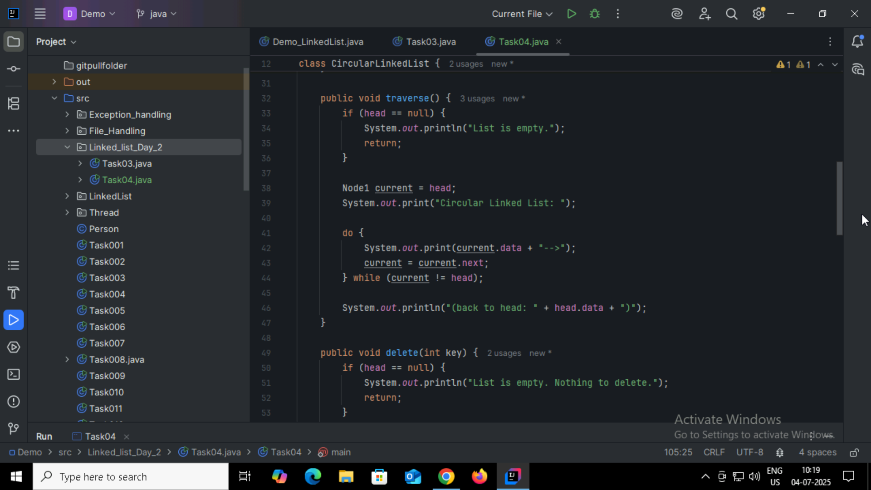
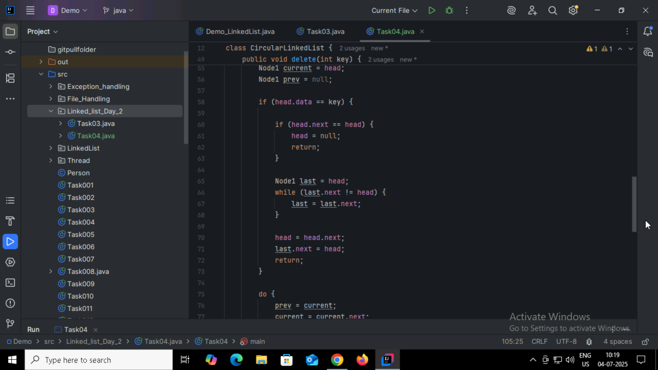
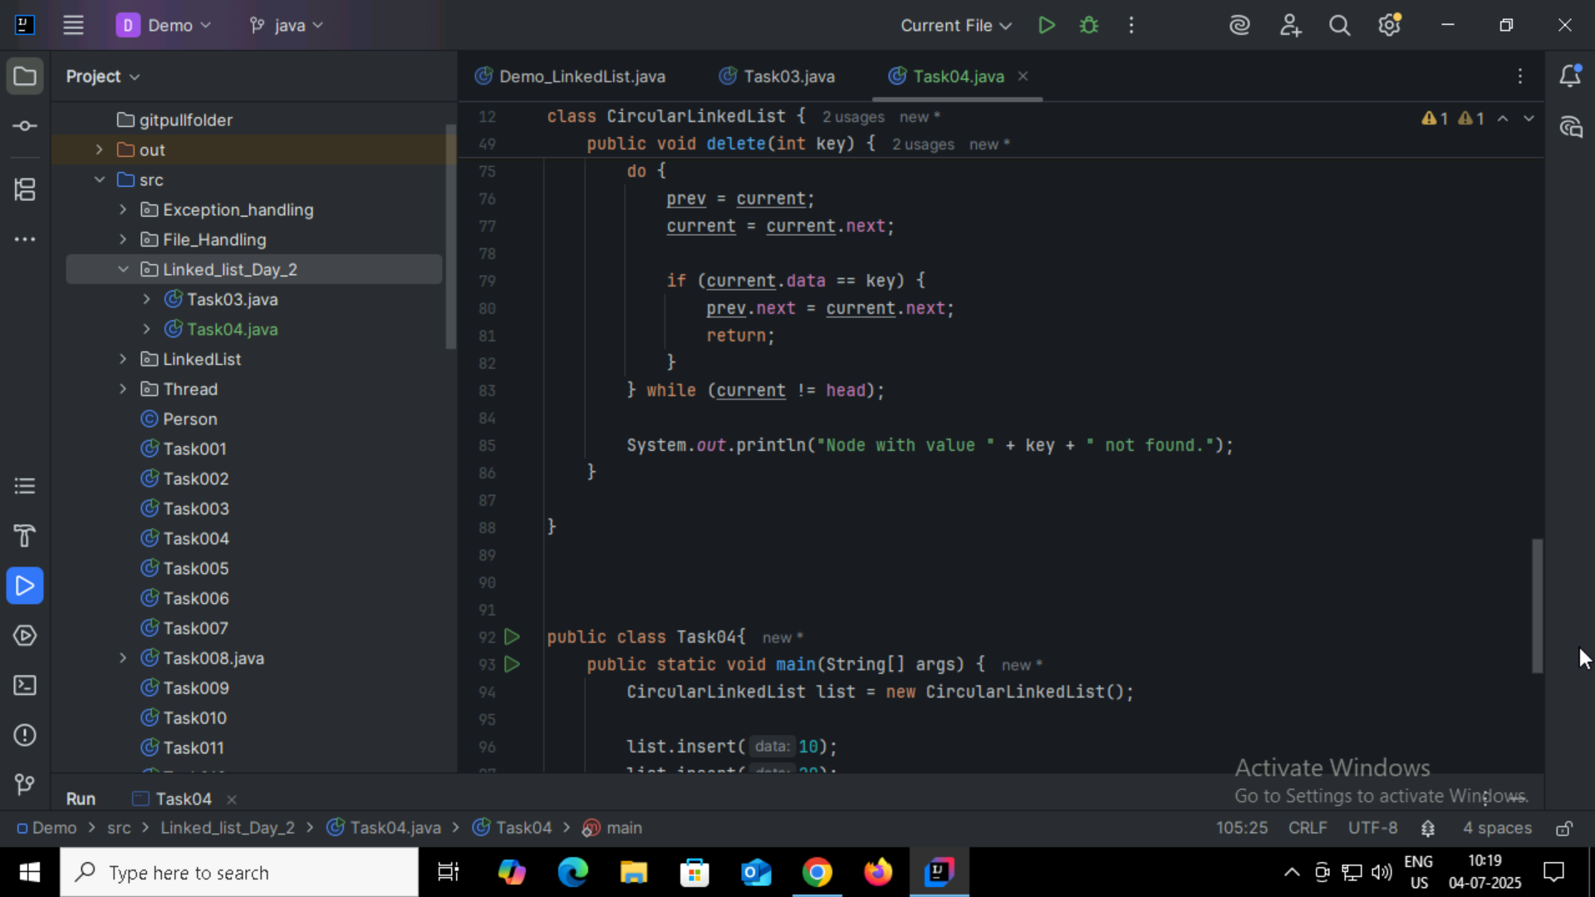
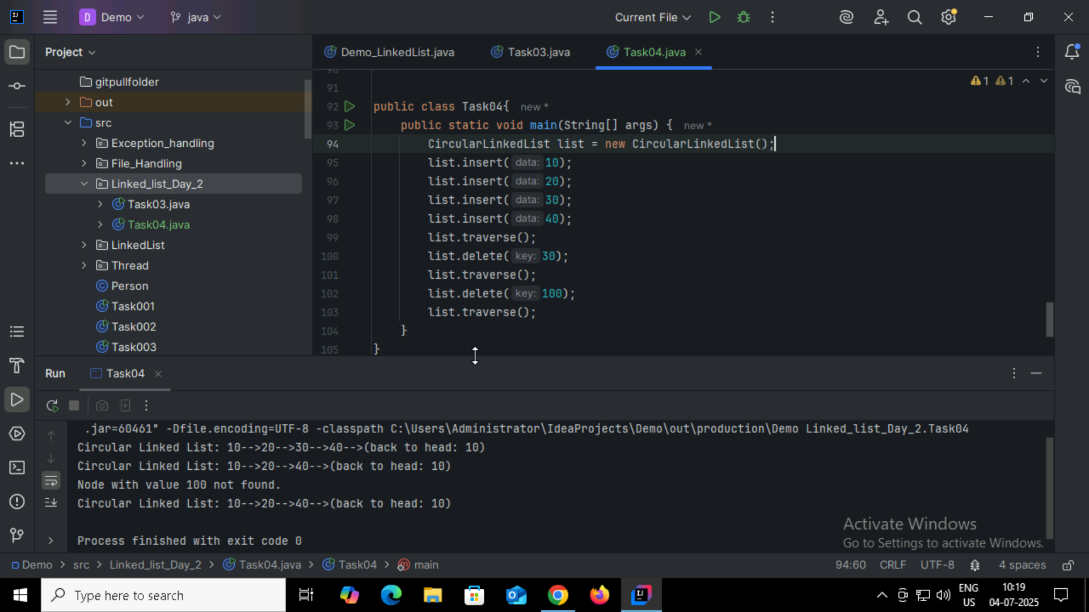

Task05:
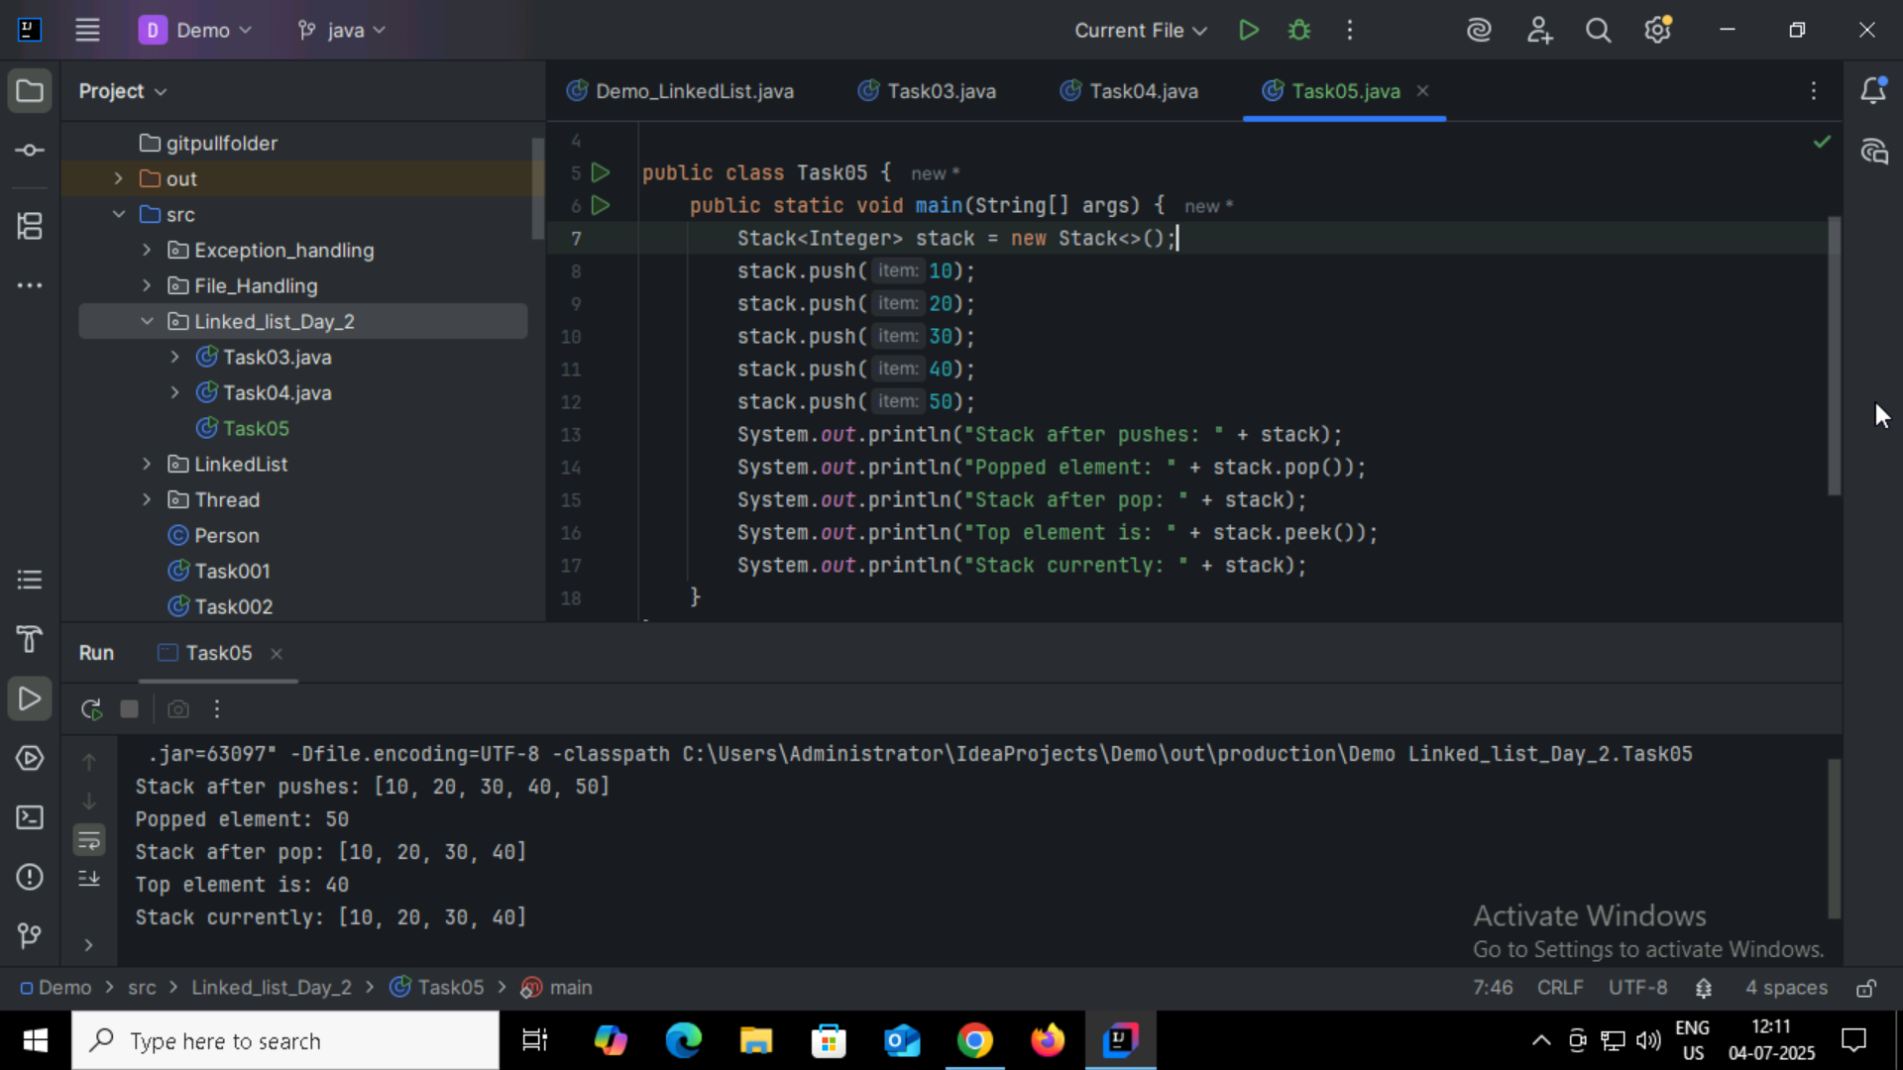

Task06:
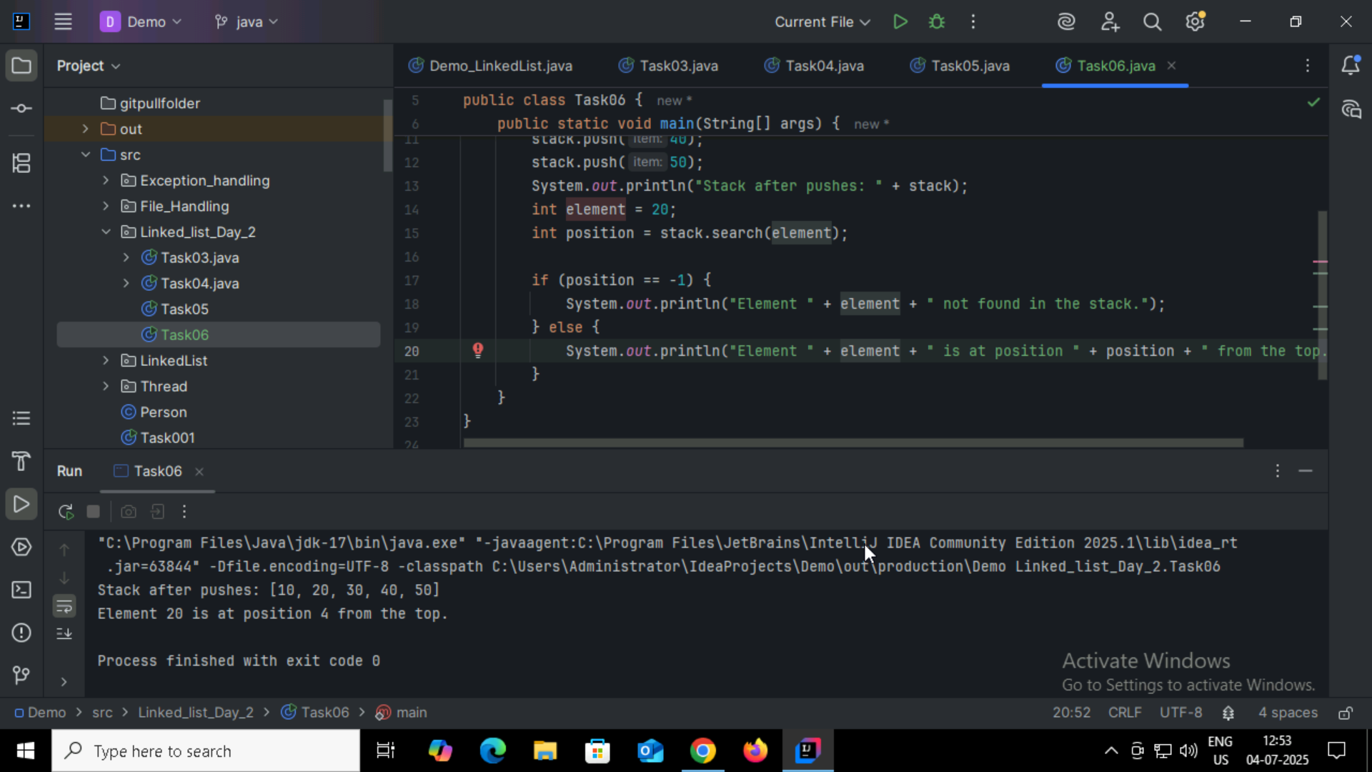

Task07:
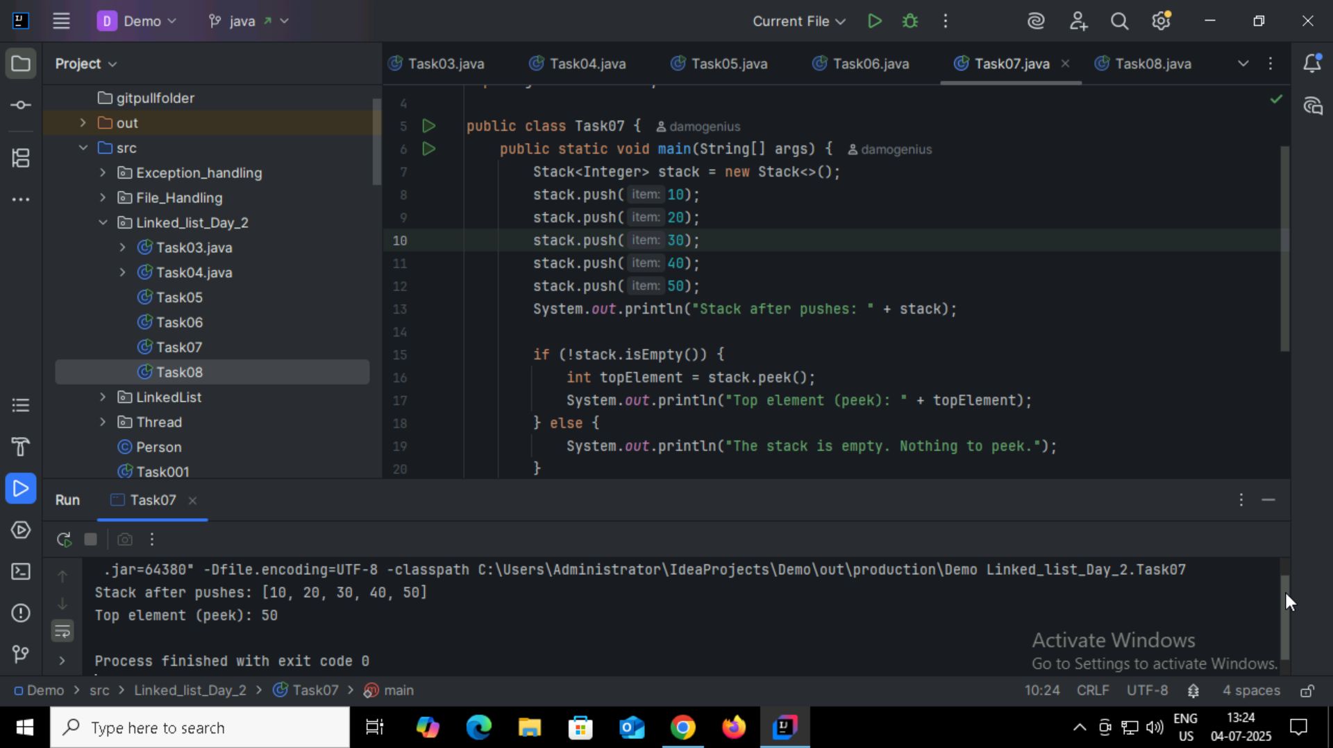

Task08:
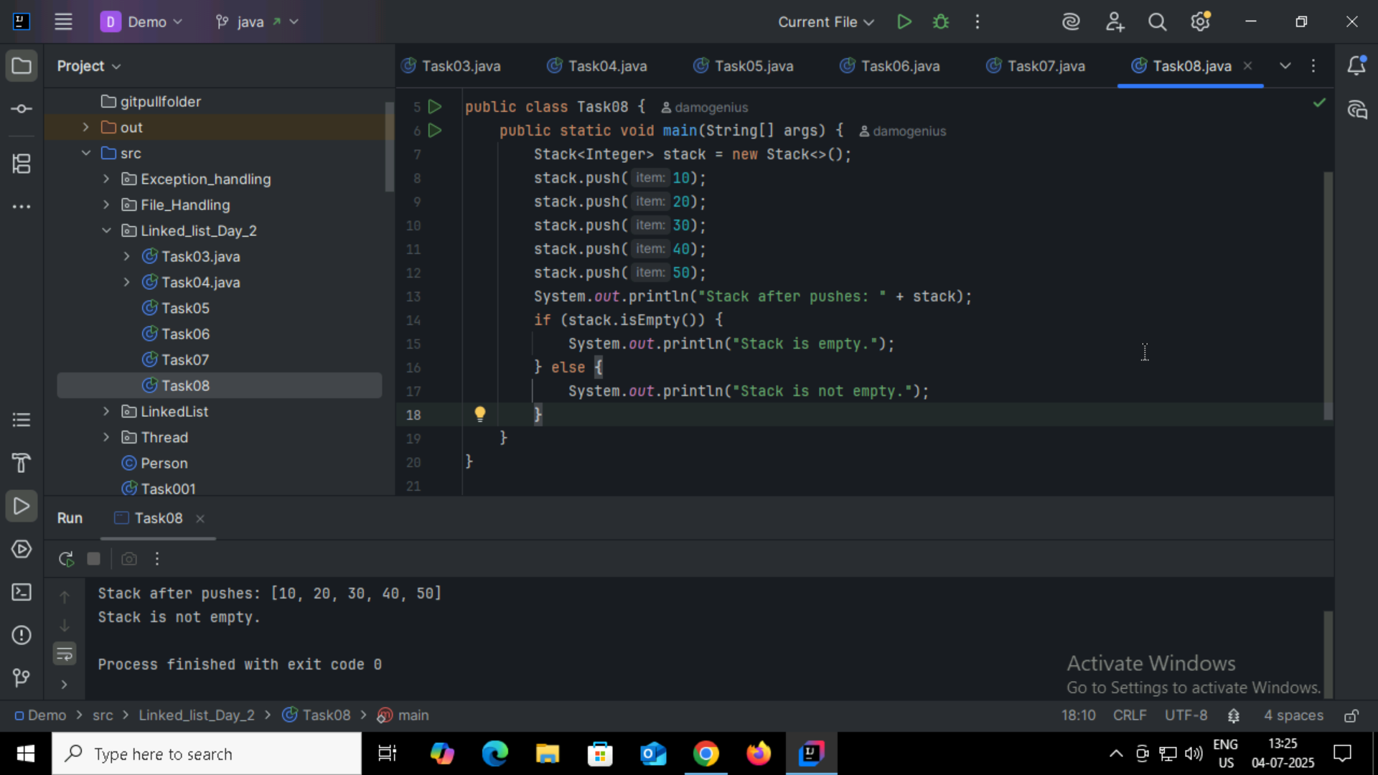

Task09:
- push(E item) – Inserts an element onto the top of the stack.
- pop() – Removes and returns the top element of the stack.
- peek() – Returns the top element without removing it.
- empty() – Returns true if the stack is empty.
- search(Object o) – Returns the 1-based position of an element from the top; -1 if not found.
- isEmpty() – Checks if the stack has no elements (inherited from Vector).
- size() – Returns the number of elements in the stack (from Vector).
- clear() – Removes all elements from the stack.
- contains(Object o) – Checks if the stack contains a specific element.
- iterator() – Returns an iterator over the elements in the stack.

Task10:
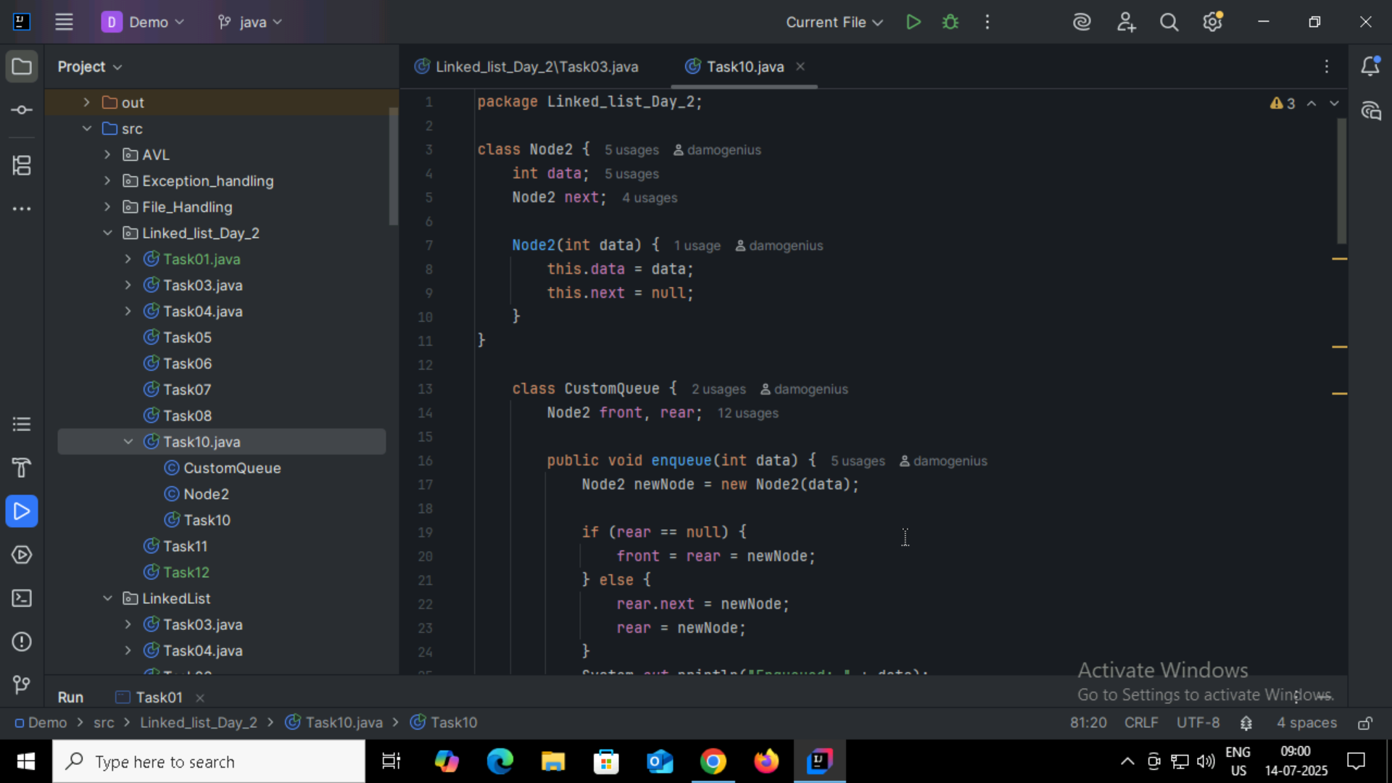
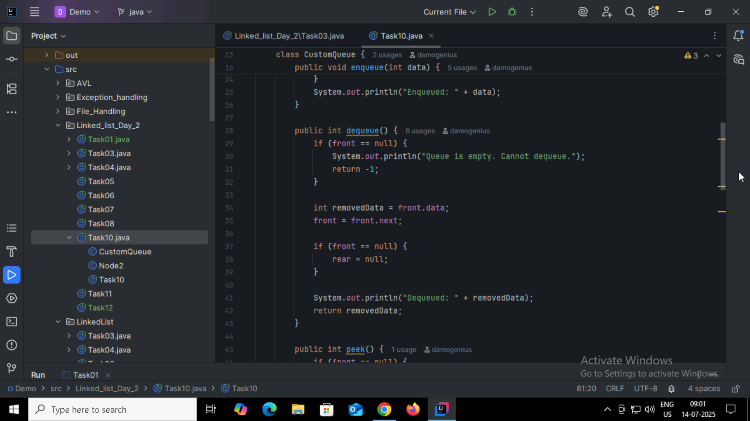
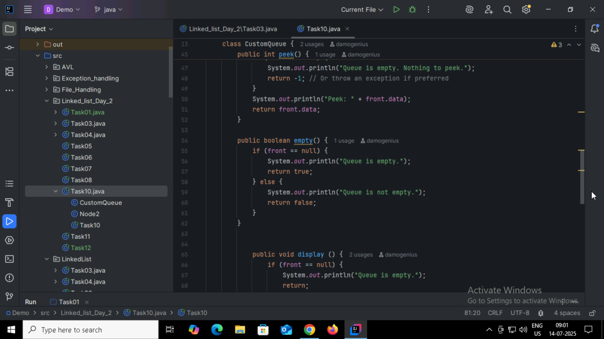
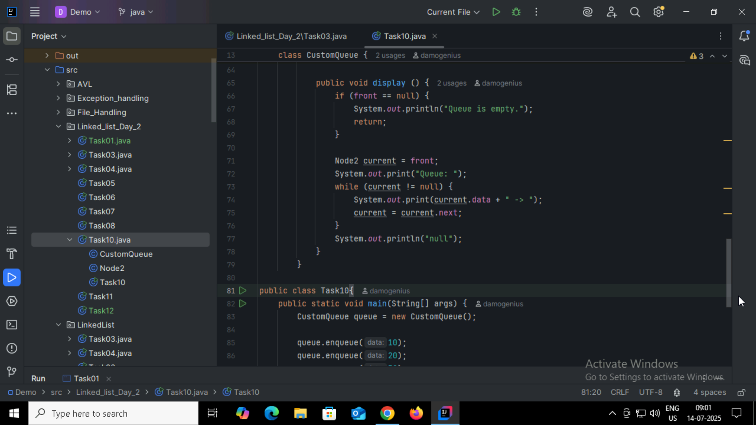
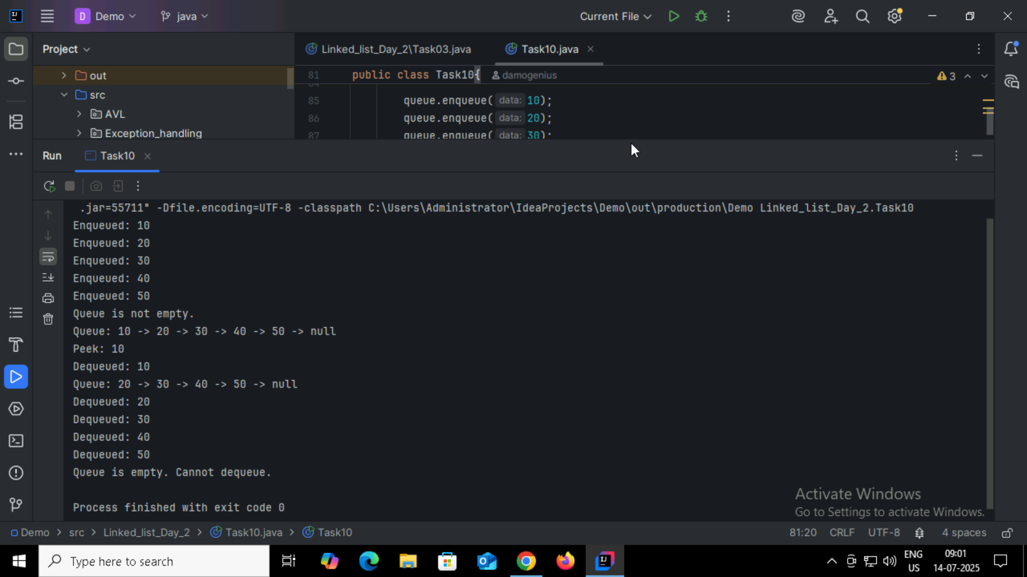

Home Task:
Factorial Number :
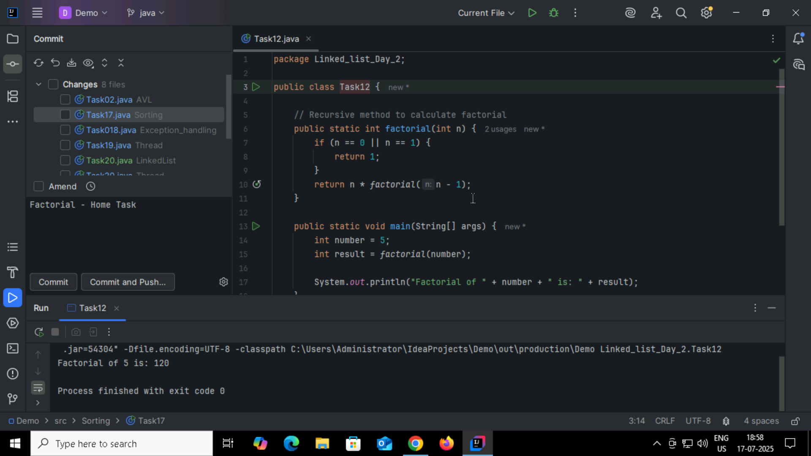

Home task02:
Fibonacci:
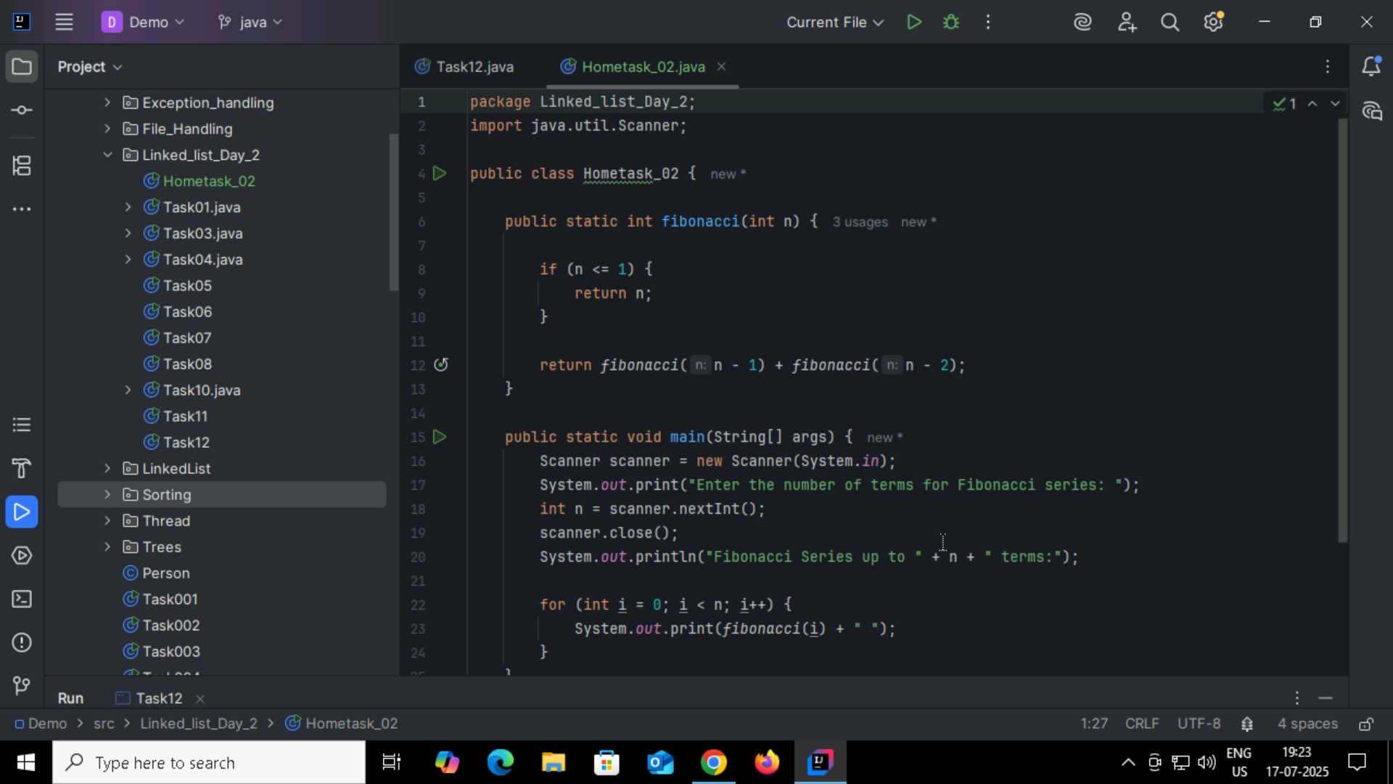
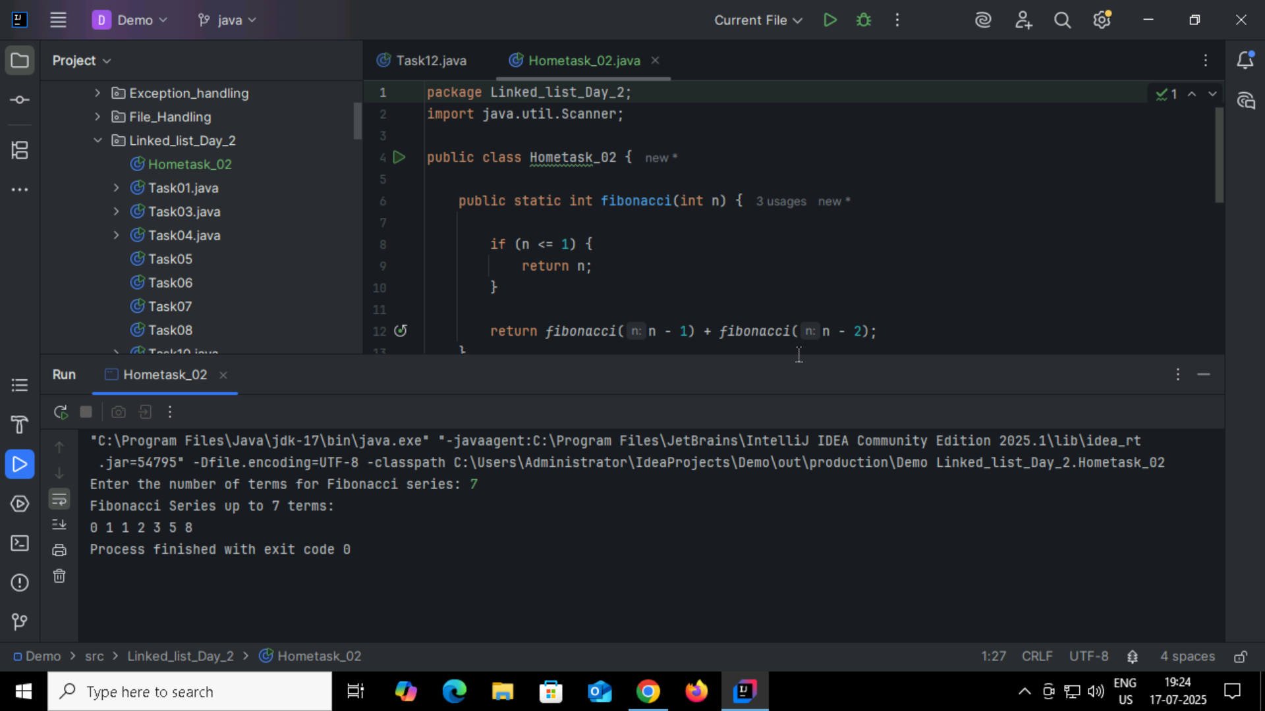

Hometask03:
Iteration:
Iteration means repeating a block of code using constructs like loops(For , While , Do While)
Recursion:
Recursion is when a function calls itself to solve a smaller instance of the same problem.

Hometask04:
