Task01:
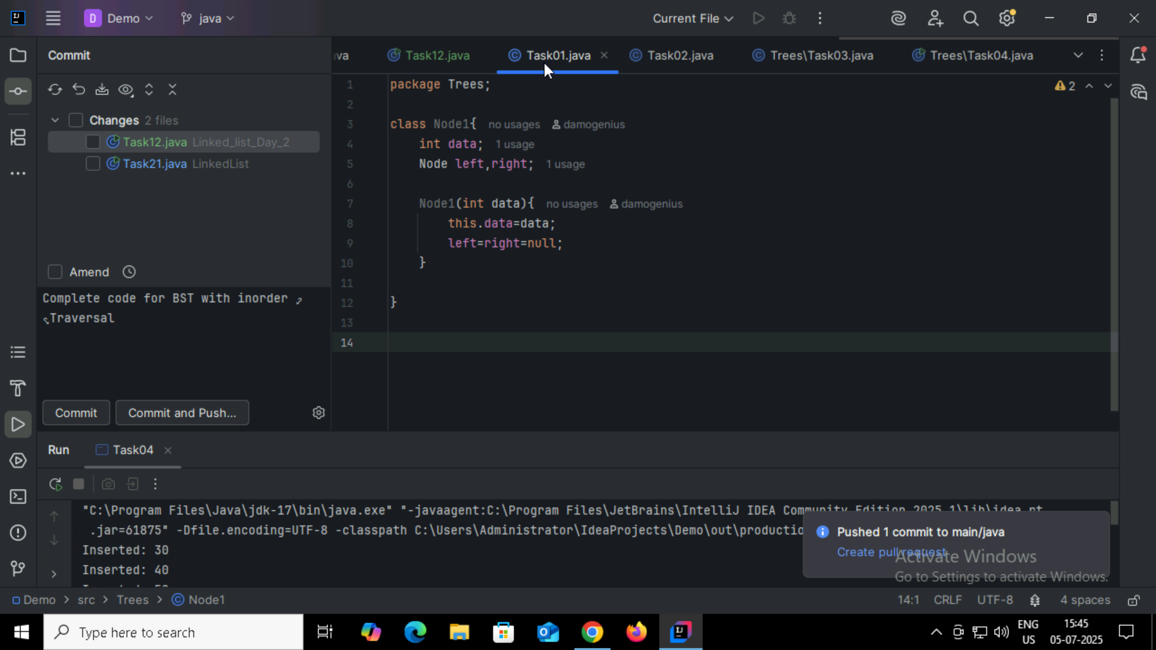

Task02:
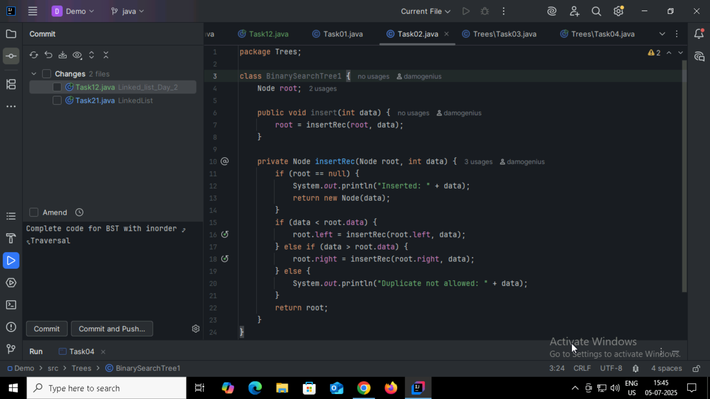

Task03:
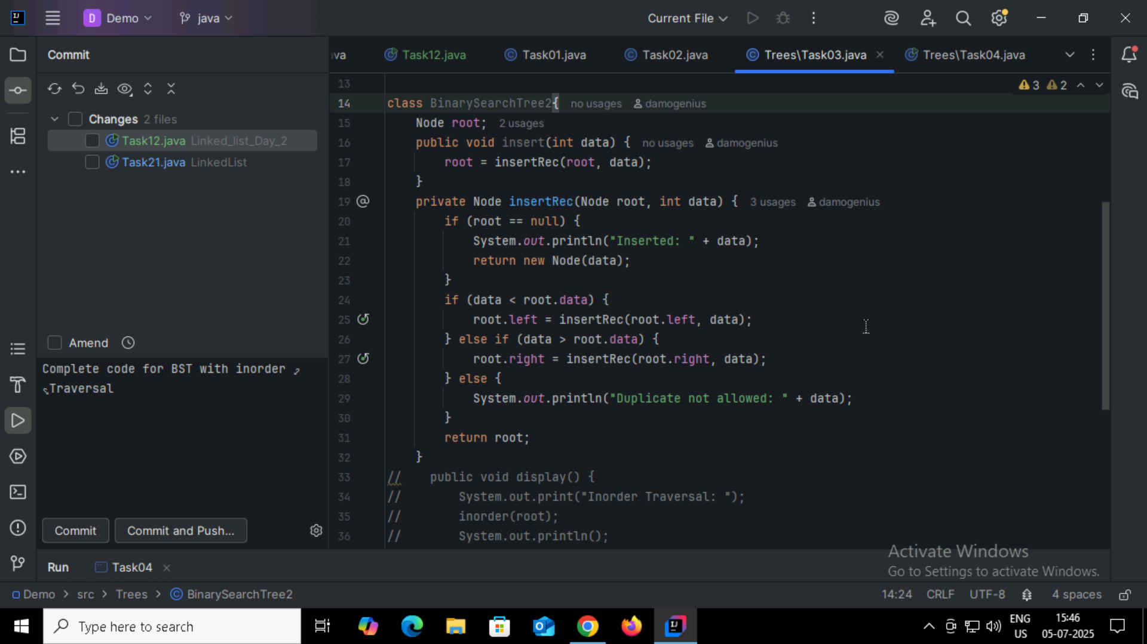

Task04:
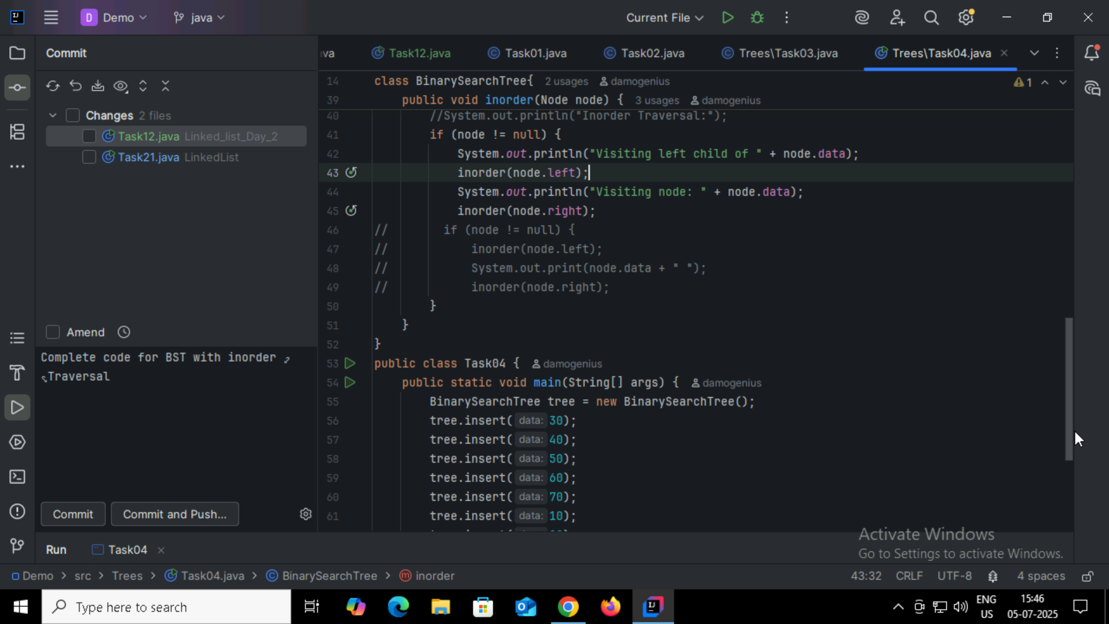

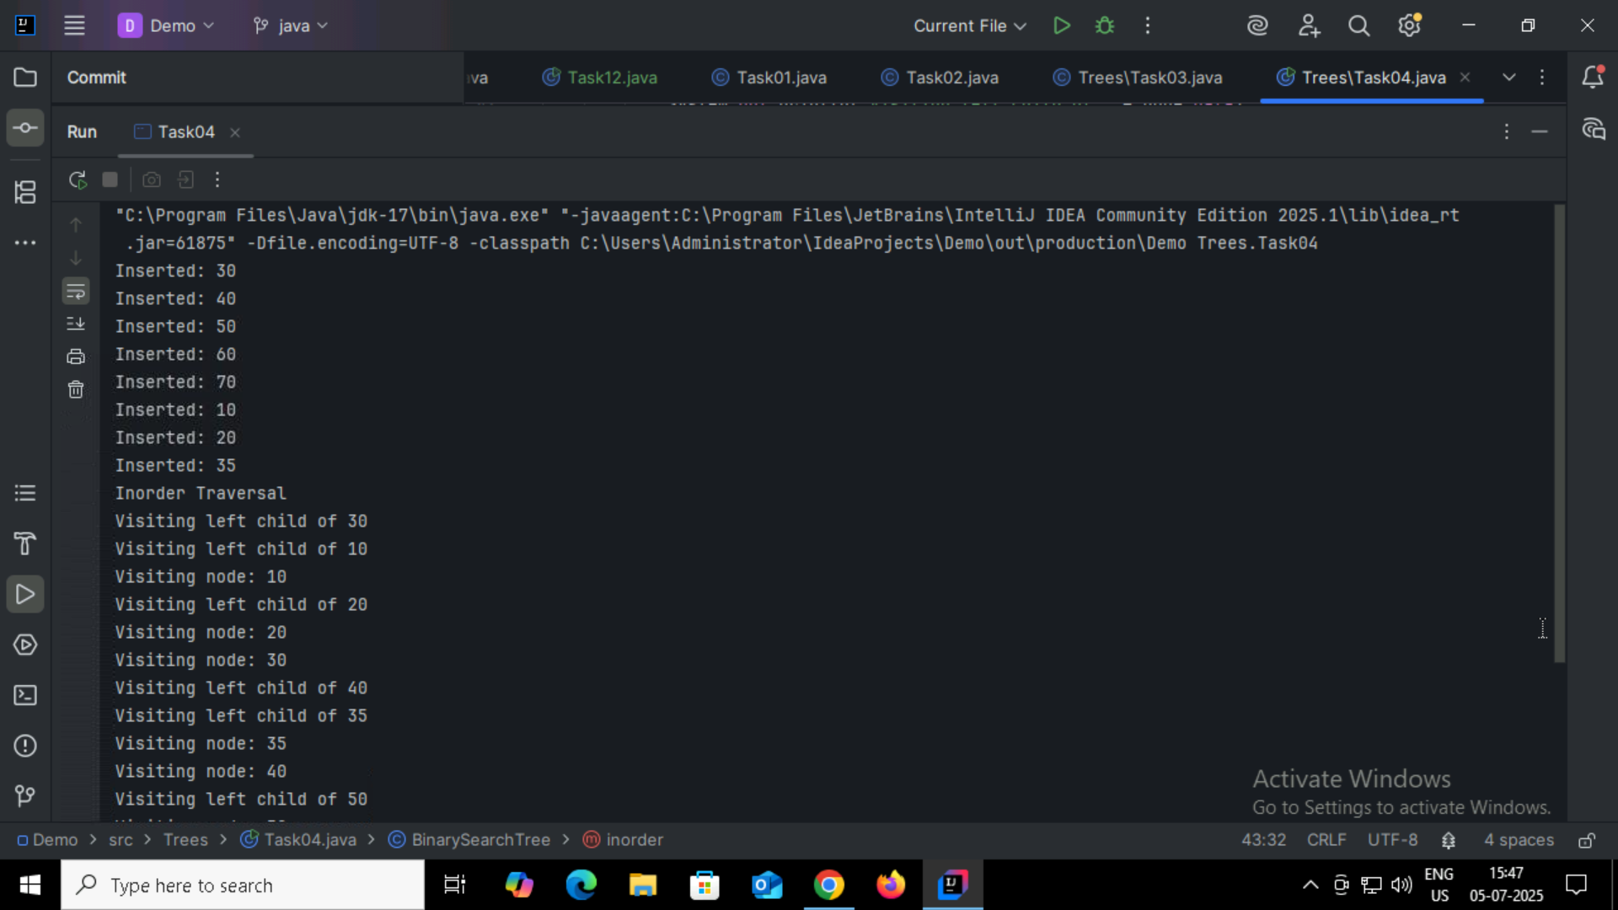
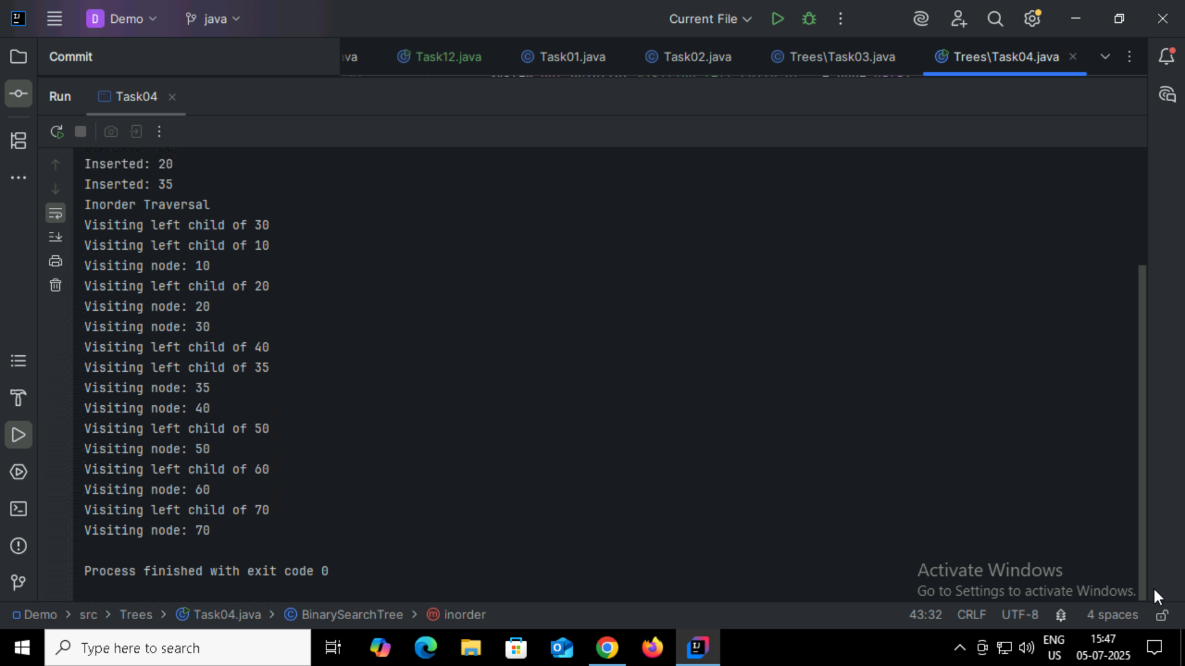

Task05:
Applications of Tree:
Binary Search
Database Indexing
GUI Hierarchies
XML/JSON Parsing
Routing Algorithms
Compiler Design
Priority Queues

Task06:
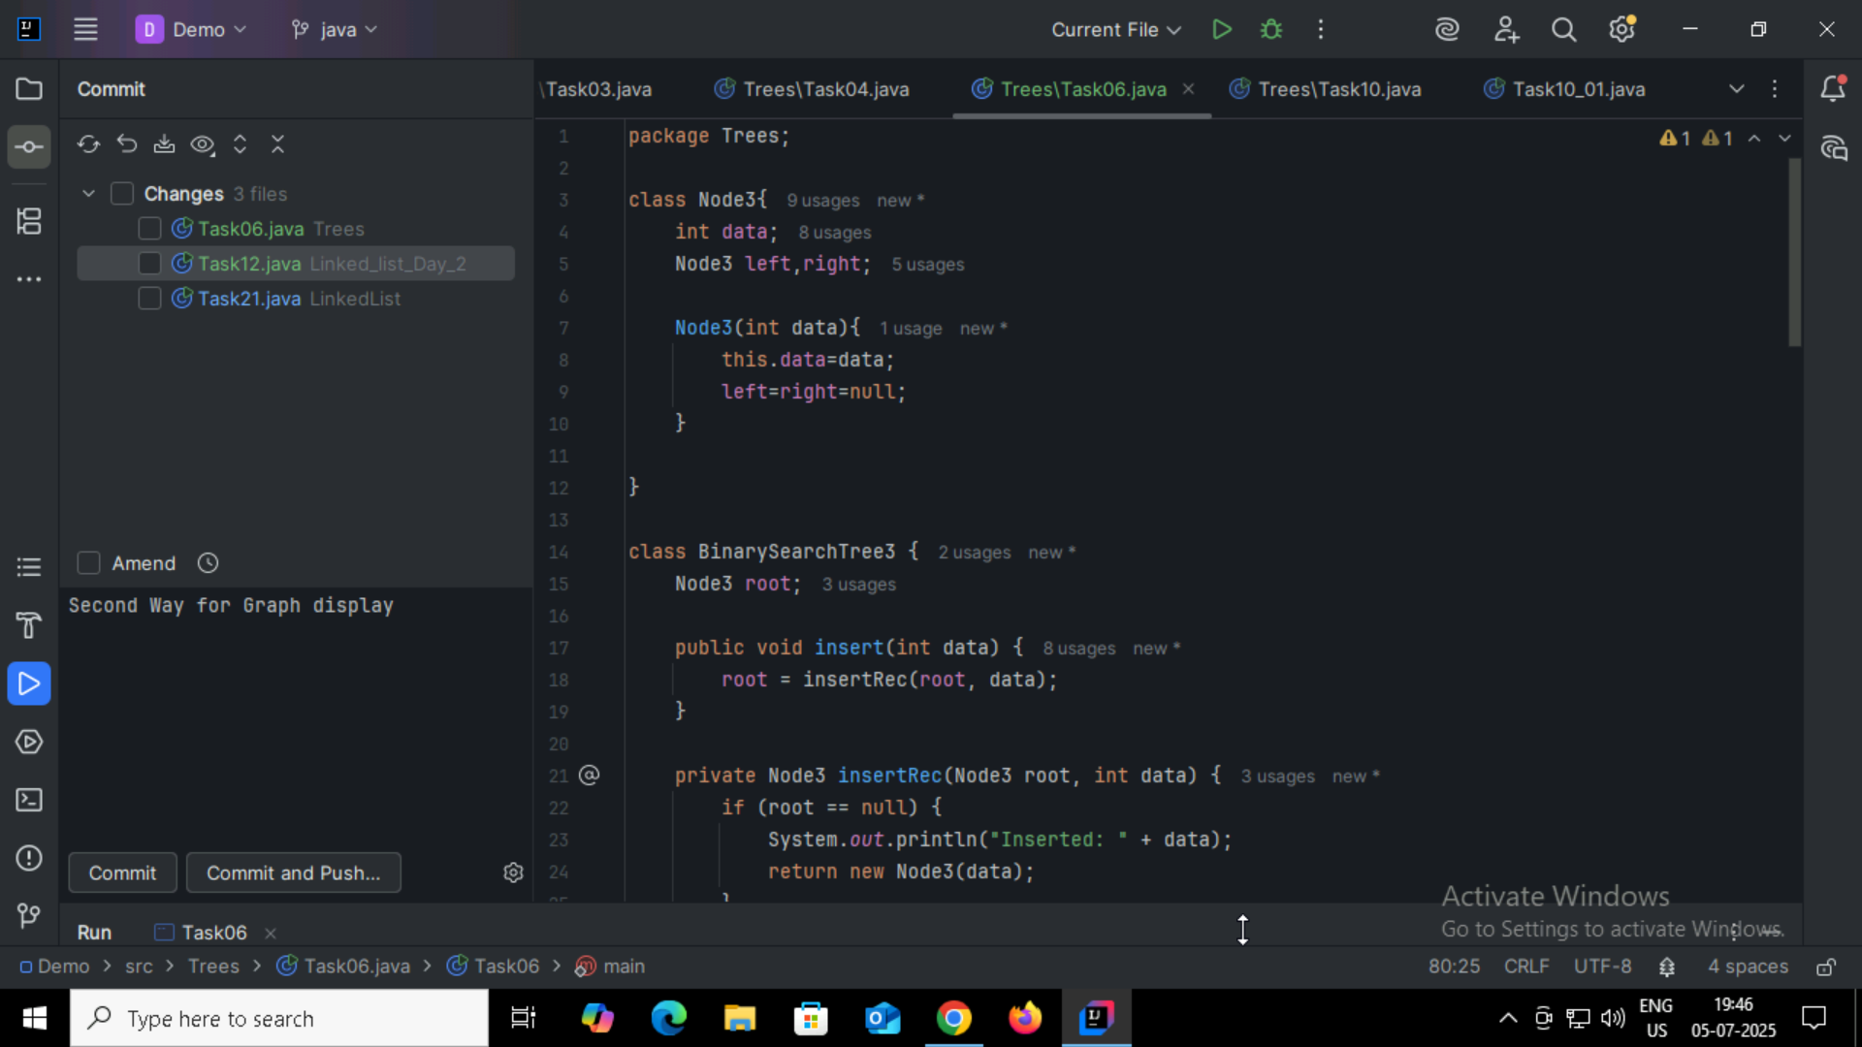
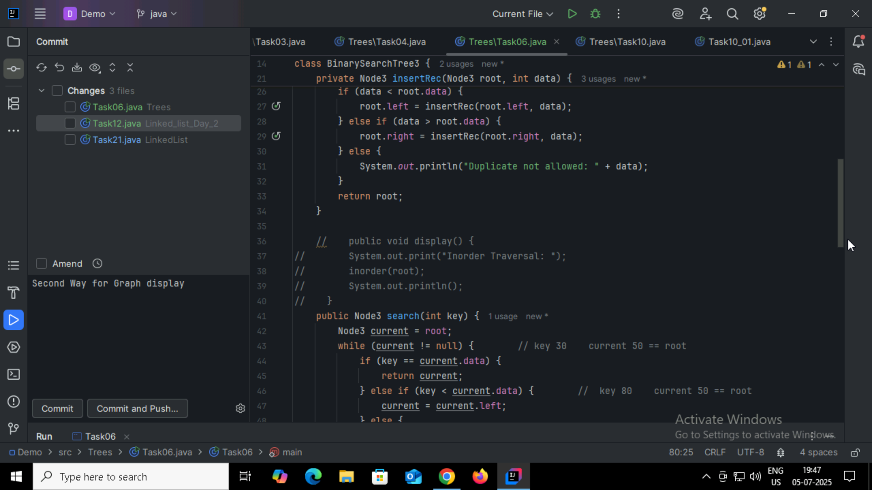
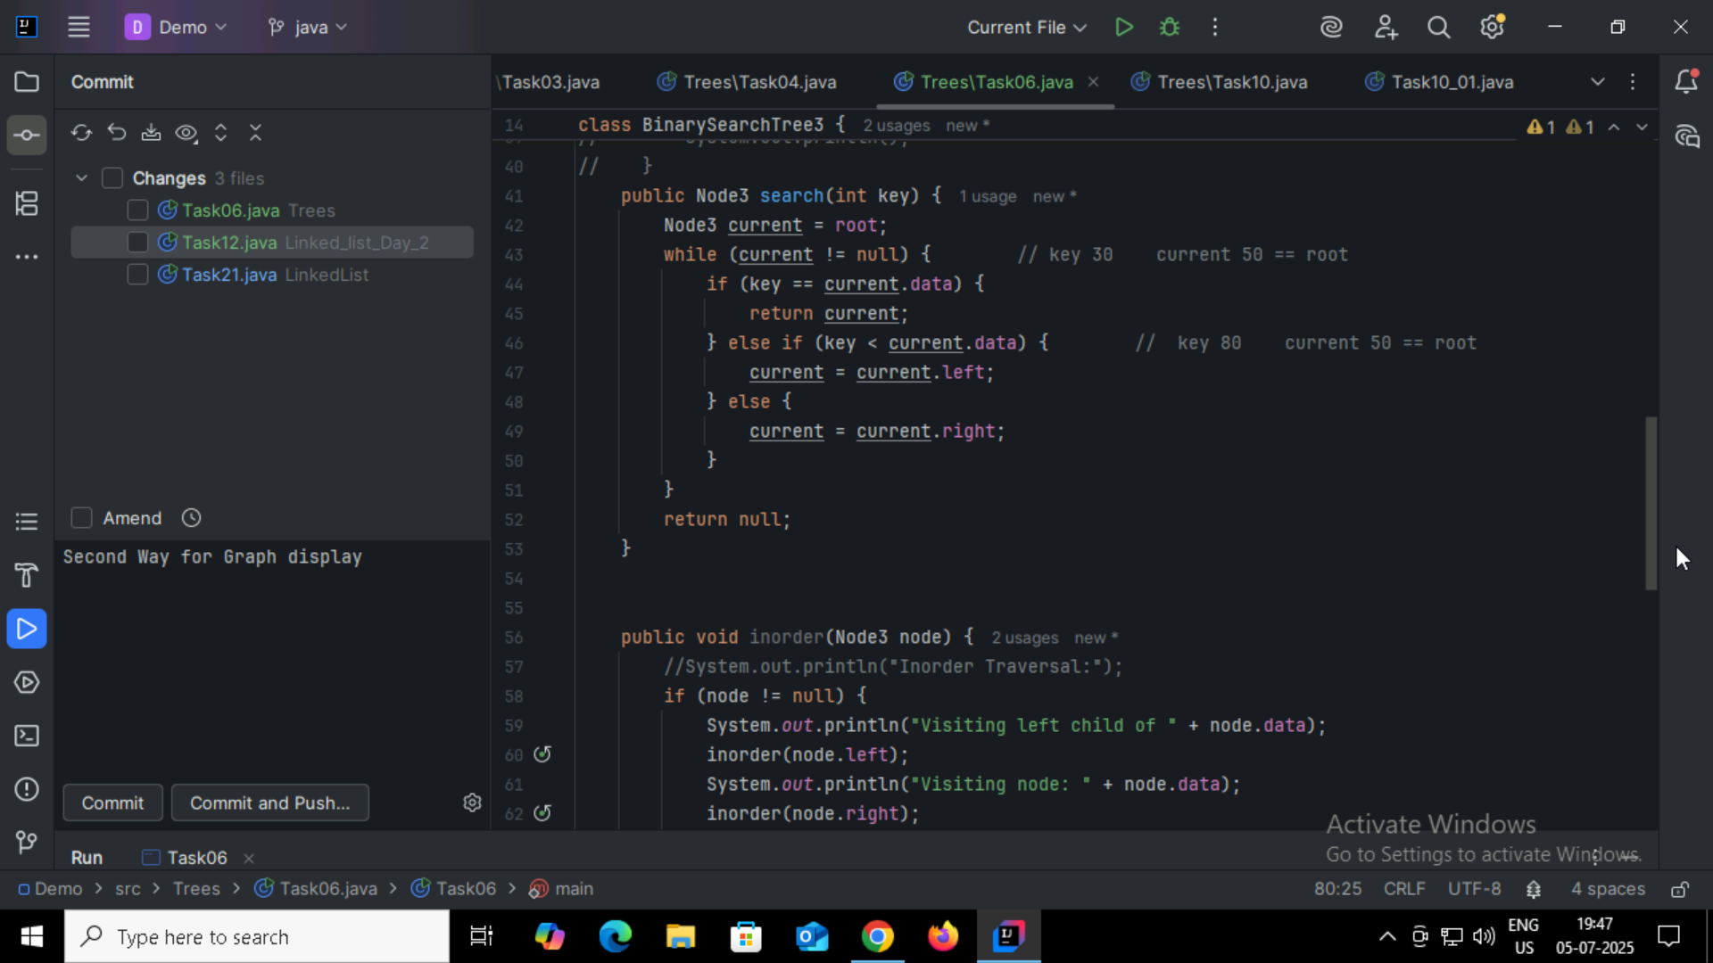
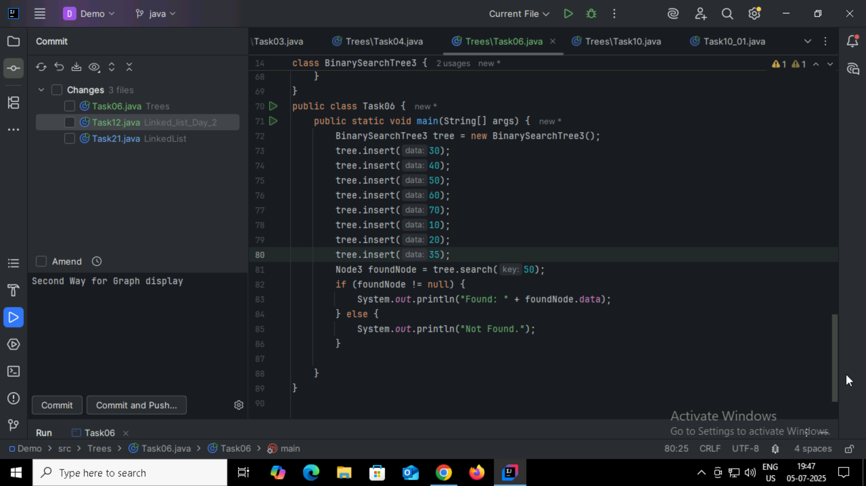
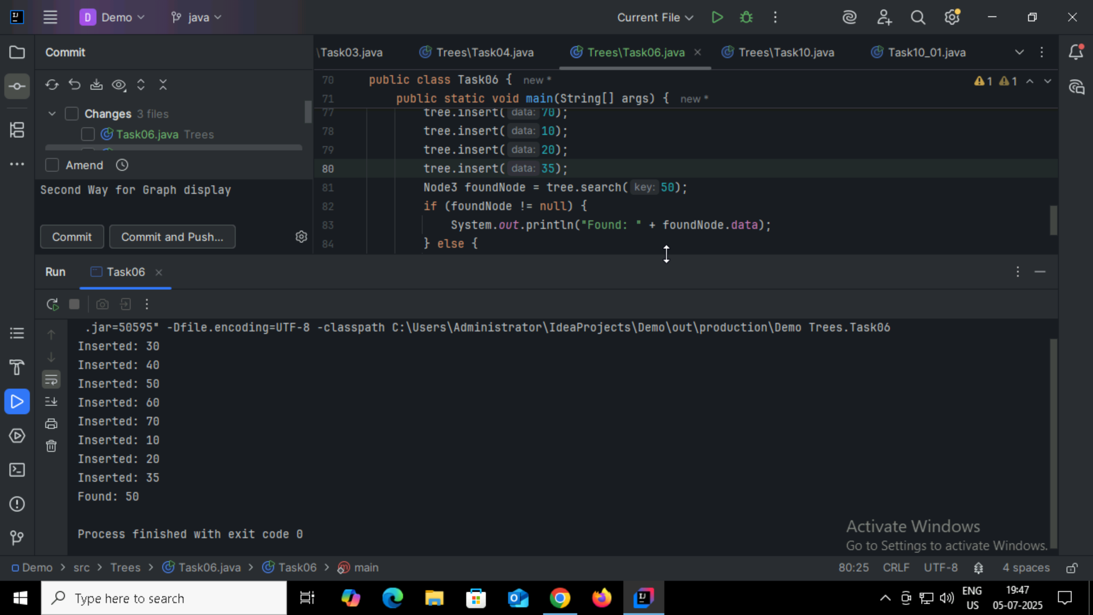

Task07:
Types of Binary Trees
Full Binary Tree
Complete Binary Tree
Perfect Binary Tree
Balanced Binary Tree
Degenerate (or Skewed) Binary Tree
Binary Search Tree (BST)
Threaded Binary Tree
AVL Tree
Red-Black Tree
Expression Tree

Task08:
Applications of graphs
Social Networks- Facebook, LinkedIn: friends, followers, connections
Google Maps, GPS Systems -Routes between cities, shortest paths, traffic optimization
Computer Networks - Internet routing, network topology, data flow
Airline Routes - Airports as nodes, flights as edges
Web Crawlers - Hyperlinks form a directed graph of the internet
Electric Circuits - Components and connections form graph structures
Supply Chain & Logistics -Distribution networks and delivery routes

Task09:
Types of graphs
Property - Type Examples
Direction - Directed, Undirected
Weight - Weighted, Unweighted
Cycle- Cyclic, Acyclic, DAG
Completeness - Complete, Sparse, Dense
Special Structure - Bipartite, Tree, Planar, Multigraph

Task10:
